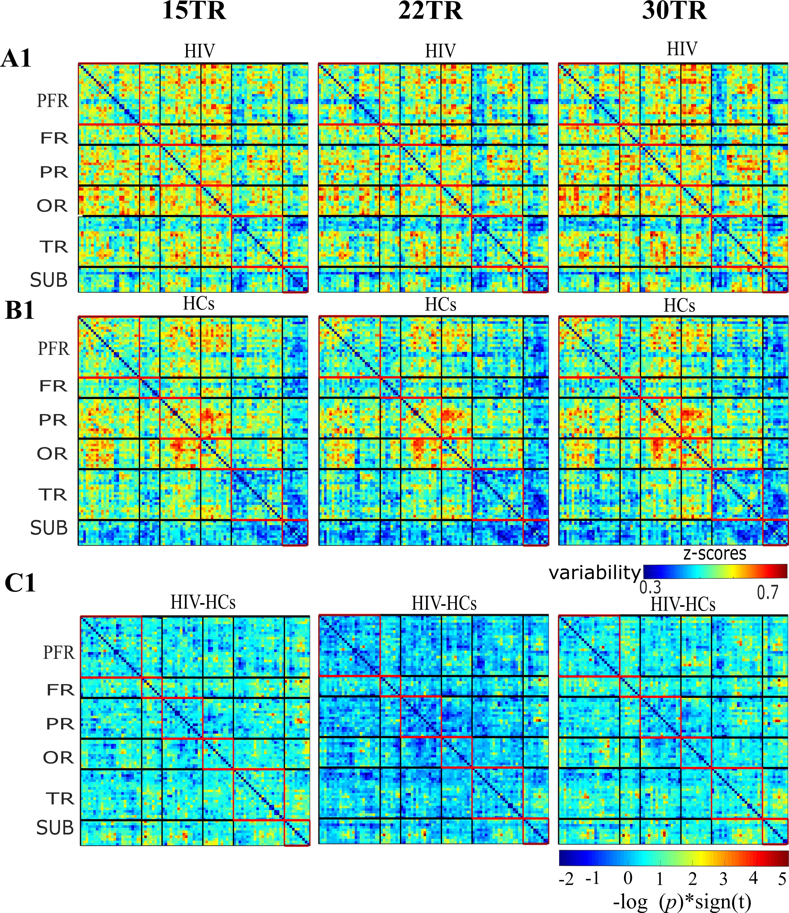
Supplementary Figure 2. The illustration of reproducibility of temporal variabilities in different windows size (15TR, 22TR, 30TR). (A1) The mean variability maps for HIV patients (HIV) at 5TR, 22TR, and 30TR. (B1) the mean variability for healthy controls (HCs). (C1) The group differences (HIV–HCs) in connectivity variabilities.

