Online Supplement
Linear mixed effect models
To account for the skew in the raw-mean scores, we used generalized linear mixed models with a logistic linking function. All models were fitted using the glm function in the stats package in R 3.31. For replicability, we report the untransformed model parameter estimates in Tables S2-S4. For interpretability of effects, we converted the effects to probabilities for the visualizations in the main body of the manuscript.

Description | Median Raw Score | Endorsement (%)
Repetitive Motor
LEGS | 3 | 0.49
HEAD | 2 | 0.38
WHOLE BODY/TORSO | 2 | 0.45
ARMS/HANDS/FINGERS | 2 | 0.41
ARMS/HANDS/FINGERS ON SURFACES | 3 | 0.41
OBJECT USAGE | 4 | 0.37
MOUTHING OBJECTS | 4 | 0.35
LOCOMOTION | 2 | 0.44
VOCALIZATIONS | 2 | 0.44
Self-Directed
HITS SELF WITH BODY PART | 1 | 0.27
HITS SELF WITH OBJECT | 1 | 0.22
HITS SELF AGAINST SURFACE | 1 | 0.27
RUBS, SCRATCHES, POKES OR PINCHES SELF | 1 | 0.2
PULLS OWN HAIR | 1 | 0.26
Restricted Interests/Ritual & Routine
LIMITED & INTENSE INTERESTS | 1 | 0.28
RESTRICTED USE OF MEDIA | 1 | 0.22
SENSORY INTERESTS | 1 | 0.24
STRONGLY ATTACHED TO SPECIFIC OBJECT | 1 | 0.35
VOCALIZATIONS | 1 | 0.23
STILLNESS | 1 | 0.10
VISUAL INSPECTION | 1 | 0.41
FASCINATION WITH MOVEMENT | 1 | 0.45
ARRANGING | 1 | 0.27
PLACEMENT OF OBJECTS | 1 | 0.15
UPSET VISITING NEW PLACES | 1 | 0.12
UPSET IF INTERRUPTED | 1 | 0.35
APPEARANCE OF OTHERS | 1 | 0.10
INFLEXIBLE ROUTINE | 1 | 0.08
EATING/MEALTIME | 1 | 0.11
SLEEPING/BEDTIME | 1 | 0.15
PLAY | 1 | 0.04
SOCIAL INTERACTION | 1 | 0.03

Table S1. Median item-level responses (min=0, max=4). Each item was converted to a binary scale (0,1) using its median split. These binarized scores were then used to calculate the proportion of samples endorsing a given item.
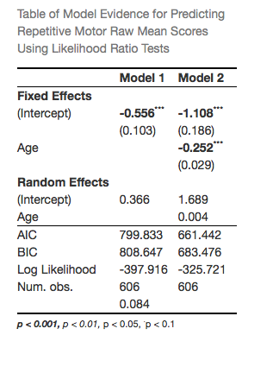
Table S2. Linear Mixed Effects Model results testing the effect of Age, Cohort, and Sex on Repetitive Motor raw mean scores. Model 1=Baseline model; Model 2=Establishing functional form; Linear fixed and random effects of age. Model did not converge when covariates (Cohort and Sex) were included, and was not considered as a candidate model, so Model 2 was adopted as final model.

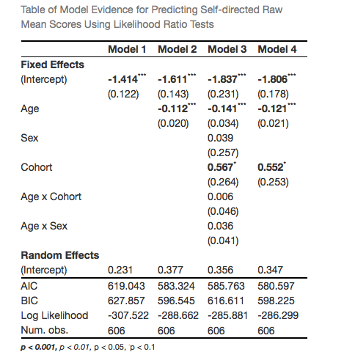

Table S3. Linear Mixed Effects Model results testing the effect of Age, Cohort, and Sex on Self-directed raw mean scores. Model 1=Baseline model; Model 2=Establishing functional form; Linear fixed effects of age. Model 3=Assessing covariates. Model 4=Final model with significant covariate of Cohort included.
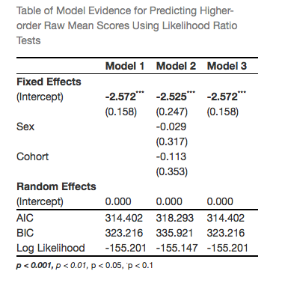
Table S4. Linear Mixed Effects Model results testing the effect of Age, Cohort, and Sex on Higher-order raw mean scores. Model 1=Baseline model. Model 2=Adding covariates (initial model establishing functional form found no significant fixed or random effects of Age). Model 3=Final model selected after removing non-significant effects of Sex and Cohort.

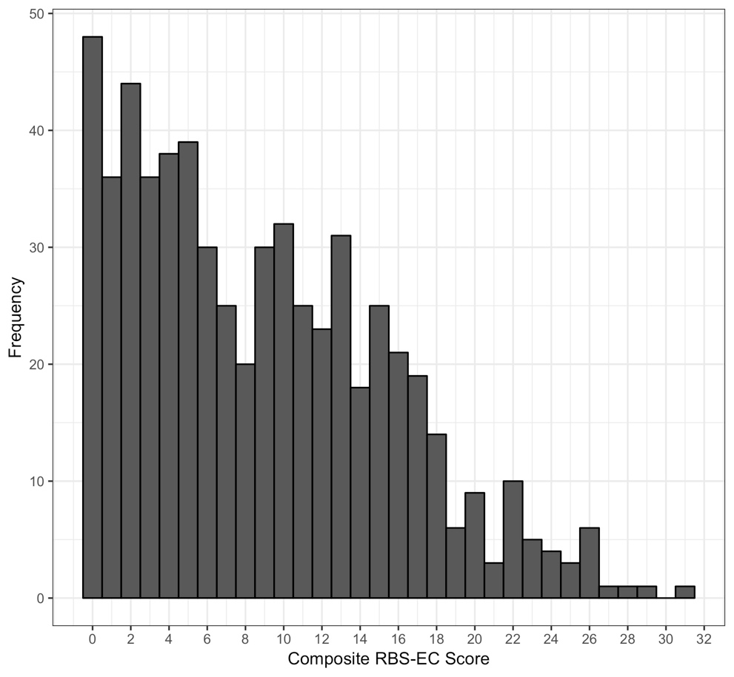
Figure S1. Sample distribution (n=606) for total items endorsed (Mean=8.79, SD=6.2).

