Appendix S1: Figures
Giorgia Ausilio, Håkan Sand, Johan Månsson, Karen Marie Mathisen, Camilla Wikenros
Ecological effects of wolves in anthropogenic landscapes: potential for trophic cascade is context-dependent
Frontiers in Ecology and Evolution

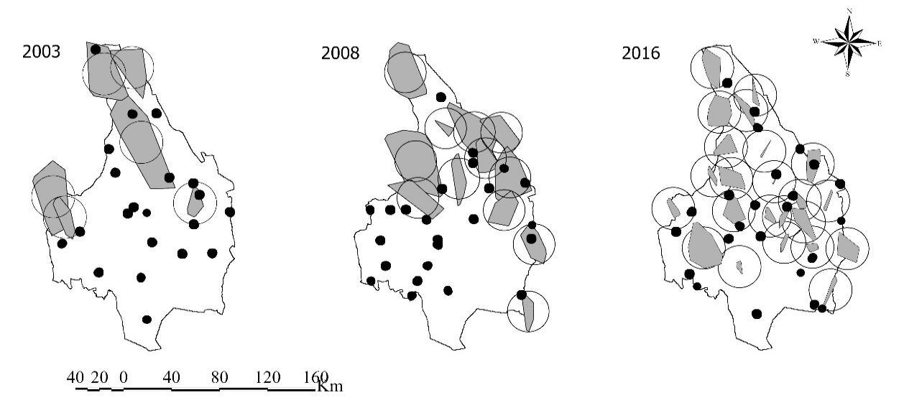
Figure S1
Distribution of the sample plots (black points) in the county of Värmland where moose browsing and pellet groups were surveyed from 2003-2016 (only three years out of 13 are shown to visualize the pattern). Plots were either classified as (I) inside a wolf territory or (II) outside a wolf territory. Wolf territory borders were based on the annual monitoring data (grey polygons) and average wolf territory size in Scandinavia (circles; Mattisson et al., 2013). Maps created using ArcGIS 10.2.2 (http://support.esri.com/Products/Desktop/arcgis-desktop/arcmap/10-2-2)

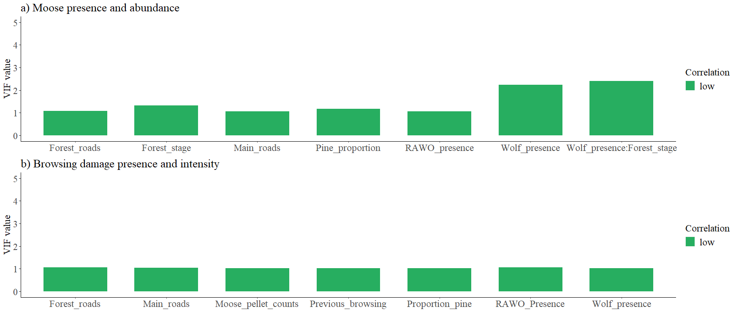
Figure S2
Variance inflation factors (VIF) values for each variable used in our models were obtained from the multicollinearity analysis performed using the R package “performance” (Lüdecke et al., 2020). Values of VIF exceeding 10 are often indicative of multicollinearity (Mason et al., 1989; Allison, 2001; Pallant, 2013).

Figure S3
Forest-plots of main effect coefficients from top probability models for moose presence (a) and browsing damage presence (b). Estimates are from logistic regression models. Wolf presence and RAWO (rowan, aspen, willow and oak) presence were defined as two-categorical variables (presence and absence), Bars represent 95% confidence intervals. Forest stage was defined as a four-categorical variable (1=clear-cut; 2= young forest; 3= thinned). The vertical intercept (x =1; dashed line) is the neutral line which indicates no effect. Odds ratios greater than 1 indicate positive associations (i.e. the presence of one event increases the odds of the other event; the blue dots), whereas odds ratios smaller than 1 indicate negative associations (i.e. the presence of one event reduces the odds of the other event; these are the red dots).

Literature Citations
Mattisson, J., et al., Home range size variation in a recovering wolf population: evaluating the effect of environmental, demographic, and social factors. Oecologia, 2013. 173(3): p. 813-825.

