

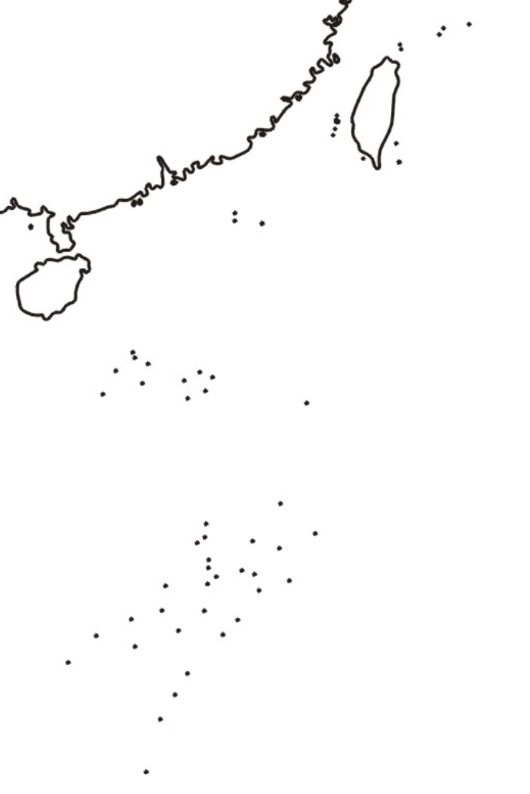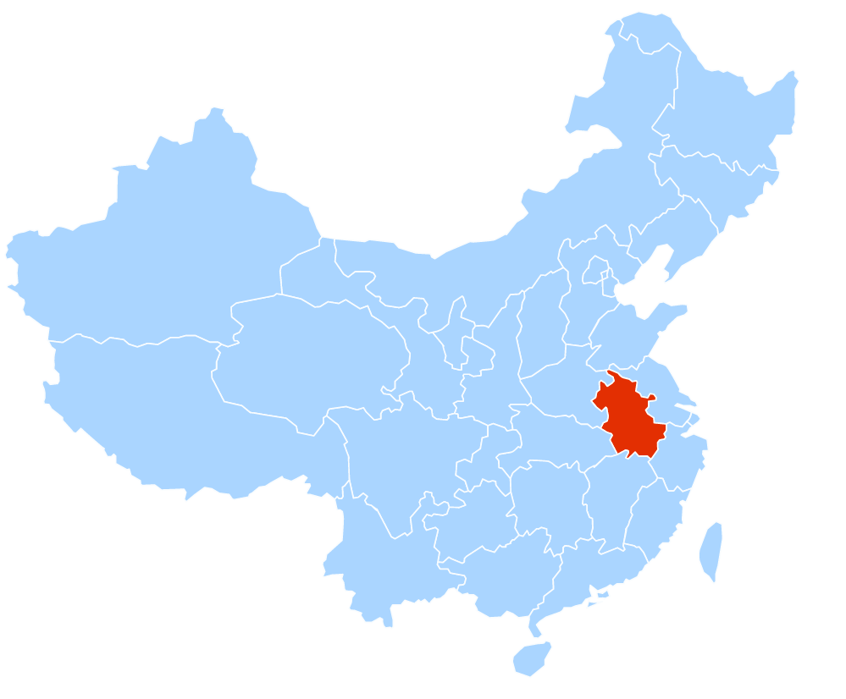

**Anhui Province**

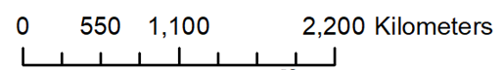

**Fig S1**. The location of sampling areas (Red areas) in Anhui Province, China. (This map shows that Anhui Province locates in the east of China and three sampling areas selected in this study; The map is available on request from the corresponding author.)