Additional file for:
Application of biochar-coated urea controlled loss of fertilizer nitrogen and increased nitrogen use efficiency
Yiman Jiaª, Zhengyi Hu^{a,b,c,*}, Yuxin Ba^{d}, wenfang Qi^{e}
ª College of Resources and Environment, University of Chinese Academy of Sciences, Beijing 101408, China
^{b} Sino- Danish Center for Education and Research, Beijing 100190, China
^{c} Research Center for Eco-Environmental Sciences, Chinese Academy of Sciences, Beijing 100085, China
^{d} Blue Sky Zhenggao (Beijing) Agricultural Science and Technology Co., LTD
^{e} Shenwu technology group corp Co., Ltd.

Corresponding author:
Zhengyi Hu
College of Resources and Environment, University of Chinese Academy of Sciences, Beijing 101408, China
E-mail: zhyhu@ucas.ac.cn

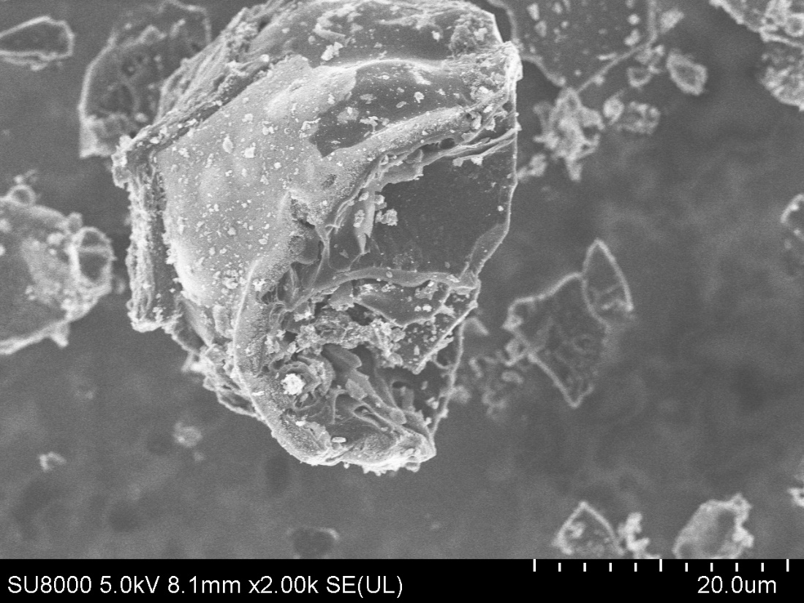
Fig. S.1 SEM images of biochar used for biochar-coated urea.

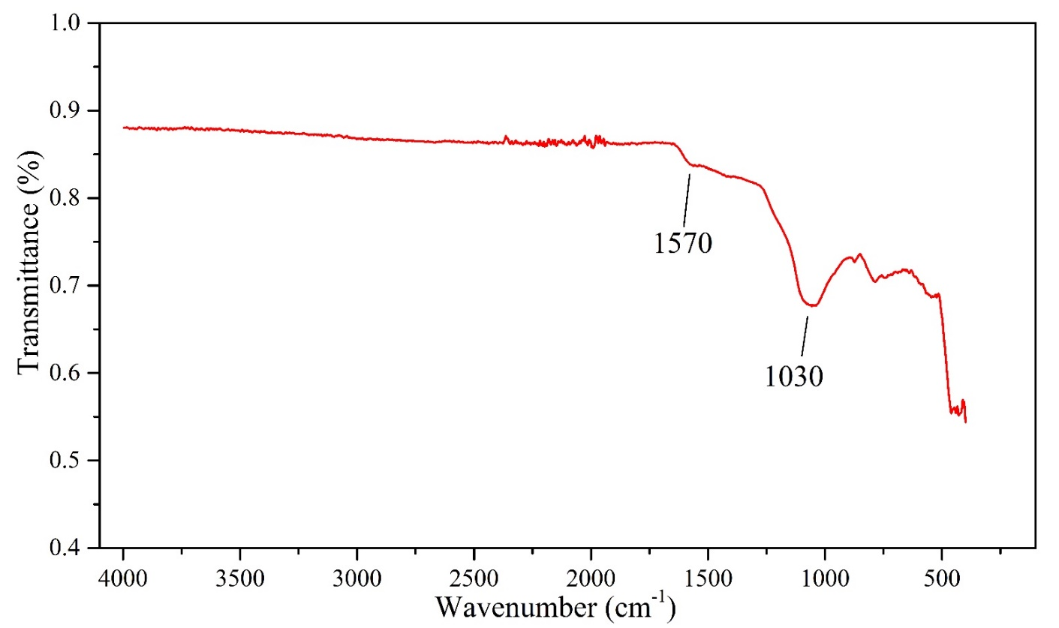
Fig. S.2 FTIR spectra of biochar used for biochar-coated urea.
The band at 1570 cm⁻¹ correspond to keto C=O stretching vibrations in esters or C=C stretching vibrations in alkene and aromatic compounds;
The band at 1030 cm⁻¹ correspond to C–O stretching vibrations in lignin derivatives or alcohols and phenols.”

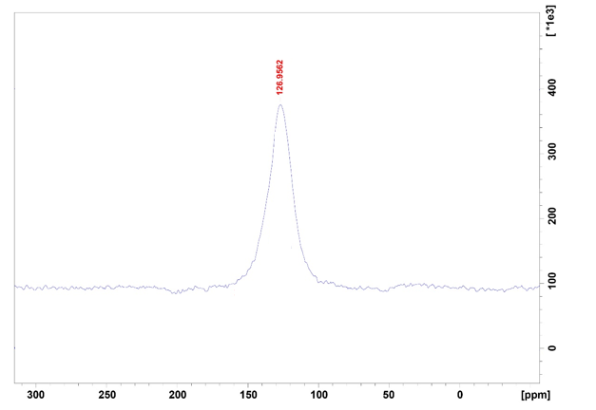
Fig. S.3 ¹³C NMR spectra of biochar used for biochar-coated urea.
Resonance region at 110–150 ppm indicated aromatic carbon.

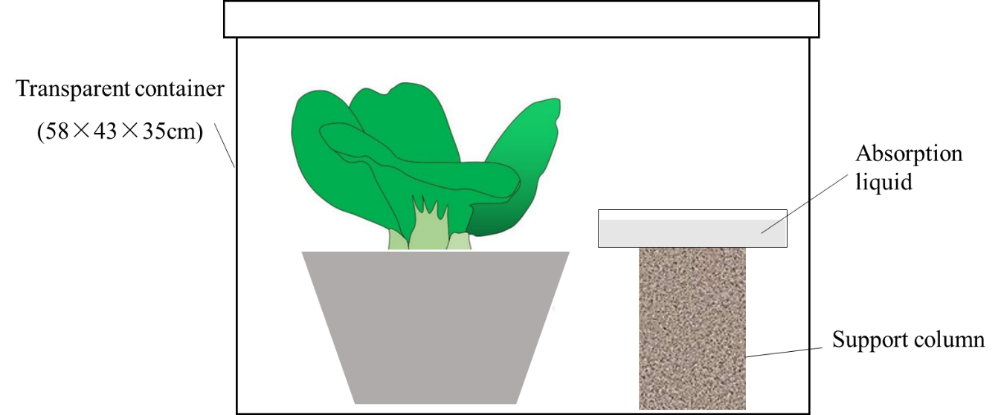
Fig. S.4 Schematic plot of ammonia volatilization collection.

