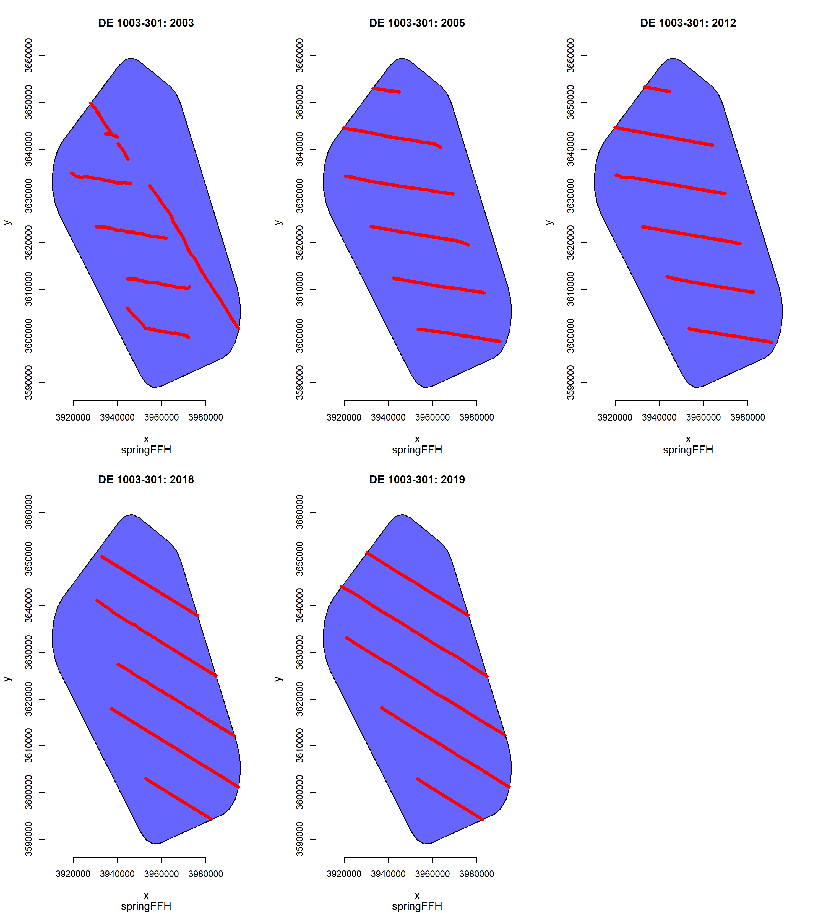
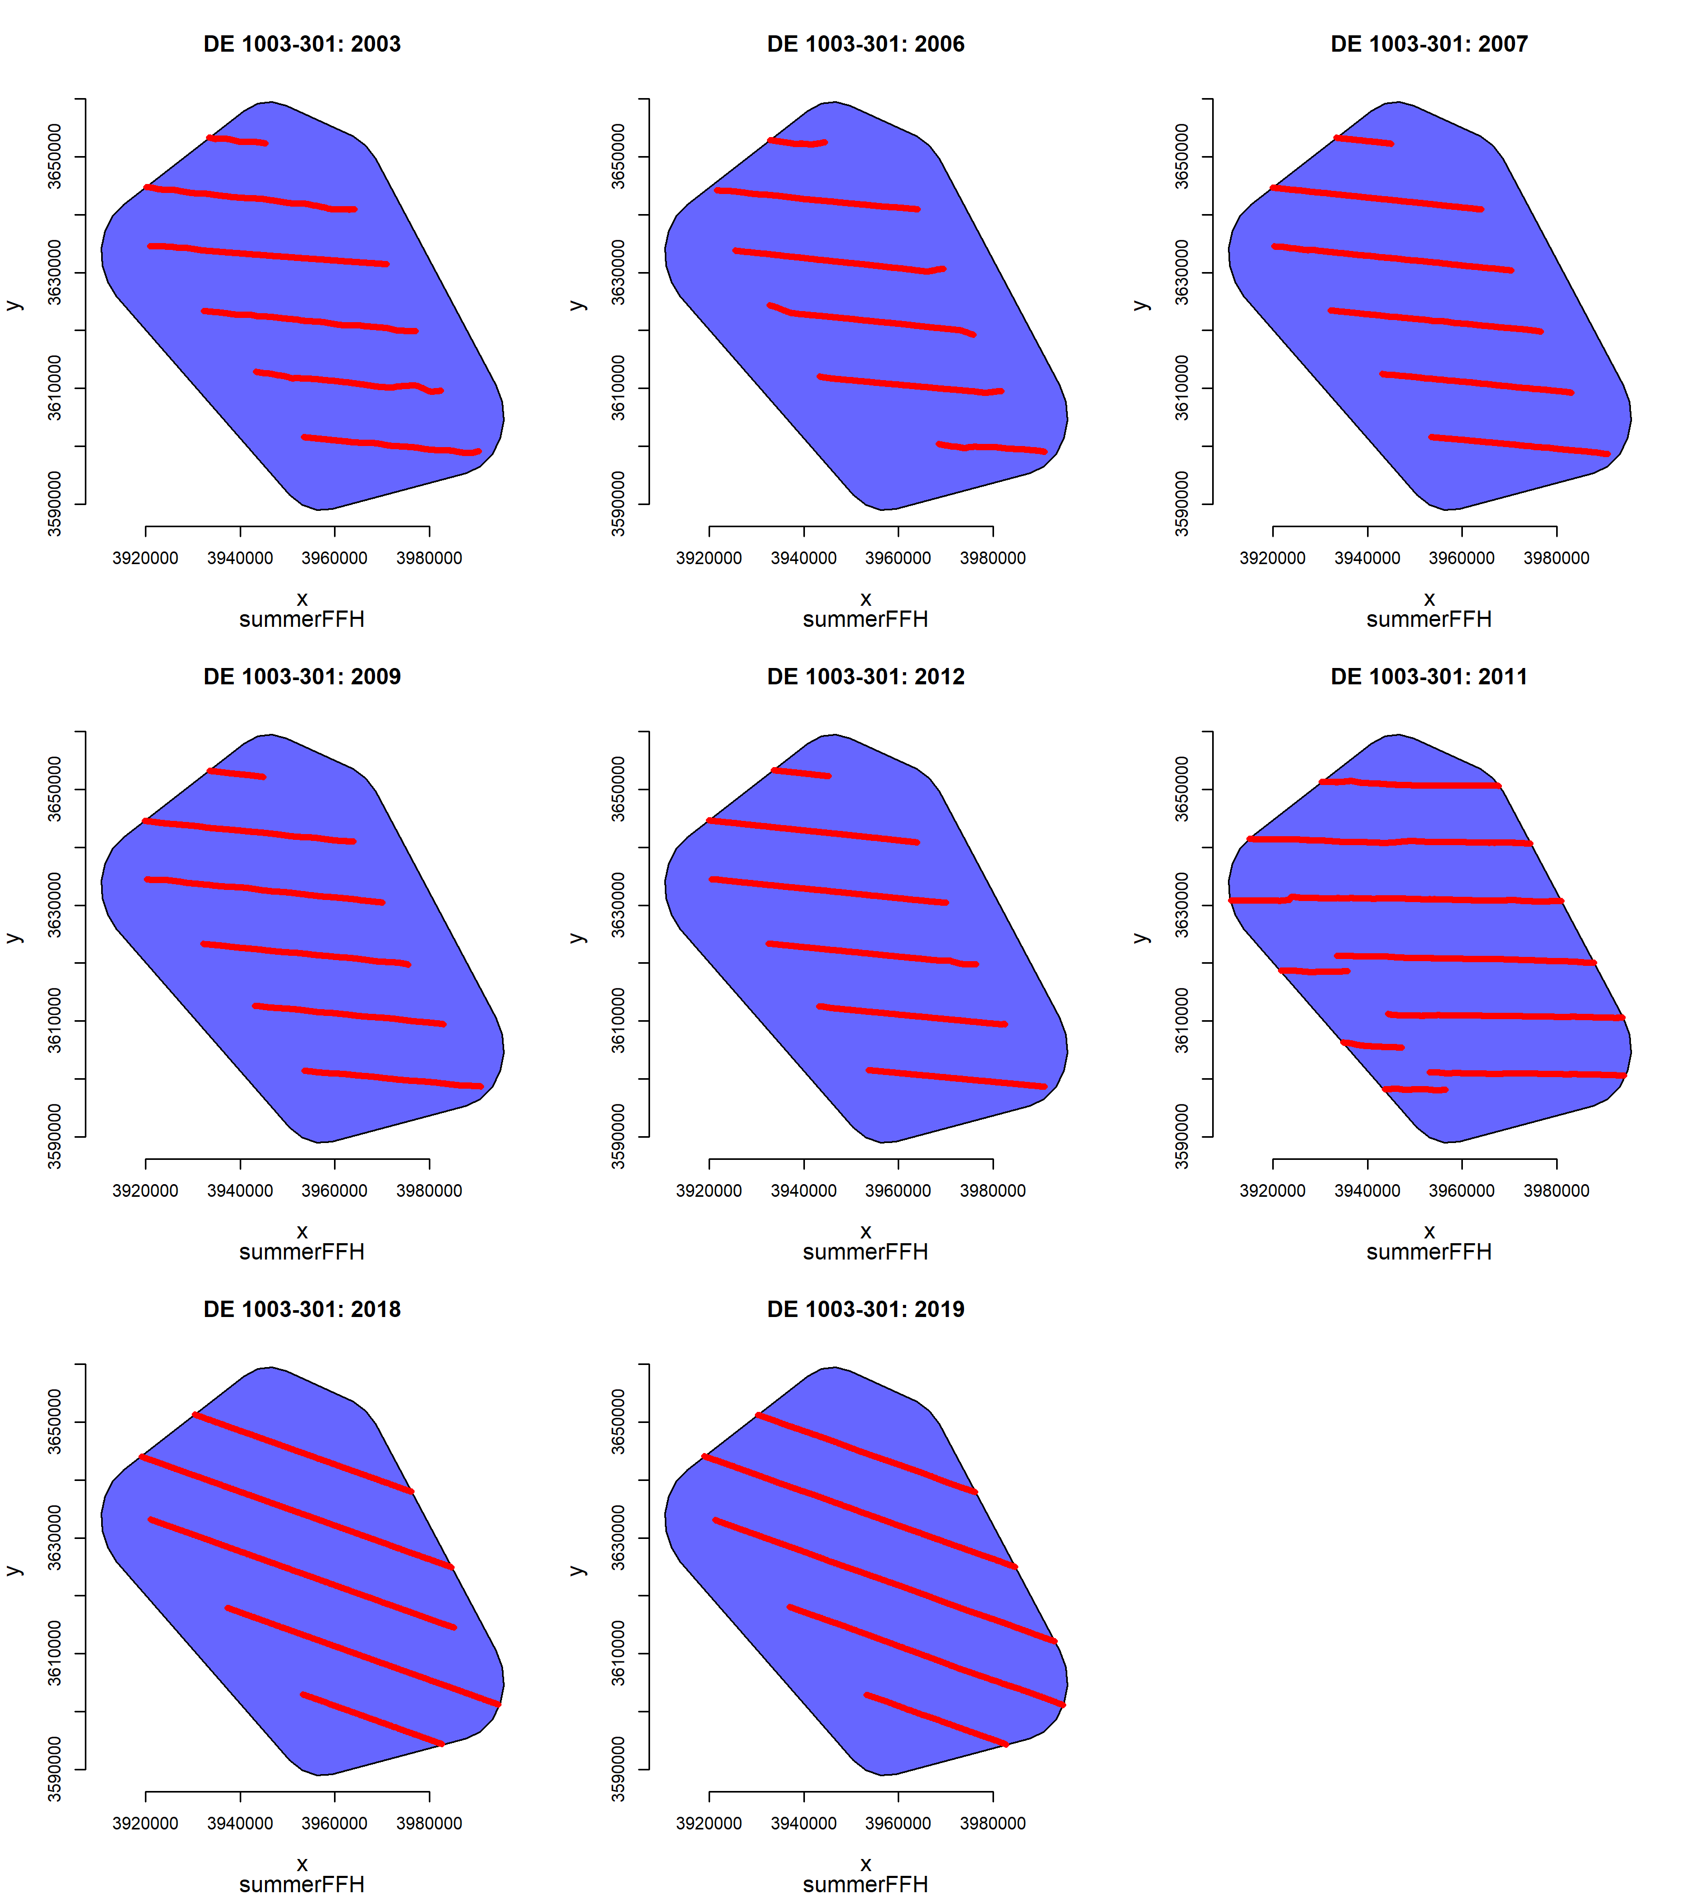
Supplementary Figure 2. Survey effort and coverage for trend analysis of the SAC Dogger Bank (DE 1003-301). Maps show the stratum (blue) and the post-stratified transects within the area (red). The upper figure illustrates the coverage in spring, the lower figure the coverage in summer.

