Supplementary Material
Supplementary Table 1. Morphospecies used in analyses, their physical descriptions, and sites where they were observed. Laser dots in images are 16 cm apart.
Classification | Image | Morphospecies | Description | Location (flank/summit/both)
STRUCTURAL SPONGES
Hexactinellid | 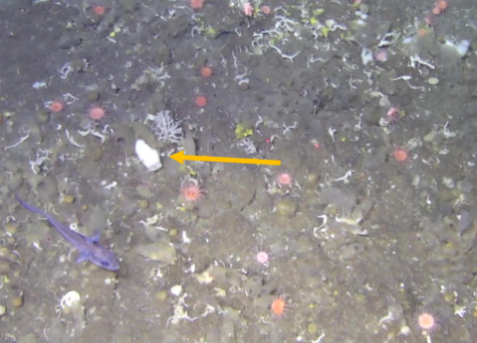 | Small Hexactinellida spp. | Small (<10 cm) | Summit
 | 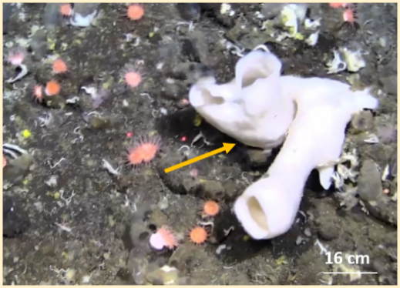 | Hexactinellida spp. | Large, tubular, palmate | Both
Demosponge | 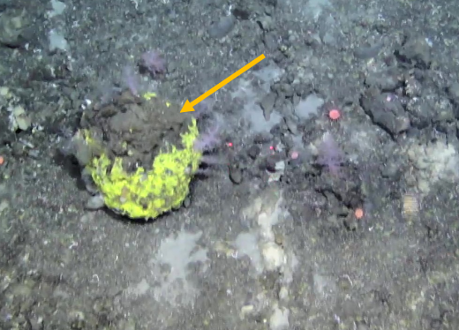 | Geodia parva (Hansen, 1885) | Masisve, globular | Summit
 | 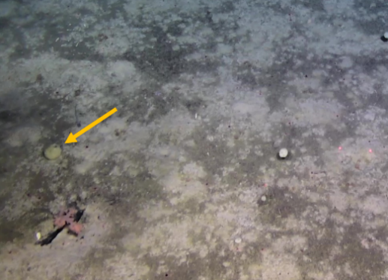 | Geodia hentscheli (Cárdenas, Rapp, Schander & Tendal, 2010) | Massive, globular | Flank
 | 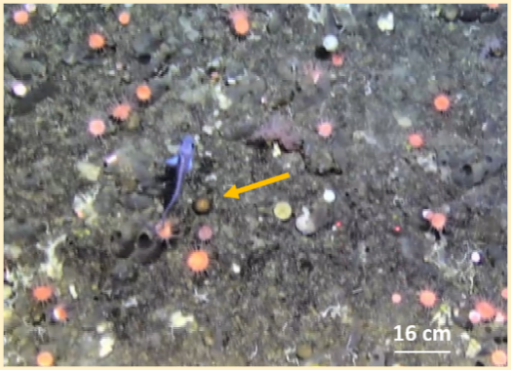 | Craniella infrequens | Small, spherical | Both
 | 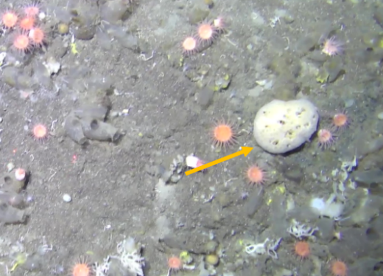 | Polymastia thielei (Koltun, 1964) | Small-medium, papillate,globular | Summit
 | 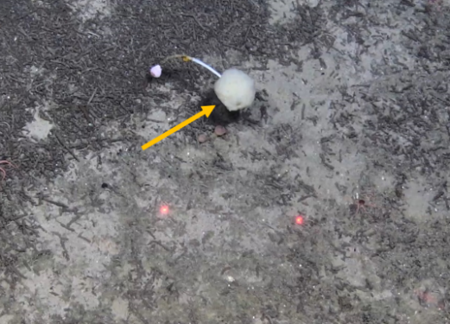 | Stylocordyla borealis (Lovén, 1868) | Small, stipitate | Both
 | 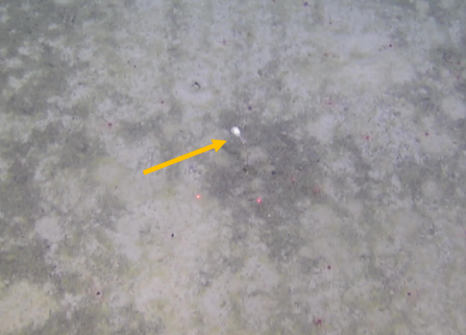 | Lycopodina sp. (Lundbeck, 1905) | Small, stipitate | Flank
 | 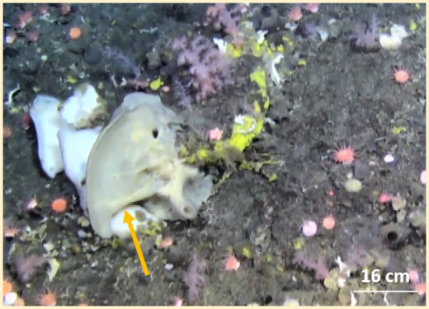 | Haliclona sp. (Grant, 1841) | Medium-large, foliaceous | Both
 | 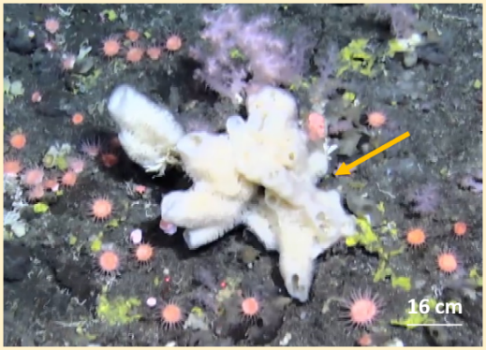 | Hemigellius sp. (Burton, 1932) | Large, tubular, palmate | Summit
 | 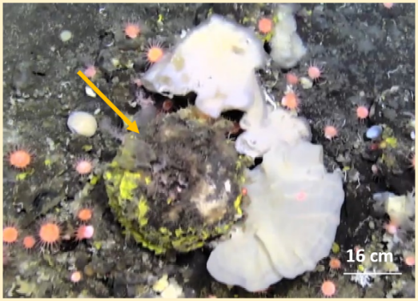 | Stelletta rhaphidiophora (Hentschel, 1929) | Massive, globular | Summit
 | 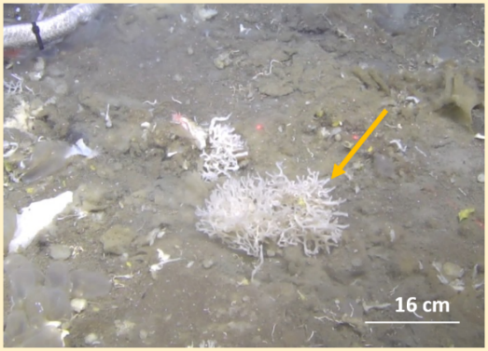 | Lissodendoryx (Lissodendoryx) complicata (Hansen, 1885) | Branched | summit
 | 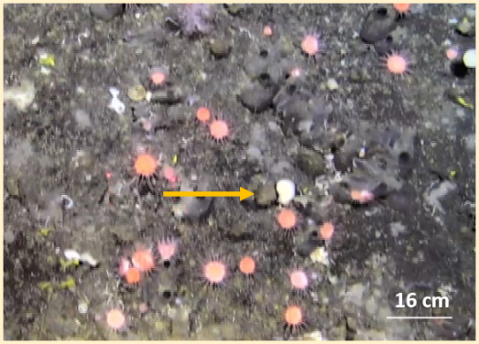 | Small demosponge | Globular (<10 cm) | Both
 | 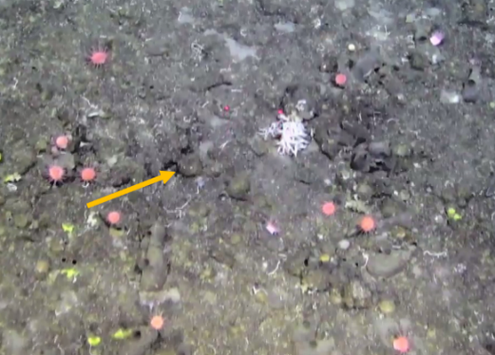 | Medium demosponge | Globular (10-20 cm) | Both
 | 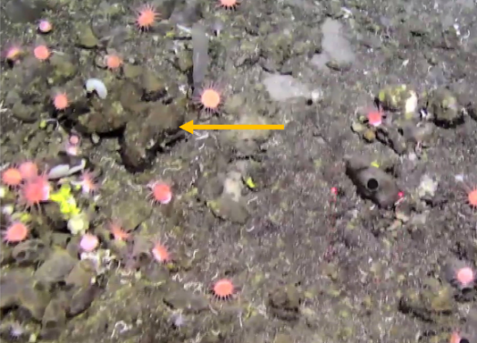 | Large demosponge | Massive, globular (>20 cm) | Both
 | 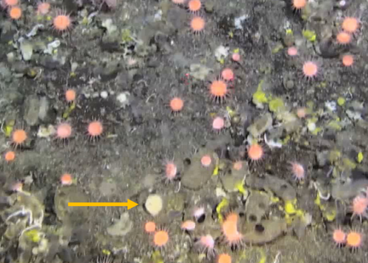 | Unidentified demosponge 3 | Small, globular, white | Summit
ASSOCIATED FAUNA
Porifera | 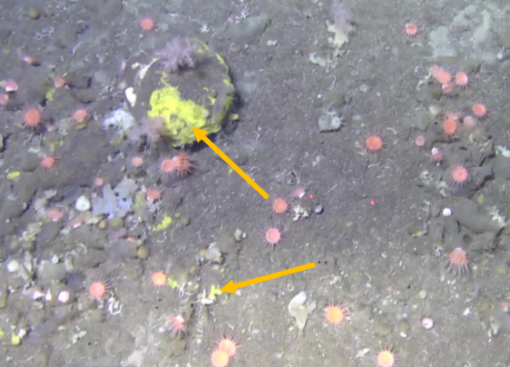 | Hexadella dedritifera (Topsent, 1913) | Encrusting, yellow | Summit
 | 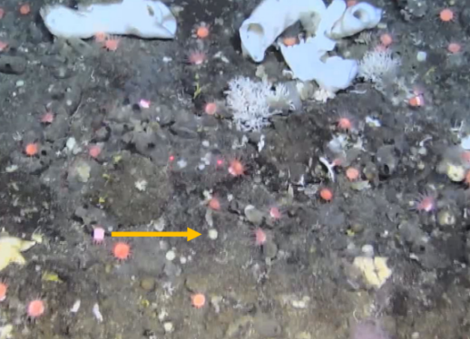 | Unidentified demosponge 1 | Encrusting, small patch, white | Summit
 | 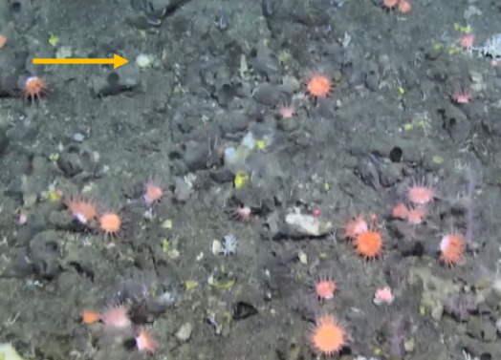 | Unidentified demosponge 2 | Encrusting, small patch, yellow/white | Summit
Cnidaria | 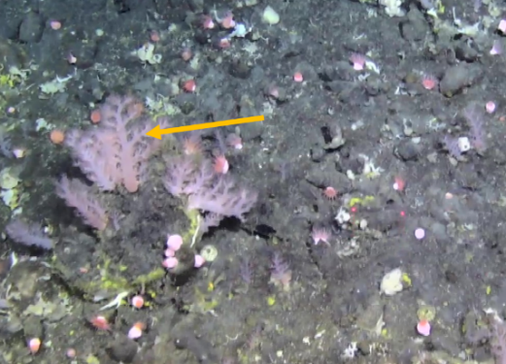 | Gersemia rubiformis (Ehrenberg, 1834) | Branching, purple, pink | Summit
 | 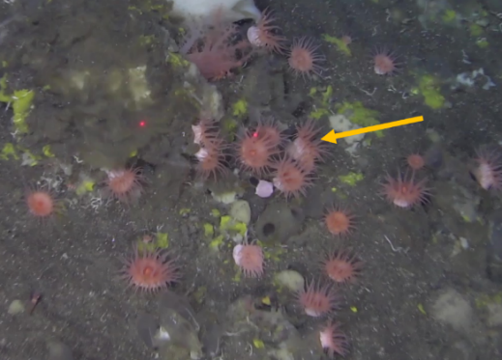 | Actiniaria sp. | Small, pink | Both
 | 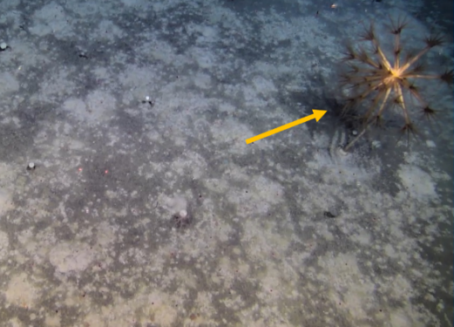 | Umbellula sp. (Gray, 1870) | Large, branched, brown | Flank
Arthropoda | 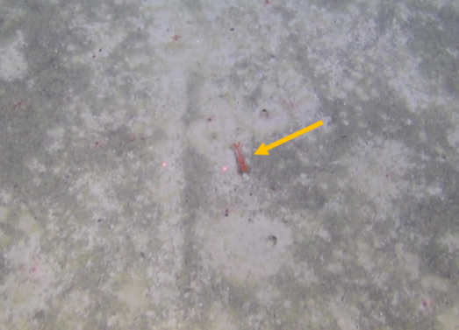 | Bythocaris sp. (G.O. Sars, 1870) | Small, red | Flank
 | 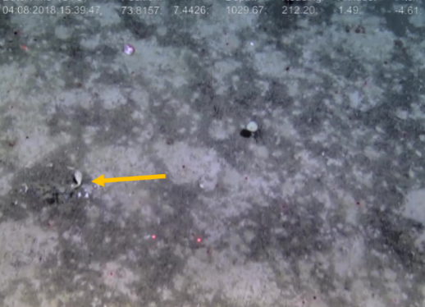 | Scalpellidae indet. | Stalked, white | Flank
Echinodermata | 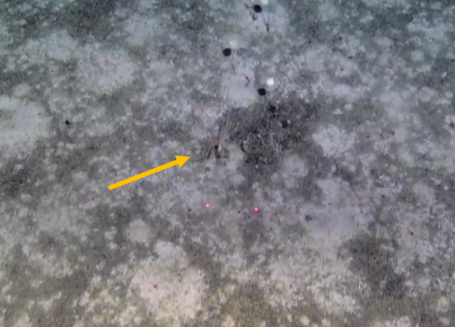 | Feather star | Branched, brown/yellow | Flank
 | 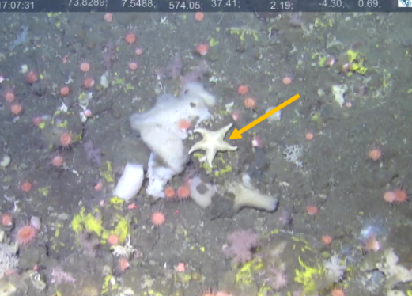 | Tylaster willei (Danielssen and Koren, 1881) |  | Summit
 | 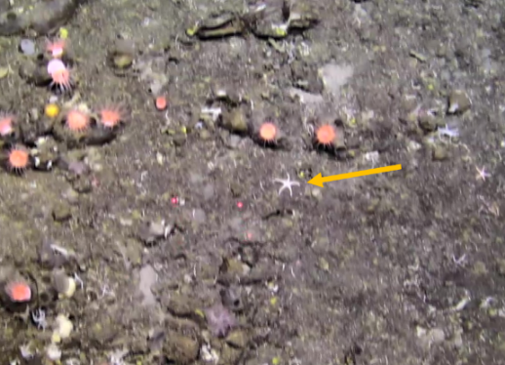 | Asteroidea sp. | Small, white | Both
 | 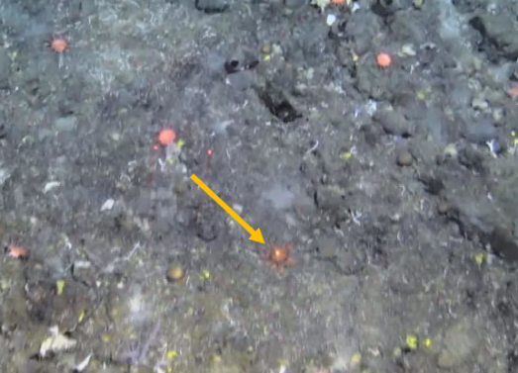 | Hymenaster sp. (Wyville Thomson, 1873) | Red/orange, spikey appearance | Summit
 | 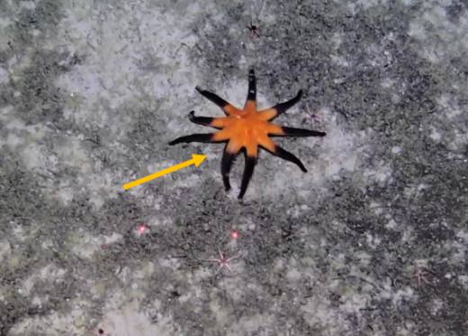 | Solaster spp. (Forbes, 1839) | Colorful, many arms | Both
 | 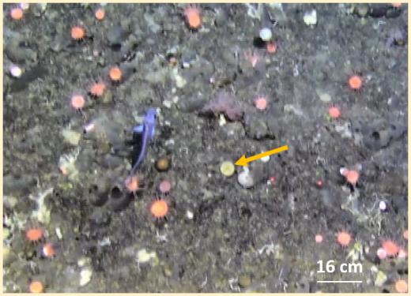 | Strongylocentrotus sp. (Brandt, 1835) |  | Summit
 | 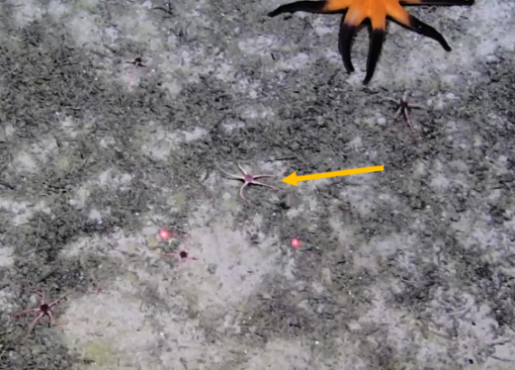 | Ophiuroid |  | Flank
Chordata | 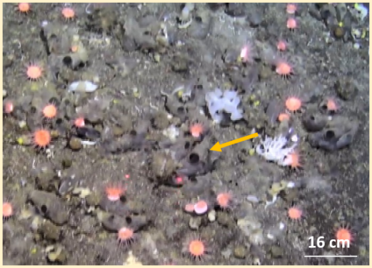 | Ascidiacea sp. 1 | Opaque, brown/gray | Both
 | 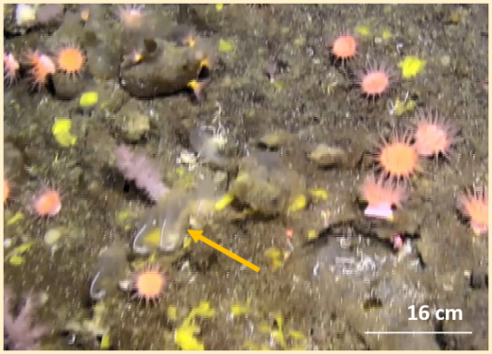 | Ascidiacea sp. 2 | Gelatinous appearance | Flank

