Supplemental Material 2
Promotional activities to engage clinicians
The CCC developed informational materials (infographics and template PowerPoint slides) with the goal of educating non-investigator clinicians about HIV and CVD and the importance of REPRIEVE. Template PowerPoint presentations were developed that provided background on HIV and CVD as well as prevalent comorbidities in HIV. These template presentations were distributed widely to clinician investigators to facilitate presentations in their local areas.
REPRIEVE also had a presence at international meetings such as the Annual ACTG Network Meeting, the Conference on Retroviruses and Opportunistic Infections (CROI), the Association of Nurses in AIDS Care, and ID Week. Presentations were provided by REPRIEVE investigators on the topic of HIV and CVD and informational materials about REPRIEVE were distributed, also the organizers of some of these meetings offered to place holder slide about REPRIEVE on screen in presentation rooms during times when presentations were not being given (see slide below).
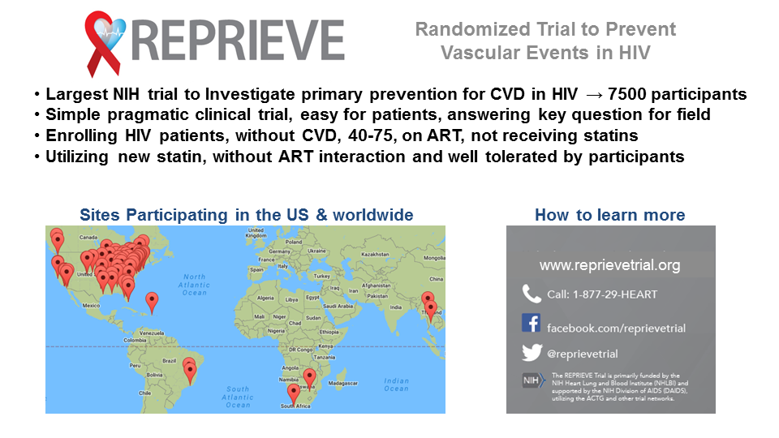

Participation in community events

REPRIEVE site teams were encouraged to participate in HIV- and/or heart-health-related events in their local communities as a mechanism to promote the trial and engage PWH and health professionals. A guide about participating in community events was developed by the CCC to assist sites with this activity. The guide was promoted in site newsletters, monthly site calls and placed in the REPRIEVE Outreach Toolkit (see below) which was available on the REPRIEVE website.
REPRIEVE Outreach Toolkit:
Participating in Community Events
By participating in local events in your community, you create awareness of and interest in cardiovascular health, HIV, and the REPRIEVE Trial. Tabling at events such as AIDS walks; health fairs; conferences on infectious disease, HIV, cardiovascular health and health care; and the like is an excellent way to stimulate enrollment and educate people living with HIV about their increased risk of cardiovascular disease.
Participating in local events can seem daunting, but with a little planning, it’s easy! The REPRIEVE Clinical Coordinating Center and other sites who have participated in events can attest to the fact that it is well worth the effort. The REPRIEVE Clinical Coordinating Center is also available to assist and provide resources to make the process easier. They can send your site REPRIEVE T-shirts, print materials, “Ask Me About REPRIEVE” buttons, and more.
Why participate?
- Generate interest in and awareness of the REPRIEVE Trial
- Help increase screening and enrollment at your site
- Educate communities on the increased risk of cardiovascular disease in people living with HIV
- Raise awareness about heart disease, stroke, and heart health in the general population
- Connect with influencers in your community
- Drive media interest in heart health, HIV and REPRIEVE
Tips & Tricks
- Identify events to participate in:
  - Search online for the next AIDS walk in your area.
  - Ask about events through your local HIV/AIDS community groups and your local CAB.
  - See if hospitals or clinics in your area are holding relevant community education events.
  - Create your own! Organize a small health fair or open house to showcase the research studies your clinic participates in, or place an educational table in your waiting room (see the below example of a tabling event for Heart Month).
- Plan it out:
  - Ensure that those staffing the table/event are familiar with REPRIEVE and are comfortable talking about it.
  - Obtain informational print materials to hand out (such as REPRIEVE recruitment materials and brochures on heart health).
  - Make a sign-up sheet for visitors to receive more information about REPRIEVE. This is important in being able to follow-up with those who show interest.
  - Have a REPRIEVE contact’s business cards available.
  - If you are able, get small giveaways for people who stop by the table. The allure of free chocolate, pens, or stickers will draw passers-by to your table! REPRIEVE may be able to supply some of these. Contact Laura Sanchez (lsanchez12@partners.org) or Katie Fitch (kfitch@partners.org) for more information.
  - Educational models of the heart and/or cardiovascular system are great to help table visitors visualize cardiovascular disease. Engaging visuals, decorations and interactive elements will help your booth stand out!
- Advertise the event:
  - Post on social media.
  - Create flyers to hang around your clinic and community.
  - Ask CAB members to spread the word.
  - If screenings are available at the event, ask large employers in your area to spread the word among employees.
  - Email local HIV or general health care listservs.
  - Reach out to local news outlets! [See Media Pitch Template for Print, Radio and TV]

AIDS Walk Health Fair
AIDS walks and similar community fundraising events are a natural opportunity to connect with groups and individuals who share your motivation to improve the lives of people living with HIV.
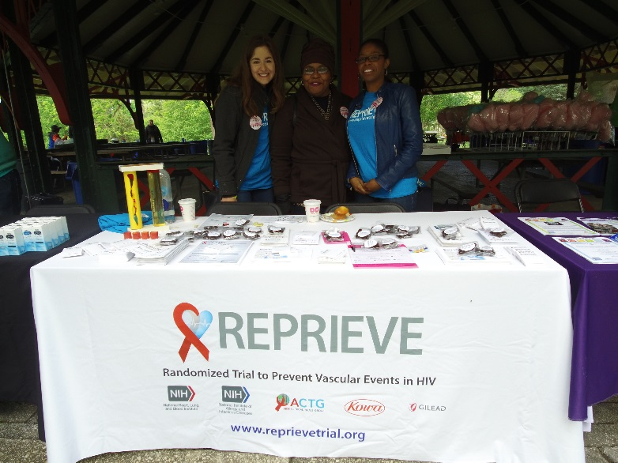
Representatives from Johns Hopkins University CRS, the REPRIEVE Clinical Coordinating Center and NIH organized and staffed a table at the 2017 Baltimore AIDS/Walk Run Health Fair. Runners, walkers, volunteers, other attendees and fellow exhibitors all stopped by to learn more about heart health in HIV.
Spreading the word about REPRIEVE at the 2017 Baltimore AIDS Walk/Run Health Fair! From left to right: REPRIEVE Clinical Coordinating Center’s Laura Sanchez, Johns Hopkins University CRS RNs Ilene Wiggins and Jamilla Howard
Results: This event helped build connections with other local organizations working with people living with HIV and generate interest for REPRIEVE sites in the Baltimore region.
Highlights of the Sunday morning event included:
- Q&A with clinical nurses on HIV, heart disease and REPRIEVE
- Educational models of the heart, written information about REPRIEVE, HIV and heart diseases
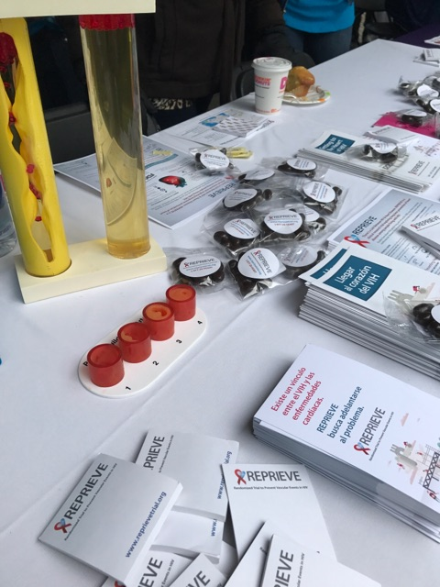
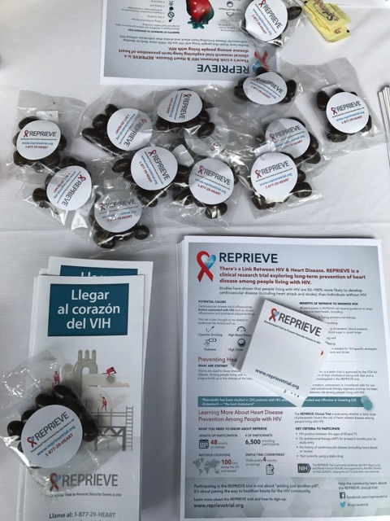
- REPRIEVE-branded chocolate-covered almonds and office supply giveaways

Long-term Promotional Event
A single event is great, but why not draw out the fun? Long-term promotional events can be a great way to honor health observances—like American Heart Month in February—and raise awareness about heart disease, heart health, and the REPRIEVE Trial with a variety of activities and installations.
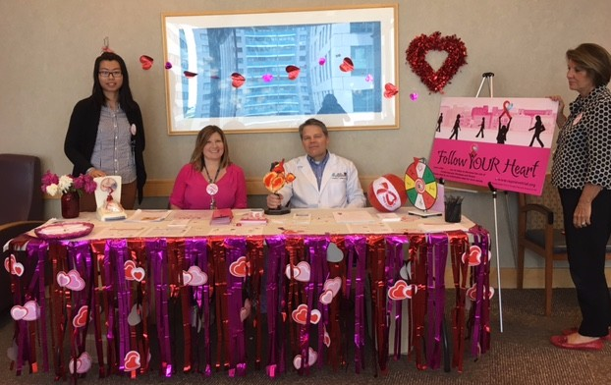
In 2016, the Massachusetts General Hospital ACTG Clinic, along with the MGH Infectious Disease Clinic, held a special event, called Follow YOUR Heart, to raise awareness about heart disease, heart health, and the REPRIEVE Trial. The main component of the event was an educational table, filled with information about REPRIEVE, heart disease, and lifestyle interventions for maintaining cardiac health, set up inside the ID clinic. Outside the clinic entrance, a colorful Follow YOUR Heart/REPRIEVE banner promoted the event. The table was staffed by ACTG and ID clinic volunteers during prime clinic hours, when patients and their family members could easily access the wealth of heart health resources and speak with enthusiastic heart health advocates.
Highlights of the two-week event included:
MGH ACTG members celebrate Heart Month and raise awareness about REPRIEVE.
- A “Wheel of Fortune” game where visitors could spin to win heart-adorned pens, pins, and beach balls. The team felt this was a good way to get the conversation started about heart health!
- A sign-up sheet for visitors to receive more info about REPRIEVE and to attend a special meeting of the MGH CAB.
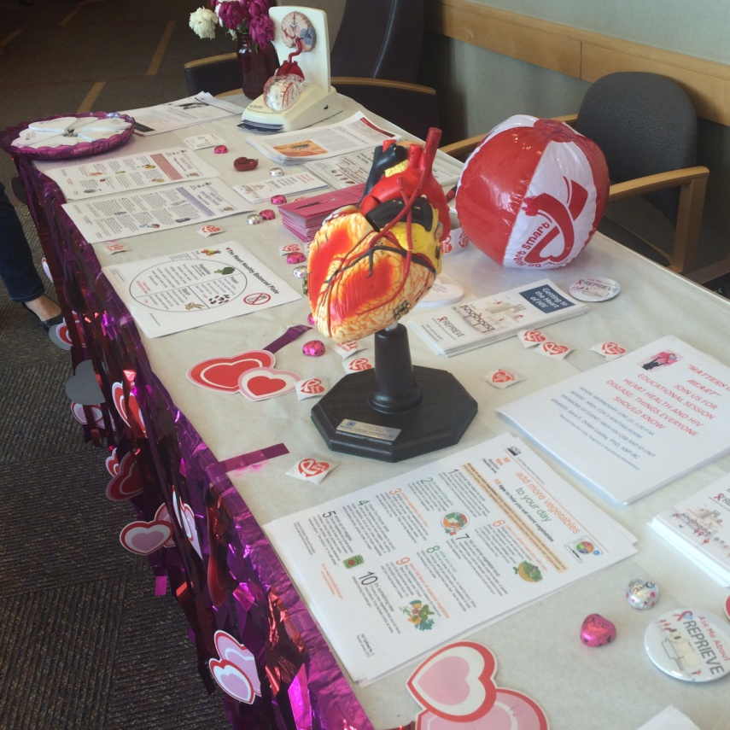
- Sara Looby, PhD, ANP-BC of the REPRIEVE team gave a lively talk on HIV and heart disease.
- Educational models of the heart, written information about REPRIEVE, HIV and heart disease, and general cardiac health populated the table.
Results: The team feels that this event generated many questions about REPRIEVE and several referrals. In addition, the ACTG site team had the opportunity to educate the MGH ID clinical staff about REPRIEVE and enlist their help in recruiting participants.
Resources used for the event
- Prizes given away for the “wheel of fortune” were found on an inexpensive party favors retail website
- Heart health information was found on the AHA website
- A Doodle poll was used to staff the table
- A sample CAB presentation can be found on the REPRIEVE trial/Follow YOUR Heart website
