Supplementary Material

Leihy, R. I., & S. L. Chown. Wind plays a major but not exclusive role in the prevalence of insect flight loss on remote islands. Proceedings of the Royal Society B, doi: 10.1098/rspb. 2020.2121.

Table S1. Bootstrap model selection results for quasi-binomial generalized linear models of the relationships between the number of indigenous flightless and flying insect species per island across the Southern Ocean and Arctic islands, as a dependent variable, and a set of environmental variables (see electronic supplementary material, Methods). Akaike's Information Criterion statistics for overdispersed count data (QAIC) and the frequency for which each of these ten candidate sub-models was the best fitting model for 999 nonparametric bootstrap samples of the dataset. The most frequently best fitting model (model 1) was chosen as the most parsimonious model.
Model | Explanatory variables | QAIC | Frequency
1 | mean wind speed + thermal seasonality + mean summer LST | 41.66 | 291
2 | mean summer LST + mean wind speed + thermal seasonality | 41.66 | 182
3 | mean wind speed + mean summer LST + thermal seasonality | 41.66 | 173
4 | thermal seasonality + mean wind speed + mean summer LST + island age | 42.13 | 117
5 | mean wind speed + mean summer LST + island age + thermal seasonality | 42.13 | 63
6 | mean wind speed + island age + mean summer LST + thermal seasonality | 42.13 | 48
7 | mean wind speed + thermal seasonality + mean summer LST + island age | 42.13 | 38
8 | mean wind speed + mean summer LST + thermal seasonality + island age | 42.13 | 33
9 | mean wind speed + island age + thermal seasonality + mean summer LST | 42.13 | 30
10 | mean wind speed + thermal seasonality + island age + mean summer LST | 42.13 | 24

Table S2. Quasi-binomial generalized linear model outcomes for the relationships between the number of flightless and flying insect species per island across Southern Ocean and Arctic islands, as a response variable, and mean wind speed. Models included all of the Southern Ocean and Arctic islands with flight data (n= 32), and those islands for which high-resolution land surface temperature data were available (n= 24). Because of the exclusion of temperature predictors, there is a significant spatial signal in the residuals of these models (all islands: Moran’s I= 0.46; P= 0.016; islands with temperature data: I= 0.59; P= 0.007).
Model | Predictor | df | Pseudo r² | Model Coeff. | SE | t | P
All islands | Mean wind speed | 31 | 0.56 | 0.75 | 0.14 | 5.49 | <0.001
Islands with  temperature data | Mean wind speed | 23 | 0.59 | 0.72 | 0.14 | 5.01 | <0.001

Table S3. Quasi-binomial generalized linear model (logit link functions) outcomes for the relationships between the number of flightless and flying insect species from each of the five most species-rich insect Orders per island across the Southern Ocean and Arctic islands, and mean wind speed and thermal seasonality; P < 0.05*
Taxa | df | Pseudo r² | Predictors | Model Coefficient | SE | t | P
Diptera | 23 | 0.65 | Mean wind speed | 1.35 | 0.35 | 3.90 | <0.001 | *
 |  |  | Thermal seasonality | 0.11 | 0.08 | 1.41 | 0.173
Coleoptera | 22 | 0.62 | Mean wind speed | 1.39 | 0.48 | 2.88 | 0.009 | *
 |  |  | Thermal seasonality | 0.10 | 0.09 | 1.12 | 0.278
Lepidoptera | 21 | 0.42 | Mean wind speed | 1.50 | 0.61 | 2.48 | 0.023 | *
 |  |  | Thermal seasonality | 0.16 | 0.16 | 1.00 | 0.331
Hymenoptera | 15 | 0.78 | Mean wind speed | 1.87 | 0.80 | 2.35 | 0.036 | *
 |  |  | Thermal seasonality | 0.12 | 0.21 | 0.56 | 0.585
Hemiptera | 12 | 0.32 | Mean wind speed | 0.74 | 0.76 | 0.97 | 0.356
 |  |  | Thermal seasonality | -0.01 | 0.20 | -0.08 | 0.941

Table S4. Negative binomial generalized linear mixed effect model (†) outcomes testing the effect of genus flight-capability (all species flying, flightless, or both flying and flightless) on the number of species per genus in indigenous Southern Ocean Island insect genera, with Family and Order as nested random effects to account for a phylogenetic signal in species richness (θ = 8.32; logLikelihood = -598.9).
Effects | Predictors | Model Coeff. | SE | z | P
Fixed | Flightless | 0.06 | 0.11 | 0.51 | 0.609
 | Both | 0.86 | 0.14 | 6.02 | < 0.001
 |  | Variance | SD | n
Random | Family:Order | 0.02 | 0.14 | 105
 | Order | 0.01 | 0.10 | 13
† Model structure: generic richness ~ flight-capability + (1 | Order/Family)
Table S5. Estimated number of independent transitions to flightlessness per Order. Number of Families represented by at least one indigenous species across the Southern Ocean Islands (SOI) comprised of only flying SOI species, flightless SOI species, or Families represented by both flying and flightless SOI species. Families with a least one flightless SOI species were considered here to represent, at a minimum, a single evolutionary transition of flightlessness.
Order | Flying | Flightless | Both | No. transitions
Coleoptera | 1 | 12 | 6 | 18
Diptera | 21 | 1 | 13 | 14
Lepidoptera | 8 | 1 | 10 | 11
Hymenoptera | 3 | 2 | 3 | 5
Hemiptera | 3 | 2 | 2 | 4
Orthoptera | 0 | 3 | 0 | 3
Psocoptera | 2 | 2 | 1 | 3
Blattodea | 0 | 1 | 0 | 1
Plecoptera | 0 | 0 | 1 | 1
Thysanoptera | 1 | 0 | 1 | 1
Trichoptera | 2 | 0 | 1 | 1
Ephemeroptera | 1 | 0 | 0 | 0
Neuroptera | 1 | 0 | 0 | 0
Total | 43 | 24 | 38 | 62

Table S6. Model selection results for quasi-binomial generalized linear models of the relationships between the number of indigenous flightless and flying insect species per island across the Southern Ocean and Arctic islands, as a dependent variable, and mean wind speed,
thermal seasonality, and mean summer land surface temperature (LST). Models ranked by QAIC (variance inflation factor = 4.728).
Model | Intercept | Summer LST | Wind speed | Seasonality | df | logLik | QAIC | delta | weight
1 | -18.36 | 0.22 | 1.53 | 0.21 | 4 | -88.13 | 47.30 | 0.00 | 0.99
2 | -8.13 | 0.10 | 0.74 | - | 3 | -113.62 | 56.10 | 8.78 | 0.01
3 | -7.17 | - | 0.72 | - | 2 | -127.12 | 59.80 | 12.49 | 0.00
4 | -9.64 | - | 0.92 | 0.06 | 3 | -123.94 | 60.40 | 13.15 | 0.00
5 | 1.01 | - | - | -0.14 | 2 | -173.50 | 79.40 | 32.11 | 0.00
6 | 0.71 | 0.03 | - | -0.13 | 3 | -172.22 | 80.80 | 33.57 | 0.00
7 | -1.19 | 0.12 | - | - | 2 | -226.40 | 101.80 | 54.49 | 0.00
8 | -0.42 | - | - | - | 1 | -259.45 | 113.70 | 66.46 | 0.00

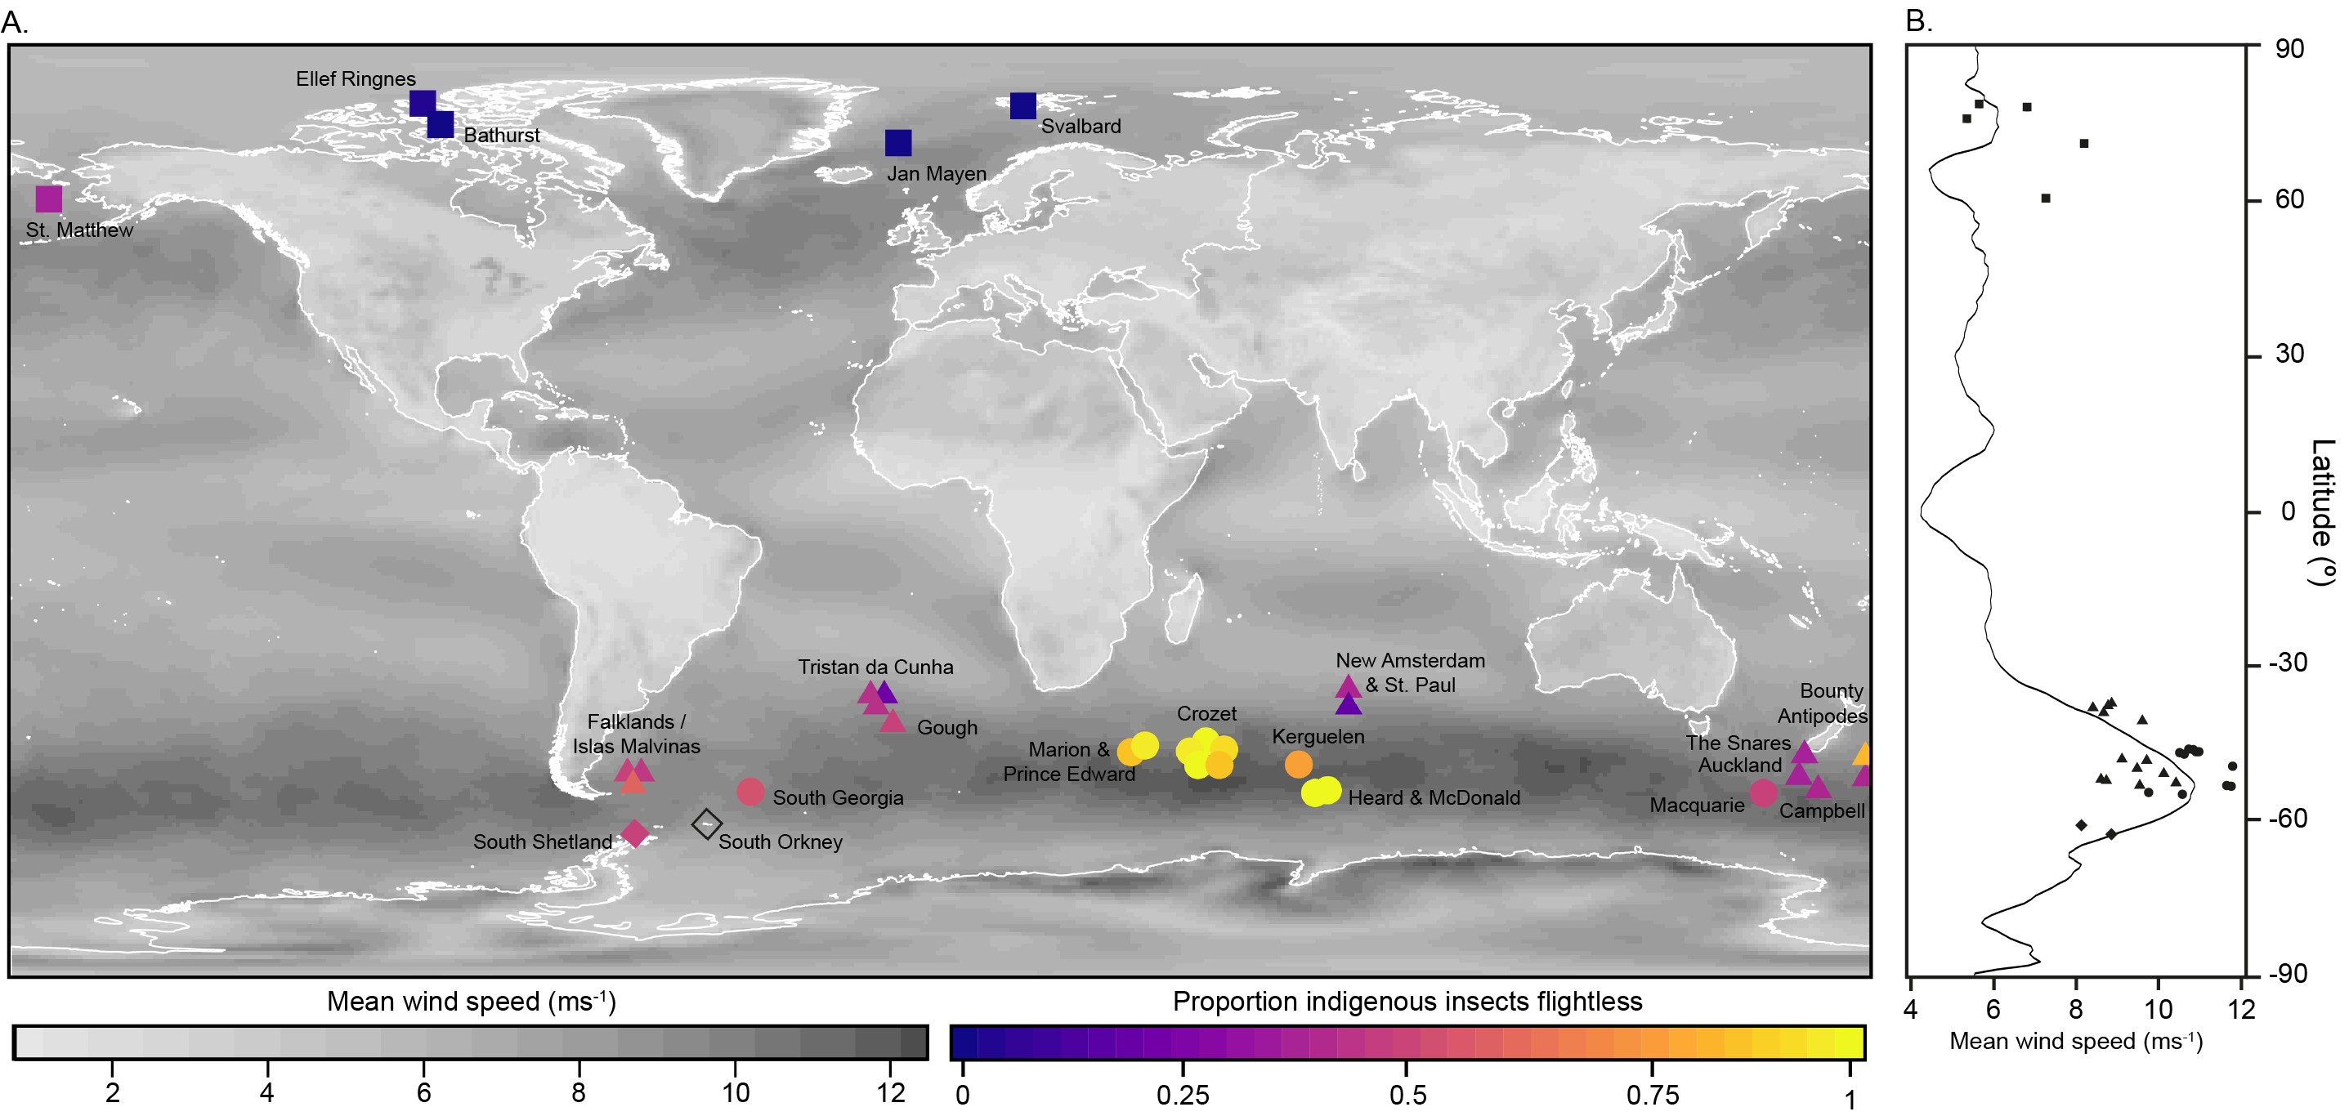
Figure S1. Proportion of indigenous insects flightless on Southern Ocean and Arctic islands (A). Islands are divided into four bioregions: temperate Southern Ocean (triangles), sub-Antarctic (circles), maritime Antarctic (diamonds) and Arctic (squares) islands. The South Orkney Islands (open diamond) were included in some analyses because, although they have no indigenous insects, one insect species has been introduced. Mean wind speeds calculated as the average decadal 10 m wind speed from October 2007 - September 2017 (ERA Interim 2018; 0.75° resolution). Mean wind speed per latitude (B); points indicate the mean wind speeds of the Southern Ocean and Arctic islands.
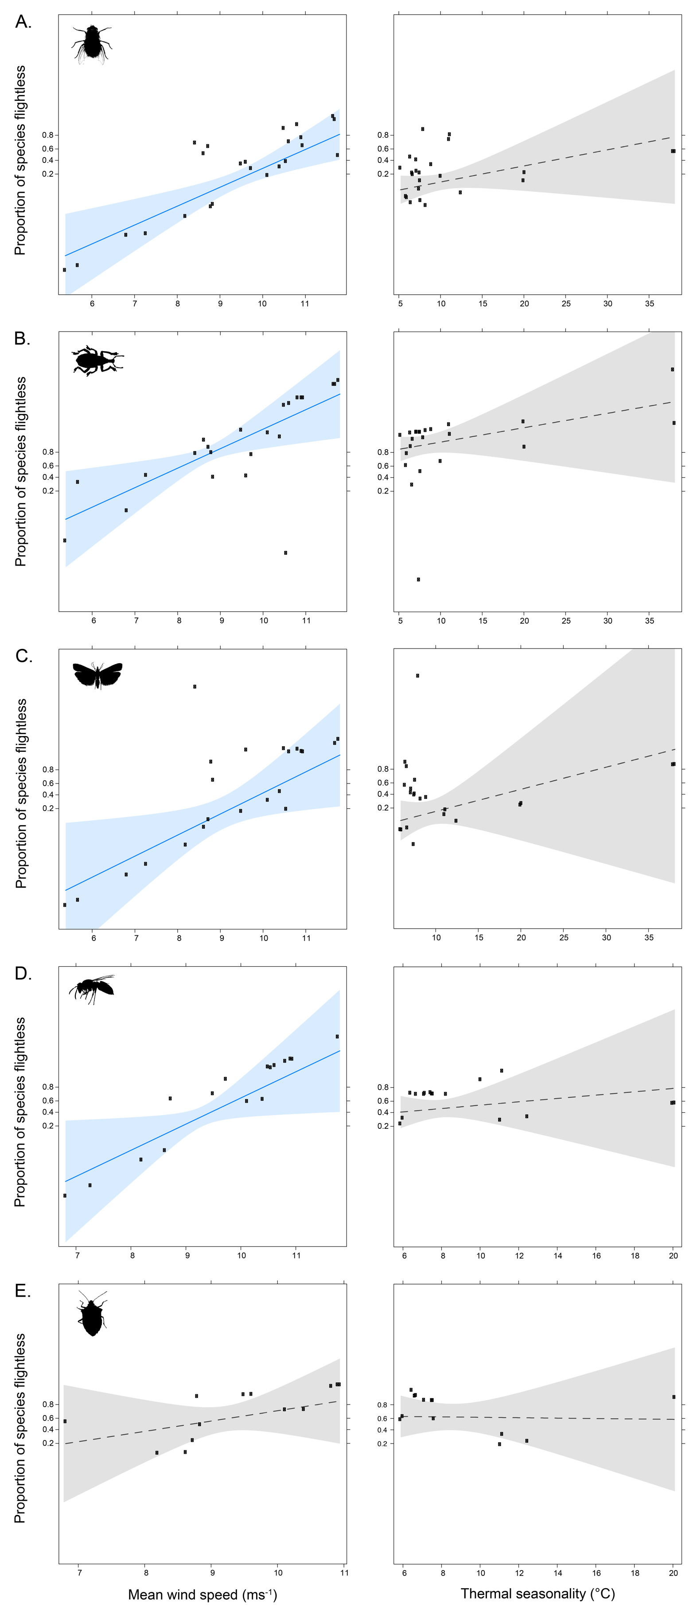
Figure S2. Partial residual plots of quasi-binomial generalized linear models for the relationships between the incidence of flightlessness species in the indigenous Diptera (A), Coleoptera (B), Lepidoptera (C), Hymenoptera (D) and Hemiptera (E) assemblages of the Southern Ocean and Arctic islands, and mean wind speed and thermal seasonality (models: [number flightless species, number of flying species] ~ mean wind speed + thermal seasonality). Significant predictors (P < 0.05) highlighted in blue (see table S3); shading around the regression line indicates its 95% confidence interval.
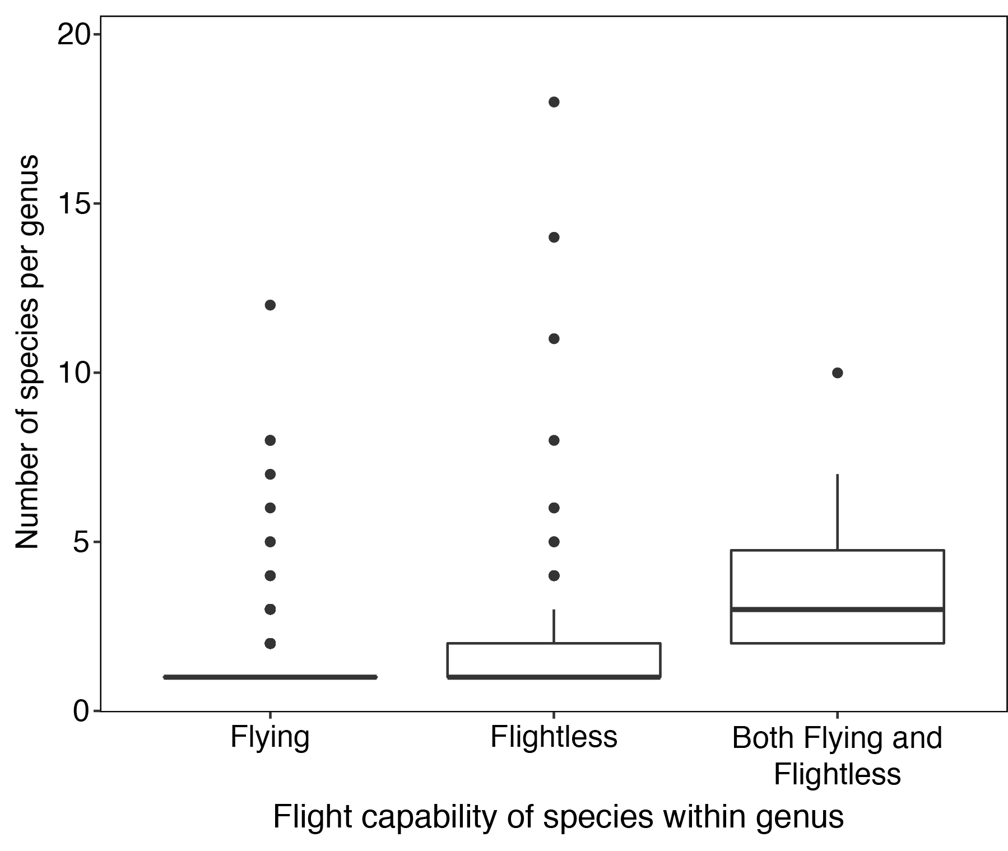
Figure S3. Number of indigenous Southern Ocean Island insect species per genus across genera with different flight-capabilities. Groups include genera comprising of only flying species (n= 197), flightless species (n= 153) and genera with both flying and flightless species (n= 26). Boxes indicate median values and interquartile ranges (IQR), whiskers indicate the largest proportion within 1.5 x IQR, points indicate outliers. Most genera are represented by only a single species in the region. Difference between flying and flightless groups non-significant (table S4).
Supplementary methods

Environmental data
To test the hypothesis that habitat fragmentation, perimeter-to-area ratio and/or isolation select for flight loss by increasing the likelihood of displacement from suitable habitats among flying individuals [1], island area, perimeter-to-surface area ratio and distance from the nearest continent were calculated for each study island. Distances to the nearest continent, excluding Antarctica but including large islands like Tasmania, Madagascar and the Canadian Arctic islands, were calculated using high-resolution spatial shapefiles of continents and large islands in the Southern Ocean and Arctic regions. Shapefiles, sourced from DIVA GIS (http://www.diva-gis.org), were converted into high-resolution (0.00833°) spatial grids for each region, where the value of every cell was equal to the distance to the nearest continent, using the ‘raster’ (ver. 2.6-7; [2]) and ‘rgdal’ (ver. 1.3-4; [3]) packages in R [4]. The centroid coordinates of each study island or archipelago were used to extract their distance to the nearest continent, in kilometres.
Island area, corrected for topographic heterogeneity, is a proxy for displacement risk and microhabitat heterogeneity. Flight is expected to be more prevalent on large islands where the risk of being displaced to sea is relatively small and/or the benefits of flight for dispersal among favourable microhabitats is greater, compared to small islands. Island areas were corrected for topographic complexity using the spatial shapefiles of each island and high-resolution (30 m) digital elevation models, sourced from the Shuttle Radar Topography Mission (SRTM; [5]). Shapefiles were corrected for topographic heterogeneity with the elevation models using the ‘raster’ and ‘insol’ packages (ver. 1.1.1; [6]) in R. The ice-free area of each island was calculated by subtracting estimates of the percentage ice-cover from the literature [7-12] from the topographically-corrected areas of each island.
Island perimeter-to-area ratio has been suggested as a proxy for the risk of insect displacement from islands, where the likelihood that a dispersing individual leaves the island and is removed from the population is expected to increase with perimeter-to-area ratio [13, 14]. Island perimeter-to-area ratios were calculated by dividing the perimeter length of each island, calculated using the island shapefiles and the ‘geosphere’ R package (ver. 1.5-7; [15]), by the uncorrected island area.
To test the hypothesis that developing flight structures and flight itself in low temperature environments are too energetically costly for insects and, therefore, inefficient [1, 16, 17], mean summer land surface temperatures (LSTs) for each island were derived from high-resolution, remote-sensed temperature observations. Mean summer LSTs are highly collinear with annual mean LSTs for the Southern Ocean Islands (SOIs; Pearson’s r: 0.99), however, due to extreme winter conditions, summer and annual mean temperatures are decoupled in the Arctic region (Pearson’s r: 0.62). Because most high-Arctic flying insects opportunistically swarm in mild conditions [18], mean summer LSTs are expected to more closely reflect Arctic flight conditions than annual mean temperatures. Monthly average day and night LSTs for the fifteen-year period between January 2001 and December 2015 were sourced from a gap-filled dataset of SOI LSTs [19]. These data were derived from the Moderate Resolution Imaging Spectroradiometer (MODIS) Land Surface Temperature and Emissivity dataset (MOD11A2; res: 0.00833°; [20]), and gap-filled to predict the values of missing observations caused by cloud-cover. The monthly average day and night LSTs of the Arctic islands were downloaded from MODIS and gap-filled following the same procedure as the SOIs data (see [19]). For every spatial cell, mean summer temperature across the fifteen-year period was calculated, and from these values, the mean island summer LST. High-resolution land surface temperature data were not available for nine of the smaller SOIs [19], therefore, the models were run with and without these islands.
To test the hypothesis that species lose the ability to fly more readily in stable, persistent and/or predictable habitats, where rapid dispersal is less advantageous than in ephemeral conditions [1, 21-25], the thermal seasonality of the islands was estimated from the high-resolution LST data. Environmental stability or persistence can be defined in several ways depending on the ecological context under investigation (e.g. [25]). Because of the stability of SOI climates [26], and because they are not water limited (so meaning that thermal conditions influence productivity [27]), thermal seasonality was chosen as a proxy for environmental stability to reflect key differences between the sub-Antarctic and Arctic climates. For every spatial cell, mean summer and winter temperatures were calculated from the fifteen-year LST time series. Seasonality was then calculated as the island mean of the differences between average summer and winter temperatures for each cell.
To test the hypothesis that the incidence of insect flightlessness is related to habitat age or persistence because insects on older islands have had more time to evolve flightlessness in response to local environmental conditions, island ages were determined from the literature [8, 11, 28-40]. In the case of islands without evidence of extensive past glaciations (e.g. Bounty and Antipodes Islands; [35, 39]), island age here refers to the minimum age that each island has been sub-aerial (i.e. above the surface of the water), and in its current geographic position. In the case of islands with extensive glacial histories, island age refers to the time since the last island-wide glaciation. Thus, these ages provide an estimate of the amount of time insects have had to evolve secondary flight loss in situ.
To test Darwin’s [41] hypothesis that strong oceanic winds select for flight-reduction, mean wind speeds for each island were extracted from the ERA-Interim dataset [42] for the decade from the 1st of October 2007 to the 30th of September 2017. The ERA-Interim data include six-hourly 10-meter U and V wind component data at a 0.75° resolution for the entire Earth’s surface, reanalysed from surface observations and forecast models [42]. For each six-hour period, mean wind speeds were calculated as the square root of the sum of the U² and V² wind components. Mean decadal wind speeds were calculated for every spatial cell across the islands and then averaged per island. Mean wind speeds were highly collinear with other wind measurements, including maximum wind speeds and the frequency of wind gusts greater than 14 ms⁻¹ (i.e. a near gale or above on the Beaufort wind force scale; Pearson’s r: 0.98), therefore, mean wind speeds were used in the analyses as a proxy for wind pressure.
To test whether predator release is a significant predictor of the number of flightless insect species, as was found among flightless insular birds [43], the number of indigenous insectivorous species per island was quantified. While the diets of birds and mammals are typically well-resolved in the literature and could be determined per species, invertebrate diets are less well-understood. Insectivorous species richness was, therefore, estimated by the total number of insectivorous mammal and bird species, all spider species, and insect species from Families that are typically insect predators or parasites (e.g. Carabidae) (see Data accessibility). Insectivorous species inventories and diets (in the case of mammal and bird species) were determined from the literature (see Data accessibility). Terrestrial mite assemblages have not been well-surveyed across many of the SOIs (e.g. the Tristan da Cunha group) and were, therefore, excluded from analyses. Although predator abundance would likely be a better proxy for predation pressure than predator richness, invertebrate surveys that enumerate the abundance of insectivorous spiders or insects have not been undertaken across the SOIs. Likewise, bird abundance data are extremely patchy across these islands. Insectivore richness is, therefore, the most comprehensive data that is consistently available for predator pressure across the Southern Ocean and Arctic islands at this time.
Most indigenous SOI insects are not parthenogenetic, therefore, potential interactions between flight-capability and parthenogenesis [13] were not considered. Likewise, although flightlessness is elsewhere considered an alpine-syndrome [16, 44-46], and potentially linked to atmospheric air pressure [16], elevational gradients in flight-capability were not considered here because the intra-island distributions of most species are unknown across the SOIs, and yet many flightless SOI insects occur in low-elevation and coastal habitats (e.g. the brachypterous kelp fly, Paractora dreuxi). The loss of flight capability as a result of selection for body size shifts was also not investigated here because, across the SOI assemblages, there are no consistent trends towards gigantism or miniaturization in insects. Intra-island patterns of body size related to environmental temperature gradients or size-specific predation have been observed in some SOI species [47], but there is little evidence that body-size shifts have occurred widely among SOI insects that have evolved flightlessness, compared to those that have remained flighted. Finally, although low-growing vegetation is expected to reduce the surface boundary layer where insects are capable of controlled-flight [48, 49], thereby exacerbating the effects of wind, vegetation height was not included in the models because all of the high-latitude islands included here are characterized by low-growing fellfield, coastal grassland and tundra plant communities [50].

Bootstrap model selection procedure
To determine which environmental predictors best predicted the incidence of flightlessness, a bootstrap model selection procedure was used to simplify the environmental generalized linear models (data and code provided, see Data accessibility). This procedure aims to identify the most important explanatory variables without comparing all possible combinations of variables and, unlike a stepwise selection method, its outcomes are not dependent on the order that explanatory variables are considered [51]. A set of candidate models was selected by drawing 999 nonparametric bootstrap samples with replacement from the dataset, using the ‘boot’ R package (v. 1.3-20; [52]). For each bootstrap sample, the global model containing all of the explanatory variables was fitted (global model: [no. flightless species, no. flying species] ~ mean summer LST + LST seasonality + mean wind speed + island area + distance to nearest continent + insectivore richness + island age + perimeter-to-area ratio), and a sub-model was developed by eliminating variables with absolute t values below a critical value. A critical |t| value of 2 was chosen as a cut-off, below which variables were excluded from the sub-model. In each sub-model, included variables were ordered by descending absolute t value. Each distinct sub-model was fitted to the complete data and the Akaike's Information Criterion statistic for overdispersed count data (QAIC; ‘MuMIn’ R package; v. 1.42.1; [53]) was calculated to identify the ten most parsimonious sub-models (i.e. those ten sub-models with the lowest QAIC values). Because these models had similar QAIC values (difference in QAIC < 1), a second round of bootstrapping was applied to assess their relative quality. The ten candidate models were each fitted to 999 nonparametric bootstrap samples of the dataset and QAIC values were calculated per sample. The model that was most frequently the best fitting model (lowest QAIC) across the bootstrap samples was selected as the most parsimonious model (table S1).
To assess whether the most parsimonious model selected using the bootstrap method (table S1) outperforms all combinations of the selected environmental variables, including an intercept only model, we generated a model selection table, using the QAIC and their weights of the sub-models [54], and the ‘MuMIn’ R package [53]. The QAIC values for this assessment (table S6) differ slightly from the bootstrap outcomes because the dispersion parameter from the final selected model was used for these comparisons.
References
1. Darlington P.J. 1943 Carabidae of mountains and islands: data on the evolution of isolated faunas, and on atrophy of wings. Ecol. Monogr. 13, 37-61. (doi:10.2307/1943589)
2. Hijmans R.J. 2017 raster: geographic data analysis and modeling. R package, v. 2.6-7.
3. Bivand R., Keitt T., Rowlings B. 2018 rgdal: bindings for the ‘geospatial’ data abstraction library. R package, v. 1.3-4.
4. R Core Team 2019 R: a language and environment for statistical computing. (3.4.1 ed. Vienna, Austria, R Foundation for Statistical Computing.
5. Farr T.G., Rosen P.A., Caro E., Crippen R., Duren R., Hensley S., Kobrick M., Paller M., Rodriguez E., Roth L., et al. 2007 The shuttle radar topography mission. Rev. Geophys. 45, RG2004. (doi:10.1029/2005RG000183)
6. Corripio J.G. 2014 insol: Solar Radiation. R package v. 1.1.1.
7. Chown S.L., Gremmen N.J.M., Gaston K.J. 1998 Ecological biogeography of Southern Ocean Islands: species-area relationships, human impacts, and conservation. Am. Nat. 152, 562-575. (doi:10.1086/286190)
8. Atkinson N. 2003 Late Wisconsinan glaciation of Amund and Ellef Ringnes islands, Nunavut: evidence for the configuration, dynamics, and deglacial chronology of the northwest sector of the Innuitian Ice Sheet. Can. J. Earth Sci. 40, 351-363. (doi:10.1139/E02-106)
9. Hagen J.O., Kohler J., Melvold K., Winther J.G. 2003 Glaciers in Svalbard: mass balance, runoff and freshwater flux. Polar Res. 22, 145-159. (doi:10.3402/polar.v22i2.6452)
10. Berthier E., Le Bris R., Mabileau L., Testut L., Rémy F. 2009 Ice wastage on the Kerguelen Islands (49°S, 69°E) between 1963 and 2006. J. Geophys. Res. 114, F03005. (doi:10.1029/2008JF001192)
11. Hodgson D.A., Graham A.G.C., Roberts S.J., Bentley M.J., Cofaigh C.O., Verleyen E., Vyverman W., Jomelli V., Favier V., Brunstein D., et al. 2014 Terrestrial and submarine evidence for the extent and timing of the Last Glacial Maximum and the onset of deglaciation on the maritime-Antarctic and sub-Antarctic islands. Quat. Sci. Rev. 100, 137-158. (doi:10.1016/j.quascirev.2013.12.001)
12. König M., Nuth C., Kohler J., Moholdt G., Pettersen R. 2014 A digital glacier database for Svalbard. In Global Land Ice Measurements from Space (pp. 229-239. Berlin, Springer.
13. Roff D.A. 1990 The evolution of flightlessness in insects. Ecol. Monogr. 60, 389-421.
14. Roff D.A. 2002 Life History Evolution. Massachusetts, Sinauer Associates.
15. Hijmans R.J. 2017 geosphere: Spherical Trigonometry. R package, v. 1.5-7.
16. Mani M.S. 1968 Ecological specializations of high altitude insects. In Ecology and Biogeography of High Altitude Insects (ed. Mani M.S.), pp. 51-74. The Hague, Dr W. Junk N. V. Publishers.
17. Byers G.W. 1969 Evolution of wing reduction in crane flies (Diptera: Tipulidae). Evolution 23, 346-354.
18. Downes J.A. 1965 Adaptations of insects in the Arctic. Annu. Rev. Entomol. 10, 257-274.
19. Leihy R.I., Duffy G.A., Nortje E., Chown S.L. 2018 High resolution temperature data for ecological research and management on the Southern Ocean Islands. Sci. Data 5, 180177. (doi: 10.1038/sdata.2018.177)
20. Wan Z. 2015 MOD11A2 MODIS/Terra Land Surface Temperature/Emissivity 8-Day L3 Global 1km SIN Grid V006. (ed. DAAC N.E.L.P.).
21. Southwood T.R.E. 1962 Migration of terrestrial arthropods in relation to habitat. Biol. Rev. 37, 171-214.
22. den Boer P.J. 1970 On the significance of dispersal power for populations of carabid-beetles (Coleoptera, Carabidae). Oecologia 4, 1-28.
23. Jarvinen O. 1976 Migration, extinction and alary polymorhpism in water-striders (Gerris Fabr). Ann. Acad. Sci. Fenn. A 206, 1-7.
24. Slater J.A. 1977 The incidence and evolutionary significance of wing polymorphism in Lygaeid bugs with particular reference to those of South Africa. Biotropica 9, 217-229.
25. Denno R.F., Hawthorne D.J., Thorne B.L., Gratton C. 2001 Reduced flight capability in British Virgin Island populations of a wing‐dimorphic insect: the role of habitat isolation, persistence, and structure. Ecol. Entomol. 26, 25-36.
26. le Roux P. 2008 Climate and climate change. In The Prince Edward Islands: Land-Sea interactions in a Changing Ecosystem (eds. Chown S.L., Froneman P.W.). Stellenbosch, Sun Press.
27. Clarke, A., Gaston, K.J. 2006 Climate, energy and diversity. Proc. R. Soc. B 273, 2257-2266. (doi:10.1098/rspb.2006.3545)
28. Blake Jr W. 1974 Studies of glacial history in Arctic Canada. II. Interglacial peat deposits on Bathurst Island. Can. J. Earth Sci. 11, 1025-1042.
29. Preece R.C., Bennett K.D., Carter J.R. 1986 The Quaternary palaeobotany of Inaccessible Island (Tristan da Cunha group). J. Biogeogr. 13, 1-33.
30. Wittbrodt P.R., Stone D.B., Turner D.L. 1989 Paleomagnetism and geochronology of St. Matthew Island, Bering Sea. Can. J. Earth Sci. 26, 2116-2129.
31. Buckland P.C., Hammond P.M. 1997 The origins of the biota of the Falkland Islands and South Georgia. Quat. Proc. 5, 59-66.
32. Quilty P.G., Wheller G. 2000 Heard Island and the McDonald Islands: A window into the Kerguelen Plateau. Pap. Proc. R. Soc. Tasmania 133, 1-12. (doi:10.26749/rstpp.133.2.1)
33. Orheim O. 1993 Glaciers of Jan Mayen, Norway. Glaciers of Europe (pp. 153-164). Washington: US Geological Survey Professional Paper.
34. Landvik J.Y., Edward J.B., Gualtieri L., Raisbeck G., Salvigsen O., Yiou F. 2003 Northwest Svalbard during the last glaciation: Ice-free areas existed. Geology 31, 905-908.
35. Quilty P.G. 2007 Origin and evolution of the sub-Antarctic Islands: The foundation. Pap. Proc. R. Soc. Tasmania 141, 35-58. (doi:10.26749/rstpp.141.1.35)
36. Carter A., Curtis M., Schwanethal J. 2014 Cenozoic tectonic history of the South Georgia microcontinent and potential as a barrier to Pacific-Atlantic through flow. Geology 42, 299-302. (doi:10.1130/G35091.1)
37. Scott J.M., Turnbull I.M., Sagar M.W., Tulloch A.J., Waight T.E., Palin J.M. 2015 Geology and geochronology of the sub-Antarctic Snares Islands/Tini Heke, New Zealand. New Zealand J. Geol. Geophys. 58, 202-212. (doi:10.1080/00288306.2015.1023810)
- 38. Duncan R.A., Quilty P.G., Barling J., Fox J.M. 2016 Geological development of Heard Island, Central Kerguelen Plateau. Aust. J. Earth Sci. 63, 81-89. (doi:10.1080/08120099.2016.1139000)
39. Mortimer N., Kohn B., Seward D., Spell T., Tulloch A. 2016 Reconnaissance thermochronology of southern Zealandia. J. Geol. Soc. 173, 370-383. (doi:10.1144/jgs2015-021)
40. Oliva M., Antoniades D., Serrano E., Giralt S., Liu E.J., Granados I., Pla-Rabes S., Toro M., Hong S.G., Vieira G. 2019 The deglaciation of Barton Peninsula (King George Island, South Shetland Islands, Antarctica) based on geomorphological evidence and lacustrine records. Polar Rec. 55, 177-188. (doi:10.1017/S0032247419000469)
41. Darwin C.R. 1855 Letter to J.D Hooker. (ed. Hooker J.D.). https://www.darwinproject.ac.uk/entry-1643, Darwin Correspondence Project.
42. Dee D.P., Uppala S.M., Simmons A.J., Berrisford P., Poli P., Kobayashi S., Andrae U., Balmaseda M.A., Balsamo G., Bauer D.P., et al. 2011 The ERA‐Interim reanalysis: Configuration and performance of the data assimilation system. Q. J. R. Meteorol. Soc. 137, 553-597. (doi:10.1002/qj.828)
43. Wright N.A., Steadman D.W., Witt C.C. 2016 Predictable evolution toward flightlessness in volant island birds. PNAS 113, 4765-4770. (doi:10.1073/pnas.1522931113)
44. Sattler K., Wojtusiak J. 2000 A new brachypterous Xenomigia species (Lepidoptera: Notodontidae) from Venezuela. Insect Syst. Evol. 30, 435-442. (doi:10.1163/187631200X00543)
45. Medeiros M.J., Gillespie R.G. 2011 Biogeography and the evolution of flightlessness in a radiation of Hawaiian moths (Xyloryctidae: Thyrocopa). J. Biogeogr. 38, 101-111. (doi:10.1111/j.1365-2699.2010.02402.x)
46. McCulloch G.A., Foster B.J., Dutoit L., Ingram T., Hay E., Veale A.J., Dearden P.K., Waters J.M. 2019 Ecological gradients drive insect wing loss and speciation: the role of the alpine treeline. Mol. Ecol. 28, 3141-3150. (doi:10.1111/mec.15114)
47. Chown S.L., Convey P. 2016 Antarctic entomology. Annu. Rev. Entomol. 61, 119-137. (doi:10.1146/annurev-ento-010715-023537)
48. Taylor L.R. 1960 The distribution of insects at low levels in the air. J. Anim. Ecol. 29, 45-63.
49. Taylor L.R. 1974 Insect migration, flight periodicity and the boundary layer. J. Anim. Ecol. 43, 225-238.
50. French D.D., Smith V.R. 1985 A comparison between Northern and Southern Hemisphere tundras and related ecosystems. Polar Biol. 5, 5-21.
51. Cheng R. 2017 Bootstrapping linear models. In Non-Standard Parametric Statistical Inference (pp. 317-334. Oxford, Oxford University Press.
52. Canty A., Ripley B. 2017 boot: Bootstrap R (S-Plus) functions. R package, v. 1.3-20.
53. Bartoń K. 2018 MuMIn: Multi-model inference. R package, v. 1.42.41.
54. Bolker B. 2020 Dealing with quasi- models in R. (https://cran.microsoft.com/web/packages/bbmle/vignettes/quasi.pdf)

