Appendix Ⅰ

Abstract
Marmota himalayana is the main large cavernicolous rodent on the Qinghai-Tibet Plateau. The analysis of den traits and their ecological functions can reveal mechanisms by which marmots have adapted to their environment, which is important for further understanding the ecological significance of this species. From July to August 2019, we measured the physical characteristics (den density, entrance size, first tunnel length, volume, orientation and plant characteristics near the den entrance) of 131 dens (45 on shaded slopes, 51 on sunny slopes, and 35 on flat areas) in the northeastern Qinghai-Tibet Plateau. The M. himalayana dens showed that they function to protect the marmots from natural enemies and bad weather, provide good drainage, and maintain a stable microclimate around the entrance. This is a result of the marmot’s adaptation to the harsh environment (cold and humidity) of the Qinghai-Tibet Plateau.

Keywords: cavernicolous animals, terrains, den characteristics, ecological adaptability, alpine meadow

Materials and methods
Study area
The present study was undertaken at the Lanzhou University Research Station in Maqu County, Gansu Province, China (101°53′E, 33°58′N, 3500 m a.s.l.). This area is located in the northeast of the QTP. The climate is cold and humid, with only a warm season (May to September) and cold season (October to April) (Sun et al. 2015). There is no absolute frost-free period throughout the year. The annual average temperature is about 1.2 °C, and the highest temperatures are from June to August, with an average of <12 °C; the lowest temperatures (average of −10 °C) are from December to February. The average annual rainfall is ~620 mm, which occurs mainly during the forage growing season (May to September). These soils are classified as Mat-Cryic Cambisols based on previous experimental work (Sun et al. 2015), and the vegetation is characteristic of a typical alpine meadow (Yang et al. 2019). Cyperaceae (Kobresia graminifolia, Kobresia humilis, and Kobresia pygmaea) constitute the constructive species, and Gramineae (Elymus nutans and Poa pratensis), Compositae (Saussurea hieracioides, Aster diplostephioides, and Anaphalis lacteal), Ranunculaceae (Saussurea hieracioides, Anaphalis lacteal, Anemone rivularis, Anemone trullifolia, and Anemone obtusiloba), and other associated plants are widely distributed among them, in addition to scattered Potentilla fruticosa shrubs (Yang et al. 2019). The entire study area has undulating mountains, with steep and changeable, complex, and fragmented terrain.

Research object
Marmots are hibernation animals. When the temperature is consistently <10 °C, they will hibernate naturally for 3−6 months and will then wake up naturally when the temperature warms. Marmots are family den social animals. Dens are generally classified as hibernation dens, summer-living dens, and temporary dens according to their functions. Each family has a den group. The den group is centered on a hibernation den and is surrounded by several summer lived dens and temporary dens.
The natural enemies of marmots in this study area are mainly stray dogs (Canis lupus familiaris), Tibetan foxes (Vulpes ferrilata), and large raptors (Bubo bubo and Buteo hemilasius). Marmots are very cautious and often look up to observe the surrounding environment during foraging. Their area of activity is typically concentrated within 2−100 m of their den entrance (Yang and Xie 1983). When they are disturbed by humans or other predators, they will sound an alarm, and the surrounding individuals will immediately enter the den after hearing the alarm (Shi 2007; S.L. Wang, personal observation, 2019). Marmots in this region begin to hibernate during mid-October and are almost all hibernating by the end of October; they end their hibernation at the end of March or in early April (Shi 2007). During the entire warm season, except for periods with severe weather (e.g., heavy rain and/or hail), they are active outside their dens. Generally, they leave their dens at sunrise and return at sunset.

Den location and field measurement
The entrance of a marmot den is oval in shape, with excavated soil/gravel piled up near the entrance (Fig. 1), which results in a truncated cone-shaped pile that is obviously different from the surrounding grassland (see Fig. A1). In addition, marmots often traverse a fixed route around the den entrance, trampling on the grass and forming a path that is easy identified (see Fig. A2). Tibetan foxes occasionally are seen in the study area, and they may use dens that have been abandoned by marmots. However, it is easy to distinguish between the den entrance of a fox and a marmot (see Fig. A1).
Marmot dens were investigated during the summer (July to September) of 2019 by searching the study area from unmanned aerial vehicles (UAVs) flying 40−50 m above the ground at speeds of 30−50 km/h. Dens located during aerial surveys were ground checked to verify their identity based on the presence of a large amount of marmot scat (see Fig. A3), footprints, trails, and the presence of an adult or cubs (Garrott et al. 1983).
During the entire study period, we investigated 32 sites and 131 dens (51 on sunny slopes (facing south or west), 45 on shady slopes (facing north or east), and 35 in flat areas). We did not carefully distinguish between temporary dens, summer lived dens, and hibernation dens. We measured the following indicators of these dens and the surrounding environment.
(1) Den density: We calculated the den density for each terrain based on the area of the surveyed sites as scanned by UAVs (Qin et al. 2019) and the number of dens recorded.
(2) Den entrance size: As the den entrance of M. himalayana is oval in shape, it thus has two parameters, the long axis (a) and the short axis (b). The entrance area (S) was calculated using the following formula:
$\text{S} \text{=} \text{π} \text{×} \frac{a}{2} \text{×} \frac{b}{2}$ (1)
(3) First tunnel length: We used a measuring tape to measure the length from the entrance to the first corner of the tunnel.
(4) Den volume: We used the equal volume method to measure the tunnel volume based on the pile of dirt beside each den. The volume of the truncated cone-shaped pile is approximately equal to the tunnel volume:
$\text{V} \text{≈} \frac{\text{1}}{\text{3}} \text{×} \text{H} \text{×} \text{π} \text{×} \left({\text{R}}^{\text{2}} \text{+} \text{R} \text{×} \text{r} \text{+} {\text{r}}^{\text{2}}\right)$ (2)
Where V is the tunnel volume; H is the height of the mound; and R and r represent the upper and lower radius of the mound, respectively.
(5) Den orientation and angle of den entrance: We used a rangefinder (Aicevoos Z5, China) to measure the orientation and angle of the entrance. Here we divided the den orientation into eight directions: N (0°, at the top (12 o’clock) position), NE (1°−89°), E (90°), SE (91°−179°), S (180°), SW (181°−269°), W (270°), and NW (271°−360°).
(6) Path density near the den entrance: We determined the path density according to the trampling situation of the vegetation around the den entrance.
(7) Vegetation characteristics near the den entrance: For each den, to avoid any influence of the mound, we selected a quadrat (0.5 m × 0.5 m) in the opposite direction of the mound and 30 cm away from the den entrance (referred to as the near entrance quadrat). At the same time, we analyzed a control quadrat (CK) at a distance of 30 m (referred to as activity area) away from the den entrance. Individual plant species (referring to species richness) and the height of each species (referring to an average height per species) were recorded in each quadrat, and aboveground vegetation was collected and dried to a constant weight at 65 °C.

Statistical analyses
Data were analyzed using Statistical Package for the Social Sciences (SPSS) (version 26.0; SPSS, Inc., Chicago, IL, USA). Data were checked for normal distribution using the Shapiro-Wilk test. Data for marmot den characteristics that were not indicated as being normally distributed were log₁₀-transformed to pursue normality and homogeneity of variances. One-way analysis of variance with a least significant difference test for multiple comparisons was used to compare various indicators of marmot den characteristics among different terrains. Figures were constructed using Origin 9.1.
Principal component analysis (PCA) was performed to study the relationship between the environmental variables (terrain and plant traits) and the den characteristics. PCA was performed using CANOCO version 5.0 (Šmilauer and Lepš 2014).

Results
Den density
According to the area searched by UAVs, the den density on shady slopes, on sunny slopes, and in flat areas was 0.83, 0.97, and 0.60/ha, respectively. The den density on sunny slopes was significantly higher than that on shady slopes and in flat areas (F_{2, 128} = 3.47, P < 0.05) (Fig. 2), which means that marmots prefer to dig burrows on sunny slopes.

Den entrance size
The long axis (28.59 ± 4.32 cm) of the oval-shaped entrances was significantly longer than the short axis (22.95 ± 3.57 cm) (F_{1, 129} = 3.24, P < 0.05). The average length of the long axis among entrances in flat areas (31.00 ± 4.27 cm) was significantly longer than that on sloped terrain (27.21 ± 3.71 cm) (F_{1, 129} = 3.37, P < 0.05). There was no significant difference in the length of the short axis of the entrance among different terrains (F_{2, 128} = 4.32, P = 0.082). In addition, there was no significant difference in the entrance area among the shady slopes (0.19 ± 0.03 m²), the sunny slopes (0.19 ± 0.04 m²), and the flat areas (0.22 ± 0.06 m²) (F_{2, 128} = 2.34, P = 0.073) (Fig. 3).

First tunnel length
Across all dens, the average length of the first tunnel was 248.64 ± 23.67 cm. The first tunnel length of the dens on the shady slopes and sunny slopes and in flat areas was 257.50 ± 101.33, 226.67 ± 93.93, and 256.25 ± 76.15 cm, respectively, and the differences among them were significant (F_{2, 128} = 4.37, P < 0.05) (Fig. 4).

Tunnel volume
Tunnel volume was not significantly different among dens on shady slopes (0.26 ± 0.08) and sunny slopes (0.32 ± 0.15) and in flat areas (0.29 ± 0.17) (F_{2, 128} = 3.25, P = 0.077) (Fig. 5).

Den orientation
Among the 45 dens on shady slopes, 37.50% had an east-facing exposure, 25.00% had a northeast-facing aspect, and 37.50% were oriented to the southeast. Among the 51 dens on sunny slopes, 20.00% had south-facing exposures, 30.00% had a southwest-facing aspect, and 50% were oriented to the west. Among the 35 dens in flat areas, 37.50% had east-facing exposures, 25.00% had a south-facing aspect, and 37.50% were oriented to the southwest (Fig. 6).

Angle of den entrance
Based on our on-site measurements, we found that the angle of the den entrance on shady slopes was 32.87 ± 3.98°, which was significantly lower than that on sunny slopes (38.67 ± 4.23°) and in flat areas (38.13 ± 3.92°) (F_{2, 128} = 1.39, P < 0.05). However, the angle of the den entrance was not significantly different between those on sunny slopes and in flat areas (F_{1, 129} = 2.37, P = 0.083) (Fig. 7).

Path density around the den entrance
Path density around the den entrance reflects the activity intensity of M. himalayana. There was an average of 2.68 ± 0.82 paths per den. The path density for dens on shady slopes and sunny slopes and in flat areas was 2.75 ± 0.97, 2.33 ± 0.75, and 2.88 ± 0.59, respectively; there were no significant differences in path densities (F_{2, 128} = 3.28, P = 0.065) (Fig. 8).

Plant characteristics near the den entrance and active area
Species richness near the den entrance (16.76 ± 3.59 species) was significantly lower than that in the active area (31.92 ± 3.43 species) across all dens (F_{1, 129} = 2.73, P < 0.05). Species richness in active areas near dens in flat areas was significantly higher than that on sloping terrain (F_{1, 129} = 0.85, P < 0.05). There was no significant difference in species richness near the entrance of the dens among the three terrains (F_{2, 128} = 4.41, P = 0.061) (Fig. 9).
Species height in the quadrat near the den entrance (20.28 ± 4.19 cm) was significantly lower than that in the active area quadrat (28.30 ± 3.52 cm) (F_{1, 129} = 2.92, P < 0.05). Species height near the entrance on shady slopes (26.96 ± 4.67 cm) was significantly higher than that near the entrance on sunny slopes (11.00 ± 2.12 cm) and in flat areas (19.71 ± 3.74 cm) (F_{2, 129} = 3.83, P < 0.05) (Fig. 9).
Across all dens, aboveground biomass in the activity area (222.72 ± 39.51 g) was significantly higher than that near the den entrance (150.77 ± 30.62 g) (F_{1, 129} = 2.78, P < 0.05). The aboveground biomass near the den entrance on sunny slopes (113.03 ± 24.17 g) was significantly lower than that on shady slopes (162.81 ± 17.96 g) and in flat areas (166.91 ± 16.70 g) (F_{2, 129} = 3.23, P < 0.05) (Fig. 9).

Relationship between environmental factors and den characteristics
In a PCA of these data, principal component (PC) 1 and PC 2 explained 89.11% of the total variation in the environmental characteristics (axis 1 = 76.73%, axis 2 = 12.38%). Terrain had a substantial influence on den density, orientation, and entrance size and on the angle of the den entrance. In addition, species richness had a substantial impact on path density and tunnel volume (Fig. 10).

Figure captions
Fig. 1. Schematic diagram of a marmot den.
Fig. 2. Den density across different terrains. Different capital letters show significant differences between different terrains (P < 0.05).
Fig. 3. Den entrance shape and size across different terrains. For the den entrance axis measurements (left), different capital letters show significant differences between the long axis and short axis (P < 0.05); different lowercase letters show significant differences between terrains (P < 0.05) for each axis. For the den entrance area (right), there were no significant differences among the terrains (P > 0.05). Here and throughout, the box-and-whisker plots show the SE data.
Fig. 4. First tunnel length across different terrains. Different capital letters show significant differences between different terrains (P < 0.05).
Fig. 5. Tunnel volume across different terrains. Different capital letters show significant differences between different terrains (P < 0.05).
Fig. 6. Den orientation across different terrains.
Fig. 7. Angle of den entrance across different terrains. Different capital letters show significant differences between different terrains (P < 0.05).
Fig. 8. Path density across different terrains. Different capital letters show significant differences between different terrains (P < 0.05).
Fig. 9. Plant characteristics near the den entrance and in the active area associated with each den. For species richness (top graph), species height (middle graph), and aboveground biomass (bottom graph), different capital letters show significant differences between the quadrats near the den entrance relative to those in the active area (P < 0.05); different lowercase letters show significant differences between terrains (P < 0.05).
Fig. 10. PCA analysis of environmental variables considered in this study. Filled blue arrows indicate den characteristics, and open gray arrows indicate environmental factors.

Appendix Ⅱ

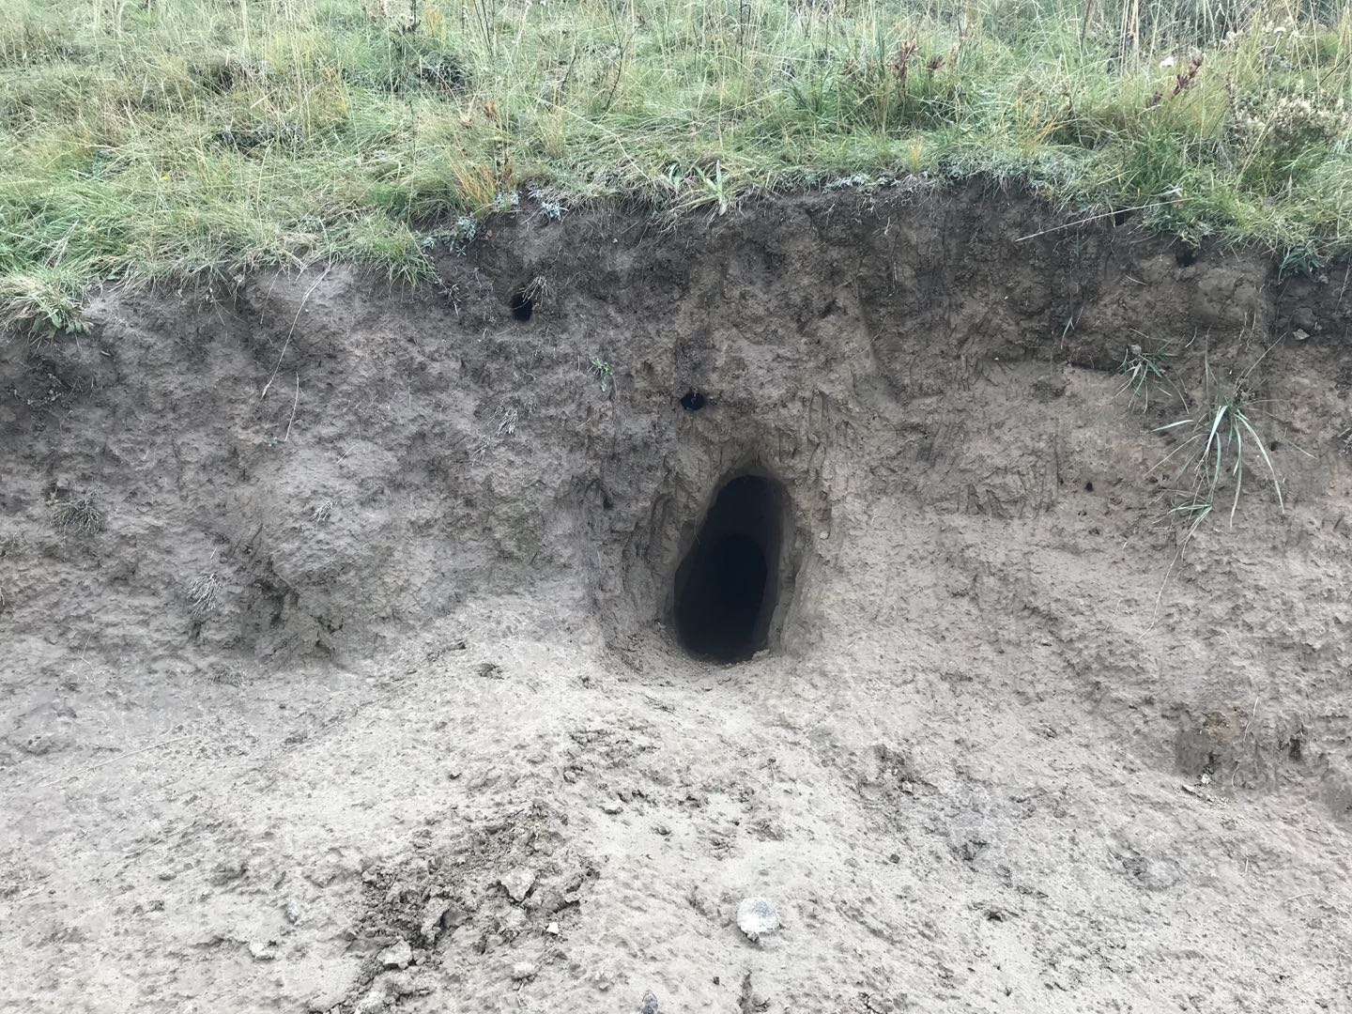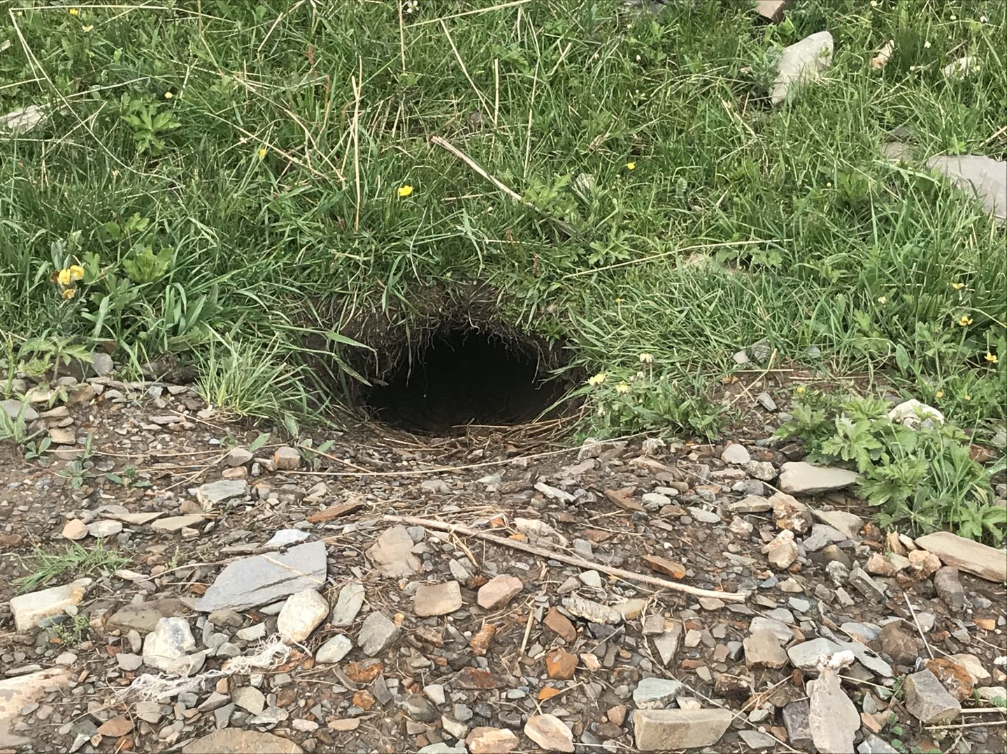
(b)
(a)
Fig. A1. Marmot den (a) and Tibetan fox den (b).

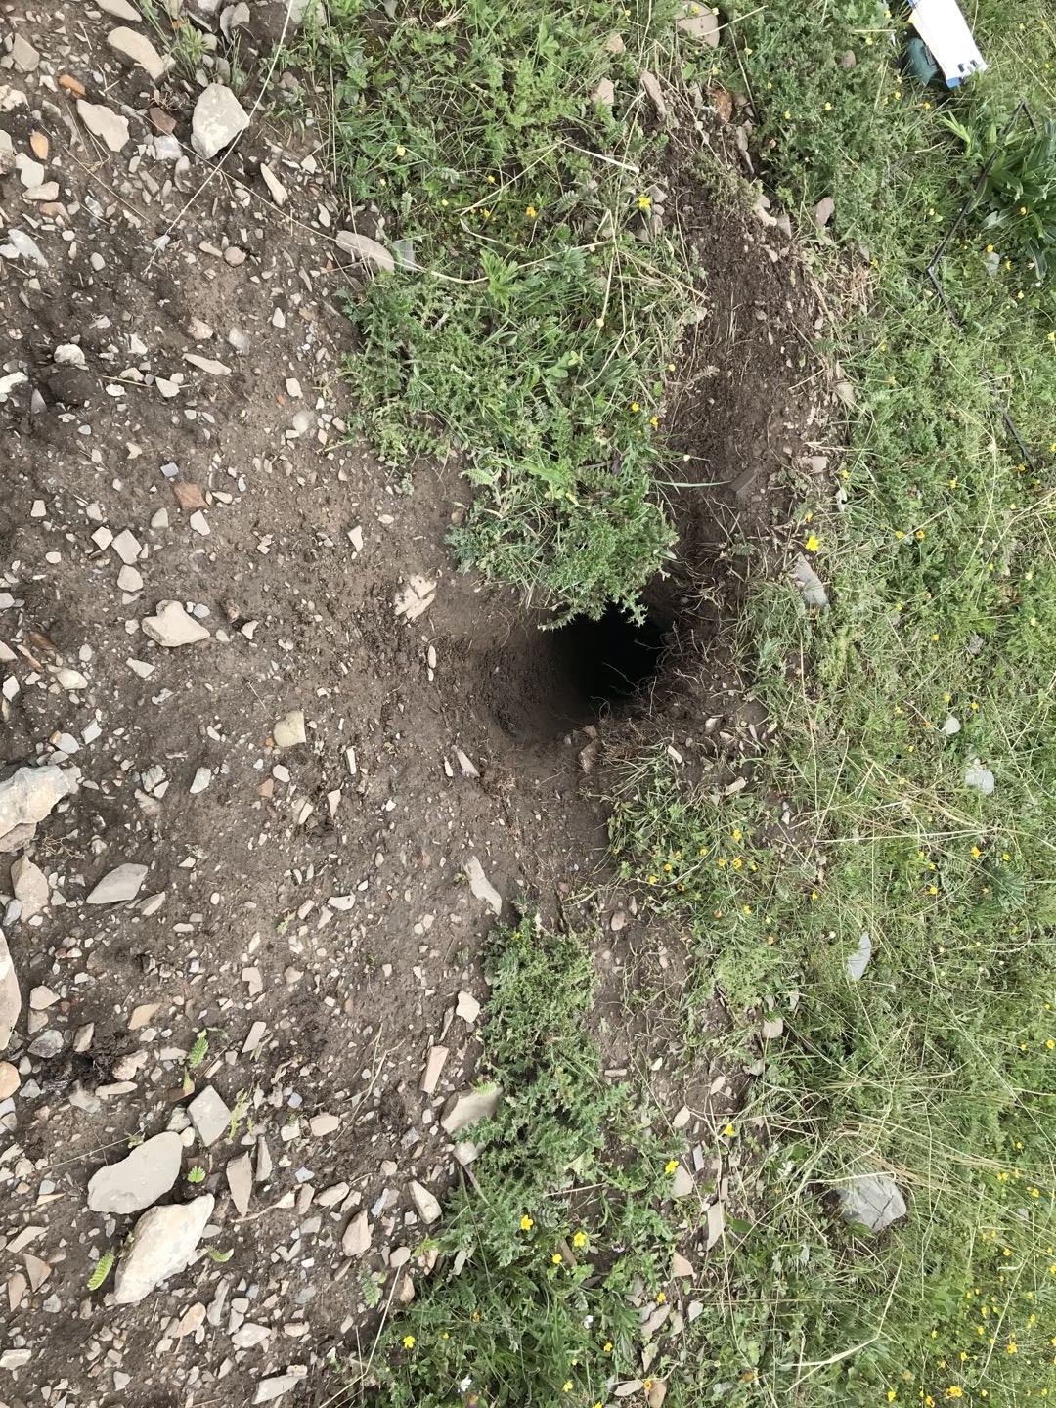
Fig. A2. Paths (marked by white arrows) near the den entrance.

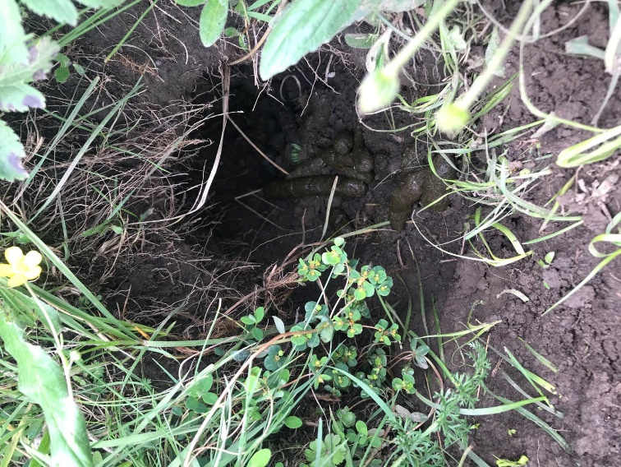
Fig. A3. Fresh marmot scat.

