Figure S1. The halos formed by the recombinant E. coli BL21(DE3) expressing different Lactobacillus feruloyl esterases (A), and E. coli BL21(DE3) containing pET-22b as negative control (B), and the extracellular cell-free supernatant of the negative control (C). FaeLac was derived from Lb. acidophilus. FaeLam was derived from Lb. amylovorus. FaeLcr was derived from Lb. crispatus. FaeLfa was derived from Lb. farciminis. FaeLfe was derived from Lb. fermentum. FaeLga was derived from Lb. gasseri. FaeLhe was derived from Lb. helveticus. FaeLjo1 and FaeLjo2 were derived from Lb. johnsonii. FaeLre was derived from Lb. reuteri.
Figure S2. The confirmation of the secreted FaeLac, FaeLjo1 and FaeLjo2 by western blot analysis. The extracellular component of E. coli containing pET-22b was used as negative control.

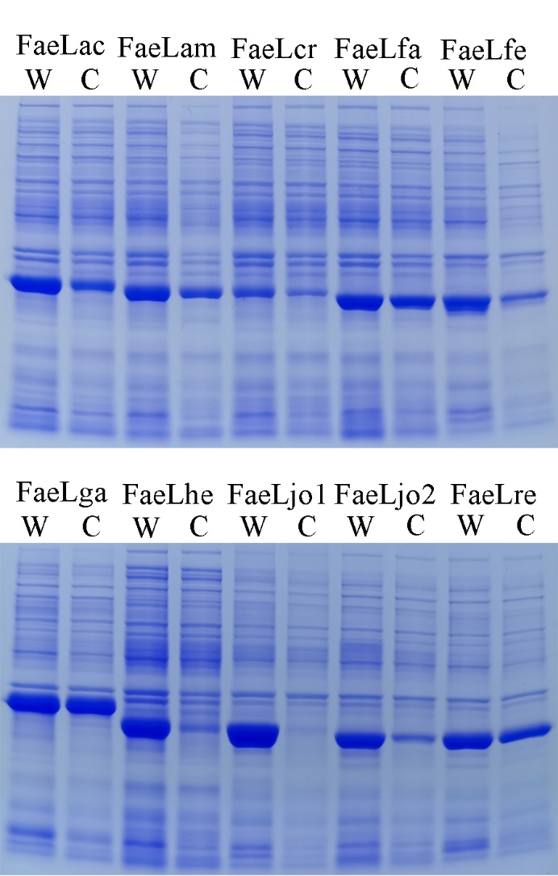
Figure S3. The whole cell (W) and cytoplasmic component (C) of recombinant E. coli expressing feruloyl esterases derived from different Lactobacillus species.

Figure S4. The releasing of ferulic acid from de-starched wheat bran by the culture supernatants of recombinant E. coli strains expressing Lactobacillus feruloyl esterases. Different letters above the column indicate significant differences at p < 0.05.

Table S1. Oligonudeotide primers used in this study
Primer | Sequence(5’-3’) | Template
FaeLac-F | taagaaggagatatacatATGTCTCGCATTACAATTG | Lb. acidophilus
FaeLac-R | gtggtggtggtggtgctcgagAAATAGGGGCTTCAAAAATTC
FaeLam-F | taagaaggagatatacatATGTCCCGCATTACAATTG | Lb. amylovorus
FaeLam-R | gtggtggtggtggtgctcgagGAATAATGGTTTTAAAAATTG
FaeLfa-F | taagaaggagatatacatATGAAAGTAGAAATTAAAC | Lb. farciminis
FaeLfa-R | gtggtggtggtggtgctcgagATCCAACATGAATTTTGTC
FaeLfe-F | taagaaggagatatacatATGGAAGTTGCAATCAAG | Lb. fermentum
FaeLfe-R | gtggtggtggtggtgctcgagCGGTTTAAGAAATCGGCCAC
FaeLga-F | taagaaggagatatacatATGGCAACAATTACAATTG | Lb. gasseri
FaeLga-R | gtggtggtggtggtgctcgagAAAAGTATTATTATCTTGTAAAAAT
FaeLhe-F | taagaaggagatatacatATGTCCCGCATTACGATTGAAAGA | Lb. helveticus
FaeLhe-R | gtggtggtggtggtgctcgagAAACGCAGGTTTTAAAAATTGCG
FaeLjo1-F | taagaaggagatatacatATGGAGACTACAATTAAACGTG | Lb. johnsonii
FaeLjo1-R | gtggtggtggtggtgctcgagTTTTATTAAAAACTCACCAAC
FaeLjo2-F | taagaaggagatatacatATGGCAACAATTACACTTG | Lb. johnsonii
FaeLjo2-R | gtggtggtggtggtgctcgagAAACGCATTATTATTCTG
FaeLre-F | taagaaggagatatacatATGGAAATAACAATCAAACG | Lb. reuteri
FaeLre-R | gtggtggtggtggtgctcgagATTTTTTAAAAAGTTAGCTAC

Table S2. The extracellular feruloyl esterase activity of the recombinant E. coli incubated at different temperatures
Feruloyl esterase | 25 °C | 30 °C | 37 °C
Control | ND | ND | ND
FaeLac | 11.8 ± 0.8^{c} | 41.0 ± 4.4^{b} | 100.0 ± 1.2ª
FaeLam | 8.5 ± 0.7^{c} | 39.7 ± 1.6^{b} | 100.0 ± 4.0ª
FaeLcr | 24.4 ± 1.7^{c} | 84.9 ± 2.4^{b} | 100.0 ± 2.3ª
FaeLfa | 20.8 ± 1.3^{c} | 52.0 ± 3.0^{b} | 100.0 ± 3.9ª
FaeLfe | 2.9 ± 0.5^{b} | 93.4 ± 2.2ª | 100.0 ± 2.0ª
FaeLga | 51.8 ± 1.7^{b} | 100.0 ± 3.5ª | 87.7 ± 2.3ª
FaeLhe | 3.8 ± 1.0^{c} | 29.7 ± 0.9^{b} | 100.0 ± 3.4ª
FaeLjo1 | 38.2 ± 1.2^{c} | 53.8 ± 1.8^{b} | 100.0 ± 2.1ª
FaeLjo2 | 57.3 ± 1.5^{b} | 86.0 ± 2.9ª | 100.0 ± 3.3ª
FaeLre | 8.1 ± 0.7^{c} | 15.5 ± 1.1^{b} | 100.0 ± 2.7ª
These strains were incubated at 25 °C, 30 °C and 37 °C for 12 h, respectively. The E. coli containing pET-22b was used as negative control. Extracellular activity was determined in 100 mM sodium phosphate buffer (pH 7.0) at 37 °C using 1 mM ρNPF as substrate. Values are means ± standard deviation, n = 3. ND means no detectable activity. The detected maximal activities for each feruloyl esterase were defined as 100 %. Different letters in the same row indicate significant differences at p < 0.05.

Table S3. The extracellular enzymatic activity and protein concentration of the recombinant E. coli when the maximal activities were detected
Feruloyl esterase | Maximal activity detected at (h) | Extracellular enzymatic activity (U/L) | Extracellular protein concentration (mg/L)
FaeLac | 24 | 88.9 ± 8.1^{f} | 51.5 ± 6.3^{c}
FaeLam | 24 | 2306.0 ± 23.7ª | 219.0 ± 11.0ª
FaeLcr | 48 | 2118.5 ± 33.8ª | 201.7 ± 4.1ª
FaeLfa | 24 | 2089.8 ± 35.1^{b} | 93.4 ± 10.9^{b}
FaeLfe | 12 | 1804.3 ± 24.3^{c} | 106.1 ± 12.6^{b}
FaeLga | 24 | 590.4 ± 11.1^{d} | 146.6 ± 6.9^{b}
FaeLhe | 24 | 2164.0 ± 34.1ª | 135.7 ± 1.8^{b}
FaeLjo1 | 12 | 294.9 ± 24.3e | 50.0 ± 3.7^{d}
FaeLjo2 | 12 | 662.5 ± 14.9^{d} | 77.7 ± 4.2^{c}
FaeLre | 8 | 2092.3 ± 31.2^{b} | 149.5 ± 8.5^{b}
The E. coli strains were incubated at 37 °C for 72 h. Extracellular activity was determined in 100 mM sodium phosphate buffer (pH 7.0) at 37 °C using 1 mM ρNPF as substrate. Values are means ± standard deviation, n = 3. Different letters in the same column indicate significant differences at p < 0.05.

