Supplementary Figure 1
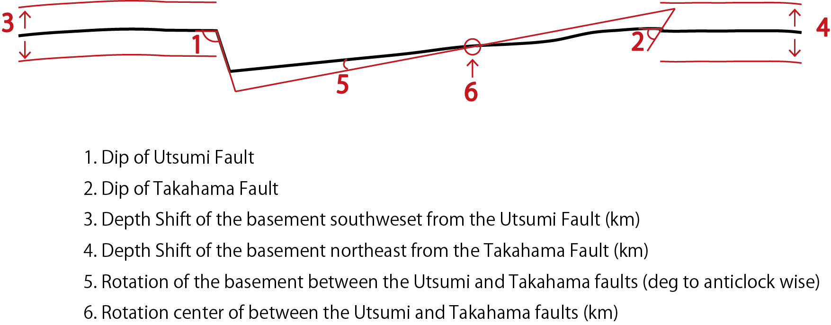

Supplementary Figure 2
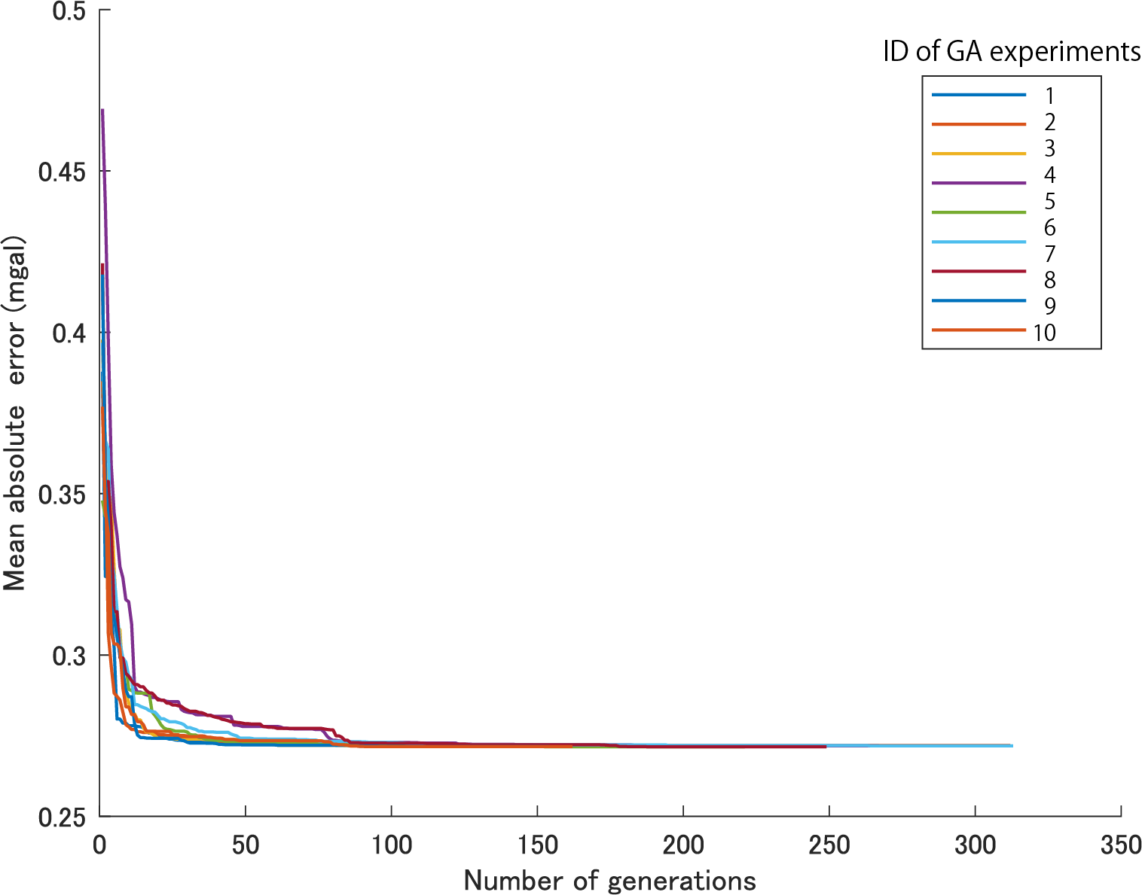
The state of convergence of the evaluation function (Mean absolute error). The ID of GA experiments are listed in Suppl. Table 3.

