Output Results of Program：
- Japanese sandfish (Arctoscopus japonicus)
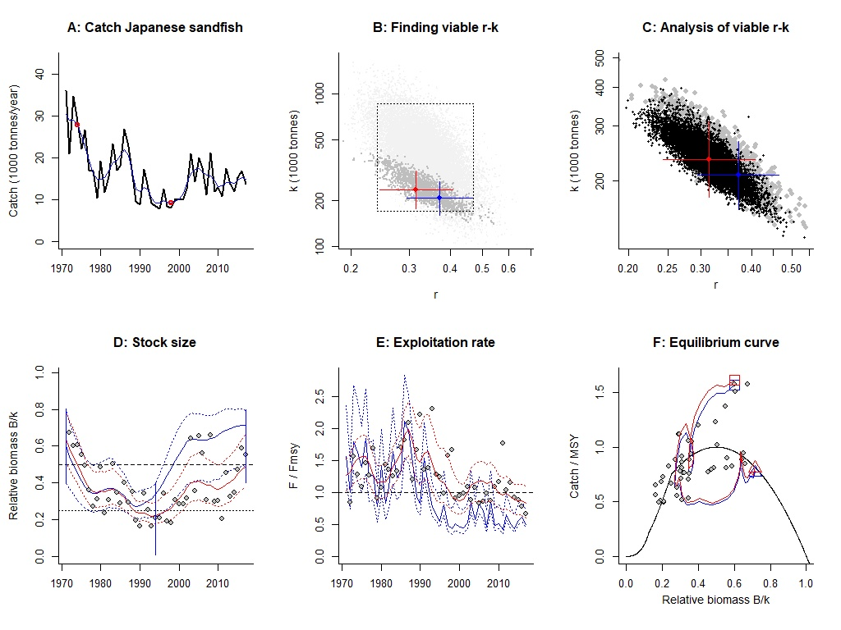Figure S1.1 Analysis of Japanese sandfish with CMSY and BSM.
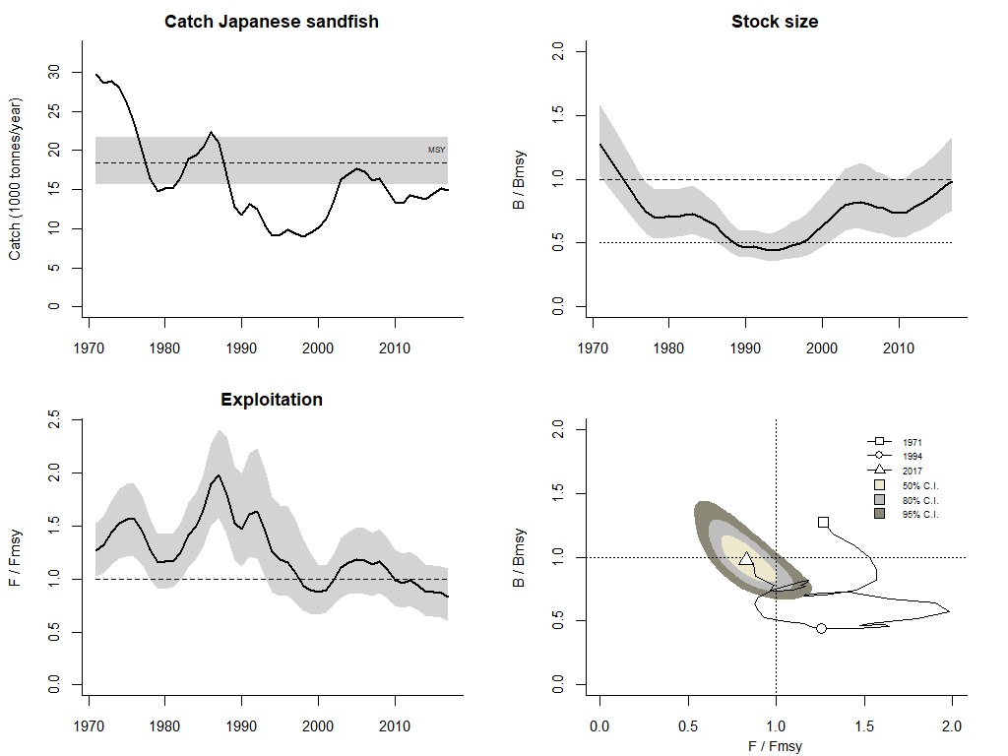Figure S1.2 Graphical output of CMSY for management purposes, for Japanese sandfish in the Japan Sea.
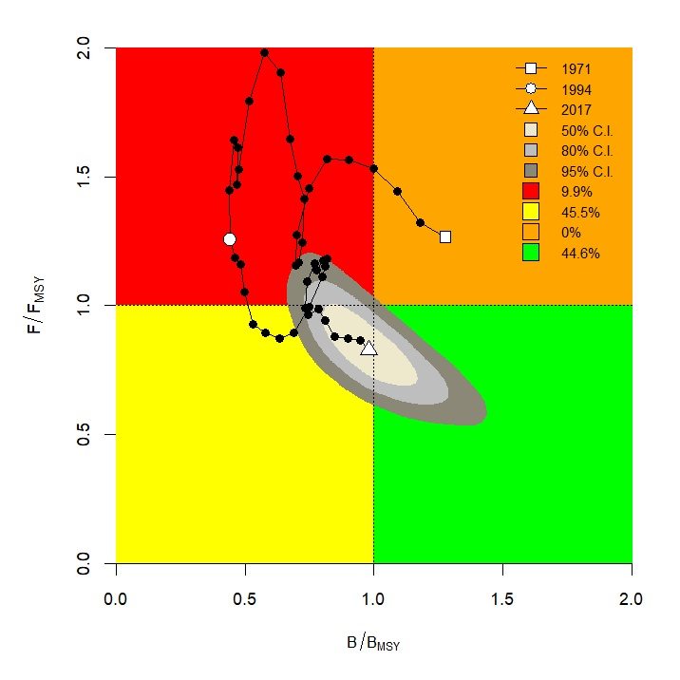Figure S1.3 CMSY results for Japanese sandfish presented in a Kobe plot.

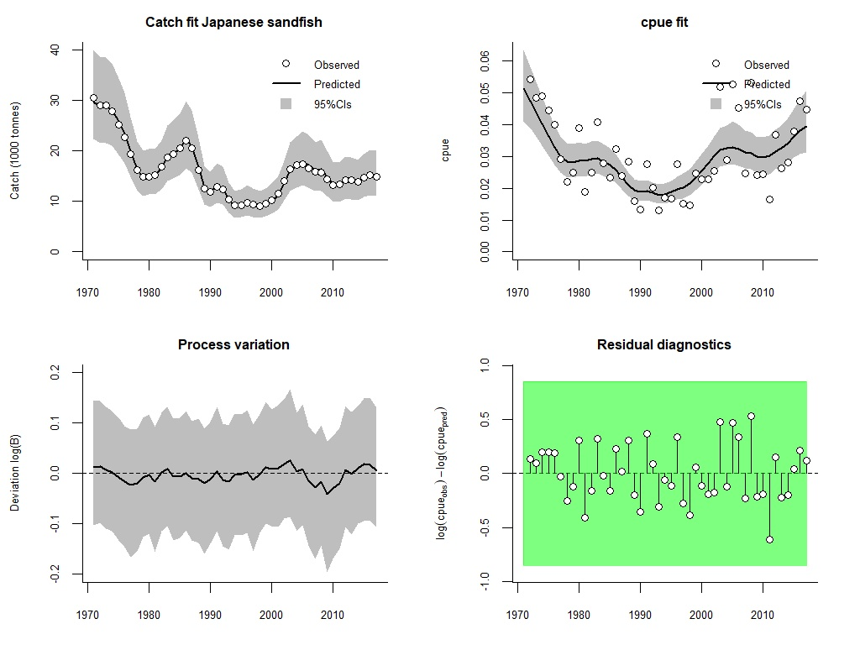Figure S1.4 Analytical graph for BSM analysis of Japanese sandfish, showing the fit of the predicted to the observed catch, the fit of predicted to observed CPUE, the deviation from observed to predicted biomass, and an analysis of the log-CPUE residuals.
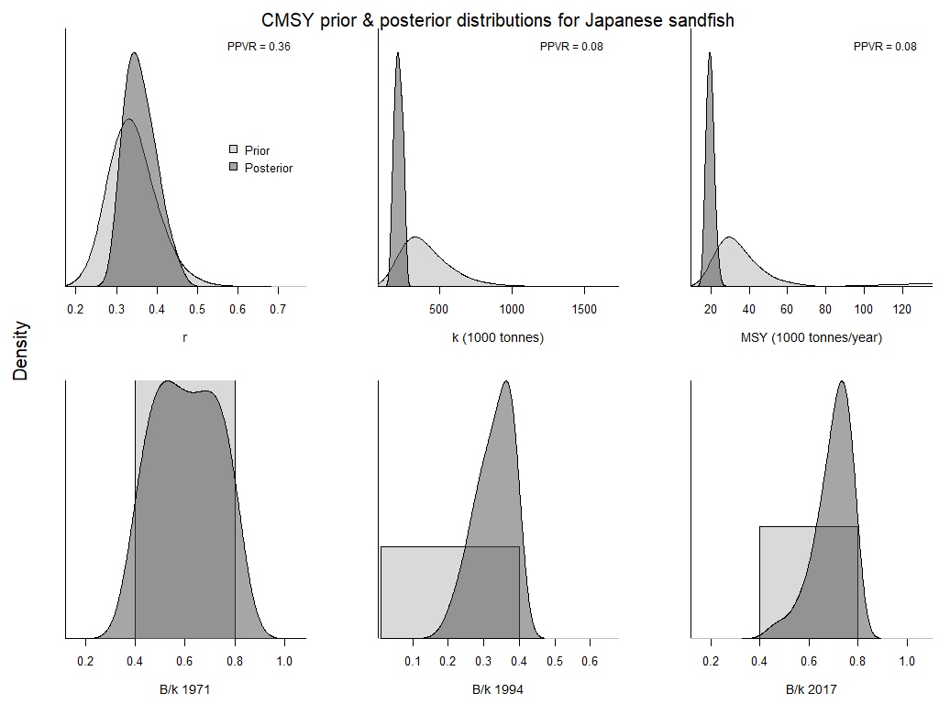Figure S1.5 Comparison of prior and posterior densities (same area under curves) for productivity (r), maximum stock size (k), maximum sustainably yield (MSY), and relative stock size (B/k) at the beginning, the end, and an intermediate year of the available time series of Japanese sandfish catch data using CMSY method.
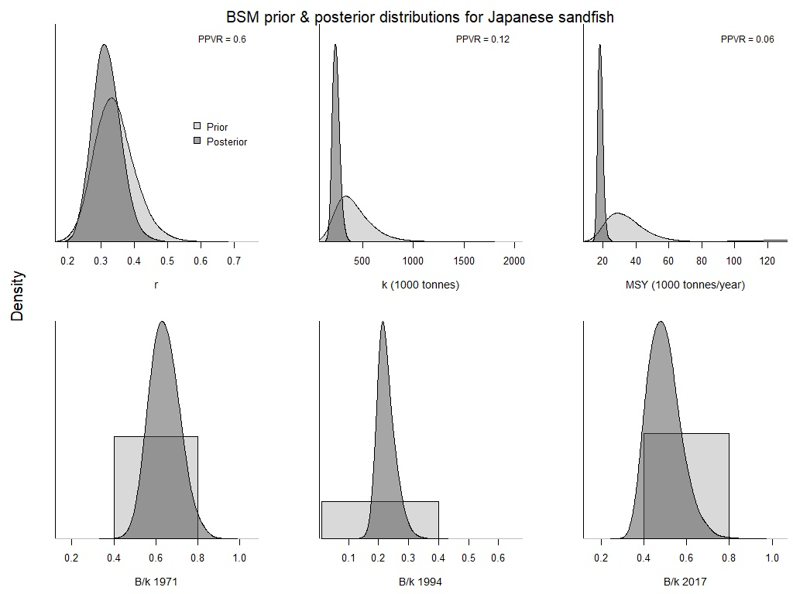Figure S1.6 Comparison of prior and posterior densities (same area under curves) for productivity (r), maximum stock size (k), maximum sustainably yield (MSY), and relative stock size (B/k) at the beginning, the end, and an intermediate year of the available time series of Red seabream catch data using BSM method.

- Sôhachi (Cleisthenes pinetorum)
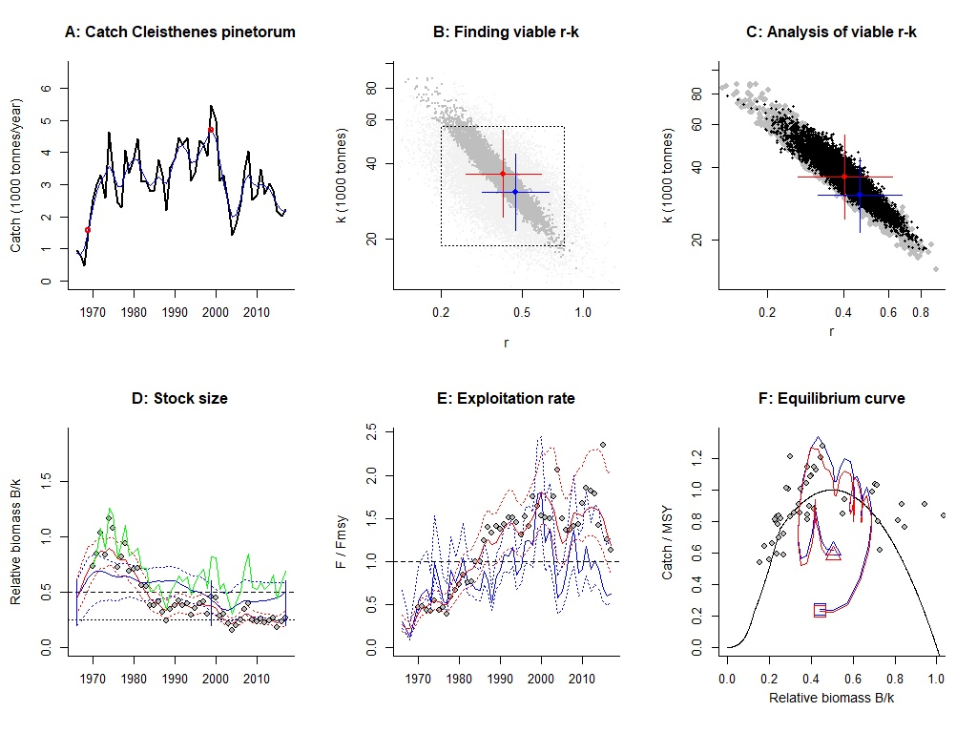Figure S2.1 Analysis of sôhachi with CMSY and BSM.
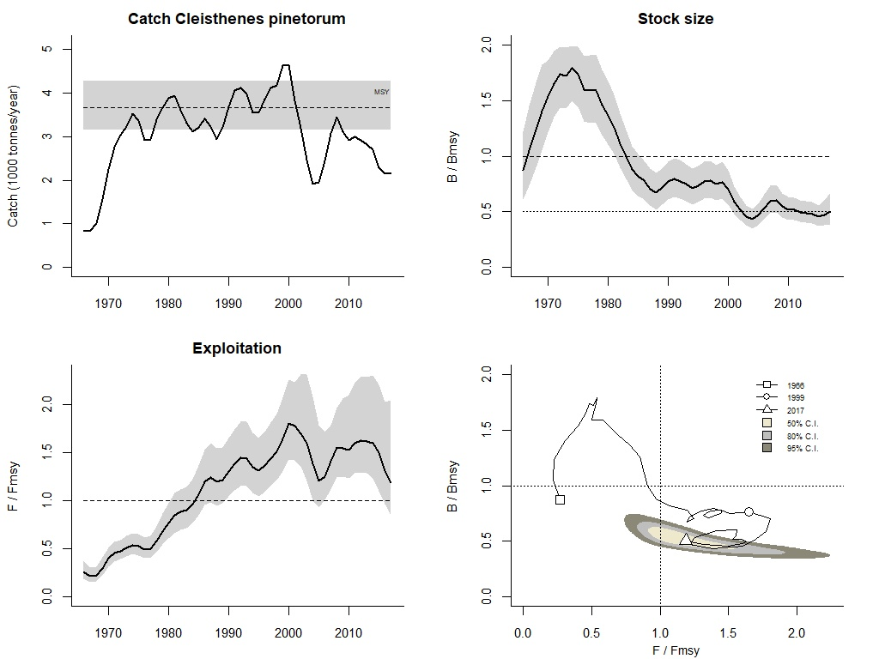Figure S2.2 Graphical output of CMSY for management purposes, for sôhachi in the Japan Sea.
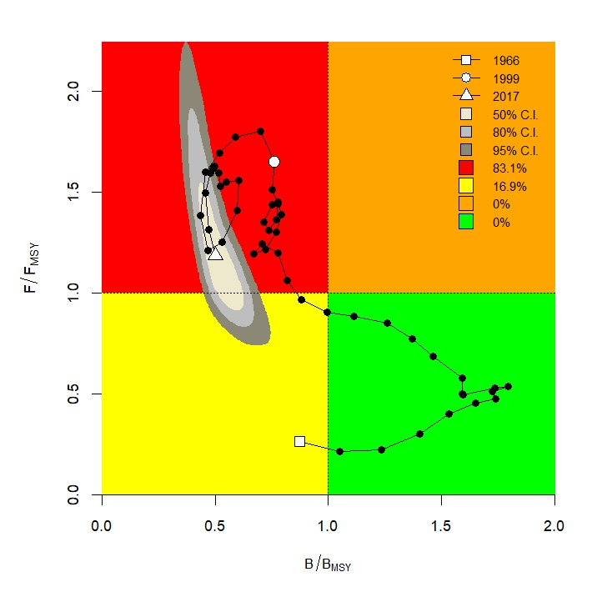Figure S2.3 CMSY results for sôhachi presented in a Kobe plot.
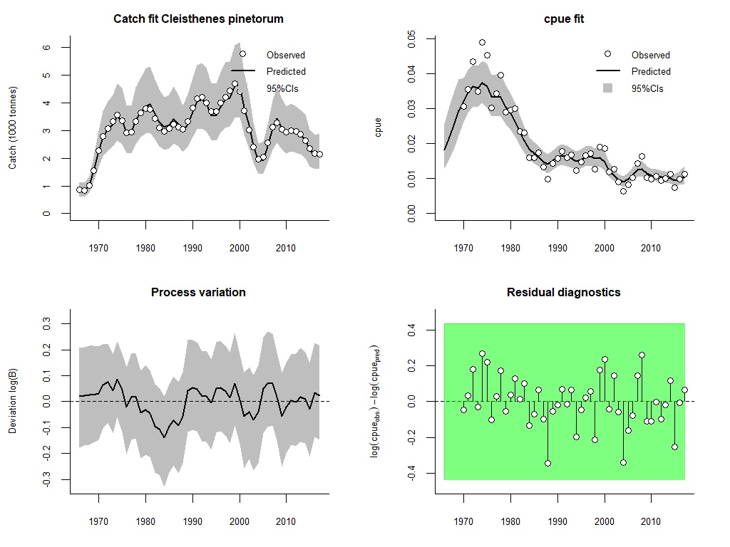 Figure S2.4 Analytical graph for BSM analysis of sôhachi, showing the fit of the predicted to the observed catch, the fit of predicted to observed CPUE, the deviation from observed to predicted biomass, and an analysis of the log-CPUE residuals.
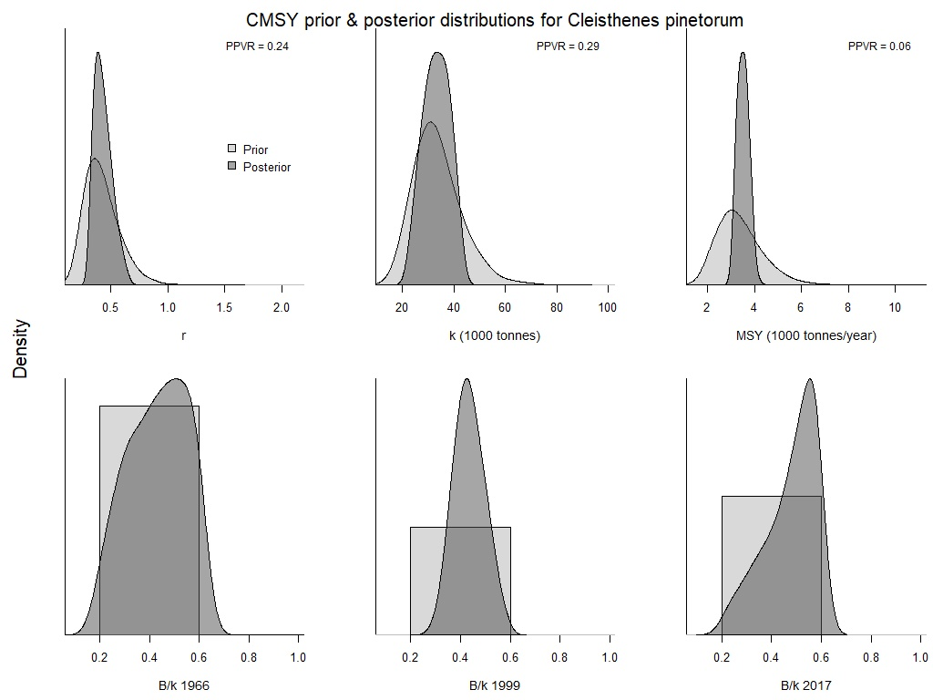 Figure S2.5 Comparison of prior and posterior densities (same area under curves) for productivity (r), maximum stock size (k), maximum sustainably yield (MSY), and relative stock size (B/k) at the beginning, the end, and an intermediate year of the available time series of sôhachi catch data using CMSY method.
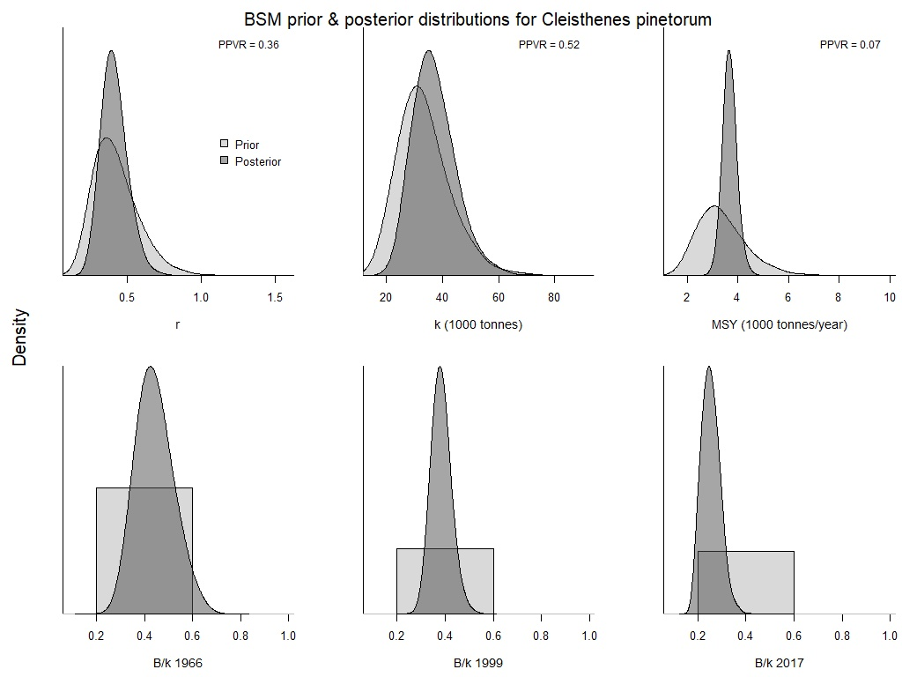
Figure S2.6 Comparison of prior and posterior densities (same area under curves) for productivity (r), maximum stock size (k), maximum sustainably yield (MSY), and relative stock size (B/k) at the beginning, the end, and an intermediate year of the available time series of sôhachi catch data using BSM method.

- Shotted halibut (Eopsetta grigorjewi)
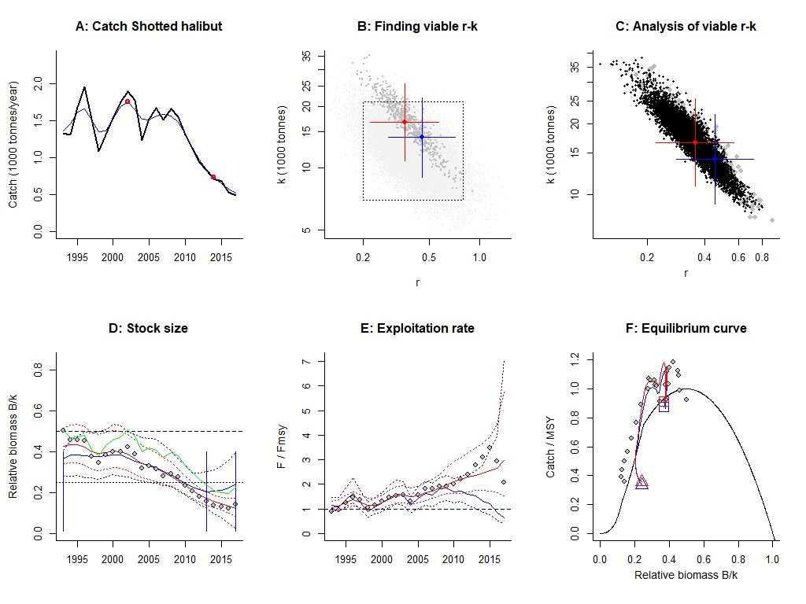Figure S3.1 Analysis of shotted halibut with CMSY and BSM.
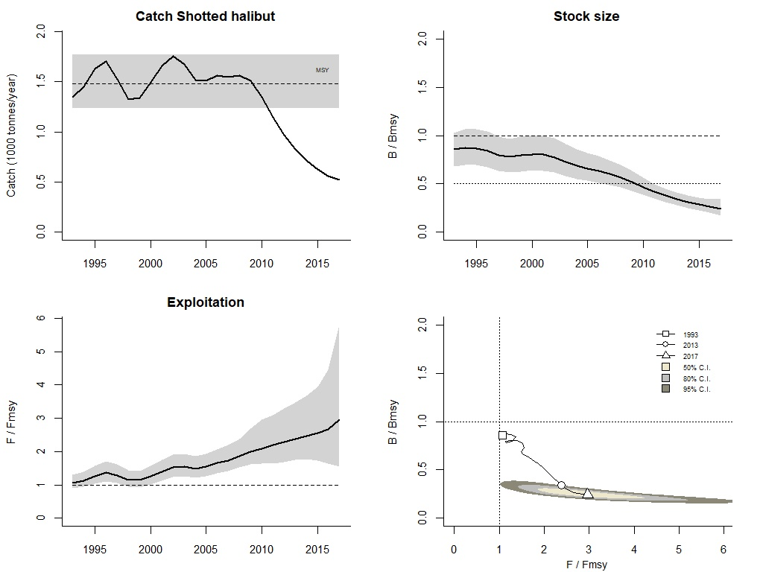Figure S3.2 Graphical output of CMSY for management purposes, for shotted halibut in the Japan Sea.
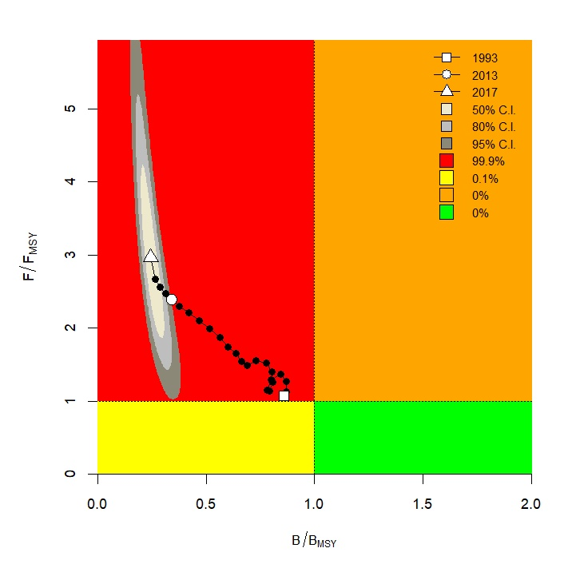Figure S3.3 CMSY results for shotted halibut presented in a Kobe plot.
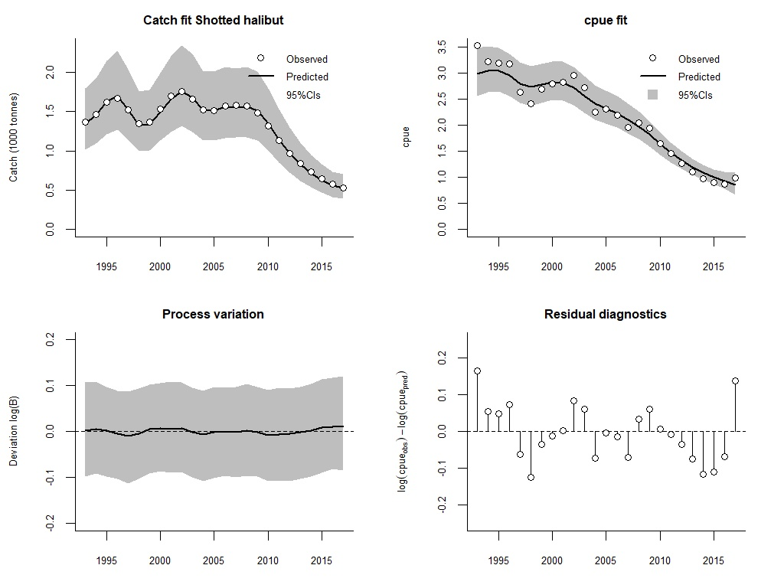Figure S3.4 Analytical graph for BSM analysis of shotted halibut, showing the fit of the predicted to the observed catch, the fit of predicted to observed CPUE, the deviation from observed to predicted biomass, and an analysis of the log-CPUE residuals.
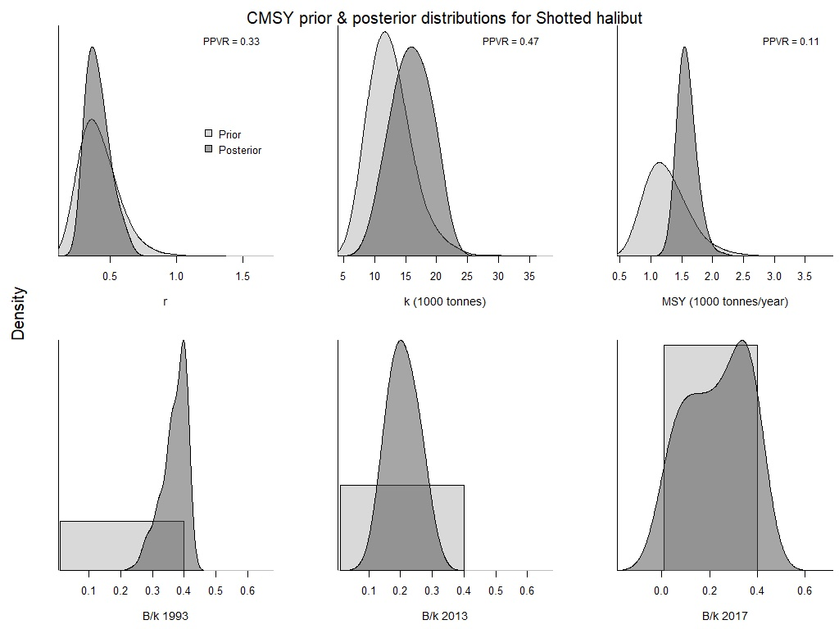Figure S3.5 Comparison of prior and posterior densities (same area under curves) for productivity (r), maximum stock size (k), maximum sustainably yield (MSY), and relative stock size (B/k) at the beginning, the end, and an intermediate year of the available time series of shotted halibut catch data using CMSY method.
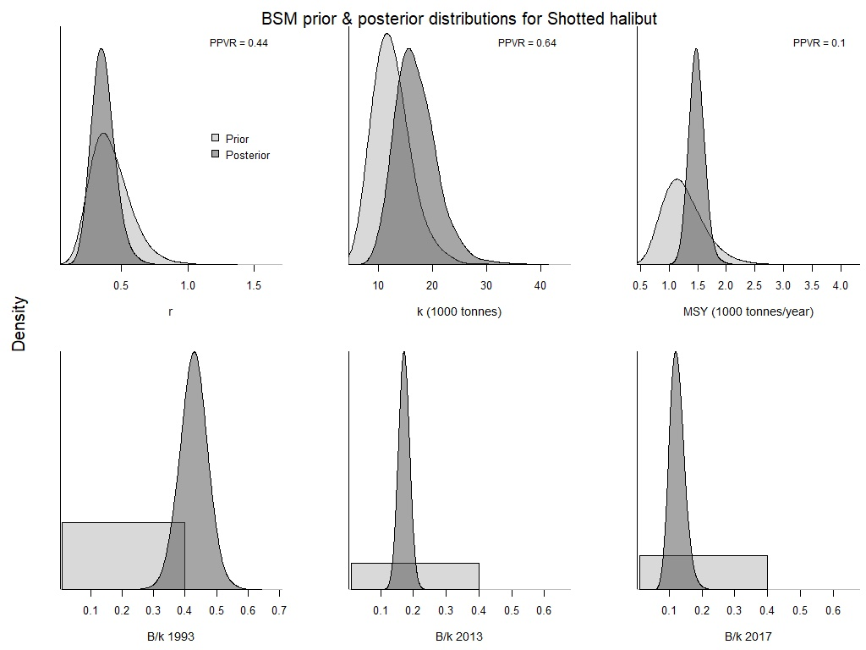Figure S3.6 Comparison of prior and posterior densities (same area under curves) for productivity (r), maximum stock size (k), maximum sustainably yield (MSY), and relative stock size (B/k) at the beginning, the end, and an intermediate year of the available time series of shotted halibut catch data using BSM method.

- Flathead flounder (Hippoglossoides dubius)
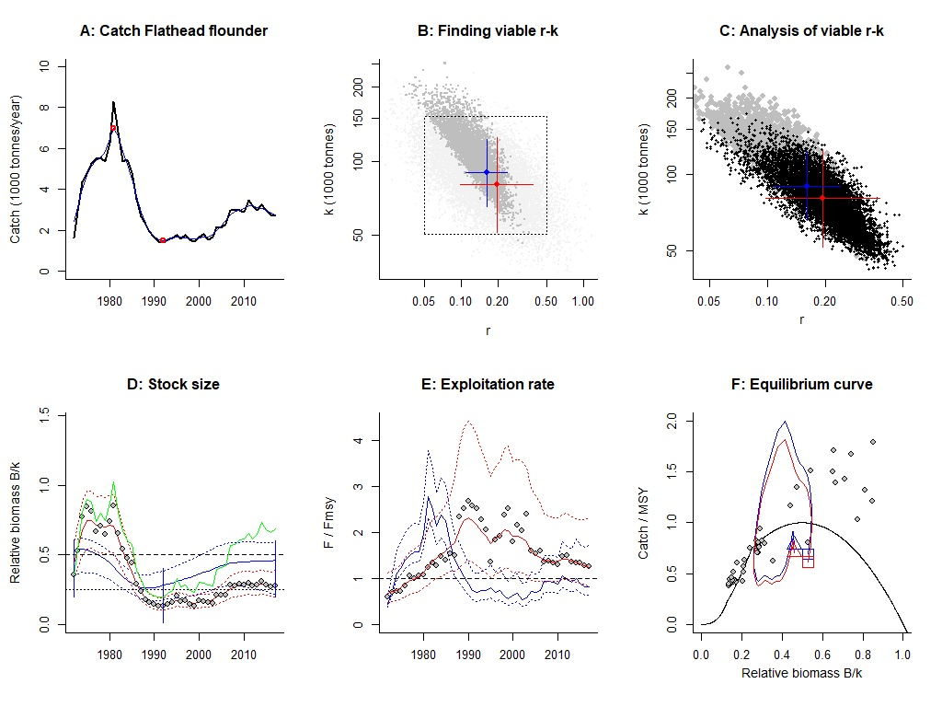Figure S4.1 Analysis of fathead flounder with CMSY and BSM.
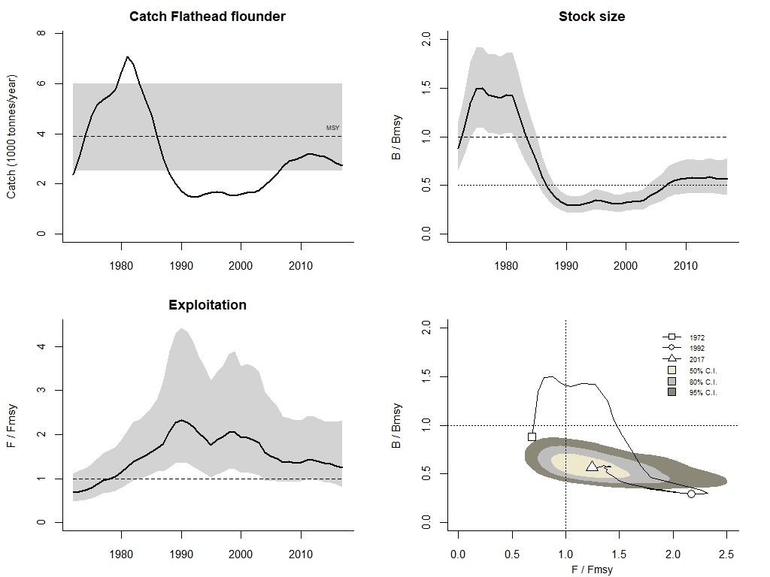Figure S4.2 Graphical output of CMSY for management purposes, for fathead flounder in the Japan Sea.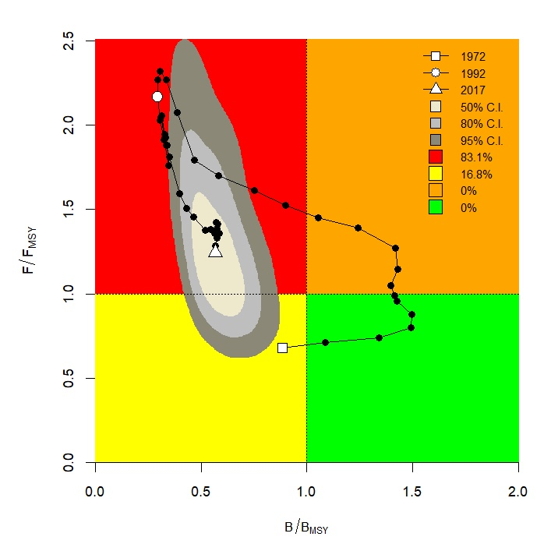Figure S4.3 CMSY results for fathead flounder presented in a Kobe plot.
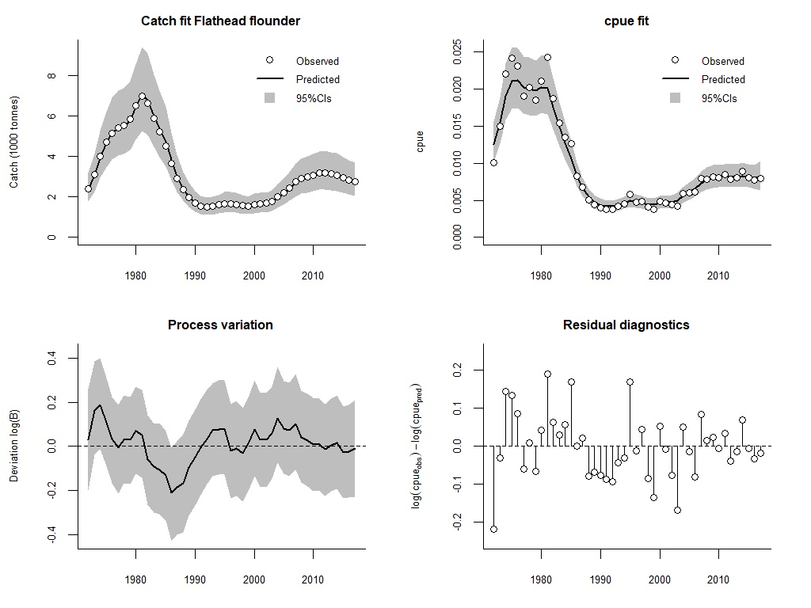Figure S4.4 Analytical graph for BSM analysis of fathead flounder, showing the fit of the predicted to the observed catch, the fit of predicted to observed CPUE, the deviation from observed to predicted biomass, and an analysis of the log-CPUE residuals.
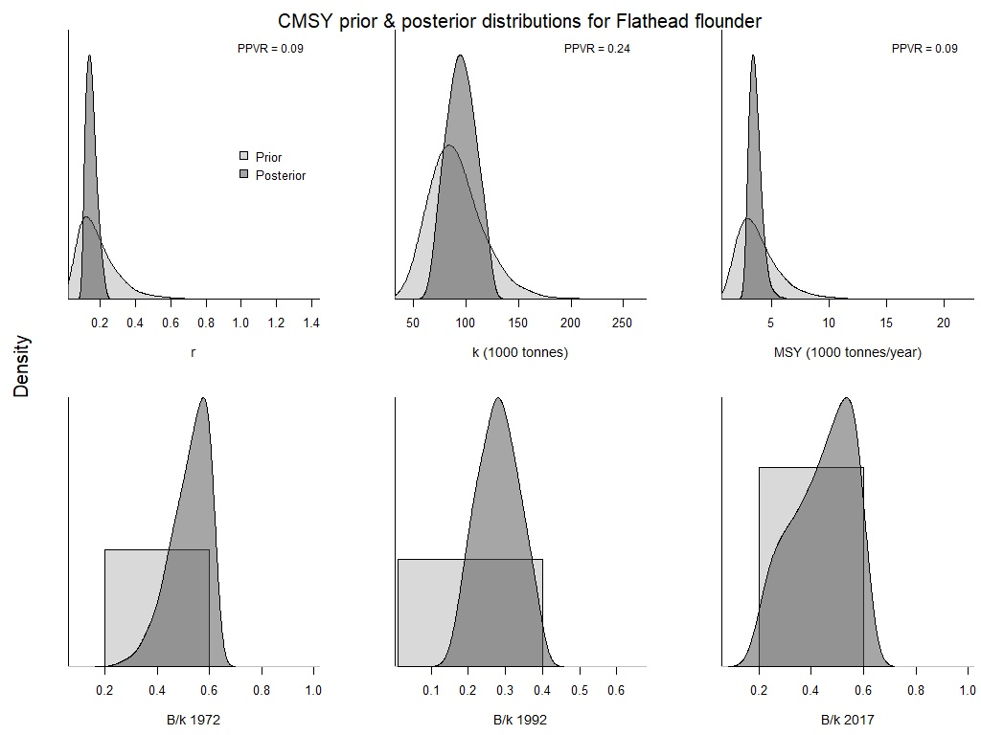Figure S4.5 Comparison of prior and posterior densities (same area under curves) for productivity (r), maximum stock size (k), maximum sustainably yield (MSY), and relative stock size (B/k) at the beginning, the end, and an intermediate year of the available time series of fathead flounder catch data using CMSY method.
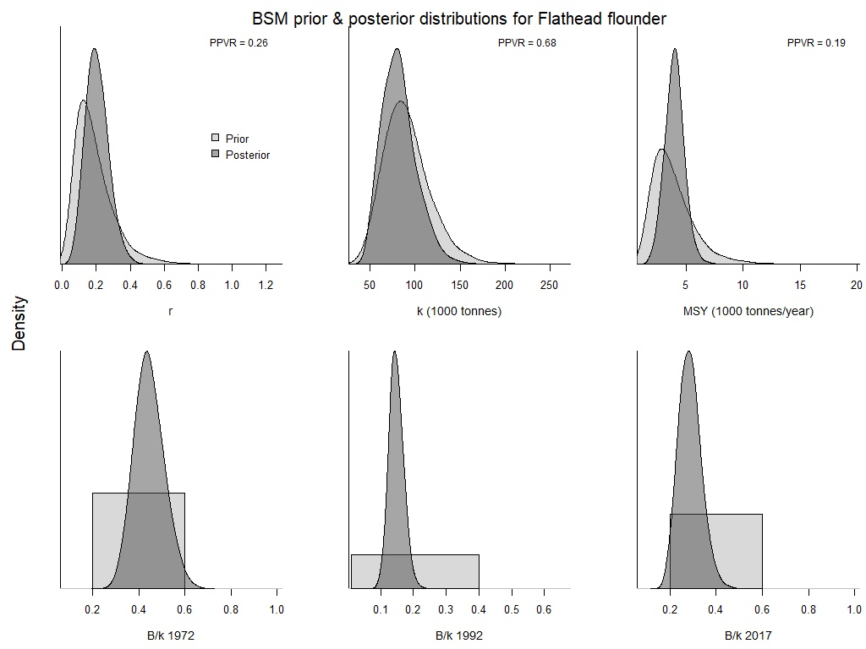Figure S4.6 Comparison of prior and posterior densities (same area under curves) for productivity (r), maximum stock size (k), maximum sustainably yield (MSY), and relative stock size (B/k) at the beginning, the end, and an intermediate year of the available time series of fathead flounder catch data using BSM method.

- Yellow striped flounder (Pseudopleuronectes herzensteini)
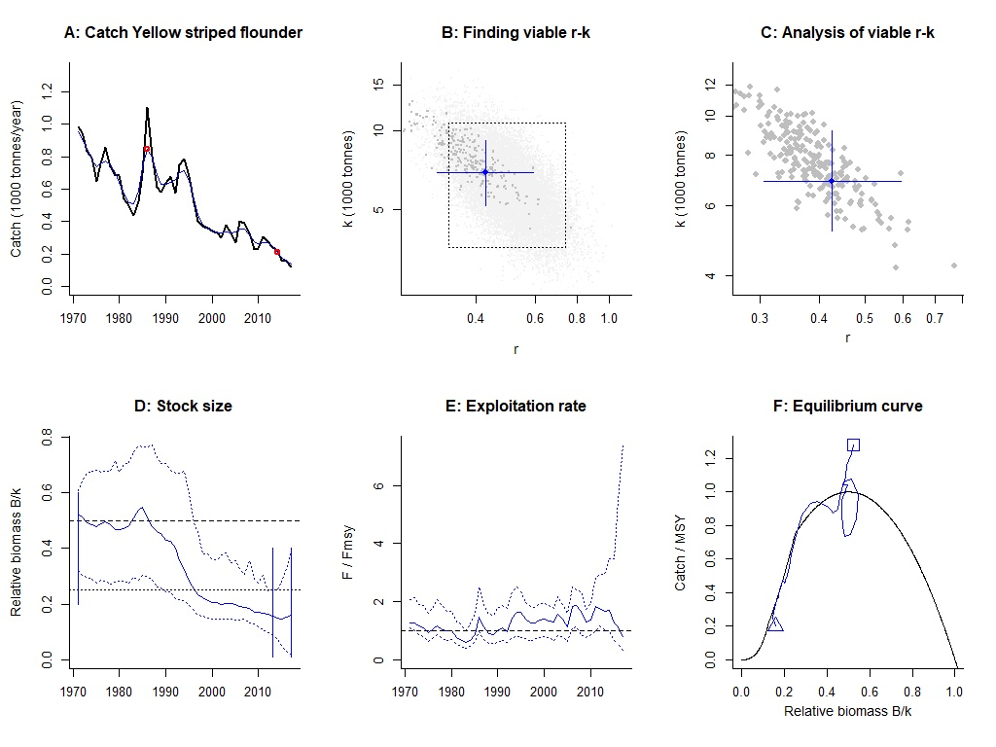Figure S5.1 Analysis of yellow striped flounder with CMSY.
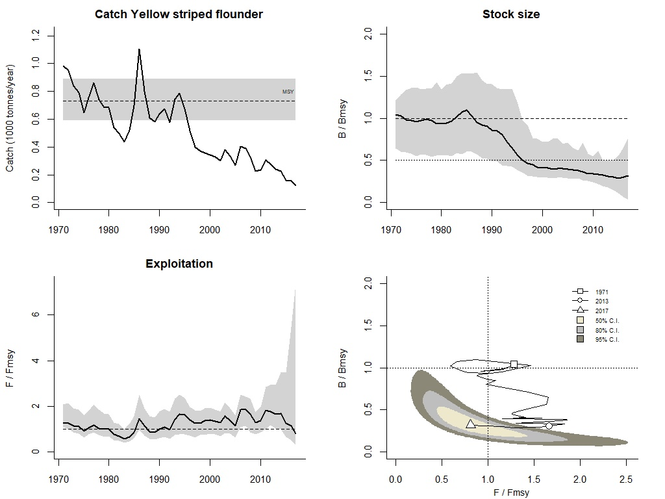 Figure S5.2 Graphical output of CMSY for management purposes, for yellow striped flounder in the Japan Sea.
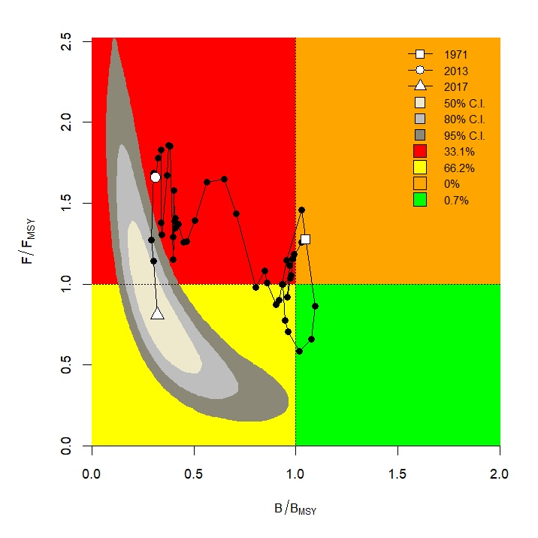 Figure S5.3 CMSY results for yellow striped flounder presented in a Kobe plot.
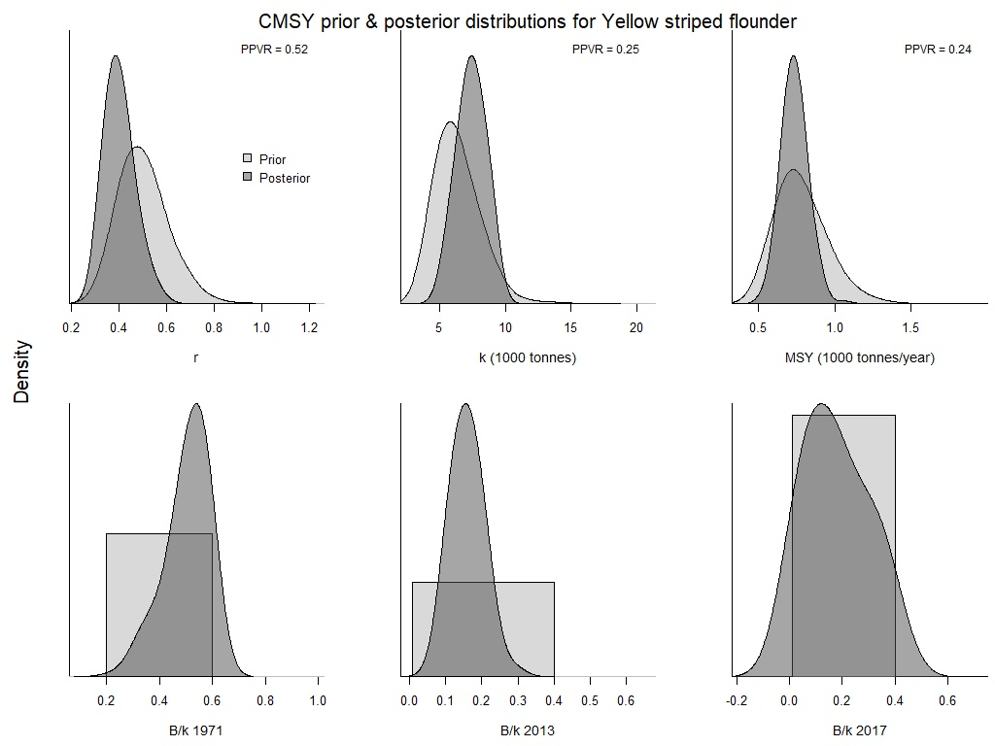 Figure S5.4 Comparison of prior and posterior densities (same area under curves) for productivity (r), maximum stock size (k), maximum sustainably yield (MSY), and relative stock size (B/k) at the beginning, the end, and an intermediate year of the available time series of yellow striped flounder catch data using CMSY method.

- Bastard halibut (Paralichthys olivaceus)
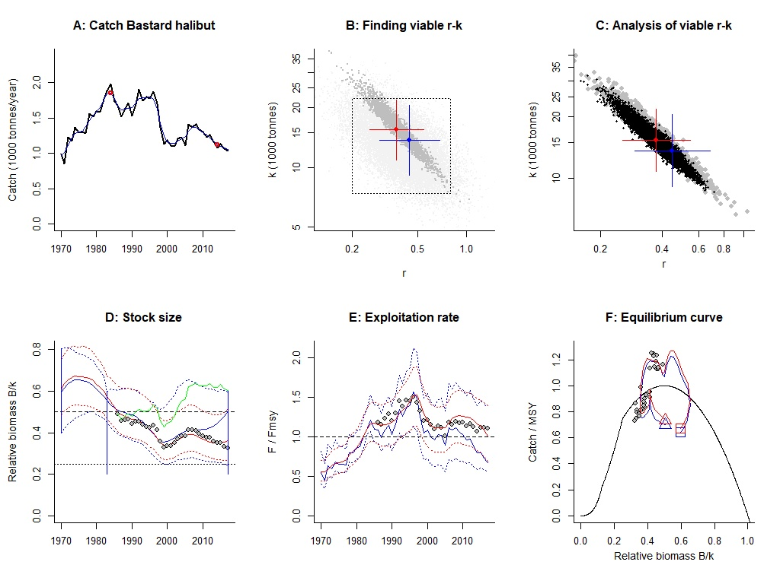Figure S6.1 Analysis of bastard halibut with CMSY and BSM.
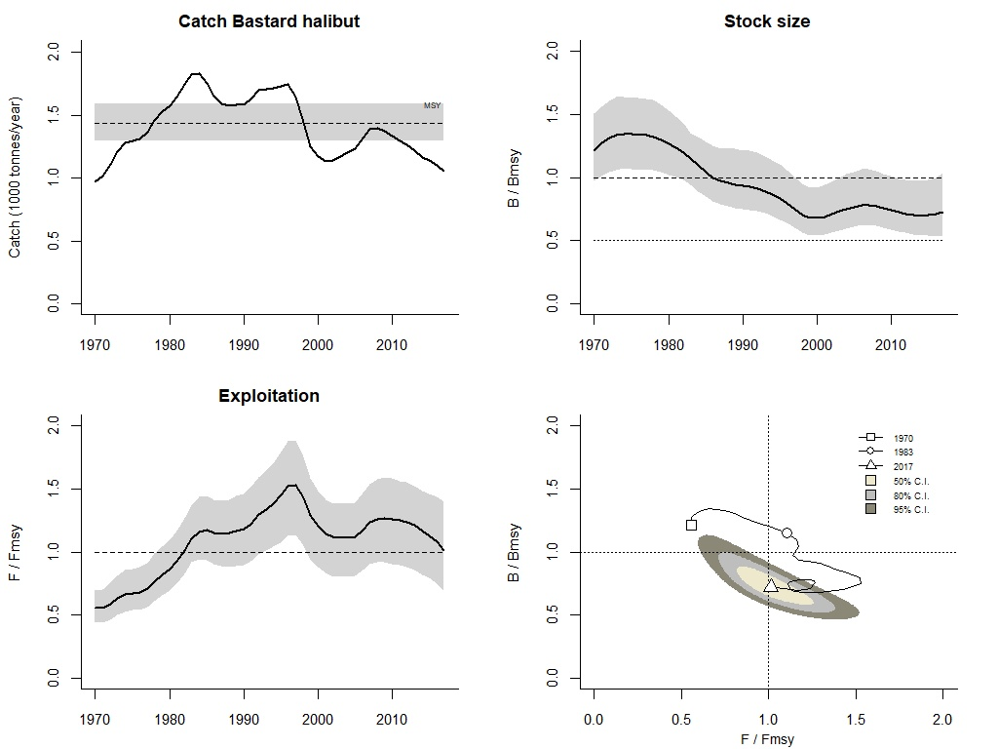Figure S6.2 Graphical output of CMSY for management purposes, for bastard halibut in the Japan Sea.
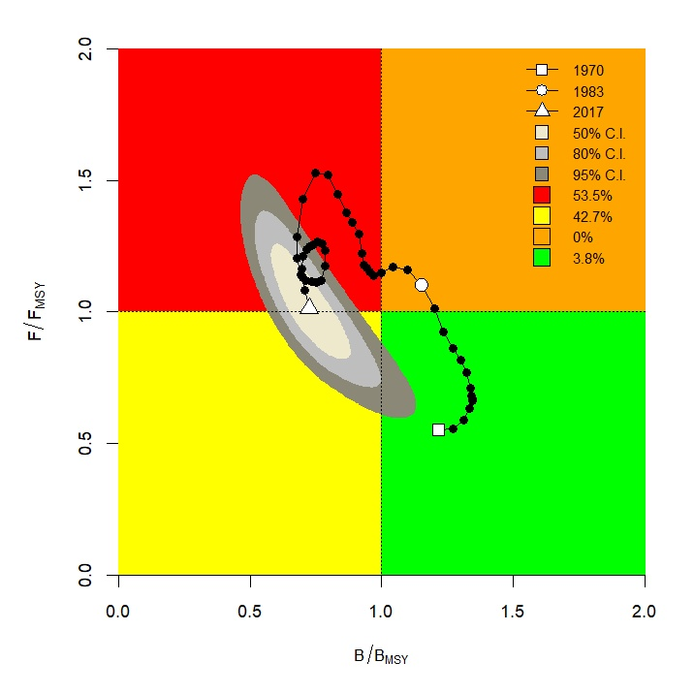Figure S6.3 CMSY results for bastard halibut presented in a Kobe plot.
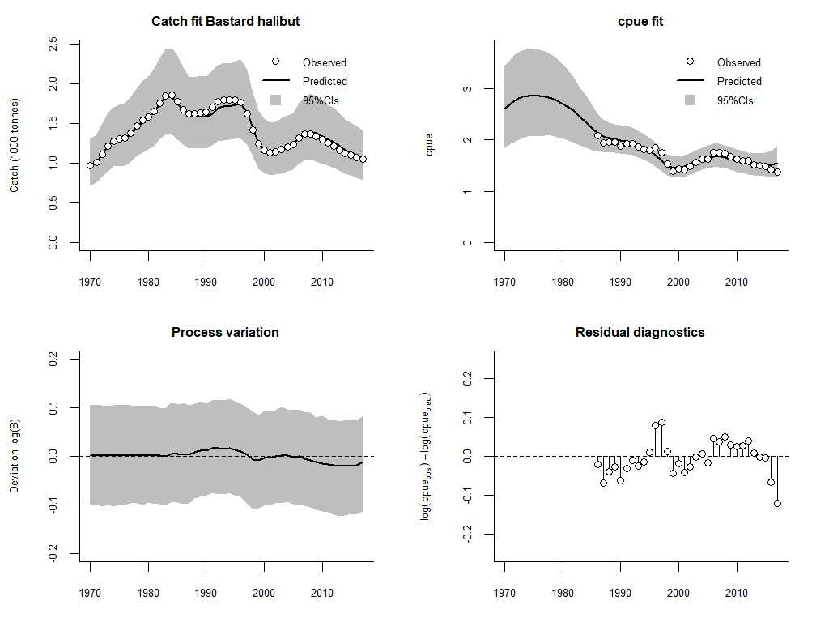Figure S6.4 Analytical graph for BSM analysis of bastard halibut, showing the fit of the predicted to the observed catch, the fit of predicted to observed CPUE, the deviation from observed to predicted biomass, and an analysis of the log-CPUE residuals.
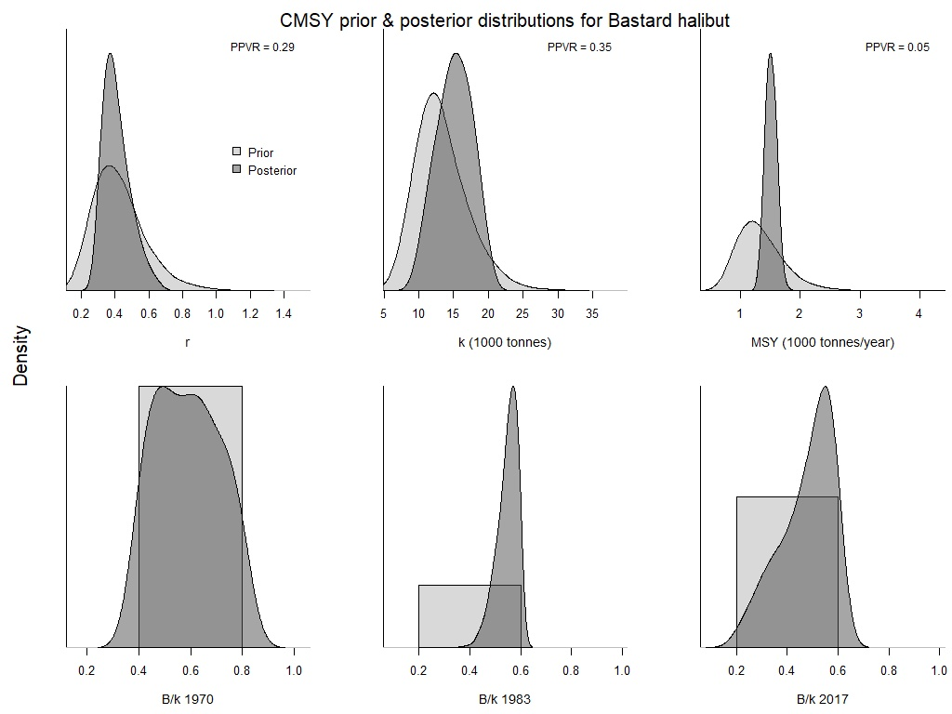Figure S6.5 Comparison of prior and posterior densities (same area under curves) for productivity (r), maximum stock size (k), maximum sustainably yield (MSY), and relative stock size (B/k) at the beginning, the end, and an intermediate year of the available time series of bastard halibut catch data using CMSY method.
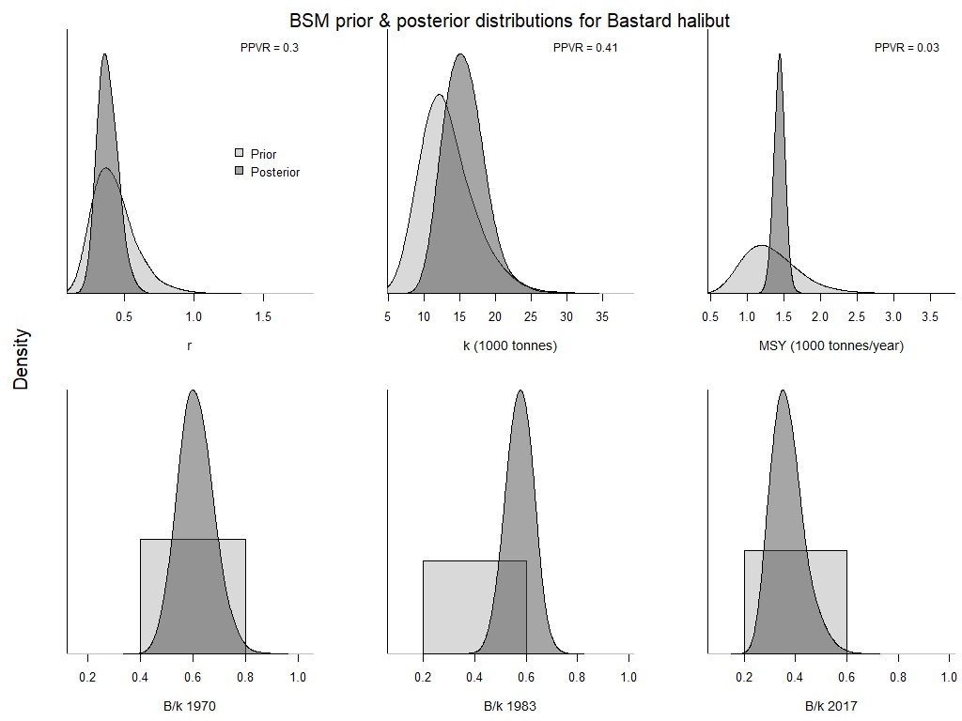Figure S6.6 Comparison of prior and posterior densities (same area under curves) for productivity (r), maximum stock size (k), maximum sustainably yield (MSY), and relative stock size (B/k) at the beginning, the end, and an intermediate year of the available time series of bastard halibut catch data using BSM method.

- Red seabream (Pagrus major)
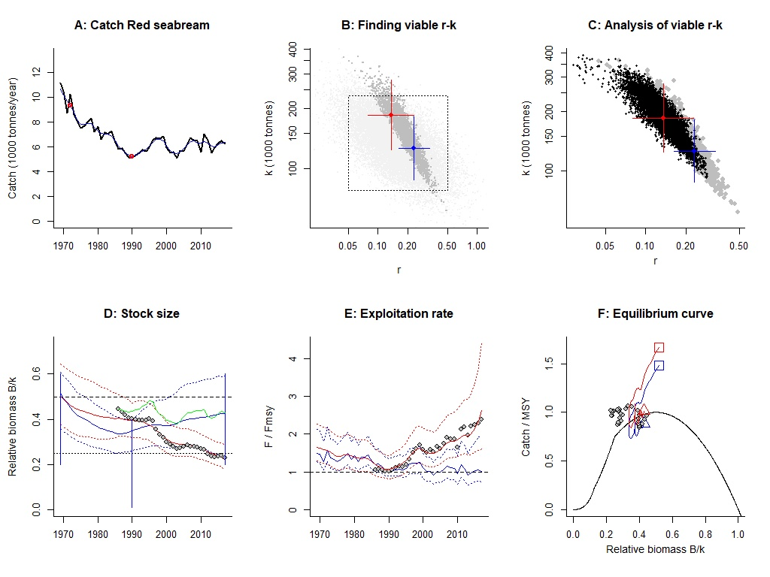
Figure S7.1 Analysis of red seabream with CMSY and BSM.

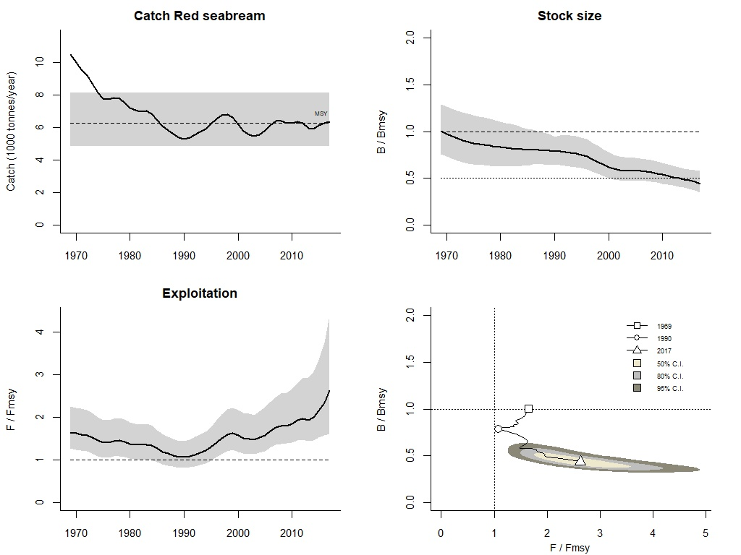Figure S7.2 Graphical output of CMSY for management purposes, for red seabream in the Japan Sea.
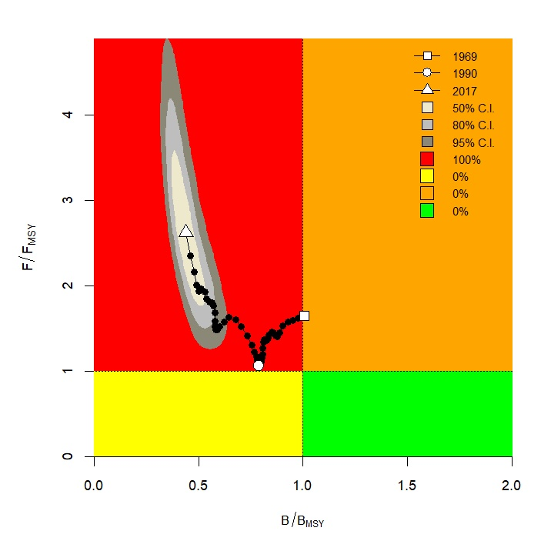Figure S7.3 CMSY results for red seabream presented in a Kobe plot.

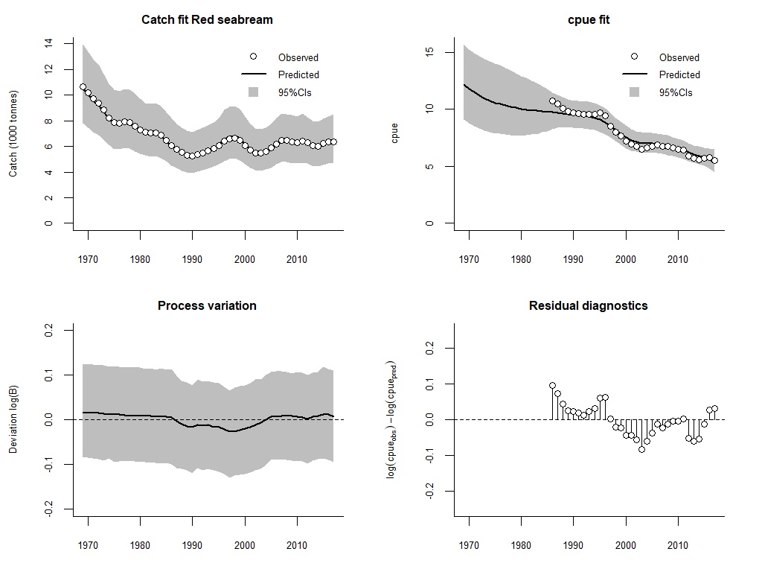Figure S7.4 Analytical graph for BSM analysis of red seabream, showing the fit of the predicted to the observed catch, the fit of predicted to observed CPUE, the deviation from observed to predicted biomass, and an analysis of the log-CPUE residuals.

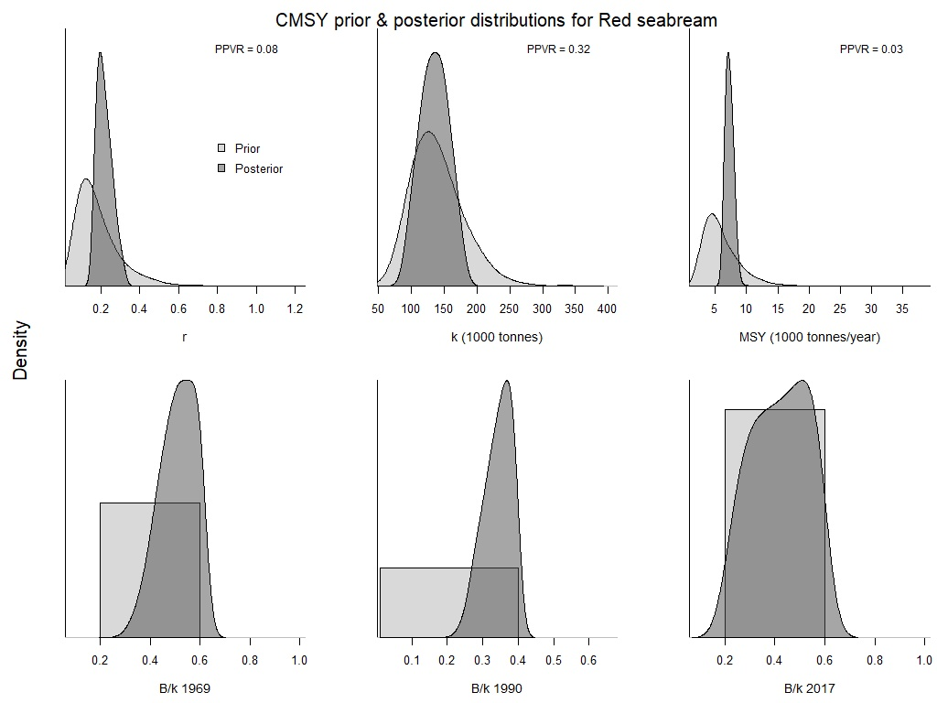
Figure S7.5 Comparison of prior and posterior densities (same area under curves) for productivity (r), maximum stock size (k), maximum sustainably yield (MSY), and relative stock size (B/k) at the beginning, the end, and an intermediate year of the available time series of red seabream catch data using CMSY method.

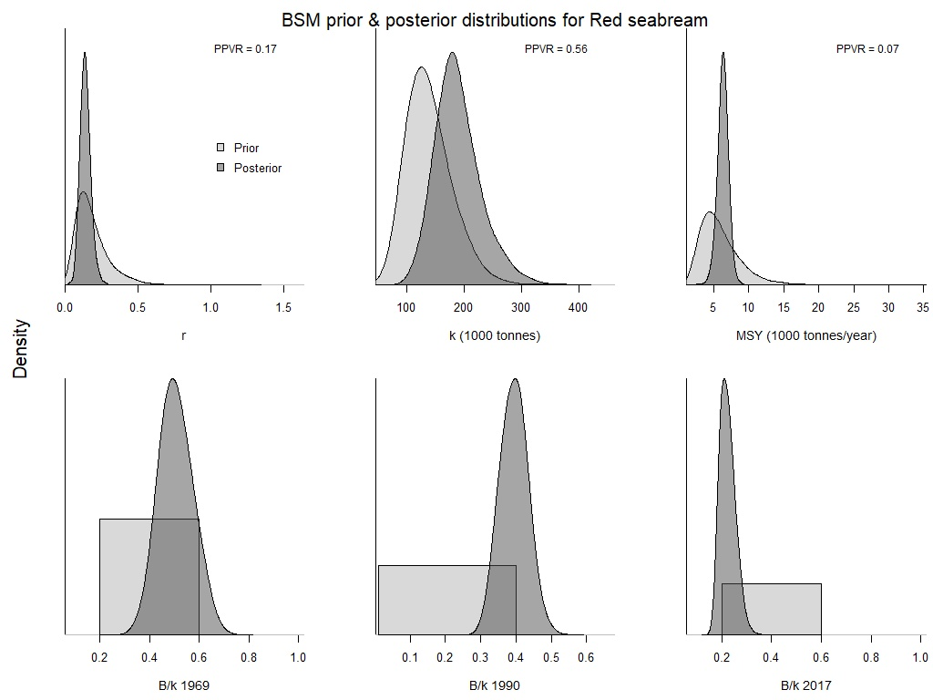Figure S7.6 Comparison of prior and posterior densities (same area under curves) for productivity (r), maximum stock size (k), maximum sustainably yield (MSY), and relative stock size (B/k) at the beginning, the end, and an intermediate year of the available time series of red seabream catch data using BSM method.

- Alaska pollock (Gadus chalcogrammus)
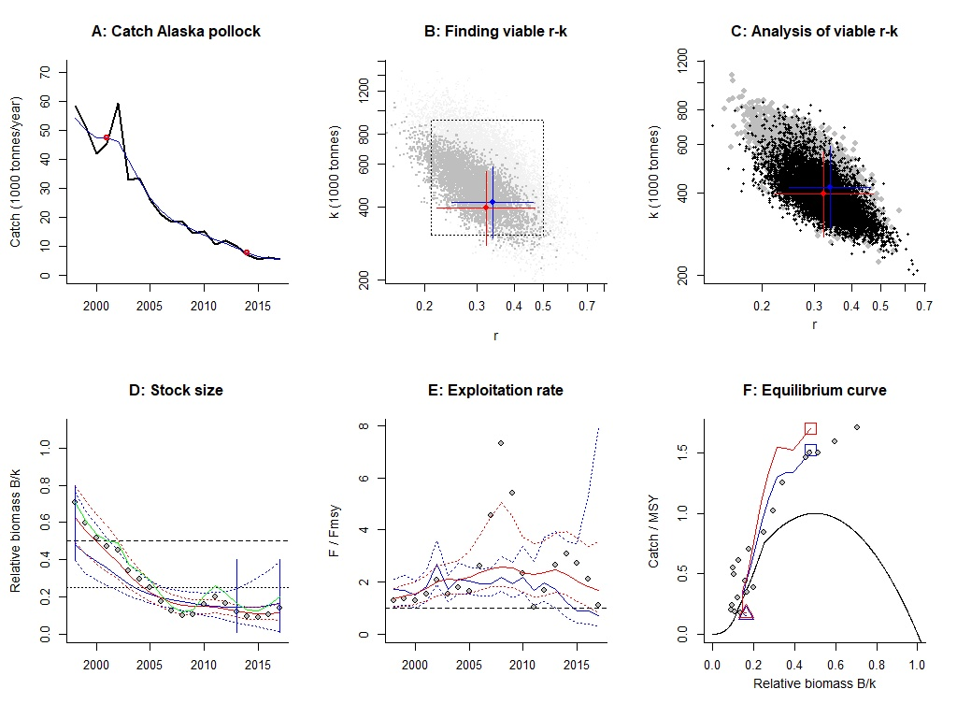Figure S8.1 Analysis of Alaska pollock with CMSY and BSM.
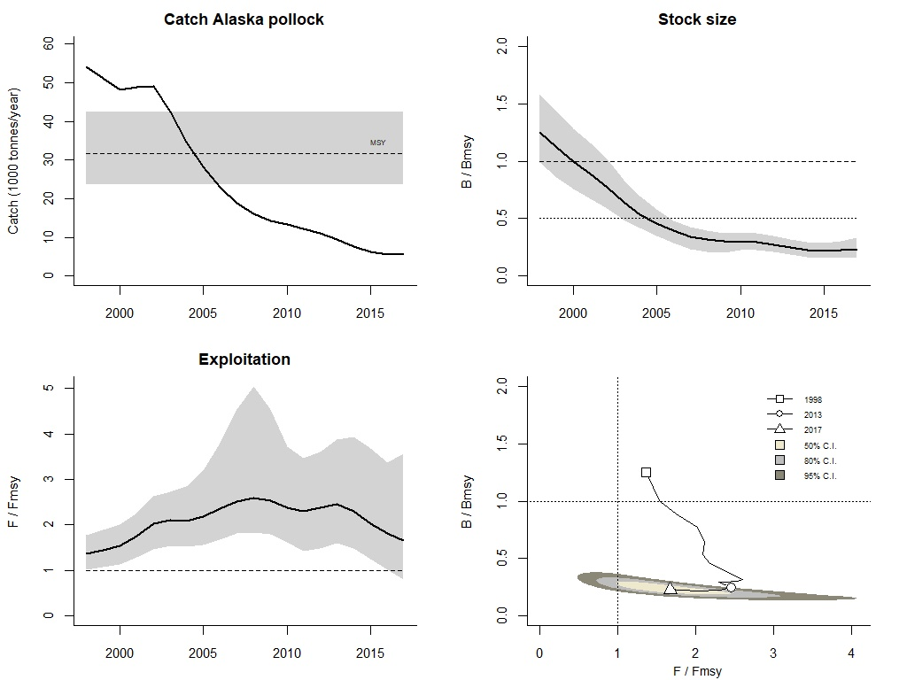
Figure S8.2 Graphical output of CMSY for management purposes, for Alaska pollock in the Japan Sea.
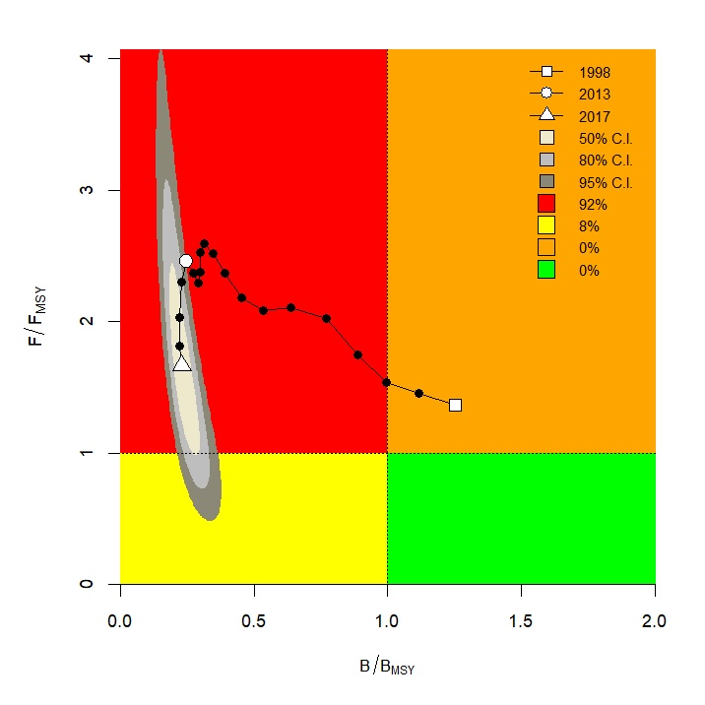Figure S8.3 CMSY results for Alaska pollock presented in a Kobe plot.
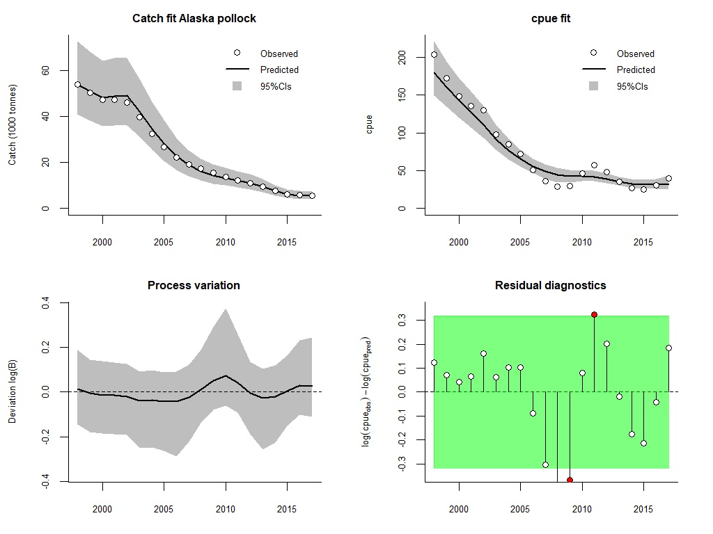Figure S8.4 Analytical graph for BSM analysis of Alaska pollock, showing the fit of the predicted to the observed catch, the fit of predicted to observed CPUE, the deviation from observed to predicted biomass, and an analysis of the log-CPUE residuals.
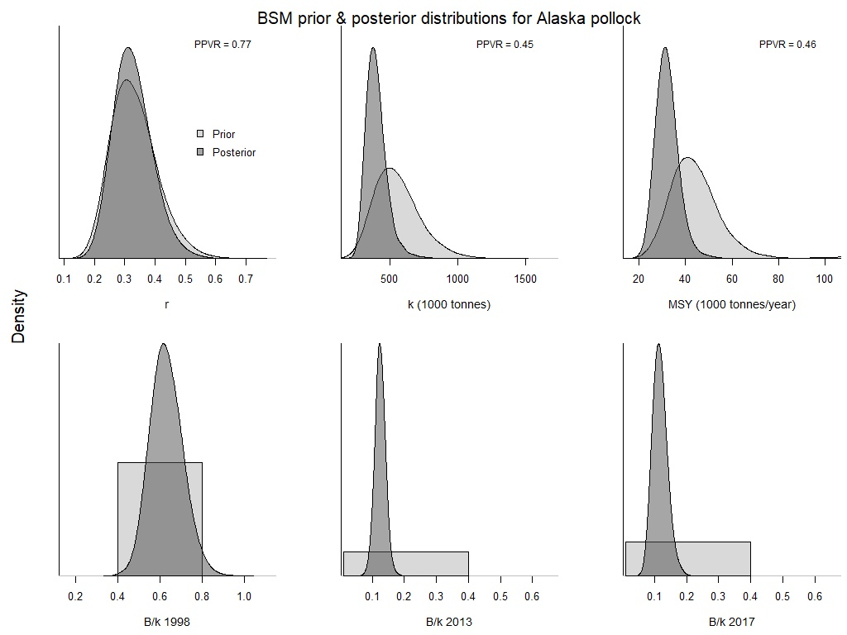Figure S8.5 Comparison of prior and posterior densities (same area under curves) for productivity (r), maximum stock size (k), maximum sustainably yield (MSY), and relative stock size (B/k) at the beginning, the end, and an intermediate year of the available time series of Alaska pollock catch data using CMSY method.
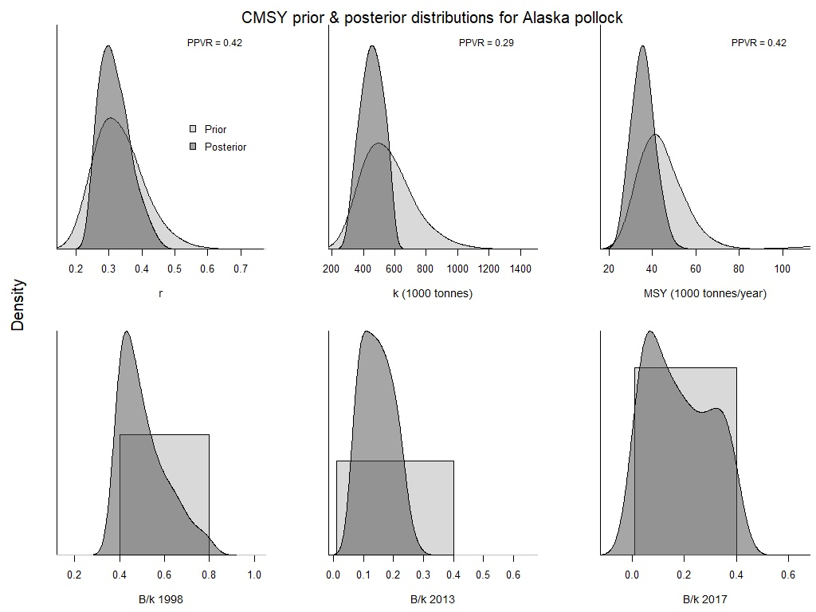Figure S8.6 Comparison of prior and posterior densities (same area under curves) for productivity (r), maximum stock size (k), maximum sustainably yield (MSY), and relative stock size (B/k) at the beginning, the end, and an intermediate year of the available time series of Alaska pollock catch data using BSM method.

- Deep-sea smelt (Glossanodon semifasciatus)
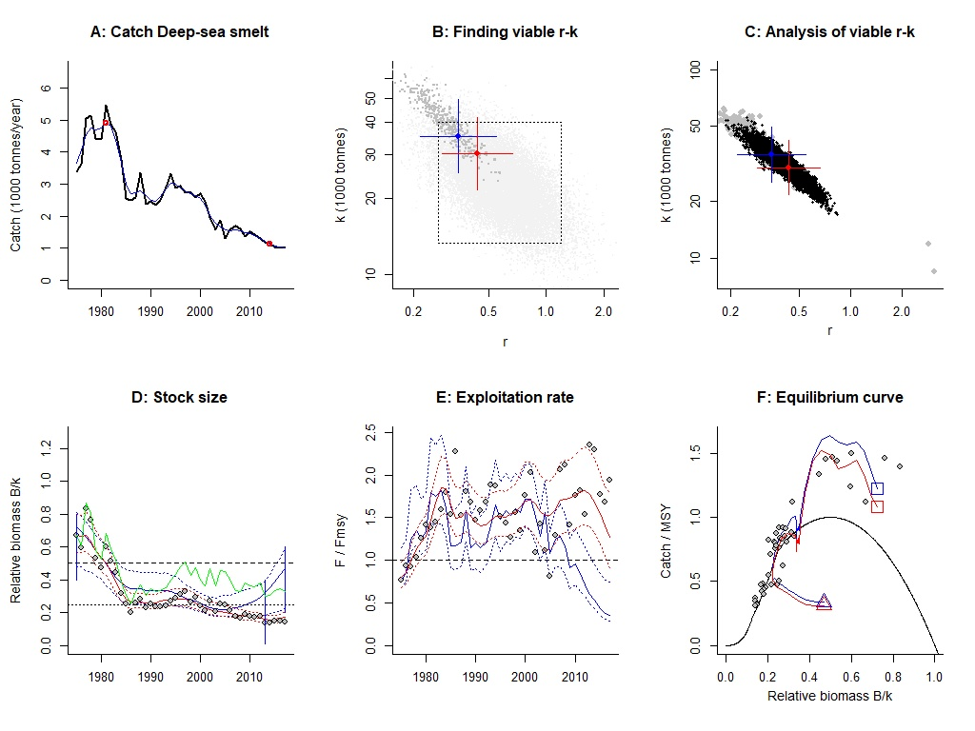Figure S9.1 Analysis of deep-sea smelt with CMSY and BSM.
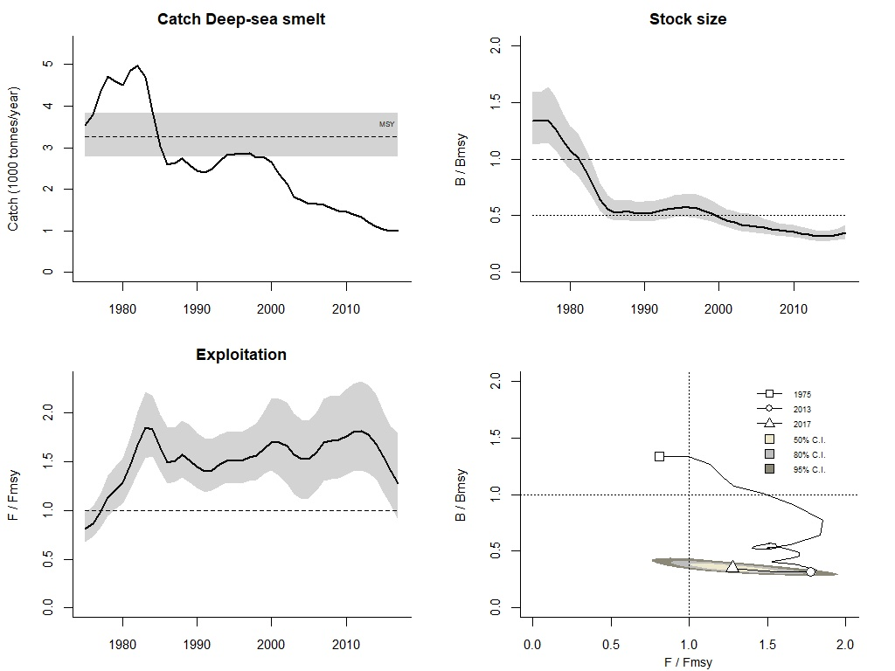Figure S9.2 Graphical output of CMSY for management purposes, for deep-sea smelt in the Japan Sea.

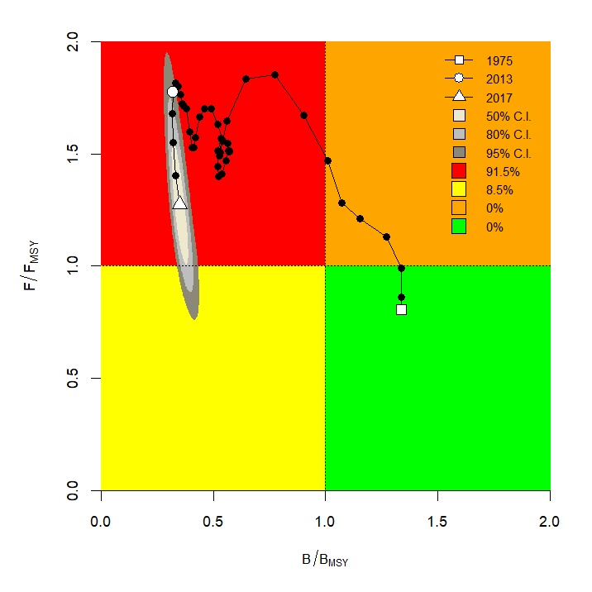Figure S9.3 CMSY results for deep-sea smelt presented in a Kobe plot.
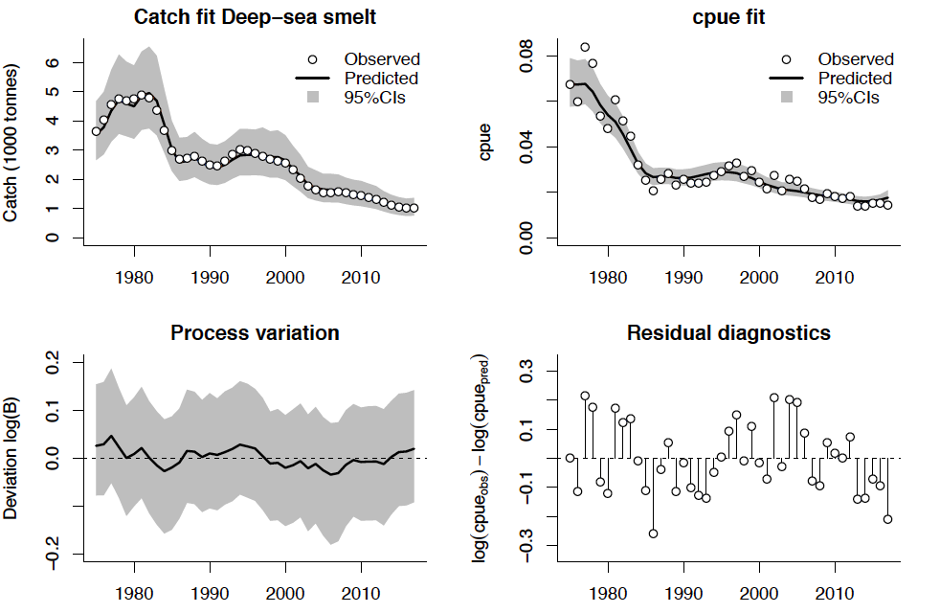
Figure S9.4 Analytical graph for BSM analysis of deep-sea smelt, showing the fit of the predicted to the observed catch, the fit of predicted to observed CPUE, the deviation from observed to predicted biomass, and an analysis of the log-CPUE residuals.

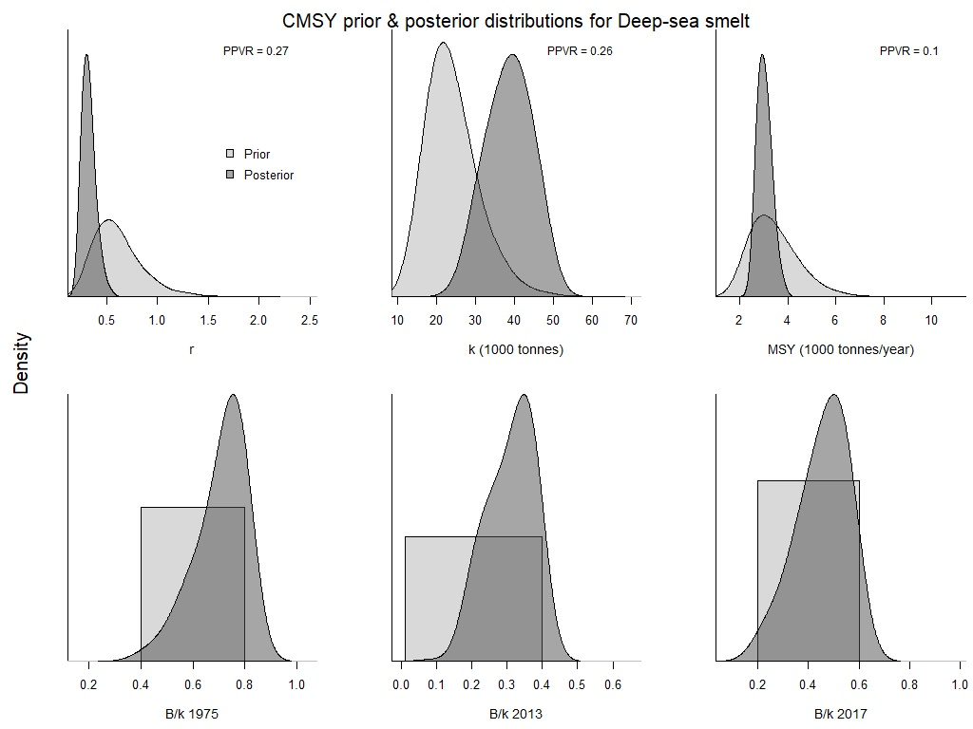
Figure S9.5 Comparison of prior and posterior densities (same area under curves) for productivity (r), maximum stock size (k), maximum sustainably yield (MSY), and relative stock size (B/k) at the beginning, the end, and an intermediate year of the available time series of deep-sea smelt catch data using CMSY method.
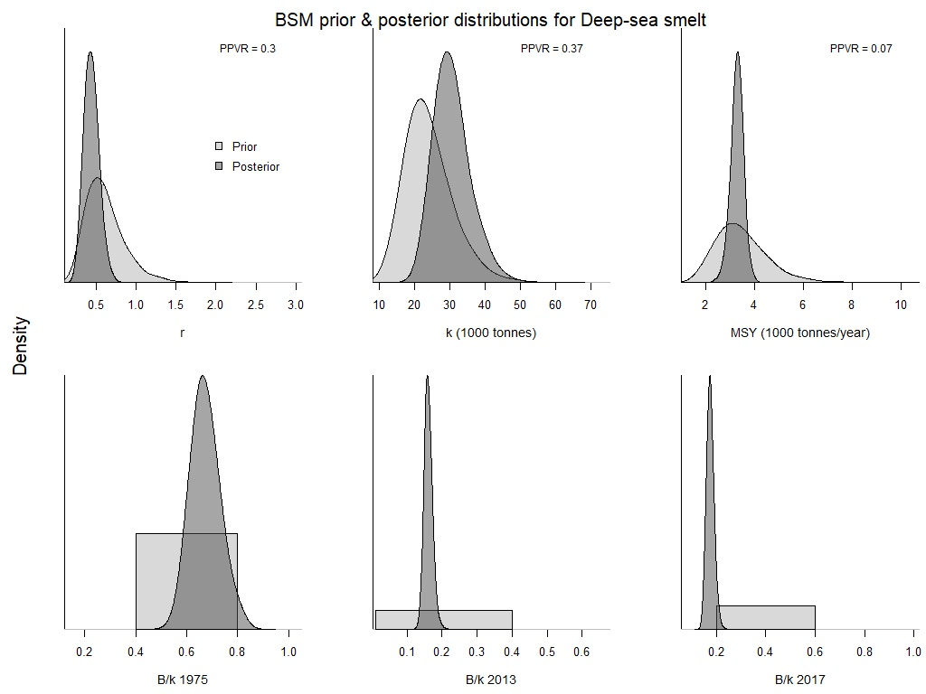
Figure S9.6 Comparison of prior and posterior densities (same area under curves) for productivity (r), maximum stock size (k), maximum sustainably yield (MSY), and relative stock size (B/k) at the beginning, the end, and an intermediate year of the available time series of deep-sea smelt catch data using BSM method.

- Snow crab (Chionoecetes opilio)
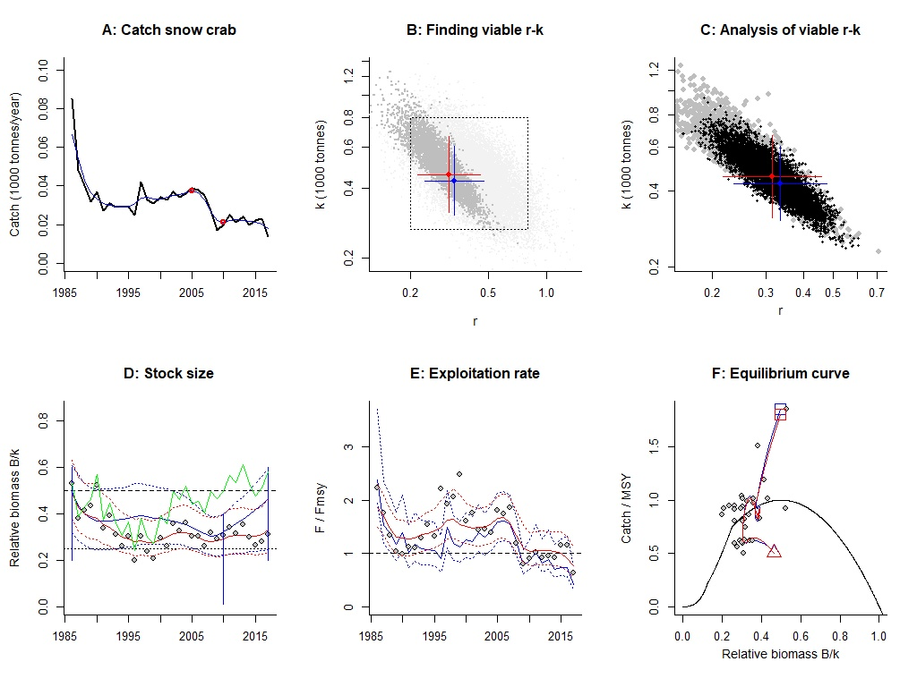Figure S10.1 Analysis of snow crab with CMSY and BSM.
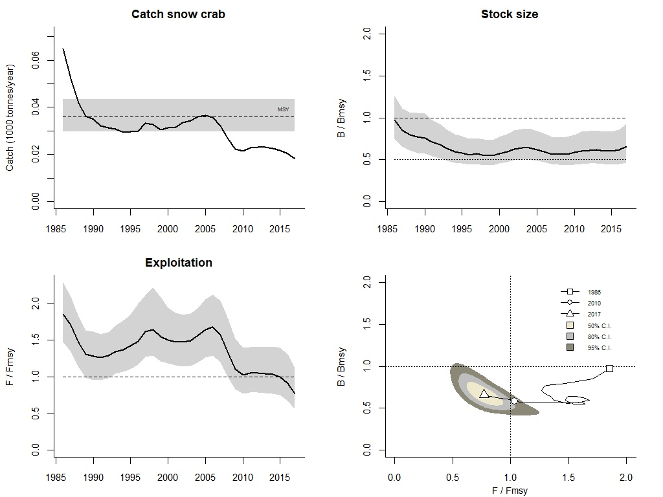Figure S10.2 Graphical output of CMSY for management purposes, for snow crab in the Japan Sea.
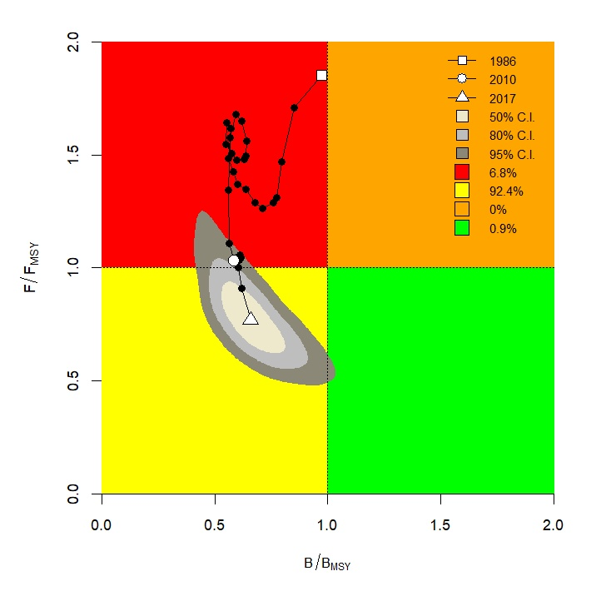Figure S10.3 CMSY results for snow crab presented in a Kobe plot. 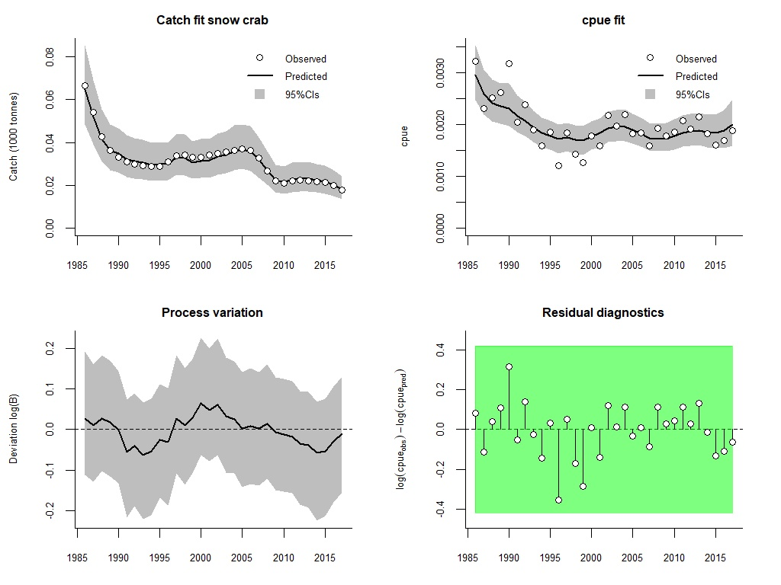Figure S10.4 Analytical graph for BSM analysis of snow crab, showing the fit of the predicted to the observed catch, the fit of predicted to observed CPUE, the deviation from observed to predicted biomass, and an analysis of the log-CPUE residuals.
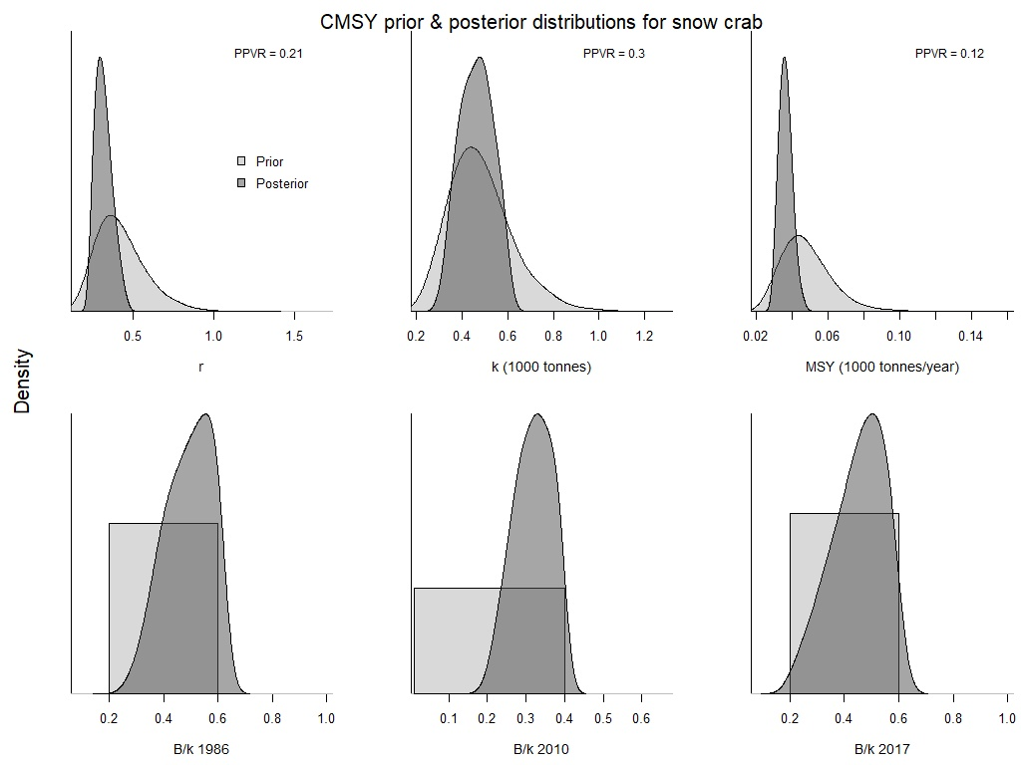Figure S10.5 Comparison of prior and posterior densities (same area under curves) for productivity (r), maximum stock size (k), maximum sustainably yield (MSY), and relative stock size (B/k) at the beginning, the end, and an intermediate year of the available time series of snow crab catch data using CMSY method.
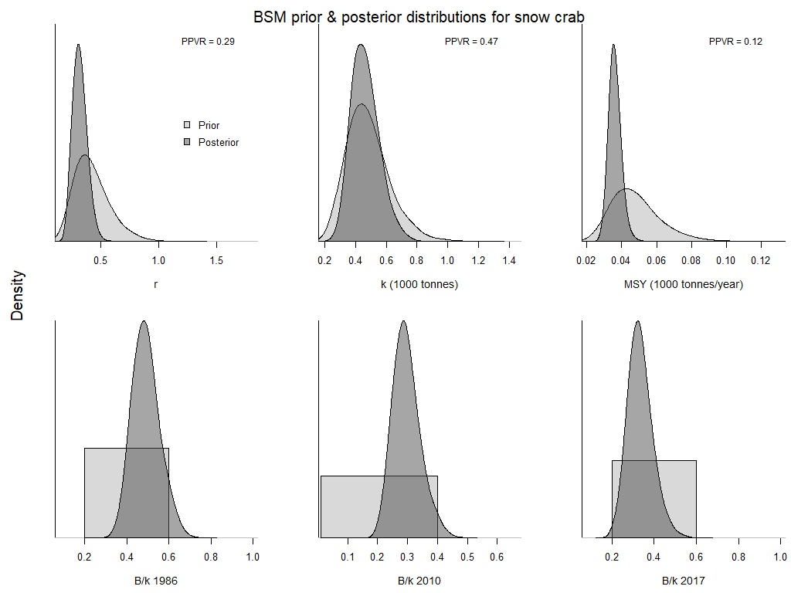 Figure S10.6 Comparison of prior and posterior densities (same area under curves) for productivity (r), maximum stock size (k), maximum sustainably yield (MSY), and relative stock size (B/k) at the beginning, the end, and an intermediate year of the available time series of snow crab catch data using BSM method.

- Alaskan pink shrimp (Pandalus eous)
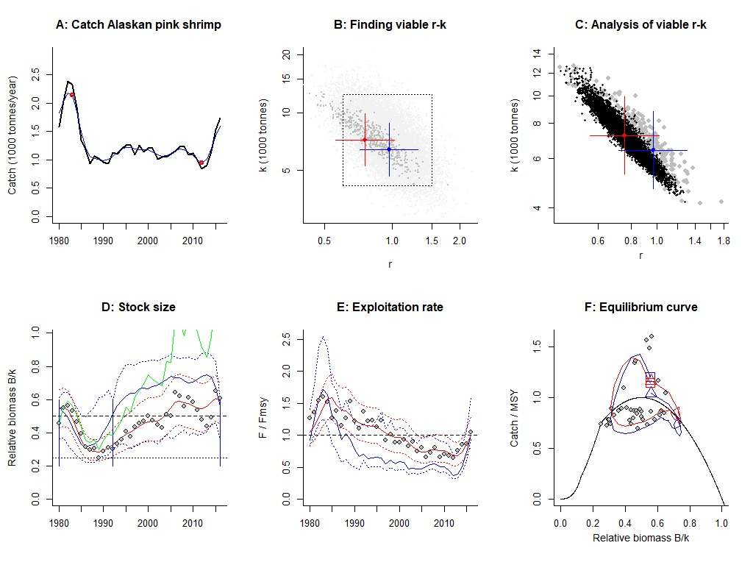Figure S11.1 Analysis of Alaskan pink shrimp with CMSY and BSM. 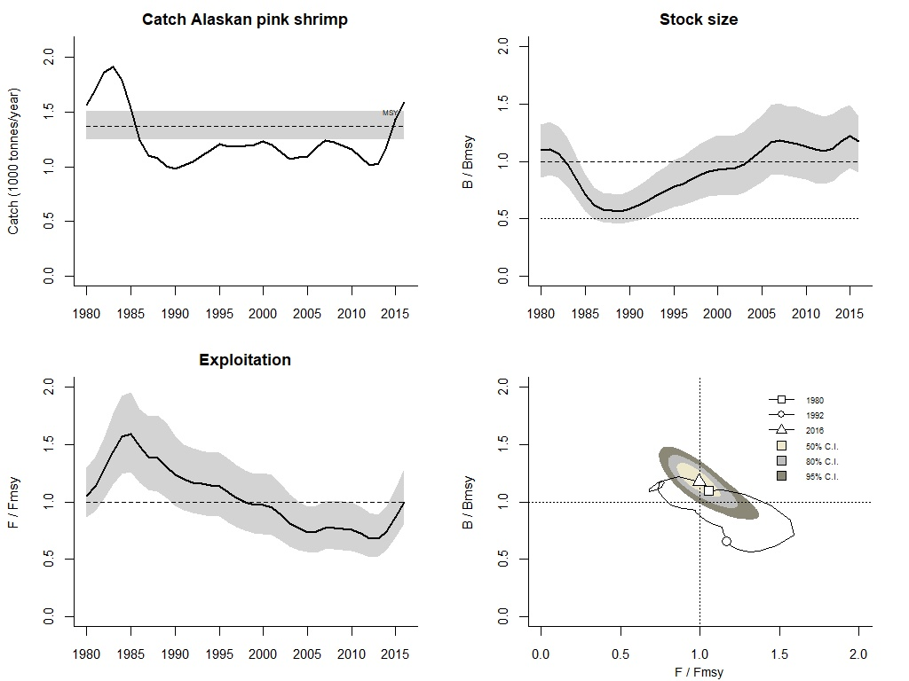 Figure S11.2 Graphical output of CMSY for management purposes, for Alaskan pink shrimp in the Japan Sea.
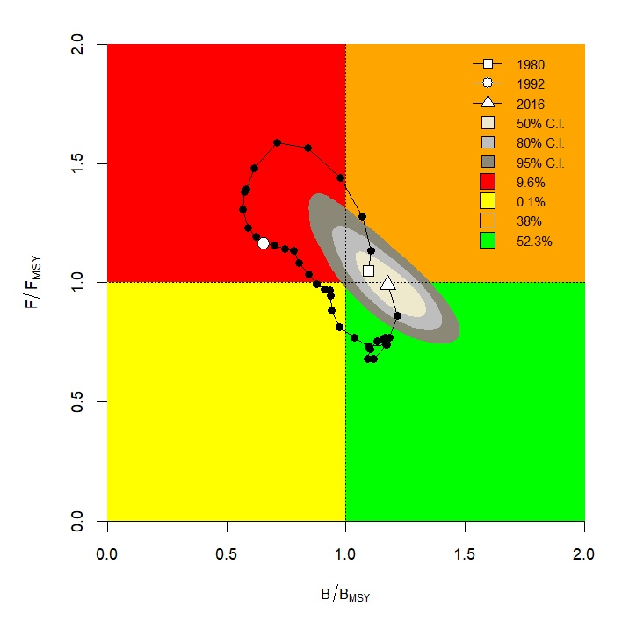Figure S11.3 CMSY results for Alaskan pink shrimp presented in a Kobe plot. 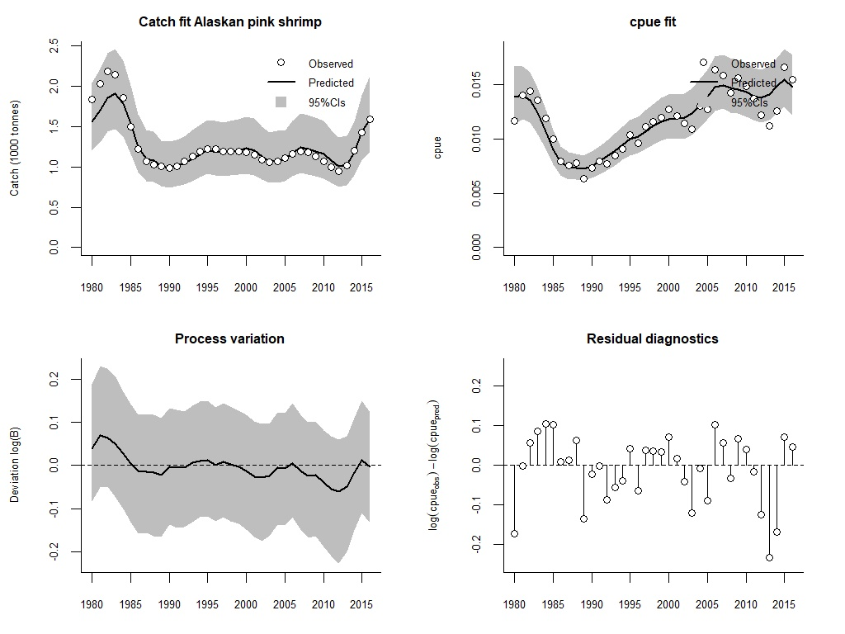 Figure S11.4 Analytical graph for BSM analysis of Alaskan pink shrimp, showing the fit of the predicted to the observed catch, the fit of predicted to observed CPUE, the deviation from observed to predicted biomass, and an analysis of the log-CPUE residuals.
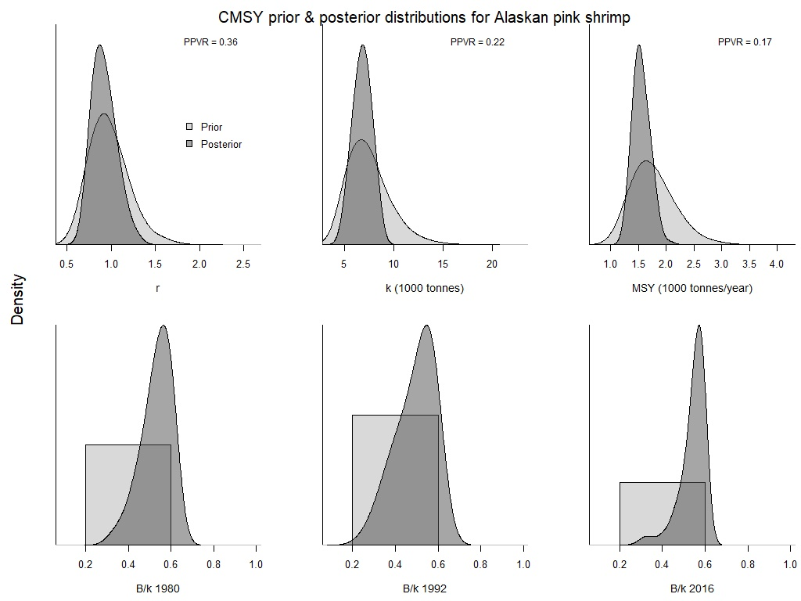
Figure S11.5 Comparison of prior and posterior densities (same area under curves) for productivity (r), maximum stock size (k), maximum sustainably yield (MSY), and relative stock size (B/k) at the beginning, the end, and an intermediate year of the available time series of Alaskan pink shrimp catch data using CMSY method.
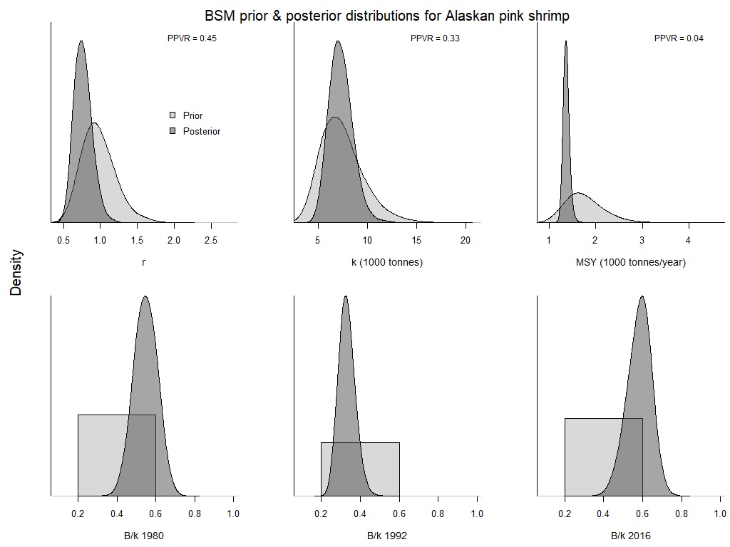
Figure S11.6 Comparison of prior and posterior densities (same area under curves) for productivity (r), maximum stock size (k), maximum sustainably yield (MSY), and relative stock size (B/k) at the beginning, the end, and an intermediate year of the available time series of Alaskan pink shrimp catch data using BSM method.

