Migratory insights from singing humpback whales recorded around central New Zealand
- supplementary material
Victoria E. Warren, Rochelle Constantine, Michael Noad, Claire Garrigue, Ellen C. Garland

S1. Detection of song in New Zealand data
The PAMGuard (1) whistle and moan detector (2) was applied to all 16 kHz data from the four recording locations. The detector was applied to spectrograms with Fast Fourier Transform (FFT) length 1024, Hann window with 50% overlap, and detected frequency contours between 100 and 600 Hz with an 8 dB threshold, median filter (length 61), average subtraction of 0.02, with minimum connection length of 10 time slices and minimum total size of 20 pixels. The detector outputs were used to direct in-depth examination of the data: data from time periods with detections were thoroughly examined to determine the presence or absence of humpback whale (Megaptera novaeangliae) song.
The PAMGuard whistle and moan detector made detections at all four recording locations (Figure S1.1). At the Kaikōura and Wairarapa recording locations, a large number of detections were made between November 2016 and the end of the recording period. These were primarily false positive detections arising from the Schlumberger Pegasus Basin 3D seismic survey (10 November 2016 to June 2017) (https://www.doc.govt.nz/our-work/seismic-surveys-code-of-conduct/marine-mammal-impact-assessments/). Outside of the seismic survey, detections were low throughout the recording period at Wairarapa (Figure S1.1). The STB detections included false positive detections between 23 October and 2 December 2016 as a result of the PGS Taranaki South 3D seismic survey (https://www.doc.govt.nz/our-work/seismic-surveys-code-of-conduct/marine-mammal-impact-assessments/) (Figure S1.1). At this location, further detections during September and the beginning of October were false positive detections of the ‘bioduck’ call from Antarctic minke whales (Balaenoptera bonaerensis) (3) (Figure S1.1). Confirmed humpback whale song detections occurred during June, July and August (Figure S1.1).

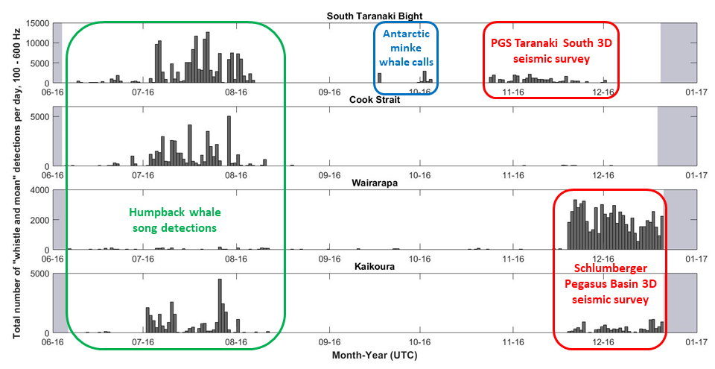
Figure S1.1. Raw outputs of the PAMGuard whistle and moan detector for the four central New Zealand recording locations in 2016. Grey blocks indicate times when the acoustic recorders were not deployed. Detections overlaid with red boxes indicate periods of seismic survey activity that resulted in false detections. Detections overlaid with a blue box indicate Antarctic minke whale vocalisations that resulted in false detections. Detections of humpback whale song are overlaid in green, and a verified plot of these detections is provided in Figure 2 of the manuscript. Small numbers of false song detections were made throughout the recording periods with no obvious cause (e.g., September at Wairarapa).

S2. Consistency of unit classification
Table S2.1. All song units qualitatively described during transcription of the New Zealand, New Caledonia and East Australia songs.
Unit short code | Full unit name
agr(pul) | pulsive ascending groan
agr(s) | short ascending groan
ahm | ascending high moan
ahs | ascending high shriek
ahs(l) | long ascending high shriek
am | ascending moan
am(l) | long ascending moan
am(pul) | pulsive ascending moan
am(pul)(s) | short pulsive ascending moan
am(s) | short ascending moan
amm | ascending modulated moan
amm(l) | long ascending modulated moan
ba | bark
ba-hm | bark into high moan
ba-w | bark into whoop
ba(pul) | pulsive bark
chug(l) | long chug-type sound
dgr | descending groan
dgr(s) | short descending groan
dhs | descending high shriek
dm | descending moan
dm(l) | long descending moan
dm(s) | short descending moan
dmm | descending modulated moan
gr | groan
gr-m(pul) | groan into pulsive moan
gr-uws | groan into U-shaped whistle
gr(l) | long groan
gr(s) | short groan
gr(s)-dhm | short groan into descending high moan
gr(s)-dm | short groan into descending moan
gr(s)-dw | short groan into descending whistle
gr(s)-mw | short groan into modulated whistle
gr(s)-uws | short groan into U-shaped whistle
gt(pul) | pulsive grunt
gw | growl
gw(l) | long growl
gw(low) | low growl
gw(pul)(l) | long pulsive growl
gw(s) | short growl
hs | high shriek
hs(l) | long high shriek
hw | high whistle
m | moan
m(pul) | pulsive moan
m(pul)(l) | long pulsive moan
m(pul)(s) | short pulsive moan
m(s) | short moan
mm | modulated moan
mm(l) | long modulated moan
mm(pul) | pulsive modulated moan
mm(s) | short modulated moan
modhs | modulated high shriek
modhs(l) | long modulated high shriek
mw | modulated whistle
mw(l) | long modulated whistle
ngr | N-shaped groan
ngr(s) | short N-shaped groan
ngr(s)-dhm | short N-shaped groan into descending high moan
ngr(s)-w | short N-shaped groan into whoop
nm | N-shaped moan
nm(pul) | pulsive N-shaped moan
nsw | N-shaped whistle
purr | purr sound
purr(l) | long purr sound
sealion | sealion barking sound
sq | squeak
um | U-shaped moan
uws | U-shaped whistle
w | whoop
w-hs | whoop into high shriek

Table S2.2. Random Forest variable description and importance measures
Acoustic parameter | Description | Mean Decrease in Gini Index
Duration (s) | Vocalisation length | 208.3
Bandwidth (Hz) | High – Low frequency | 105.5
High frequency (Hz) | Maximum frequency | 102.8
Frequency trend (Hz) | Start / End frequency | 102.7
End frequency (Hz) | End frequency | 97.2
Number of inflections | Number of reversals in slope | 87.9
Low frequency (Hz) | Minimum frequency | 85.1
Start frequency (Hz) | Start frequency | 83.7
Frequency range (Hz) | High / Low frequency | 81.4
Peak frequency (Hz) | Frequency of the spectral peak | 71.2
Pulse repetition rate (per second) | For pulsive sounds | 41.2

Random Forest confusion matrix
Random Forest confusion matrix included separately as file ‘CSV_S1_RFconfusion.csv’

S3. Description of phrase types and themes
Theme similarity matrix
Theme similarity matrix included separately as file ‘CSV_S2_PhraseThemeMatrix.csv’

Table S3.1. The typical unit sequence (set median) for each phrase type per location and year. Within-set similarity reveals the similarity of unit sequences within a phrase type (between 0, no similarity, and 1, complete similarity). N = sample size. Location key: NZ = New Zealand, NC = New Caledonia, EA = East Australia.
Theme | Phrase type | N | Location/year present | Set median unit sequence | Within-set similarity
1 | 1 | 105 | NZ 2016 | modhs(l), modhs, gw, gw(l) | 0.39
 |  | 21 | NC 2016 | modhs(l), modhs, gw, gw(l)
 |  | 22 | EA 2015 | hs(l), ahs, gw, gw(l)
2 | 2 | 57 | NZ 2016 | am(l), am, gw, gw(l) | 0.83
 |  | 1 | NC 2016 | modhs, am, gw, gw(l)
 |  | 5 | EA 2015 | am(l), am, gw, gw(l)
3 | 3 | 50 | NZ 2016 | dm, w, w, w, w, w, dm, w, w, w, w, w, w, dm | 0.55
 |  | 8 | NC 2016 | dm, w, sq, w, sq, w, sq, w, w, dm, w, w, w, w, w, w, w, dm
 |  | 42 | NC 2017 | m(pul), sq, w, sq, w, sq, w, m(pul), sq, w, sq, w, sq, w, m(pul)
 |  | 18 | EA 2015 | dm, w, sq, w, sq, w, sq, w, sq, dm, w, sq, w, sq, w, sq, w, sq, w, sq, dm
 |  | 71 | EA 2016 | m(pul), sq, w, sq, w, sq, w, m(pul), sq, w, sq, w, sq, w, sq, w, m(pul)
 |  | 37 | EA 2017 | mm(pul), w, w, w, w, w, w, mm(pul), w, w, w, w, w, w, mm(pul)
 | 3b | 27 | NC 2017 | m(pul), ba, ba, ba, ba, m(pul), ba, ba, ba, ba | 0.54
 |  | 22 | EA 2016 | m(pul), ba, ba, ba, ba, m(pul), ba, ba, ba, ba, m(pul)
 |  | 12 | EA 2017 | mm(pul), ba, ba, ba, ba, ba, ba, mm(pul), ba, ba, ba, ba, ba, ba, mm(pul)
4 | 4 | 45 | NZ 2016 | dm, ngr(s), ngr(s), ngr(s), ngr(s), dm, ngr(s), ngr(s), ngr(s), ngr(s), ngr(s), dm | 0.66
 |  | 9 | NC 2016 | dm, ngr(s), ngr(s), ngr(s), ngr(s), dm, ngr(s), ngr(s), ngr(s), ngr(s), dm
 |  | 1 | NC 2017 | nm(pul), ngr(s), ngr(s), ngr(s), m(pul), ngr(s), ngr(s), ngr(s), am(pul)
 |  | 11 | EA 2015 | dm, ngr(s), ngr(s), ngr(s), dm, ngr(s), ngr(s), ngr(s), ngr(s), dm
5 | 5 | 248 | NZ 2016 | dm, gr(s)-uws, ba, ba, gr(s)-uws, ba, ba, gr(s)-uws | 0.28
 |  | 122 | NC 2015B | gr(s), gr(s)-dw, ba(pul), ba(pul), gr(s)-dw, ba(pul), ba(pul), gr(s)-dw
 |  | 246 | NC 2016 | gr(s)-uws, ba, ba, ba, gr(s)-uws, ba, ba, ba, gr(s)-uws, m
 |  | 151 | EA 2015 | m, gr(s)-uws, ba, ba, gr(s)-uws, ba, ba, gr(s)-uws
 | 5b | 35 | NZ 2016 | gr, uws, uws, gr, uws, gw, gw(l) | 0.45
 |  | 3 | NC 2016 | gr(s)-uws, uws, gr(s)-uws, gw, gw(l)
 | 5c | 169 | NC 2015B | m, ba-hm, ba, ba, ba-hm, ba, ba, ba-hm | 0.41
6 | 6 | 16 | NZ 2016 | m, am(s), am(s), am(s), am(s), am(s), am(s) | 0.43
 |  | 120 | NC 2015B | m, am(s), am(s), am(s), am(s)
 |  | 81 | NC 2016 | m, am(s), am(s), am(s), am(s)
 |  | 55 | EA 2015 | m, am(s), am(s), am(s), am(s)
 |  | 1 | EA 2017 | am(pul)(s), am(s), am(s), am(s), am(s)
7 | 7 | 12 | NZ 2016 | dm, am(pul)(s), am(pul)(s), am(pul)(s), am(pul)(s) | 0.17
 |  | 30 | NC 2015B | am, gw(s), gw(s), gw(s), gw(s)
 |  | 66 | NC 2016 | m, m(pul), m(pul)
8 | 8 | 13 | NZ 2016 | m, sealion, sealion | 0.38
 |  | 29 | NC 2015B | m, chug(l), chug(l)
 |  | 16 | NC 2016 | m, sealion, sealion
 |  | 58 | EA 2015 | m, chug(l), chug(l)
9 | 9 | 19 | NC 2017 | gr-m(pul), ba(pul), gr-m(pul), mm(l) | 0.39
 |  | 2 | EA 2015 | m(pul), nm, nm, am, nm
 |  | 7 | EA 2016 | gr-m(pul), ba(pul), gr-m(pul), mm(l)
 |  | 35 | EA 2017 | m(pul), ba(pul), m(pul), mm(l)
10 | 10 | 215 | NC 2017 | gr, nsw, nsw, gr, nsw, gr, gw(low) | 0.59
 |  | 167 | EA 2016 | gr, nsw, nsw, gr, nsw, gr, gw(low)
 |  | 156 | EA 2017 | gr, mw, nsw, gr, mw, gr, gr(s), gw(low)
11 | 11 | 61 | NC 2017 | mm, mm, mm, purr, purr(l) | 0.51
 |  | 29 | EA 2016 | mm, mm, am, purr, purr(l)
 |  | 19 | EA 2017 | dm, mm, um, purr(l)
12 | 12 | 108 | NC 2015A | dgr, m, ba, m, ba, ba, m | 0.33
 | 12b | 67 | NC 2015A | dgr, gw(s), w-hs, w-hs | 0.71
13 | 13 | 74 | NC 2015A | dgr, m, m | 0.80
 | 13b | 63 | NC 2015A | dgr, mm, w, w, mm | 0.89
14 | 14 | 70 | NC 2015A | ahm, ahm, gw | 0.57
 | 14b | 23 | NC 2015A | gw(l), w-hs, w-hs | 0.55
15 | 15 | 14 | NC 2015A | dgr, ngr(s)-dhm, ngr(s)-w, ngr(s)-dhm, ngr(s)-w, ngr(s)-dhm | 0.37
16 | 16 | 18 | NC 2015B | mw, ba, w, w, gr(s)-mw, w, w, w, gr(s)-mw, w, w, w, w, gr(s)-mw | 0.47

Figure S3.1. Bootstrapped (n=1000) dendrogram of average-linkage clustering of the median song strings per phrase type recorded at different locations and years, based on Levenshtein Similarity Index analysis. Red dots indicate AU values >95% where divisions were stable and likely to occur. Red boxes indicate the resulting clusters. The labels are structured as follows: LocationYear_PhraseType.

S4. Song sequences for each location and year
Information regarding the themes present at each location/year. The ‘themes/phrase types present’ are the themes that were entered into Dice’s Similarity Index analysis. Set medians per location/year, and per sample were calculated (see ‘Materials and Methods’) to provide an overview of the typical theme sequences and presence.

New Zealand, 2016
Themes/phrase types present
1, 2, 3, 4, 5, 5b, 6, 7, 8
Song set median
1, 2, 3, 4, 5, 5b
Song set median, per sample
NZ_STB_X: 1, 2, 3, 4, 5, 5b (n=7)
NZ_STB_Y: 1, 2, 3, 4, 5, 5b (n=5)
NZ_STB_Z: 1, 2, 3, 4, 5 (n=4)
NZ_CS_X: 1, 2, 3, 4, 5, 5b (n=4)
NZ_CS_Y: 1, 2, 3, 4, 5, 5b (n=3)
NZ_CS_Z: 5, 6, 7, 8 (n=7)

New Caledonia, song A, 2015
Themes/phrase types present
12, 12b, 13, 13b, 14, 14b, 15
Song set median
12, 13b
Song set median, per sample
NC_15a_X: 13, 12, 14, 15 (n=7)
NC_15a_Y: 12, 13b (n=8)
NC_15a_Z: 12, 13b, 12b, 14b (n=5)

New Caledonia, song B, 2015
Themes/phrase types present
5, 5c, 6, 7, 8, 16
Song set median
5c, 6, 8
Song set median, per sample
NC_15b_X: 5, 16 (n=7)
NC_15b_Y: 5c, 6 (n=8)
NC_15b_Z: 5c, 6, 7, 8 (n=9)

New Caledonia, 2016
Themes/phrase types present
1, 2, 3, 4, 5, 5b, 6, 7, 8
Song set median
5, 6, 7
Song set median, per sample
NC_16_X: 5, 6, 7 (n=8)
NC_16_Y: 5, 6, 7 (n=9)
NC_16_Z: 5, 6, 7 (n=7)

New Caledonia, 2017
Themes/phrase types present
3, 3b, 4, 9, 10, 11
Song set median
3, 3b, 10, 11
Song set median, per sample
NC_17_X: 3, 3b, 10, 11 (n=4)
NC_17_Y: 3, 3b, 9, 10, 11 (n=5)
NC_17_Z: 3, 3b, 10, 11 (n=8)

East Australia, 2015
Themes/phrase types present
1, 2, 3, 4, 5, 6, 8, 9
Song set median
5, 6, 8
Song set median, per sample
EA_15_X (northbound): 5, 6, 8 (n=1)
EA_15_Y (northbound): 5, 6, 8 (n=5)
EA_15_Z (southbound): 1, 2, 3, 4, 5 (n=5)

East Australia, 2016
Themes/phrase types present
3, 3b, 9, 10, 11
Song set median
3, 3b, 9, 10, 11
Song set median, per sample
EA_16_X: 3, 3b, 9, 10, 11 (n=3)
EA_16_Y: 3, 3b, 9, 10, 11 (n=2)
EA_16_Z: 3, 3b, 9, 10, 11 (n=3)

East Australia, 2017
Themes/phrase types present
3, 3b, 6, 9, 10, 11
Song set median
3, 3b, 9, 10, 11
Song set median, per sample
EA_17_X: 3, 3b, 9, 10, 11 (n=5)
EA_17_Y: 3, 3b, 9, 10, 11 (n=4)
EA_17_Z: 3, 3b, 9, 10, 11 (n=5)

S5. Spectrograms of song types for each location and year

Spectrograms of the median song strings for each song type recorded per location and year (FFT length 4096, Hann window, 75% overlap, displaying 4 kHz and 140 s, generated in Raven Pro 1.5). Corresponding audio files are provided for each song type (electronic supplementary material, Audio_S1–S10).

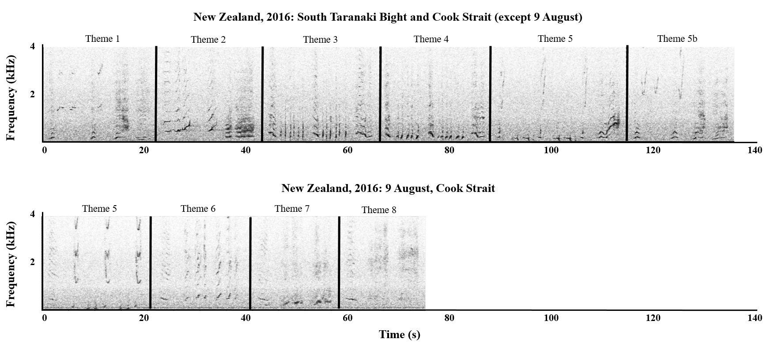

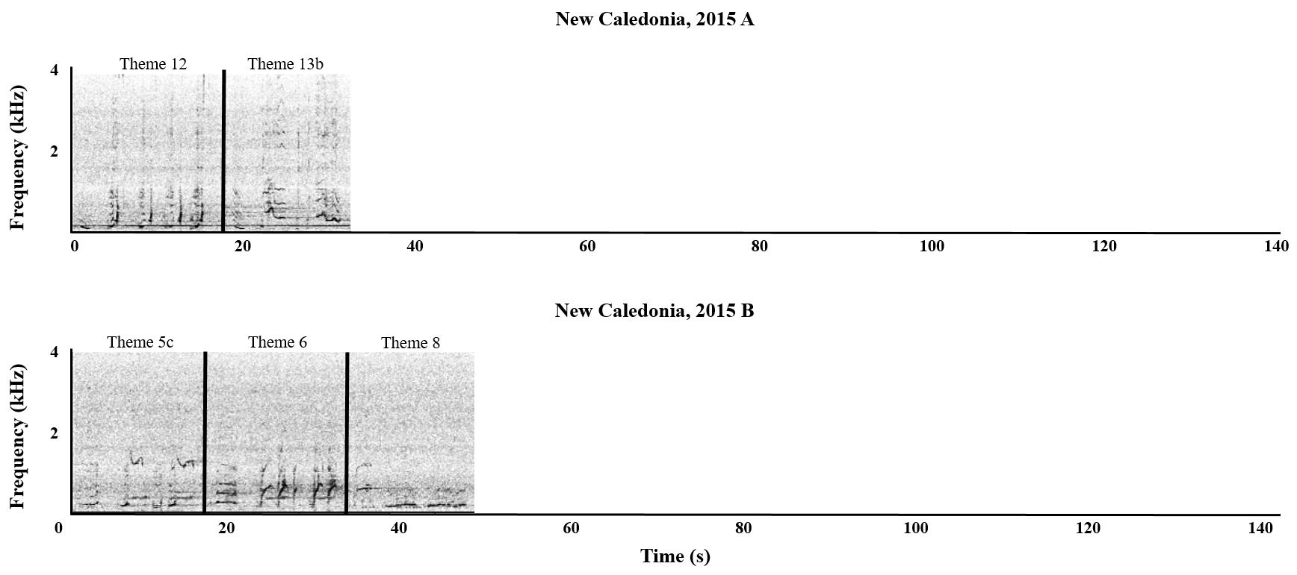
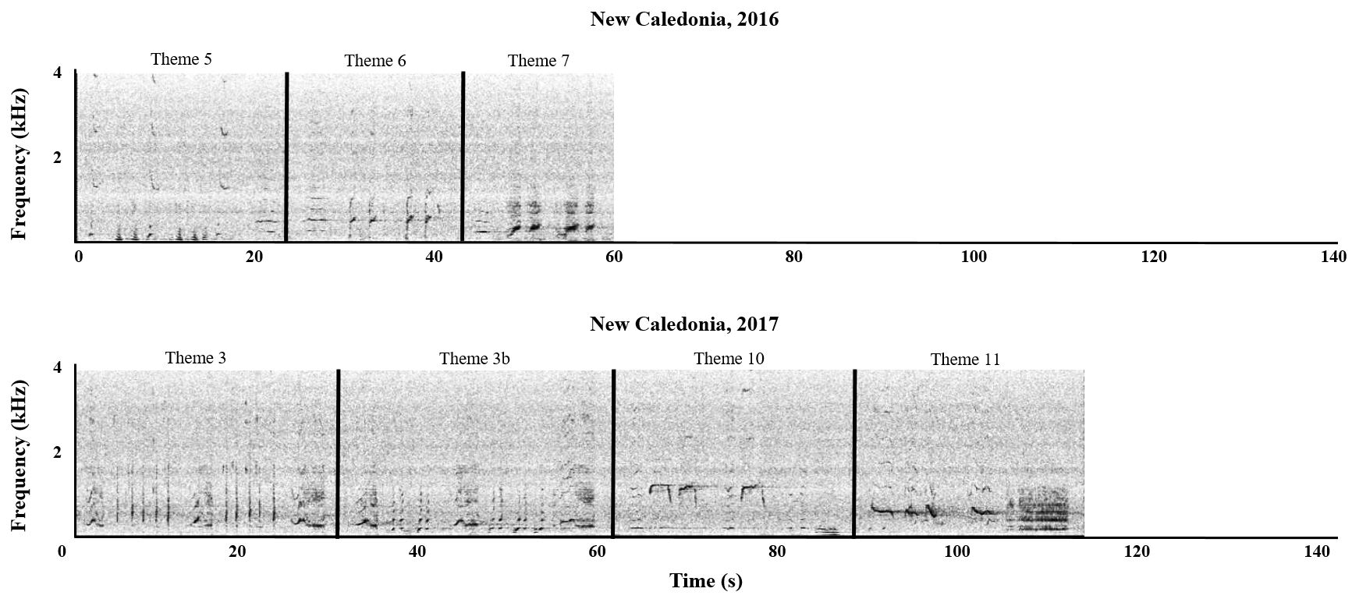
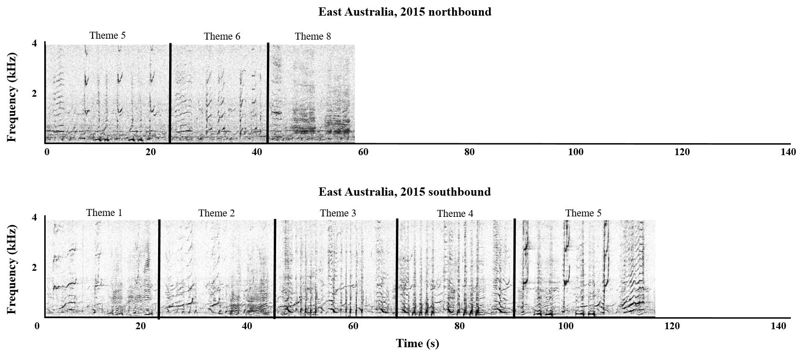
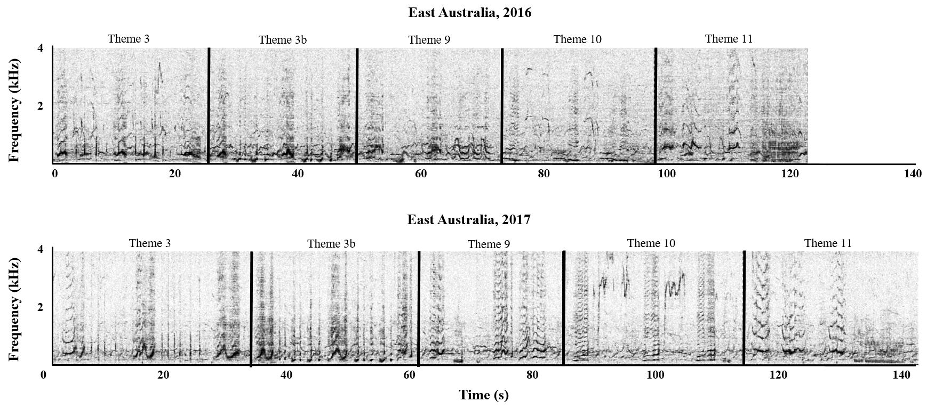

S6. LSI song matching using the theme similarity matrix
Theme similarity matrix
Theme similarity matrix included separately as file ‘CSV_S3_SongThemeMatrix.csv’

Figure S6.1. Bootstrapped (n=1000) dendrogram of average-linkage clustering of the theme similarity matrix of song strings recorded at different locations and years, based on Levenshtein Distance Similarity Index analysis. Red dots indicate AU values >95% where divisions were stable and likely to occur. Red boxes indicate the resulting clusters. The labels are structured as follows: Location_Year_Sub-Location (if applicable)_SongIdentifier. Sub-locations are included for New Zealand 2016: STB = South Taranaki Bight; CS = Cook Strait.

REFERENCES

1. Gillespie D, Mellinger DK, Gordon J, McLaren D, Redmond P, McHugh R, et al. PAMGUARD: Semiautomated, open source software for real‐time acoustic detection and localization of cetaceans. J Acoust Soc Am. 2009;125(4):2547.
2. Gillespie D, Caillat M, Gordon J, White P. Automatic detection and classification of odontocete whistles. J Acoust Soc Am. 2013;134(3):2427-37.
3. Risch D, Gales NJ, Gedamke J, Kindermann L, Nowacek DP, Read AJ, et al. Mysterious bio-duck sound attributed to the Antarctic minke whale (Balaenoptera bonaerensis). Biol Lett. 2014;10(4).

