**Figure S1.** Distributions of bin completeness and contamination of S*C*F- and S*C*R- of human gut microbiome data.

**Figure S2.** Upset plots for the shared genus (A: S*CF-*, C: S*CR-*) and species (B: S*CF-*, D: S*CR-*) of different subsampling datasets.

**Figure S3.** Comparison of the contig NG50 and NGA50 between Illumina short-reads (Illumina) and 10x linked-reads (MS*C1*) from the mock community.

**Figure S4.** Comparison of the contig NG50 and NGA50 between PacBio CCS reads (CCS) and 10x linked-reads (MS*C1*) from the mock community.



**Figure S5.** Parameter distributions of linked-read sequencing from human gut microbiome. PDF: probability density function; CDF: cumulative density function.



**Figure S6.** Parameter distributions of linked-read sequencing from human genome (NA24385). PDF: probability density function; CDF: cumulative density function.

**Figure S7.** Workflow of LRTK-SIM to simulate linked-reads for microbial genomes with uneven depth.

**Figure S8.** Workflow of linked-reads metagenome assembly on simulated data.

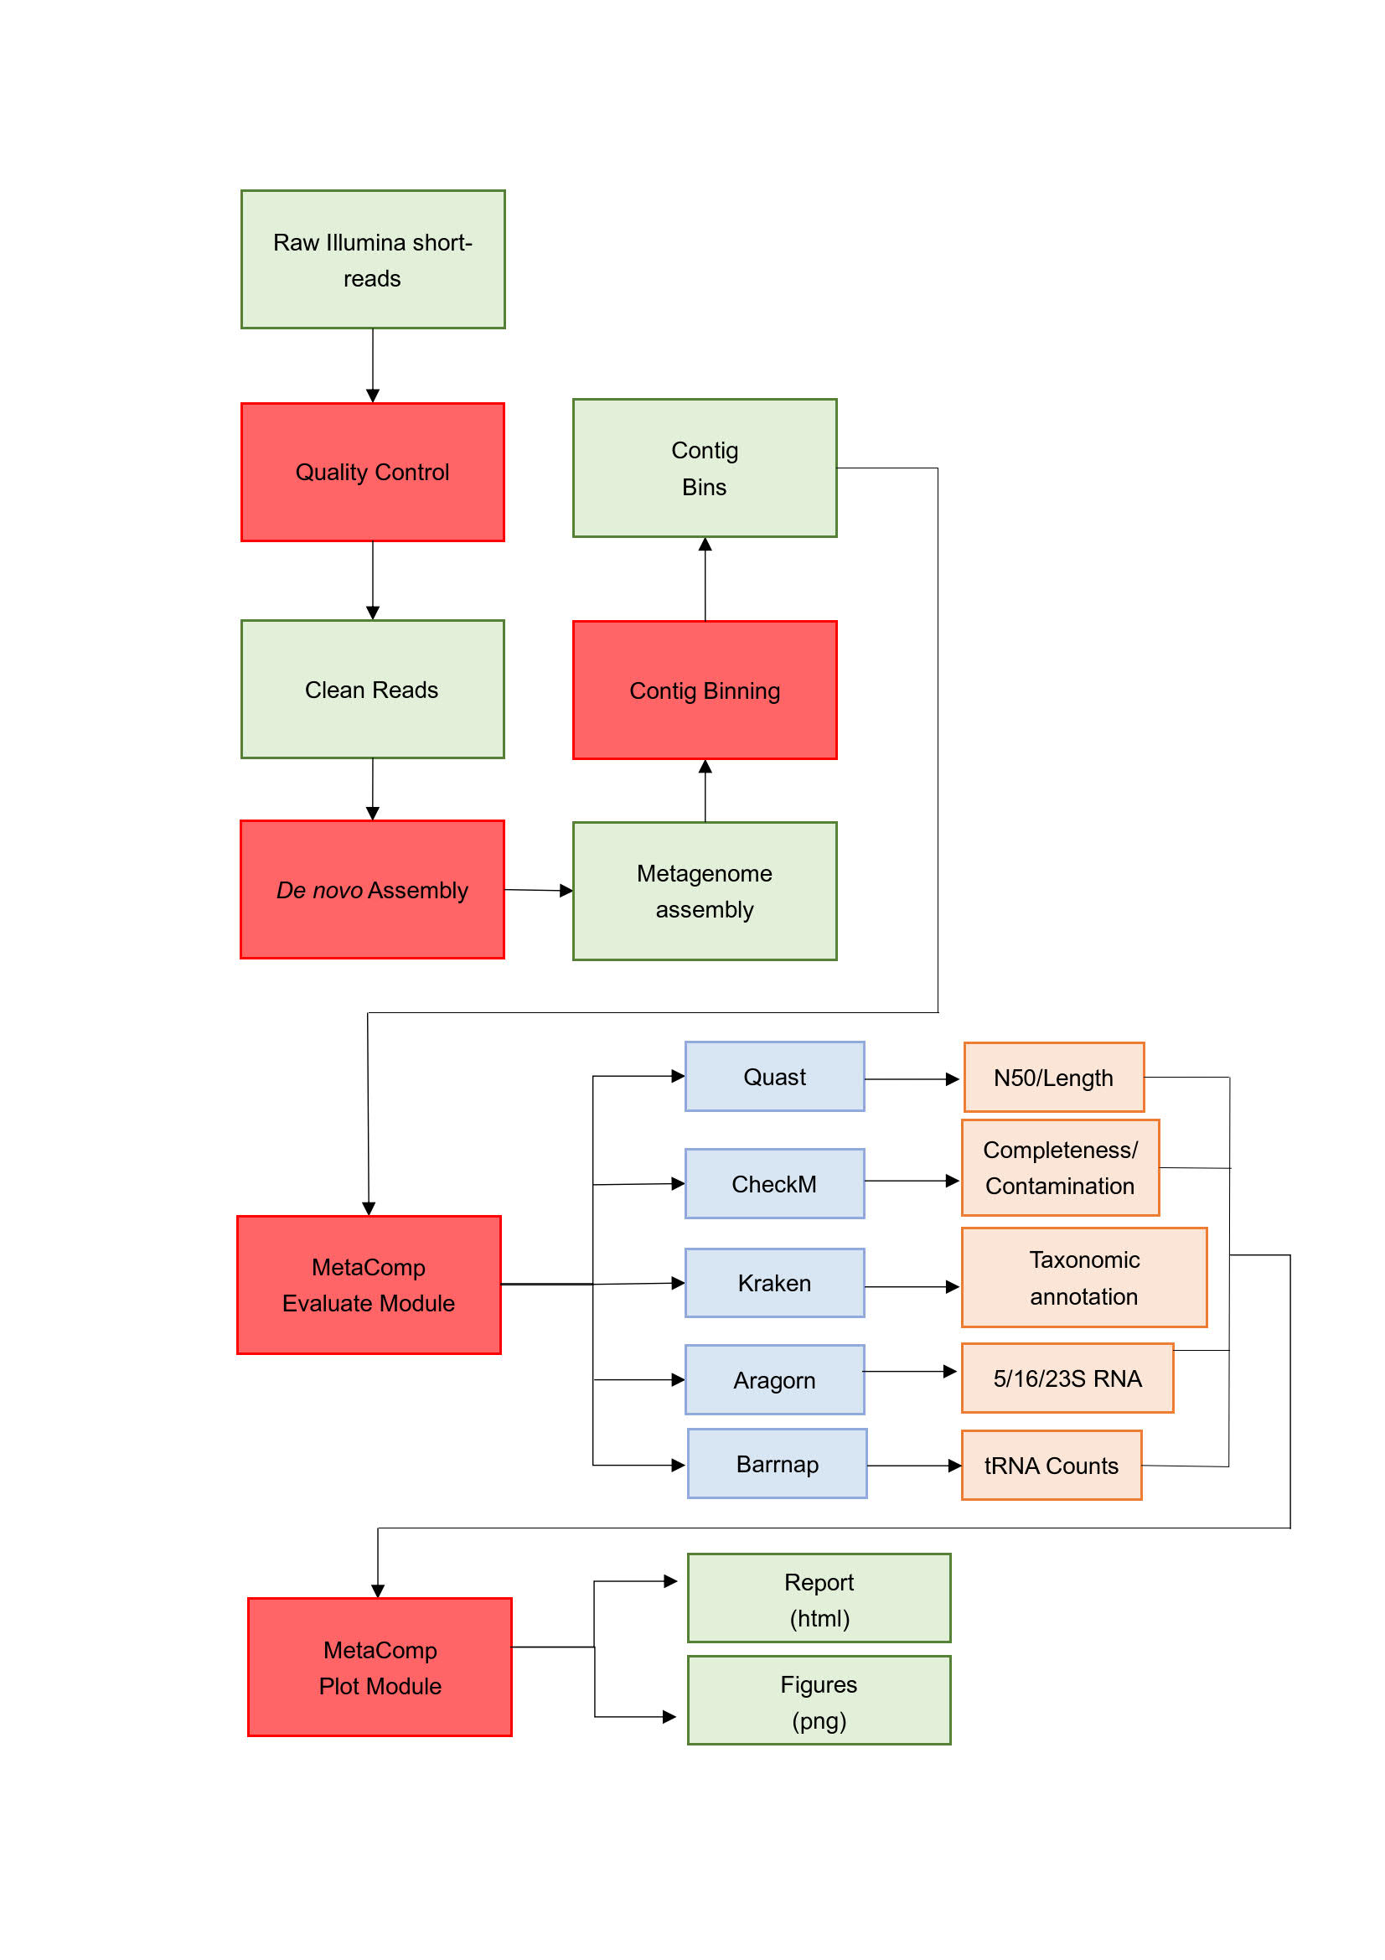

**Figure S9.** Workflow for evaluating and comparing different metagenome assemblies.



Depth



Read depth (X)

**Figure S10.** The distributions of genomic coverage and read depth for the microbes in human microbiome project according to the alignment of the linked-reads from human gut microbiome. CDF: cumulative density function.

**Supplementary Note**

**1. Complexity and statistics for linked-reads from human gut microbiome**

The barcode sequences of 4.7% linked-reads were discarded due to sequencing errors. These barcode-stripped reads could be aligned to 65,535 microbial genomes (34.85%; **Table S7** and **Figure S10**) from human microbiome project and 1,285 of them were well covered (genomic coverage>90%, read depth>20X, **Table S8**), suggesting a high diversity of metagenomic composition between individuals. The PCR duplication rate was 24.89%.

**2. Command lines adopted for the analysis**

A. Correct barcode base error and generate barcode-stripped reads

longranger basic --id=mock --fastqs=./input_fastq

B. Barcode-aware linked-reads alignment and calculate PCR duplication rate

longranger align --id=mock_alignment --reference=refdata-atcc20-refs --fastqs=./input_fastq

C. Assemble barcode-stripped reads

metaspades.py --12 /path/to/reads -o /path/to/metaspades/out

D. Align barcode-stripped reads to contigs

bwa index /path/to/metaspades/out/contigs.fasta

bwa mem -C -p /path/to/metaspades/out/contigs.fasta /path/to/reads | samtools sort -o align-reads.metaspades-contigs.bam –

samtools index align-reads.metaspades-contigs.bam

E. Assemble linked-reads by Athena-meta

athena-meta --config /path/to/config.json

F. Assemble PacBio ccs reads by Canu

canu -p atcc20 -d canu_grid genomeSize=66930628 correctedErrorRate=0.025 -pacbio-corrected ATCC20_CCS.fastq useGrid=remote gnuplot="~/software/anaconda3/envs/python2/bin/gnuplot" java="~/software/anaconda3/envs/python2/bin/java" minThreads=10 maxThreads=60

G. Bin quality evaluation

checkm lineage_wf -t 10 -x fasta bin_folder output_folder > output_file

H. Contig binning

perl run_MaxBin.pl -contig contig.fasta -reads read1.fastq.gz -reads2 read2.fastq.gz -out output_dir -threads 32

I. Calculate basic statistics

quast -o output_dir input.fasta

J. tRNA prediction

aragorn input.fasta -o result.txt

K. rRNA prediction

barrnap –quiet input.fasta > result.txt

L. annotate taxonomic classification

kraken --threads 8 --db kraken_db --output result.txt input.fasta

kraken-report --db kraken_db result.txt > result.report