**S1 Protocol**



Scheme 1: Method A: NEt3, CHCl3, 0oC; Method B: K2CO3, CH2Cl2/H2O, 0oC. R = H. Me, X = O, S.* Chiral centres

**Materials and Methods for Chemical synthesis of compounds 1 – 9**

All reactions were monitored by thin layer chromatography and visualised by either I2, UV light or phosphomolybdic acid. Flash chromatography was carried out on Fluorochem Silicagel 60Å (40-63 micron) with eluting solvent as indicated. 1H and 13C NMR spectroscopy was carried out on a Bruker Ultrashielded Plus 400 MHz spectrometer in CDCl3 unless otherwise stated and are reported in ppm referenced to the solvent internal standard at 7.62 and 77.160 ppm respectively. Infrared spectroscopy was carried out on a Bruker Alpha ATR using solid state compound. Mass spectrum were recorded on either a Finnigan MAT 900 XLT or a Finnigan MAT 95 XP at the EPSRC National Mass Spectrometry Service Centre in Swansea. Optical rotations were determined on an ADP440 Polarimeter.

**Method A** (Used for compounds **1, 2, 7** and **9**)

The acyl halide (1.00-2.65 equiv.) was added in a dropwise manner over 5 min to a stirred and cooled (0°C) solution of the aminolactone salt (1 equiv.) and triethylamine (2 equiv.) dissolved in chloroform. After 2 h the reaction was warmed to rt and stirred for 16 h. After evaporation, the mixture was triturated with EtOAc (3 x 10 mL), filtered, evaporated and purified via column chromatography.

**Method B** (Used for compounds **3, 4, 5, 6** and **8**)

The acyl halide (1.00-2.65 equiv.) was added in a dropwise manner over 5 min to a stirred and cooled (0°C) solution of the aminolactone salt (1 equiv.) and potassium carbonate (3. equiv.) dissolved in a mixture of chloroform and water. After 2 h the reaction was warmed to rt and stirred for 16 h whereupon the organic layer was separated, and the aqueous phase extracted with chloroform (20 mL). The combined organic layers were washed with tartaric acid solution (5% aq., 2 x 5 mL) and water (2 x 5 mL), dried over MgSO4, evaporated, and purified by column chromatography.

**Compound 1: 2-bromo-N-(2-oxotetrahydrofuran-3-yl)acetamide 11**



Bromoacetyl bromide (1.47 g, 7.27 mmol, 0.63 mL), α-amino-γ-butyrolactone hydrobromide (500 mg, 2.75 mmol), triethylamine (556 mg, 5.49 mmol), in chloroform (20 mL). Column chromatography (50% EtOAc in chloroform) gave **1** (612 mg, 2.76 mmol) in 75% yield as a white solid. **H** 6.95 (1H, br s, NH), 4.56 (1H, ddd, *J* 6.1, 8.6, 11.5 Hz, CH), 4.52 (1H, br t, *J* 8.9 Hz, CH), 4.33 (1H, ddd, *J* 5.9, 9.5, 11.1 Hz), 3.96 (1H, d, *J* 14.0 Hz, CH), 3.92 (1H, d, *J* 14.0 Hz, CH), 2.84-2.92 (1H, m, CH), 2.18-2.29 (1H, m, 1H) ;** C** 174.6, 166.4, 66.2, 50.0, 30.1, 28.4; ***v*max** 3250, 3062, 1760, 1659, 1548, 1180; MS(CI) 222.0 (100%, [C6H879BrNO3+H]+) 224.0 (98%, [C6H881BrNO3+H]+), 244.0 (85%, [C6H879BrNO3+Na]+), 246.0 (85%, [C6H879BrNO3+Na]+); HRMS(ES) found 221.9762, C6H979BrNO3+ ([M+H]+) requires 221.9760; Microanalysis: found C 32.6, H 3.8, N 6.4, Br 36.0; C6H8BrNO3 requires C 32.4, H 3.6, N 6.3, Br 36.0.

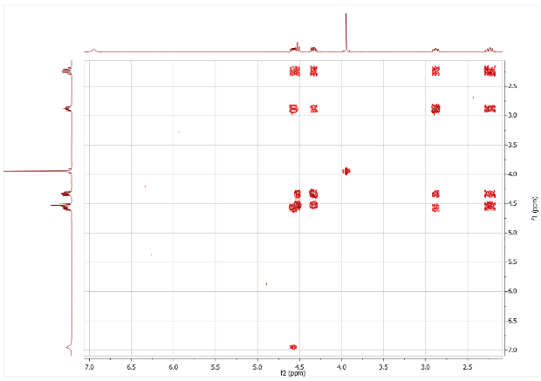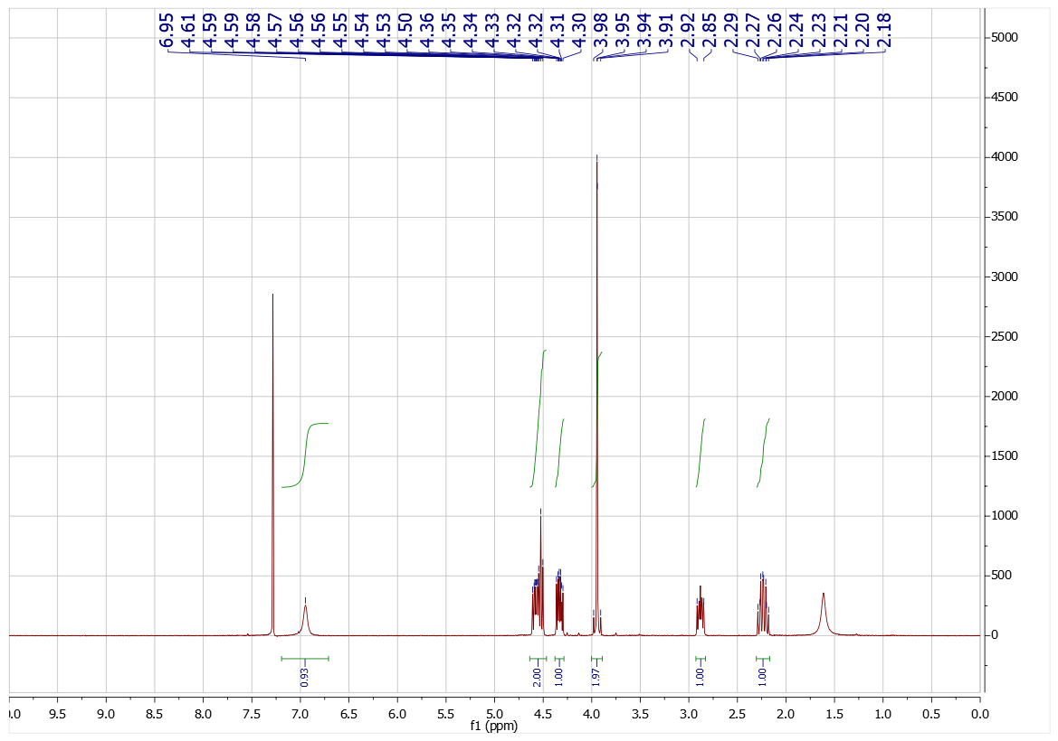



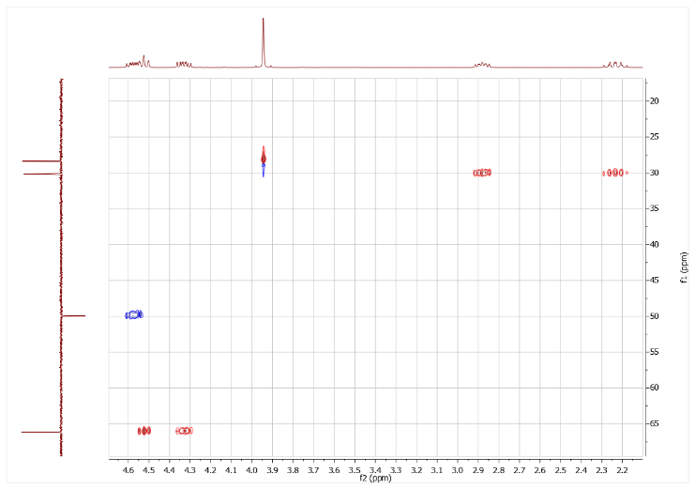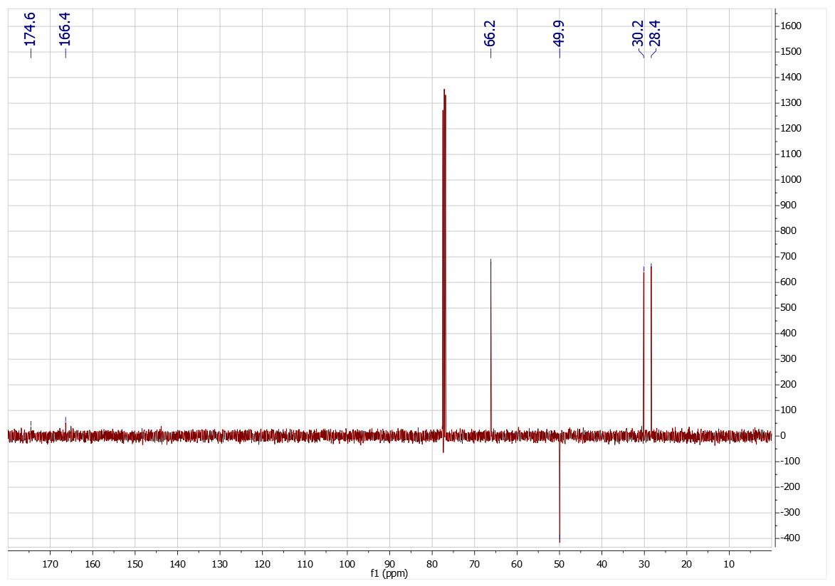



**Compound 2: 2-bromo-N-(2-oxotetrahydrofuran-3-yl)propanamide 2**



Bromopropionoyl bromide (593 mg, 2.75 mmol, 0.29 mL), α-amino-γ-butyrolactone hydrobromide (500 mg, 2.75 mmol) and triethylamine (556 mg, 5.49 mmol) in chloroform (20 mL). Column chromatography (50% EtOAc in chloroform) gave **2** (215 mg, 0.91 mmol) in 33% yield as a white solid (1:1 mixture of diasteroisomers). **H** 6.82/6.77 (1H, 2 br s, NH), 4.41-4.58 (3H, m, 3 x CH), 4.27-4.34 (1H, m, CH), 2.83-2.90 (1H, m, CH), 2.14-2.26 (1H, m, CH), 1.89/1.91 (3H, 2 x d, *J* 6.7 Hz, 2 x CH3); **C** 66.2, 50.0/49.9, 43.9/43.7, 30.2/30.2, 22.9/22.8 (2 x C not observed); *v*max 3284, 3083, 2946, 1775, 1656, 1551, 1165; MS(CI) 236.0 (80%, [C7H1079BrNO3+H]+) 238.0 (80%, [C7H1081BrNO3+H]+), 258.0 (100%, [C7H1079BrNO3+Na]+), 260.0 (98%, [C7H1081BrNO3+Na]+); HRMS(ES) found 235.9919, C7H1179BrNO3+ ([M+H]+) requires 235.9917.

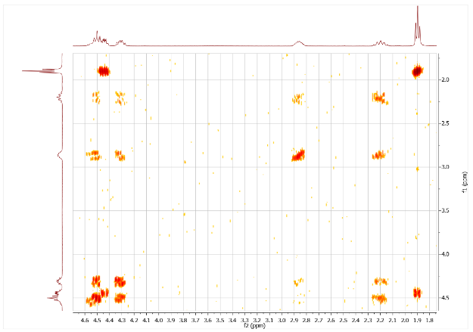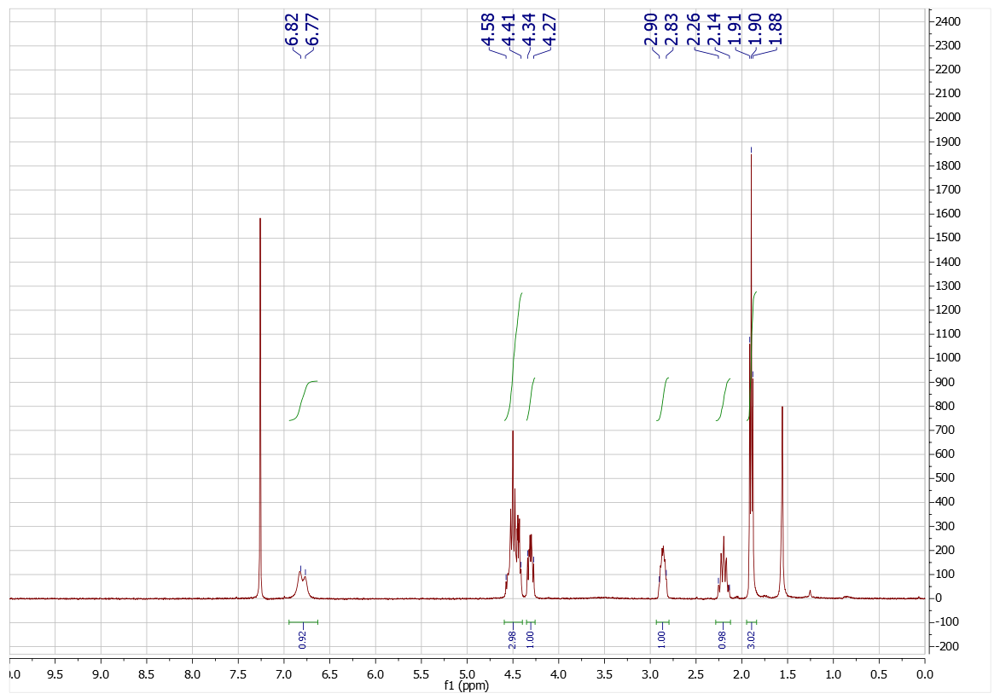



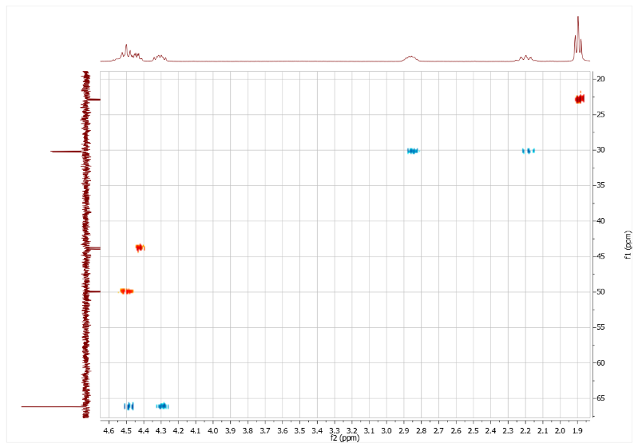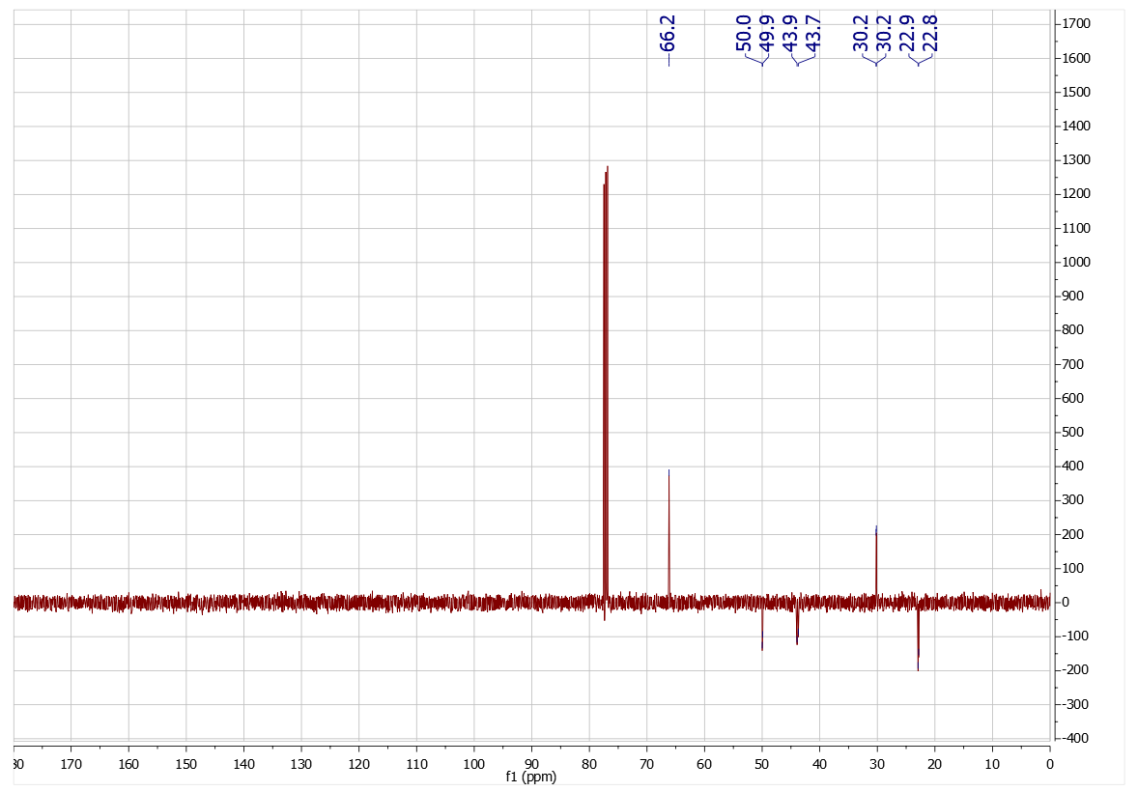



**Compound 3: 2-bromo-*N*-(2-oxotetrahydrothiophen-3-yl)acetamide 3**



Bromoacetyl bromide (1.31 g, 6.51 mmol, 0.57 mL), homocysteine thiolactone hydrochloride (500 mg, 3.25 mmol), potassium carbonate (1.35 g, 9.76 mmol), water (20 mL), chloroform (20 mL). Column chromatography (50% EA in CF) gave **3** (307 mg, 1.29 mmol) in 40% yield as a white solid. **H** 6.92 (1H, s, NH), 4.51 (1H, ddd, *J* 6.6, 6.6, 12.4 Hz, CH), 3.93 (1H, d, *J* 13.7 Hz, CH), 3.89 (1H, d, *J* 13.7 Hz, CH), 3.38 (1H, ddd, *J* 5.1, 11.6, 12.0 Hz, CH), 3.23 (1H, ddd, *J* 0.8, 7.0, 12.2 Hz, CH), 2.88-2.94 (1H, m, CH), 2.00 (dddd, *J* 7.0, 12.0, 12.2, 12.4 Hz, CH); **C** 204.6, 166.3, 59.9, 31.5, 28.6, 27.7; ***v*max** 3262, 1697, 1658, 1537, 1453; MS(CI) 238.0 (95%, [C6H879BrNO2S+H]+) 240.0 (100%, [C6H881BrNO2S+H]+), 260.0 (80%, [C6H879BrNO2S+Na]+), 262.0 (85%, [C6H881BrNO2S+Na]+); HRMS(ES) found 237.9534, C6H979BrNO2S+ ([M+H]+) requires 237.9532.

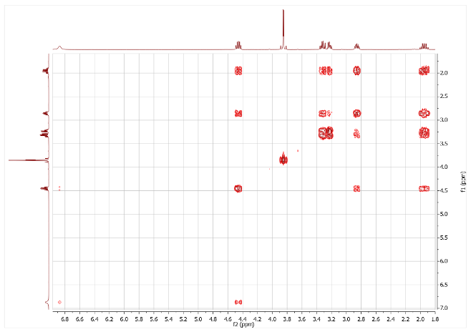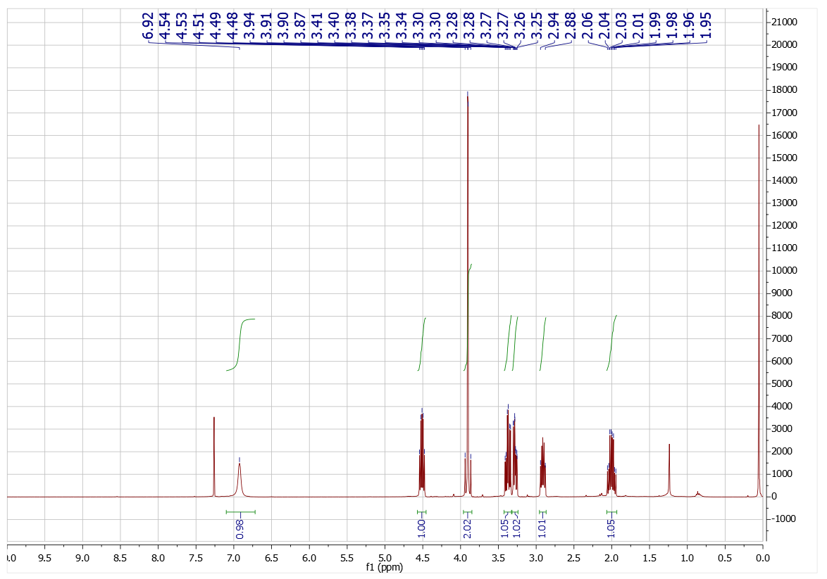



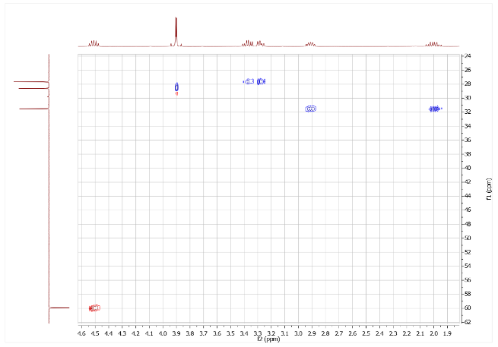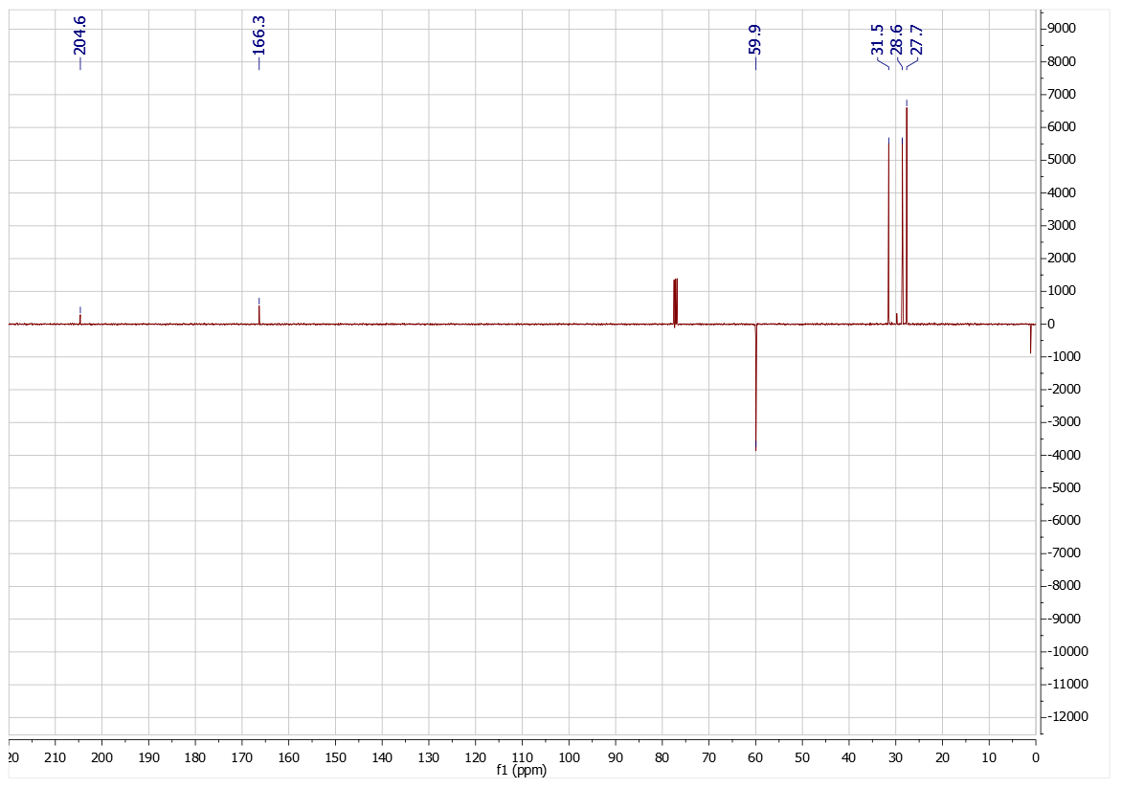



**Compound 4: 2-bromo-N-(2-oxotetrahydrothiophen-3-yl)propanamide 4**



Bromopropionyl bromide (1.41 g, 6.51 mmol, 0.68 mL), homocysteine thiolactone hydrochloride (500 mg, 3.25 mmol), potassium carbonate (1.35 g, 9.76 mmol), water (20 mL), chloroform (20 mL). Column chromatography (50% EtOAc in chloroform) gave **4** (598 mg, 2.37 mmol) in 73% yield as a white solid. **H** 6.82/6.76 (1H, 2 x br s, 2 x NH), 4.40-4.53 (1H, m, CH), 3.34-3.41 (1H, m, CH), 3.25-3.30 (1H, m, CH), 2.90-2.96 (1H, m, CH), 1.93-2.04 (1H, m, CH), 1.86/1.89 (3H, d/d, *J* 7.0/7.1 Hz, 2 x CH3); **C** 204.9/204.7, 170.1/170.1, 60.0/60.0, 44.2/43.9, 31.6/31.5, 27.7/27.7, 23.0/22.8; ***v*max** 3256, 3080, 2970, 1686, 1644, 1553; MS(CI) 252.0 (95%, [C7H1079BrNO2S+H]+) 254.0 (100%, [C7H1081BrNO2S+H]+), 269.0 (65%, [C7H1079BrNO2S+Na]+), 271.0 (65%, [C7H1081BrNO2S+Na]+); HRMS(ES) found 251.9688, C7H1179BrNO2S+ ([M+H]+) requires 251.9688.

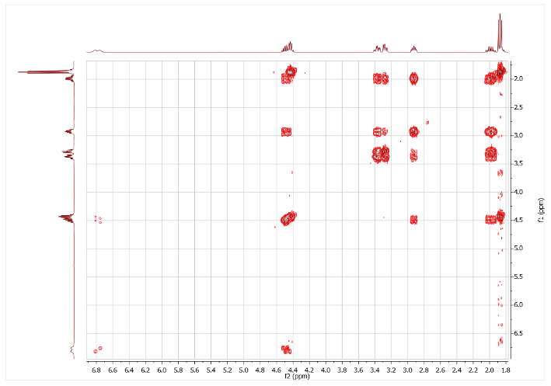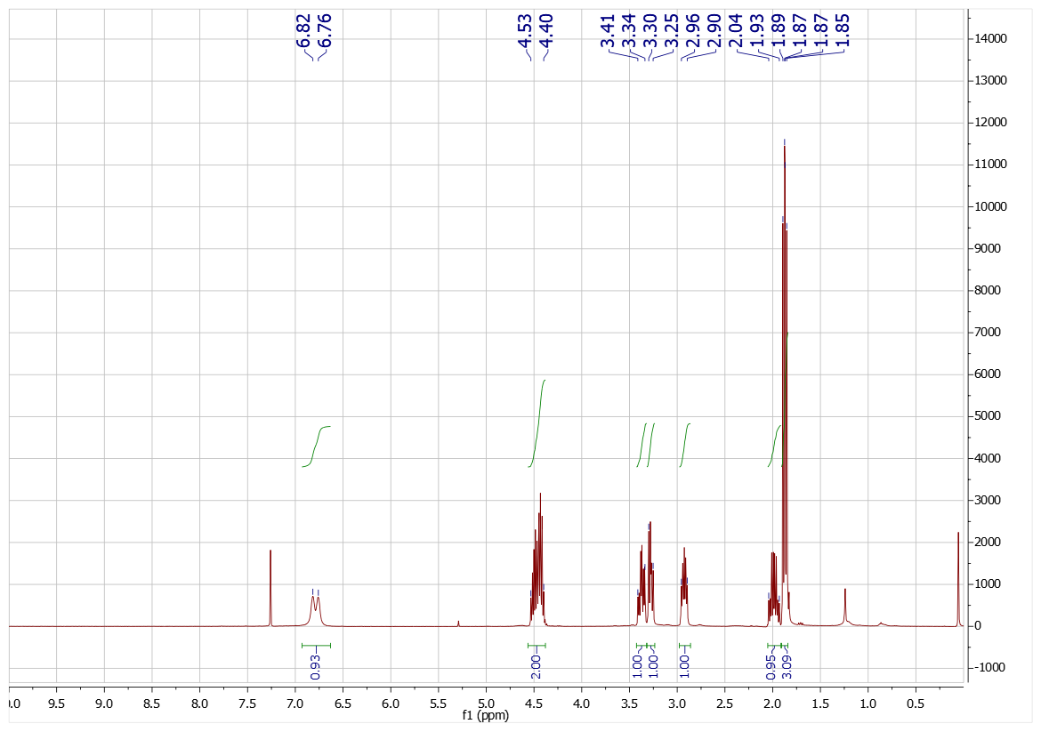

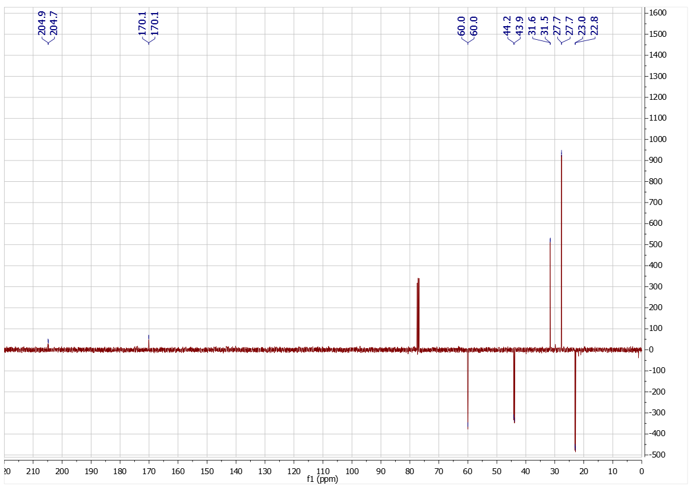

**Compound 5: (*R*)-2-bromo-N-(2-oxotetrahydrofuran-3-yl)acetamide 5**



Bromoacetyl bromide (1.47 g, 7.27 mmol, 0.63 mL), (*R*)-(+)-α-Amino-γ-butyrolactone hydrochloride (500 mg, 3.63 mmol), potassium carbonate (1.51 g, 10.90 mmol), water (20 mL), chloroform (20 mL). column chromatography (50% EA in CF) gave **5** (204 mg, 0.92 mmol) in 25% yield as a white solid. [****]D19 -22 (c = 0.1 CHCl3), **H** 6.91 (1H, br s, NH), 4.55 (1H, ddd, *J* 6.1, 8.6, 11.5 Hz, CH), 4.52 (1H, br t, *J* 8.9 Hz, CH), 4.34 (1H, ddd, *J* 5.9, 9.5, 11.1 Hz), 3.96 (1H, d, *J* 13.7 Hz, CH), 3.92 (1H, d, *J* 13.7 Hz, CH), 2.82-2.90 (1H, m, CH), 2.15-2.26 (1H, m, 1H);** C** 174.6, 166.4, 66.2, 50.0, 30.2, 28.4; ***v*max** 3253, 3064, 1762, 1657, 1551, 1179; MS(CI) 222.0 (98%, [C6H879BrNO3+H]+) 224.0 (97%, [C6H881BrNO3+H]+), 244.0 (98%, [C6H879BrNO3+Na]+), 246.0 (98%, [C6H879BrNO3+Na]+); HRMS(ES) found 221.9762, C6H979BrNO3+ ([M+H]+) requires 221.9760.

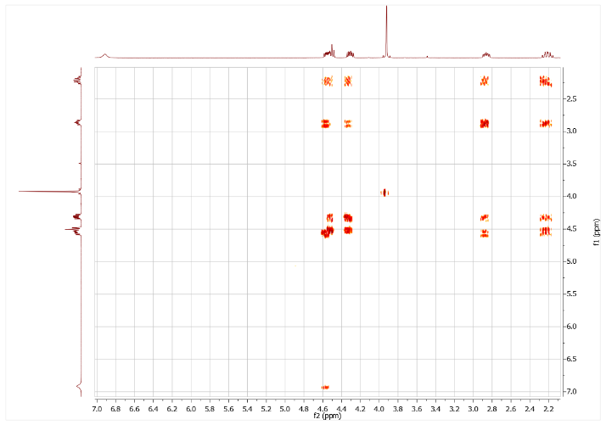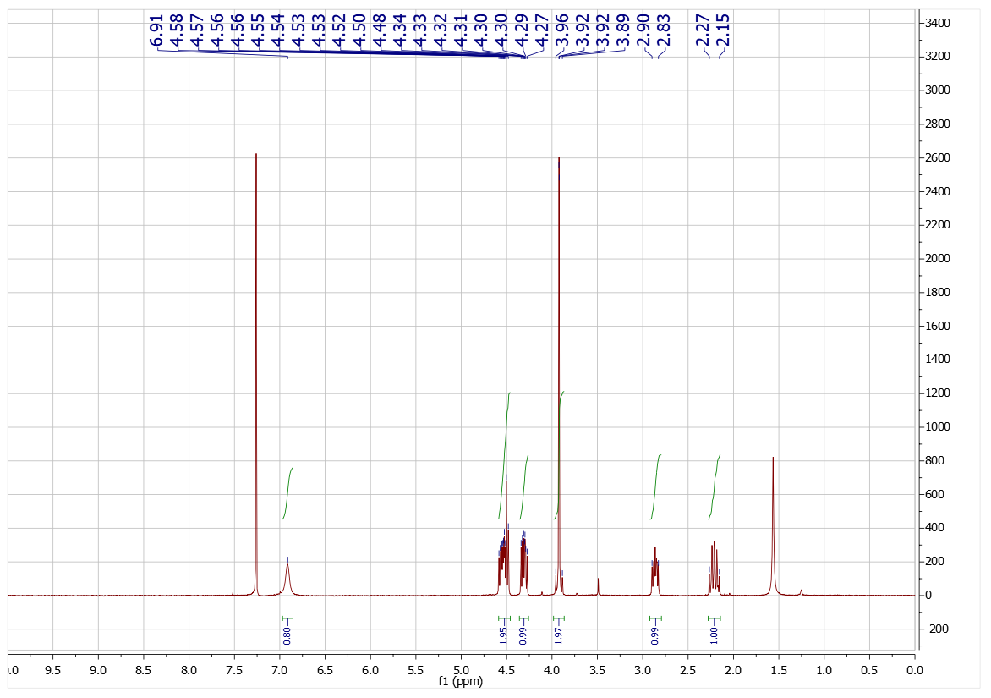



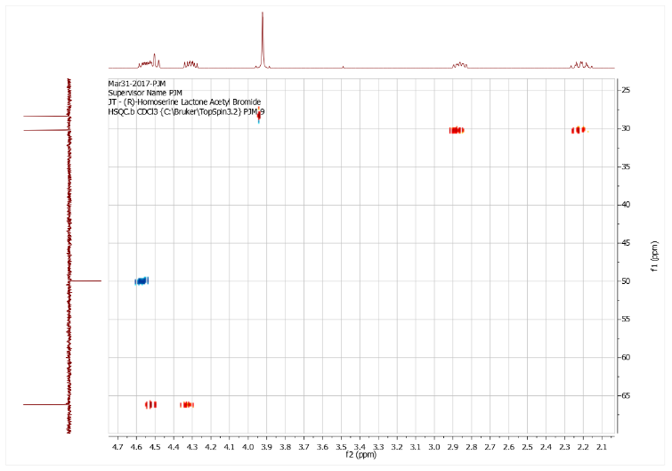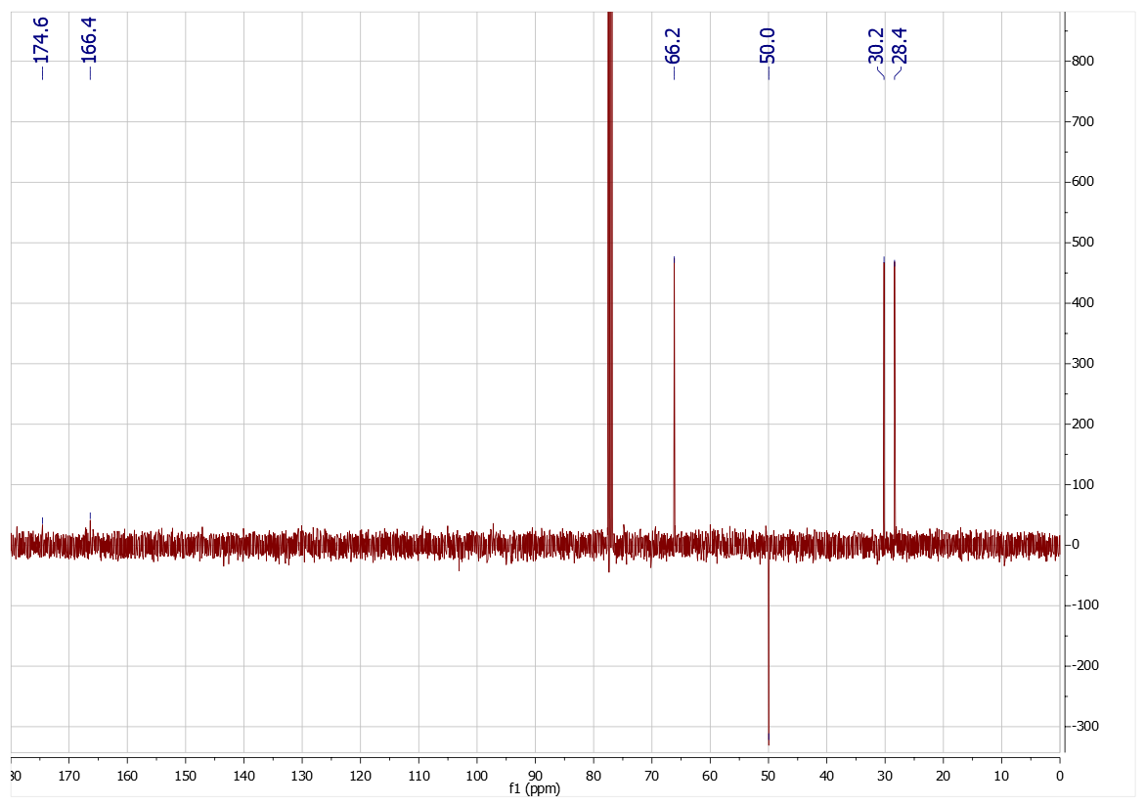



**Compound 6: (*S*)-2-bromo-N-(2-oxotetrahydrofuran-3-yl)acetamide 613**



Bromoacetyl bromide (1.47 g, 7.27 mmol, 0.63 mL), (*S*)-(-)-α-Amino-γ-butyrolactone hydrochloride (500 mg, 3.63 mmol), potassium carbonate (1.35 g, 9.76 mmol), water (20 mL), chloroform (20 mL). Column chromatography (50% EA in CF) gave **6** (116 mg, 0.52 mmol) in 14% yield as a white solid. [****]D19 21 (c = 0.1 CHCl3), Lit.13 [****]D22 20.5 (c = 0.0074 CHCl3); **H** 6.99 (1H, s, NH), 4.55 (1H, ddd, *J* 6.1, 8.6, 11.5 Hz, CH), 4.52 (1H, br t, *J* 8.9 Hz, CH), 4.34 (1H, ddd, *J* 5.9, 9.5, 11.1 Hz), 3.96 (1H, d, *J* 13.7 Hz, CH), 3.92 (1H, d, *J* 13.7 Hz, CH), 2.81-2.87 (1H, m, CH), 2.17-2.28 (1H, m, 1H);** C** 174.7, 166.4, 66.2, 49.9, 30.1, 28.4; ***v*max** 3254, 3065, 1762, 1656, 1551, 1177; MS(CI) 222.0 (100%, [C6H879BrNO3+H]+) 224.0 (98%, [C6H881BrNO3+H]+), 244.0 (85%, [C6H879BrNO3+Na]+), 246.0 (85%, [C6H879BrNO3+Na]+); HRMS(ES) found 221.9761, C6H979BrNO3+ ([M+H]+) requires 221.9760.

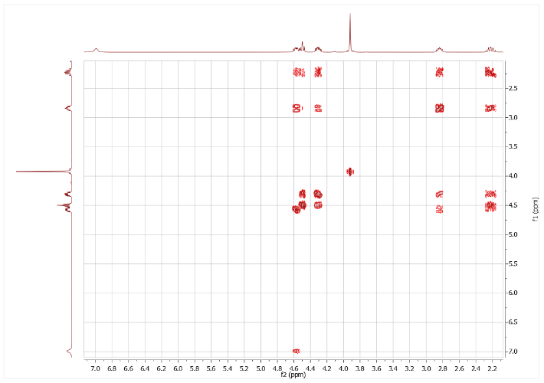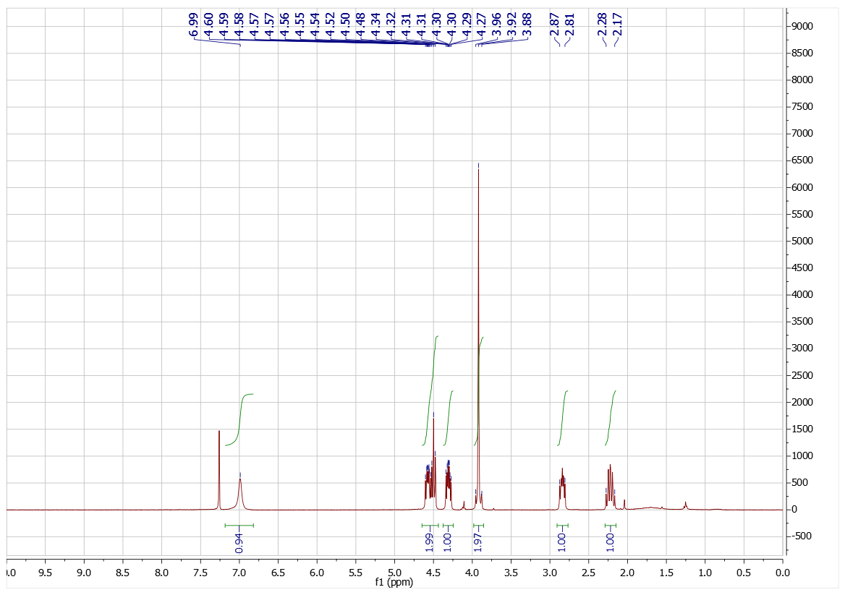



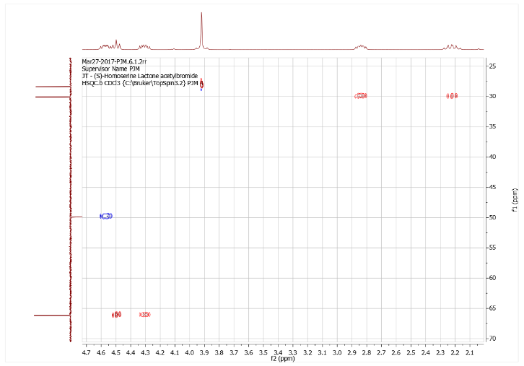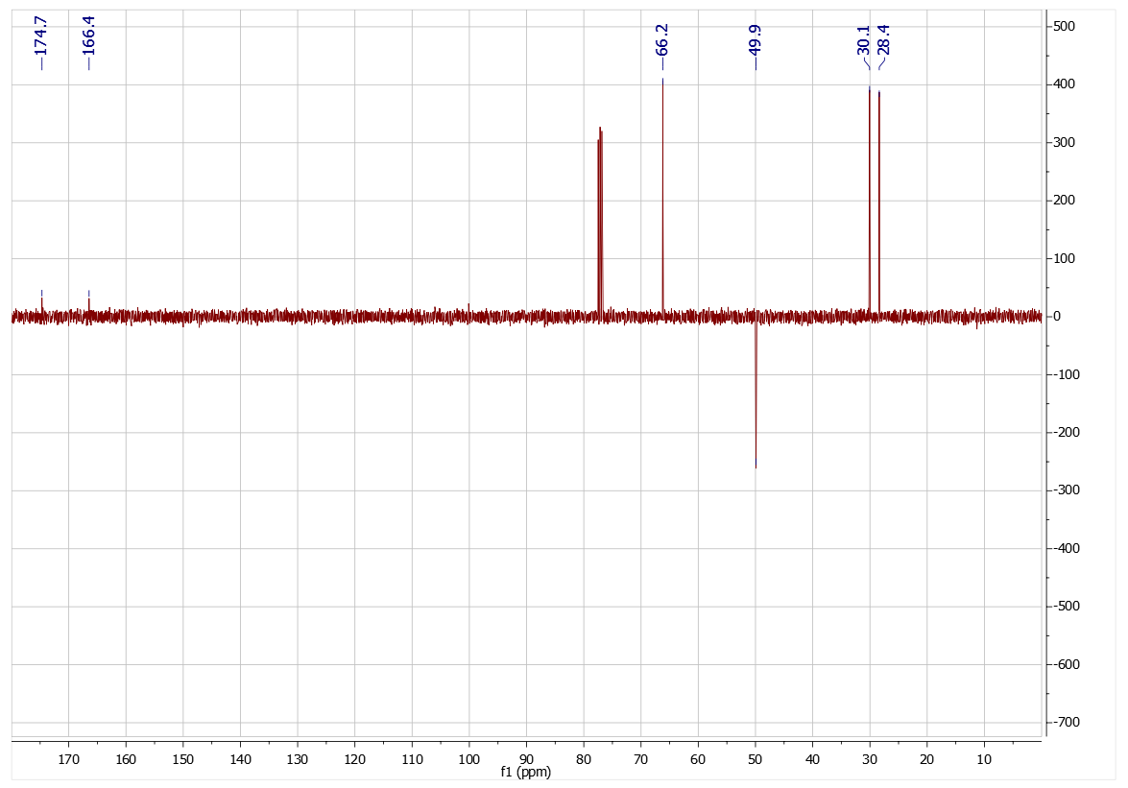



**Compound 7: 2-chloro-N-(2-oxotetrahydrofuran-3-yl)acetamide 7**



Chloroacetyl chloride (310 mg, 2.75 mmol, 0.22 mL), α-amino-γ-butyrolactone hydrobromide (500 mg, 2.75 mmol), triethylamine (556 mg, 5.49 mmol), chloroform (20 mL). Column chromatography (50% EtOAc in chloroform) gave **7** (334 mg, 1.88 mmol) in 68% yield as a white solid. **H** 7.05 (1H, br s, NH), 4.58 (1H, ddd, *J* 6.6, 8.6, 11.4 Hz, CH), 4.50 (1H, br t, *J* 9.0 Hz, CH), 4.31 (1H, ddd, *J* 5.9, 9.7, 10.8 Hz, CH), 4.10 (2H, s, CH2), 2.81-2.88 (1H, m, CH), 2.17-2.28 (1H, m, 1H); **C**174.6, 166.8, 66.1, 49.6, 42.3, 30.1; ***v*max** 3251, 3069, 1762, 1662, 1556, 1179, 1024; **MS(CI)** 178.0 (100%, [C6H835ClNO3+H]+) 180.0 (30%, [C6H837ClNO3+H]+), 200.0 (100%, [C6H835ClNO3+Na]+), 202.0 (30%, [C6H837ClNO3+Na]+); HRMS(ES) found 178.0264, C6H937ClNO3+ ([M+H]+) requires 178.0265.

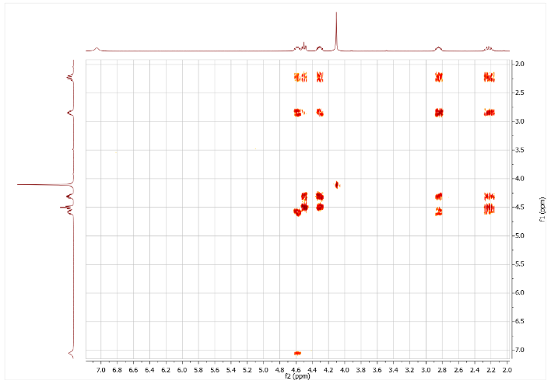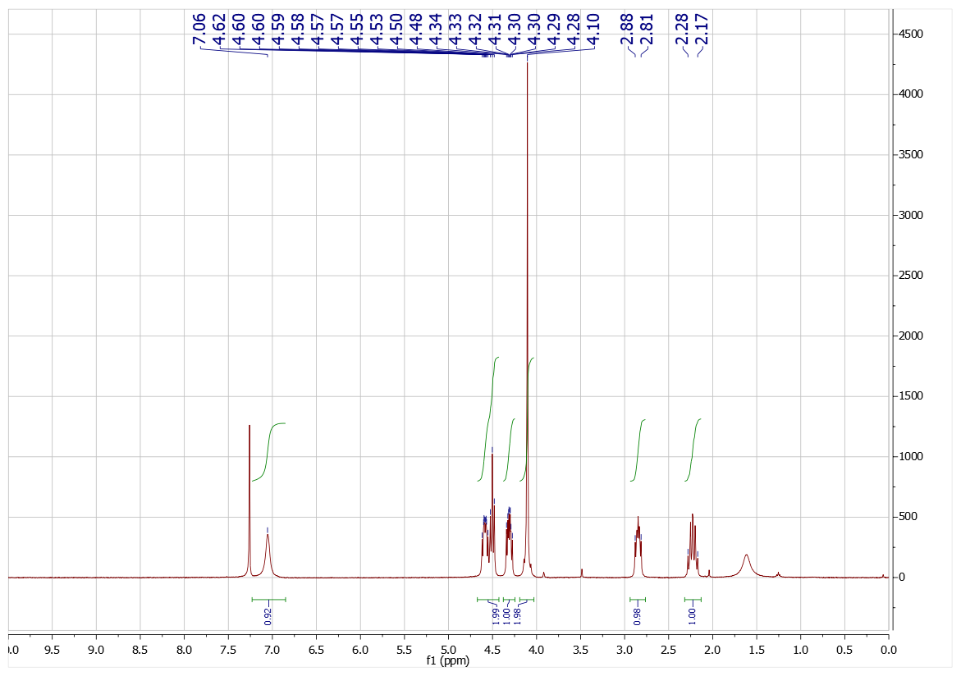



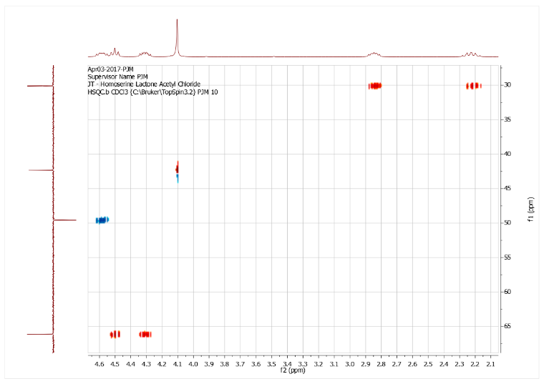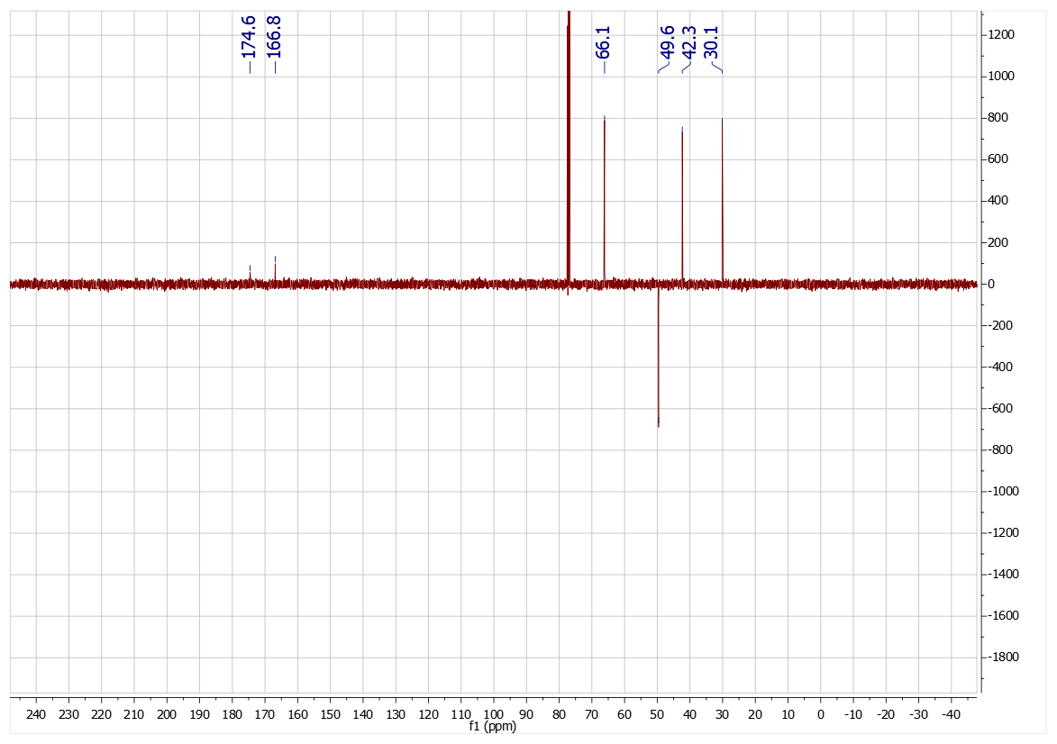



**Compound 8: 2-chloro-N-(2-oxotetrahydrothiophen-3-yl)acetamide 8**



Chloroacetyl chloride (753 mg, 6.51 mmol, 0.52 mL), homocysteine thiolactone hydrochloride (500 mg, 3.25 mmol), potassium carbonate (1.35 g, 9.76 mmol), water (20 mL), chloroform (20 mL). Column chromatography (50% EA in CF) gave **8** (382 mg, 1.97 mmol) in 61% yield as a white solid. **H** 6.95 (1H, br s, NH), 4.52 (1H, apparent pentet, 6.5 Hz, CH), 4.12 (1H, d, *J* 15.1 Hz, CH), 4.07 (1H, d, *J* 15.1 Hz, CH), 3.39 (1H, ddd, *J* 5.1, 11.6, 11.6 Hz, CH), 3.29 (1H, br dd, *J* 7.0, 11.2 Hz, 1H), 2.91-2.98 (1H, m, CH), 2.00 (1H, dddd, *J* 7.0, 12.5, 12.5, 12.5 Hz, 1H); **C** 204.5, 166.7, 59.7, 42.5, 31.7, 27.7; ***v*max** 3293, 2941, 1702, 1643, 1534, 1262; MS(CI) 194.0 (100%, [C6H835ClNO2S+H]+) 196.0 (35%, [C6H837ClNO2S +H]+), 216.0 (65%, [C6H835ClNO2S +Na]+), 218.0 (23%, [C6H837ClNO2S +Na]+); HRMS(ES) found 194.0037, C6H935ClNO2S+ ([M+H]+) requires 194.0037.

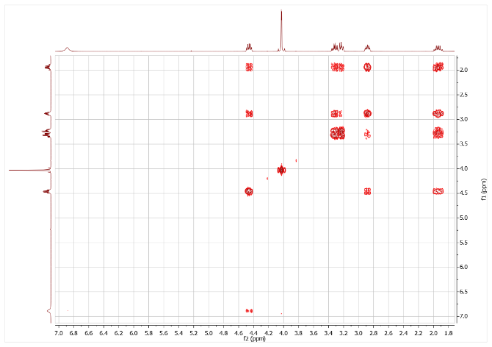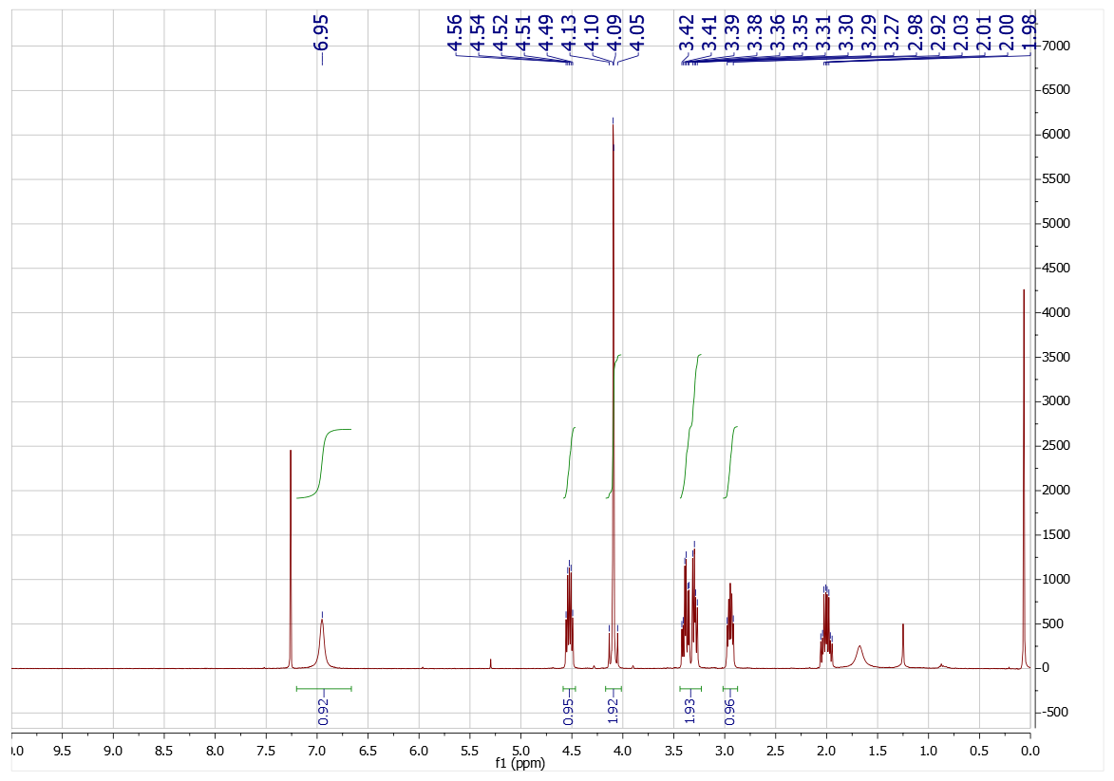



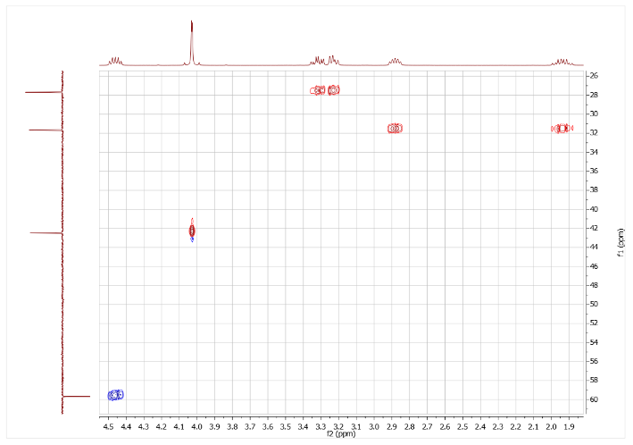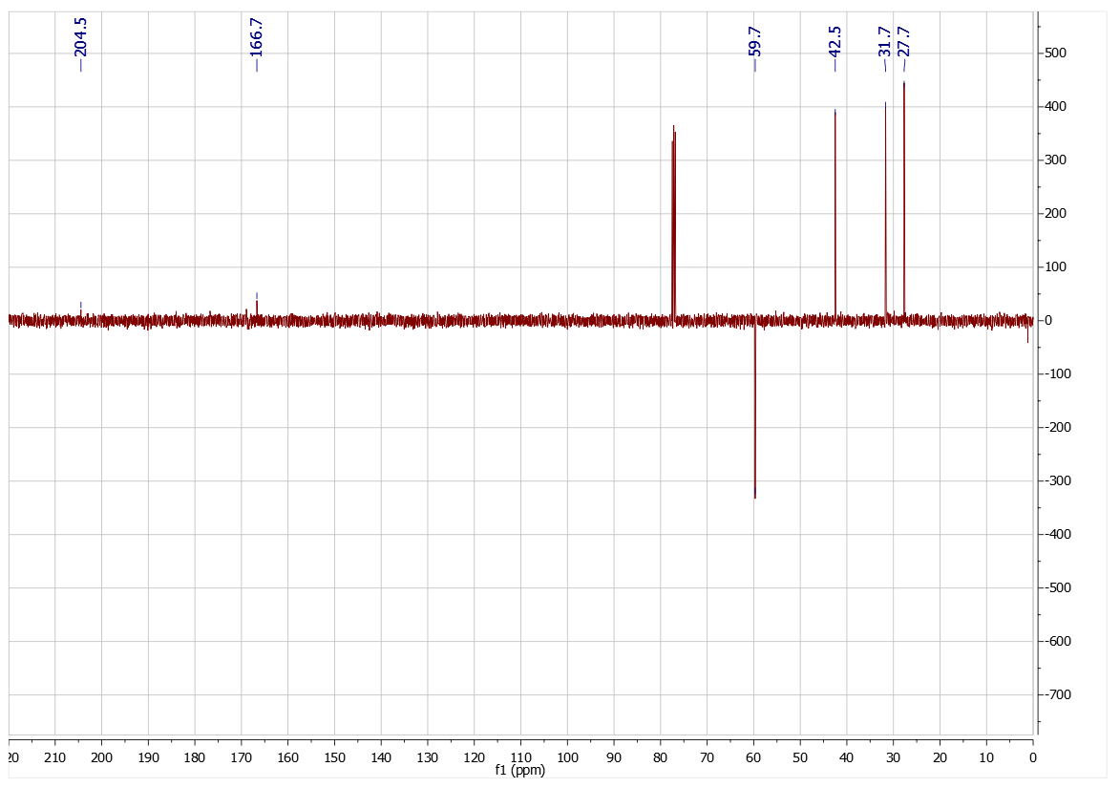



**Compound 9: 2-chloro-N-(2-oxotetrahydrofuran-3-yl)propanamide 9**



Chloropropianoyl chloride (349 mg, 2.75 mmol, 0.27 mL), α-amino-γ-butyrolactone hydrobromide(500 mg, 2.75 mmol) and triethylamine (556 mg, 5.49 mmol), chloroform (20 mL). Column chromatography (50% EtOAc in chloroform) gave **9** (341 mg, 1.78 mmol) in 65% yield as a white solid (1:1 mixture of diastereoisomers). **H** 6.99 (1H, br s, NH), 4.36-4.52 (3H, m, 3 x CH), 4.21-4.27 (1H, m, CH), 2.74-2.81 (1H, m, CH), 2.09-2.20 (1H, m, CH), 1.70/1.69 (3H, 2 x d, *J* 6.8/6.7 Hz, Me); **C** 174.7/174.7, 170.4/170.4, 66.1/66.1, 55.3/55.2, 49.6, 30.1/30.1, 22.5; ***v*max** 3285, 3085, 1775, 1660, 1551, 1167; MS(CI) 192.0 (100%, [C7H1035ClNO3+H]+) 194.0 (35%, [C7H1037ClNO3+H]+), 214.0 (85%, [C7H1035ClNO3+Na]+), 216.0 (25%, [C7H1037ClNO3+Na]+); HRMS(ES) found 192.0422, C7H1179ClNO3+ ([M+H]+) requires 192.0422.

