Supplemental data
Xrn1-resistant RNA structures are well-conserved within the genus flavivirus
Ivar W. Dilwegª, Assia Bouabda^{b}, Tim Dalebout^{b}, Alexander P. Gultyaev^{cd} ,Peter Bredenbeek^{b}, René C. Olsthoornª
aLeiden Institute of Chemistry, Leiden University, P.O. Box 9502, 2300 RA Leiden, The Netherlands; bDepartment of Medical Microbiology, Leiden University Medical Center , 2300 RC, Leiden The Netherlands; cLeiden Institute of Advanced Computer Science, Leiden University, P.O. Box 9512, 2300 RA Leiden, The Netherlands; dDepartment of Viroscience, Erasmus Medical Center, P.O. Box 2040, 3000 CA Rotterdam, The Netherlands.
Correspondence: R.C. Olsthoorn, olsthoor@chem.leidenuniv.nl, Leiden University, P.O. Box 9502, 2300 RA Leiden, the Netherlands

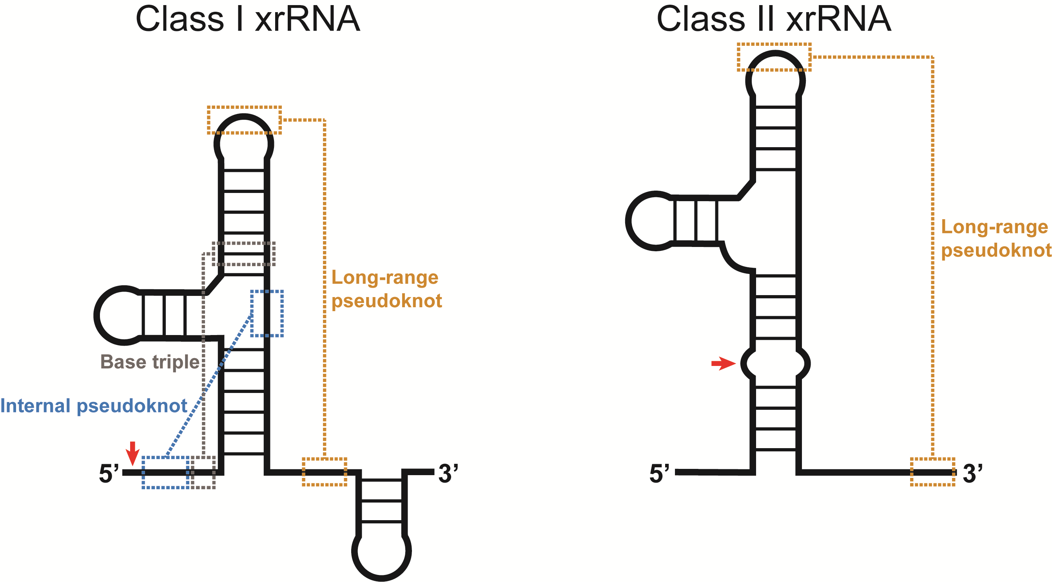
Supplementary Figure S1. Schematic representation of the secondary structure two classes of flaviviral xrRNA, as proposed by MacFadden et al. Previously identified tertiary interactions are depicted in colored, dashed boxes. The previously proposed Xrn1-stalling site is depicted by the red arrows for each class.
Supplementary Figure S2. Additional three-dimensional model structures of TBEV and NKVFV Xrn1 stalling sites. Models are based on structural alignment following the sequences gained from the following accession numbers: second Xrn1 stalling site of Tick-borne encephalitis virus Sofjin-HO (TBEV 2nd), AB062064; Montana myotis leukoencephalitis virus (MMLV), NC_004119; first and second Xrn1 stalling site of Apoi virus (APOIV 1st/2nd), AF452050.

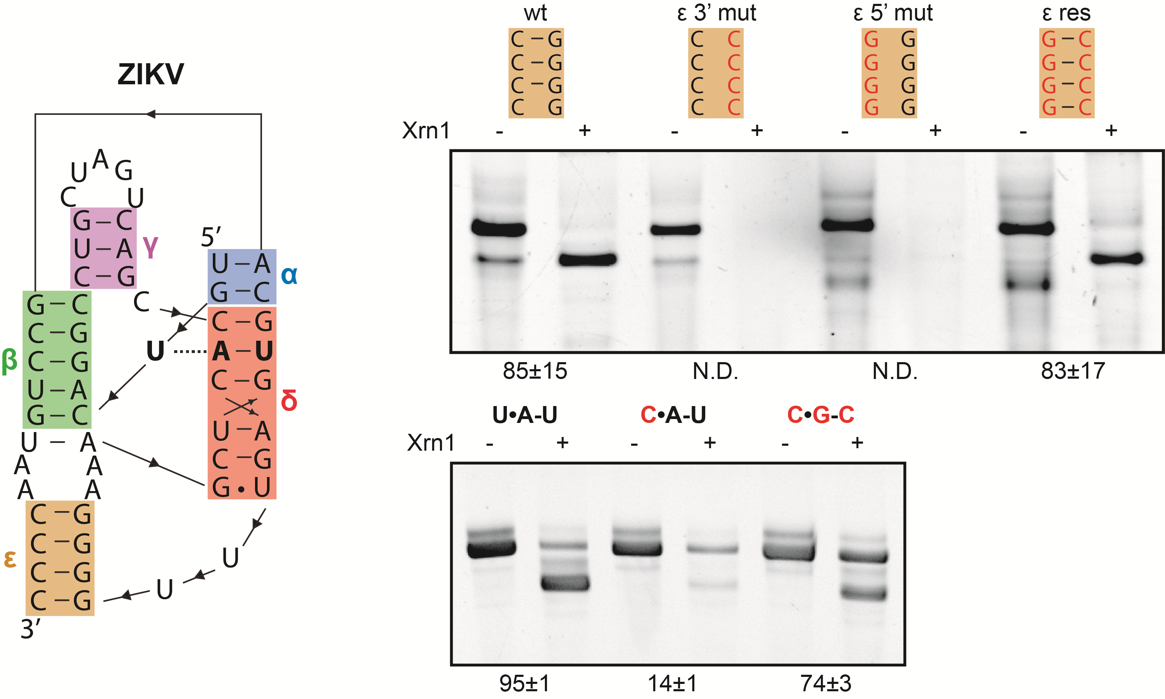
Supplementary Figure S3. In vitro Xrn1 degradation assay demonstrating the effects of mutations targeted at the ε–stem (upper panel) and the base triple (lower panel) on Xrn1 resistance. Mutant constructs, treated either with or without Xrn1, are represented above the corresponding denaturing polyacrylamide gels. Data below the gels depict the average percentage (± SD) of Xrn1-resistant RNA. ‘N.D.’ signifies that this value could not be determined reliably, but does not exceed 10%.
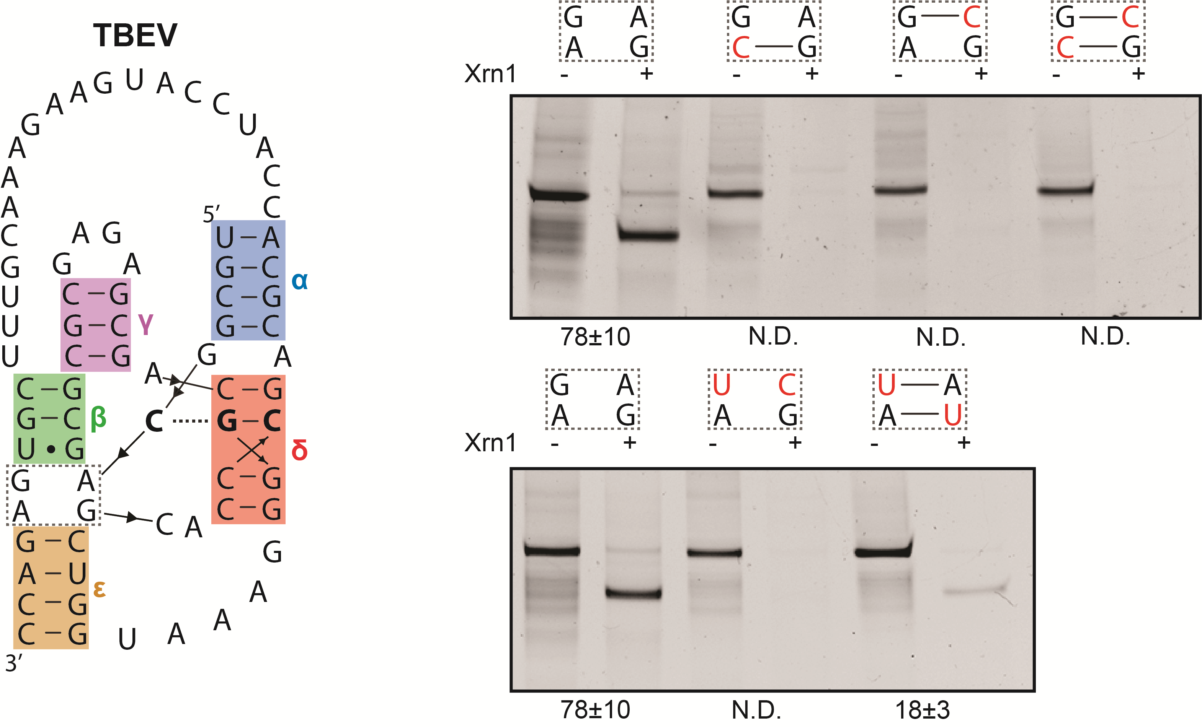
Supplementary Figure S4. In vitro Xrn1 degradation assay demonstrating the disruptive effects of mutations in the junction between stem β and ε. The dashed box within the structural model of the first xrRNA of TBEV strain Sofjin-HO shown on the left indicates the nucleotides of interest. Mutant constructs, treated either with or without Xrn1, are represented in similar boxes above the corresponding denaturing polyacrylamide gels. Data below the gels depict the average percentage (± SD) of Xrn1-resistant RNA. ‘N.D.’ signifies that this value could not be determined reliably, but does not exceed 10%.

