Supplementary Materials

Study on the community structure and function of symbiotic bacteria from different growth and developmental stages of Hypsizygus marmoreus

Shujing Sun#*, Fan Li#, Xin Xu, Yunchao Liu, Xuqiang Kong, Jianqiu Chen, Ting Liu, and Liding Chen

College of Life Sciences, Fujian Agriculture and Forestry University, Fuzhou 350002, People’s Republic of China

#These authors contributed equally to this work and joint first authors.

* To whom correspondence should be addressed: College of Life Sciences, Fujian Agriculture and Forestry University, Fuzhou 350002, P. R. China. Tel.: +86-591-83789492; Fax: +86-591-83789352. E-mail address: shjsun2004@126.com

Short title: Mushroom symbiotic bacteria and their function

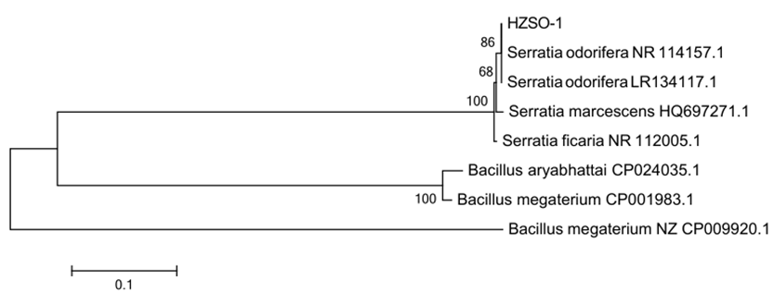
Fig. S1 Phylogenetic tree of HZSO-1 strain based on 16S rDNA sequences
Note: The value on the branch point is the support rate. The ruler 0.1 is the evolution distance

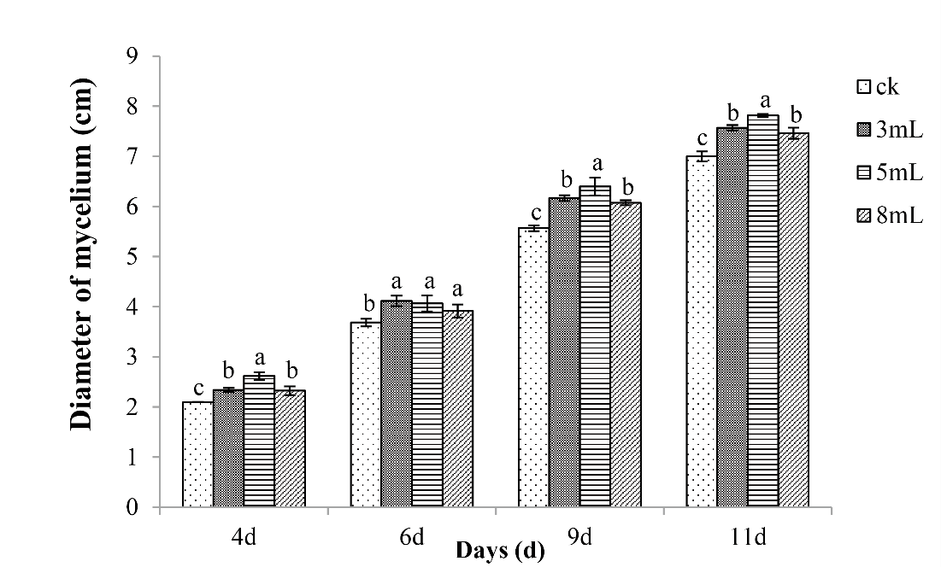
Fig. S2 Dosage effects of 0.22-μm filter-sterilized fermentation broth of S. odorifera HZSO-1 on the growth rate of H. marmoreus hyphae. Note: Different lowercase letters indicate a significant difference between treatments at the P<0.05 level.

Table S1 A description of the content of each sample as shown in Figure 7
A | B | C | D | E
Hyphae | --- | Mycelia | Mycelia | Mycelia
PDA enrichment medium | Cultivation substrate | Cultivation substrate | Cultivation substrate | Cultivation substrate

Table S2 OTUs from the different samples and replicates
Samples  Replicates | HMCK | HMBH | HMBF | HMBm | HMPM
1 | 64 | 39 | 38 | 45 | 458
2 | 181 | 34 | 61 | 209 | 527
3 | 32 | 21 | 52 | 86 | 501

