Supplementary Material
Resolution of  Sensors in m | 0-10 | 0-15 | 10-350 | 0-70 | 15-200 | 70-350 | 350-1000 | 200-1000 | 1000-2000 (occ.l)
CTD | 1 | - | 1 | - | - | - | 10 | - | 50
OCR504 | - | 0.2 | - | - | 1 | - | - | 1 night-cast | -
ECO | 0.2 | - | 1 | - | - | - | 1 | - | 10
OPTODE | 1 | - | 1 | - | - | - | 10 | - | 50
SUNA | - | - | - | 2 | - | 10 | 30/50 | - | 50
Table S1: Vertical resolution for the Pro-Ice sensors. After the first deployments, modifications were carried out essentially for the OCR acquisition layer reduced from 250 m to 200 m, except for night-casts.
Quality Control of data of the Pro-Ice payload
For all Pro-Ice data, Takuvik implemented Delayed-Mode Quality Control (DMQC) procedures to correct the bias and drift of O2, NO3 and FChla.
Oxygen
The DMQC on O₂ data was to correct “storage drift” (Johnson et al., 2015), a well-known calibration problem (Körtzinger et al. ,2005) in the form a sensor drift occurring before deployment, with very limited change during the measurement period (Bittig et al., 2018a). To date, the best correction method for the O₂ drift is the air-calibration method (Johnson et al., 2015), which compares the float-observed air oxygen partial pressure (pO₂) with the NCEP re-analysis product, as shown in Eq. 1.
pO_{2 Air,NCEP} = g × pO_{2 Air,raw} (1)
G = median (g_{Air}) (2)
[O₂]_{QC} = G × [O₂]_{raw} (3)
Here, [O2]_{raw} and [O2]_{QC} represent the raw and quality-controlled (corrected) float O2 values, respectively. pO2_{Air,raw} represents the float-observed raw in-air pO2, pO2_{Air,NCEP} represents the NCEP in-air pO2 at the same float position in the same month, g represents the ratio of the two pO2 values for each profile; G was determined as the median of all g values for each float (Eq. 2), as the final correction coefficient (Eq. 3).
Nitrate
The DMQC on nitrate data was to correct its “dark drift”, which resulted from the initial calibration offset and a possible dark current drift over time, and thus was regarded as a constant offset for all observation values within a certain profile (i.e. an offset correction) (Johnson et al., 2013). The “Drift” correction was to compare the raw float nitrate concentration to a reference estimate for nitrate at deep waters (e.g. 1000 m) where nitrate concentration was basically stable. For our data, the reference estimates were derived from CANYON-B (Bayesian version of CArbonate system and Nutrients concentration from hydrological properties and Oxygen using a Neural-network) (Bittig et al., 2018b), and “Drift” was determined by examining the averaged difference (drift) between reference and the raw float-observed nitrate within 850–1000 m (Eq. 4). If its standard deviation (σ₀) was lower than 0.2 μmol/kg, then its averaged value was treated as the “Drift” to correct all profiles (Eq. 6); if not, then a linear regression between drift and cycle number was applied. If the standard deviation of linear regression (σ₁) was lower than 0.2 μmol/kg, the regressed relationship was used for the “Drift” correction (Eq. 8); if not, a stagewise linear regression was applied, and the “breaking point” was determined by visual checks until σ became lower than 0.2 μmol/kg.
drift = average ([NO₃]_{raw}(z>850 & z<1000) – [NO₃]_{CANYON-B}(z>850 & z<1000)) (4)
σ₀ = (average ((drift – average (drift))²))^{0.5} (5)
Drift = average (drift) (if σ₀ < 0.2) (6)
σ₁ = (average ((drift – A – B × Cycle)²))^{0.5} (7)
Drift = A + B × Cycle (if σ₀ > 0.2 & σ₁ < 0.2) (8)
[NO₃]_{QC} = [NO₃]_{raw} – Drift (9)
Here, [NO3]_{raw} and [NO3]_{QC} are the raw and quality-controlled (corrected) float NO3 values, respectively. [NO3]_{CANYON-B} represents the reference profiles provided by CANYON-B, Cycle is the cycle number; A and B represent the linear regression coefficients between drift and Cycle.
FChla
The DMQC on FChla included the dark current correction, non-photochemical quenching (NPQ) correction and slope correction. The dark current bias was due to the “float-sensor combination effect” which resulted in a dark signal change (typically ranging from 3 to 5 counts) when the sensor was mounted on the float. Its correction used the “deep-offset” method: 1) In each “deep” profile (defined as those profiles where maximal observation depth is deeper than 500 m), the minimum FChla after a 5-point median filter is determined, 2) all “minimum FChla” values are collected for each sensor, 3) the median value of minimum FChla observed by each sensor is taken as the Offset for this sensor. NPQ was due to the algal physiological mechanism that phytoplankton undertakes to protect their photosynthetic apparatus from damage when exposed to high light, and its correction followed Xing et al. (2018). Slope bias was due to: 1) the factory calibration issue (Roesler et al., 2017), as well as 2) fluorescence variability with ambient environment (temperature, light, nutrient availability) and phytoplankton community composition. The slope bias is corrected based on the radiometry-based method (Xing et al., 2011).
FChla_{DC} = FChla_{raw} – Offset (10)
FChla_{X12+} = max (FChla_{DC} (z ≤ min(MLD, z_{iPAR15}))) (11)
z_{X12+} = z(FChla_{DC} = max(FChla_{DC} (z ≤ min(MLD, z_{iPAR15})))) (12)
FChla_{NPQC}(z) = FChla_{DC}(z) (if z > z_{X12+}) (13)
= FChla_{X12+} (if z ≤ z_{X12+})
FChla_{QC} = FChla_{NPQC} × F₄₉₀ (14)
Here, FChla_{raw}, FChla_{DC}, FChla_{NPQC} and FChla_{QC} represent the raw, dark-corrected, NPQ-corrected, and final quality-controlled float FChla values, respectively. MLD is the mixed-layer depth, z_{iPAR15} is the depth where PAR reaches 15 μmol photons m⁻² s⁻¹, zx₁₂₊ represents the estimated maximal depth where NPQ affects float Chla values, F490 is the radiometry-based method derived slope correction coefficient.
Pro-Ice | WMO | 1st profile | last profile | Nb profiles | Nb of days | ISA threshold | Deployment area | Comment
takapm014b | 6902668 | 09/07/2016 | 31/10/2016 | 99 | 114 | -1.1°c | GE | Disappeared during 1st winter
takapm005b | 4901803 | 09/07/2016 | 31/10/2016 | 98 | 114 | -1.1°c | GE | Disappeared during 1st winter
takapm009b | 6902667 | 09/07/2016 | 31/10/2016 | 99 | 114 | -1.1°c | GE | Disappeared during 1st winter
takapm013b | 4901802 | 09/07/2016 | 31/10/2016 | 98 | 114 | -1.1°c | GE | Disappeared during 1st winter
takapm019b | 4901801 | 30/05/2016 | 25/05/2017 | 363 | 360 | -1.1°c | Labrador Sea | (only O₂)
takapm008b | 6902669 | 20/07/2017 | 03/11/2017 | 102 | 106 | -1.1°c | GE | Disappeared during 1st winter
takapm012b | 4901805 | 20/07/2017 | 12/08/2018 | 118 | 388 | -1.3°c | GE | Recovered – refit
takapm006c | 4901804 | 20/07/2017 | 29/07/2017 | 10 | 9 | -1.3°c | GE | Lost after grounding
takapm015b | 6902670 | 20/07/2017 | 05/11/2017 | 108 | 118 | -1.3°c | GE | Surface-blocked/last descent
takapm017b | 6902829 | 23/07/2017 | 9/04/2018 | 105 | 260 | -1.3°c | BB2 | Destroyed upon recovery
takapm007b | 6902666 | 23/07/2017 | 27/09/2017 | 70 | 66 | -1.3°c | BB2 | Lost after grounding
takapm016b | 6902671  6902953 | 23/07/2017 | 29/07/2019 | 185 | 736 | -1.3°c | BB2 | Remote firmware upgrade  (change of WMO)
takapm020b | 6902897 | 17/7/2018 | 12/10/2019 | 186 | 452 | -1.3°c | GE | Recovered for refit
takapm011b | 6902896 | 17/07/2018 | 31/05/2019 | 133 | 318 | -1.3°c | GE | Flooded after ice contact
takapm018b | 6902967 | 14/07/2019 | - | 115 | - | -1.3°c | GE | active
takapm004b | 4901806 | 17/07/2019 | 02/09/19 | 8 | 47 | -1.3°c | BB2 | Recovered for maintenance and refit

Table S2: Number of profiles per Pro-Ice float (2016-2019).
Variable | O₂ | NO₃ |  | Chla
Bias | Storage drift | Dark drift |  | Dark current | Scale factor
Method | Air calibration | Deep-value Reference |  | Deep-offset | Radiometry-based
Reference | Johnson et al. (2015) | Johnson et al. (2017) |  | Xing et al. (2018) | Xing et al. (2011)
WMO⁽¹⁾ | G | Drift | σ | Offset | F₄₉₀
6902668 | 1.1317 | No such sensor |  | 0.0511 | 0.537
4901803 | 1.1103 | No such sensor |  | 0.0504 | 0.553
6902667 | 1.1014 | 6.529 + 0.012×Cycle | 0.11 | 0.0288 | 0.590
4901802 | 1.0773 | 3.717 | 0.14 | 0.0360 | 0.725
4901801 | 1.0744 | No such sensor |  | No such sensor | No such sensor
6902669 | 1.0697 | 13.479 - 0.8815×Cycle  (Cycle≤5)  8.4379 + 0.0639×Cycle  (6≤Cycle≤12)  9.7468 - 0.0128×Cycle (Cycle≥13) | 0.18 | 0.0418 | 0.645
4901805 | 1.1026 | 2.649  (Cycle≤11)  1.479 + 0.0215×Cycle (Cycle≥12) | 0.11 | 0.0360 | 0.492
6902670 | 1.1174 | 2.453 + 0.012×Cycle | 0.14 | 0.0511 | 0.600
6902829 | 1.1509 | 3.9356 + 0.0343×Cycle  (Cycle≤25)  4.8000  (26≤Cycle≤96)  9.7891 - 0.0528×Cycle  (Cycle≥97) | 0.11 | 0.0511 | 0.925
6902666 | 1.1440 | 13.752 | 0.13 | 0.0073 | 0.6945
6902671⁽²⁾ | 1.1408 | 1.059 + 0.0217×Cycle  (Cycle≤91)  12.454 - 0.1062×Cycle  (92≤Cycle≤104)  0.4946 + 0.0091×Cycle  (Cycle≥105) | 0.09 | 0.0511 | 0.6105
6902953⁽²⁾ | 1.1479 | 1.9019 - 0.0194×Cycle  (Cycle≤7)  2.6784 - 0.1795×Cycle  (8≤Cycle≤13)  0.6523 + 0.0164×Cycle  (Cycle≥14) | 0.08 | 0.0438 | 0.756
6902897 | 1.0454 | 1.6914 + 0.005×Cycle | 0.16 | 0.0365 | 0.603
6902896 | 1.1001 | 11.005 + 0.0067×Cycle  (Cycle≤99)  22.625 - 0.1102×Cycle  (Cycle≥100) | 0.10 | 0.0584 | 0.567
6902967 | 1.0949 | 6.207 | 0.18 | 0.0360 | 0.5955
Table S3: Correction coefficients of the Delayed Mode QC of Pro-Ice BGC-Argo data
⁽¹⁾ No DMQC on 4901804 and 4901806 due to too few data.
⁽²⁾ 6902671 and 6902953 were the same float, renumbered after a remote firmware update.
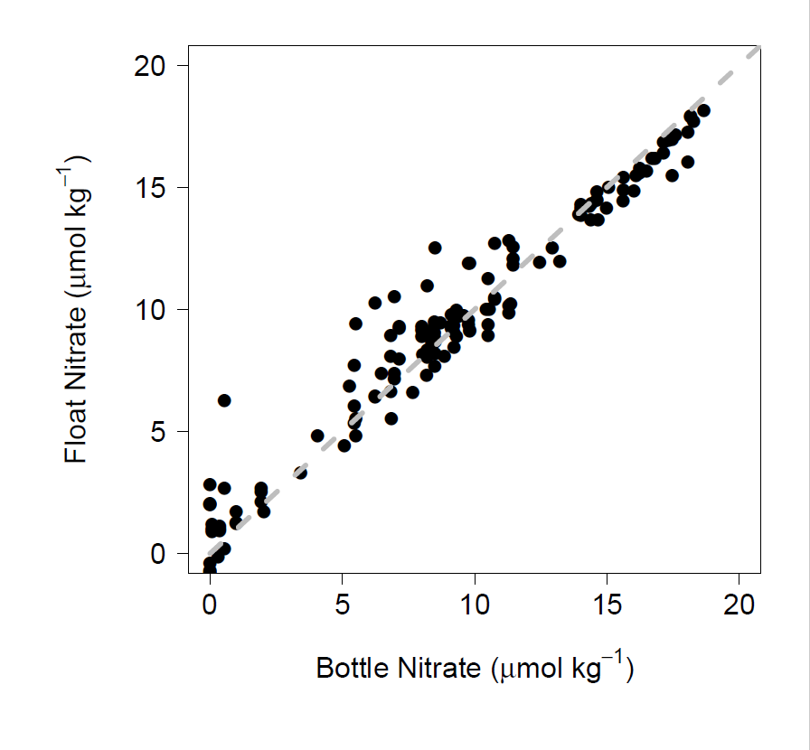
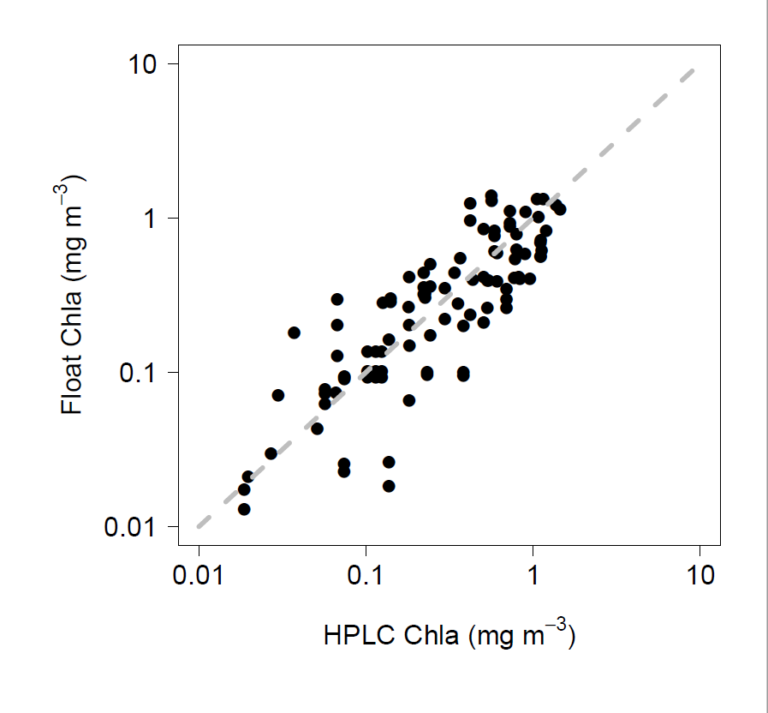

Figure S1: Pro-Ice Comparison Figure S2: Pro-Ice Comparison
HPLC Chla / Float Chla Bottle Nitrate / Float Nitrate (Suna)

