Are non-reef habitats as important to benthic diversity and composition as coral reef and rubble habitats in submarine canyons? Analysis of controls on benthic megafauna distribution in the Porcupine Bank Canyon, NE Atlantic

Appah J. K. M. *^{a)}, Lim, A. ^{a)}, Harris K. ^{a)}, O’ Riordan R. ^{a)}, O’Reilly L. ^{a)}, Wheeler A. J. ^{a, b)}
^{a)} School of Biological, Earth and Environmental Sciences / Environmental Research Institute, University College Cork, Distillery Fields, North Mall, Cork, Ireland

^{b)} Irish Centre for Research in Applied Geosciences / Marine & Renewable Energy Institute (MaREI), University College, Cork

Corresponding author*: john.appah@ucc.ie
Abstract
Submarine canyons support high biomass communities as they act as conduits where sediments, nutrients and organic matter from continental shelves, or those that are carried along by slope currents, are transported into the abyssal zone. The Porcupine Bank Canyon (PBC), located on the Irish continental margin and isolated from terrigenous inputs, reveals a complex terrain and substrate variation that affect the distribution of benthic fauna. Here, ROV-based benthic video, Conductivity-Temperature-Depth (CTD), current velocity profiles, suspended particulate organic matter (POM) and bathymetric data were assessed to determine the controls on the distribution of benthic megafauna throughout the canyon. Multivariate analysis of the benthic community reveals significant differences in community structure among habitats and site locations throughout the canyon. Furthermore, these results show that non-reef habitats exhibit more variation in the composition of benthic taxa than coral reef and rubble habitats, with the following species contributing most to the structural differentiation between habitats: Leiopathes glaberrima (12.46%), Hexadella dendritifera (10.37%), Cidaris cidaris (9.31%), Aphrocallistes beatrix (9.33%), Areaosoma fenestratum (9.11%), Stichopathes cf. abyssicola (7.39%), Anthomastus glandiflorus (4.66%) and Benthogonea rosea (3.84%). In addition, greater diversity, taxa evenness and high abundance of motile fauna were observed in non-reef habitat and the canyon flank. Seabed terrain features (depth, slope) are the most important environmental drivers that affect benthic taxa distribution while site locations and habitat type are the categorical variables that influence taxa distribution in the PBC. The highest mean current speed was observed on the canyon flank where the highest Shannon’s diversity was recorded while mean current speed ranged from 18.2 - 31.3 cm s⁻¹. As the PBC is cut off from direct terrigenous input, this research contributes to understanding cold-water coral habitat responses to natural Northeast Atlantic environmental conditions. The findings of the current study will inform key stakeholders on how to responsibly interact with the canyon benthic habitats and can help inform policy makers on the effective conservation and management of the cold-water coral habitat in the PBC and other canyons.

Keywords: Biodiversity, Porcupine Bank Canyon, POM, cold-water coral, non-reef habitat, species distribution, habitat variability

Supplementary Materials
- Supplementary Figures

Supplementary Figure 1 | A map showing the area of the Porcupine Bank Canyon and the Southwest Porcupine Bank designated as special area of conservation (SAC) (demarcated by red polygon). Coordinates of area of PBC designated as SAC are listed in Supplementary Table 5 (as a separate excel file).

Supplementary Figure 2 | Benthic taxa in the PBC. Scale bar = 10 cm: A) Opisthoteuthis agassizii B) Porifera sp. C) Crinoid D) Kophobelemnon sp. E) Geodia sp. F) Leiopathes glaberrima G) Chrysogorgia sp. H) Pennatula sp. I) Bathypathes sp. J) Hexadella dendritifera K) Anthomastus glandiflorus L) Araeosoma fenestratum

Supplementary Figure 3 | Benthic taxa in the PBC. Scale bar = 10 cm: A) Pliobothrus symmetricus B) Asteroidea sp. C) Lophelia pertusa

Supplementary Figure 4 | Benthic taxa in the PBC. Scale bar = 10 cm: A) Unidentified sp. B) Euplectellid sp. C) Asteroidea sp. D) Actinaria sp. E) Chaecon affinis. F) Aphrocallistes beatrix G) Ascidian sp. H) Asteroidea sp I) Bathypathes sp. with squat crab J) Porania sp K) Decapoda sp L) Stichopathes cf. abyssicola M) Paramuricea sp.

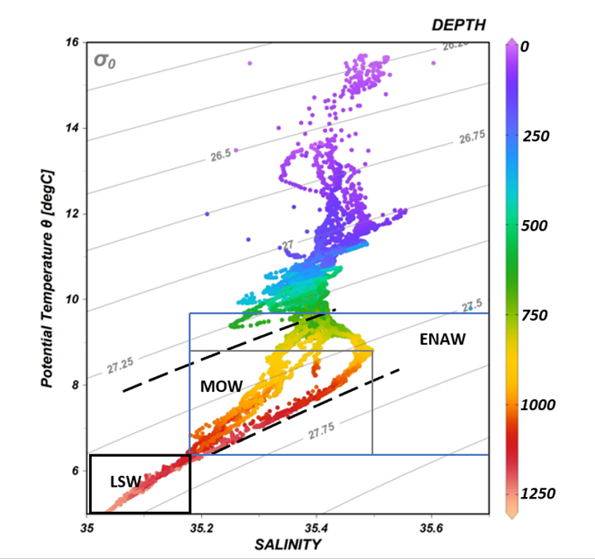

Supplementary Figure 5 | T-S plot of CTD data with density contours to characterise the water mass properties through a 1200 m depth from the surface water in the PBC: ENAW (Eastern North Atlantic Water), MOW (Mediterranean Outflow Water, LSW (Labrador Sea Water). Space between broken lines reveal the predicted density envelope for NE Atlantic CWCs (Dullo et al., 2008).

Supplementary Figure 6 | Particulate organic matter distribution in the Porcupine Bank Canyon (PBC).

Supplementary Figure 7 | Lophelia pertusa mean percentage cover among site locations in the PBC. A significant (P < 0.05) difference between the canyon south and flank was observed. The sample size for canyon flank, head and south are 555, 612 and 656 respectively.

Supplementary Figure 8 | Seabed types that exist in the PBC and identified evidence of human activities, scale bar = 10 cm: A) sediment & dropstone (SD) (n = 84), B) sediment (S) (n = 867), C) bedrock (B) (n = 141), D) live/dead coral (DL) (n = 65), E) coral rubble (R) (n = 666), F) fishing line, G) metal fish trap, H) tool marks (837 m), I) tool marks (774 m)

- Supplementary Tables

Supplementary Table 1 | ROV transects in the PBC, length (km), mean depth and depth range and date for each transect
Video lines | Depth range | Mean depth | Length | video lines |  | Date of dive
 | (m) | (m) | (km) | Start (Lat/Long) | End (Lat/Long)
5 | 582 - 1019 | 822 | 5.02 | 52.2004755 | 52.2162493 | 23/06/2017
 |  |  |  | -14.8749045 | -14.8134502
4 | 582 - 1054 | 936 | 8.43 | 52.2199477 | 52.2587293 | 22/06/2017
 |  |  |  | -14.9410820 | -14.8434248
8 | 654 - 1233 | 936 | 2.56 | 52.1160897 | 52.1049630 | 24/06/2017
 |  |  |  | -14.9035102 | -14.8781872
7 | 709 - 1039 | 878 | 1.78 | 52.1418340 | 52.1340797 | 23/06/2017
 |  |  |  | -14.8656937 | -14.8478487
10 | 695 - 1231 | 905 | 1.73 | 52.0417677 | 52.0307722 | 24/06/2017
 |  |  |  | -14.9472790 | -14.9295458
11 | 681 - 1008 | 789 | 3.20 | 51.9872062 | 51.9817048 | 24/06/2017
 |  |  |  | -15.0386897 | -14.9956017
12 | 704 - 1020 | 813 | 0.46 | 52.0060868 | 52.0037287 | 25/06/2017
 |  |  |  | -14.9961498 | -14.9907723
16 | 760 - 967 | 903 | 0.39 | 51.9479248 | 51.9468131 | 26/06/2017
 |  |  |  | -15.0758619 | -15.0706514
20 | 701 - 972 | 827 | 0.78 | 51.9920744 | 51.9866632 | 26/06/2017
 |  |  |  | -15.0246131 | -15.0175038
21 | 762 - 995 | 849 | 0.35 | 51.9966081 | 51.9949090 | 26/06/2017
 |  |  |  | -15.0090888 | -15.0072242
21a | 740 - 922 | 793 | 0.31 | 51.9955653 | 51.9935245 | 27/06/2017
 |  |  |  | -15.0073699 | -15.0042819
22 | 686 - 1021 | 790 | 0.64 | 52.0124273 | 52.0094863 | 27/06/2017
 |  |  |  | -14.9877423 | -14.9797737
23 | 729 - 1026 | 860 | 0.32 | 52.0196988 | 52.0183787 | 27/06/2017
 |  |  |  | -14.9786440 | -14.9746790
19 | 715 - 969 | 782 | 0.68 | 51.9756827 | 51.9722080 | 26/06/2017
 |  |  |  | -15.0473160 | -15.0391987
15 | 622 - 1070 | 744 | 9.11 | 51.7817563 | 51.7818997 | 26/06/2017
 |  |  |  | -15.0542793 | -14.9290390
14 | 567 - 1039 | 769 | 4.37 | 51.8159363 | 51.8229947 | 25/06/2017
 |  |  |  | -15.0136093 | -14.9559127
13 | 596 - 1043 | 772 | 6.68 | 51.8571415 | 51.8840042 | 25/06/2017
 |  |  |  | -15.0047455 | -14.9196713

Supplementary Table 2 | Seabed classification system used for this study
Seafloor type | % cell coverage | Environment
Live/dead coral (DL) | >50% cell coverage | Coverage with observable living or dead parts
Coral rubble (R) | >60% cell coverage | Coverage with observable biogenic materials
Sediment & dropstone (SD) | >60% cell coverage | Coverage with observable dropstones
Sediment (S) | >90% cell coverage | Coverage with no observable biogenic material and dropstones
Bedrock (B) | >60% cell coverage | Coverage with observable bedrock

Supplementary Table 4 | Seawater samples from the PBC collected on 08-08-2018 showing Time (UTC), station number, sample depth and coordinates
Time | Station number | Sample depth (m) | Lat | Long
6.45am | 61 | 599 | 52°13.295 | 14°52.569
6.45am | 61 | 550 | 52°13.298 | 14°52.572
7.52am | 62 | 519 | 52°05.66 | 14°51.61
9.16am | 63 | 894 | 52°03.82 | 15°00.50
9.16am | 63 | 992 | 52°03.81 | 15°00.49
9.16am | 63 | 695 | 52°03.84 | 15°00.52
9.16am | 63 | 1050 | 52°03.80 | 15°00.48
9.16am | 63 | 592 | 52°03.85 | 15°00.53
9.16am | 63 | 795 | 52°03.83 | 15°00.51
12.52pm | 65 | 797 | 51°56.69 | 15°05.96
12.52pm | 65 | 994 | 51°56.67 | 15°05.94
12.52pm | 65 | 599 | 51°56.71 | 15°05.98
12.52pm | 65 | 895 | 51°56.68 | 15°05.95
12.52pm | 65 | 697 | 51°56.70 | 15°05.97
15.37pm | 66 | 696 | 51°49.68 | 15°01.24
15.37pm | 66 | 994 | 51°49.65 | 15°01.21
15.37pm | 66 | 597 | 51°49.69 | 15°01.25
15.37pm | 66 | 894 | 51°49.66 | 15°01.22
15.37pm | 66 | 796 | 51°49.70 | 15°01.26
21.36pm | 42 | 1093 | 51°49.66 | 15°01.13
21.36pm | 42 | 993 | 51°49.66 | 15°01.13
21.36pm | 42 | 843 | 51°49.66 | 15°01.13
21.36pm | 42 | 747 | 51°49.66 | 15°01.13
21.36pm | 42 | 599 | 51°49.66 | 15°01.13
7.58am | 43 | 1044 | 52°03.88 | 15°00.77
7.58am | 43 | 976 | 52°03.88 | 15°00.77
7.58am | 43 | 849 | 52°03.88 | 15°00.77
8.05am | 43 | 750 | 52°03.88 | 15°00.78
8.08am | 43 | 620 | 52°03.88 | 15°00.77
8.10am | 43 | 560 | 52°03.88 | 15°00.77
10.04am | 44 | 892 | 52°13.23 | 14°52.52
10.06am | 44 | 850 | 52°13.23 | 14°52.52
10.08am | 44 | 750 | 52°13.23 | 14°52.52
10.09am | 44 | 630 | 52°13.23 | 14°52.52
10.12am | 44 | 580 | 52°13.23 | 14°52.52
10.12am | 44 | 490 | 52°13.23 | 14°52.52

