P53

Bax
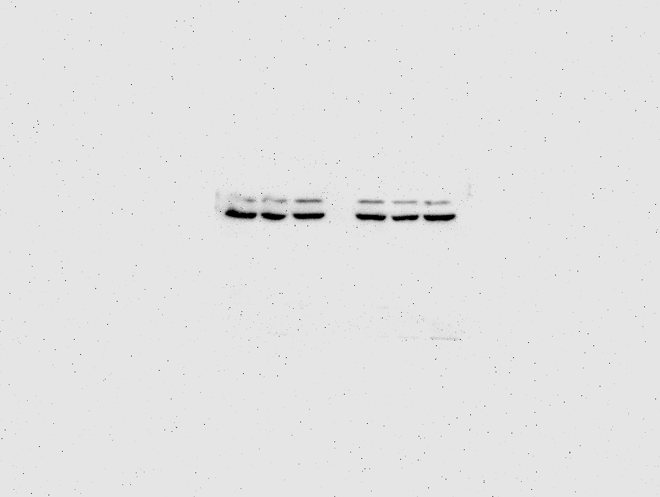
Actin (after p53 was stripped with stripping buffer)

Bcl-2

Supplemental Fig.1 Full image of western blotting bands for p53 and its internal control actin shown in Figure 7F. Membrane was pre-cut according to the molecular weight of p53 and Bax. After p53 (or Bax) staining, the membrane was stripped with stripping buffer and reprobed with the actin antibody (or Bcl-2).
Note that the remanant obscure p53 band was seen right above the actin band.

