Supplementary Material

Supplementary Figures and Tables
Supplementary Table 1. Specimens assessed for tooth and jaw development, institutions and sexes. MTUM= Michigan Technological University Museum collection of Isle Royale moose ROM=Royal Ontario Museum collection.

Specimen No. | Institution | Birth Year | Sex
136 | MTUM | 1959 | male
215 | MTUM | 1959 | male
229 | MTUM | 1959 | female
332 | MTUM | 1959 | male
333 | MTUM | 1962 | male
334 | MTUM | 1962 | female
336 | MTUM | 1962 | male
349 | MTUM | 1961 | male
427 | MTUM | 1962 | female
452 | MTUM | 1962 | male
460 | MTUM | 1960 | male
504 | MTUM | 1962 | male
506 | MTUM | 1961 | male
555 | MTUM | 1962 | male
557 | MTUM | 1962 | female
564 | MTUM | 1963 | male
566 | MTUM | 1963 | male
600 | MTUM | 1961 | male
663 | MTUM | 1962 | male
680 | MTUM | 1962 | male
873 | MTUM | 1970 | female
1067 | MTUM | 1959 | male
1071 | MTUM | 1971 | male
1092 | MTUM | 1970 | male
1193 | MTUM | 1973 | male
1518 | MTUM | 1972 | male
1526 | MTUM | 1972 | male
1543 | MTUM | 1976 | male
1548 | MTUM | 1970 | male
1582 | MTUM | 1972 | male
1753 | MTUM | 1972 | NA
1827 | MTUM | 1972 | NA
1850 | MTUM | 1972 | NA
1854 | MTUM | 1972 | male
1857 | MTUM | 1972 | male
1880 | MTUM | 1972 | female
1885 | MTUM | 1972 | male
1902 | MTUM | 1972 | male
1933 | MTUM | 1972 | female
1960 | MTUM | 1972 | male
1964 | MTUM | 1972 | male
2003 | MTUM | 1972 | male
2067 | MTUM | 1986 | male
2070 | MTUM | 1986 | male
2073 | MTUM | 1986 | male
2084 | MTUM | 1977 | male
2089 | MTUM | 1981 | male
2097 | MTUM | 1985 | male
2108 | MTUM | 1982 | male
2109 | MTUM | 1979 | male
2141 | MTUM | 1986 | male
2142 | MTUM | 1977 | male
2144 | MTUM | 1979 | male
2163 | MTUM | 1978 | female
2172 | MTUM | 1982 | male
2185 | MTUM | 1979 | male
2188 | MTUM | 1980 | male
2228 | MTUM | 1978 | male
2229 | MTUM | 1978 | male
2230 | MTUM | 1982 | male
2234 | MTUM | 1978 | male
2247 | MTUM | 1982 | male
2276 | MTUM | 1985 | male
2282 | MTUM | 1979 | male
2295 | MTUM | 1981 | male
2299 | MTUM | 1985 | female
2318 | MTUM | 1981 | male
2319 | MTUM | 1981 | male
2326 | MTUM | 1980 | male
2327 | MTUM | 1980 | male
2351 | MTUM | 1982 | male
2370 | MTUM | 1981 | male
2372 | MTUM | 1980 | male
2427 | MTUM | 1983 | male
3510 | MTUM | 1997 | male
4046 | MTUM | 1993 | NA
4048 | MTUM | 1993 | male
4050 | MTUM | 1992 | male
4054 | MTUM | 1993 | male
4055 | MTUM | 1992 | male
4057 | MTUM | 1993 | female
4060 | MTUM | 1995 | male
4066 | MTUM | 1993 | male
4070 | MTUM | 1993 | female
4072 | MTUM | 1986 | male
4073 | MTUM | 1992 | male
4074 | MTUM | 1989 | male
4077 | MTUM | 1993 | male
4080 | MTUM | 1990 | male
4081 | MTUM | 1988 | female
4085 | MTUM | 1992 | male
4086 | MTUM | 1996 | male
4087 | MTUM | 1989 | female
4089 | MTUM | 1990 | male
4093 | MTUM | 1989 | male
4163 | MTUM | 1997 | NA
4176 | MTUM | 1996 | male
4204 | MTUM | 1992 | NA
4205 | MTUM | 2003 | NA
4237 | MTUM | 1998 | male
4244 | MTUM | 1998 | male
4259 | MTUM | 1996 | male
4289 | MTUM | 1999 | NA
4293 | MTUM | 1997 | female
4310 | MTUM | 2001 | NA
4320 | MTUM | 2000 | male
4324 | MTUM | 2006 | female
4329 | MTUM | 1997 | male
4330 | MTUM | 1997 | male
4333 | MTUM | 1998 | female
4338 | MTUM | 1999 | male
4348 | MTUM | 1997 | NA
4356 | MTUM | 2000 | female
4406 | MTUM | 1999 | male
4410 | MTUM | 1997 | male
4415 | MTUM | 1997 | male
4419 | MTUM | 1997 | male
4422 | MTUM | 1999 | male
4424 | MTUM | 1997 | male
4436 | MTUM | 1997 | NA
4445 | MTUM | 1997 | male
4446 | MTUM | 1997 | male
4451 | MTUM | 1992 | male
4454 | MTUM | 1998 | male
4457 | MTUM | 1999 | male
4459 | MTUM | 2001 | NA
4467 | MTUM | 1993 | male
4505 | MTUM | 1999 | male
4529 | MTUM | 1997 | male
4531 | MTUM | 1998 | female
4534 | MTUM | 2000 | male
4537 | MTUM | 1996 | male
4548 | MTUM | 1996 | male
4552 | MTUM | 2005 | male
4565 | MTUM | 1999 | NA
4570 | MTUM | 1999 | NA
4575 | MTUM | 1999 | NA
4615 | MTUM | 1991 | NA
4649 | MTUM | 2002 | NA
4686 | MTUM | 1999 | NA
4706 | MTUM | 2003 | NA
4766 | MTUM | 2005 | NA
4959 | MTUM | 2003 | NA
16387 | ROM | 1945 | male
16683 | ROM | 1946 | male
18399 | ROM | NA | male
18413 | ROM | 1947 | female
18445 | ROM | 1947 | male
18451 | ROM | 1947 | male
18471 | ROM | 1947 | male
18512 | ROM | 1947 | male
18516 | ROM | 1947 | male
18847 | ROM | 1948 | female
18850 | ROM | 1948 | male
18851 | ROM | 1948 | male
18860 | ROM | 1948 | female
19293 | ROM | NA | male
19294 | ROM | NA | male
19329 | ROM | 1948 | male
19338 | ROM | 1948 | male
19341 | ROM | 1949 | male
19356 | ROM | 1948 | male
19366 | ROM | 1948 | male
19367 | ROM | 1948 | male
19460 | ROM | NA | male
19491 | ROM | 1949 | male
19516 | ROM | NA | male
19524 | ROM | NA | male
19551 | ROM | 1947 | male
19601 | ROM | 1949 | male
19912 | ROM | NA | male
19912 | ROM | 1949 | male
19957 | ROM | 1949 | male
19973 | ROM | NA | female
19990 | ROM | 1949 | male
20195 | ROM | 1950 | male
20327 | ROM | 1950 | female
25910 | ROM | NA | NA
25911 | ROM | 1953 | male
25912 | ROM | NA | female
25912 | ROM | 1953 | male
25913 | ROM | 1953 | male
25914 | ROM | 1953 | male
25915 | ROM | 1953 | male
25916 | ROM | NA | male
25916 | ROM | 1953 | female
25917 | ROM | NA | male
25917 | ROM | 1953 | male
25918 | ROM | NA | male
25918 | ROM | 1953 | male
25919 | ROM | NA | male
25919 | ROM | 1953 | female
25920 | ROM | 1953 | male
33889 | ROM | 1951 | male
101559 | ROM | 1953 | male
101560 | ROM | NA | male
101569 | ROM | 1952 | male
101590 | ROM | NA | male
101602 | ROM | NA | male
101653 | ROM | NA | male
101667 | ROM | 1951 | male
101696 | ROM | NA | male
101736 | ROM | NA | male
101763 | ROM | 1953 | male
101769 | ROM | NA | male
101785 | ROM | NA | male
101789 | ROM | NA | male
101831 | ROM | 1951 | male
101834 | ROM | NA | male
115-53 | ROM | NA | NA
126-53 | ROM | NA | NA
14-23-25-1 | ROM | 1953 | NA
239-53 | ROM | NA | NA
99-53 | ROM | NA | NA

Supplementary Table 2. General linear models, log likelihood, and AIC scores organized by skeletal measure and sex. Analysis was performed in R 4.0.0 using the RRPP package (Collyer and Adams 2019). Models with the greatest loglikelihood and two models with similar AIC and log likelihood scores to the best model are presented here with their summary statistics. POP= Population density at year of birth. NAO= North Atlantic Oscillation value, our climate proxy. AGE=numeric age in years. WLF= Wolf density at year of birth
Group | Model | Source | Log Likelihood | AIC | R2 | Model Intercept | Model Coefficients | Standard Errors | t Values | F Statistic
Female DEH | logPOP + logNAO | RRPP | -99.578 | 207.156 | 0.007 | -2.957 | 0.553 0.3 | 1.361 0.571 | 0.498 0.527 | 0.249
 | logPOP | RRPP | -100.610 | 207.221 | 0.069 | -2.824 | 0.637 | 1.344 | 0.474 | 0.224
 | logPOP + logAGE + logWLF | RRPP | -99.776 | 209.552 | 0.011 | 3.596 | -0.613 -0.052 -1.41 | 1.55 1.126 1.854 | -0.395 -0.047 -0.763 | 0.212
Female Metatarsus | logPOP + logAGE | RRPP | 50.336 | -92.672 | 0.150 | 5.93 | -0.024 0.011 | 0.014 0.006 | -1.571 1.755 | 2.358
 | logAGE + logWLF | RRPP | 50.400 | -92.800 | 0.102 | 5.873 | 0.009 0.11 | 0.006 0.013 | 1.499 0.861 | 1.424
 | logPOP + logAGE + logNAO | RRPP | 50.473 | -90.946 | 0.102 | 5.92 | -0.003 -0.023 0.021 | 0.025 0.034 0.054 | -0.128 1.471 1.416 | 1.636
Female Mandible | logAGE + logWLF | RRPP | 787.260 | -1566.520 | 0.142 | 5.730 | 0.04*** 0.01 | 0.0054 0.008 | 7.373 1.159 | 29.99***
 | logPOP + logAGE | RRPP | 787.215 | -1566.430 | 0.143 | 5.774 | -0.109 0.397 | 0.008 0.005 | -1.27 7.279 | 30.14
 | logPOP + logAGE + logWLF | RRPP | 787.645 | -1565.290 | 0.144 | 5.75 | -0.008 0.006 0.038*** | 0.01 0.01 0.005 | -.828 0.646 7.197 | 20.3***
Male DEH | logPOP + logWLF + logAGE | RRPP | -136.923 | 283.846 | 0.012 | -3.298 | -0.069 -1.073 -0.461 | 1.457 1.554 1.097 | -1.185 | 0.375
 | logAGE + logWLF | RRPP | -136.945 | 281.890 | 0.012 | 2.990 | -0.265 -0.128 | 0.358 0.445 | -0.739 -0.288 | 0.567
 | logPOP | RRPP | -138.163 | 282.327 | 0.027 | -3.475 | 1.747 | 1.101 | 1.587 | 2.518
Male Metatarsus | logPOP + logAGE | RRPP | 75.864 | -143.729 | 0.266 | 5.892 | -0.031 0.037 | 0.011 0.008 | -2.775 4.559 | 11.9***
 | logPOP + logWLF | RRPP | 75.667 | -143.334 | 0.127 | 5.802 | 0.001 0.0335 | 0.014 0.012 | 0.064 2.59 | 4.95**
 | logPOP + logWLF + logNAO | RRPP | 67.306 | -124.612 | 0.166 | 5.381 | 0.01 0.047** -0.008 | 0.022 0.022 0.006 | 0.745 2.956 -0.913 | 3.792*
Male Mandible | logAGE | RRPP | 787.117 | -1568.234 | 0.327 | 5.758 | 0.058*** | 0.004 | 13.27 | 176***
 | logPOP + logAGE + logNAO | RRPP | 789.959 | -1569.918 | 0.566 | 5.76 | -0.013 0.063*** 0.004 | 0.007 0.004 0.002 | -1.84 14.3 1.73 | 112.6***
 | logPOP + logAGE | RRPP | 789.959 | -1571.917 | 0.333 | 5.77 | -0.013 0.055*** | 0.007 0.004 | -1.716 12.331 | 169.2***
All Metatarsus | logPOP + logWLF + logAGE | RRPP | 121.924 | -233.848 | 0.194 | 5.834 | -0.007 0.019* 0.021*** | 0.008 0.007 0.005 | -0.834 2.459 4.023 | 9.403***
 | logPOP + logWLF | RRPP | 121.899 | -235.797 | 0.123 | 5.804 | 0.003 0.035*** | 0.01 0.009 | 0.34 3.84 | 8.851***
 | logAGE + logWLF | RRPP | 121.843 | -235.685 | 0.189 | 5.829 | 0.019*** 0.024** | 0.005 0.006 | 3.97 3.372 | 13.79***
All DEH | logPOP + logWLF | RRPP | -254.457 | 516.915 | 0.019 | -2.952 | -1.5 -0.144 | 0.89 1.043 | -0.714 1.685 -0.137 | 1.772
 | logAGE + logWLF | RRPP | -254.710 | 517.419 | 0.010 | 1.66 | 0.294 -1.194 | 0.677 0.956 | 0.435 -1.248 | 0.886
 | logPOP + logWLF + logAGE | RRPP | -254.457 | 518.915 | 0.010 | 1.88 | -0.115 -1.248 0.0325 | 1.04 1.07 0.7355 | -0.11 -1.16 0.443 | 0.591
All Mandible | logPOP + logAGE | RRPP | 1514.725 | -3021.450 | 0.198 | 5.78 | -0.014* 0.044*** | 0.006 0.004 | -1.3 12.73 | 93.84***
 | logPOP + logWLF + logAGE | RRPP | 1515.233 | -3020.466 | 0.202 | 5.743 | -0.004 0.011 0.044*** | 0.007 0.006 0.004 | -.699 1.84 12.418 | 63.88***
 | logAGE + logWLF | RRPP | 1514.950 | -3021.901 | 0.201 | 5.724 | 0.045*** 0.013* | 0.035 0.053 | 12.68 2.5 | 95.64***

Supplementary Figures

Supplementary Figure 1. Radiograph images of moose tooth development from birth to full adult dentition. Moose are born while the M1 crown is mineralizing; weaning occurs between 5 and 6 months of age while the M2 crown is mineralizing and the M3 is beginning to form. For additional radiographs, see Peterson (1950).

Supplemental Figure 2. Isle Royale dental enamel hypoplasia (DEH) morphologies, our assigned relative severity score, and a description of the ameloblast disruption that results in each morphology adapted from Witzel et al. 2006.
Hypoplastic Defect | Morphology | Score | Ameloblast Cohorts Affected
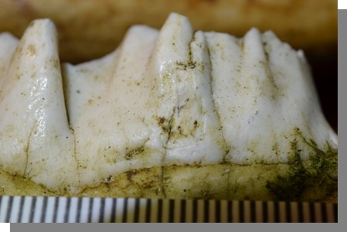 | Depression | 1 | Multiple; moderate impact and long duration
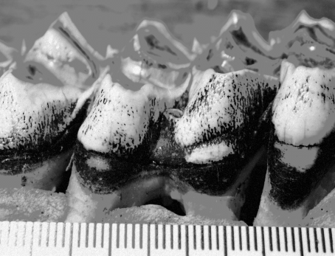 | Linear Enamel Hypoplasia (LEH), furrow morphology | 2 | Single; severe impact and very short duration
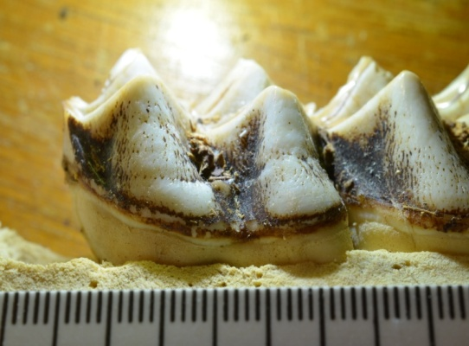 | Linear Enamel Hypoplasia (LEH), pit morphology | 2 | Single; severe impact and very short duration
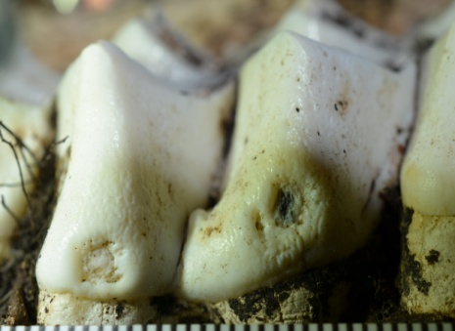 | Pit | 3 | Multiple; severe impact and short duration, thin enamel present on bottom of pit
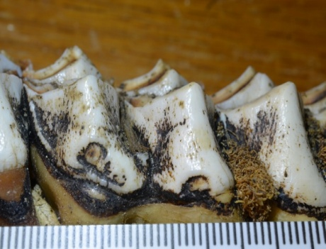 | Missing Enamel | 3 | Multiple; severe impact and short duration, enamel-secreting cells cease activity and tooth pulp (dentin) is exposed

Supplemental Figure 3. Anatomical landmarks used for mandible length measurements. The solid yellow line represents measured jaw length. Image adapted from the Isle Royale Wolf Project.

Supplemental Figure 4. The relationship between the North Atlantic Oscillation (NAO)--a proxy for winter severity--and surveyed skeletal and dental characters. The correlations between mandible length and population density during the birth year, gestation year and two years prior to birth were all weak and relatively noisy. A) NAO vs mandible length B) NAO vs total hypoplasia count C) NAO vs post-weaning hypoplasia count D) NAO vs metatarsus length.

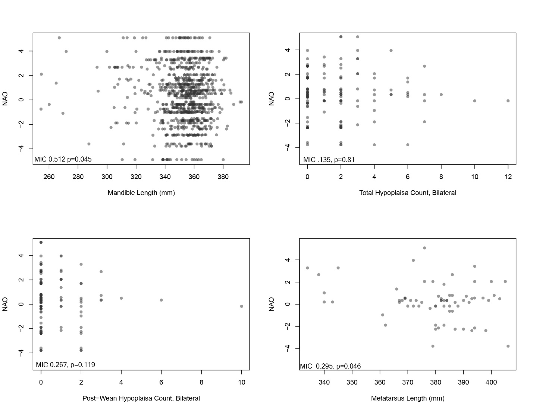

Supplemental Figure 5. Heatmap depiction of the relative risk of hypoplasia types between periods. Colors represent the risk of hypoplasia in the period on the y axis relative to the corresponding period on the x axis. Data plotted here can be found in table 2.3.
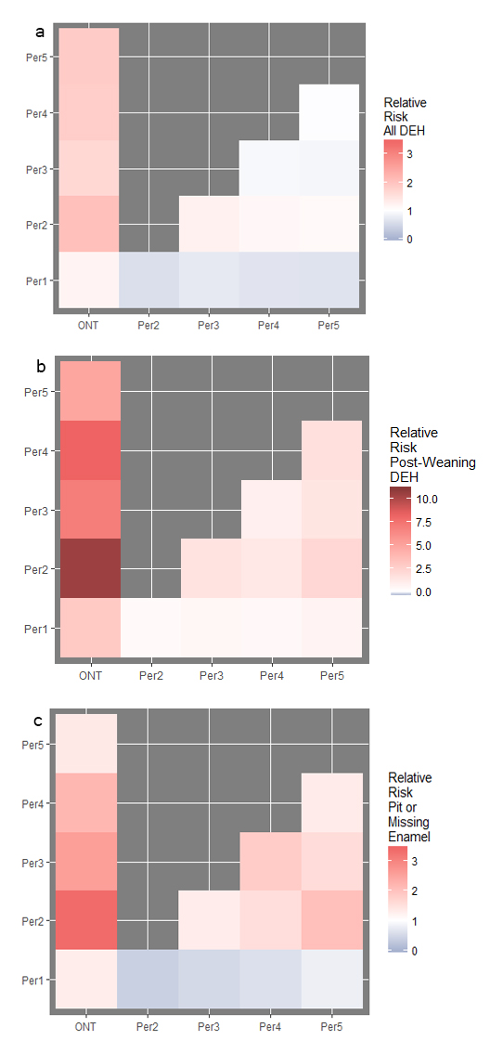
Collyer ML, Adams DC (2019). “RRPP: Linear Model Evaluation with Randomized Residuals in a Permutation Procedure. R package version 0.4.0.” https://CRAN.R-project.org/package=RRPP.

