Figure 1: Map of Tijuana and San Diego
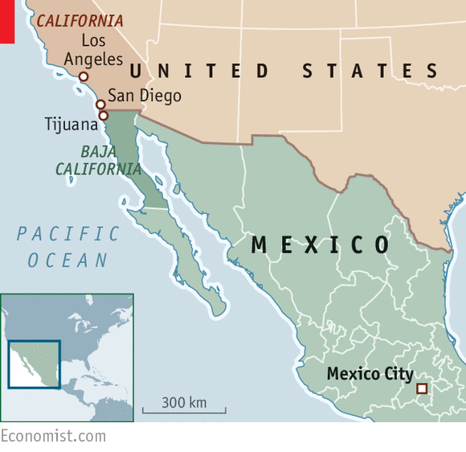
Source: The Economist. 2017. “How a Mexican Border City is reacting to President Trump” January 29. https://www.economist.com/the-americas/2017/01/29/how-a-mexican-border-city-is-reacting-to-president-trump

Figure 2: Strait of Gibraltar With Shipping Traffic
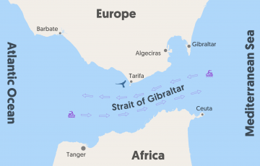
Source: https://www.firmm.org/en/strait-of-gibraltar

