Additional file 1:
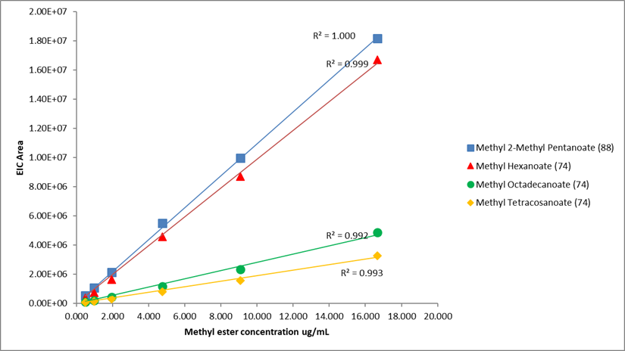
Figure S1 – Linearity of response of selected FAMEs in GC-MS analysis

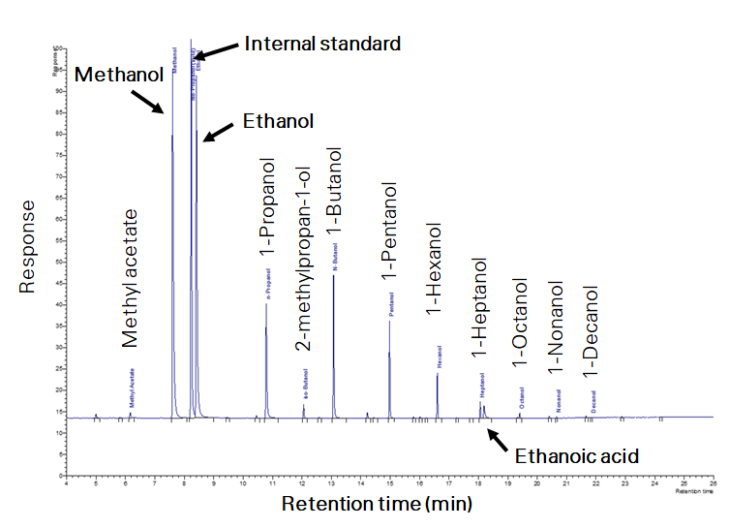
Figure S2: GC chromatogram of aqueous phase, Aq1
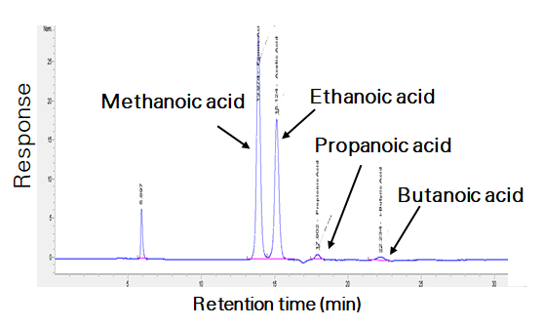
Figure S3 – HPLC chromatogram of aqueous phase, Aq1

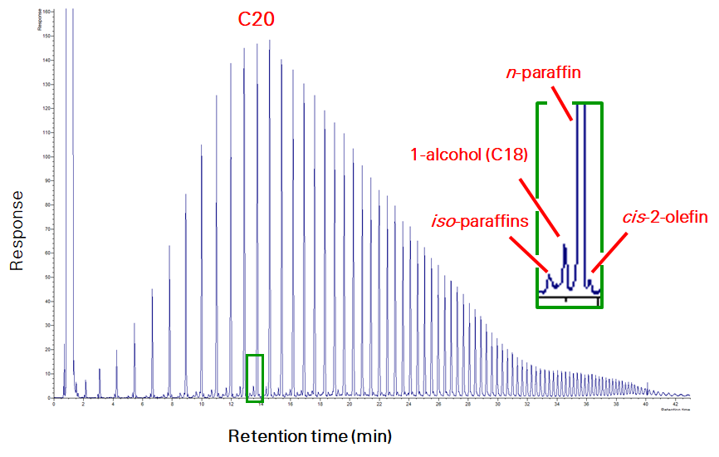
Figure S4 – 1D GC analysis of wax, Wax1, including expanded C₂₀ region of the chromatogram
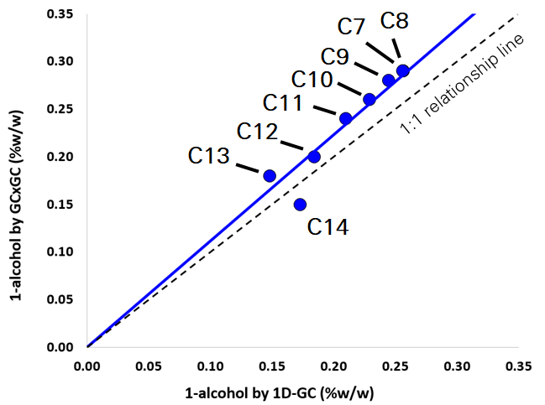
Figure S5 – Comparison of 1-alcohols in LHcL1 using 1D-GC and GCxGC, showing the 1:1 relationship expected as well as the linear regression fit to the data (forced to fit the origin)

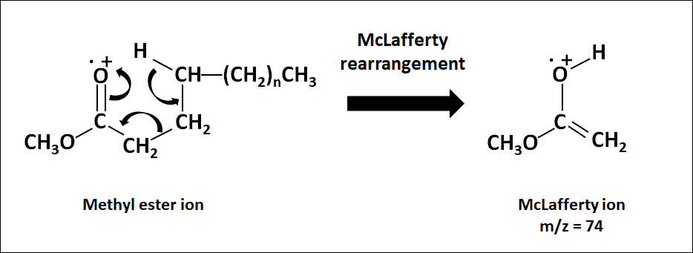
Figure S6 – McLafferty rearrangement of long chain methyl ester to form the McLafferty ion

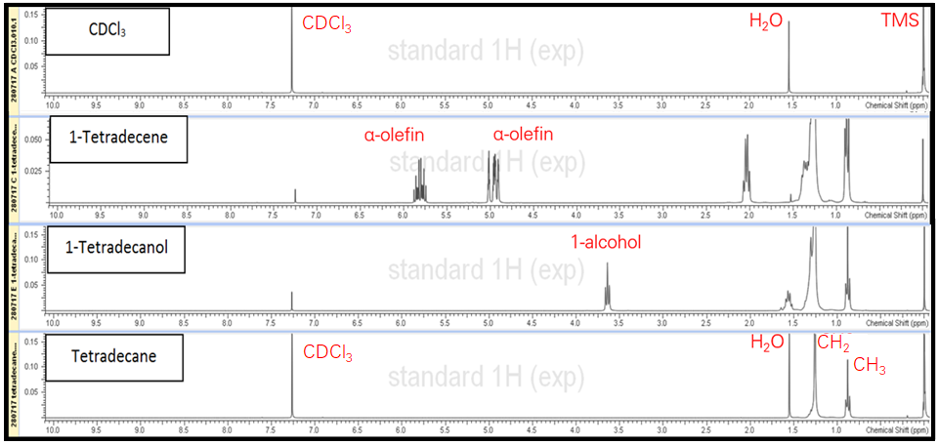
Figure S7 – ¹H NMR of C₁₄ standards, 1%w/w in CDCl₃

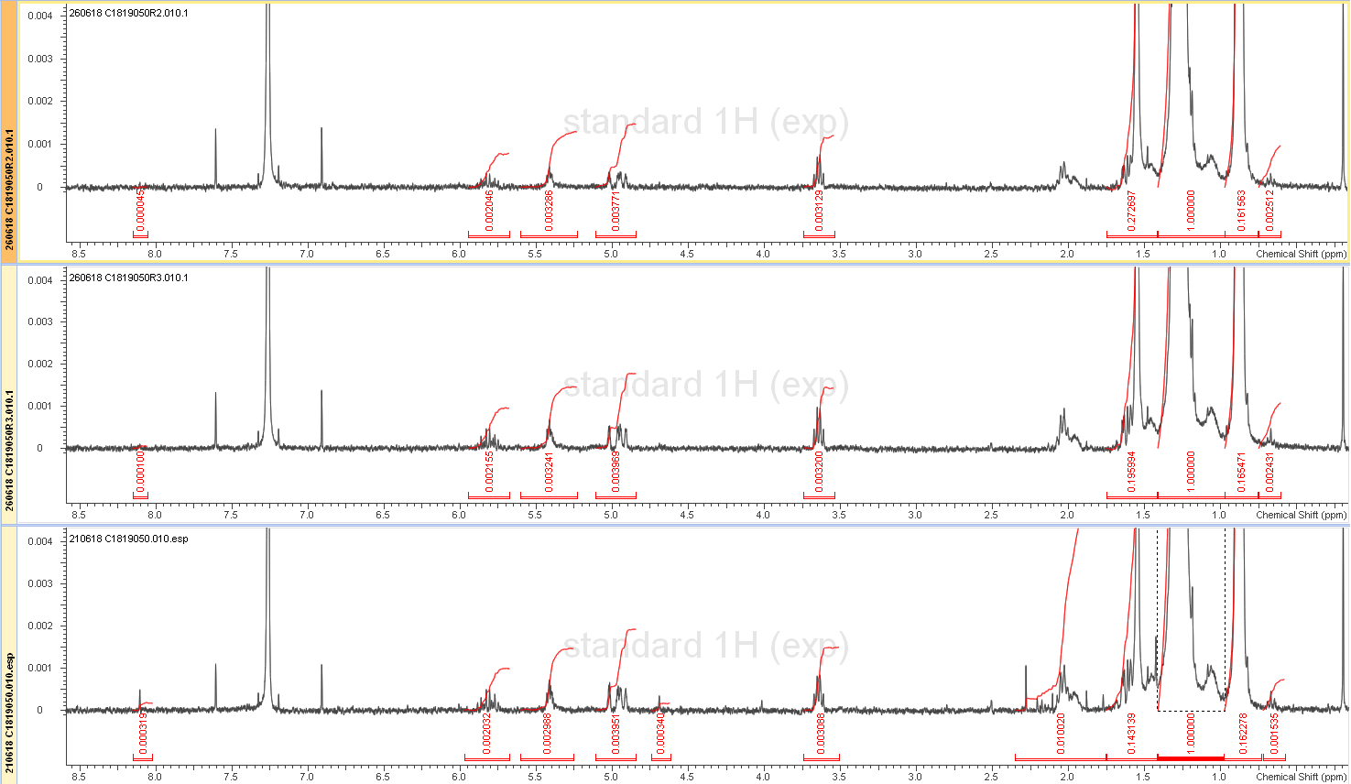
Figure S8 – Repeatability of ¹HMR analysis of a wax sample
The presence of a small amount of formate in ¹H NMR spectra shown in Figure S9, indicated by the peak at approximately 8.2ppm, was caused by a small level of contamination originating from the vial lid during solvation of the wax in the CDCl₃. This was an artefact and no formate was observed to be present in any further samples once this problem had been resolved.

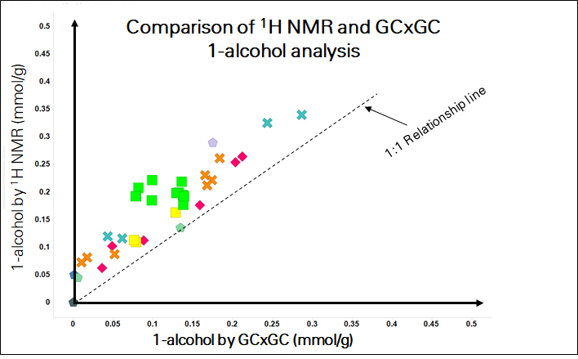Figure S9 – Comparison of ¹H NMR and GCxGC analysis of 1-alcohols in FT waxes and light hydrocarbons

Analyte | Relative Response |  |  |  |  |  |  |  |  |  | RSD %
 | Run 1 | Run 2 | Run 3 | Run 4 | Run 5 | Run 6 | Run 7 | Run 8 | Run 9 | Run 10
Methyl hexanoate | 1.091 | 1.106 | 1.101 | 1.101 | 1.109 | 1.108 | 1.093 | 1.123 | 1.122 | 1.134 | 1.2
Methyl Octanoate | 1.202 | 1.210 | 1.200 | 1.199 | 1.206 | 1.215 | 1.154 | 1.241 | 1.253 | 1.240 | 2.3
Methyl decanoate | 1.575 | 1.591 | 1.574 | 1.557 | 1.562 | 1.589 | 1.515 | 1.624 | 1.652 | 1.619 | 2.5
Methyl dodecanoate | 1.991 | 2.070 | 2.039 | 2.038 | 2.057 | 2.061 | 2.089 | 2.136 | 2.109 | 2.121 | 2.1
Methyl tetradecanoate | 2.456 | 2.480 | 2.465 | 2.453 | 2.462 | 2.467 | 2.600 | 2.566 | 2.528 | 2.529 | 2.1
Methyl hexadecanoate | 2.830 | 2.878 | 2.836 | 2.841 | 2.838 | 2.840 | 3.068 | 2.967 | 2.909 | 2.889 | 2.6
Methyl octadecanoate | 3.200 | 3.253 | 3.201 | 3.200 | 3.159 | 3.166 | 3.444 | 3.286 | 3.235 | 3.207 | 2.6
Methyl eicosanoate | 3.538 | 3.606 | 3.540 | 3.524 | 3.494 | 3.485 | 3.813 | 3.587 | 3.519 | 3.469 | 2.8
Methyl docosanoate | 3.876 | 3.929 | 3.893 | 3.865 | 3.831 | 3.811 | 4.191 | 3.927 | 3.827 | 3.748 | 3.1
Methyl tetracosanoate | 4.179 | 4.250 | 4.224 | 4.197 | 4.167 | 4.128 | 4.600 | 4.264 | 4.120 | 4.070 | 3.5
Table S1 – Relative standard deviation (RSD) established for FAME analyte response at a concentration of 10.0 µg mL⁻¹ over 10 analyses for the methyl esters of C₆ – C₂₄ carboxylic acids in GC-MS analysis

 | Recovered  µg/kg | Actual  µg/kg | Recovery  %
Hexanoic acid | 42 | 45 | 93
Decanoic acid | 53 | 50 | 106
Octadecanoic acid | 49 | 51 | 96
Table S2 – Recovery of carboxylic acid standards in GC-MS analysis

Carboxylic acid measured  as methyl ester | Concentration mg/kg
 | Preparation 1 | Preparation 2
Hexanoic acid | 34.9 | 33.5
Heptanoic acid | 45.5 | 45.9
Octanoic acid | 49.4 | 49.9
Nonanoic acid | 56.5 | 56.8
Decanoic acid | 60.0 | 61.1
Undecanoic acid | 62.7 | 64.4
Dodecanoic acid | 60.7 | 61.4
Tridecanoic acid | 50.1 | 50.8
Tetradecanoic acid | 37.0 | 37.7
Pentadecanoic acid | 23.5 | 24.0
Hexadecanoic acid | 26.0 | 24.4
Heptadecanoic acid | 8.81 | 8.77
Octadecanoic acid | 20.1 | 16.9
Nonadecanoic acid | 3.48 | 3.47
Icosanoic acid | 2.45 | 2.43
Henicosanoic acid | 1.56 | 1.54
Docosanoic acid | <1 | <1
Tricosanoic acid | <1 | <1
Tetracosanoic acid | <1 | <1
Pentacosanoic acid | <1 | <1
Hexacosanoic acid | <1 | <1
Heptacosanoic acid | <1 | <1
Octacosanoic acid | <1 | <1
Nonacosanoic acid | <1 | <1
Triacontanoic acid | <1 | <1
Table S3 – Example of a duplicate sample preparations of a liquid hydrocarbon for carboxylic acid analysis

C14 Standard | Average calculated carbon number | Average class compound group per carbon chain
 |  | 1-olefin | 2- olefin | 1-Alcohol
Tetradecane | 14.0 | 0.00 | 0.00 | 0.00
1-Tetradecene | 14.1 | 0.98 | 0.00 | 0.00
1-Tetradecanol | 13.5 | 0.00 | 0.00 | 0.98
Table S4 – ¹H NMR of C₁₄ standards, calculation of average carbon number and class compound per carbon chain

Wax sample replicate | Average carbon number | 1-olefin (mmol/g) | 2- olefin (mmol/g) | 1-alcohol (mmol/g)
A | 19.1 | 0.246 | 0.186 | 0.192
B | 19.0 | 0.235 | 0.204 | 0.195
C | 18.6 | 0.246 | 0.201 | 0.199
Table S5 – Concentration of class compounds in repeat analyses of a wax sample

Calculations using ¹H NMR peak integrations
The response of all protons in the ¹H NMR spectra were assumed to be constant and therefore the proportion of carbon atoms in different locations of the hydrocarbon structure and functional groups could be calculated. For example, if the Fischer-Tropsch product was a purely paraffinic product, being composed of only saturated linear chains, then the calculation of average carbon number, Nc, would simply be:
- Nc = $([Total C as CH2]/[Total C as CH3] )x2 +2$
The ¹H NMR inputs for the calculation of Nc would therefore be the intensity of the peaks associated with CH₂ and the terminal CH₃ which are assigned as F and G respectively in table 7. Considering the ratio of the protons on each carbon type the calculation becomes:
- Nc = $([3xF])/([G])+2$
However, since 1-olefin, 2-olefin, 1-alcohol and aldehyde functionalities were detected in the ¹H NMR analysis of the pilot plant products then the calculation becomes more complicated and the following equations should be used:
- Total C within chain, $X=[A]+[C]+[E]/2+[F]/2$
- Total C at chain ends$, Y=[B]/2+[C]/2+[D]/2+[G]/3+[H]$
- Nc = $2x([X]/[Y] )+2$
Since the peak due to the methyl at the chain end of the 2-olefin group, at ~1.6ppm, is close to that of water, which is present to some degree in the most CDCl₃ solvents, the accurate quantification of the contribution of this carbon is not possible. Therefore, the value of C is included again with an appropriate factor being applied, i.e. C/2. This then gives the contribution of the methyl chain end of the 2-olefin to the calculation of total chain ends, Y.
The concentration of functional groups, as mmol/g, is given by the following calculation.
- Concentration (mmol/g) $=\left[Mole fraction of functional group\right]x1000/[Average Mw of product]$
These units are chosen for quantification to allow for an accurate assessment rather than assuming each functional group is equally populated across the chain lengths, and then quoting these as mol%, which would certainly not be correct for the olefins. The appropriate number of carbon atoms contribution to the functionality group and the number of protons associated with these carbon atoms need to be considered in these calculations. For example, the calculation of 1-olefin calculation uses only the terminal CH2 group, that of the 2-olefin uses both CH parts of the olefinic double bond and the 1-alcohol uses the CH2 group associated with the terminal oxygenate functionality.
- Average Mw of product, W, $=[Nc]x([A]x13+[B/2]x14+[C]x13+[C/2]x15+[D/2]x31+[E/2]x14+[F/2]x14+[G/3]x15+[H]x29)/(([X]+[Y]) )$
- 1-olefin (mmol/g) $=(([B/2])x2/[Y])x1000/[W]$
- 2-olefin (mmol/g) $=(([C/2])x2/[Y])x1000/[W]$
- 1-alcohol (mmol/g) $=(([D/2])x2/[Y])x1000/[W]$

Calculations using ¹³C NMR peak integrations
The integration of the quantitative ¹³C NMR spectra, with peak assignments given in table 8 allows the average chain length and concentration of the specific groups to be calculated. Again, the functional group concentrations are given in units of mmolg⁻¹. For the calculation of the concentration the total intensity of the ¹³C NMR peaks associated with the functional group and the total number of carbon atoms contributing are used as inputs.
- Total C within chain, S $=\left[A\right]+\left[C\right]+\left[D\right]+\left[E\right]+\left[F\right]+\left[K\right]$
- Total C at chain ends, T $=\left[B\right]+\left[G\right]+\left[H\right]+\left[I\right]+[J]$
- Average carbon chain length, Nc2 $= 2x([S]/[T] )+2$
- Average Mw, V $=[Nc2]x(\left(\left[A\right]+\left[C\right]+\left[D\right]+\left[E\right]+\left[F\right]\right)x13+\left(\left[B\right]+\left[G\right]+[K])x14\right)+(\left[G\right]x17)+\left([H\right]+\left[I\right]+[J])x15))/([S]+[T])$
- 1-olefin (mmolg⁻¹)$= ((\left[A\right]+\left[B\right])/2)x1000/(\left[V\right])$
- 2-olefin (mmolg⁻¹) $((\left[C\right]+\left[D\right]+\left[E\right]+[F])/2)x1000/(\left[V\right])$
- 1-alcohol (mmolg⁻¹) $=[G]x1000/(\left[V\right])$

