Appendix A: Description of communities
To find communities of similar pages based on the number of links sites shared with each other, I used the following community-finding algorithms, which achieved the following modularity:
Table 1: Modularity for different community-finding algorithms
Algorithm | Modularity
Raghavan, Albert, and Kumara (2007) | 0.542
Clauset, Newman, and Moore (2004) | 0.669
Rosvall, Axelsson, and Berstrom (2009) | 0.633
Blondel, Guillaume, Lambiotte, and Lefebvre (2008) | 0.666
Pons and Latapy (2005) | 0.641

Therefore, I decided that the communities found following Clauset, Newman, and Moore (2004) best represent the distribution of communities within our network.
I found the following communities:

Largest community: moderate contra-refugee pages
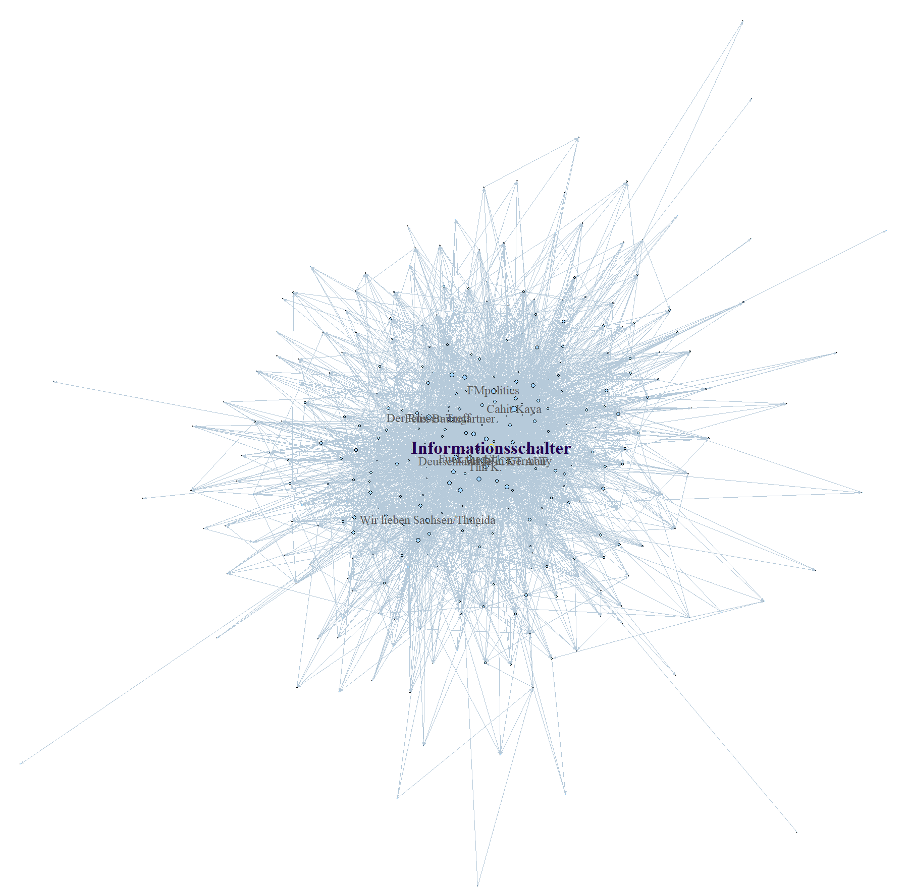
Figure 1: Moderate contra refugee community
This community consists of pages critical of Germany taking in refugees. The largest pages in this community are news aggregating groups like Informationsschalter, Deutschland DECKT AUF and Fuck the EU, and author pages of individuals like ex-Muslim Cahit Kaya and Tim K. This community also includes the activist group Thügida, an off-shoot of Pegida (see 7th largest community).

2nd largest community: far-left pro-refugee pages
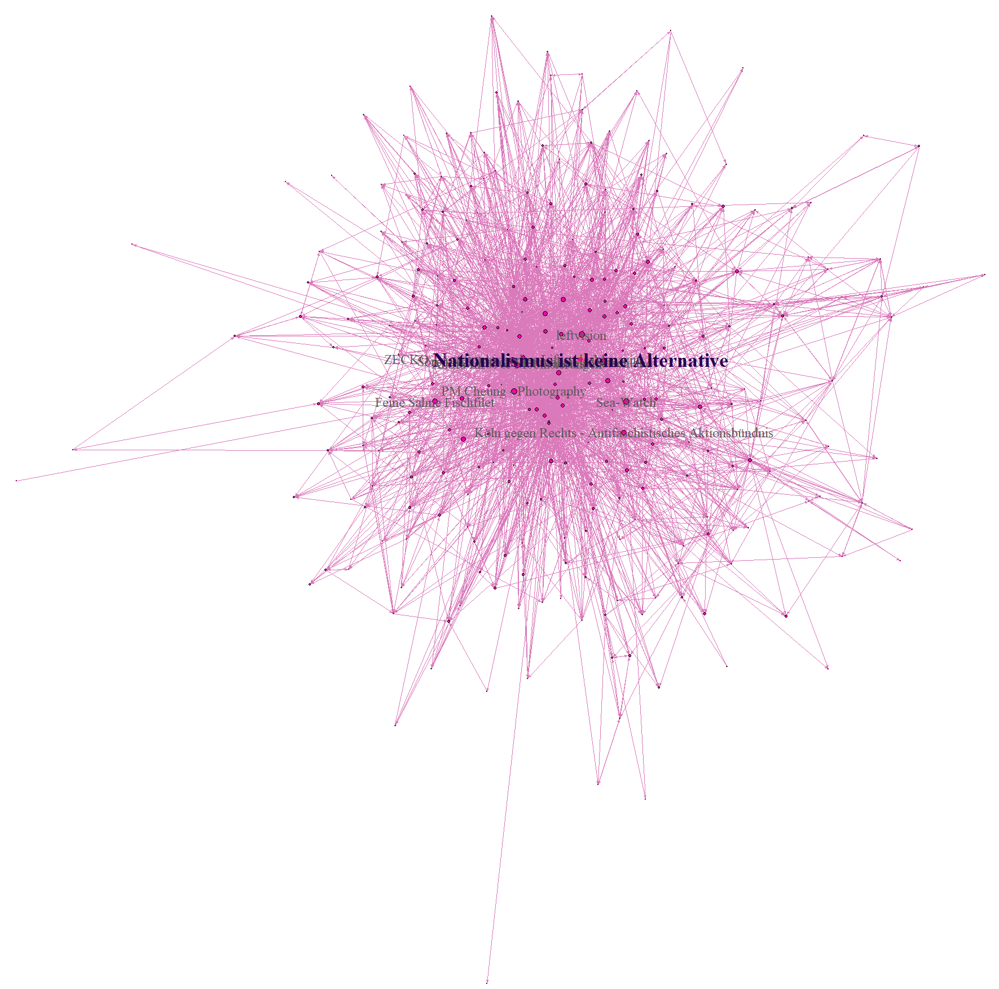
Figure 2: Far-left pro-refugee community
This community consists of far-left pro-refugee activist groups like Nationalismus ist keine Alternative, antifa groups, and anti-Nazi groups like Köln gegen Rechts, Berlin Nazifrei and Dresden Nazifrei.

3rd largest community: moderate pro-refuge pages
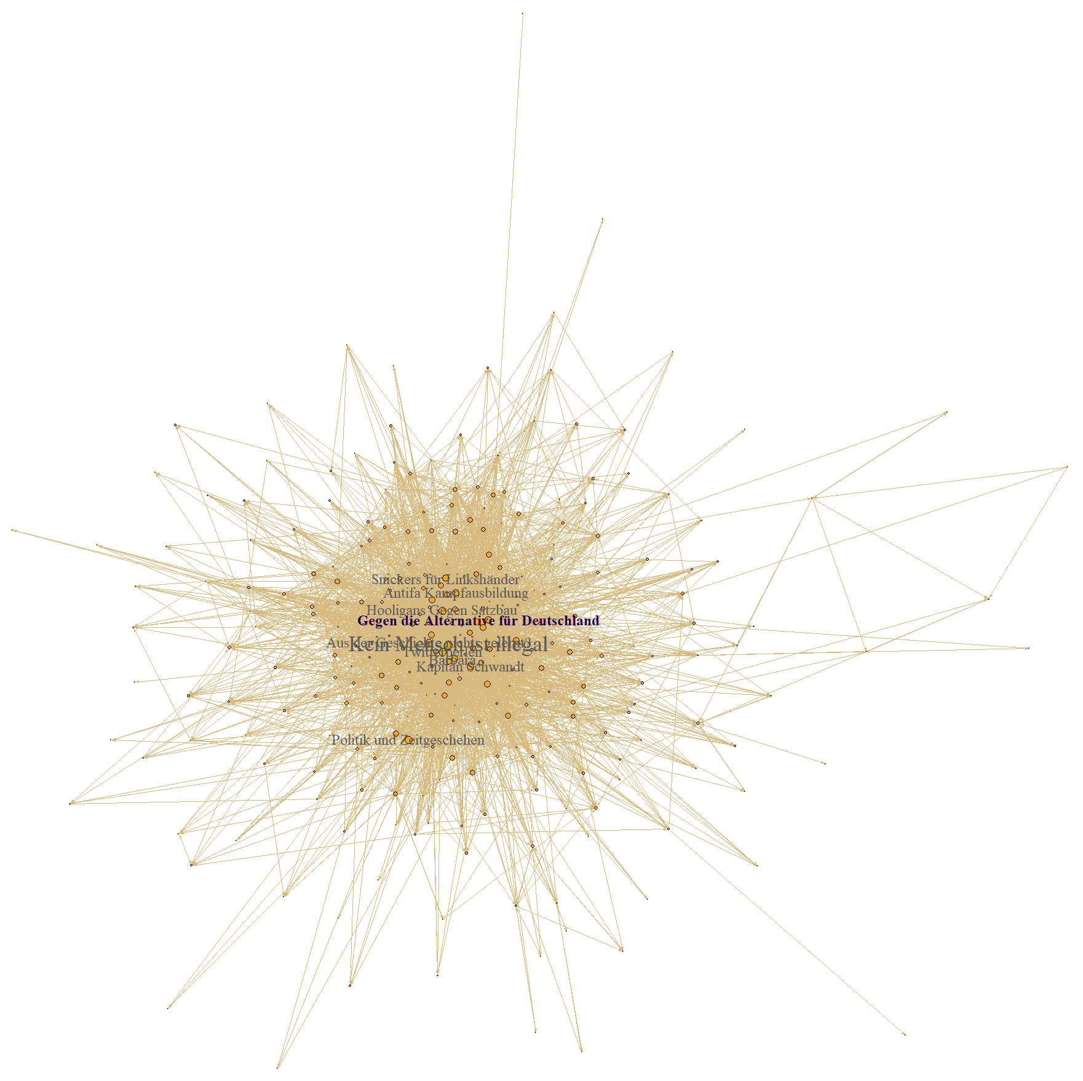
Figure 3: Moderate pro-refugee community
This community contains more moderate pro-refugee and anti-right-wing groups, including Kein Mensch ist illegal and Gegen die Alternative für Deutschland. A large number of pages have puns or humorous names, like Hooligans gegen Satzbau (Hooligans against grammar, a play on the name of right-wing group Hooligans against the Islamisation of Europe), Army of Gutmenschen Trollkommando (Army of do-gooder trolls), or Legasthenische Volksfront (Popular Front of Dyslexics).
4rth largest community: conspiracy theory pages
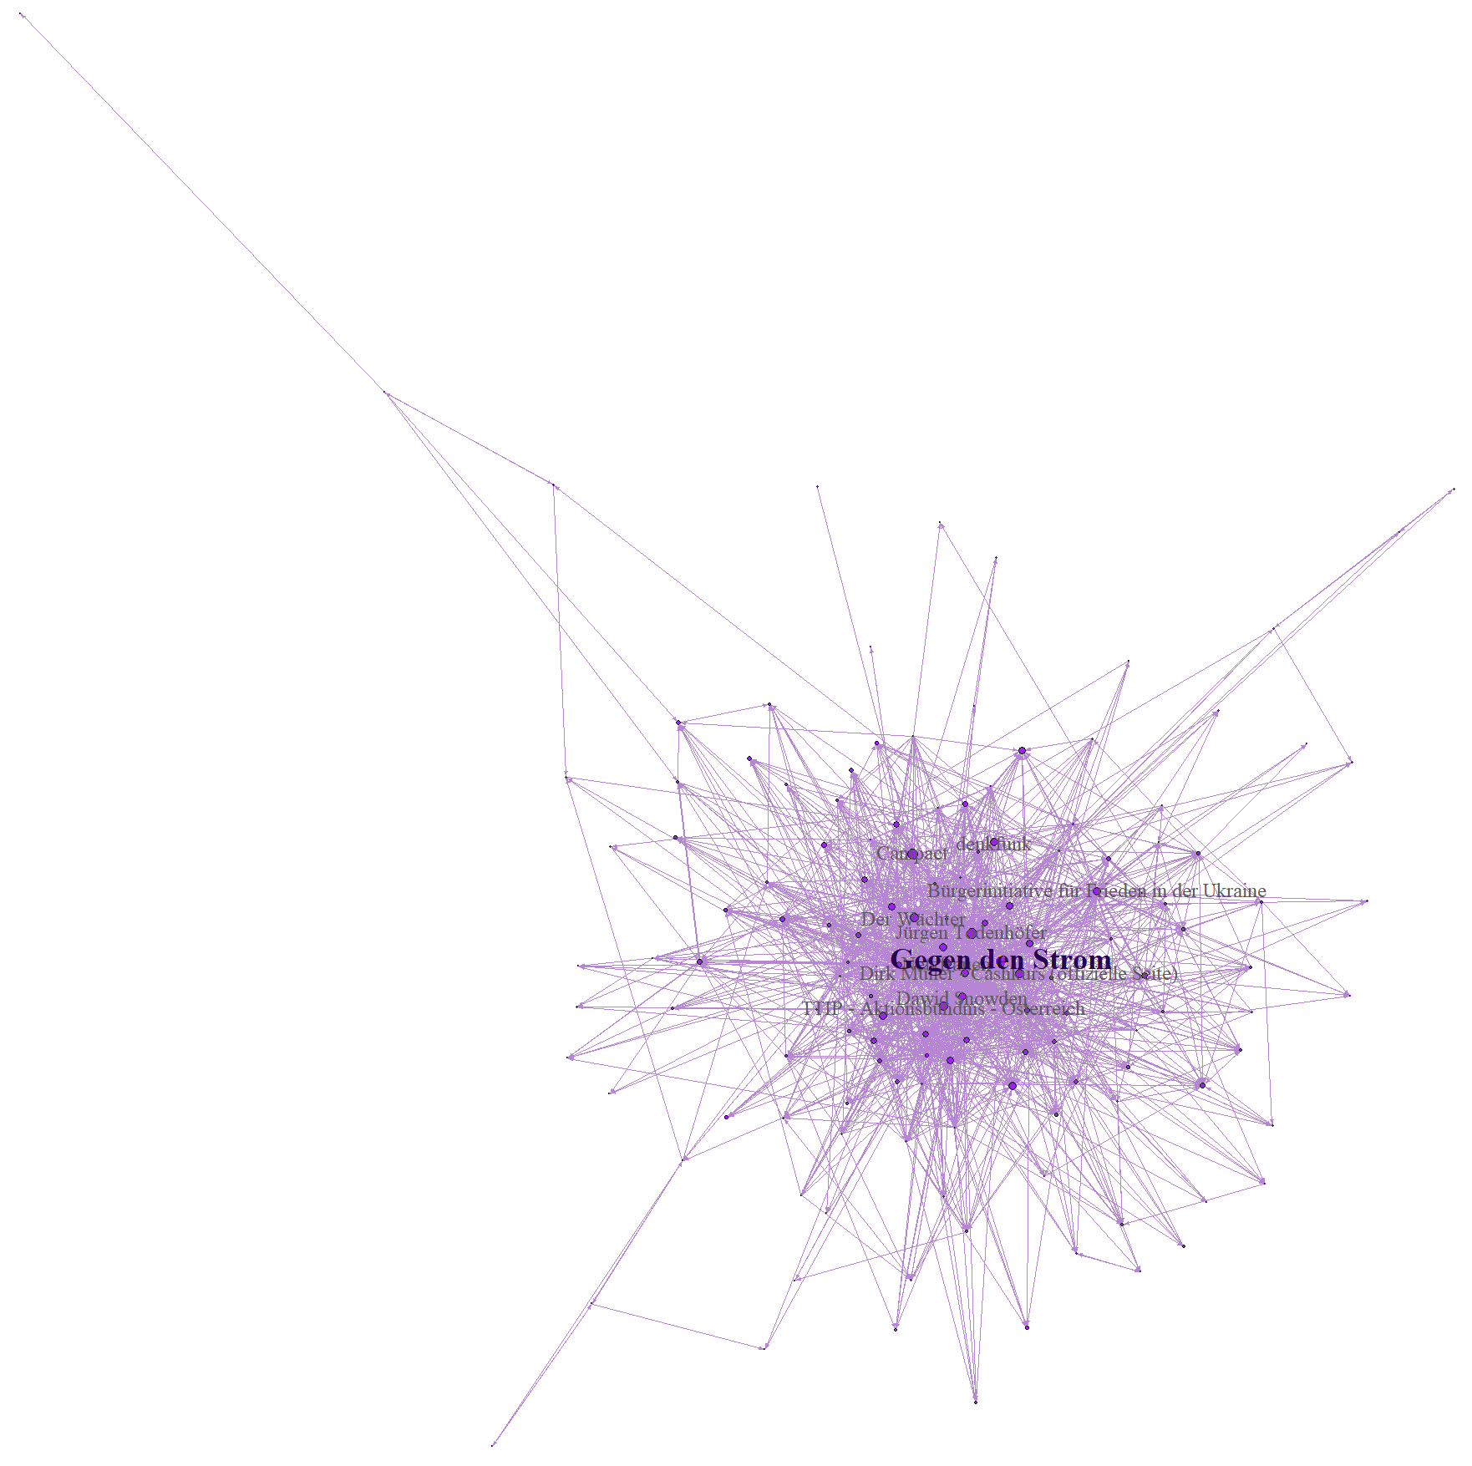
Figure 4: Conspiracy theory pages
This community consists of pages that spread a wide variety of conspiracy theories. The largest page Gegen den Strom can be considered more moderate (see Appendix B), followed by celebrities like Jürgen Todenhöfer (a controversial former conservative politician and anti-war activist) and Dirk Müller (a stock trader known for controversial opinions explaining economic crises), and smaller conspiracy theory pages like Der Wächter, Dawid Snowden and “Bürgerinitiative für Frieden in der Ukraine” (citizen’s initiative for peace in Ukraine, a page spreading pro-Russian news during the Ukraine crisis). Interestingly, anti-TTIP activist groups and moderate left activist page Campact are also part of this cluster.
5th largest community: pro-refugee activist pages
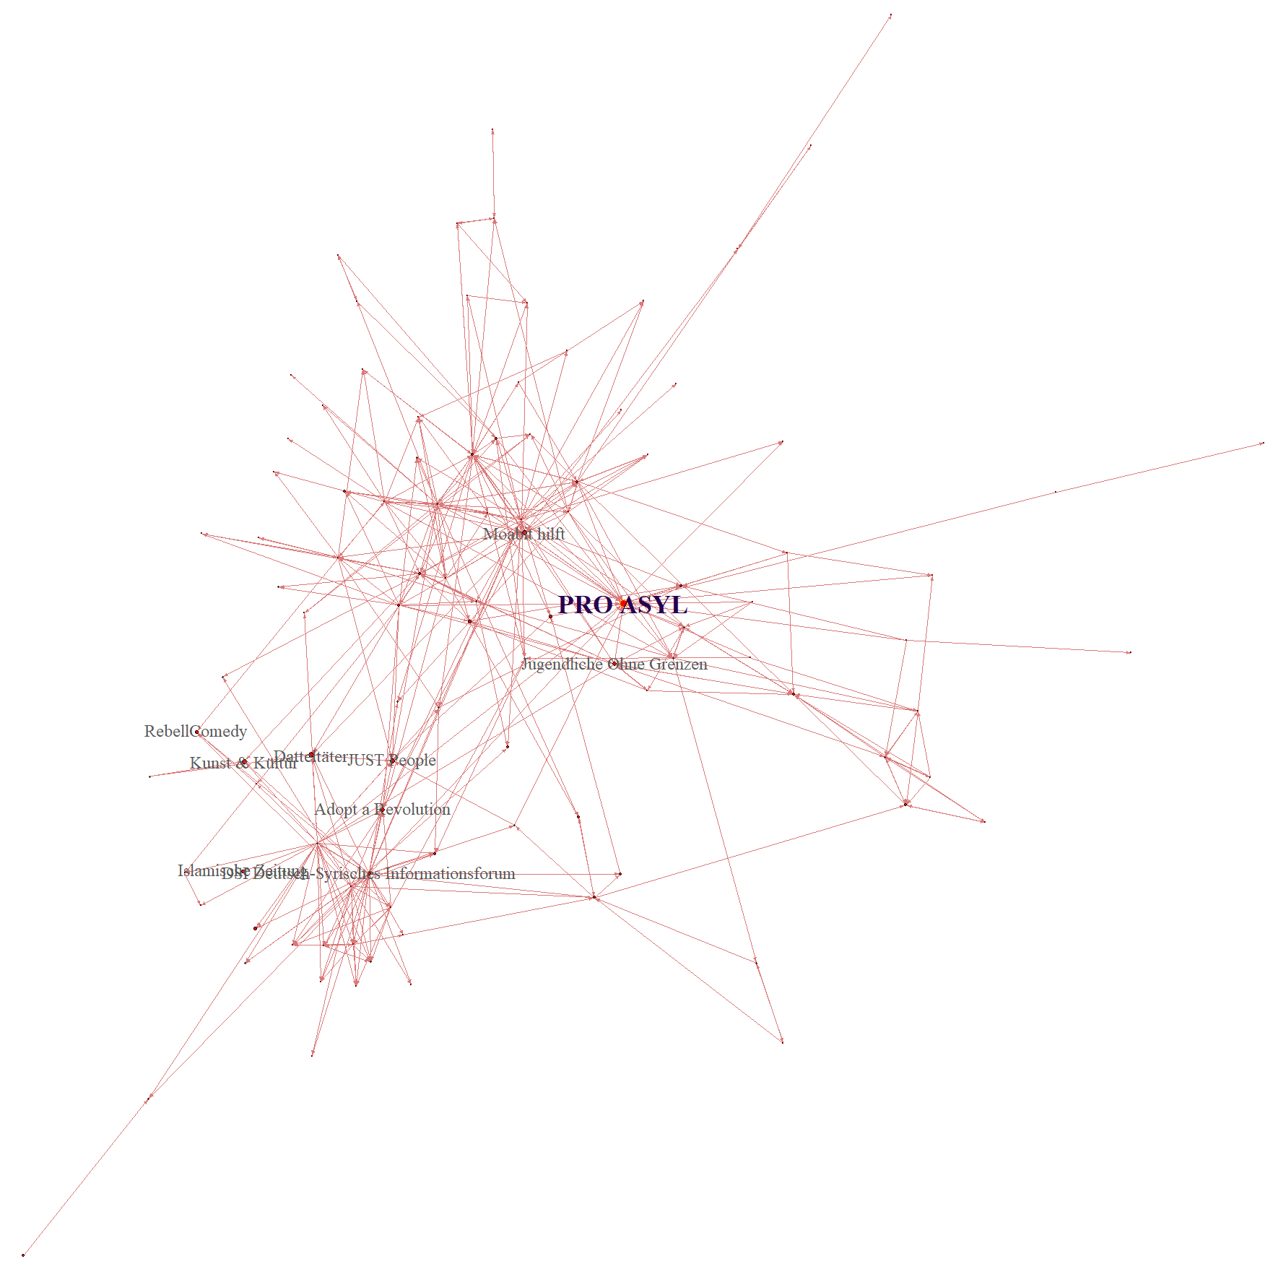
Figure 5: pro-refugee activist community
This cluster consists of local refugee-aid groups like ProAsyl, which coordinates refugee aid in Germany, and Moabit hilft (a local refugee aid group in Berlin-Moabit), Jugendliche ohne Grenzen (youth without borders) and Adopt a Revolution, a group aiming to support Syrian civil society.
6th largest community: church-based groups
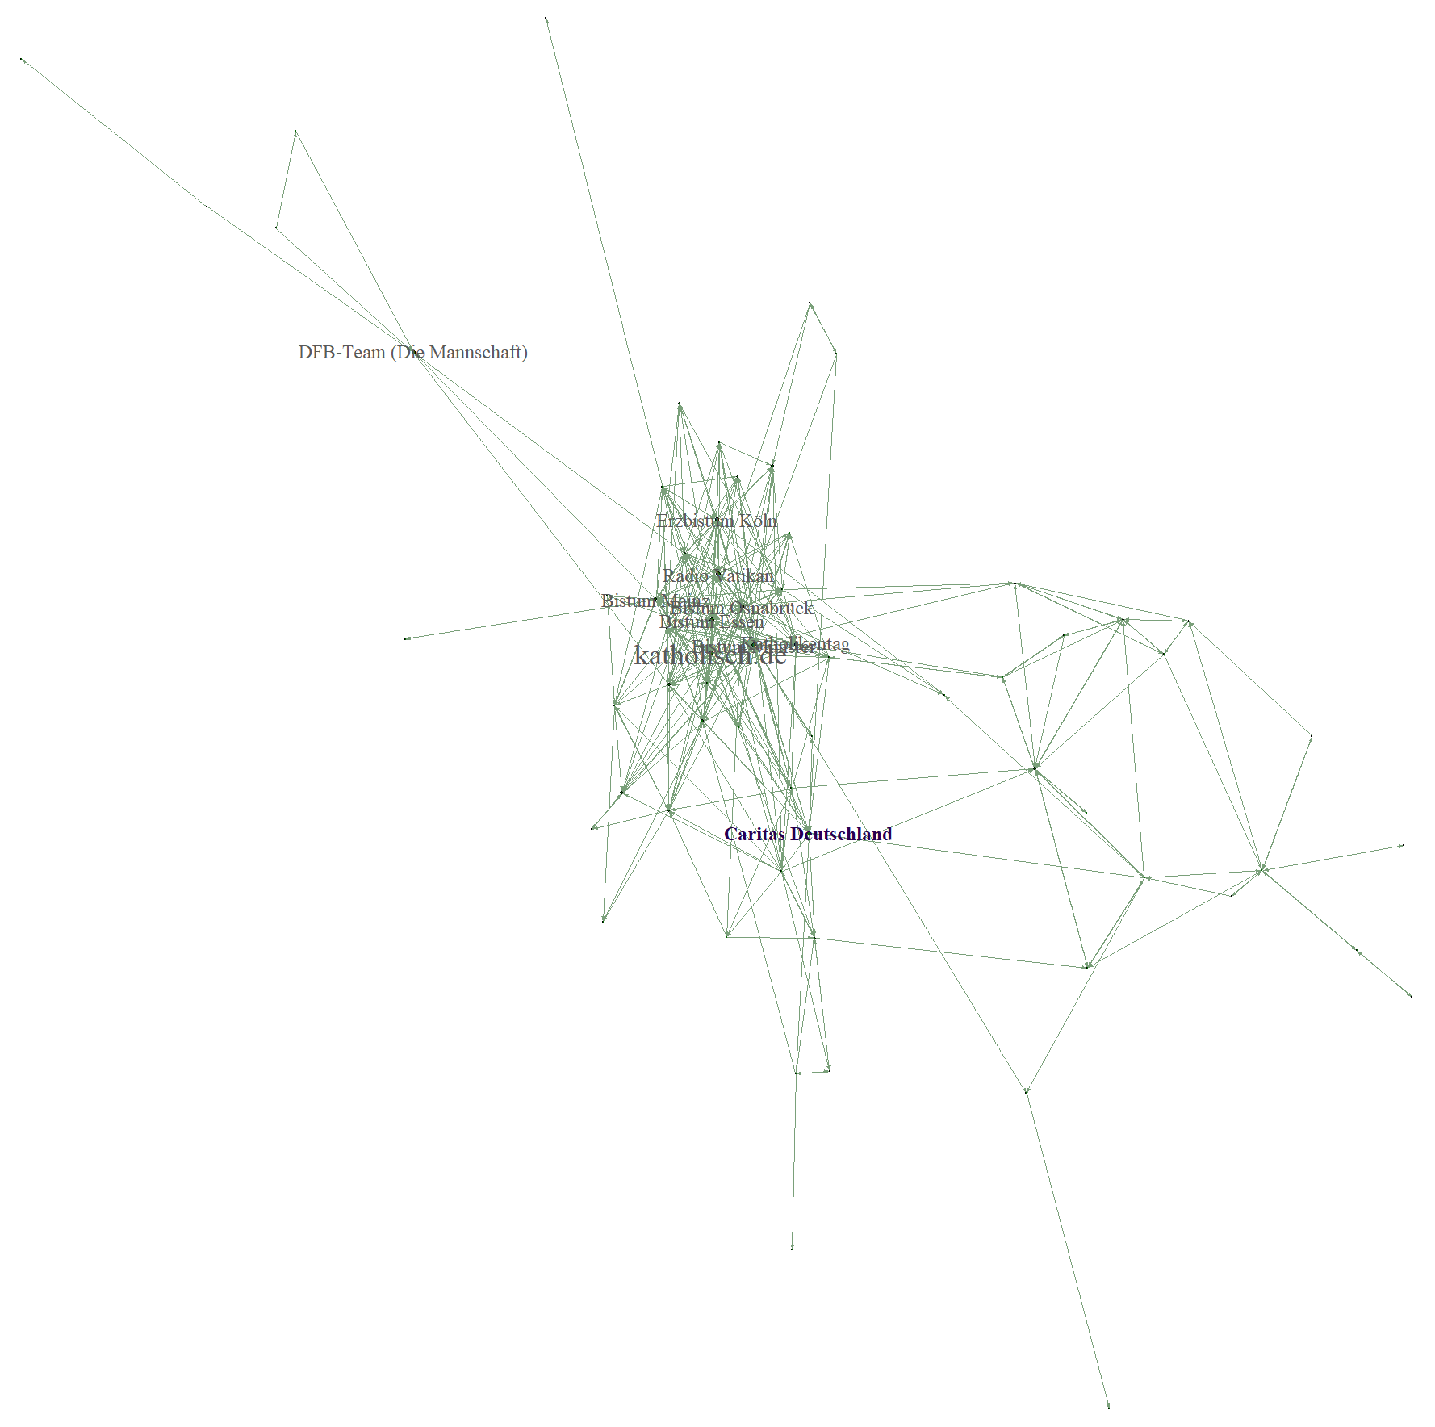
Figure 6: church-based groups community
Groups within this community consist of Catholic church-groups’ pages. Since the Catholic church was active in refugee aid, church-based groups like Caritas actively debated refugee aid in 2016

7th largest community: contra refugee activist pages
Figure 7: contra-refugee activist community
This community consist of local protest group Pegida (Patriots against the Islamisation of the Occident), a protest movement located in Dresden, and several local groups associated with the movement, like Legida (the Pegida group in Leipzig), Pegida Chemnitz, and Pegida Munich.

8th largest community: far-right contra refugee pages
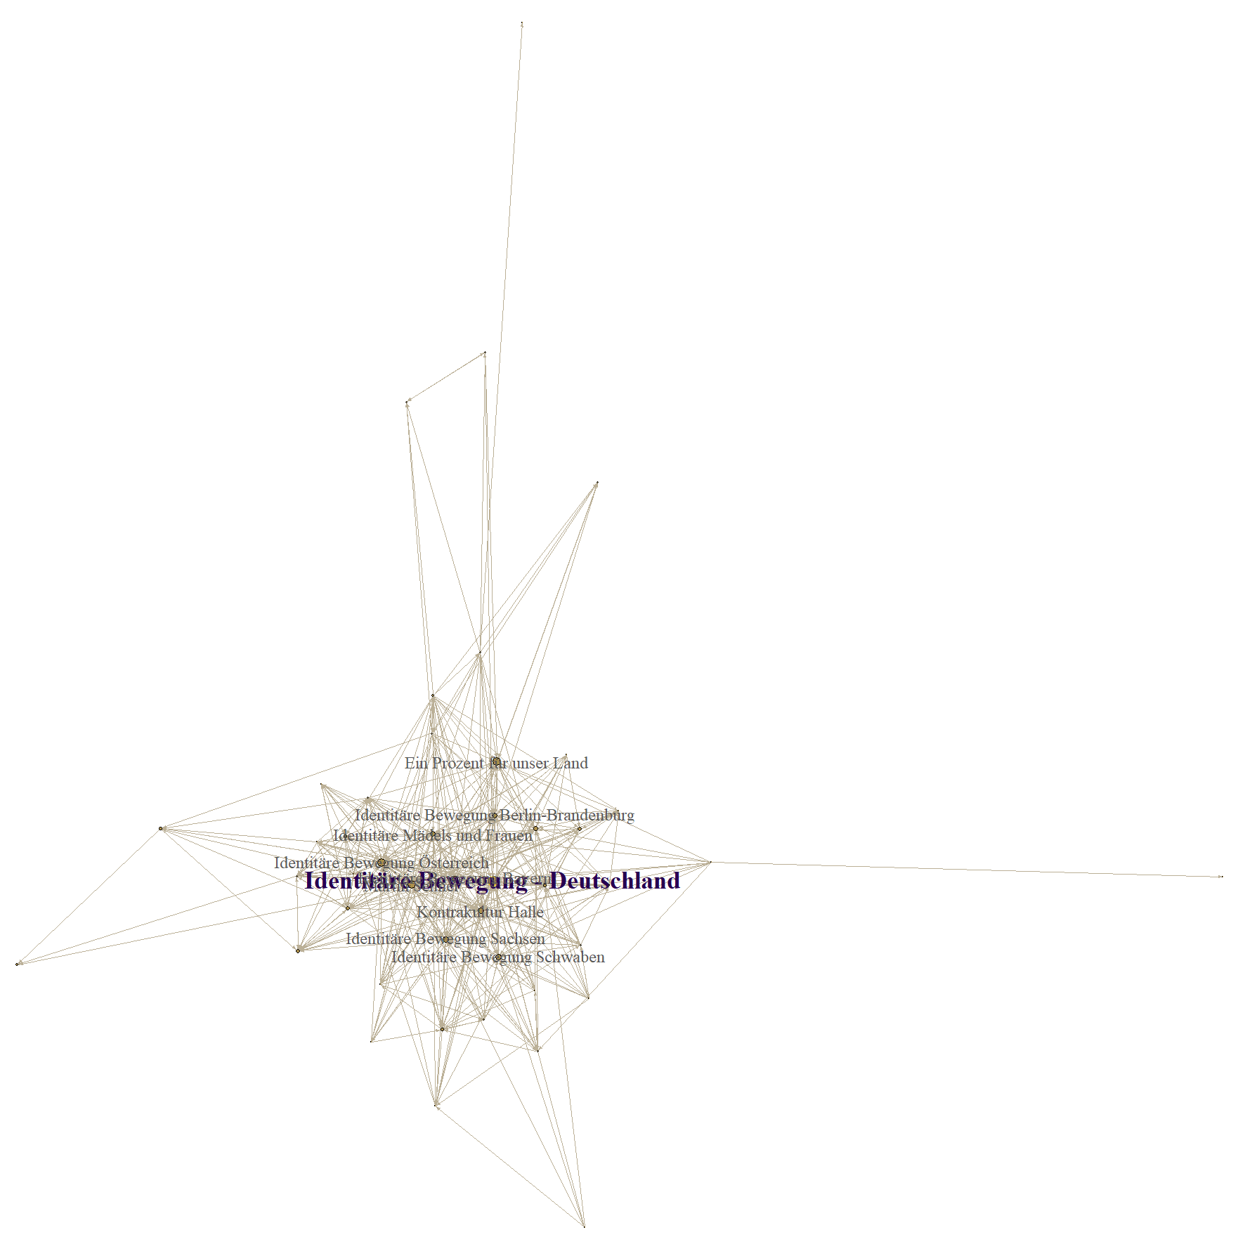
Figure 8: Far-right contra refugee community
Pages in this community consist of far-right groups, mainly those associated with the Identitarian movement (“Identitäre Bewegung”), with local groups making up the largest pages. This community also includes “Ein Prozent für unser Land”, a group that tries to connect the Identitarian movement with other rightwing groups like Pegida.
9th largest community: Libertarian pages
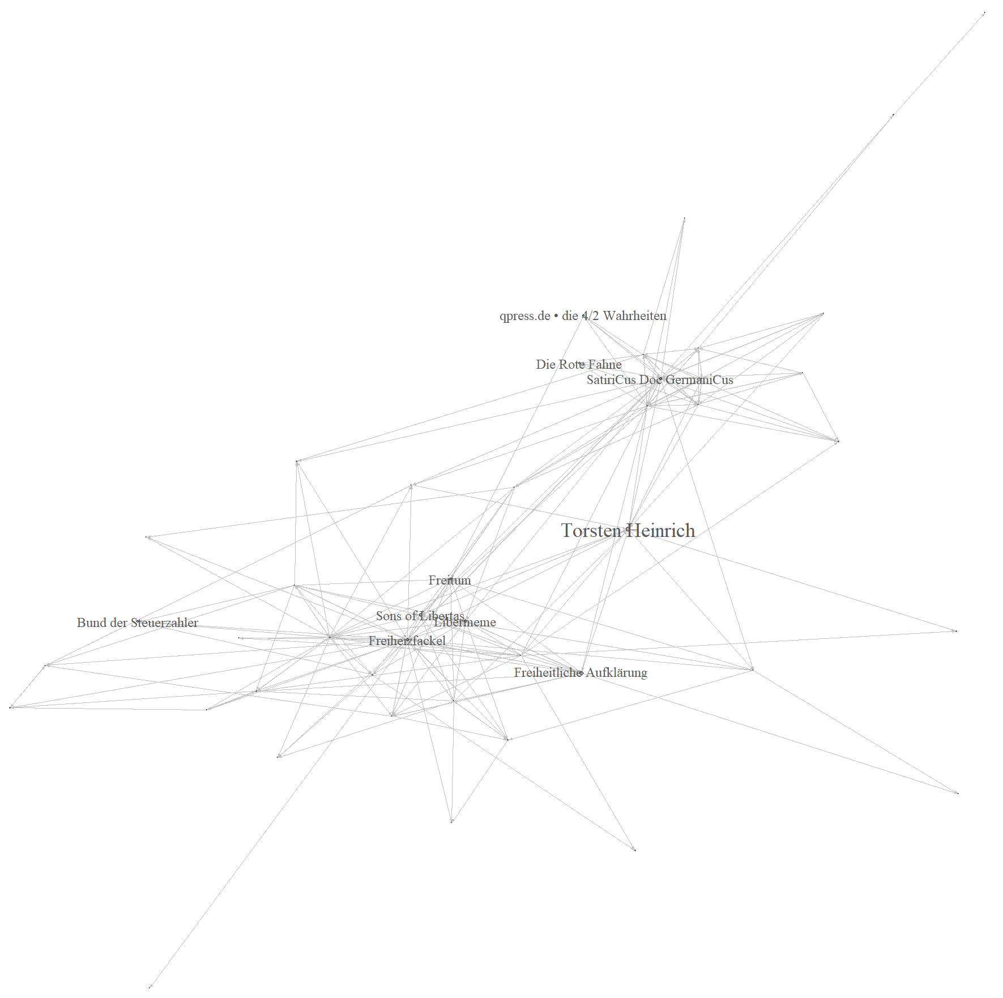
Figure 9: Libertarian community

Image 1: Libertarian community
Within this network, we found pages with names like “Freiheitliche Aufklärung” (“libertarian enlightenment”), “Sons of libertas”. The pages were inconsistent in their assessment of refugee policy – some taking a strong pro-immigration stance, others a strong contra-immigration stance.
10th largest community: Pro-Turkey pages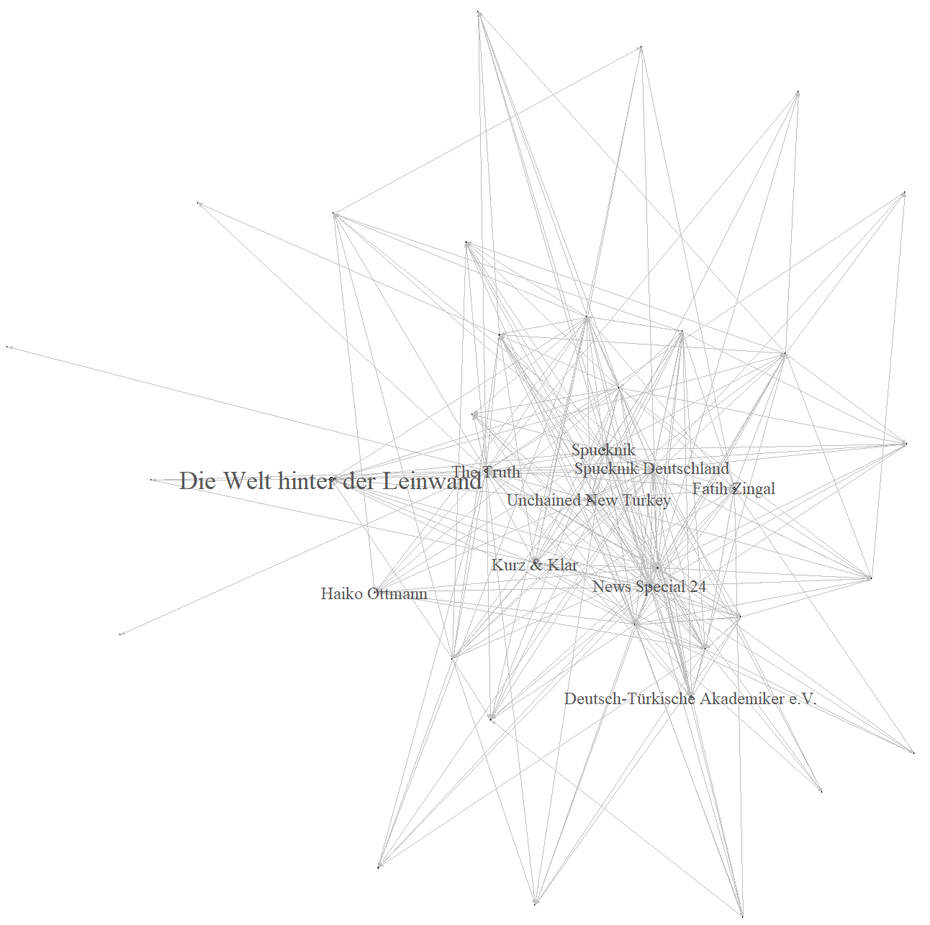
Figure 10: Pro-Turkey community
This network consists of pages that aim to counter a negative portrayal of Turkey’s government within German media. Their posts on refugee policy mostly thematize Turkey’s own intake of refugees, and the refugee deals between Germany and Turkey.
11th largest community: Alevi communities
Figure 11: Alevi community
The pages within this cluster are critical of the German government’s cooperation with the Turkish government in its refugee deals. Representing the Alevi minority, they are critical of Turkey’s government.

12th largest community: firefighters and red cross
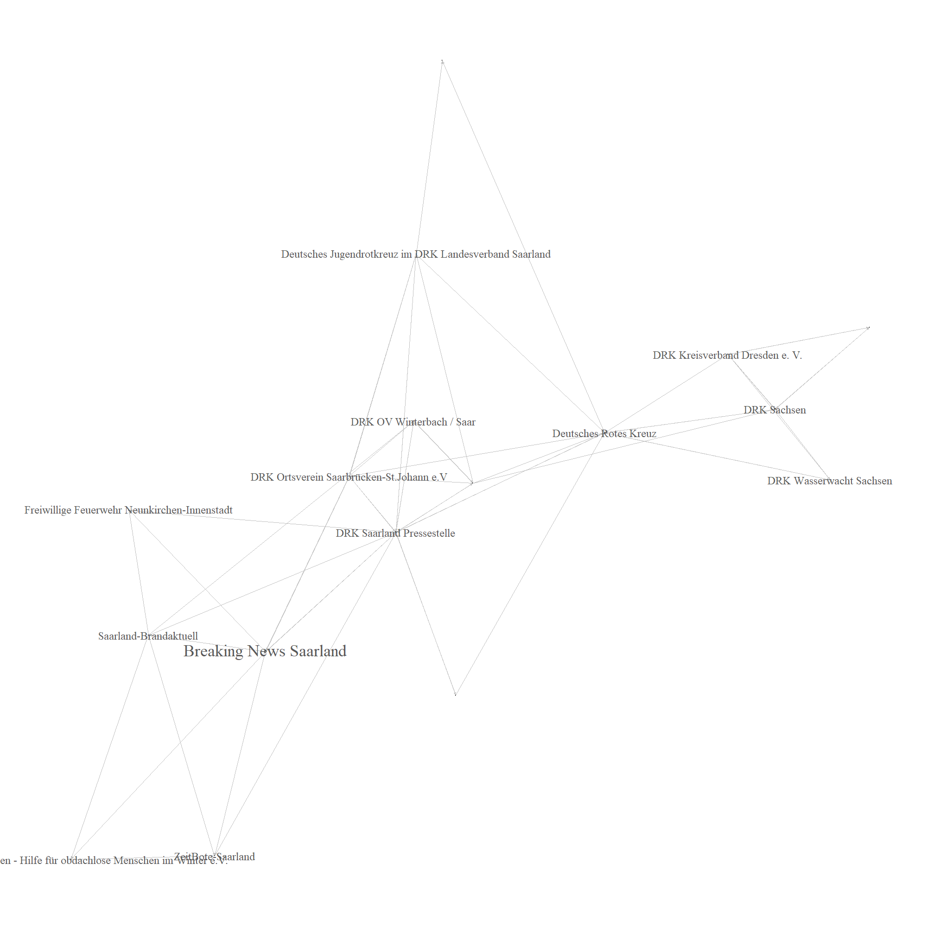
Figure 12: Firefighter community
The pages in this community represent local red-cross and firefighter groups. Refugee policy is of interest in regards to refugee aid, fires within refugee homes and pro-refugee activities organized by these groups.

13th largest community: Police unions, firefighters
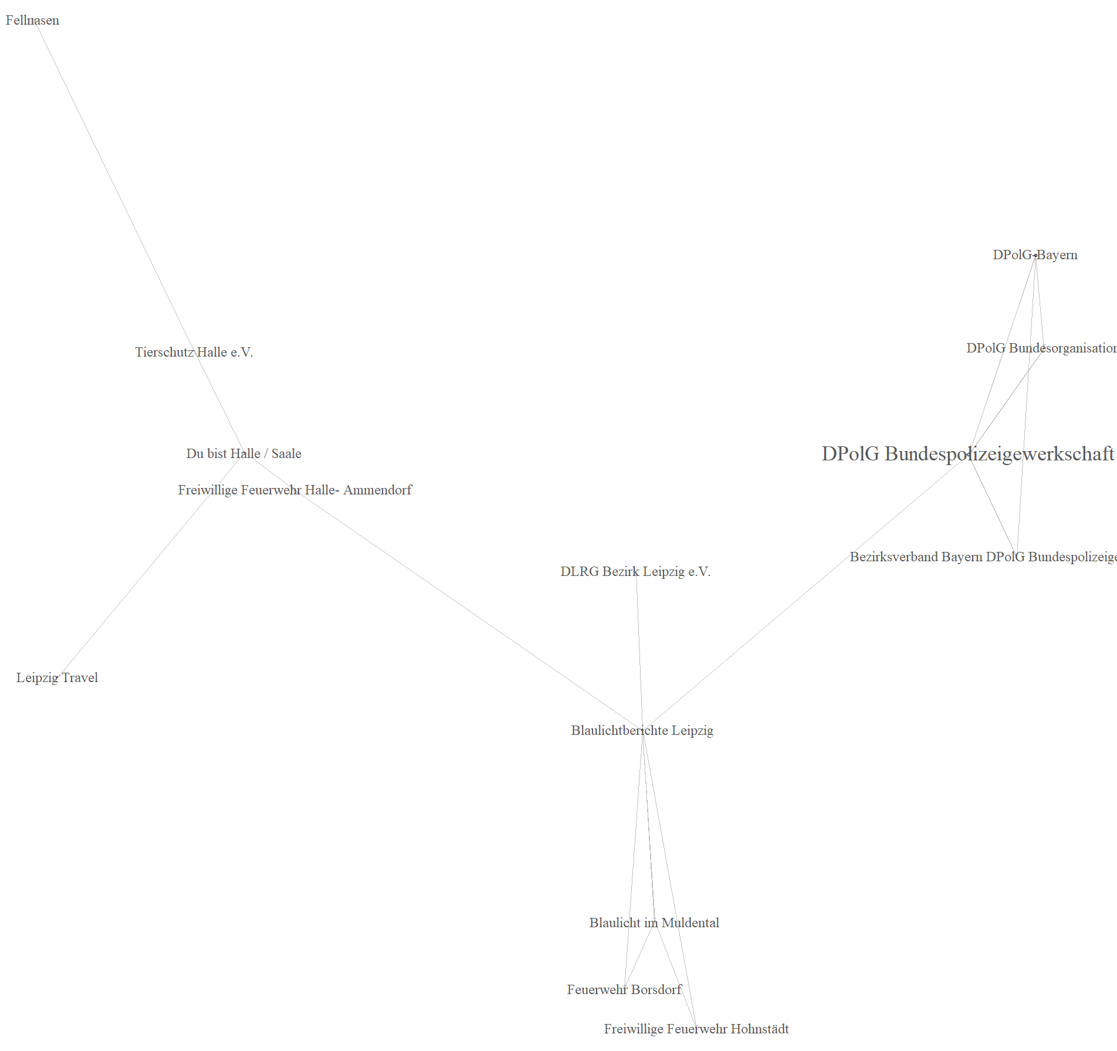
Figure 13: Police unions community
Like the previous community, pages within this group discuss firefighting and refugee aid. Additionally, the conservative police union DPolG, which is critical of Germany’s refugee intake, is prominent within this community.

14th largest community: Anonymous pages and Amnesty International
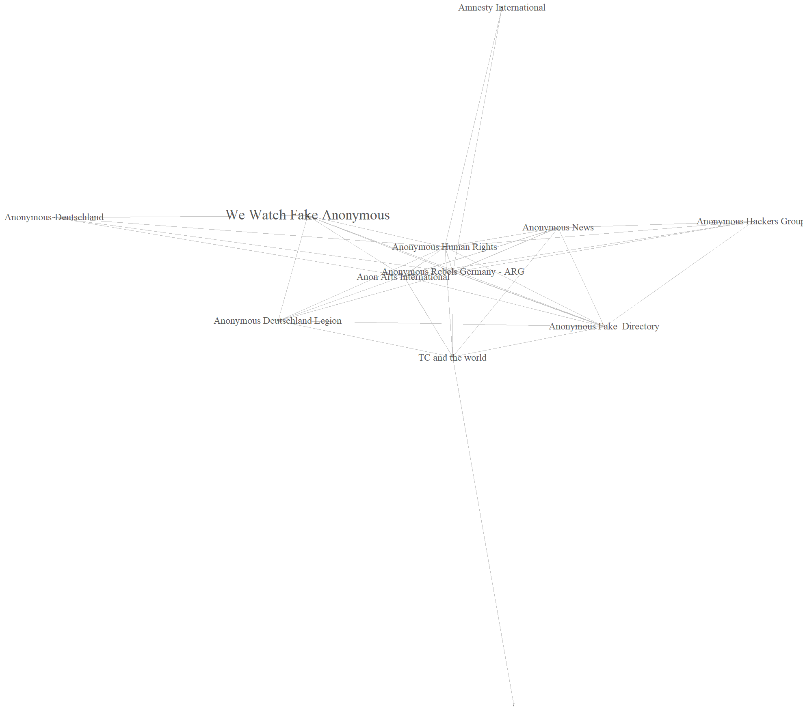
Figure 14: Anonymous community
Within this community, we found several German pages that claim to be part of the Anonymous network. Who actually belongs to Anonymous was contested, as can be seen by the largest node “We Watch Fake Anonymous.” This was partially due to a far-right attempt to present contra-refugee narratives as propagated by Anonymous.
Interestingly, the page of Amnesty International, the international human rights organization, ended up in this community – probably due to the page’s low linkage with pages in general.

15th largest community: Austrian anti-right-wing pages
Figure 15: Austrian anti-right-wing community
This community consists of Austrian pages of activist groups countering right-wing narratives, as in the biggest node “Offensive gegen Rechts” (“Offensive against the right”). This community also includes Austrian Caritas pages.

16th largest community: Pro-Israel pages and fact-checking pages
#
Figure 16: Pro-Israel community
Within this community we found pro-Israel pages, as, for example the biggest node “Israel in Deutschland” (“Israel in Germany”). It also includes nodes from the fact-checker collective “Correctiv” and the associated blog “Ruhrbarone”, pages which counter rightwing disinformation.

17th largest community: Comedy pages
Figure 17: Comedy community
This community consists of pages that post comedic content, as, for example the largest node “Kein Schwanz wird so hart wie das Leben” (“No penis becomes as hard as life”). Refugees were a topic for dark humor, which is how these nodes ended up in our sample.
18th - 25th largest nodes
The smaller communities consisted of two to three pages each, consisting of smaller pro- and contra-refugee activist groups.

Sources
Blondel, Vincent D., Jean- Loup Guillaume, Renaud Lambiotte, and Etienne Lefebvre. "Fast unfolding of communities in large networks." J. Stat. Mech., 2008: P10008.
Clauset, A., M. E. Newman, and C. Moore. "Finding community structure in very large networks." Physical Review E, 2004: 066111.
Pons, Pascal, and Matthieu Latapy. "Computing communities in large networks using random walks." International symposium on computer and information sciences, 2005: 284-293.
Raghavan, U.N., R. Albert, and S. Kumara. "Near linear time algorithm to detect community structures in large-scale networks." Phys Rev E, 2007: 036106.
Rosvall, M., D. Axelsson, and C. T. Berstrom. "The map equation." Eur. Phys. J. Special Topics, 2009: 13.

