**Supplementary material to:**

Tao et al. Teleaudiology hearing aid fitting follow-up consultations for adults: a single blinded randomised control trial and cohort study. IJA Special edition on teleaudiology.

**CONTENTS**

**Supplementary material S.1.** Alterations to outcome measurement tools used in this study. 3

**Supplementary material S.2.** Hearing Aid Issues Instrument (HAII). 3

**Supplementary material S.3.** HA Services Satisfaction for Patients/Participants (HASS-P) – self-report survey. 8

**Supplementary material S.4.** HA Services Satisfaction for Audiologists (HASS-A) – self-report survey. 12

**Supplementary material S.5.** Intervals between consultations (days) for all the participants as a group (G1 and G2) and for each group, and statistical results for the comparison of intervals between G1 and G2 (G1 versus G2)*.* 15

**Supplementary material S.6.** Figures (A) to (F) show between and within group comparisons, and the results of statistical analyses (cross-sectional and longitudinal) for participants’ COSI (Scale of Improvement) scores. 15

**Supplementary material S.7.** Distribution of participants’ COSI (Scale of Improvement) scores per group resulting from each consultation (n = 28) (A) Boxplot shows median, interquartile range, range and outliers; (B) Table shows means and standard deviations. 16

**Supplementary material S.8.** Figures (A) to (F) show between and within group comparisons, and the results of statistical analyses (cross-sectional and longitudinal) for participants’ HAII (Scale of Improvement) scores. 16

**Supplementary material S.9.** Distribution of participants’ HAII (Scale of Improvement) scores per group resulting from each consultation (total and initial fitting issues n = 28, and new fitting issues n = 14): **(A)** Boxplot shows median, interquartile range, range and outliers; **(B)** Table shows means and standard deviations. 17

**Supplementary material S.10.** Statistical results of the changes in the aspects of quality of life (activity limitations, participation restrictions and impact on others) before-after treatment (rehabilitation program) for the participants as a group (G1 and G2), within and between G1 and G2. 17

**Supplementary material S.11.** Statistical results of the HASS-P on the changes of the satisfaction with second face-to-face and remote follow-up consultations coming from first consultations with opposite mode of service-delivery for all participants as a group (G1 and G2) and within and between G1 and G2; n (%), mean and statistic values from non-parametric tests (*U, z* and *p value)*. 19

# **Supplementary material S.1.** Alterations to outcome measurement tools used in this study.

|  |  |  |  |
| --- | --- | --- | --- |
| **Outcome measurement tool** | **Item number (#)** | **Original item** | **Applied item** |
| IOI-HA | #3 | Think again about the situation where you most wanted to hear better. When you use your present hearing aid(s), how much difficulty do you STILL have in that situation? | Think about the situation where you most wanted to hear better. How much difficulty do you have in that situation? |
|  | #5 | Over the past two weeks, with your present hearing aid(s), how much have your hearing difficulties affected the things you can do? | Over the past two weeks, how much have your hearing difficulties affected the things you can do? |
|  | #6 | Over the past two weeks, with your present hearing aid(s), how much do you think other people were bothered by your hearing difficulties? | Over the past two weeks, how much do you think other people were bothered by your hearing difficulties? |
|  | #8 | How much hearing difficulty do you have when you are not wearing a hearing aid? | How much hearing difficulty do you have? |
| HAUQ | #6 | How would you describe your satisfaction with the HA service provided by the clinic? Options for answers included: ‘have not needed any repairs’ | This option for answer was not provided in this research, as participants had recently been fitted with a new set of HAs and hence repairs are rarely required in follow-up HA fitting consultations. In addition, if new HAs malfunction, these are replaced with new ones by the manufacturer. |
|  | #7 | How would you describe your satisfaction with the way you have been treated by the AHS hearing centres? | How would you describe your satisfaction with the way you have been treated by all involved in the service provided? |

*Note*: The IOI-HA eighth item was developed by the questionnaire authors only for categorizing respondents into different groups related to the severity of hearing loss for normative data, based on the seven other items (Cox et al. 2003). However, this item was used for before-after comparisons, to investigate whether participants’ self-perception of their hearing difficulties changed after treatment. The ‘AHS hearing centres’ were replaced by ‘all involved in the service provided’ in the item #7 of HAUQ to ease understanding and avoid confusion, as the meaning of ‘AHS’ was not described and can be thought of as a specific clinic chain.

# **Supplementary material S.2.** Hearing Aid Issues Instrument (HAII).

*(on the next page)*

**Hearing Aid Issues Instrument (HAII)**

**Administration guidelines:**

**Aim of the instrument:** (i) Identify hearing aid fitting issues reported by the patient as specific problems or complaints affecting participant’s benefit and satisfaction with the hearing aid fitting and (ii) determine the benefit with the consultation perceived by the patient through the measurement of the degree of change in these problems after receiving the follow-up hearing aid service.

**Instructions:** The audiologist will administer this instrument to collect information from the patient.

**Identification of specific problems or complaints:**

***Instruction prior to first follow-up consultation:***

Step 1: Please ask your patient to describe the specific problems or complaints he/she wants to address for improvement in this follow-up consultation. Use the space provided in the answer sheet to describe the self-reported problem. Please also indicate the ear side affected (left or right) for each self-reported problem.

Step 2: Using your expertise, ask about the non-self-reported problems to explore patient specific needs for improvement with the follow-up consultation and write down each explored problem in the space provided in the answer sheet. Please also indicate the ear side affected (left or right) for each identified problem.

Step 3: Indicate in the small box at the left, the order of importance according to your patient although the aim is to improve and solve each problem (this step is optional).

***Instruction prior second follow-up consultation:***

Step 1: Please ask if each problem identified in the previous consultation is yet affecting the patient to decide whether you need to continue addressing the problem in this consultation. Also, to apply the scale of improvement, ask how much better/worse the patient feel each of the previous identified problems is on the consultation day compared to before.

Step 2: Please check if the remaining problem is still on the same ear side and ask your patient to describe any other specific problems or complaint he/she would like to have addressed in the consultation. Also, you can explore any other possible problem to check if everything else is still fine. Then, describe the identified each new problem in the space provided in the answer sheet and indicate the ear side affected (left or right).

Step 3: Indicate in the small box the right of the scale of improvement, the new order of importance according to your patient for the remaining and/or new identified problems (this step is optional).

**Note:** If you want, you can use the reference list of possible problems to identify the specific problem and its description(s), if it is not in the list, mark as “other” and describe each problem in the space provided in the answer sheet.

**Reference list:**



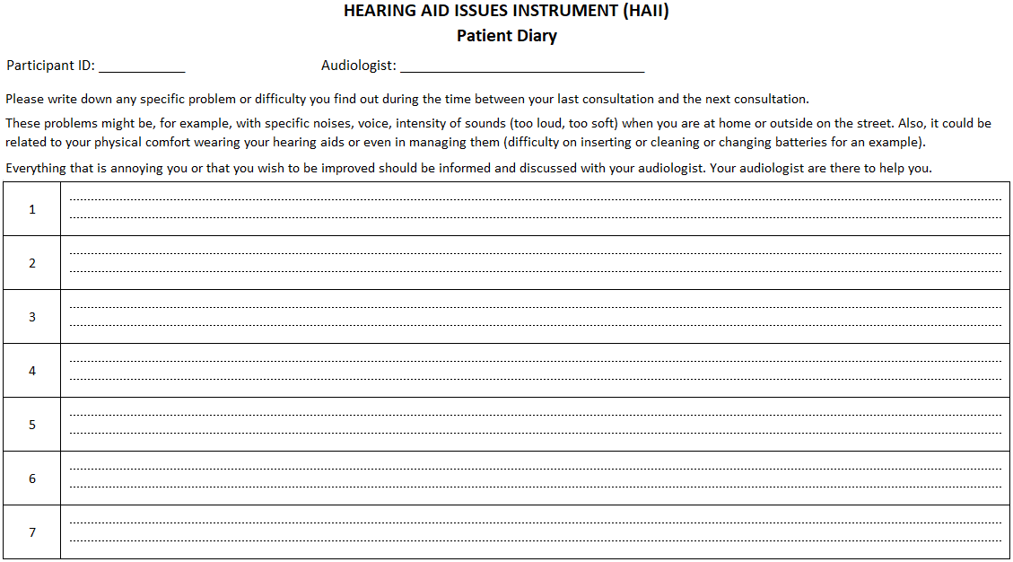

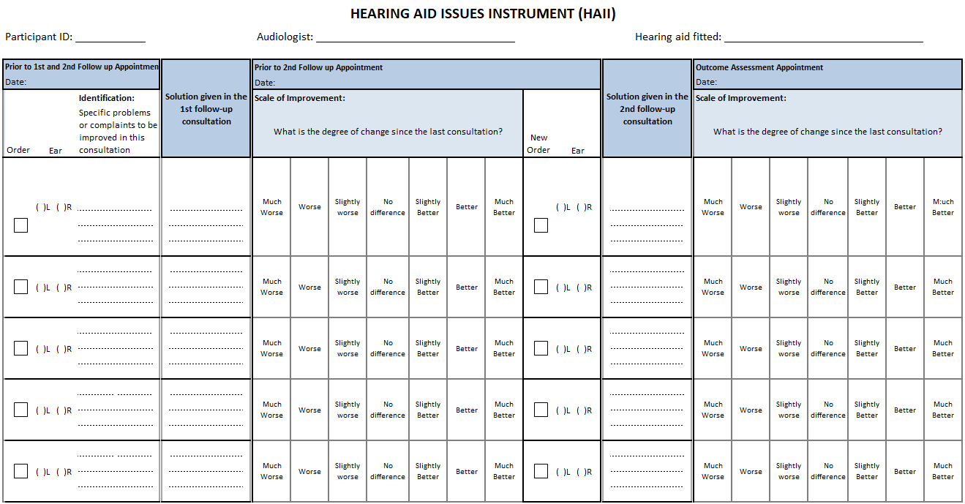

# **Supplementary material S.3.** HA Services Satisfaction for Patients/Participants (HASS-P) – self-report survey.

**Administration guideline:**

Aim: To determine the satisfaction with the quality of various aspects of the follow-up consultation (face-to-face **or** remote).

To be applied immediately after follow-up consultations - prior intervention during the next consultations (about 1-2 and 3-4 weeks post first fitting).

Participants are encouraged to complete this survey without any assistance from the audiologist or remote facilitator.

*(questionnaire continues on the next page)*

**Hearing Aid Service Satisfaction for Patients/Participants (HASS-P) –**

**self-report survey**

Participant ID: __________ Date: ____ / ____ /____

Audiologist: _______________

Type of consultation:Face-to-face RemoteAssistant (if remote): ___________

**This survey asks you to consider your experiences during the hearing aid consultation you received today. It asks about your satisfaction with different aspects of the consultation.**

These aspects include for instance, handling your hearing aids, the sound-quality of your hearing aids, the physical comfort of wearing your hearing aids, and listening in different situations.

**Please answer all questions by circling the most appropriate answer or writing in the box provided. In case you need help, someone closely related to you and present in the consultations can assist to answer the questions.**

**Neutral:** Choose this answer only if this aspect of the consultation did not change anything, meaning you are neither satisfied nor dissatisfied.

**Not applicable:** Choose only if this aspect of the consultation did not apply today.

**Questions related to today’s consultation.**













# **Supplementary material S.4.** HA Services Satisfaction for Audiologists (HASS-A) – self-report survey.

**Administration guideline:**

Aim: To determine satisfaction with the quality of the follow-up consultation (face-to-face **or** remote).

To be applied immediately after 1st and 2nd follow-up consultations.

*(questionnaire continues on the next page)*

**Hearing Aid Service Satisfaction for Audiologists (HASS-A) –**

**self-report survey**

Participant ID: __________ Date: ____ / ____ /____

Audiologist: ______________

Type of consultation:Face-to-face RemoteAssistant (if remote): ___________

***This survey asks you to consider your experiences during today’s hearing aid consultation with the patient. It asks about your satisfaction with various aspects of the consultation.***

These aspects include for instance, training the patient in handling his/her hearing aids, adjusting the hearing aids, managing the physical comfort of wearing the hearing aids, and managing their listening in different situations.

Please, circle **one** answer for each question.

**Neutral:** Choose this only if this aspect of the consultation did not change anything for your patient, meaning you are neither satisfied nor dissatisfied with the outcome.

**Not applicable:** Choose only if this aspect of the consultation did not apply today.

**Questions related to today’s consultation.**













# **Supplementary material S.5.** Intervals between consultations (days) for all the participants as a group (G1 and G2) and for each group, and statistical results for the comparison of intervals between G1 and G2 (G1 versus G2)*.*

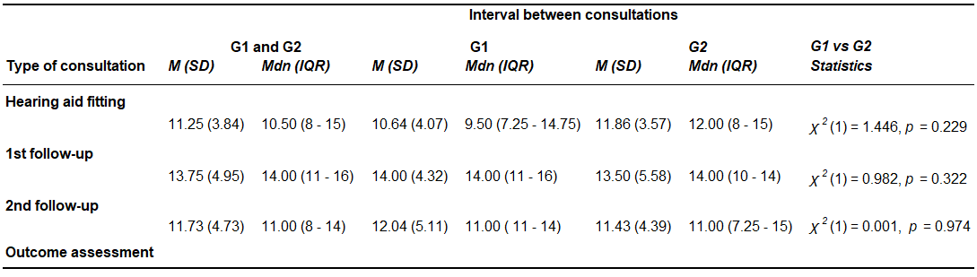

Legend: *M* = mean / *SD* = standard deviation /*Mdn*  = median / *IQR* = interquartile range

# **Supplementary material S.6.** Figures (A) to (F) show between and within group comparisons, and the results of statistical analyses (cross-sectional and longitudinal) for participants’ COSI (Scale of Improvement) scores.

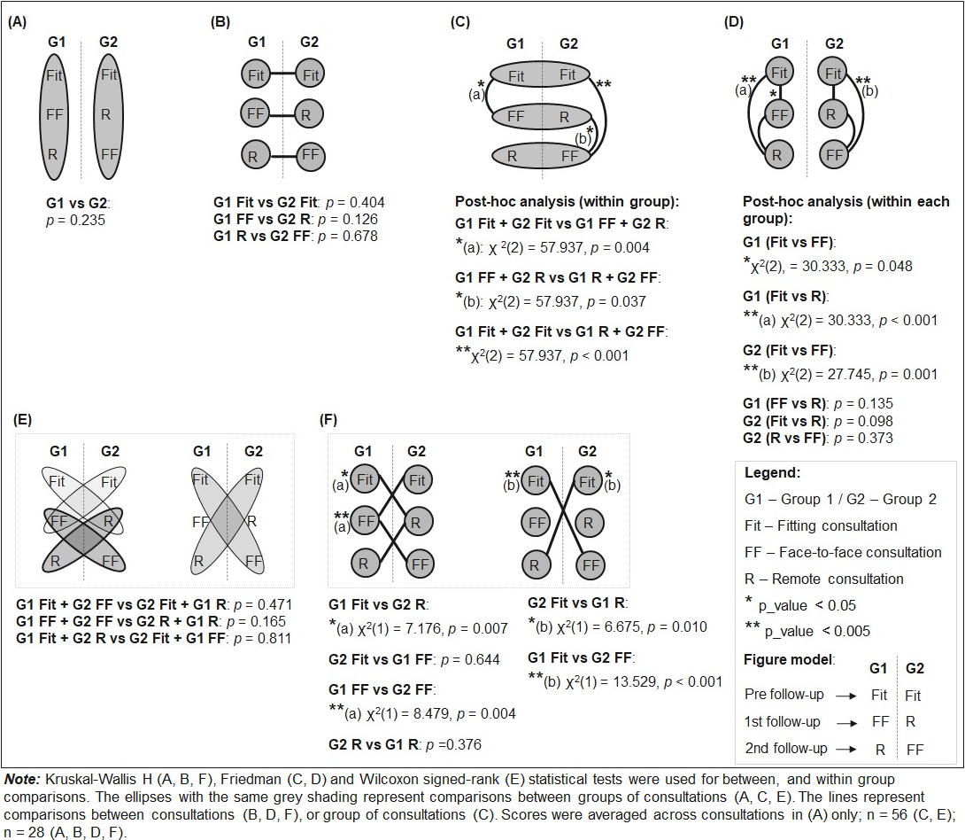

# **Supplementary material S.7.** Distribution of participants’ COSI (Scale of Improvement) scores per group resulting from each consultation (n = 28) (A) Boxplot shows median, interquartile range, range and outliers; (B) Table shows means and standard deviations.

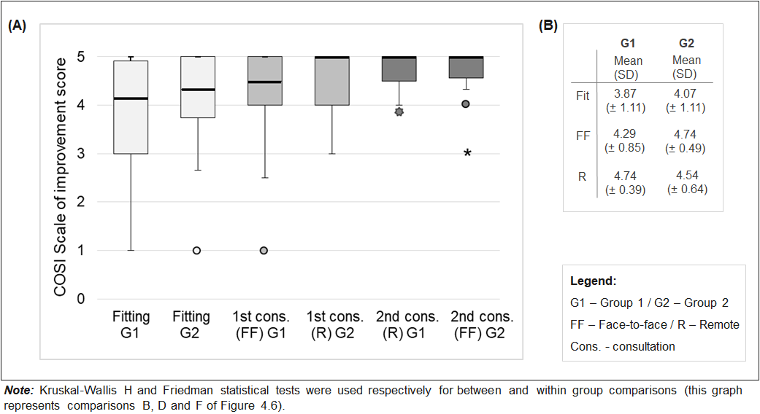

# **Supplementary material S.8.** Figures (A) to (F) show between and within group comparisons, and the results of statistical analyses (cross-sectional and longitudinal) for participants’ HAII (Scale of Improvement) scores.

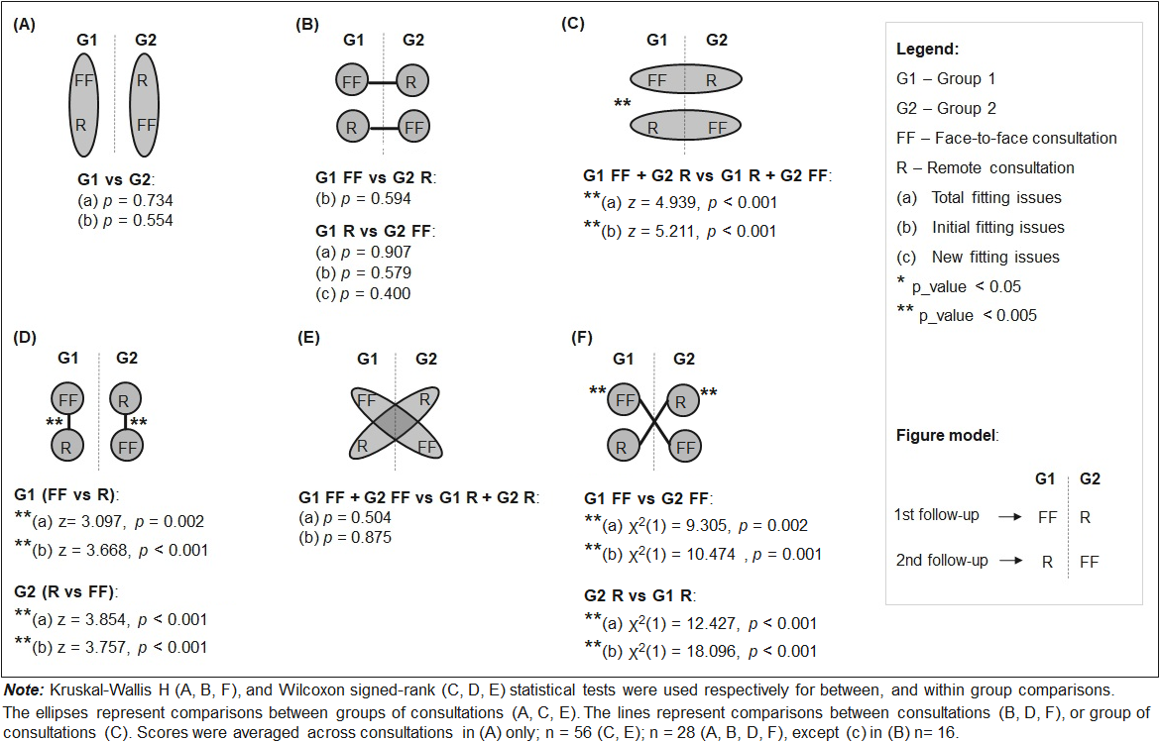

# **Supplementary material S.9.** Distribution of participants’ HAII (Scale of Improvement) scores per group resulting from each consultation (total and initial fitting issues n = 28, and new fitting issues n = 14): **(A)** Boxplot shows median, interquartile range, range and outliers; **(B)** Table shows means and standard deviations.

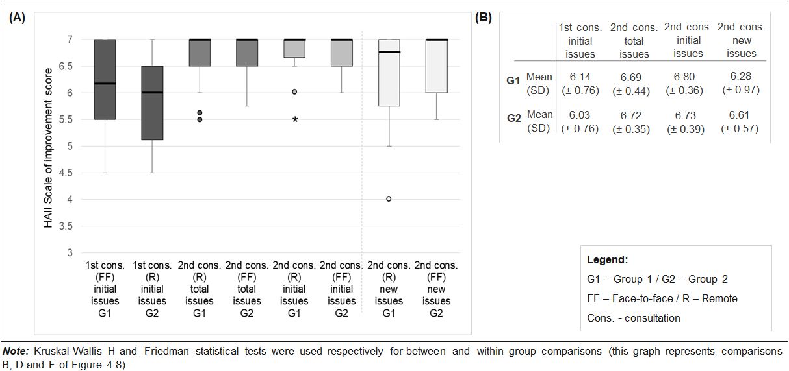

# **Supplementary material S.10.** Statistical results of the changes in the aspects of quality of life (activity limitations, participation restrictions and impact on others) before-after treatment (rehabilitation program) for the participants as a group (G1 and G2), within and between G1 and G2.

*(on the next page)*

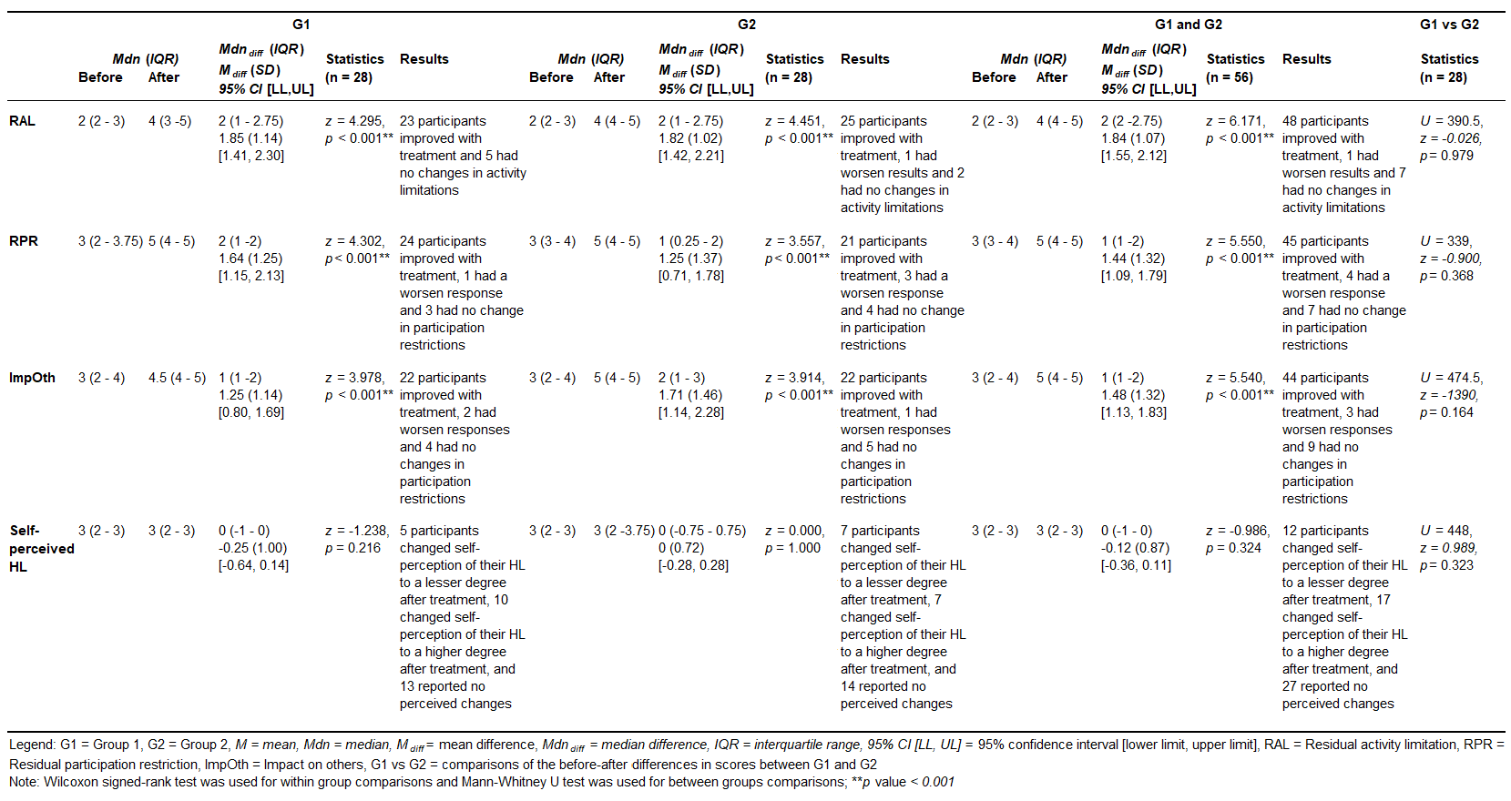

# **Supplementary material S.11.** Statistical results of the HASS-P on the changes of the satisfaction with second face-to-face and remote follow-up consultations coming from first consultations with opposite mode of service-delivery for all participants as a group (G1 and G2) and within and between G1 and G2; n (%), mean and statistic values from non-parametric tests (*U, z* and *p value)*.

