Supporting Information

Modelling the bioaccumulation and biomagnification potential of microplastics in a cetacean foodweb of the Northeastern Pacific: A prospective tool to assess the risk exposure to plastic particles.

Juan José Alava

Ocean Pollution Research Unit, Institute for the Oceans and Fisheries, University of British Columbia, 2202 Main Mall, Vancouver, BC V6T 1Z4, Canada

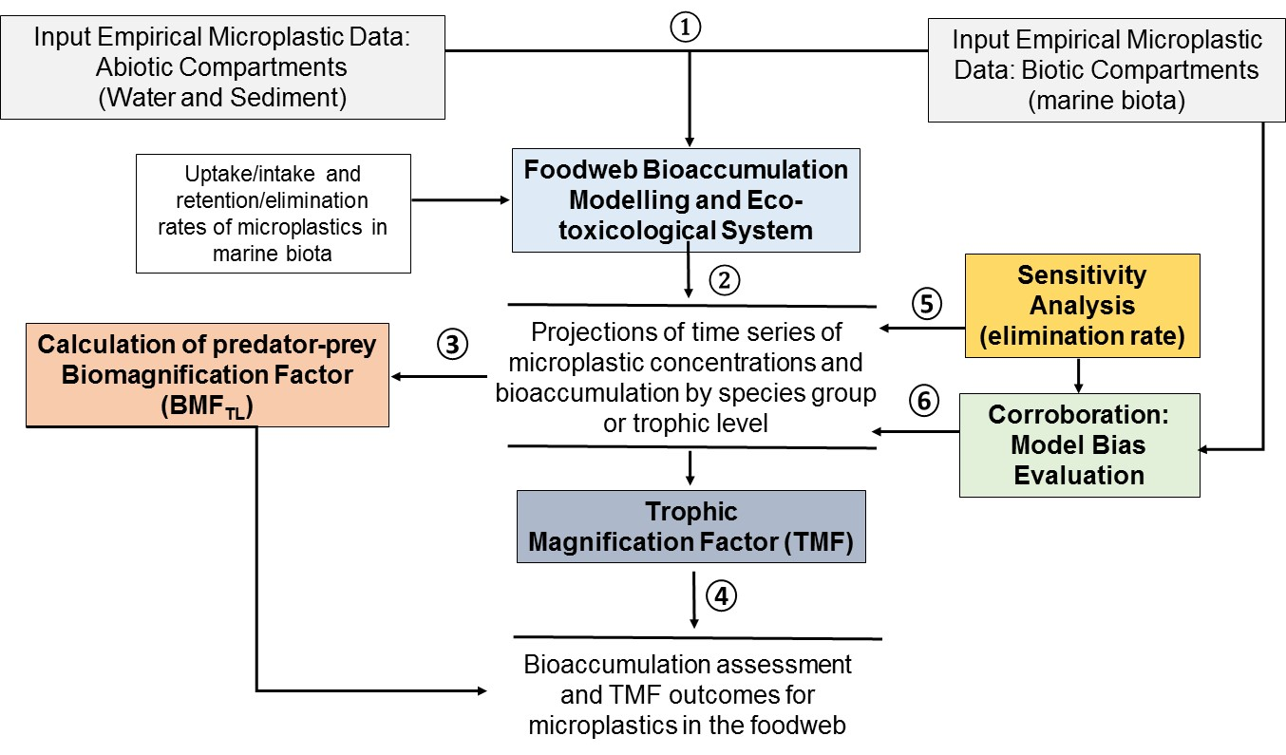
Figure S1. Conceptual model framework illustrating the basic relationships of modelling components for the prediction and assessment the microplastic levels and bioaccumulation potential in the marine food web. (1) The empirical data for microplastics (i.e., documented empirical concentrations measured in water and sediments from the studied region) is a key input for the modelling work to predict concentrations in a particular species or functional groups of species in the marine food webs over time to simulate the bioaccumulation potential in the food web; (2) Then, following the inclusion of observed microplastic data in waster and sediment, the foodweb model is run to predict and simulate the concentrations in each species or functional group to produce the projections of time series in the food web; (3) The predict microplastic data in marine biota is used as input data to estimate the predator-prey magnification factor (BMF_{TL}) aimed to analyze preliminary biomagnification potential in predators relative to the predicted microplastic data in preys; (4) following the application of BMF_{TL}, the contaminant data generated from is also used to compute trophic magnification factors (TMF) for microplastics to further explore the potential magnification of microplastics at each trophic level in the marine food web; (5) a sensitivity analysis is performed on the elimination rate (k_{E}) of microplastics in a given organisms and a fundamental trophic level or a functional group (e.g., zooplankton) to assess how sensitive is this parameter and the model to changes in the parameter values; and, (6) to corroborate the projections resulting from the simulations, a model bias (MB) evaluation approach is required to assess the performance of the foodweb bioaccumulation model (i.e. whether the model is reproducing fairly well concentration values for microplastics similar to those observed from the empirical contaminant data available).

Table S1. Data for retention time, biological half-lives and elimination rates of microplastics in the organisms of the food webs used for the foodweb bioaccumulation modelling work.

Food web species |  | Retention time (d) | Biological half-life time (d) | Elimination rate constant (/d) | Source/comments
 | TL | τ= 1/ k | t _{1/2} = 0.693(τ) | k_{E} = 0.693/t _{½}
Zooplankton (Copepoda, Neocalanus) | 2 | 7 | 4.851 | 0.143 | Cole et al. (2013)
Polychaete-1 (Neanthes succinea) | 2.1 | 1 | 0.693 | 1.000 | Assumed, based on Besseling et al. (2013); Setälä et al. (2014)
Polychaete-2 (Harmothoe imbricata) | 2.1 | 1 | 0.693 | 1.000 | Assumed, based on Besseling et al. (2013); Setälä et al. (2014):
Blue mussel (Mytilus edulis) | 2.3 | 1 | 0.693 | 1.000 | Dimitrijevic (2018): 24 hours or 1 day
Pacific Oyster (Crassostrea gigas) | 2.3 | 1 | 0.693 | 1.000 | Dimitrijevic (2018): 24 hours or 1 day
Amphipods (Themisto sp.) | 2.4 | 7 | 4.851 | 0.143 | Based on Cole et al. (2013)
Mysid shrimp (Mysis sp.) | 2.5 | 1 | 0.693 | 1.000 | Setälä et al. (2014): 12 hours or 0.5 day ~ 1 day
Dungeness crab (Cancer magister) | 2.8 | 14 | 9.702 | 0.071 | Based on and assuming retention times observed by Farrel and Nelson (2013) and Watts et al. (2014)
Crangon shrimp | 2.9 | 14 | 9.702 | 0.071 | Farrel and Nelson (2013); Watts et al. (2014)
Shiner surfperch (Cymatogaster aggregata) | 3.2 | 21.1 | 14.64 | 0.047 | Critchelland Hoogenboom (2018); Batel et al. (2016)
Pacific Herring (Clupea pallasi) | 3 | 42 | 29.11 | 0.024 | Critchell and Hoogenboom (2018)
Walleye pollock (Theragra chalcogramma) | 3 | 42 | 29.11 | 0.024 | Critchell and Hoogenboom (2018)
Northern anchovy (Engraulis mordax) | 3.1 | 42 | 29.11 | 0.024 | Critchell and Hoogenboom (2018)
Dover Sole (Microstomus pacificus | 3.3 | 21.1 | 14.64 | 0.047 | Critchell and Hoogenboom (2018); Batel et al. (2016)
Chum salmon (Oncorhynchus keta) | 3.4 | 21.1 | 14.64 | 0.047 | Critchell and Hoogenboom (2018); Batel et al. (2016)
Gonatid squid (Gonatius) | 3.5 |  |  |  | N/A, but the growth dilution rate constant (0.0022) was used as a proxy to account for k_{E}
Food web species |  | Retention time (d) | Biological half-life time (d) | Elimination rate constant (/d) | Source/comments
 |  | TL | τ= 1/ k | t _{1/2} = 0.693(τ)
Sablefish (Anoplopoma fimbria) | 3.8 | 21.1 | 14.64 | 0.047 | Critchell and Hoogenboom (2018); Batel et al. (2016)
Coho salmon (Oncorhynchus kisutch) | 4.2 | 21.1 | 14.64 | 0.047 | Critchell and Hoogenboom (2018); Batel et al. (2016)
Lingcod (Ophiodon elongates) | 4.3 | 21.1 | 14.64 | 0.047 | Critchell and Hoogenboom (2018); Batel et al. (2016)
Halibut (Hippoglossus stenolepis ) | 4 | 21.1 | 14.64 | 0.047 | Critchell and Hoogenboom (2018); Batel et al. (2016)
Chinook salmon (Oncorhynchus tshawytscha ) | 4 | 21.1 | 14.64 | 0.047 | Critchell and Hoogenboom (2018); Batel et al. (2016)
Humpback whale (Megaptera novaeangliae) | 3.3 | 6 | 4.158 | 0.167 | Based on Grellier and Hammond (2006)
Fish-eating (resident) killer whale (Orcinus orca) | 5 | 6 | 4.158 | 0.167 | Based on Grellier and Hammond (2007)

Table S2. Empirical data for microplastic concentrations observed in seawater and sediments from the study region and concentration scenarios used in the foodweb bioaccumulation modelling work; and estimated concentration in units of mass (g) using the mean mass of microplastic (~ 0.00443 g), following the rationale and calculations shown in Table S3.

Scenarios | Location | Seawater (particles/L) | Sediment (particles/kg dw) | Microplastic type | Microplastic size | Seawater in units of mass (g/L) | Sediment in units of mas  (g/kg dw) | Source
Scenario 1: Low concentration | East coast of Vancouver Island, British Columbia, Canada | 0.66 | 60 | >90% microfibers | 100-5000 µm in length; 10-20 µm in diameter | 0.003 | 0.266 | Water and sediment: Collicutt et al. (2019)
Scenario 2: Moderate concentration | Water: Northeastern Pacific (West Coast Vancouver Island, Queen Charlotte Islands, Strait of Georgia)  Sediment: Lambert Channel & Baynes Sound (Strait of Georgia) | 2.0 | 200 | Water: Microfibers;  filaments; and  plastic fragments  Sediments: 50%->60% microbeads, microfibers, microfragments | Water: the mean ±SD size was 606 ± 221 µm, ranging 64.8 µm to 5810 µm.  Sediments:  < 0.63 μm and 250–0.63 μm | 0.010 | 0.886 | Water: Desforges et al. (2014);  Sediment: Kazmiruk et al. (2018)
Scenario 3: High concentration | Water: Northeastern Pacific (West Coast Vancouver Island, Queen Charlotte Islands, Strait of Georgia).  Sediment: Lambert Channel and Baynes Sound (Strait of Georgia) | 9.0 | 25000 | Water: microfibers;  filaments; and  plastic fragments  Sediments: 50%->60% microbeads, microfibers, microfragments | Water: the mean ±SD size was 606 ± 221 µm, ranging 64.8 µm to 5810 µm.  Sediments: < 0.63 μm and 250–0.63 μm | 0.040 | 111 | Water: Desforges et al. (2014); Sediment: Kazmiruk et al. (2018)

Table S3. Plastic particle sizes used to estimate the volume and mean mass of microplastics based on the observed data reported by Desforges et al. (2014) for the Northeastern Pacific.
Particles size classes (Desforges et al., 2014) | MP diameters (µm) | cm | r = radius (cm) | r³ (cm³) | Volume (sphere) cm³ | Mean density (g/cm³) based on most commonly found free-floating MPs: polypropylene  (PP) and polyethylene (PE)* | Mass_{MP} (g) =  [Density_{MP}] x [Volume_{MP}]**
Lower range small microplastics (LR-SMPs): 250 µm | 250 | 0.025 | 0.013 | 1.95 x 10⁻⁰⁶ | 8.18 x 10⁻⁰⁶ | 0.925 | 7.57 x10⁻⁰⁶
Upper range small microplastics (UR-SMPs): 750µm | 750 | 0.075 | 0.038 | 5.27 x 10⁻⁰⁵ | 2.21 x 10⁻⁰⁴ | 0.925 | 2.04 x 10⁻⁰⁴
Large microplastics (LMPs): 3000µm | 3000 | 0.300 | 0.15 | 0.003 | 0.014 | 0.925 | 1.31 x 10⁻⁰²
Mean | 1333 | 0.133 | 0.07 | 0.001 | 0.005 | 0.925 | 0.00443
Min |  |  |  |  |  |  | 7.57E-06
Max |  |  |  |  |  |  | 0.013
*The density for floating microplastic particles was based on Van Cauwenberghe (2015)
** Equation to calculate the mass of plastic particles (see Everaert et al., 2018).

Table S4. Table S3. Dietary composition matrix and feeding preferences for the species of the marine food web.
Foodweb species | TL | Prey (Diet Fraction)/Feeding preferences
 |  | Sediment | Phytoplankton | Zooplankton | Polychaete sp1 | Polychaete sp2 | Blue mussel | Pacific Oyster | Amphipods | Mysid shrimp | Dungeness crab | Crangon shrimp | Shiner surfperch | Pacific Herring | Walleye pollock | Northern anchovy | Dover Sole | Chum salmon | Gonatid squid | Coho salmon | Lingcod | Sablefish | Halibut | Chinook salmon
Phytoplankton | 1.0 | 0 | 0 | 0 | 0 | 0 | 0 | 0 | 0 | 0 | 0 | 0 | 0 | 0 | 0 | 0 | 0 | 0 | 0 | 0 | 0 | 0 | 0 | 0
Zooplankton (Copepoda, Neocalanus) | 2.0 | 0 | 1 | 0 | 0 | 0 | 0 | 0 | 0 | 0 | 0 | 0 | 0 | 0 | 0 | 0 | 0 | 0 | 0 | 0 | 0 | 0 | 0 | 0
Polychaete-1 (Neanthes succinea) | 2.1 | 0.9 | 0.05 | 0.05 | 0 | 0 | 0 | 0 | 0 | 0 | 0 | 0 | 0 | 0 | 0 | 0 | 0 | 0 | 0 | 0 | 0 | 0 | 0 | 0
Polychaete-2 (Harmothoe imbricata) | 2.1 | 0.3 | 0.35 | 0.35 | 0 | 0 | 0 | 0 | 0 | 0 | 0 | 0 | 0 | 0 | 0 | 0 | 0 | 0 | 0 | 0 | 0 | 0 | 0 | 0
Blue mussel (Mytilus edulis) | 2.3 | 0.15 | 0.6 | 0.25 | 0 | 0 | 0 | 0 | 0 | 0 | 0 | 0 | 0 | 0 | 0 | 0 | 0 | 0 | 0 | 0 | 0 | 0 | 0 | 0
Pacific Oyster (Crassostrea gigas) | 2.3 | 0.15 | 0.6 | 0.25 | 0 | 0 | 0 | 0 | 0 | 0 | 0 | 0 | 0 | 0 | 0 | 0 | 0 | 0 | 0 | 0 | 0 | 0 | 0 | 0
Amphipods (Themisto sp.) | 2.4 | 0.3 | 0.35 | 0.35 | 0 | 0 | 0 | 0 | 0 | 0 | 0 | 0 | 0 | 0 | 0 | 0 | 0 | 0 | 0 | 0 | 0 | 0 | 0 | 0
Mysid shrimp (Mysis sp.) | 2.5 | 0.1 | 0.45 | 0.45 | 0 | 0 | 0 | 0 | 0 | 0 | 0 | 0 | 0 | 0 | 0 | 0 | 0 | 0 | 0 | 0 | 0 | 0 | 0 | 0
Dungeness crab (Cancer magister) | 2.8 | 0.43 | 0.02 | 0.1 | 0.05 | 0.05 | 0.05 | 0.05 | 0.05 | 0.05 | 0 | 0.05 | 0.05 | 0.05 | 0 | 0 | 0 | 0 | 0 | 0 | 0 | 0 | 0 | 0
Crangon shrimp (Crangon) | 2.9 | 0.15 | 0 | 0.04 | 0 | 0.015 | 0 | 0 | 0.3 | 0.5 | 0 | 0 | 0 | 0 | 0 | 0 | 0 | 0 | 0 | 0 | 0 | 0 | 0 | 0
Shiner surfperch (Cymatogaster aggregata) | 3.2 | 0.05 | 0.1 | 0.1 | 0.1 | 0.1 | 0 | 0 | 0.2 | 0.15 | 0 | 0.2 | 0 | 0 | 0 | 0 | 0 | 0 | 0 | 0 | 0 | 0 | 0 | 0
Pacific Herring (Clupea pallasi) | 3.0 | 0 | 0 | 0.98 | 0.01 | 0 | 0 | 0 | 0.01 | 0 | 0 | 0 | 0 | 0 | 0 | 0 | 0 | 0 | 0 | 0 | 0 | 0 | 0 | 0
Walleye pollock (Theragra chalcogramma) | 3.0 | 0 | 0 | 0.95 | 0.025 | 0 | 0 | 0 | 0.025 | 0 | 0 | 0 | 0 | 0 | 0 | 0 | 0 | 0 | 0 | 0 | 0 | 0 | 0 | 0
Northern anchovy (Engraulis mordax) | 3.1 | 0 | 0.2 | 0.2 | 0 | 0 | 0 | 0 | 0.15 | 0.25 | 0 | 0.2 | 0 | 0 | 0 | 0 | 0 | 0 | 0 | 0 | 0 | 0 | 0 | 0
Dover Sole (Microstomus pacificus) | 3.3 | 0 | 0 | 0 | 0.27 | 0.27 | 0.07 | 0.07 | 0.01 | 0.1 | 0.1 | 0.1 | 0 | 0 | 0 | 0 | 0 | 0 | 0 | 0 | 0 | 0 | 0 | 0
Chum salmon (Oncorhynchus keta) | 3.4 | 0.12 | 0 | 0.24 | 0.005 | 0.005 | 0 | 0 | 0.09 | 0 | 0.02 | 0 | 0 | 0.175 | 0 | 0.175 | 0 | 0 | 0.17 | 0 | 0 | 0 | 0 | 0
Gonatid squid (Gonatius) | 3.5 | 0 | 0 | 0.5 | 0 | 0 | 0 | 0 | 0.03 | 0.05 | 0 | 0.05 | 0.093 | 0.09 | 0.09 | 0.093 | 0 | 0 | 0 | 0 | 0 | 0 | 0 | 0
Sablefish (Anoplopoma fimbria) | 3.8 | 0 | 0 | 0.1 | 0.05 | 0 | 0 | 0 | 0.05 | 0 | 0.05 | 0.1 | 0.03 | 0.03 | 0.45 | 0.03 | 0.025 | 0 | 0.08 | 0 | 0 | 0 | 0 | 0
Coho salmon (Oncorhynchus kisutch) | 4.2 | 0 | 0 | 0.26 | 0 | 0 | 0 | 0 | 0.34 | 0 | 0.04 | 0.04 | 0 | 0.16 | 0 | 0.08 | 0 | 0.08 | 0 | 0 | 0 | 0 | 0 | 0
Lingcod (Ophiodon elongates) | 4.3 | 0 | 0 | 0 | 0 | 0 | 0 | 0 | 0.1 | 0.07 | 0.067 | 0.07 | 0 | 0 | 0.25 | 0 | 0.25 | 0 | 0.2 | 0 | 0 | 0 | 0 | 0
Halibut (Hippoglossus stenolepis) | 4.0 | 0 | 0 | 0.01 | 0.01 | 0.01 | 0.01 | 0.01 | 0.01 | 0.1 | 0.14 | 0.14 | 0.05 | 0.05 | 0.38 | 0 | 0.01 | 0 | 0.05 | 0.01 | 0 | 0.01 | 0 | 0
Chinook salmon (Oncorhynchus tshawytscha) | 4.0 | 0 | 0 | 0.05 | 0 | 0 | 0 | 0 | 0.01 | 0 | 0 | 0.04 | 0.1 | 0.25 | 0.25 | 0.1 | 0.1 | 0 | 0.1 | 0 | 0 | 0 | 0 | 0
Humpback whale (Megaptera novaeangliae) | 3.3 | 0 | 0 | 0.1 | 0 | 0 | 0 | 0 | 0 | 0 | 0 | 0 | 0 | 0.9 | 0 | 0 | 0 | 0 | 0 | 0 | 0 | 0 | 0 | 0
Killer whale (Orcinus orca) | 5.0 | 0 | 0 | 0 | 0 | 0 | 0 | 0 | 0 | 0 | 0 | 0 | 0 | 0 | 0 | 0 | 0.03 | 0.1 | 0.03 | 0.05 | 0.03 | 0.03 | 0.03 | 0.7

Table S5. Sensitivity Analysis for scenario 1 (conservative scenario) at 1 yr showing the percentage change increase from k_{E} = 1/d (retention time = 1 d) to k_{E} = 0.143/d (retention time = 7 d) at MP water concentration of 0.003 g/L and MP sediment concentration of 0.266 g/kg dw.
 | Zooplankton | Polychaeta sp1 | Polychaeta sp2 | Blue mussels | Pacific oyster | Amphipods | Mysis shrimp | Dungeness crab | Crangon shrimp | Shiner surfperch | Pacific herring | Walleye Pollock | Pacific Anchovy | Dove sole | Chum | Gonatid squid | Coho salmon | Lingcod | Sablefish | Halibut | Chinook salmon | Humpback whale | Killer whale
Time
0
5 | 0.00 | 0.00 | 0.00 | 0.00 | 0.00 | 0.00 | 0.00 | 0.00 | 0.00 | 0.00 | 0.00 | 0.00 | 0.00 | 0.00 | 0.00 | 0.00 | 0.00 | 0.00 | 0.00 | 0.00 | 0.00 | 0.00 | 0.00
10 | 13.33 | 0.00 | 0.00 | 0.00 | 0.00 | 0.00 | 0.00 | 0.00 | 0.00 | 0.00 | 0.00 | 0.00 | 0.00 | 0.00 | 0.00 | 0.00 | 0.00 | 0.00 | 0.00 | 0.00 | 0.00 | 0.00 | 0.00
15 | 24.08 | 0.00 | 0.02 | 0.02 | 0.02 | 0.03 | 0.06 | 0.00 | 0.00 | 0.01 | 2.37 | 1.09 | 0.13 | 0.00 | 0.03 | 0.98 | 0.08 | 0.00 | 0.06 | 0.01 | 0.17 | 4.04 | 0.00
20 | 32.80 | 0.00 | 0.04 | 0.06 | 0.06 | 0.09 | 0.15 | 0.01 | 0.01 | 0.03 | 4.60 | 2.14 | 0.32 | 0.00 | 0.08 | 1.89 | 0.21 | 0.03 | 0.13 | 0.05 | 0.36 | 6.52 | 0.05
25 | 39.93 | 0.00 | 0.08 | 0.10 | 0.10 | 0.17 | 0.28 | 0.02 | 0.03 | 0.06 | 6.62 | 3.11 | 0.55 | 0.01 | 0.16 | 2.71 | 0.39 | 0.08 | 0.22 | 0.11 | 0.55 | 8.67 | 0.13
30 | 45.80 | 0.01 | 0.12 | 0.16 | 0.16 | 0.27 | 0.43 | 0.04 | 0.06 | 0.08 | 8.43 | 3.97 | 0.81 | 0.02 | 0.26 | 3.44 | 0.61 | 0.14 | 0.31 | 0.19 | 0.74 | 10.57 | 0.23
35 | 50.66 | 0.01 | 0.16 | 0.22 | 0.22 | 0.37 | 0.60 | 0.06 | 0.10 | 0.11 | 10.01 | 4.73 | 1.10 | 0.04 | 0.38 | 4.07 | 0.86 | 0.22 | 0.41 | 0.28 | 0.93 | 12.23 | 0.35
40 | 54.73 | 0.01 | 0.21 | 0.28 | 0.28 | 0.47 | 0.77 | 0.08 | 0.14 | 0.15 | 11.40 | 5.39 | 1.40 | 0.06 | 0.51 | 4.62 | 1.14 | 0.31 | 0.50 | 0.39 | 1.11 | 13.68 | 0.48
45 | 58.15 | 0.01 | 0.27 | 0.35 | 0.35 | 0.57 | 0.95 | 0.10 | 0.19 | 0.18 | 12.61 | 5.97 | 1.72 | 0.07 | 0.66 | 5.11 | 1.44 | 0.40 | 0.60 | 0.50 | 1.29 | 14.93 | 0.61
50 | 61.05 | 0.01 | 0.32 | 0.42 | 0.42 | 0.68 | 1.14 | 0.12 | 0.24 | 0.21 | 13.65 | 6.46 | 2.04 | 0.09 | 0.82 | 5.53 | 1.76 | 0.49 | 0.69 | 0.62 | 1.46 | 16.02 | 0.74
55 | 63.52 | 0.02 | 0.38 | 0.49 | 0.49 | 0.78 | 1.33 | 0.15 | 0.30 | 0.25 | 14.56 | 6.89 | 2.37 | 0.12 | 0.99 | 5.91 | 2.10 | 0.58 | 0.78 | 0.74 | 1.62 | 16.95 | 0.88
60 | 65.64 | 0.02 | 0.43 | 0.56 | 0.56 | 0.88 | 1.52 | 0.17 | 0.36 | 0.28 | 15.34 | 7.26 | 2.70 | 0.14 | 1.17 | 6.24 | 2.44 | 0.67 | 0.87 | 0.86 | 1.78 | 17.75 | 1.01
65 | 67.47 | 0.02 | 0.49 | 0.63 | 0.63 | 0.97 | 1.71 | 0.20 | 0.42 | 0.31 | 16.02 | 7.57 | 3.02 | 0.16 | 1.34 | 6.53 | 2.78 | 0.76 | 0.95 | 0.98 | 1.93 | 18.44 | 1.14
70 | 69.07 | 0.02 | 0.55 | 0.70 | 0.70 | 1.06 | 1.90 | 0.23 | 0.48 | 0.34 | 16.60 | 7.84 | 3.33 | 0.18 | 1.52 | 6.79 | 3.12 | 0.84 | 1.03 | 1.10 | 2.07 | 19.03 | 1.27
75 | 70.46 | 0.03 | 0.60 | 0.76 | 0.76 | 1.15 | 2.09 | 0.25 | 0.54 | 0.37 | 17.09 | 8.07 | 3.64 | 0.21 | 1.70 | 7.03 | 3.46 | 0.93 | 1.10 | 1.22 | 2.21 | 19.53 | 1.39
80 | 71.69 | 0.03 | 0.66 | 0.83 | 0.83 | 1.23 | 2.27 | 0.28 | 0.61 | 0.40 | 17.52 | 8.25 | 3.95 | 0.23 | 1.88 | 7.24 | 3.79 | 1.01 | 1.17 | 1.33 | 2.33 | 19.95 | 1.50
85 | 72.78 | 0.03 | 0.72 | 0.90 | 0.90 | 1.31 | 2.45 | 0.30 | 0.67 | 0.43 | 17.87 | 8.41 | 4.24 | 0.25 | 2.06 | 7.42 | 4.12 | 1.09 | 1.23 | 1.43 | 2.45 | 20.31 | 1.62
90 | 73.74 | 0.03 | 0.77 | 0.96 | 0.96 | 1.39 | 2.63 | 0.33 | 0.73 | 0.46 | 18.18 | 8.54 | 4.52 | 0.28 | 2.23 | 7.59 | 4.44 | 1.17 | 1.29 | 1.53 | 2.57 | 20.60 | 1.73
95 | 74.60 | 0.04 | 0.83 | 1.03 | 1.02 | 1.46 | 2.80 | 0.35 | 0.80 | 0.49 | 18.43 | 8.65 | 4.80 | 0.30 | 2.40 | 7.75 | 4.74 | 1.25 | 1.35 | 1.63 | 2.67 | 20.85 | 1.83
100 | 75.38 | 0.04 | 0.88 | 1.09 | 1.09 | 1.53 | 2.97 | 0.37 | 0.86 | 0.51 | 18.64 | 8.73 | 5.06 | 0.32 | 2.56 | 7.88 | 5.04 | 1.32 | 1.40 | 1.72 | 2.77 | 21.04 | 1.93
105 | 76.07 | 0.04 | 0.94 | 1.15 | 1.15 | 1.59 | 3.14 | 0.40 | 0.93 | 0.54 | 18.80 | 8.79 | 5.31 | 0.35 | 2.72 | 8.01 | 5.32 | 1.40 | 1.44 | 1.81 | 2.86 | 21.20 | 2.02
110 | 76.70 | 0.04 | 0.99 | 1.21 | 1.21 | 1.66 | 3.30 | 0.42 | 0.99 | 0.56 | 18.94 | 8.84 | 5.56 | 0.37 | 2.88 | 8.12 | 5.59 | 1.47 | 1.48 | 1.89 | 2.95 | 21.32 | 2.11
115 | 77.27 | 0.04 | 1.04 | 1.27 | 1.26 | 1.72 | 3.46 | 0.44 | 1.05 | 0.59 | 19.04 | 8.88 | 5.79 | 0.39 | 3.03 | 8.22 | 5.85 | 1.53 | 1.52 | 1.97 | 3.03 | 21.41 | 2.20
120 | 77.79 | 0.05 | 1.09 | 1.32 | 1.32 | 1.77 | 3.62 | 0.46 | 1.12 | 0.61 | 19.12 | 8.90 | 6.01 | 0.41 | 3.17 | 8.32 | 6.09 | 1.60 | 1.56 | 2.04 | 3.11 | 21.48 | 2.28
125 | 78.27 | 0.05 | 1.14 | 1.38 | 1.38 | 1.83 | 3.77 | 0.48 | 1.18 | 0.63 | 19.18 | 8.91 | 6.23 | 0.43 | 3.31 | 8.40 | 6.33 | 1.66 | 1.59 | 2.11 | 3.18 | 21.52 | 2.35
130 | 78.70 | 0.05 | 1.19 | 1.43 | 1.43 | 1.88 | 3.92 | 0.50 | 1.24 | 0.66 | 19.21 | 8.91 | 6.43 | 0.45 | 3.44 | 8.48 | 6.55 | 1.72 | 1.62 | 2.17 | 3.25 | 21.54 | 2.43
135 | 79.10 | 0.05 | 1.24 | 1.49 | 1.48 | 1.93 | 4.07 | 0.52 | 1.30 | 0.68 | 19.22 | 8.90 | 6.63 | 0.47 | 3.57 | 8.55 | 6.76 | 1.78 | 1.65 | 2.23 | 3.31 | 21.53 | 2.50
140 | 79.46 | 0.05 | 1.28 | 1.54 | 1.54 | 1.98 | 4.21 | 0.54 | 1.36 | 0.70 | 19.22 | 8.88 | 6.81 | 0.49 | 3.69 | 8.61 | 6.95 | 1.84 | 1.68 | 2.29 | 3.37 | 21.52 | 2.56
145 | 79.80 | 0.06 | 1.33 | 1.59 | 1.59 | 2.02 | 4.35 | 0.56 | 1.42 | 0.72 | 19.20 | 8.86 | 6.99 | 0.51 | 3.81 | 8.67 | 7.14 | 1.89 | 1.70 | 2.34 | 3.42 | 21.48 | 2.63
150 | 80.11 | 0.06 | 1.37 | 1.64 | 1.63 | 2.06 | 4.48 | 0.58 | 1.48 | 0.73 | 19.17 | 8.83 | 7.16 | 0.52 | 3.92 | 8.72 | 7.32 | 1.95 | 1.72 | 2.39 | 3.47 | 21.44 | 2.69
155 | 80.40 | 0.06 | 1.42 | 1.68 | 1.68 | 2.10 | 4.61 | 0.59 | 1.53 | 0.75 | 19.13 | 8.80 | 7.33 | 0.54 | 4.03 | 8.77 | 7.48 | 2.00 | 1.74 | 2.44 | 3.52 | 21.38 | 2.74
160 | 80.67 | 0.06 | 1.46 | 1.73 | 1.73 | 2.14 | 4.74 | 0.61 | 1.59 | 0.77 | 19.08 | 8.76 | 7.48 | 0.56 | 4.13 | 8.81 | 7.64 | 2.05 | 1.76 | 2.49 | 3.56 | 21.31 | 2.80
165 | 80.92 | 0.06 | 1.50 | 1.78 | 1.77 | 2.18 | 4.87 | 0.62 | 1.65 | 0.78 | 19.02 | 8.72 | 7.63 | 0.57 | 4.23 | 8.85 | 7.79 | 2.10 | 1.77 | 2.53 | 3.60 | 21.23 | 2.85
170 | 81.15 | 0.06 | 1.54 | 1.82 | 1.82 | 2.22 | 4.99 | 0.64 | 1.70 | 0.80 | 18.95 | 8.67 | 7.77 | 0.59 | 4.32 | 8.88 | 7.93 | 2.14 | 1.79 | 2.57 | 3.64 | 21.15 | 2.90
175 | 81.36 | 0.07 | 1.58 | 1.86 | 1.86 | 2.25 | 5.11 | 0.65 | 1.76 | 0.82 | 18.88 | 8.62 | 7.91 | 0.60 | 4.41 | 8.91 | 8.06 | 2.19 | 1.80 | 2.60 | 3.67 | 21.06 | 2.94
180 | 81.57 | 0.07 | 1.62 | 1.91 | 1.90 | 2.28 | 5.22 | 0.67 | 1.81 | 0.83 | 18.80 | 8.57 | 8.04 | 0.62 | 4.49 | 8.94 | 8.18 | 2.23 | 1.81 | 2.64 | 3.70 | 20.96 | 2.99
185 | 81.75 | 0.07 | 1.66 | 1.95 | 1.94 | 2.31 | 5.33 | 0.68 | 1.86 | 0.84 | 18.71 | 8.52 | 8.16 | 0.63 | 4.57 | 8.96 | 8.30 | 2.27 | 1.82 | 2.67 | 3.73 | 20.85 | 3.03
190 | 81.93 | 0.07 | 1.70 | 1.99 | 1.98 | 2.34 | 5.44 | 0.69 | 1.91 | 0.86 | 18.62 | 8.47 | 8.28 | 0.64 | 4.65 | 8.99 | 8.40 | 2.31 | 1.83 | 2.70 | 3.76 | 20.75 | 3.07
195 | 82.09 | 0.07 | 1.73 | 2.03 | 2.02 | 2.37 | 5.55 | 0.70 | 1.97 | 0.87 | 18.52 | 8.41 | 8.40 | 0.65 | 4.72 | 9.00 | 8.50 | 2.35 | 1.84 | 2.72 | 3.79 | 20.64 | 3.11
200 | 82.25 | 0.07 | 1.77 | 2.06 | 2.06 | 2.39 | 5.66 | 0.72 | 2.02 | 0.88 | 18.42 | 8.35 | 8.51 | 0.67 | 4.79 | 9.02 | 8.60 | 2.39 | 1.85 | 2.75 | 3.81 | 20.52 | 3.14
205 | 82.39 | 0.07 | 1.80 | 2.10 | 2.10 | 2.42 | 5.76 | 0.73 | 2.06 | 0.89 | 18.32 | 8.30 | 8.61 | 0.68 | 4.86 | 9.03 | 8.69 | 2.43 | 1.86 | 2.78 | 3.83 | 20.40 | 3.18
210 | 82.53 | 0.08 | 1.84 | 2.14 | 2.13 | 2.44 | 5.86 | 0.74 | 2.11 | 0.91 | 18.22 | 8.24 | 8.71 | 0.69 | 4.92 | 9.05 | 8.77 | 2.46 | 1.86 | 2.80 | 3.85 | 20.28 | 3.21
215 | 82.65 | 0.08 | 1.87 | 2.17 | 2.17 | 2.47 | 5.96 | 0.75 | 2.16 | 0.92 | 18.11 | 8.18 | 8.81 | 0.70 | 4.98 | 9.06 | 8.85 | 2.49 | 1.87 | 2.82 | 3.87 | 20.16 | 3.24
220 | 82.77 | 0.08 | 1.90 | 2.21 | 2.20 | 2.49 | 6.05 | 0.76 | 2.21 | 0.93 | 18.01 | 8.12 | 8.90 | 0.71 | 5.04 | 9.06 | 8.92 | 2.53 | 1.87 | 2.84 | 3.89 | 20.04 | 3.27
225 | 82.88 | 0.08 | 1.93 | 2.24 | 2.24 | 2.51 | 6.14 | 0.77 | 2.25 | 0.94 | 17.90 | 8.06 | 8.98 | 0.72 | 5.09 | 9.07 | 8.99 | 2.56 | 1.88 | 2.86 | 3.90 | 19.91 | 3.30
230 | 82.99 | 0.08 | 1.97 | 2.27 | 2.27 | 2.53 | 6.23 | 0.78 | 2.30 | 0.95 | 17.79 | 8.00 | 9.07 | 0.73 | 5.14 | 9.07 | 9.05 | 2.59 | 1.88 | 2.88 | 3.92 | 19.79 | 3.32
235 | 83.09 | 0.08 | 1.99 | 2.31 | 2.30 | 2.55 | 6.32 | 0.78 | 2.34 | 0.95 | 17.68 | 7.94 | 9.15 | 0.74 | 5.19 | 9.08 | 9.11 | 2.62 | 1.88 | 2.89 | 3.93 | 19.66 | 3.35
240 | 83.18 | 0.08 | 2.02 | 2.34 | 2.33 | 2.57 | 6.41 | 0.79 | 2.39 | 0.96 | 17.56 | 7.88 | 9.23 | 0.74 | 5.24 | 9.08 | 9.16 | 2.65 | 1.89 | 2.91 | 3.94 | 19.53 | 3.37
245 | 83.27 | 0.08 | 2.05 | 2.37 | 2.36 | 2.58 | 6.49 | 0.80 | 2.43 | 0.97 | 17.45 | 7.82 | 9.30 | 0.75 | 5.28 | 9.08 | 9.21 | 2.68 | 1.89 | 2.92 | 3.95 | 19.41 | 3.40
250 | 83.36 | 0.09 | 2.08 | 2.40 | 2.39 | 2.60 | 6.57 | 0.81 | 2.47 | 0.98 | 17.34 | 7.76 | 9.37 | 0.76 | 5.33 | 9.08 | 9.26 | 2.70 | 1.89 | 2.94 | 3.97 | 19.28 | 3.42
255 | 83.44 | 0.09 | 2.11 | 2.43 | 2.42 | 2.62 | 6.65 | 0.81 | 2.51 | 0.99 | 17.23 | 7.70 | 9.44 | 0.77 | 5.37 | 9.08 | 9.31 | 2.73 | 1.89 | 2.95 | 3.97 | 19.15 | 3.44
260 | 83.51 | 0.09 | 2.13 | 2.46 | 2.45 | 2.63 | 6.73 | 0.82 | 2.55 | 0.99 | 17.12 | 7.65 | 9.51 | 0.77 | 5.41 | 9.07 | 9.35 | 2.75 | 1.89 | 2.96 | 3.98 | 19.03 | 3.46
265 | 83.58 | 0.09 | 2.16 | 2.48 | 2.48 | 2.64 | 6.81 | 0.83 | 2.59 | 1.00 | 17.01 | 7.59 | 9.57 | 0.78 | 5.44 | 9.07 | 9.38 | 2.78 | 1.89 | 2.97 | 3.99 | 18.90 | 3.48
270 | 83.65 | 0.09 | 2.18 | 2.51 | 2.51 | 2.66 | 6.88 | 0.83 | 2.63 | 1.01 | 16.89 | 7.53 | 9.63 | 0.79 | 5.48 | 9.06 | 9.42 | 2.80 | 1.89 | 2.98 | 4.00 | 18.78 | 3.50
275 | 83.71 | 0.09 | 2.21 | 2.54 | 2.53 | 2.67 | 6.95 | 0.84 | 2.67 | 1.01 | 16.78 | 7.47 | 9.69 | 0.79 | 5.51 | 9.06 | 9.45 | 2.82 | 1.89 | 2.99 | 4.00 | 18.65 | 3.52
280 | 83.77 | 0.09 | 2.23 | 2.56 | 2.56 | 2.68 | 7.02 | 0.85 | 2.71 | 1.02 | 16.67 | 7.42 | 9.75 | 0.80 | 5.54 | 9.05 | 9.48 | 2.85 | 1.89 | 3.00 | 4.01 | 18.53 | 3.53
285 | 83.83 | 0.09 | 2.25 | 2.59 | 2.58 | 2.69 | 7.09 | 0.85 | 2.75 | 1.02 | 16.57 | 7.36 | 9.80 | 0.80 | 5.57 | 9.04 | 9.51 | 2.87 | 1.89 | 3.01 | 4.01 | 18.41 | 3.55
290 | 83.88 | 0.09 | 2.27 | 2.61 | 2.61 | 2.71 | 7.16 | 0.86 | 2.78 | 1.03 | 16.46 | 7.31 | 9.86 | 0.81 | 5.60 | 9.04 | 9.53 | 2.89 | 1.89 | 3.01 | 4.02 | 18.29 | 3.56
295 | 83.93 | 0.09 | 2.29 | 2.64 | 2.63 | 2.72 | 7.22 | 0.86 | 2.82 | 1.03 | 16.35 | 7.25 | 9.91 | 0.81 | 5.63 | 9.03 | 9.55 | 2.91 | 1.89 | 3.02 | 4.02 | 18.17 | 3.58
300 | 83.98 | 0.10 | 2.31 | 2.66 | 2.66 | 2.73 | 7.29 | 0.87 | 2.85 | 1.04 | 16.24 | 7.20 | 9.96 | 0.82 | 5.66 | 9.02 | 9.57 | 2.93 | 1.89 | 3.03 | 4.03 | 18.05 | 3.59
305 | 84.03 | 0.10 | 2.33 | 2.68 | 2.68 | 2.74 | 7.35 | 0.87 | 2.89 | 1.04 | 16.14 | 7.15 | 10.00 | 0.82 | 5.68 | 9.01 | 9.59 | 2.94 | 1.89 | 3.03 | 4.03 | 17.93 | 3.61
310 | 84.07 | 0.10 | 2.35 | 2.71 | 2.70 | 2.75 | 7.41 | 0.87 | 2.92 | 1.05 | 16.03 | 7.09 | 10.05 | 0.83 | 5.70 | 9.00 | 9.61 | 2.96 | 1.89 | 3.04 | 4.03 | 17.81 | 3.62
315 | 84.11 | 0.10 | 2.37 | 2.73 | 2.72 | 2.75 | 7.47 | 0.88 | 2.96 | 1.05 | 15.93 | 7.04 | 10.09 | 0.83 | 5.73 | 8.99 | 9.62 | 2.98 | 1.89 | 3.05 | 4.03 | 17.70 | 3.63
320 | 84.15 | 0.10 | 2.39 | 2.75 | 2.74 | 2.76 | 7.53 | 0.88 | 2.99 | 1.05 | 15.83 | 6.99 | 10.14 | 0.83 | 5.75 | 8.97 | 9.64 | 3.00 | 1.89 | 3.05 | 4.04 | 17.58 | 3.64
325 | 84.19 | 0.10 | 2.41 | 2.77 | 2.77 | 2.77 | 7.59 | 0.89 | 3.02 | 1.06 | 15.73 | 6.94 | 10.18 | 0.84 | 5.77 | 8.96 | 9.65 | 3.01 | 1.89 | 3.05 | 4.04 | 17.47 | 3.65
330 | 84.22 | 0.10 | 2.43 | 2.79 | 2.79 | 2.78 | 7.64 | 0.89 | 3.05 | 1.06 | 15.63 | 6.89 | 10.22 | 0.84 | 5.79 | 8.95 | 9.66 | 3.03 | 1.89 | 3.06 | 4.04 | 17.36 | 3.66
335 | 84.26 | 0.10 | 2.44 | 2.81 | 2.81 | 2.79 | 7.70 | 0.89 | 3.08 | 1.06 | 15.53 | 6.84 | 10.26 | 0.84 | 5.81 | 8.94 | 9.67 | 3.04 | 1.89 | 3.06 | 4.04 | 17.25 | 3.67
340 | 84.29 | 0.10 | 2.46 | 2.83 | 2.83 | 2.79 | 7.75 | 0.90 | 3.11 | 1.06 | 15.43 | 6.80 | 10.29 | 0.85 | 5.82 | 8.92 | 9.68 | 3.06 | 1.89 | 3.07 | 4.04 | 17.14 | 3.68
345 | 84.32 | 0.10 | 2.48 | 2.85 | 2.84 | 2.80 | 7.80 | 0.90 | 3.14 | 1.07 | 15.34 | 6.75 | 10.33 | 0.85 | 5.84 | 8.91 | 9.68 | 3.07 | 1.88 | 3.07 | 4.04 | 17.03 | 3.69
350 | 84.35 | 0.10 | 2.49 | 2.87 | 2.86 | 2.81 | 7.85 | 0.90 | 3.17 | 1.07 | 15.24 | 6.70 | 10.37 | 0.85 | 5.85 | 8.90 | 9.69 | 3.08 | 1.88 | 3.07 | 4.04 | 16.93 | 3.70
355 | 84.37 | 0.10 | 2.51 | 2.89 | 2.88 | 2.81 | 7.90 | 0.90 | 3.20 | 1.07 | 15.15 | 6.66 | 10.40 | 0.85 | 5.87 | 8.88 | 9.70 | 3.10 | 1.88 | 3.07 | 4.04 | 16.82 | 3.71
360 | 84.40 | 0.10 | 2.52 | 2.91 | 2.90 | 2.82 | 7.95 | 0.91 | 3.23 | 1.07 | 15.06 | 6.61 | 10.43 | 0.85 | 5.88 | 8.87 | 9.70 | 3.11 | 1.88 | 3.08 | 4.04 | 16.72 | 3.72
365 | 84.42 | 0.11 | 2.53 | 2.92 | 2.92 | 2.82 | 8.00 | 0.91 | 3.25 | 1.08 | 14.97 | 6.57 | 10.47 | 0.86 | 5.90 | 8.86 | 9.70 | 3.12 | 1.88 | 3.08 | 4.04 | 16.62 | 3.73
Average | 75 | 0.06 | 1.5 | 1.7 | 1.7 | 2.0 | 5 | 0.58 | 1.73 | 0.72 | 16 | 7 | 7.06 | 0.54 | 3.84 | 7.91 | 6.91 | 2.00 | 1.53 | 2.23 | 3.19 | 18.3 | 2.59
SD | 17.0 | 0.03 | 0.81 | 0.92 | 0.91 | 0.87 | 2.51 | 0.30 | 1.06 | 0.34 | 3.8 | 1.8 | 3.19 | 0.28 | 1.95 | 2.05 | 3.13 | 0.97 | 0.54 | 0.97 | 1.13 | 4.02 | 1.15
95%CI | 3.89 | 0.01 | 0.19 | 0.21 | 0.21 | 0.20 | 0.58 | 0.07 | 0.24 | 0.08 | 0.88 | 0.40 | 0.73 | 0.07 | 0.45 | 0.47 | 0.72 | 0.22 | 0.12 | 0.22 | 0.26 | 0.92 | 0.26

Table S6. Sensitivity analysis for scenario 2 (least conservative scenario) showing the percentage change increase from k_{E} = 1/d (retention time = 1 d) to k_{E} = 0.143/d (retention time = 7 d) at MP water concentration of 0.010 g/L and MP sediment concentration of 0.886 g/kg dw.
 | Zooplankton | Polychaeta sp1 | Polychaeta sp2 | Blue mussels | Pacific oyster | Amphipods | Mysis shrimp | Dungeness crab | Crangon shrimp | Shiner surfperch | Pacific herring | Walleye Pollock | Pacific Anchovy | Dove sole | Chum | Gonatid squid | Coho salmon | Lingcod | Sablefish | Halibut | Chinook salmon | Humpback whale | Killer whale
Time
0
5 | 0.00 | 0.00 | 0.00 | 0.00 | 0.00 | 0.00 | 0.00 | 0.00 | 0.00 | 0.00 | 0.00 | 0.00 | 0.00 | 0.00 | 0.00 | 0.00 | 0.00 | 0.00 | 0.00 | 0.00 | 0.00 | 0.00 | 0.00
10 | 13.3 | 0.00 | 0.00 | 0.00 | 0.00 | 0.00 | 0.00 | 0.00 | 0.00 | 0.00 | 0.00 | 0.00 | 0.00 | 0.00 | 0.00 | 0.00 | 0.00 | 0.00 | 0.00 | 0.00 | 0.00 | 0.00 | 0.00
15 | 24.1 | 0.00 | 0.01 | 0.02 | 0.02 | 0.03 | 0.05 | 0.00 | 0.00 | 0.01 | 2.20 | 1.00 | 0.12 | 0.00 | 0.03 | 0.90 | 0.07 | 0.00 | 0.05 | 0.01 | 0.16 | 3.84 | 0.00
20 | 32.8 | 0.00 | 0.04 | 0.05 | 0.05 | 0.08 | 0.14 | 0.01 | 0.01 | 0.03 | 4.28 | 1.97 | 0.29 | 0.00 | 0.07 | 1.74 | 0.19 | 0.02 | 0.12 | 0.04 | 0.33 | 6.16 | 0.04
25 | 39.9 | 0.00 | 0.07 | 0.09 | 0.09 | 0.16 | 0.26 | 0.02 | 0.03 | 0.05 | 6.18 | 2.86 | 0.50 | 0.01 | 0.15 | 2.50 | 0.35 | 0.07 | 0.20 | 0.10 | 0.50 | 8.17 | 0.12
30 | 45.8 | 0.00 | 0.11 | 0.14 | 0.14 | 0.24 | 0.39 | 0.04 | 0.06 | 0.08 | 7.86 | 3.65 | 0.74 | 0.02 | 0.24 | 3.16 | 0.55 | 0.13 | 0.28 | 0.17 | 0.67 | 9.94 | 0.21
35 | 50.7 | 0.01 | 0.15 | 0.20 | 0.20 | 0.33 | 0.54 | 0.05 | 0.09 | 0.10 | 9.34 | 4.35 | 1.00 | 0.04 | 0.34 | 3.74 | 0.78 | 0.20 | 0.37 | 0.26 | 0.84 | 11.5 | 0.32
40 | 54.7 | 0.01 | 0.20 | 0.26 | 0.26 | 0.43 | 0.70 | 0.07 | 0.13 | 0.13 | 10.6 | 4.96 | 1.28 | 0.05 | 0.47 | 4.25 | 1.04 | 0.28 | 0.46 | 0.35 | 1.01 | 12.8 | 0.43
45 | 58.1 | 0.01 | 0.24 | 0.32 | 0.32 | 0.52 | 0.87 | 0.09 | 0.17 | 0.16 | 11.8 | 5.49 | 1.57 | 0.07 | 0.60 | 4.70 | 1.32 | 0.36 | 0.55 | 0.46 | 1.17 | 14.0 | 0.56
50 | 61.0 | 0.01 | 0.29 | 0.38 | 0.38 | 0.62 | 1.04 | 0.11 | 0.22 | 0.19 | 12.7 | 5.95 | 1.87 | 0.09 | 0.75 | 5.09 | 1.61 | 0.44 | 0.63 | 0.57 | 1.33 | 15.0 | 0.68
55 | 63.5 | 0.02 | 0.34 | 0.44 | 0.44 | 0.71 | 1.21 | 0.14 | 0.27 | 0.22 | 13.6 | 6.34 | 2.16 | 0.11 | 0.90 | 5.43 | 1.91 | 0.53 | 0.71 | 0.68 | 1.48 | 15.9 | 0.80
60 | 65.6 | 0.02 | 0.39 | 0.51 | 0.51 | 0.80 | 1.39 | 0.16 | 0.32 | 0.25 | 14.3 | 6.68 | 2.46 | 0.13 | 1.06 | 5.74 | 2.22 | 0.61 | 0.79 | 0.79 | 1.62 | 16.6 | 0.92
65 | 67.5 | 0.02 | 0.45 | 0.57 | 0.57 | 0.88 | 1.56 | 0.18 | 0.38 | 0.28 | 14.9 | 6.97 | 2.76 | 0.15 | 1.22 | 6.01 | 2.54 | 0.69 | 0.87 | 0.90 | 1.76 | 17.3 | 1.04
70 | 69.1 | 0.02 | 0.50 | 0.63 | 0.63 | 0.97 | 1.73 | 0.21 | 0.44 | 0.31 | 15.5 | 7.21 | 3.05 | 0.17 | 1.39 | 6.25 | 2.85 | 0.77 | 0.94 | 1.00 | 1.89 | 17.8 | 1.15
75 | 70.5 | 0.02 | 0.55 | 0.70 | 0.69 | 1.04 | 1.90 | 0.23 | 0.49 | 0.34 | 15.9 | 7.42 | 3.33 | 0.19 | 1.55 | 6.46 | 3.16 | 0.85 | 1.00 | 1.11 | 2.01 | 18.3 | 1.26
80 | 71.7 | 0.03 | 0.60 | 0.76 | 0.76 | 1.12 | 2.07 | 0.25 | 0.55 | 0.37 | 16.3 | 7.59 | 3.61 | 0.21 | 1.71 | 6.65 | 3.47 | 0.92 | 1.06 | 1.21 | 2.13 | 18.7 | 1.37
85 | 72.8 | 0.03 | 0.65 | 0.82 | 0.82 | 1.19 | 2.24 | 0.28 | 0.61 | 0.39 | 16.7 | 7.74 | 3.88 | 0.23 | 1.88 | 6.83 | 3.77 | 1.00 | 1.12 | 1.30 | 2.24 | 19.0 | 1.47
90 | 73.7 | 0.03 | 0.70 | 0.88 | 0.87 | 1.26 | 2.40 | 0.30 | 0.67 | 0.42 | 16.9 | 7.86 | 4.14 | 0.25 | 2.03 | 6.98 | 4.06 | 1.07 | 1.18 | 1.40 | 2.34 | 19.3 | 1.57
95 | 74.6 | 0.03 | 0.75 | 0.93 | 0.93 | 1.33 | 2.56 | 0.32 | 0.73 | 0.44 | 17.2 | 7.95 | 4.39 | 0.27 | 2.19 | 7.12 | 4.34 | 1.14 | 1.23 | 1.49 | 2.44 | 19.5 | 1.67
100 | 75.4 | 0.03 | 0.80 | 0.99 | 0.99 | 1.39 | 2.72 | 0.34 | 0.79 | 0.47 | 17.4 | 8.03 | 4.63 | 0.29 | 2.34 | 7.25 | 4.61 | 1.21 | 1.27 | 1.57 | 2.53 | 19.7 | 1.76
105 | 76.1 | 0.04 | 0.85 | 1.05 | 1.04 | 1.45 | 2.87 | 0.36 | 0.84 | 0.49 | 17.5 | 8.09 | 4.86 | 0.31 | 2.49 | 7.37 | 4.87 | 1.27 | 1.31 | 1.65 | 2.61 | 19.8 | 1.84
110 | 76.7 | 0.04 | 0.90 | 1.10 | 1.10 | 1.51 | 3.02 | 0.38 | 0.90 | 0.51 | 17.6 | 8.13 | 5.09 | 0.33 | 2.63 | 7.47 | 5.12 | 1.33 | 1.35 | 1.72 | 2.69 | 19.9 | 1.92
115 | 77.3 | 0.04 | 0.95 | 1.15 | 1.15 | 1.56 | 3.16 | 0.40 | 0.96 | 0.53 | 17.7 | 8.16 | 5.30 | 0.35 | 2.76 | 7.56 | 5.35 | 1.40 | 1.39 | 1.79 | 2.77 | 20.0 | 2.00
120 | 77.8 | 0.04 | 0.99 | 1.21 | 1.20 | 1.62 | 3.31 | 0.42 | 1.02 | 0.56 | 17.8 | 8.18 | 5.51 | 0.37 | 2.90 | 7.65 | 5.58 | 1.46 | 1.42 | 1.86 | 2.84 | 20.1 | 2.08
125 | 78.3 | 0.04 | 1.04 | 1.26 | 1.25 | 1.67 | 3.45 | 0.44 | 1.07 | 0.58 | 17.9 | 8.19 | 5.71 | 0.39 | 3.02 | 7.73 | 5.80 | 1.51 | 1.45 | 1.92 | 2.90 | 20.1 | 2.15
130 | 78.7 | 0.05 | 1.08 | 1.31 | 1.30 | 1.71 | 3.58 | 0.46 | 1.13 | 0.60 | 17.9 | 8.18 | 5.89 | 0.41 | 3.14 | 7.80 | 6.00 | 1.57 | 1.48 | 1.98 | 2.96 | 20.1 | 2.21
135 | 79.1 | 0.05 | 1.13 | 1.35 | 1.35 | 1.76 | 3.72 | 0.48 | 1.18 | 0.61 | 17.9 | 8.18 | 6.08 | 0.43 | 3.26 | 7.86 | 6.19 | 1.62 | 1.50 | 2.04 | 3.02 | 20.1 | 2.28
140 | 79.5 | 0.05 | 1.17 | 1.40 | 1.40 | 1.80 | 3.85 | 0.49 | 1.24 | 0.63 | 17.9 | 8.16 | 6.25 | 0.44 | 3.37 | 7.92 | 6.37 | 1.68 | 1.53 | 2.09 | 3.07 | 20.1 | 2.34
145 | 79.8 | 0.05 | 1.21 | 1.45 | 1.44 | 1.84 | 3.97 | 0.51 | 1.29 | 0.65 | 17.9 | 8.14 | 6.41 | 0.46 | 3.48 | 7.97 | 6.55 | 1.73 | 1.55 | 2.14 | 3.12 | 20.0 | 2.40
150 | 80.1 | 0.05 | 1.25 | 1.49 | 1.49 | 1.88 | 4.10 | 0.52 | 1.34 | 0.67 | 17.8 | 8.11 | 6.57 | 0.48 | 3.58 | 8.02 | 6.71 | 1.77 | 1.57 | 2.18 | 3.17 | 20.0 | 2.45
155 | 80.4 | 0.05 | 1.29 | 1.53 | 1.53 | 1.92 | 4.22 | 0.54 | 1.40 | 0.68 | 17.8 | 8.08 | 6.72 | 0.49 | 3.68 | 8.06 | 6.86 | 1.82 | 1.59 | 2.23 | 3.21 | 19.9 | 2.50
160 | 80.7 | 0.06 | 1.33 | 1.58 | 1.57 | 1.95 | 4.34 | 0.55 | 1.45 | 0.70 | 17.7 | 8.04 | 6.86 | 0.51 | 3.77 | 8.10 | 7.01 | 1.87 | 1.60 | 2.27 | 3.25 | 19.9 | 2.55
165 | 80.9 | 0.06 | 1.37 | 1.62 | 1.62 | 1.99 | 4.45 | 0.57 | 1.50 | 0.71 | 17.7 | 8.00 | 7.00 | 0.52 | 3.86 | 8.13 | 7.15 | 1.91 | 1.62 | 2.30 | 3.29 | 19.8 | 2.60
170 | 81.1 | 0.06 | 1.41 | 1.66 | 1.66 | 2.02 | 4.56 | 0.58 | 1.55 | 0.73 | 17.6 | 7.96 | 7.13 | 0.53 | 3.95 | 8.17 | 7.27 | 1.95 | 1.63 | 2.34 | 3.32 | 19.7 | 2.64
175 | 81.4 | 0.06 | 1.44 | 1.70 | 1.70 | 2.05 | 4.67 | 0.59 | 1.60 | 0.74 | 17.5 | 7.92 | 7.26 | 0.55 | 4.03 | 8.19 | 7.39 | 1.99 | 1.64 | 2.37 | 3.35 | 19.6 | 2.68
180 | 81.6 | 0.06 | 1.48 | 1.74 | 1.73 | 2.08 | 4.78 | 0.61 | 1.65 | 0.76 | 17.5 | 7.87 | 7.38 | 0.56 | 4.10 | 8.22 | 7.51 | 2.03 | 1.65 | 2.40 | 3.38 | 19.5 | 2.73
185 | 81.8 | 0.06 | 1.51 | 1.77 | 1.77 | 2.11 | 4.88 | 0.62 | 1.70 | 0.77 | 17.4 | 7.82 | 7.49 | 0.57 | 4.18 | 8.24 | 7.61 | 2.07 | 1.66 | 2.43 | 3.41 | 19.4 | 2.76
190 | 81.9 | 0.06 | 1.55 | 1.81 | 1.81 | 2.13 | 4.98 | 0.63 | 1.74 | 0.78 | 17.3 | 7.77 | 7.60 | 0.58 | 4.25 | 8.26 | 7.71 | 2.11 | 1.67 | 2.46 | 3.43 | 19.3 | 2.80
195 | 82.1 | 0.07 | 1.58 | 1.85 | 1.84 | 2.16 | 5.08 | 0.64 | 1.79 | 0.79 | 17.2 | 7.72 | 7.71 | 0.59 | 4.32 | 8.28 | 7.81 | 2.14 | 1.68 | 2.49 | 3.46 | 19.2 | 2.83
200 | 82.2 | 0.07 | 1.61 | 1.88 | 1.88 | 2.18 | 5.18 | 0.65 | 1.84 | 0.80 | 17.1 | 7.67 | 7.81 | 0.61 | 4.38 | 8.29 | 7.89 | 2.18 | 1.68 | 2.51 | 3.48 | 19.1 | 2.87
205 | 82.4 | 0.07 | 1.64 | 1.92 | 1.91 | 2.21 | 5.27 | 0.66 | 1.88 | 0.81 | 17.0 | 7.61 | 7.91 | 0.62 | 4.44 | 8.30 | 7.98 | 2.21 | 1.69 | 2.53 | 3.50 | 19.0 | 2.90
210 | 82.5 | 0.07 | 1.68 | 1.95 | 1.95 | 2.23 | 5.36 | 0.67 | 1.93 | 0.82 | 16.9 | 7.56 | 8.00 | 0.63 | 4.50 | 8.31 | 8.05 | 2.24 | 1.70 | 2.55 | 3.52 | 18.9 | 2.93
215 | 82.7 | 0.07 | 1.71 | 1.98 | 1.98 | 2.25 | 5.45 | 0.68 | 1.97 | 0.83 | 16.8 | 7.50 | 8.09 | 0.64 | 4.55 | 8.32 | 8.12 | 2.27 | 1.70 | 2.57 | 3.53 | 18.8 | 2.96
220 | 82.8 | 0.07 | 1.73 | 2.01 | 2.01 | 2.27 | 5.54 | 0.69 | 2.01 | 0.84 | 16.7 | 7.45 | 8.17 | 0.64 | 4.61 | 8.33 | 8.19 | 2.30 | 1.71 | 2.59 | 3.55 | 18.6 | 2.98
225 | 82.9 | 0.07 | 1.76 | 2.04 | 2.04 | 2.29 | 5.62 | 0.70 | 2.05 | 0.85 | 16.6 | 7.39 | 8.25 | 0.65 | 4.66 | 8.34 | 8.25 | 2.33 | 1.71 | 2.61 | 3.56 | 18.5 | 3.01
230 | 83.0 | 0.07 | 1.79 | 2.07 | 2.07 | 2.31 | 5.71 | 0.71 | 2.10 | 0.86 | 16.5 | 7.34 | 8.33 | 0.66 | 4.70 | 8.34 | 8.31 | 2.36 | 1.71 | 2.62 | 3.58 | 18.4 | 3.03
235 | 83.1 | 0.07 | 1.82 | 2.10 | 2.10 | 2.32 | 5.79 | 0.71 | 2.14 | 0.87 | 16.4 | 7.28 | 8.41 | 0.67 | 4.75 | 8.34 | 8.37 | 2.39 | 1.72 | 2.64 | 3.59 | 18.3 | 3.06
240 | 83.2 | 0.08 | 1.84 | 2.13 | 2.13 | 2.34 | 5.87 | 0.72 | 2.18 | 0.88 | 16.3 | 7.23 | 8.48 | 0.68 | 4.79 | 8.34 | 8.42 | 2.41 | 1.72 | 2.65 | 3.60 | 18.2 | 3.08
245 | 83.3 | 0.08 | 1.87 | 2.16 | 2.15 | 2.36 | 5.95 | 0.73 | 2.22 | 0.88 | 16.2 | 7.17 | 8.55 | 0.68 | 4.83 | 8.34 | 8.46 | 2.44 | 1.72 | 2.67 | 3.61 | 18.0 | 3.10
250 | 83.4 | 0.08 | 1.89 | 2.19 | 2.18 | 2.37 | 6.02 | 0.73 | 2.25 | 0.89 | 16.1 | 7.12 | 8.61 | 0.69 | 4.87 | 8.34 | 8.51 | 2.46 | 1.72 | 2.68 | 3.62 | 17.9 | 3.12
255 | 83.4 | 0.08 | 1.92 | 2.21 | 2.21 | 2.38 | 6.09 | 0.74 | 2.29 | 0.90 | 16.0 | 7.06 | 8.68 | 0.70 | 4.91 | 8.34 | 8.55 | 2.49 | 1.72 | 2.69 | 3.63 | 17.8 | 3.14
260 | 83.5 | 0.08 | 1.94 | 2.24 | 2.23 | 2.40 | 6.17 | 0.75 | 2.33 | 0.90 | 15.9 | 7.01 | 8.74 | 0.70 | 4.95 | 8.34 | 8.58 | 2.51 | 1.72 | 2.70 | 3.64 | 17.7 | 3.16
265 | 83.6 | 0.08 | 1.97 | 2.26 | 2.26 | 2.41 | 6.24 | 0.75 | 2.37 | 0.91 | 15.8 | 6.96 | 8.80 | 0.71 | 4.98 | 8.33 | 8.62 | 2.53 | 1.72 | 2.71 | 3.64 | 17.5 | 3.18
270 | 83.6 | 0.08 | 1.99 | 2.29 | 2.28 | 2.42 | 6.30 | 0.76 | 2.40 | 0.92 | 15.6 | 6.90 | 8.85 | 0.72 | 5.01 | 8.33 | 8.65 | 2.55 | 1.73 | 2.72 | 3.65 | 17.4 | 3.19
275 | 83.7 | 0.08 | 2.01 | 2.31 | 2.31 | 2.44 | 6.37 | 0.76 | 2.44 | 0.92 | 15.5 | 6.85 | 8.91 | 0.72 | 5.04 | 8.32 | 8.68 | 2.57 | 1.73 | 2.73 | 3.66 | 17.3 | 3.21
280 | 83.8 | 0.08 | 2.03 | 2.34 | 2.33 | 2.45 | 6.44 | 0.77 | 2.47 | 0.93 | 15.4 | 6.80 | 8.96 | 0.73 | 5.07 | 8.32 | 8.71 | 2.59 | 1.73 | 2.74 | 3.66 | 17.2 | 3.23
285 | 83.8 | 0.08 | 2.05 | 2.36 | 2.36 | 2.46 | 6.50 | 0.77 | 2.51 | 0.93 | 15.3 | 6.75 | 9.01 | 0.73 | 5.10 | 8.31 | 8.73 | 2.61 | 1.73 | 2.74 | 3.67 | 17.1 | 3.24
290 | 83.9 | 0.09 | 2.07 | 2.38 | 2.38 | 2.47 | 6.56 | 0.78 | 2.54 | 0.94 | 15.2 | 6.70 | 9.06 | 0.74 | 5.13 | 8.30 | 8.76 | 2.63 | 1.73 | 2.75 | 3.67 | 17.0 | 3.25
295 | 83.9 | 0.09 | 2.09 | 2.41 | 2.40 | 2.48 | 6.62 | 0.78 | 2.57 | 0.94 | 15.1 | 6.65 | 9.11 | 0.74 | 5.15 | 8.29 | 8.78 | 2.65 | 1.73 | 2.76 | 3.67 | 16.8 | 3.27
300 | 84.0 | 0.09 | 2.11 | 2.43 | 2.42 | 2.49 | 6.68 | 0.79 | 2.60 | 0.94 | 15.0 | 6.60 | 9.15 | 0.74 | 5.17 | 8.28 | 8.79 | 2.67 | 1.72 | 2.76 | 3.68 | 16.7 | 3.28
305 | 84.0 | 0.09 | 2.13 | 2.45 | 2.44 | 2.50 | 6.74 | 0.79 | 2.63 | 0.95 | 14.9 | 6.55 | 9.20 | 0.75 | 5.20 | 8.27 | 8.81 | 2.69 | 1.72 | 2.77 | 3.68 | 16.6 | 3.29
310 | 84.1 | 0.09 | 2.15 | 2.47 | 2.46 | 2.50 | 6.80 | 0.80 | 2.67 | 0.95 | 14.8 | 6.50 | 9.24 | 0.75 | 5.22 | 8.26 | 8.83 | 2.70 | 1.72 | 2.77 | 3.68 | 16.5 | 3.30
315 | 84.1 | 0.09 | 2.16 | 2.49 | 2.48 | 2.51 | 6.85 | 0.80 | 2.70 | 0.95 | 14.7 | 6.45 | 9.28 | 0.76 | 5.24 | 8.25 | 8.84 | 2.72 | 1.72 | 2.78 | 3.68 | 16.4 | 3.31
320 | 84.2 | 0.09 | 2.18 | 2.51 | 2.50 | 2.52 | 6.90 | 0.80 | 2.73 | 0.96 | 14.6 | 6.40 | 9.32 | 0.76 | 5.26 | 8.24 | 8.85 | 2.73 | 1.72 | 2.78 | 3.69 | 16.3 | 3.33
325 | 84.2 | 0.09 | 2.20 | 2.53 | 2.52 | 2.53 | 6.96 | 0.81 | 2.75 | 0.96 | 14.5 | 6.36 | 9.36 | 0.76 | 5.28 | 8.23 | 8.87 | 2.75 | 1.72 | 2.79 | 3.69 | 16.2 | 3.34
330 | 84.2 | 0.09 | 2.21 | 2.55 | 2.54 | 2.53 | 7.01 | 0.81 | 2.78 | 0.96 | 14.5 | 6.31 | 9.40 | 0.76 | 5.30 | 8.22 | 8.88 | 2.76 | 1.72 | 2.79 | 3.69 | 16.1 | 3.34
335 | 84.3 | 0.09 | 2.23 | 2.57 | 2.56 | 2.54 | 7.06 | 0.81 | 2.81 | 0.97 | 14.4 | 6.27 | 9.43 | 0.77 | 5.31 | 8.21 | 8.88 | 2.77 | 1.72 | 2.79 | 3.69 | 16.0 | 3.35
340 | 84.3 | 0.09 | 2.24 | 2.58 | 2.58 | 2.55 | 7.11 | 0.81 | 2.84 | 0.97 | 14.3 | 6.22 | 9.47 | 0.77 | 5.33 | 8.20 | 8.89 | 2.79 | 1.72 | 2.80 | 3.69 | 15.9 | 3.36
345 | 84.3 | 0.09 | 2.26 | 2.60 | 2.59 | 2.55 | 7.16 | 0.82 | 2.87 | 0.97 | 14.2 | 6.18 | 9.50 | 0.77 | 5.34 | 8.18 | 8.90 | 2.80 | 1.72 | 2.80 | 3.69 | 15.8 | 3.37
350 | 84.3 | 0.09 | 2.27 | 2.62 | 2.61 | 2.56 | 7.20 | 0.82 | 2.89 | 0.97 | 14.1 | 6.14 | 9.53 | 0.77 | 5.36 | 8.17 | 8.90 | 2.81 | 1.71 | 2.80 | 3.69 | 15.7 | 3.38
355 | 84.4 | 0.09 | 2.28 | 2.64 | 2.63 | 2.56 | 7.25 | 0.82 | 2.92 | 0.98 | 14.0 | 6.10 | 9.56 | 0.78 | 5.37 | 8.16 | 8.91 | 2.83 | 1.71 | 2.80 | 3.69 | 15.6 | 3.39
360 | 84.4 | 0.10 | 2.30 | 2.65 | 2.64 | 2.57 | 7.29 | 0.82 | 2.94 | 0.98 | 13.9 | 6.05 | 9.59 | 0.78 | 5.38 | 8.15 | 8.91 | 2.84 | 1.71 | 2.81 | 3.69 | 15.5 | 3.39
365 | 84.4 | 0.10 | 2.31 | 2.67 | 2.66 | 2.57 | 7.34 | 0.83 | 2.97 | 0.98 | 13.8 | 6.01 | 9.62 | 0.78 | 5.40 | 8.13 | 8.91 | 2.85 | 1.71 | 2.81 | 3.69 | 15.4 | 3.40
Average | 75 | 0.06 | 1.4 | 1.6 | 1.6 | 1.8 | 4 | 0.53 | 1.57 | 0.66 | 15 | 7 | 6 | 0.5 | 3.51 | 7.27 | 6.34 | 1.82 | 1.40 | 2.03 | 2.91 | 17.0 | 2.36
SD | 17.0 | 0.03 | 0.74 | 0.84 | 0.83 | 0.79 | 2.30 | 0.27 | 0.97 | 0.31 | 3.55 | 1.61 | 2.94 | 0.26 | 1.79 | 1.88 | 2.88 | 0.89 | 0.49 | 0.89 | 1.03 | 3.74 | 1.05
95%CI | 3.89 | 0.01 | 0.169 | 0.192 | 0.191 | 0.18 | 0.53 | 0.06 | 0.22 | 0.07 | 0.82 | 0.37 | 0.67 | 0.06 | 0.41 | 0.43 | 0.66 | 0.2 | 0.11 | 0.2 | 0.24 | 0.86 | 0.24

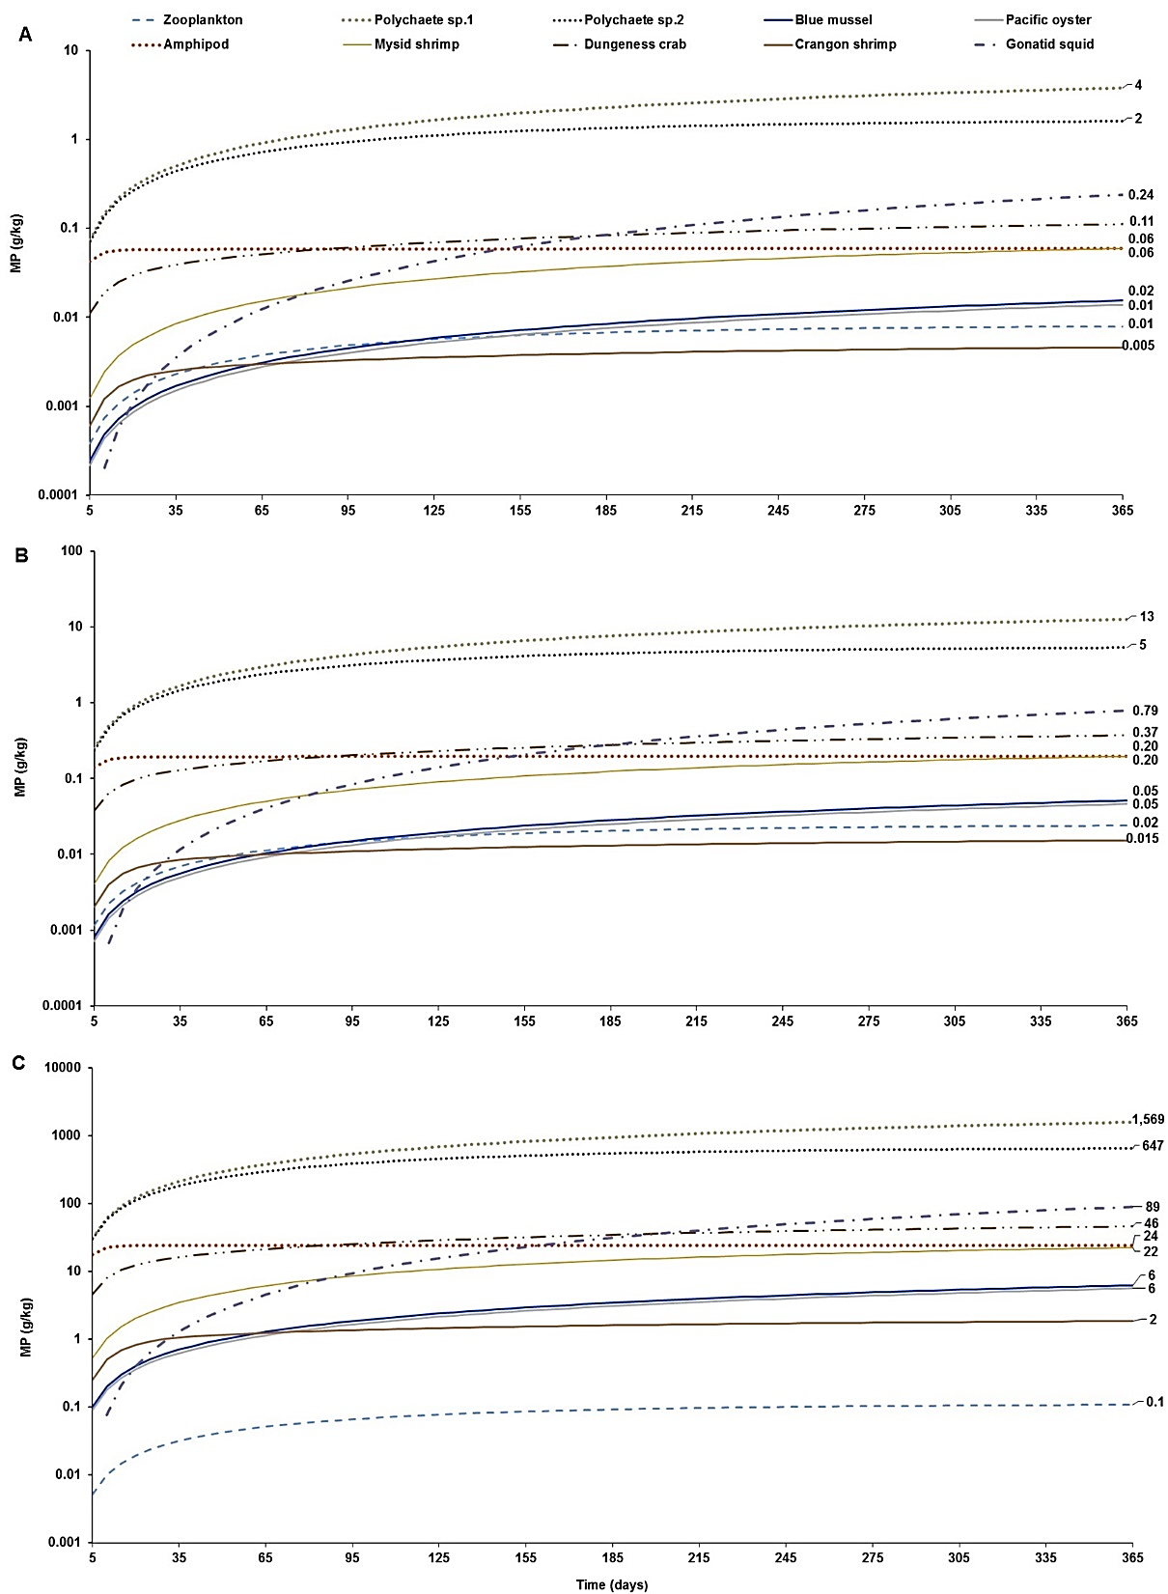
Figure S2. Foodweb model simulations showing the projections of microplastics (MPs) bioaccumulation in marine invertebrates of the marine mammalian food web for the three concentration scenarios: (A) low concentration (scenario 1): seawater [0.003 g/L] and sediment [0.266 g/kg dw]; (B) moderate concentration (scenario 2): seawater [0.010 g/L] and sediment [0.886 g/kg dw]; and, (C) high concentration (scenario 3): seawater [0.040 g/L] and sediment [111 g/kg dw]. The simulations for the bioaccumulation include the elimination rates, and growth dilution for most organisms based on the literature reported elsewhere (see Table S1). For zooplankton, as the key trophic level for the initial uptake of microplastics a k_{E} = 0.143/d (i.e. retention time = 7 d) was used as a least conservative scenario, based on the study by Cole et al. (2013).
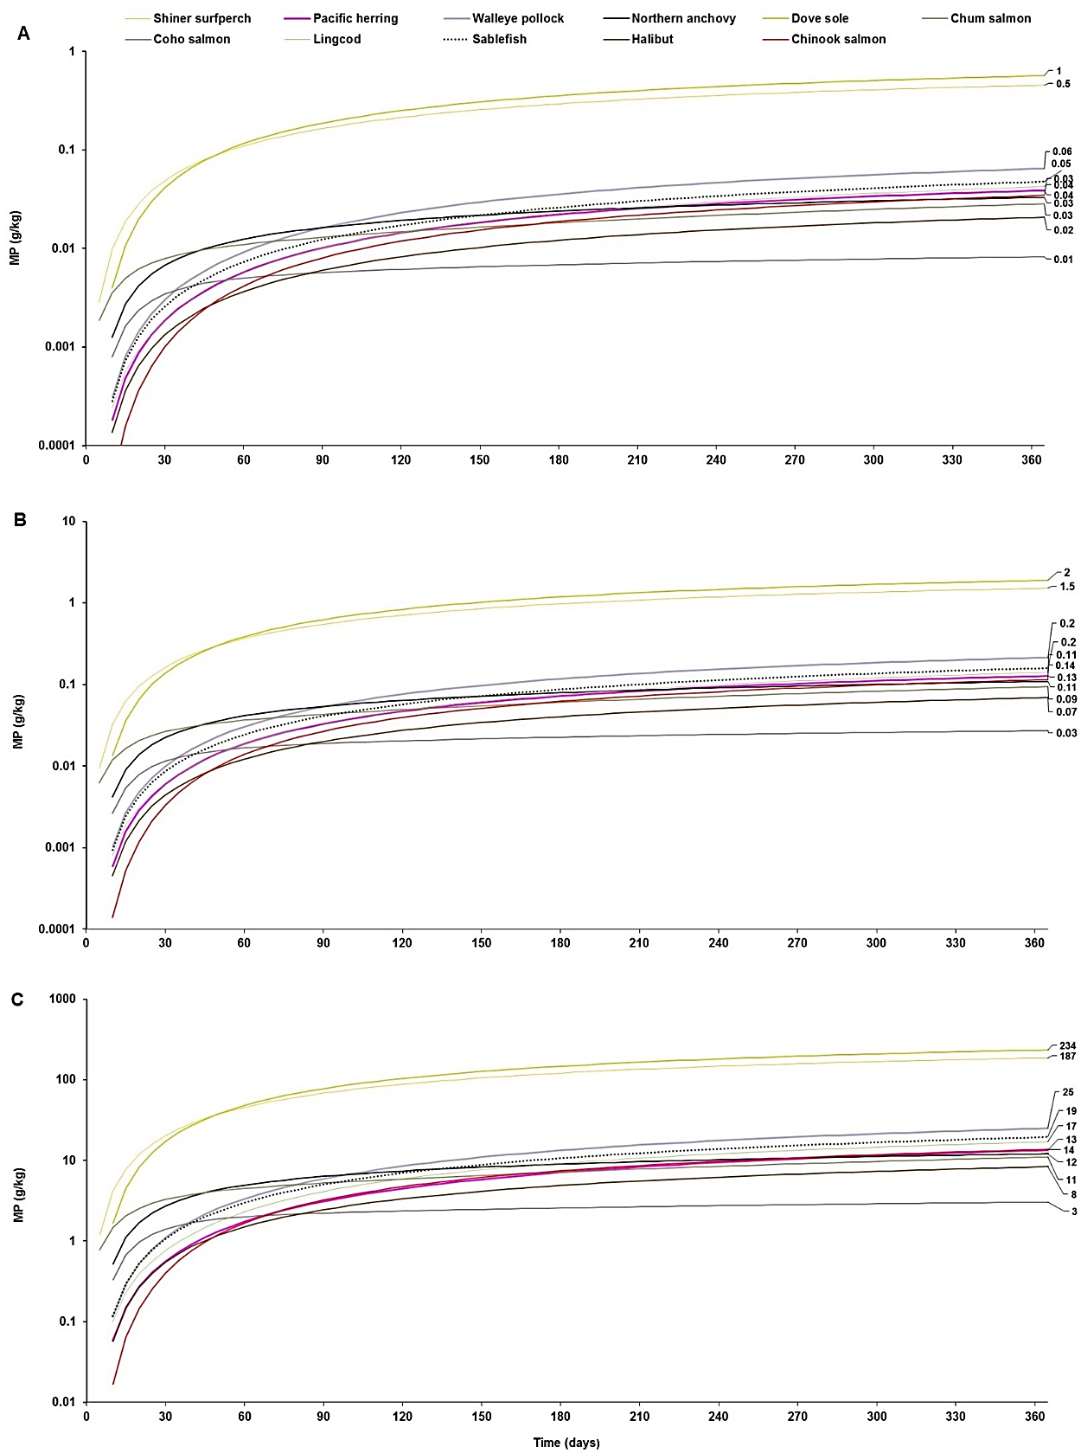
Figure S3. Foodweb model simulations showing the projections of microplastics (MPs) bioaccumulation in fish species of the marine food web for the three concentration scenarios: (A) low concentration (scenario 1): seawater [0.003 g/L] and sediment [0.266 g/kg dw]; (B) moderate concentration (scenario 2): seawater [0.010 g/L] and sediment [0.886 g/kg dw]; and, (C) high concentration (scenario 3): seawater [0.040 g/L] and sediment [111 g/kg dw]. The simulations for the bioaccumulation include the elimination rates, and growth dilution for most organisms based on the literature reported elsewhere (see Table S1). Scenarios were run with a k_{E} = 0.143/d (i.e. retention time = 7 d) in zooplankton as a least conservative scenario, based on the study by Cole et al. (2013).
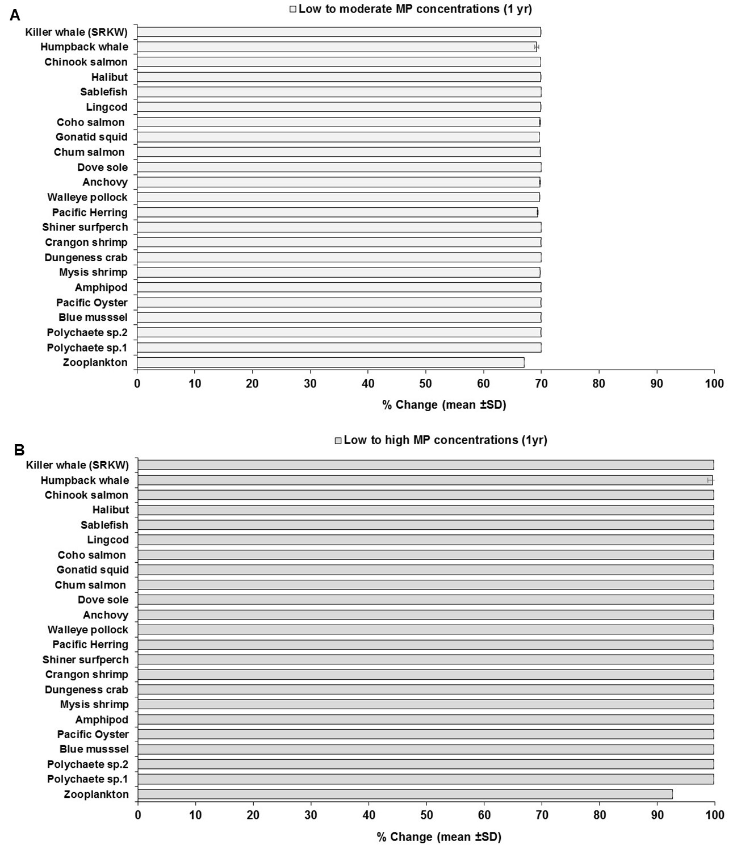
Figure S4. Changes (% mean ± SD) in microplastic concentrations in marine biota of the marine mammalian foodweb in response to changes in abiotic concentrations (water and sediments) from low concentrations (scenario 1: seawater [0.003 g/L] and sediment [0.266 g/kg dw]), to moderate concentration (scenario 2: seawater [0.010 g/L] and sediment [0.886 g/kg dw]); and from low concentrations (scenario 1) to high concentrations (scenario 3: seawater [0.040 g/L] and sediment [111 g/kg dw]) concentrations scenarios (see Table S2) at 1yr of simulation.

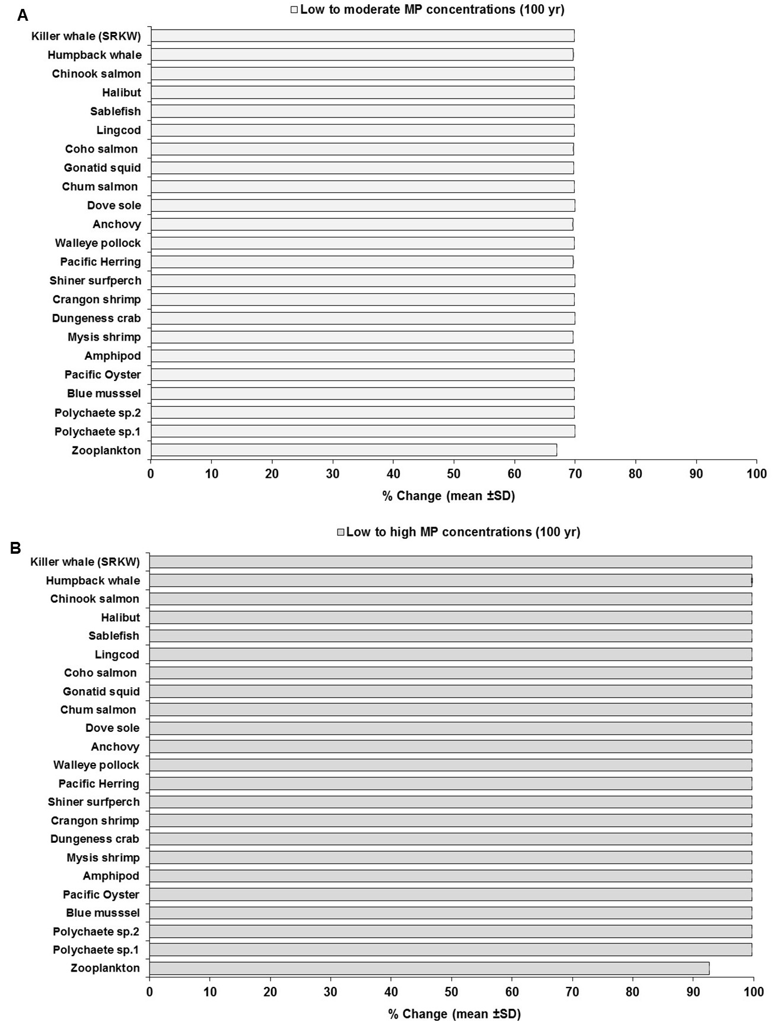
Figure S5. Changes (% mean ± SD) in microplastic concentrations in marine biota of the marine mammalian foodweb in response to changes in abiotic concentrations (water and sediments) from low concentrations (scenario 1: seawater [0.003 g/L] and sediment [0.266 g/kg dw]), to moderate concentration (scenario 2: seawater [0.010 g/L] and sediment [0.886 g/kg dw]); and from low concentrations (scenario 1) to high concentrations (scenario 3: seawater [0.040 g/L] and sediment [111 g/kg dw]) concentrations scenarios (see Table S2) at 100 yr of simulation.

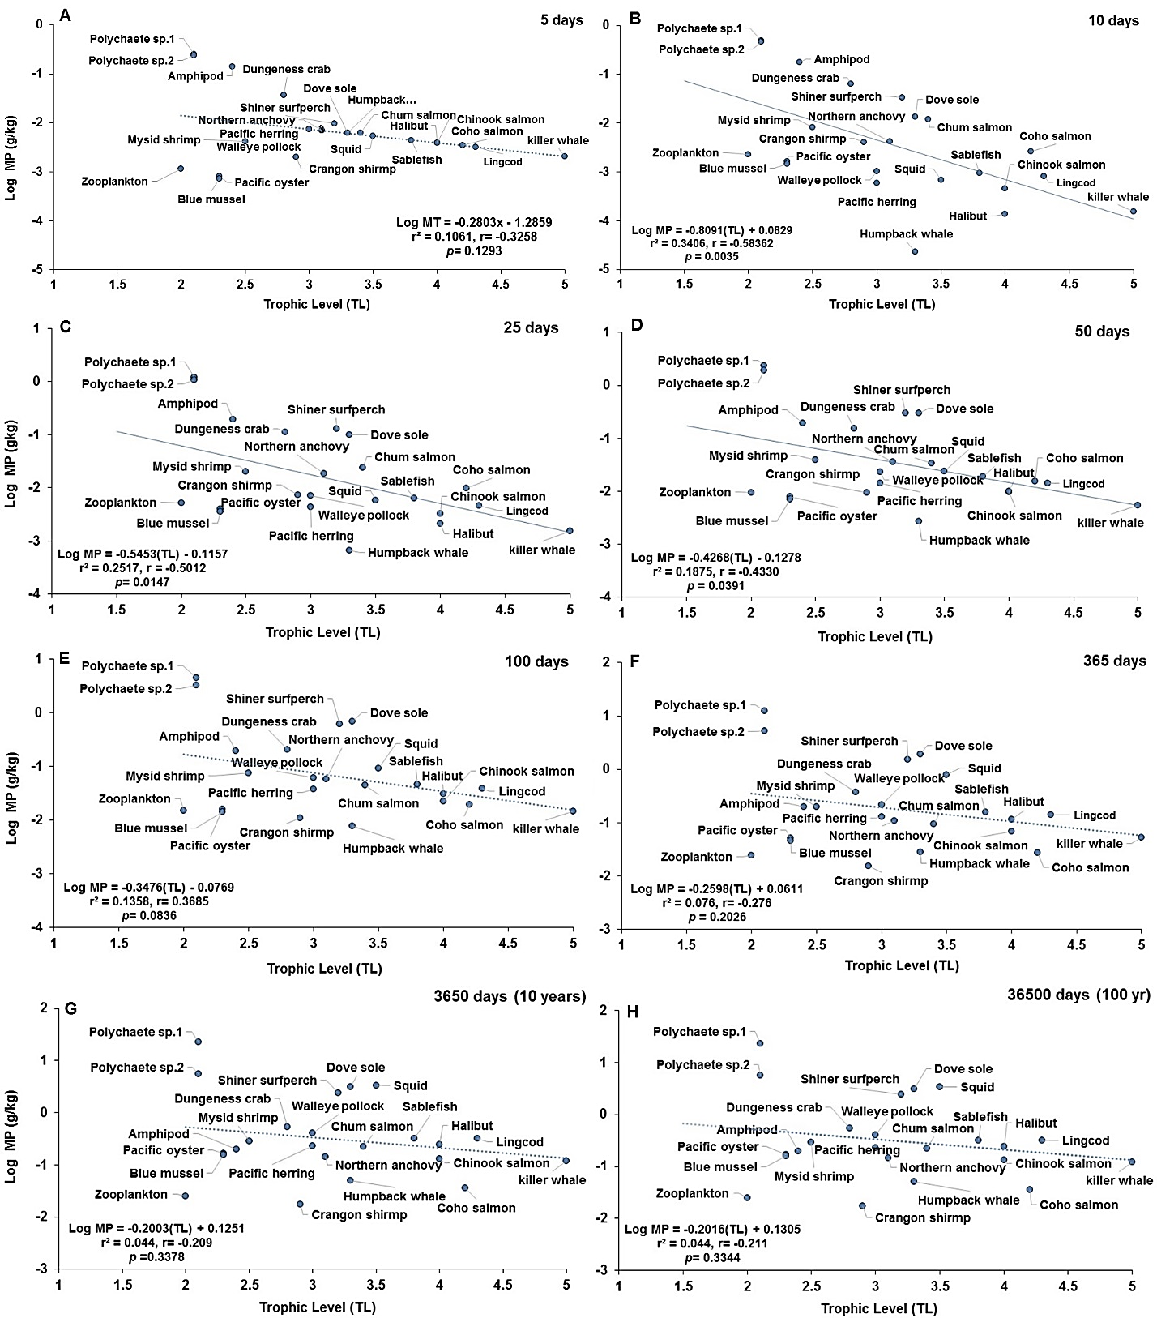
Figure S6. Projections of the apparent trophic magnification factor (TMF) as a function of predicted concentration of microplásticos (MPs) versus trophic level (TL) in the cetaceans’ food web of the Northeastern Pacific for simulations under a scenario of moderate abiotic concentrations (scenario 2: seawater= [0.010 particles/L]; and, sediment= [0.886 g/kg dw] at: (A) 5 d (no regression line due to lack of significant relationship); (B) 10 d(regression line indicates a strong negative, significant relationship); (C) 25 d (regression line indicates a moderate and negative, significant relationship); (D) 50 d (regression line indicates a weak and negative, significant relationship); (E) 100 d (lack of significant relationship); (F) 365 d or 1 yr (lack of significant relationship); (G) 3650 d or 10 yr (lack of significant relationship); and,(H) 36500 d or 100 yr (the dotted line indicates the slope direction and a slight positive trend, but lack of a significant relationship).
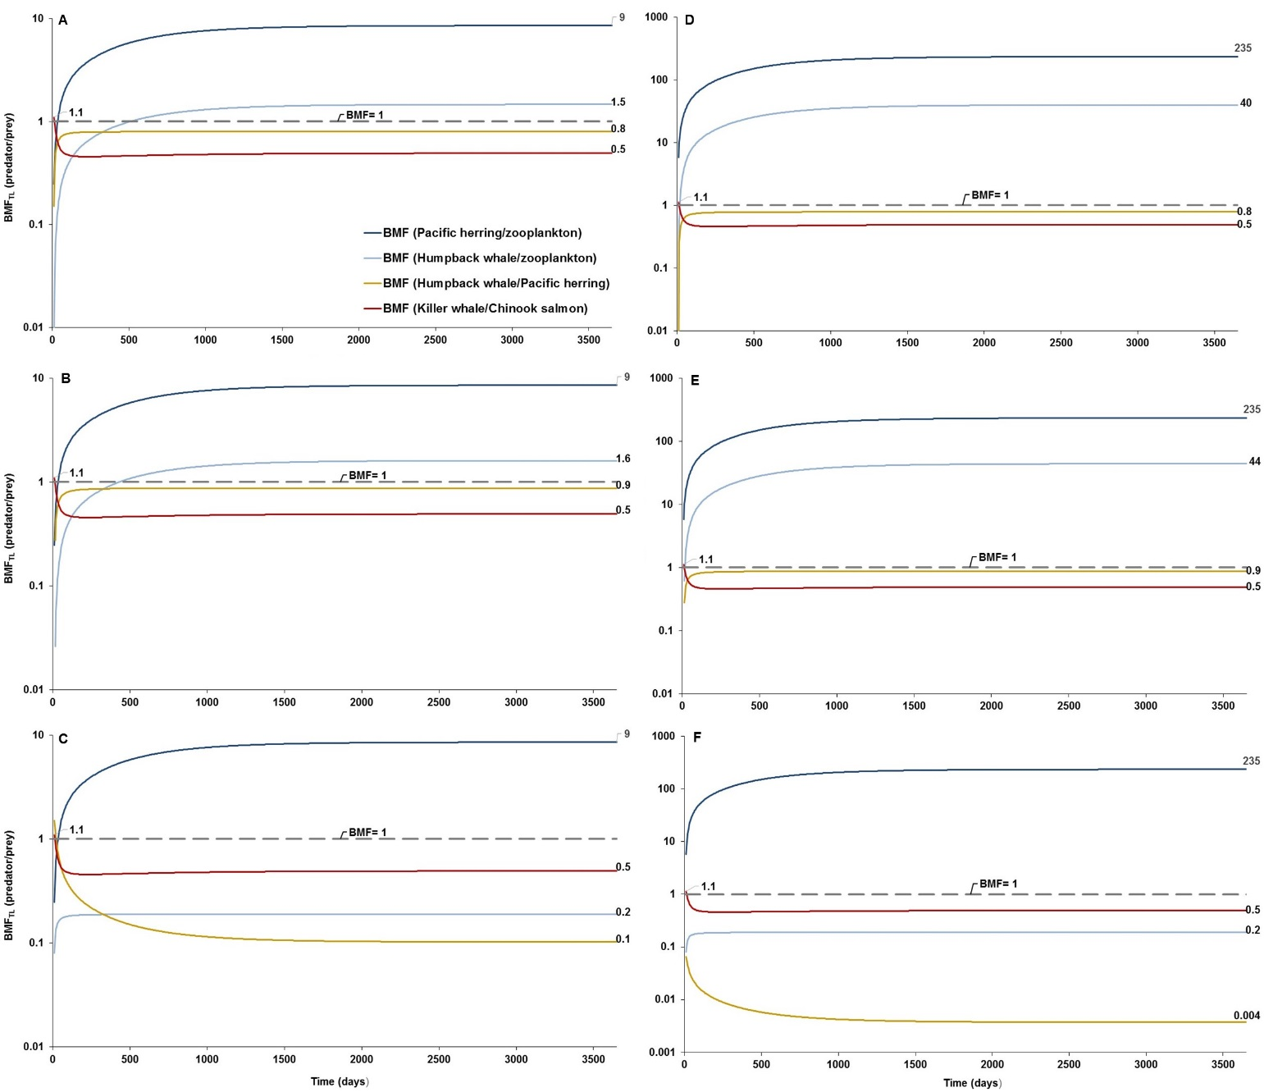
Figure S7. Predator-prey biomagnification factor (BMF_{TL}) subject to changes in the humpback whale diet: (A) BMF_{TL} simulation at low concentrations in water and sediment (scenario 1: 0.003 g/L; and 0.266 g/kg dw, respectively) with a humpback whale’s baseline diet of 10% zooplankton and 90% herring; (B) BMF_{TL} simulation under scenario 1 with changes in the humpback whale’s diet from 90% herring and 10% zooplankton to 100% herring and 0% zooplankton; (C) BMF_{TL} simulation under scenario 1 with changes in the humpback whale’s diet from 90% herring and 10% zooplankton to 0% herring and 100% zooplankton; (D) BMF_{TL} simulation at high concentrations in water and sediment (scenario 3: 0.04 g/L; and 111 g/kg dw, respectively) with a humpback whale’s baseline diet of 10% zooplankton and 90% herring; E) BMF_{TL} simulation under scenario 3 with changes in the humpback whale’s diet from 90% herring and 10% zooplankton to 100% herring and 0% zooplankton; and (F) BMF_{TL} simulation under scenario 3 with changes in the humpback whale’s diet from 90% herring and 10% zooplankton to 0% herring and 100% zooplankton. Dashed line represents equal partitioning or distribution of MP concentrations (BMF_{TL} = 1) between predator and prey. All simulations run with a low elimination rate of k_{E} = 0.143/d for zooplankton.

