S1 Figure. Experimental material for both synchronous (immediate) and asynchronous (7 minutes delay) conditions: a) = with emojis, positive answers, b) text only, positive answers, c) with emojis, negative answers, d) text only, negative answers.

a) 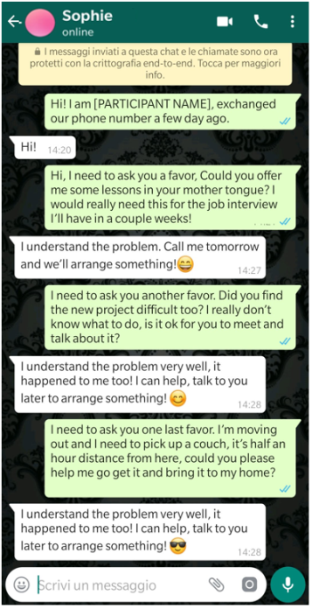 b) 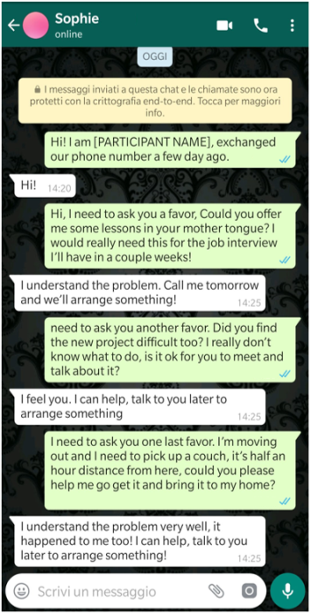
c) 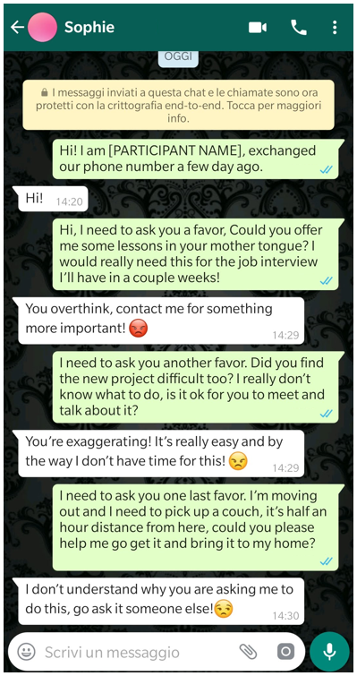 d) 