Refactoring the formicamycin biosynthetic gene cluster to make high-level producing strains and new molecules

Rebecca Devine, Hannah McDonald, Zhiwei Qin, Corinne Arnold, Katie Noble, Govind Chandra, Barrie Wilkinson* and Matthew I. Hutchings*

Department of Molecular Microbiology, John Innes Centre, Norwich Research Park, Norwich, UK, NR4 7UH.

*Correspondence to barrie.wilkinson@jic.ac.uk and matt.hutchings@jic.ac.uk

Structure determination of new fasamycin and formicamycin congeners
Structures were assigned based on our published data ⁴. The substituent variations including chlorination and O-methylations were determined by 2D HSQC and NOESY NMR.
Formicamycin R

Molecular formula: C₂₉H₂₃O₈Cl₅
Isolated yield: 16.5 mg
UV (PDA): λ_{max} = 245 and 290 nm
Specific rotation: [α]_{D}² ⁰ = 305.1
HRMS (ESI) m/z: calculated [M - H]⁻ = 672.9763, observed [M - H]⁻ = 672.9759, Δ
= -0.59 ppm
NMR (Methanol-d4; 600 MHz & 125 MHz): ¹H, ¹³C, HSQC, HMBC, NOESY
Table 1: Structural determination of Formicamycin R

Position | δ_{C} ppm | δ_{H} ppm (no. of protons, multiplicity, J in Hz) | HMBC | NOESY
1 | 134.5 |  | 25
2 | 119.4 |  | 25
3 | 153.3 |  | 29
4 | 115.8
5 | 150.8
6 | 130.0 |  | 24, 25
7 | 140.6 |  | 24
8 | 124.5 |  | 20, 24
9 | 195.3 |  | 19
10 | 80.4 |  | 19, 20
11 | 199.9 |  | 19
12 | 115.0
13 | 160.8
14 | 108.9
15 | 161.5
16 | 109.9
17 | 147.1 |  | 19, 26, 27
18 | 41.3 |  | 19, 20, 26, 27
19 | 51.3 | 2.5 (1H, dd, 10.16, 6.09) | 20, 26, 27 | 20, 26, 27
20 | 30.3 | 2.8 (1H, dd, 18.86, 10.16) |  | 19
 |  | 3.7 (1H, dd, 18.86, 6.09)
21 | 143.4 |  | 20
22 | 122.7 |  | 20, 24
23 | 160.4 |  | 24, 28
24 | 115.6 | 6.8 (1H, s) |  | 25, 28
25 | 18.3 | 2.0 (3H, s) |  | 24
26 | 27.3 | 1.7 (3H, s) | 27 | 19, 20, 27
27 | 29.3 | 1.9 (3H, s) | 19, 26 | 19, 26
28 | 57.5 | 4.0 (3H, s) |  | 24
29 | 61.3 | 3.5 (3H, s)

Formicamycin S

Molecular formula: C₃₀H₂₅O₈Cl₅
Isolated yield: 7.0 mg
UV (PDA): λ_{max} = 240 and 292 nm
Specific rotation: [α]_{D}² ⁰ = 278.0
HRMS (ESI) m/z: calculated [M - H]⁻ = 686.9919, observed [M - H]⁻ = 686.9918, Δ
= -0.15 ppm
NMR (Methanol-d4; 600 MHz & 125 MHz): ¹H, ¹³C, HSQC, HMBC, NOESY
Table 2: Structural determination of Formicamycin S
Position | δ_{C} ppm | δ_{H} ppm (no. of protons, multiplicity, J in Hz) | HMBC | NOESY
1 | 135.5 |  | 25
2 | 121.8 |  | 25
3 | 153.7 |  | 29
4 | 116.2
5 | 153.7 |  | 30
6 | 135.1 |  | 24, 25
7 | 140.1 |  | 24
8 | 124.3 |  | 20, 24
9 | 195.4 |  | 19
10 | 80.4 |  | 19, 20
11 | 199.5 |  | 19
12 | 126.2
13 | 161.6
14 | 108.9
15 | 161.7
16 | 109.5
17 | 146.9 |  | 19, 26, 27
18 | 41.3 |  | 19, 20, 26, 27
19 | 51.3 | 2.5 (1H, dd, 9.81, 5.54) | 20, 26, 27 | 20, 26, 27
20 | 30.3 | 2.8 (1H, dd, 18.91, 9.81) |  | 19
 |  | 3.7 (1H, dd, 18.08, 5.54)
21 | 143.5 |  | 20
22 | 122.9 |  | 20, 24
23 | 160.5 |  | 24, 28
24 | 115.1 | 6.9 (1H, s) |  | 25, 28
25 | 18.2 | 2.0 (3H, s) |  | 24
26 | 27.3 | 1.7 (3H, s) | 27 | 19, 20, 27
27 | 29.3 | 1.9 (3H, s) | 19, 26 | 19, 26
28 | 57.5 | 3.92 (3H, s) |  | 24
29 | 61.4 | 3.5 (3H, s)
30 | 61.2 | 3.90 (3H, s)

Fasamycin L

Molecular formula: C₂₈H₂₁O₇Cl₃
Isolated yield: 45.8 mg
UV (PDA): λ_{max} = 249, 290, 350 and 419 nm
Specific rotation: [α]_{D}² ⁰ = 6.8
HRMS (ESI) m/z: calculated [M + Na]⁺ = 597.0245, observed [M + Na]⁺ = 597.0254, Δ
= 1.51 ppm
NMR (Methanol-d4; 600 MHz & 125 MHz): ¹H, ¹³C, HSQC, HMBC, NOESY
Table 3: Structural determination of Fasamycin L
Position | δ_{C} ppm | δ_{H} ppm (no. of protons, multiplicity, J in Hz) | HMBC | NOESY
1 | 135.6 |  | 25
2 | 113.7 |  | 4, 25
3 | 157.1 |  | 4, 28
4 | 98.6 | 6.5 (1H, s) |  | 28
5 | 153.9 |  | 4
6 | 126.6 |  | 4, 24, 25
7 | 138.8
8 | 118.8 |  | 20, 24
9 | 166.7
10 | 108.1 |  | 20
11 | 191.6
12 | 107.5 |  | 16
13 | 162.0
14 | 109.1 |  | 16
15 | 162.5 |  | 14, 16
16 | 107.2 | 6.8 (1H, s) |  | 26, 27
17 | 153.2 |  | 16, 26, 27
18 | 40.2 |  | 16, 20, 26, 27
19 | 148.0 |  | 20, 26, 27
20 | 112.5 | 7.9 (1H, s) |  | 26, 27
21 | 139.0 |  | 20
22 | 114.3 |  | 20, 24
23 | 156.0 |  | 24
24 | 122.1 | 6.8 (1H, s) |  | 25
25 | 18.4 | 2.0 (3H, s) |  | 24
26 | 35.0 | 1.7 (3H, s) | 27
27 | 35.0 | 1.7 (3H, s) | 26
28 | 56.3 | 3.6 (3H, s) |  | 4
Fasamycin M

Molecular formula: C₂₈H₂₁O₇Cl₃
Isolated yield: 2.3 mg
UV (PDA): λ_{max} = 249, 289, 352 and 413 nm
Specific rotation: [α]_{D}² ⁰ = 29.1
HRMS (ESI) m/z: calculated [M + Na]⁺ = 597.0245, observed [M + Na]⁺ = 597.0246, Δ
= 0.17 ppm
NMR (Methanol-d4; 600 MHz & 125 MHz): ¹H, ¹³C, HSQC, HMBC, NOESY
Table 4: Structural determination of Fasamycin M

Position | δ_{C} ppm | δ_{H} ppm (no. of protons, multiplicity, J in Hz) | HMBC | NOESY
1 | 134.7 |  | 25
2 | 119.1 |  | 25
3 | 150.6
4 | 114.9
5 | 153.0
6 | 132.1 |  | 24, 25
7 | 137.2
8 | 118.2 |  | 20, 24
9 | 165.7
10 | 108.4 |  | 20
11 | 191.7
12 | 108.6 |  | 14, 16
13 | 167.2
14 | 102.4 | 6.2 (d, 2.22) | 16
15 | 167.4 |  | 14, 16
16 | 107.7 | 6.7 (d, 2.22) | 14 | 26, 27
17 | 156.0 |  | 26, 27
18 | 40.4 |  | 16, 20, 26, 27
19 | 148.7 |  | 20, 26, 27
20 | 112.5 | 7.9 (1H, s) |  | 26, 27
21 | 138.7
22 | 115.0 |  | 20, 24
23 | 156.4
24 | 122.4 | 6.8 (1H, s) |  | 25, 28
25 | 18.3 | 2.0 (3H, s) |  | 24
26 | 35.0 | 1.8 (3H, s) | 27 | 16, 20
27 | 35.1 | 1.8 (3H, s) | 26 | 16, 20
28 | 60.9 | 3.5 (3H, s) |  | 24

Fasamycin N

Molecular formula: C₂₈H₂₁O₇Cl₃
Isolated yield: 10.7 mg
UV (PDA): λ_{max} = 253, 293, 365 and 424 nm
Specific rotation: [α]_{D}² ⁰ = 3.9
HRMS (ESI) m/z: calculated [M + Na]⁺ = 597.0245, observed [M + Na]⁺ = 597.0262, Δ
= 2.85 ppm
NMR (Methanol-d4; 600 MHz & 125 MHz): ¹H, ¹³C, HSQC, HMBC, NOESY
Table 5: Structural determination of Fasamycin N

Position | δ_{C} ppm | δ_{H} ppm (no. of protons, multiplicity, J in Hz) | HMBC | NOESY
1 | 135.6 |  | 25
2 | 113.7 |  | 4, 25
3 | 157.1 |  | 4, 28
4 | 98.6 | 6.5 (1H, s) |  | 28
5 | 153.9 |  | 4
6 | 126.6 |  | 4, 24, 25
7 | 139.1
8 | 118.4 |  | 20, 24
9 | 166.0
10 | 106.9 |  | 20
11 | 191.8
12 | 109.4 |  | 14
13 | 164.0 |  | 14
14 | 103.9 | 6.5 (1H, s)
15 | 166.0 |  | 14
16 | 114.0
17 | 151.1 |  | 26, 27
18 | 41.4 |  | 20, 26, 27
19 | 150.1 |  | 26, 27
20 | 113.3 | 7.9 (1H, s) |  | 26, 27
21 | 138.9
22 | 114.0 |  | 20, 24
23 | 155.9 |  | 24
24 | 122.1 | 6.8 (1H, s) |  | 25
25 | 18.4 | 2.0 (3H, s) |  | 24
26 | 30.7 | 2.1 (3H, s) | 27 | 20
27 | 30.8 | 2.1 (3H, s) | 26 | 20
28 | 56.3 | 3.6 (3H, s) |  | 4

Fasamycin O

Molecular formula: C₂₉H₂₃O₇Cl₃
Isolated yield: 3.2 mg
UV (PDA): λ_{max} = 252, 292, 336 and 420 nm
Specific rotation: [α]_{D}² ⁰ = 3.0
HRMS (ESI) m/z: calculated [M - H]⁻ = 587.0437, observed [M - H]⁻ = 587.0463, Δ
= 4.43 ppm
NMR (Methanol-d4; 600 MHz & 125 MHz): ¹H, ¹³C, HSQC, HMBC, NOESY
Table 6: Structural determination of Fasamycin O
Position | δ_{C} ppm | δ_{H} ppm (no. of protons, multiplicity, J in Hz) | HMBC | NOESY
1 | 135.7 |  | 25
2 | 113.8 |  | 4, 25
3 | 157.1 |  | 4, 28
4 | 98.6 | 6.5 (1H, s) |  | 29
5 | 157.1 |  | 4, 29
6 | 126.8 |  | 4, 25
7 | 138.1
8 | 119.5 |  | 20
9 | 170.2
10 | 108.4 |  | 20
11 | 191.1
12 | 107.9 |  | 16
13 | 166.6
14 | 108.2
15 | 164.9
16 | 108.4 | 6.8 (1H, s) |  | 26, 27
17 | 153.0 |  | 26, 27
18 | 40.2 |  | 16, 20, 26, 27
19 | 148.3 |  | 26, 27
20 | 112.5 | 8.0 (1H, s) |  | 26, 27
21 | 139.5
22 | 116.7 |  | 20
23 | not detected
24 | 117.4 | 7.0 (1H, s) |  | 25, 28
25 | 18.5 | 2.0 (3H, s) |  | 24
26 | 35.0 | 1.7 (3H, s) | 27 | 16, 20
27 | 35.0 | 1.7 (3H, s) | 26 | 16, 20
28 | 57.4 | 4.0 (3H, s) |  | 24
29 | 56.3 | 3.6 (3H, s) |  | 4

Fasamycin P

Molecular formula: C₂₈H₂₀O₇Cl₄
Isolated yield: 2.3 mg
UV (PDA): λ_{max} = 253, 294, 360 and 419 nm
Specific rotation: [α]_{D}² ⁰ = 41.7
HRMS (ESI) m/z: calculated [M - H]⁻ = 606.9890, observed [M - H]⁻ = 606.9903, Δ
= 2.14 ppm
NMR (Methanol-d4; 600 MHz & 125 MHz): ¹H, ¹³C, HSQC, HMBC, NOESY
Table 7: Structural determination of Fasamycin P
Position | δ_{C} ppm | δ_{H} ppm (no. of protons, multiplicity, J in Hz) | HMBC | NOESY
1 | 134.8 |  | 25
2 | 119.1 |  | 25
3 | not detected
4 | 114.9
5 | 153.0 |  | 28
6 | 132.1 |  | 24, 25
7 | 138.9
8 | 117.9 |  | 20, 24
9 | 165.0
10 | 107.3 |  | 20
11 | 191.4
12 | 115.2
13 | not detected
14 | 104.2 | 6.4 (1H, s)
15 | 166.2 |  | 14
16 | 108.5 |  | 14
17 | 151.6 |  | 26, 27
18 | 41.4 |  | 20, 26,27
19 | 149.7 |  | 26, 27
20 | 113.4 | 7.9 (1H, s) |  | 26, 27
21 | 137.2
22 | 114.7 |  | 20, 24
23 | 155.9 |  | 24
24 | 122.2 | 6.8 (1H, s) |  | 25, 28
25 | 18.3 | 2.0 (3H, s) |  | 24
26 | 30.7 | 2.1 (3H, s) | 27 | 20
27 | 30.7 | 2.1 (3H, s) | 26 | 20
28 | 60.9 | 3.5 (3H, s) |  | 24

Fasamycin Q

Molecular formula: C₂₈H₂₀O₇Cl₄
Isolated yield: 5.0 mg
UV (PDA): λ_{max} = 254, 293, 361 and 429 nm
Specific rotation: [α]_{D}² ⁰ = 21.3
HRMS (ESI) m/z: calculated [M - H]⁻ = 606.9890, observed [M - H]⁻ = 606.9897, Δ
= 1.15 ppm
NMR (Methanol-d4; 600 MHz & 125 MHz): ¹H, ¹³C, HSQC, HMBC, NOESY
Table 8: Structural determination of Fasamycin Q
Position | δ_{C} ppm | δ_{H} ppm (no. of protons, multiplicity, J in Hz) | HMBC | NOESY
1 | 135.6
2 | 113.7 |  | 4
3 | 157.1 |  | 4
4 | 98.6 | 6.5 (1H, s) |  | 28
5 | 153.9 |  | 4
6 | 126.7 |  | 4, 24
7 | 138.8 |  | 24
8 | 118.5 |  | 20, 24
9 | 165.6
10 | 107.0 |  | 20
11 | 190.5
12 | 116.5
13 | 161.5
14 | 109.9
15 | not detected
16 | 107.1
17 | 151.1
18 | 41.2 |  | 20, 26, 27
19 | 147.2
20 | 113.2 | 7.8 (1H, s) |  | 26, 27
21 | 138.9
22 | 114.0 |  | 20, 24
23 | 155.6 |  | 24
24 | 121.9 | 6.7 (1H, s) |  | 25
25 | 18.5 | 2.0 (3H, s) |  | 24
26 | 30.8 | 2.1 (3H, s) |  | 20
27 | 30.9 | 2.1 (3H, s) |  | 20
28 | 56.3 | 3.6 (3H, s) |  | 4

¹H NMR Spectra

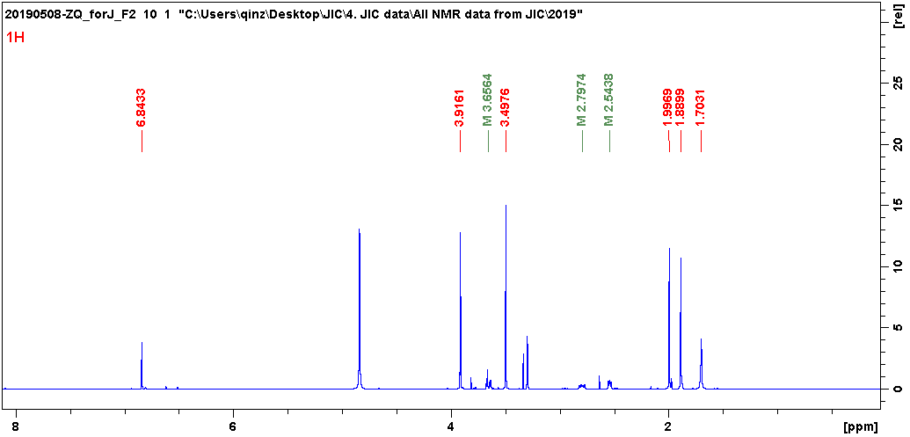

Figure 1. ¹H NMR spectrum for formicamycin R. CD₃OD, 600 MHz.

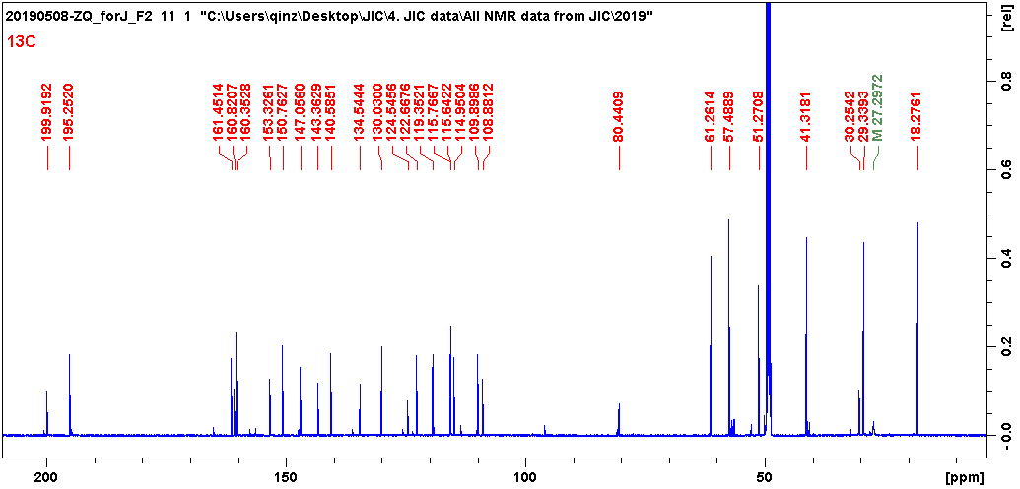

Figure 2. ¹³C NMR spectrum for formicamycin R. CD₃OD, 150 MHz.

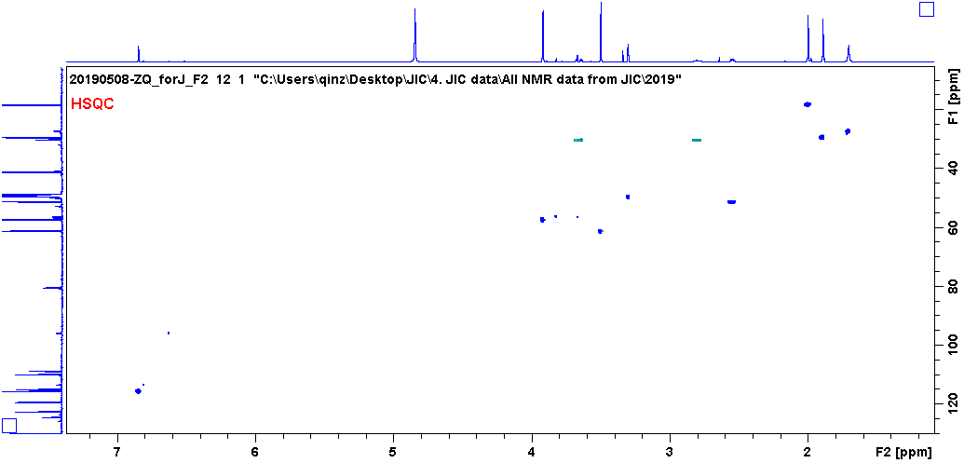

Figure 3. HSQC spectrum for formicamycin R. CD₃OD.

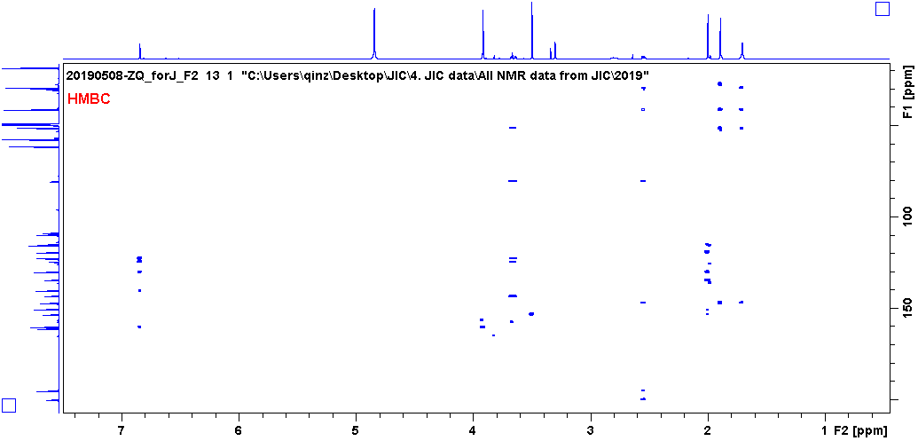

Figure 4. HMBC spectrum for formicamycin R. CD₃OD.

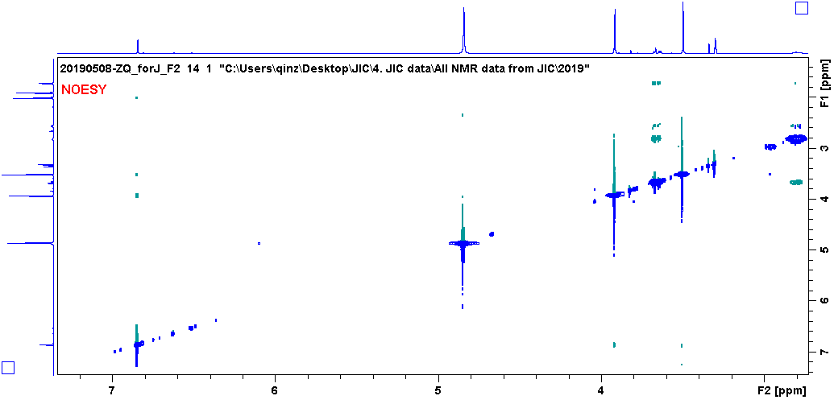

Figure 5. NOESY spectrum for formicamycin R. CD₃OD.

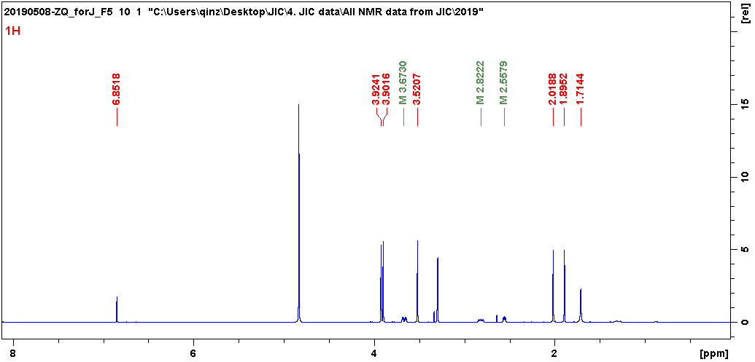

Figure 6. ¹H NMR spectrum for formicamycin S. CD₃OD, 600 MHz.

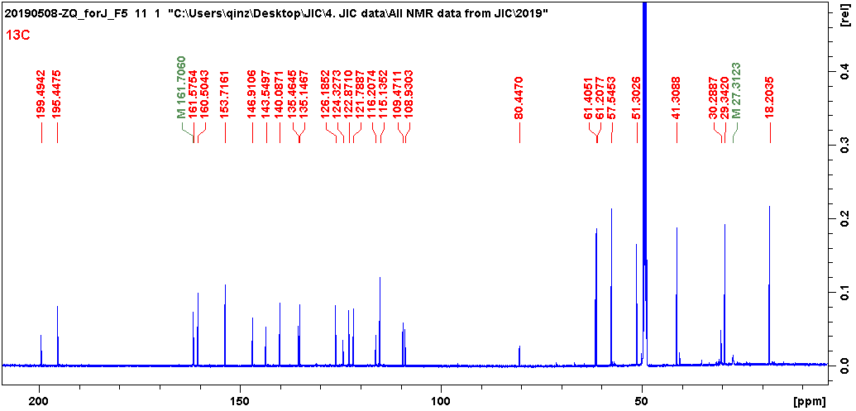

Figure 7. ¹³C NMR spectrum for formicamycin S. CD₃OD, 150 MHz.

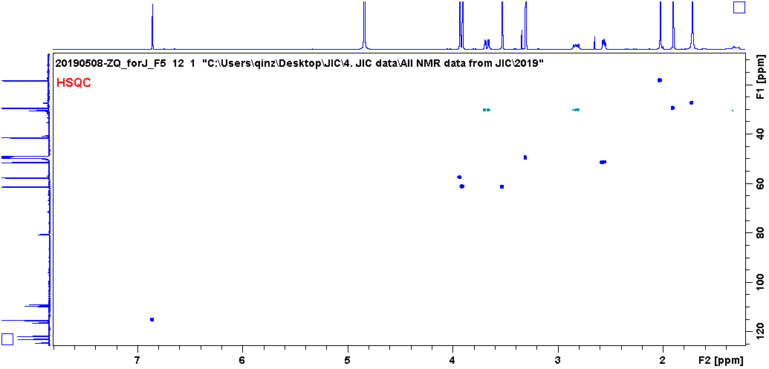

Figure 8. HSQC spectrum for formicamycin S. CD₃OD.

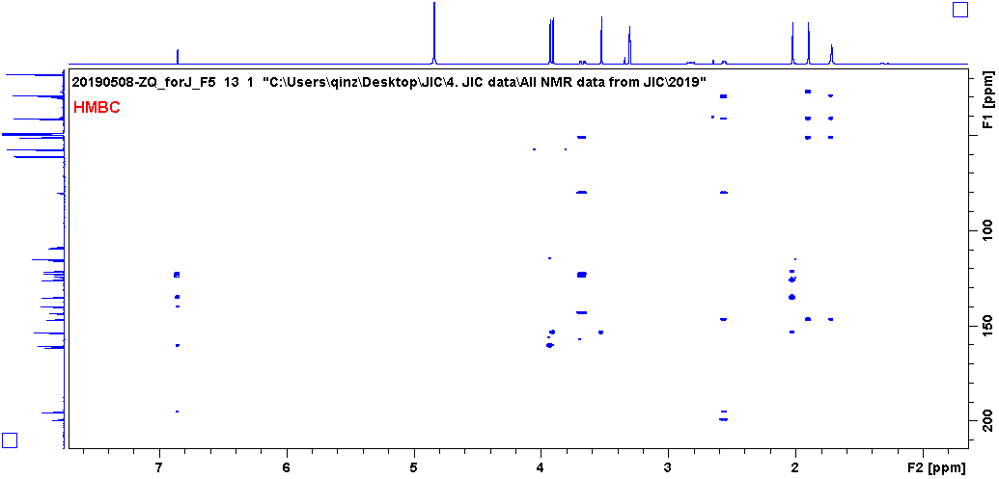

Figure 9. HMBC spectrum for formicamycin S. CD₃OD.

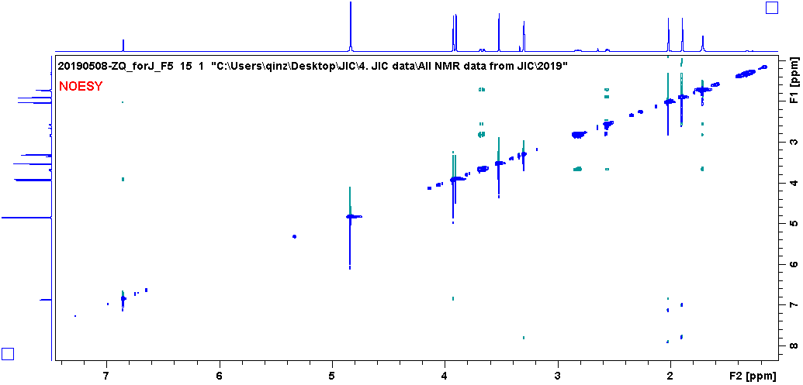
Figure 10. NOESY spectrum for formicamycin S. CD₃OD.

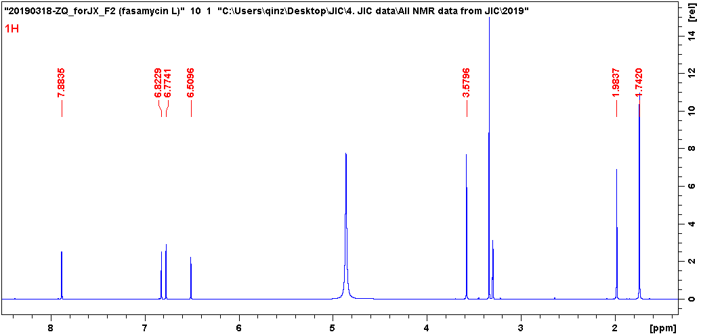

Figure 11. ¹H NMR spectrum for fasamycin L. CD₃OD, 600 MHz.

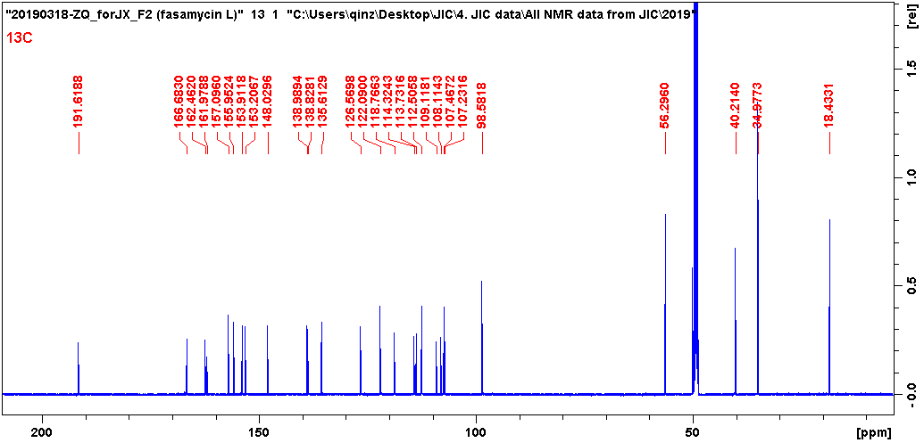

Figure 12. ¹³C NMR spectrum for fasamycin L. CD₃OD, 150 MHz.

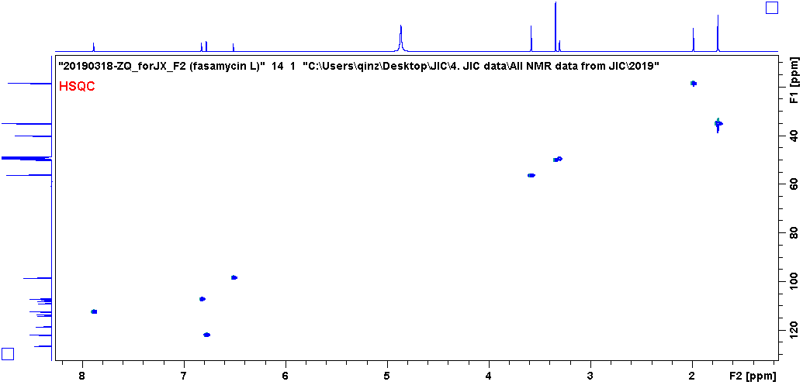

Figure 13. HSQC spectrum for fasamycin L. CD₃OD.

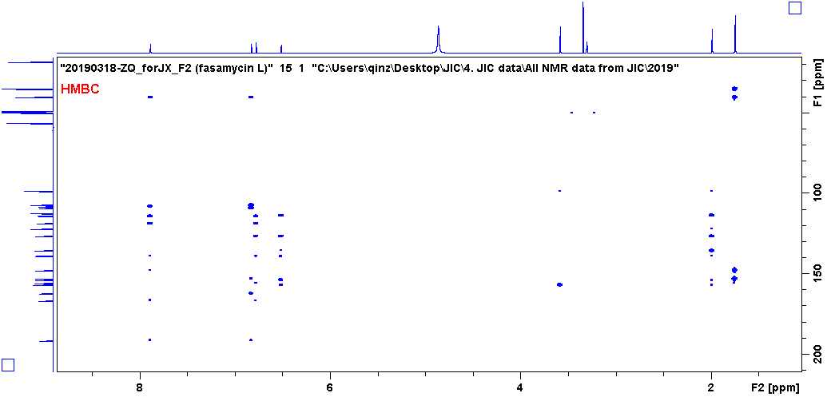

Figure 14. HMBC spectrum for fasamycin L. CD₃OD.

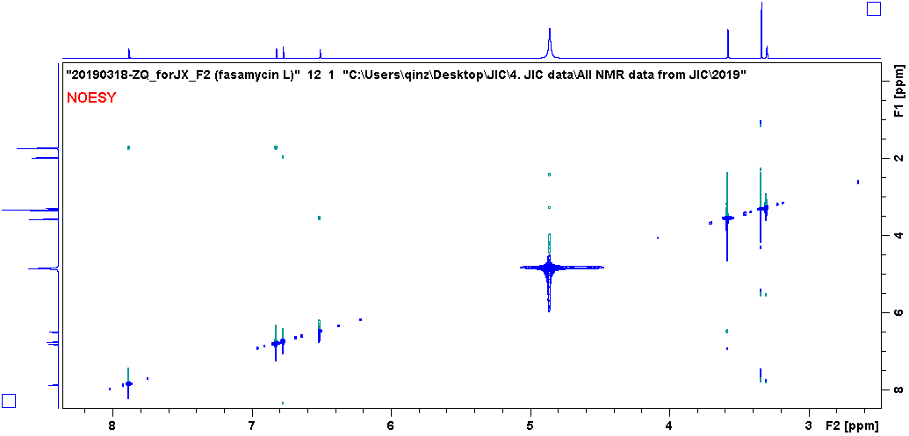

Figure 15. NOESY spectrum for fasamycin L. CD₃OD.

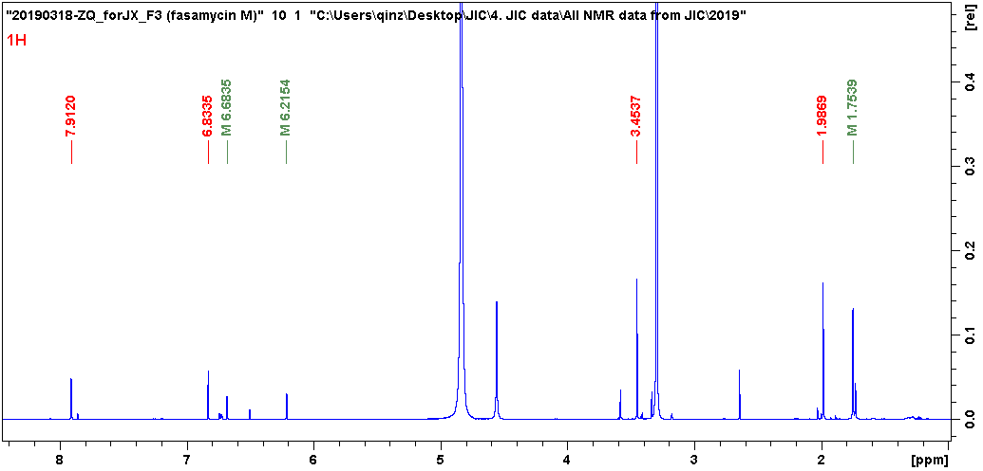

Figure 16. ¹H NMR spectrum for fasamycin M. CD₃OD, 600 MHz.

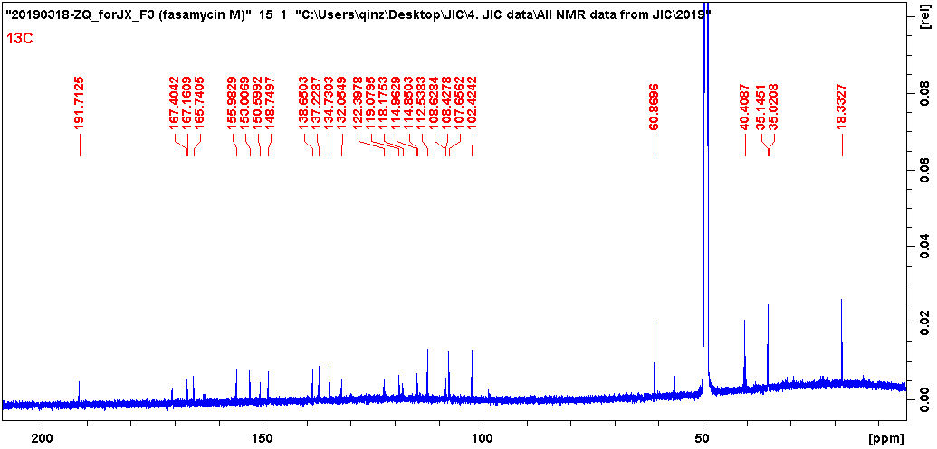

Figure 17. ¹³C NMR spectrum for fasamycin M. CD₃OD, 150 MHz.

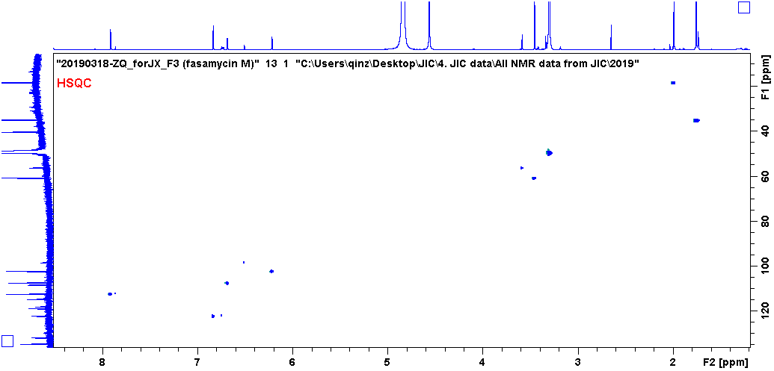

Figure 18. HSQC spectrum for fasamycin M. CD₃OD.

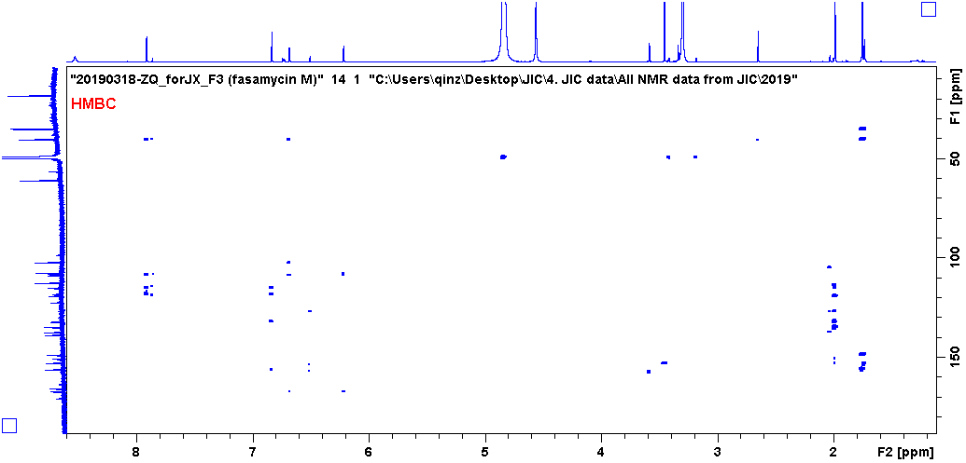

Figure 19. HMBC spectrum for fasamycin M. CD₃OD.

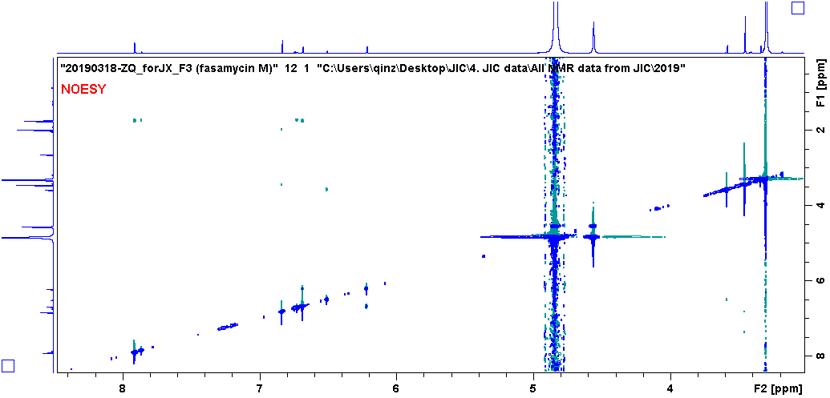

Figure 20. NOESY spectrum for fasamycin M. CD₃OD.

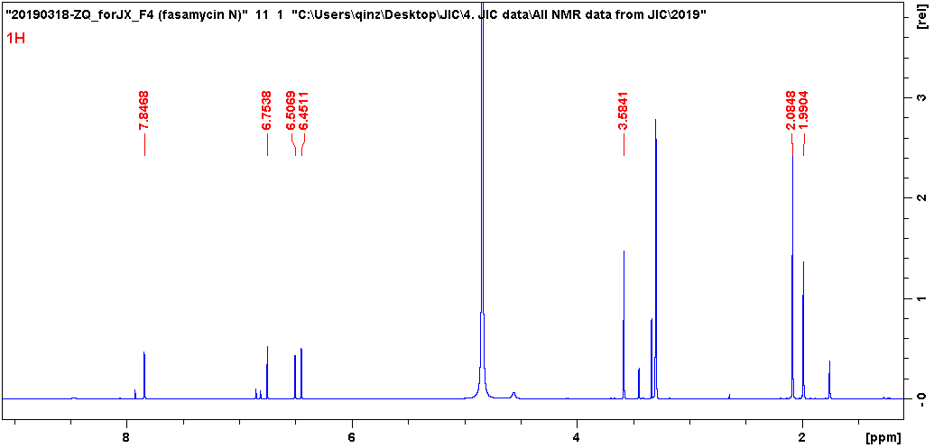

Figure 21. ¹H NMR spectrum for fasamycin N. CD₃OD, 600 MHz.

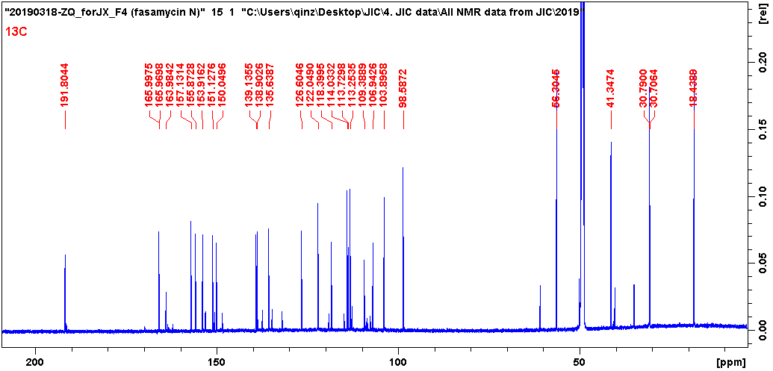

Figure 22. ¹³C NMR spectrum for fasamycin N. CD₃OD, 150 MHz.

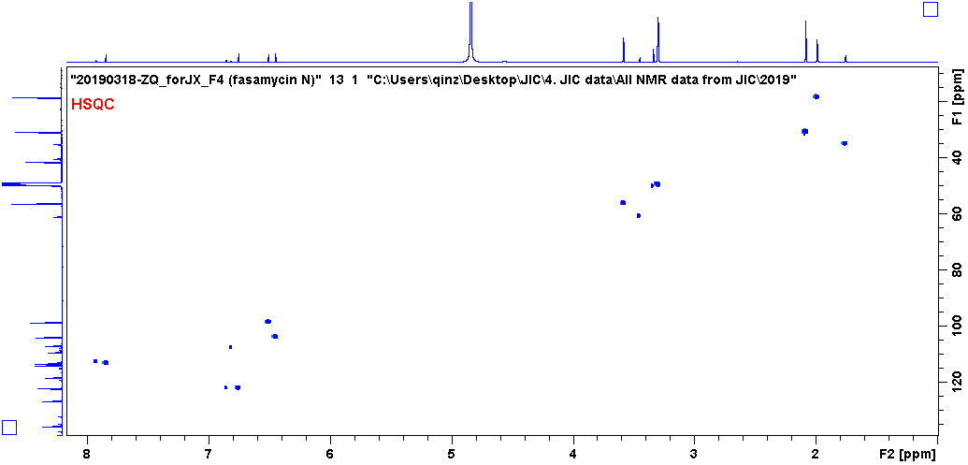

Figure 23. HSQC spectrum for fasamycin N. CD₃OD.

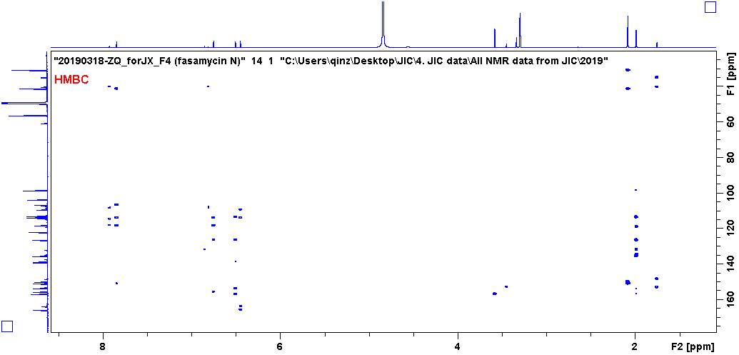

Figure 24. HMBC spectrum for fasamycin N. CD₃OD.

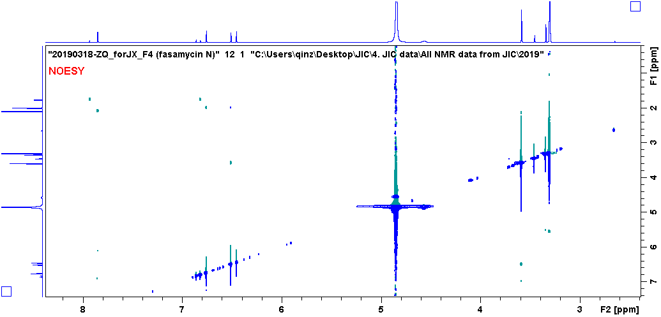

Figure 25. NOESY spectrum for fasamycin N. CD₃OD.

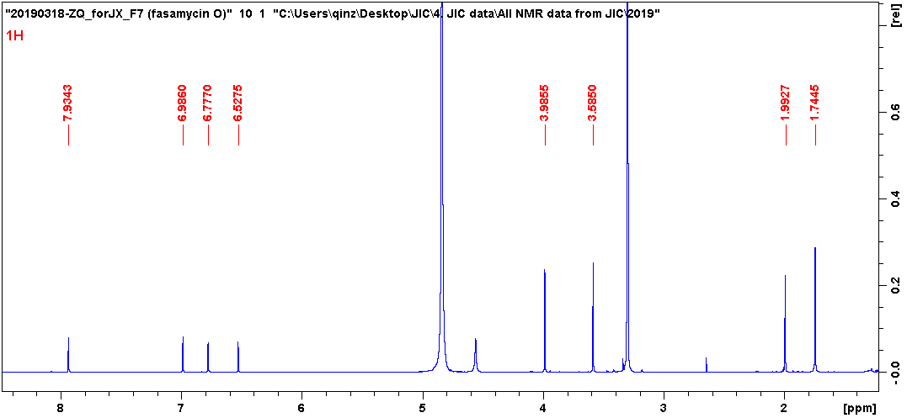

Figure 26. ¹H NMR spectrum for fasamycin O. CD₃OD, 600 MHz.

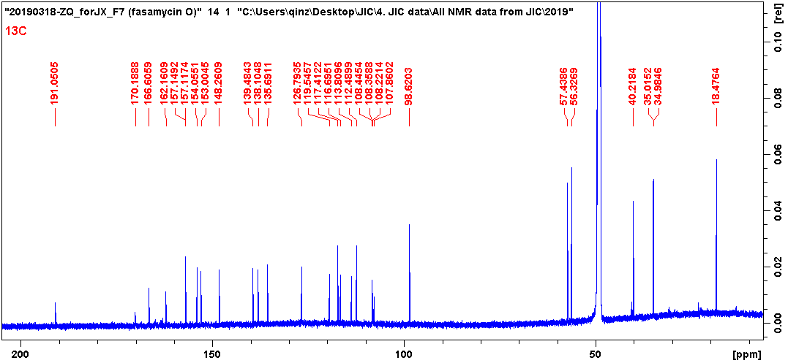

Figure 27. ¹³C NMR spectrum for fasamycin O. CD₃OD, 150 MHz.

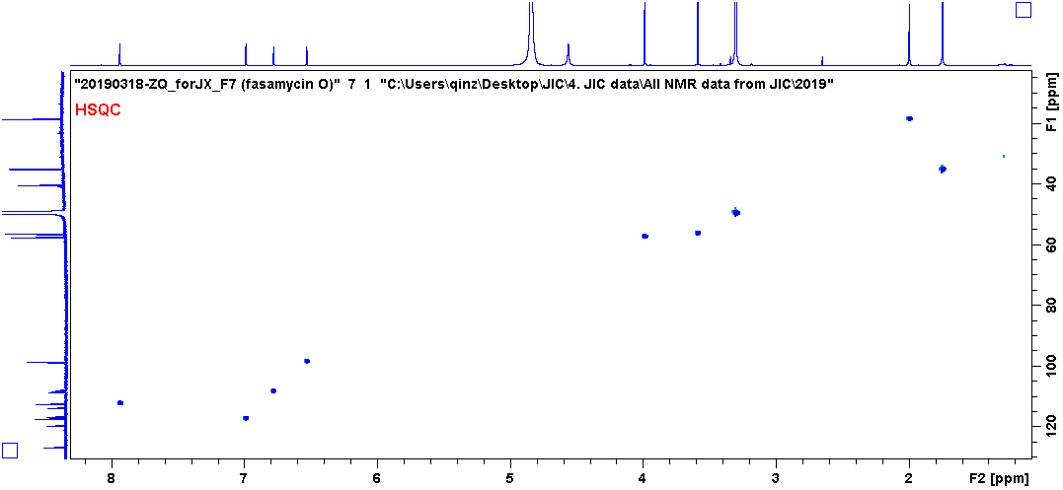

Figure 28. HSQC spectrum for fasamycin O. CD₃OD.

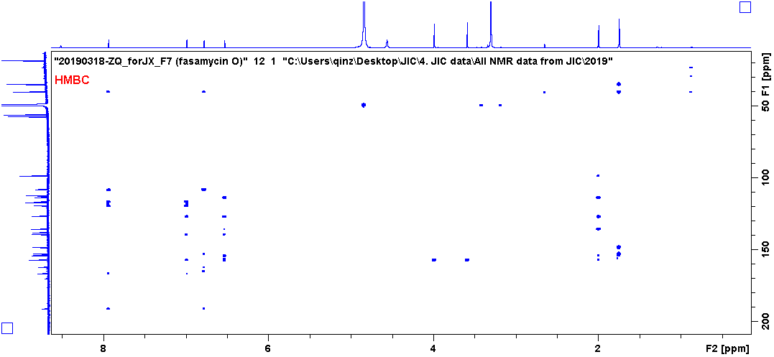

Figure 29. HMBC spectrum for compound 6. CD₃OD.

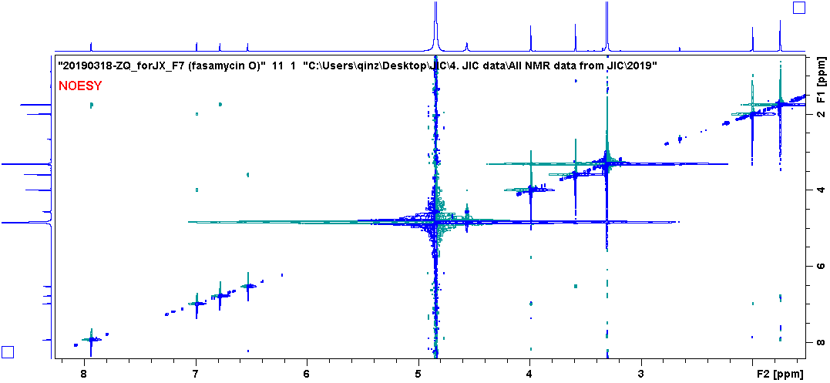

Figure 30. NOESY spectrum for fasamycin O. CD₃OD.

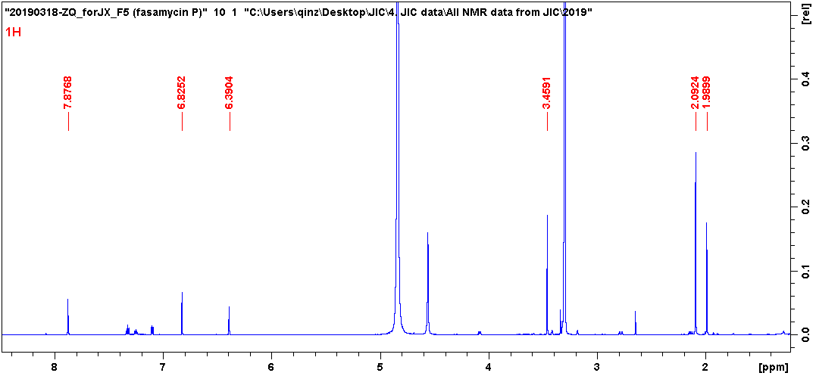

Figure 31. ¹H NMR spectrum for fasamycin P. CD₃OD, 600 MHz.

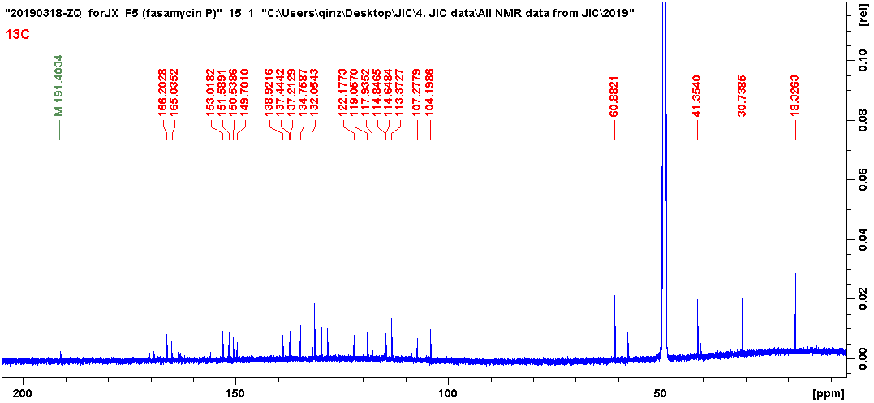

Figure 32. ¹³C NMR spectrum for fasamycin P. CD₃OD, 150 MHz.

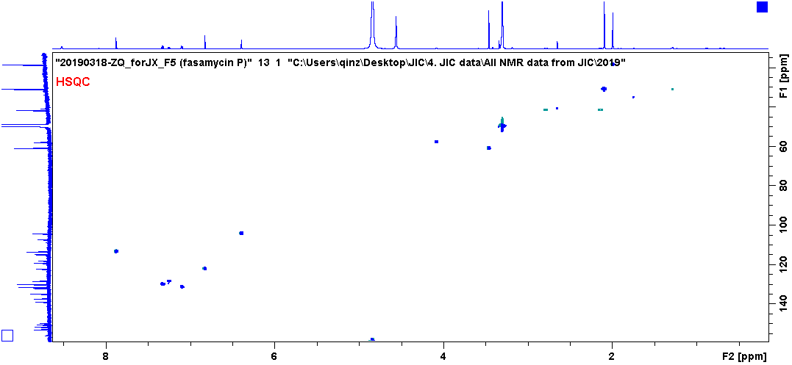

Figure 33. HSQC spectrum for fasamycin P. CD₃OD.

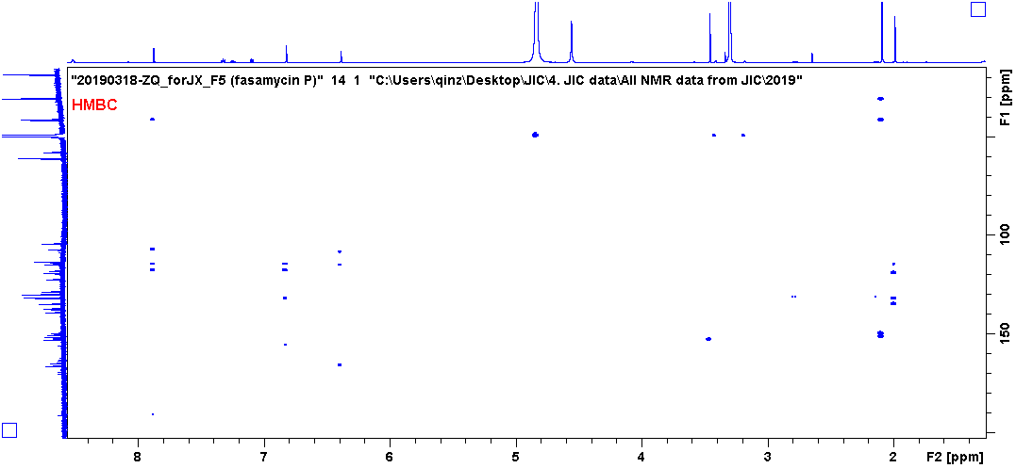

Figure 34. HMBC spectrum for fasamycin P. CD₃OD.

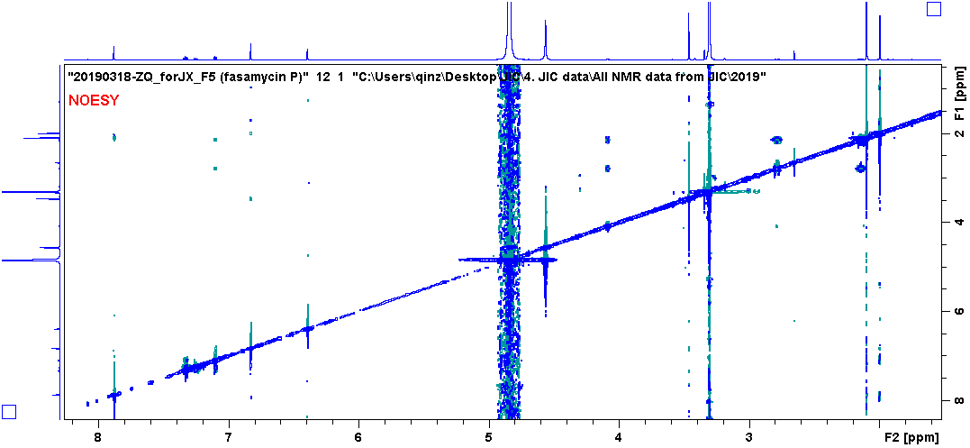

Figure 35. NOESY spectrum for fasamycin P. CD₃OD.

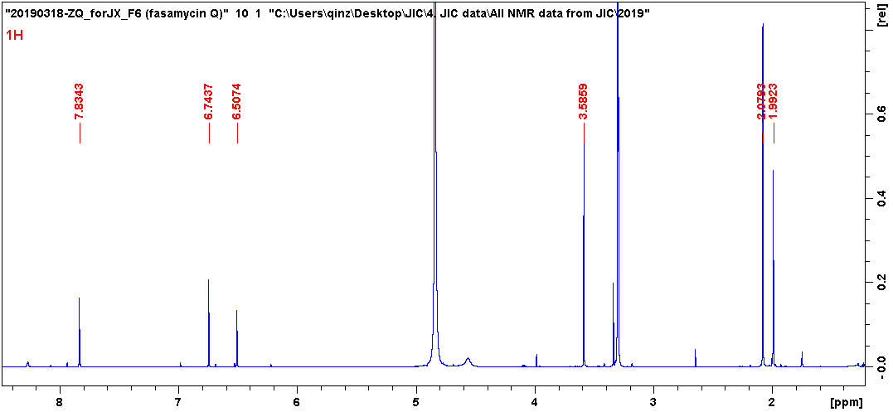

Figure 36. ¹H NMR spectrum for fasamycin Q. CD₃OD, 600 MHz.

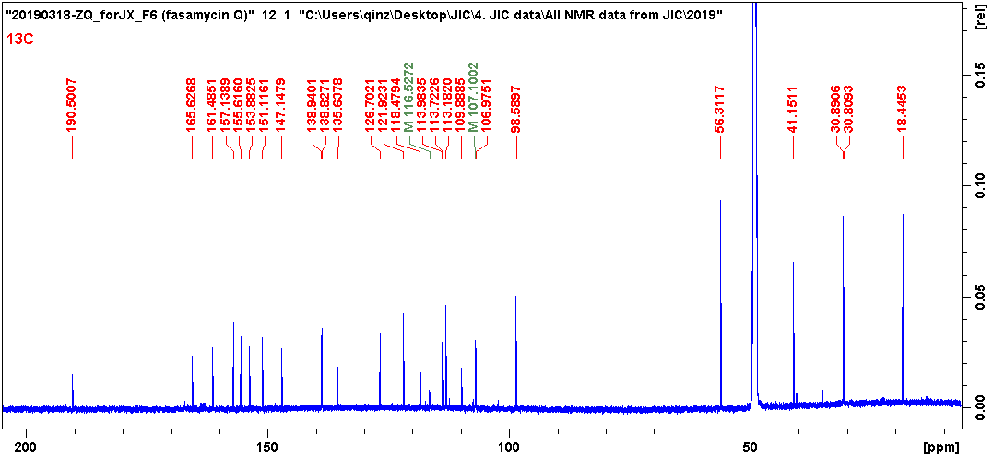

Figure 37. ¹³C NMR spectrum for fasamycin Q. CD₃OD, 150 MHz.

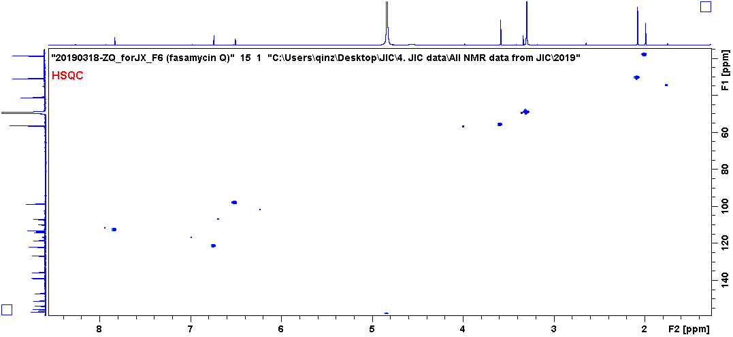

Figure 38. HSQC spectrum for fasamycin Q. CD₃OD.

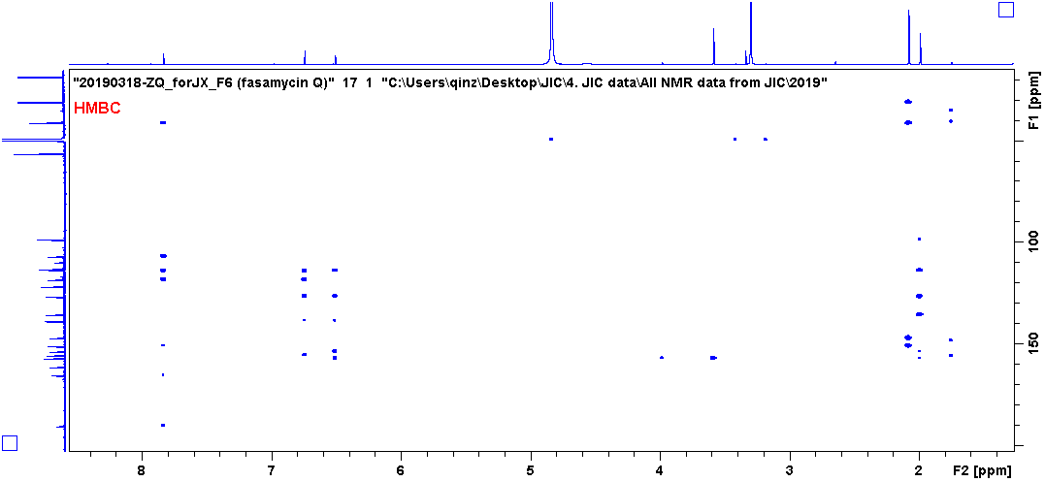

Figure 39. HMBC spectrum for fasamycin Q. CD₃OD.

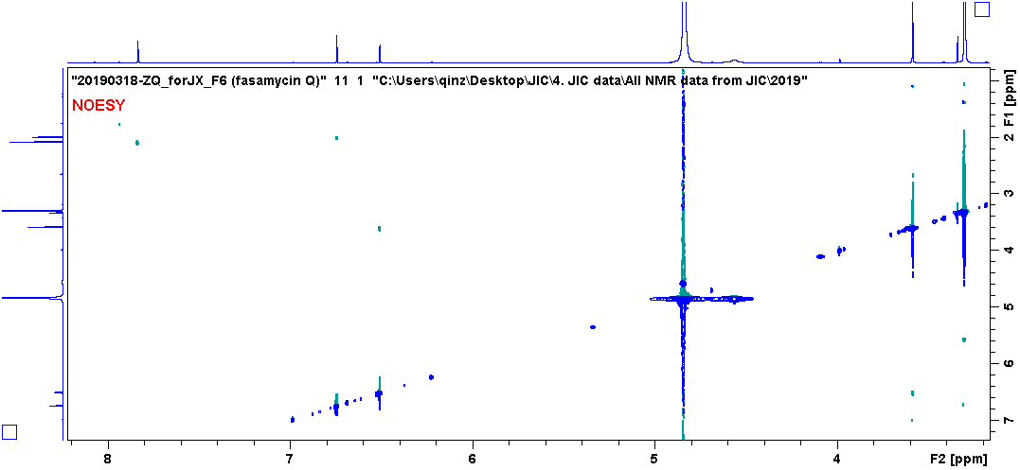

Figure 40. NOESY spectrum for fasamycin Q. CD₃OD.

