Cell-free fermentation broth of Bacillus velezensis strain S3-1 improves the quality of Pakchoi and changes the bacterial community structure of the rhizosphere soil
Kaiheng Lu1*,Qing Jin1, Yibo Lin1,Wenwei Lu1,Songshuo Li1, Chenhao Zhou1,Jieren Jin1, Qiuyan Jiang1,Ming Xiao1*
College of Life Sciences, Shanghai Normal University, Shanghai, 200234, China

*Corresponding authors: Professor Ming Xiao
Mr. Kaiheng Lu,
college of Life Sciences Shanghai Normal University Shanghai, 200234
P. R. China
Tel: ++86-17621543755
Fax: ++86-(0)-21-65642468

E-mail addresses: xiaom88@shnu.edu.cn

lukaiheng@otulook.com

Fig. S1 Effect of inoculation of B.velezensis stain S3-1 on plant root length and shoot length. Different letters indicate significant differences for root or shoot among treatments.

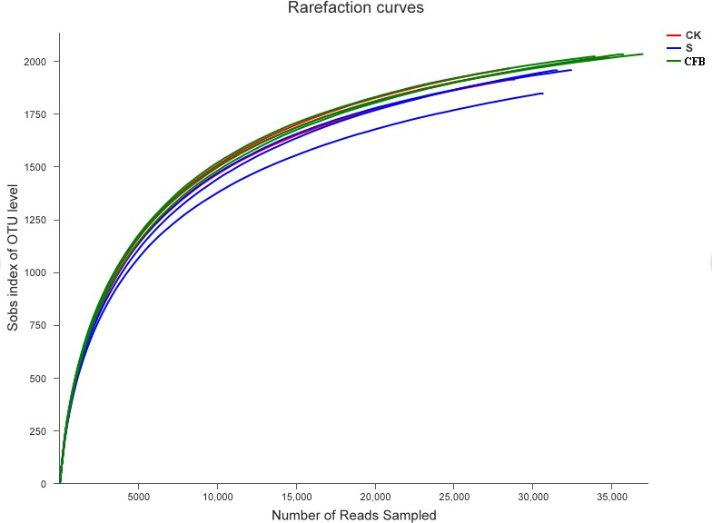

Fig. S2 The rarefaction curve of each sample

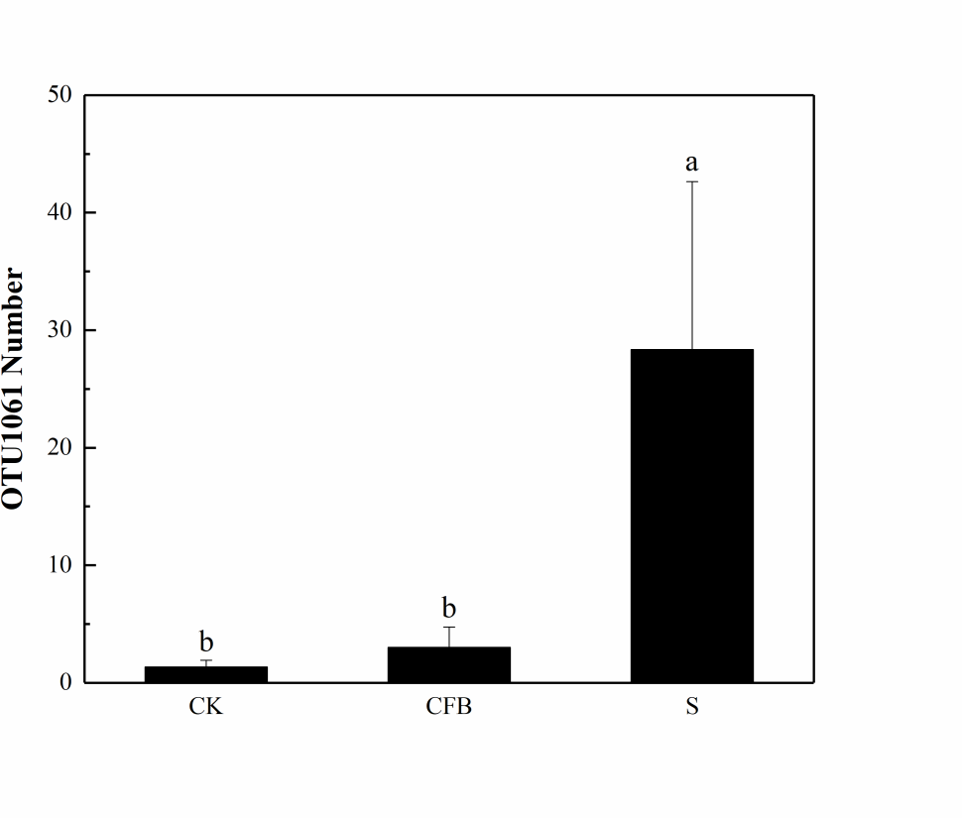

Fig.S3 Observed number of OTU1061

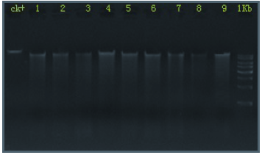

Fig.S4 Results of DNA integrity test

Table S1 Metabolites of B. velezensis S3-1
Metabolite | Metabolite | Metabolite | Metabolite
L-glutamic acid | galactinol | maleic acid | trans-3-hydroxy-L-proline
S(-)willardiine | trigonelline | isoxanthopterin | 4-quinolinecarboxylic acid
glycine | mucic acid | 3-hydroxyanthranilic acid | L-lysine
L-methionine | dihydro-4,4-dimethyl-2,3-furandione | Methaqualone | valeramide
Cannabinol | nicotinic acid | 4-aminophenol | dibenzofuran
iminodiacetic acid | 2-hydroxybiphenyl | beta-glycerolphosphate | 3-methyl-L-histidine
L-allothreonine | 1-octanol | cycloleucine | L-proline
heptadecanoic acid | N-omega-acetylhistamine | 3-Hydroxy-3',4'-Dimethoxyflavone | prunetin
D-sphingosine | 4-O-Methylphloracetophenone | alpha ketoglutaric acid | threose
glycolic acid | 3,5-dihydroxyphenylglycine | 2,3-butanediol | D-mannitol
1-methyl-L-tryptophan | L-threonine | tyrosine | cysteinylglycine
benzoquinone | 1,4-dihydroxy-2-naphthoic acid | psicose | butylbenzene
22-hydroxycholesterol | threonic acid | pipecolic acid | DL-4-hydroxymandelic acid
Oxymorphone | adenosine'-monophosphate | melatonin4 | pantolactone
orcinol | 1-octadecene | epsilon-caprolactam | trans-resveratrol
4-Acetoxyphenol | xanthosine | L-histidine | mandelic acid
beta-hydroxyisovalerate | 6-methyl-5-hepten-2-one | 2-furoic acid | 2-aminooctanoic acid
2-Methoxyxanthone | benzoic acid | beta-ionone | cellotetraose
7,4'-Dihydroxyflavone | glycerol | 2,3-dihydroxypyridine | 1,2,4,5-tetramethylbenzene
3-aminopropionitrile | DL-3,4-dihydroxyphenyl glycol | serotonin | kestose
juglone | L-cysteine | spermidine | 5,6-dihydrouracil
citraconic acid | L-serine | N-carbamyl-L-glutamic acid | tyrosine methyl ester
malonic acid | 6-hydroxynicotinic acid | cyclohexanamine | 4-hydroxyphenylglycine
benzyl thiocyanate | 1,3-propanediol | DL-dihydrosphingosine | IS
orotic acid | carbazole | glycylproline | 2,6-diaminopimelic acid
Barbital | acetohydroxamic acid | 1,2-cyclohexanedione | 2-amino-2-methyl-1,3-propanediol
N-acetyl-5-hydroxytryptamine | L-pyroglutamic acid | N-acetyl-D-tryptophan | 5alpha-Cholestan-3beta-Ol-6-One
galactitol | 1-stearoyl-rac-glycerol | acetanilide | citric acid
porphine | fumaric acid | phytosphingosine | benzoylformic acid
5-hydroxyindole-2-carboxylic acid | Oxazepam | tyramine | fructose
L-sorbose | D-Ala-D-Ala2 | trans-aconitic acid | 4-hydroxypyridine
DL-isoleucine | eicosapentaenoic acid | trans-4-hydroxy-L-proline | Apigenin
N-gamma-acetyl-N-2-formyl-5-methoxykynurenamine | 4-(2-hydroxyethyl)phenol | guanosine | benzene-1,2,4-triol
DL-4-hydroxy-3-methoxymandelic acid | 5-cholesten-3-beta-7-alpha-diol | 2-indanone | acetol
L-Phenylalanine | glyceric acid | glycerol-phosphate | 2-hydroxypyridine
methyl-beta-D-galactopyranoside | 8-aminocaprylic acid | L-mimosine | beta-myrcene
L-ornithine | trans,trans-muconic acid | 1-octen-3-ol | myo-inositol
5-aminovaleric acid | D-allose | Fenfluramine | 5-Hydroxy-2',4',7,8-Tetramethoxyflavone
phytol | synephrine | oxalic acid | adenine
N-methylglutamic acid | 3,4',5,6,7-Pentamethoxyflavone | ethanolamine | 1-methylhydantoin
5,6-dihydro-5-methyluracil | trans caftaric acid | Thebaine | 3-chloro-L-tyrosine
4-vinylphenol | 2-piperidone | uric acid | ribitol
5,6-dimethylbenzimidazole | neryl acetate | Antiarol | xylulose
benzyl isothiocyanate | maleamic acid | L-homocystine | saccharin
2'-Deoxyadenosine 3':5'-cyclic monophosphate | 1-nonanol | 4-hydroxycinnamic acid | taxifolin
putrescine | hypoxanthine | 3-hydroxyflavone | cytosine
5-methoxy-3-indoleacetic acid | O-benzyl-L-tyrosine | octopine | L-alanine
D-trehalose | 1-hexadecanol | 1,4-dideoxy-1,4-imino-D-arabinitol | trans-3-hydroxy-L-proline
L-norleucine | xanthine | sarcosine | 4-quinolinecarboxylic acid

Number | Sample name | Concentration(ng/μl) | OD260/280 | OD260/230
1 | S1 | 36.60 | 1.90 | 0.08
2 | S2 | 50.60 | 1.85 | 0.14
3 | S3 | 40.60 | 1.81 | 0.07
4 | SF1 | 58.50 | 1.88 | 0.33
5 | SF2 | 53.30 | 1.89 | 0.11
6 | SF3 | 50.40 | 1.80 | 0.16
7 | CK1 | 44.60 | 1.85 | 0.17
8 | CK2 | 32.00 | 1.79 | 0.28
9 | CK3 | 36.30 | 1.94 | 0.06

Table S2 DNA concentration between nine samples

Sample name | CK1 | CK2 | CK3 | S1 | S2 | S3 | CFB1 | CFB2 | CFB3
NIST | 0.122 | 0.135 | 0.155 | 0.153 | 0.131 | 0.134 | 0.129 | 0.119 | 0.138

Table S3 NIST values of different treatment

