Supplementary Material

Supplementary Table S1. Sample list including herbarium and location details. Literature references of samples published before are given below. Samples originated from herbaria at the British Antarctic Survey (AAS), Botanic Garden, Meise (BR), British Museum of Natural History (BM), Royal Botanical Gardens Edinburgh (E), the University of Wollongong (WOLL) and the New York Botanical Garden (NY), augmented by fresh collections during expeditions of authors (EB, PC, SR).
Label in study | Geographic Origin | Ref. | Herbarium or University | Collection | Coordinates | rps4 | atpB-rbcL | trnL-F | ITS
AAS 03988 Ant. Peninsula | Recess Cove, Charlotte Bay, Ant. Peninsula |  | AAS | Smith R.I.L. 03988 | -64.58, -61.63 | MN542517 | MN542618 | MN552307 | MN556620
AAS 07625 Ant. Peninsula | James Ross I., Ant. Peninsula |  | AAS | Smith R.I.L. 07625 | -63.87, -57.90 | MN542518 | MN542619 | MN552308
CP24 S. Orkney Is. | Moe I, off Signy Is., South Orkney Is. | 1,2 | AAS | Smith R.I.L. 5237 | -60.44, -45.41 | MN542519 |  |  | MN556619
BR 12045376 Papua New Guinea | Mt. Kaindi, Papua New Guinea |  | BR 5040120453763 | Hoffmann I. 90-414 | -7.33, 146.68 ¹ | MN542520 | MN542610 | MN552309 | MN556631
BR 32032632 Costa Rica | Serra de la Muerte, Costa Rica |  | BR 5040320326324 | Arts. T. CR 14/27 | 9.56, -83.80 ¹ | MN542521 | MN542611 | MN552310
BR 27280945 Bolivia | NW of Quime, Bolivia |  | BR 5040272809456 | Lewis M. 87585 | -16.95, -67.28 | MN542522 | MN542604 | MN552311
AY881045 Reunion I. | Piton de la Fournaise, Reunion I. | 3 | DUKE | Arts REU 44/15 | -21.24, 55.71 ¹ |  | AY881045
BM 20823 Mexico | W of Popocatépetl, Sierra Nevada, Mexico |  | BM | Herman F.J. 20823 | 19.02, -98.63 ¹ | MN542523 |  | MN552312
CP17 Nepal | Sindure, Nepal | 1,2 | RBGE | Long D.G. 16417 | 28.17, 84.30 | MN542524 |  | MN552313
BR 27272962 Greece | Chania, Omalos, Crete, Greece |  | BR 5040272729624 | Gradstein S.R. & Smittenberg J.H. 1214 | 35.34, 23.90 ¹ | MN542525 | MN542625 | MN552314 | MN556618
AY881059 Greece | Argalasti, Greece | 3 | DUKE | Cano & Ros 23.3.1999 | 39.23, 23.22 ¹ |  | AY881059
BM 27 Canary Is. | Above Aguamansa, Canary Is. |  | BM | Champion C.L. 27 | 28.37, -16.50 ¹ | MN542526 |  | MN552315
BM R08277a Reunion I. | Le Maido, W of Cirque de Mafate, Reunion I. |  | BM | Ellis L. & Wilbraham J. R08-277a | -21.40, 55.23 | MN542527 | MN542626 | MN552316 | MN556621
CP13 Malawi | Lichenya, Malawi | 1,2 | RBGE | Longton R.E. M8593A | -15.55, 35.83 ¹ | MN542528 | MN542627 | MN552317
AY881052 Reunion I. | Piton de la Fournaise, Reunion I. | 3 | DUKE | Arts REU 44/15 | -21.24, 55.71 ¹ |  | AY881052
AY881057 South Africa | Table Mt, W Cape Prov., South Africa | 3 | DUKE | Hedderson 13371 | -33.96, 18.41 ¹ |  | AY881057
AB980065 Uganda | Rwenzori Mountains, Stanlay Plateau, Uganda |  | Uetake et al., unpubl. | Uetake J. (“taxon:3225”) | 0.38, 29.88 | AB848717 | AB980065
AY881031 Indonesia | Amlapura, Bali, Indonesia | 3 | DUKE | Schäfer-Verwimp 21099 | -8.46, 115.61 ¹ |  | AY881031
AY881034 Chile | PN Alerces Osorno, Chile | 3 | DUKE | Cox 602/00 | -41.11, -72.36 ¹ |  | AY881034
AY881046 Wilkes sector, Antarctica | Casey Base, Antarctica | 3 | DUKE | Robinson & Wasley 99/00 | -66.28, 110.53 ¹ |  | AY881046
AY881048 Chile | Navarino I., Magellanes, Chile | 3 | DUKE | Goffinet 6990 | -55.11, -67.71 ¹ |  | AY881048
AY881053 Australia | Kangaroo I., S. Australia | 3 | NY | Streimann 54883 | -35.77, 137.21 ¹ |  | AY881053
AY881051 Tasmania, Australia | Hobart, Tasmania, Australia | 3 | DUKE | Newton & Bell 5780 | -42.88, 147.32 ¹ |  | AY881051
AY881049 Australia | Oberon, New South Wales, Australia | 3 | NY | Gilmore 65 | -33.70, 149.85 ¹ |  | AY881049
AY881043 Oregon, USA | Columbia, R. Gorge, Oregon, USA | 3 | DUKE | Sargent 6.VIII.00 | 45.71, -121.52 ¹ |  | AY881043
AY881037 California, USA | Pt. Reyes, NS California, USA | 3 | DUKE | Shaw 10 090 | 38.04, -122.80 ¹ |  | AY881037
AY881040 Australia | Stanthorpe, Queensland, Australia | 3 | NY | Streimann 52925 | -28.65, 151.94 ¹ |  | AY881040
AAS 03708 Ant. Peninsula | Joinville I., Ant. Peninsula |  | AAS | Smith R.I.L. 03708 | -63.25, -55.75 | MN542529 | MN542620 | MN552318 | MN556633
AAS 04324 Ant. Peninsula | W of Lahille I., Ant. Peninsula |  | AAS | Smith R.I.L. 04324 | -65.53, -64.37 | MN542530 | MN542621 | MN552319 | MN556644
BR 01907765 Idaho, USA | Boundary County, Copeland, Idaho, USA |  | BR 5040019077650 | Anderson L.E. 22618 | 48.90, -116.38 ¹ | MN542531 | MN542622 | MN552320 | MN556630
BM BM000977576 Montana, USA | Targhee Pass, W Yellowstone, Montana, USA |  | BM | Stern R.C. BM000977576 | 44.67, -111.28 ¹ | MN542532 | MN542623 | MN552321
BM 21661 Alaska, USA | Valdez Quadrangle, Old Valdez, Alaska, USA |  | BM | Herman F.J. 21661 | 61.11, -146.26 ¹ | MN542533 | MN542624 | MN552322 | MN556653
CP25 S. Shetland Is. | West Baily Head, Deception I., S. Shetland Is. | 1,2 | AAS | Mason D. 00001 | -62.58, -60.30 | MN542534 | MN542605 | MN552323
CP32 Ant Peninsula | Charcot Is, Ant. Peninsula | 1,2 | AAS | Convey P. 00368 | -69.45, -75.15 | MN542535 | MN542612 | MN552324
CP28 Ant. Peninsula | Danco Coast, Cuverville I, Ant. Peninsula | 1,2 | AAS | Leeuw C. de 00020 | -64.41, -62.38 | MN542536 | MN542613 | MN552325 | MN556645
CP34 Ant. Peninsula | W Anchorage I., Ant. Peninsula | 1,2 | AAS | Smith R.I.L. 09212 | -67.36, -68.14 | MN542537 | MN542614 | MN552326 | MN556634
CP30 S. Sandwich Is. | Irving Point, Visokoi I., S. Sandwich Is. | 1,2 | AAS | Convey P. 00242 | -56.43, -27.04 | MN542538 | MN542615 | MN552327 | MN556638
AY881058 India | Lam Pokhari, Sikkim, India | 3 | DUKE | Long 22687 | 27.50, 88.20 ¹ |  | AY881058
AY881047 Illinois, USA | Schuyler, Illinois, USA | 3 | NY | Hill 30219 | 40.18, -90.63 ¹ |  | AY881047
AY881036 Alaska, USA | Denali N. P., Alaska, USA | 3 | DUKE | Vanderpoorten 4998 | 63.06, -151.00 ¹ |  | AY881036
BR 02840177 S. Shetland Is. | King George I., Admiralty Bay, S. Shetland Is. |  | BR 5040028401774 | Ochyra R. 4887/79 | -62.17, -58.44 | MN542539 |  | MN552328
AAS 00064 S. Shetland Is. | Deception I., S. Shetland Is. |  | AAS | Smith R.I.L. 00064 | -63.00, -60.52 | MN542540
CP23 S. Shetland Is. | Pendulum Cove, Deception I, S. Shetland Is. | 1,2 | AAS | Smith R.I.L. 11191 | -62.56, -60.36 | MN542541 |  | MN552329 | MN556635
CS30 S. Shetland Is. | Carlini Station, King George I., S. Shetland Is. |  | WOLL | Casanova-Katny A. CS30 | -62.23, -58.67 | MN542542
AAS 725 Argentina | Argentina |  | AAS ACHE | Matteri-Schiavone 725 | -54.50, -68.00 | MN542543 | MN542628 | MN552330
AAS 4545909 Wilkes sector, Antarctica | Clark Pen, Wilkes Sector, Antarctica |  | AAS ACHE | Seppelt R.D. 5909 ACHE 454 | -66.15, 110.36 | MN542544 | MN542629 | MN552331
AAS 04120 Ant. Peninsula | Omega I., Melchior I., Ant. Peninsula |  | AAS | Smith, R.I.L. 04120 | -64.33, -62.93 | MN542545 | MN542630 | MN552332
AAS 09644A Ross sector, Antarctica | Harrow Peaks, Victoria Land. |  | AAS | Smith, R.I.L. 09644A | -74.07, 164.75 | MN542546 | MN542631 | MN552333 | MN556627
AAS 00165 S. Orkney Is. | W of Matthews I., S. Orkney Is. |  | AAS | Smith, R.I.L. 00165 | -60.75, -45.17 | MN542547 | MN542632 | MN552334 | MN556636
Biersma 18 Chile | Navarino I., Magellanes, Chile |  | BAS collections | Biersma, E.M. 18 | -54.93, -67.28 ¹ | MN542548 | MN542633 | MN552335 | MN556632
BM 33207 Chile | 5 km E of Quidico, Prov. Arauco, Chile |  | BM | Ireland, R.R. & Bellolio, G. 33207 | -38.15, -73.27 | MN542549 | MN542634 | MN552336
CP5 Australia | Mt Beauty, Victoria, Australia | 1,2 | WOLL ARC | Clarke, L.J. CP5 | -36.74, 147.17 | MN542550 | MN542635 | MN552337 | MN556625* MN556650*
CP44 Heard I. | Dovers Moraine, Heard I. | 1,2 | WOLL ARC | Turnbull, J.D. CP44 | -53.12, 73.70 | MN542551 | MN542607 | MN552338 | MN556651
CP21 Maud Land, Antarctica | Ice Axe Peak, Maud Land, Antarctica | 1,2 | AAS | Watkins, B.P. 00020A | -71.47, -3.25 | MN542552 | MN542608 | MN552339 | MN556642
CP39 Heard I. | Paddock Valley, Heard I. | 1,2 | WOLL ARC | Turnbull, J.D. CP39 | -53.08, 73.50 | MN542553 | MN542609 | MN552340
BR 02155925 Switzerland | Valais, Bagnes, Versegers, Switzerland |  | BR 5040021559250 | Lawalrée, A. 23282 | 46.06, 7.23 ¹ | MN542554 | MN542636 | MN552341 | MN556647
BR 02316781 Switzerland | Valais, Bagnes, Lourtier, Switzerland |  | BR 5040023167811 | Lawalrée, A. 24147 | 46.04, 7.26 ¹ | MN542555 | MN542637 | MN552342 | MN556654
BR 08930464 Poland | Plaine de Walcz, Ilowiec, Poland |  | BR 5040089304649 | Lisowski, S., Rusinska, A. & Melosik, I. 27 | 50.83, 23.40 ¹ | MN542556 | MN542638
BR 12018401 Siberia, Russia | Baikal lake, Listvianka, Siberia, Russia |  | BR 5040120184018 | Vašák, V. s.n. | 51.85, 104.83 ¹ | MN542557 | MN542639 | MN552343
BR 13051247 Svalbard | Isbjörnkamna, Honsund, Svalbard |  | BR 5040130512474 | Godzik, B. & Grodzinska, K. s.n. | 77.02, 15.57 | MN542558 | MN542616 | MN552344 | MN556655
BR 13622234 France | Foret de Fontainebleau, France |  | BR 5040136222346 | Bamps, P. 4685 | 48.41, 2.63 ¹ | MN542559 | MN542640 | MN552345
BR 30658767 Japan | Campus Hiroshima University, Japan |  | BR 5040306587671 | Yamaguchi, T. & Iwatsuki, Z. 29 | 36.07, 138.08 ¹ | MN542560 | MN542641 | MN552346
BR 31255218 Hawaii, USA | Near Pu'u hulu-hulu, Big Island, Hawaii, USA |  | BR 5040312552182 | Arts, T. HAW 11/04 | 19.37, -155.20 ¹ | MN542561 | MN542642 | MN552347
BR 31460231 Ecuador | Imbabura, Lago Cuicocha, Ecuador |  | BR 5040314602311 | Arts, T. 13/007A | 0.38, -78.11 ¹ | MN542562 | MN542617 | MN552348
BR 36261428 Vermont, USA | Chittenden, Vermont, USA |  | BR 5040362614281 | White, H. & White, C. 1158 | 43.73, -72.94 ¹ | MN542563 | MN542643 | MN552349 | MN556656
BR 27271447 Hawaii, USA | Oahu, Kaala, Hawaii, USA |  | BR 5040272714477 | Hoe W.J. 3048.0 | 21.44, -158.00 ¹ | MN542564 | MN542644 | MN552350 | MN556657
BR 27272356 Quebec, Canada | Iles-de-la-Madeleine, Quebec, Canada |  | BR 5040272723561 | De Sloover J.L. 7786 | 47.38, -61.88 ¹ | MN542565 | MN542645 | MN552351 | MN556662
BR 27270639 Colorado, USA | Clear Creek County, Colorado, USA |  | BR 5040272706397 | Miller J.S. 6887 | 39.82, 105.75 | MN542566 | MN542606 | MN552352
CP8 Hawaii, USA | Mauna Kea, Hawaii, USA | 1,2 | RBGE | Degener O. & Degener I. 34420 | 19.82, -155.47 | MN542567 | MN542646 | MN552353 | MN556622* MN556663*
CP11 New York, USA | New York (Botanical Gardens), USA | 1,2 | NY | S.N. | 40.86, -73.88 | MN542568 | MN542647 | MN552354 | MN556658
BM A1003 Alaska, USA | Chandler Lake, Endicott Mts, Alaska, USA |  | BM | Smith, G.L. A1003 | 68.12, -152.47 | MN542569 | MN542648 | MN552355 | MN556643
BM 1228 Japan | Honshu, Tsukuba-shi, Amakubo, Japan |  | BM | Higuchi, M. 1228 | 36.06, 140.06 | MN542570 | MN542649 | MN552356
BR 02873422 UK | Bedfordshire, UK |  | BR 5040028734223 | Jury, S.L. J2359 | 51.92, 0.66 | MN542571 | MN542650 | MN552357
AY881062 Morocco | Bab Bou Idir, Morocco | 3 | DUKE | Cano and Ros 21.4. 1997 | 34.07, -4.12 ¹ |  | AY881062
AY881061 Arizona, USA | Madira Canyon, Arizona, USA | 3 | NY | Schofield 105061 | 34.05, -111.09 ¹ |  | AY881061
AY881044 Ecuador | Otavalo, Ecuador | 3 | DUKE | McDaniel E112 | 0.23, -78.26 ¹ |  | AY881044
AY881038 Colorado, USA | Boulder, Colorado, USA | 3 | DUKE | Weber 19426 | 40.01, -105.27 ¹ |  | AY881038
AY881060 New York, USA | Adirondack Mts, New York, USA | 3 | NY | Miller 11911 | 43.95, -73.73 ¹ |  | AY881060
AY881055 Germany | Baden-Württemberg, Germany | 3 | DUKE | Schäfer-Verwimp 25550 | 48.66, 9.35 ¹ |  | AY881055
AY881054 Alberta, Canada | Edson, Alberta, Canada | 3 | NY | Schofield 103437 | 53.58, -116.44 ¹ |  | AY881054
AY881050 Siberia, Russia | Kurgan, Siberia, Russia | 3 | DUKE | Kurbatova 21 V 2000 | 55.46, 65.30 ¹ |  | AY881050
AY881042 New York, USA | Ithaca, New York, USA | 3 | DUKE | Shaw 12.VI. 2000 | 42.44, -76.50 ¹ |  | AY881042
AY881041 Sweden | Hamra, Halsingland, Sweden | 3 | S | Hedenäs B38313 | 61.66, 15.01 ¹ |  | AY881041
AY881039 Liaoning, China | Baishilaji Reserve, Liaoning, China | 3 | NY | Buck 23783 | 41.83, 123.43 ¹ |  | AY881039
AY881035 Nova Scotia, Canada | Digby, Nova Scotia, Canada | 3 | NY | Schofield 95576 | 44.62, -65.76 ¹ |  | AY881035
AY881033 France | Soultzeren, Alsace, France | 3 | DUKE | Untereiner 12.05.00 | 48.06, 7.10 ¹ |  | AY881033
AY881032 Germany | Baden-Württemberg, Germany | 3 | DUKE | Schäfer-Verwimp 25550 | 48.66, 9.35 ¹ |  | AY881032
AY881056 Pennsylvania, USA | Palmerton, Pennsylvania, USA | 3 | DUKE | McDaniel B135 | 40.80, -75.61 ¹ |  | AY881056
Biersma 21 Chile | Navarino I., Magellanes, Chile |  | BAS collections | Biersma, E.M. 21 | -54.95, -67.26 ¹ | MN542572 |  | MN552358 | MN556649
BM 31149 Chile | 6 km S of Contulmo, Prov. Arauco, Chile |  | BM | Ireland, R.R. & Bellolio, G. 31149 | -38.00, -73.13 | MN542573 |  | MN552359 | MN556648
BM 33951 Chile | Waterfalls near Santa Juana, S of Curali, Chile |  | BM | Ireland, R.R. & Bellolio, G. 33951 | -37.15, -72.57 | MN542574 |  | MN552360
CP16 Australia | Australian Nat. Uni., Canberra, Australia | 2 | WOLL ARC | Clarke, L.J. CP16 | -35.28, 149.12 | MN542575 |  | MN552361
219 Wilkes sector, Antarctica | Clark Peninsula, Antarctica | 2,4 | WOLL ARC | Robinson, S.A. 219 | -66.25, 110.57 | MN542576 |  | MN552362 | MN556626
Biersma 1 Chile | Navarino I., Magellanes, Chile |  | BAS collections | Biersma, E.M. 1 | -54.93, -67.60 ¹ | MN542577 |  |  | MN556666
Biersma 4 Chile | Navarino I., Magellanes, Chile |  | BAS collections | Biersma, E.M. 4 | -54.93, -67.61 ¹ | MN542578 |  |  | MN556624
Biersma 20 Chile | Navarino I., Magellanes, Chile |  | BAS collections | Biersma, E.M. 20 | -54.95, -67.21 ¹ | MN542579
BR 27264979 Australia | Leura Gap, Bimberi Range, Canberra, Australia |  | BR 5040272649793 | Streimann H. 34959 | -35.63, 148.77 | MN542580
CP6 Wilkes sector, Antarctica | ASPA135 Melt Lake, Windmill Is., Antarctica | 2,4 | WOLL ARC | Robinson, S.A. CP6 | -66.33, 110.47 ¹ | MN542581 |  | MN583240
CP7 Australia | Macquarie University, Ryde, Sydney, Australia | 2 | WOLL ARC | Downing, A. CP7 | -33.77, 151.11 | MN542582
76 Wilkes sector, Antarctica | Red Shed, Casey, Windmill Is., Antarctica | 2,4,10 | WOLL ARC | Robinson, S.A. 76 | -66.28, 110.53 | MN542583
CPMP Wilkes sector, Antarctica | ASPA135 A2, Windmill Is., Antarctica | 2,4,10 | WOLL ARC | Robinson, S.A. CPMP | -66.28, 110.54 | MN542584
WPD8 Wilkes sector, Antarctica | ASPA136 C1, Windmill Is., Antarctica | 2,4,10 | WOLL ARC | Robinson, S.A. WPD8 | -66.25, 110.56 | MN542585
B10 Australia | Wollongong, Australia | 2 | WOLL ARC | Wyber, R. B10 | -34.40, 150.86 | MN542586
B11 Australia | Wollongong, Australia | 2 | WOLL ARC | Wyber, R. B11 | -34.40, 150.86 | MN542587
B12 Australia | Wollongong, Australia | 2 | WOLL ARC | Wyber, R. B12 | -34.40, 150.86 | MN542588
B20 Wilkes sector, Antarctica | Casey Station, Windmill Is., Antarctica | 2,4 | WOLL ARC | Robinson, S.A. B20 | -66.28, 110.69 | MN542589 |  |  | MN556623
WPD5 Wilkes sector, Antarctica | ASPA136 C1, Windmill Is., Antarctica | 2,4,10 | WOLL ARC | Robinson, S.A. WPD5 | -66.25, 110.56 | MN542590 |  |  | MN556639
166CP Wilkes sector, Antarctica | ASPA135, Melt Lake, Windmill Is., Antarctica | 2,4 | WOLL ARC | Robinson, S.A. 166CP | -66.28, 110.54 | MN542591
Biersma 2 Chile | Navarino I., Magellanes, Chile |  | BAS collections | Biersma, E.M. 2 | -54.93, -67.60 ¹ | MN542592
CP20 Victoria Land, Antarctica | Edmonson Pnt, Victoria Land, Antarctica | 1,2 | AAS | Smith R.I.L. S.N. | -74.20, 165.08 | MN542593 |  | MN552363
AJ554004 UK | Berkshire, Reading, UK | 5 | RNG | S.N. | 51.45, -0.98 ¹ | AJ554004
BR 01726701 Wisconsin, USA | St Croix Falls, Wisconsin, USA |  | BR 5040017267015 | Janssens, J.A. 8222 | 45.41, -92.64 ¹ | MN542594 |  | MN552364
BR 31381116 Spain | Erjos, near the Casa Forestal, Tenerife |  | BR 5040313811165 | Arts, T. 24078 | 28.29, -16.62 ¹ | MN542595 |  | MN552365 | MN556659
BR 33783783 Luxemburg | Consdorf, Kalkesbaach, Luxemburg |  | BR 5040337837837 | Arts, T. 15180 | 49.82, 6.35 ¹ | MN542596 |  | MN552366
BM 14349 British Colombia, Canada | Howe Sound, British Columbia, Canada |  | BM | Schofield, W.B. 14349 | 49.15, 123.15 | MN542597 |  | MN552367 | MN556664
BR 01997691 Poland | Sejny Lake District, Giby-Podkaczan, Poland |  | BR 5040019976915 | Ochyra R. 220 | 54.11, 23.35 ¹ | MN542598 |  |  | MN556660
BR 33783581 Switzerland | Luzern, Gütschenwald, Switzerland |  | BR 5040337835819 | Arts, T. 1218 | 47.05, 8.28 ¹ | MN542599 |  |  | MN556646
BR 11900583 Siberia, Russia | Pikhtovaia gora, Bratsk, Siberia, Russia |  | BR 5040119005836 | Vašák, V. s.n. | 56.17, 101.60 ¹ | MN542600 |  |  | MN556652
BR 01997893 Cuacasus, Russia | Itkol, Baksan, Mnt. Elbrus, Caucasus |  | BR 5040019978933 | Vašák, V. s.n. | 43.68, 43.54 ¹ | MN542601 |  |  | MN556665
BR 16775643 British Columbia, Canada | SE of Chilliwack Lake, British Columbia, Canada |  | BR 5040167756438 | Schofield, W.B. 57917 | 49.13, 121.23 | MN542602
BR 31460433 Ecuador | Volcan Cotopaxi, near Sindipamba, Ecuador |  | BR 5040314604339 | Arts, T. 23/026A | -0.68, -78.43 ¹ | MN542603
AF435271 British Columbia, Canada | Bennett Bay, Mayne I., British Columbia, Canada | 6 | DUKE | Belland & Schofield 17530 | 48.84, -123.24 | AF435271
FJ572605 NE China | Changbai, NE China | 7 | SHNU CB158 | S.N. | 42.00, 128.00 | FJ572605
FJ572589 NE China | Changbai, NE China | 7 | SHNU CB43 | S.N. | 42.00, 128.00 | FJ572589
AY908122 UK | St. Abbs, Scotland, UK | 8 | DUKE | Long, D.L. 21805 | 55.89, -2.14 ¹ | AY908122
AY908121 W Virginia, USA | Larenim County Park, W Virginia, USA | 8 | DUKE | Bachmann 538 | 38.59, -80.45 ¹ | AY908121
AAS 06209B Wilkes sector, Antarctica | E of Wilkes Station, Clark Peninsula, Antarctica |  | AAS | Smith, R.I.L. 06209B | -66.25, 110.55 |  |  | MN552368 | MN556640
AAS 06213A Wilkes sector, Antarctica | E of Wilkes Station, Clark Peninsula, Antarctica |  | AAS | Smith, R.I.L. 06213A | -66.25, 110.55 |  |  | MN552369 | MN556641
BR 33783278 Madeira | Madeira, Boca de Encumeade |  | BR 5040337832788 | Arts, T. 15982 | 32.76, -16.96 ¹ |  |  | MN552370
AAS 363835 New Zealand | Doubtful Sound, Fjordland, New Zealand |  | AAS CHR | Allan, H.H. 363835 | -45.43, 167.72 ¹ |  |  | MN552371
AAS 02192 Enderby sector Antarctica | West Ongul Island. |  | AAS | Shimizu, H. 02192 | -69.02, 39.53 |  |  | MN552372
AAS 05301A Ant. Peninsula | Dundee I., Trinity Peninsula, Ant. Peninsula |  | AAS | Booth, R.G. 05301A | -63.48, -56.25 |  |  | MN552373
AAS BA 02827 Chile | Puerto Toro, Prov. Magallanes, Chile |  | AAS BA | Matteri, C.M. 02827 | -51.40, -73.07 |  |  | MN552374
CP02 Australia | Lucas Heights, Australia |  | WOLL ARC | Clarke, L.J. CP02 | -34.05, 150.98 |  |  | MN552375
AAS 03231 S. Orkney Is. | Coronation I., S. Orkney Is. |  | AAS | Smith, R.I.L. 03231 | -60.67, -45.60 |  |  | MN552376
BR 10334136 France | Aude, Pic de Nore, France |  | BR 5040103341360 | De Sloover J.L. 45210 | 43.42, 2.46 ¹ |  |  | MN552377 | MN556629
AAS 00139 Chile | S shore Lago Porteno, Prov. Magallanes, Chile |  | BA AAS | Greene, S.W. 00139 | -51.37, -72.75 |  |  | MN552378
AAS 09876A Victoria Land, Antarctica | Harrow Peaks, Victoria Land, Antarctica |  | AAS | Smith, R.I.L. 09876A | -74.07, 164.75 |  |  | MN552379 | MN556628
AY156591 Victoria Land, Antarctica | Edmonson Point, N. Victoria Land | 9 | - | S.N. | -74.03, 165.00 |  |  |  | AY156591
AY613336 Victoria Land, Antarctica | Crater Cirque, N. Victoria Land | 9 | - | S.N. | -72.62, 169.37 |  |  |  | AY613336
AY156589 Macquarie I. | Macquarie I. | 9 | - | S.N. | -54.62, 158.85 |  |  |  | AY156589
AY156590 Victoria Land, Antarctica | Botany Bay, Victoria Land, Antarctica | 9 | - | S.N. | -76.88, 162.73 |  |  |  | AY156590
AY156587 Australia | Sydney, Australia | 9 | - | S.N. | -33.87, 151.20 |  |  |  | AY156587
AY156586 Australia | Canberra, Australia | 9 | - | S.N. | -35.30, 149.13 |  |  |  | AY156586
AAS 00070A S. Shetland Is. | Deception I., S. Shetland Is. |  | AAS | Smith, R.I.L. 00070A | -63.00, -60.57 |  |  |  | MN556637
BR 30659878 Italy | Sardegna, Broncu Spina, Gennargentu, Italy |  | BR 5040306598783 | Pedrotti, C.C. s.n. | 40.12, 9.01 ¹ |  |  |  | MN556661
AY156588 Heard I. | Heard I. | 9 | - | S.N. | -53.10, 73.52 |  |  |  | AY156588
¹ = Longitudes and latitudes not provided with sample. Approximate location found via http://mynasadata.larc.nasa.gov/latitudelongitude-finder/
*= Multiple copies of ITS derived from the same specimens (in samples from Hawaii and Australia).
Samples or GenBank sequences used from references: 1: Clarke et al., 2008, 2: Wyber, 2013, 3: McDaniel and Shaw, 2005, 4: Clarke et al., 2009, 5: Hedderson et al., 2004, 6: La Farge et al., 2002, 7: Liu et al., 2010, 8: Shaw et al., 2005, 9: Skotnicki et al., 2004, 10: Robinson et al., 2018.

References:
Clarke, L. J., Ayre, D. J., and Robinson, S. A. (2008). Somatic mutation and the Antarctic ozone hole. J. Ecol. 96, 378–385. https://doi.org/10.1111/j.1365-2745.2007.01347.x
Clarke, L. J., Robinson, S. A., and Ayre, D. J. (2009). Genetic structure of Antarctic populations of the moss Ceratodon purpureus. Antarct. Sci. 21, 51–58. doi: https://doi.org/10.1017/S0954102008001466
Excoffier, L., and Lischer, H. E. (2010). Arlequin suite ver 3.5: a new series of programs to perform population genetics analyses under Linux and Windows. Mol. Ecol. Resour. 10, 564–567. doi: 10.1111/j.1755-0998.2010.02847.x
Hedderson, T. A., Murray, D. J., Cox, C. J., and Nowell, T. L. (2004). Phylogenetic relationships of haplolepideous mosses (Dicranidae) inferred from rps4 gene sequences. Syst. Biol. 29, 29–41. https://doi.org/10.1600/036364404772973960
La Farge, C., Shaw, A. J. and Vitt, D. H. (2002) The circumscription of the Dicranaceae (Bryopsida) based on the chloroplast regions trnL-trnF and rps4. Syst. Bot. 27, 435–452. https://doi.org/10.1043/0363-6445-27.3.435
Liu, Y., Yan, H. -F., Cao, T. and Ge, X. -J. (2010). Evaluation of 10 plant barcodes in Bryophyta (Mosses). J. Syst. Evol. 48, 36-46. https://doi.org/10.1111/j.1759-6831.2009.00063.x
McDaniel, S. F., and Shaw, A. J. (2005). Selective sweeps and intercontinental migration in the cosmopolitan moss Ceratodon purpureus (Hedw.) Brid. Mol. Ecol. 14, 1121–32. doi: https://doi.org/10.1111/j.1365-294X.2005.02484.x
Robinson, S. A., King, D. H., Bramley-Alves, J., Waterman, M. J., Ashcroft, M. B., Wasley, J., et al. (2018). Rapid change in East Antarctic terrestrial vegetation in response to regional drying. Nat. Clim. Change 8, 879–884. https://doi.org/10.1038/s41558-018-0280-0
Schofield, W.B. (1992). "Bryophyte distribution patterns." in Bryophytes and Lichens in a Changing Environment, ed. J.W. Bates and A.M. Farmer. (Oxford: Clarendon Press)
Shaw, A .J., Cox, C. J. and Goffinet, B. (2005). Global patterns of moss diversity: taxonomic and molecular inferences. Taxon, 54, 337-352. https://doi.org/10.2307/25065362
Skotnicki, M. L., Mackenzie, A. M., Ninham, J.A. and Selkirk, P.M. (2004) High levels of genetic variability in the moss Ceratodon purpureus from continental Antarctica, subantarctic Heard and Macquarie Islands, and Australasia. Polar Biol. 27, 687-698. https://doi.org/10.1007/s00300-004-0640-2
Wyber, R. A. (2013). Phylogeny of Three East Antarctic Mosses. [PhD thesis]. [Wollongong, (Australia)]: University of Wollongong

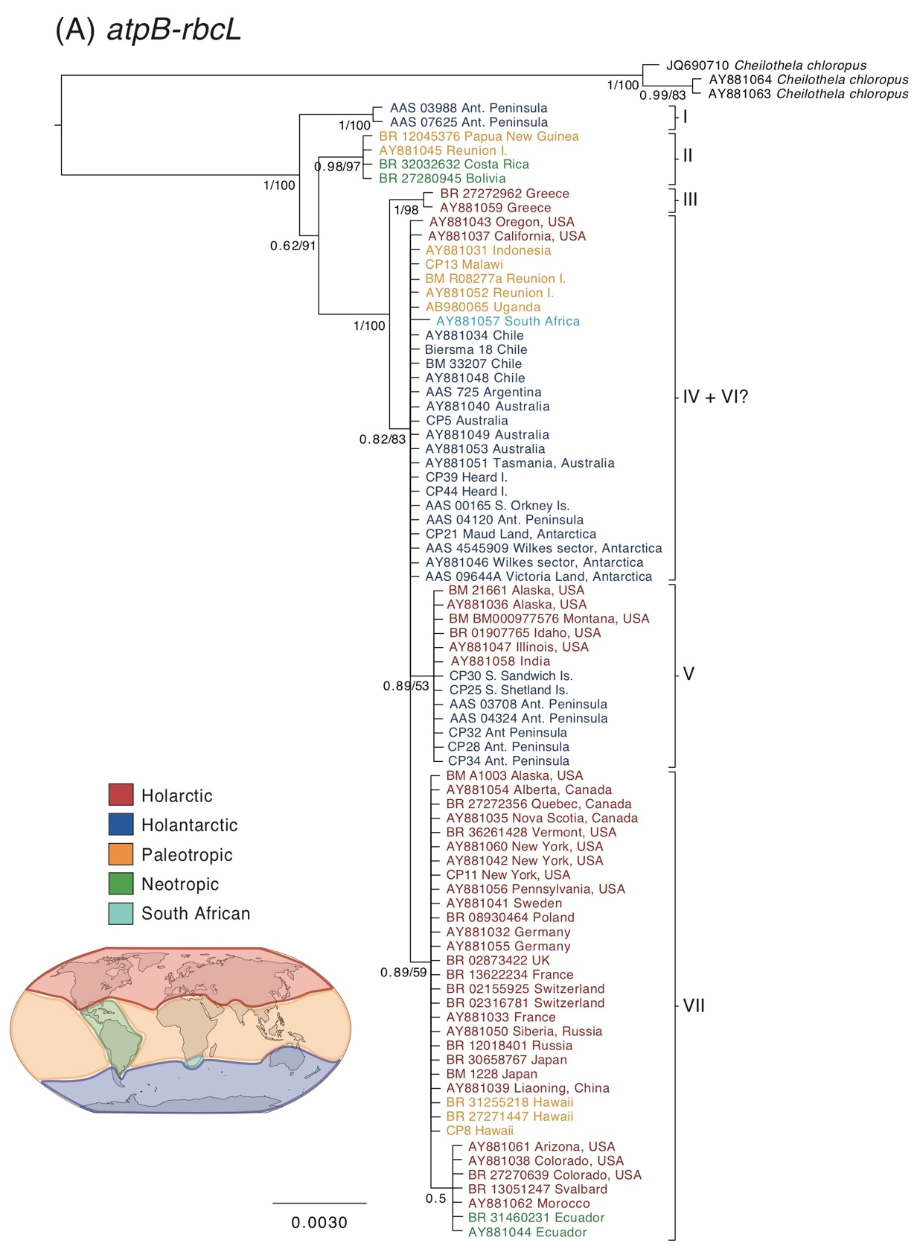
Supplementary Fig. S1. Bayesian phylogenies for Ceratodon purpureus constructed with cpDNA markers (A) atpB-rbcL, (B) rps4, (C) trnL-F and (D) a concatenated dataset of atpB-rbcL and rps4 (for B-D see continuation in the next three pages). Taxon colours refer to the bryofloristic kingdoms of the world (see map; redrawn from Schofield, 1992) and do not follow the same colour scheme as Fig. 2 and 3, as singe gene trees do not show evidence of all clades. Outgroups are shown in black. The scale bar represents the mean number of nucleotide substitutions per site.
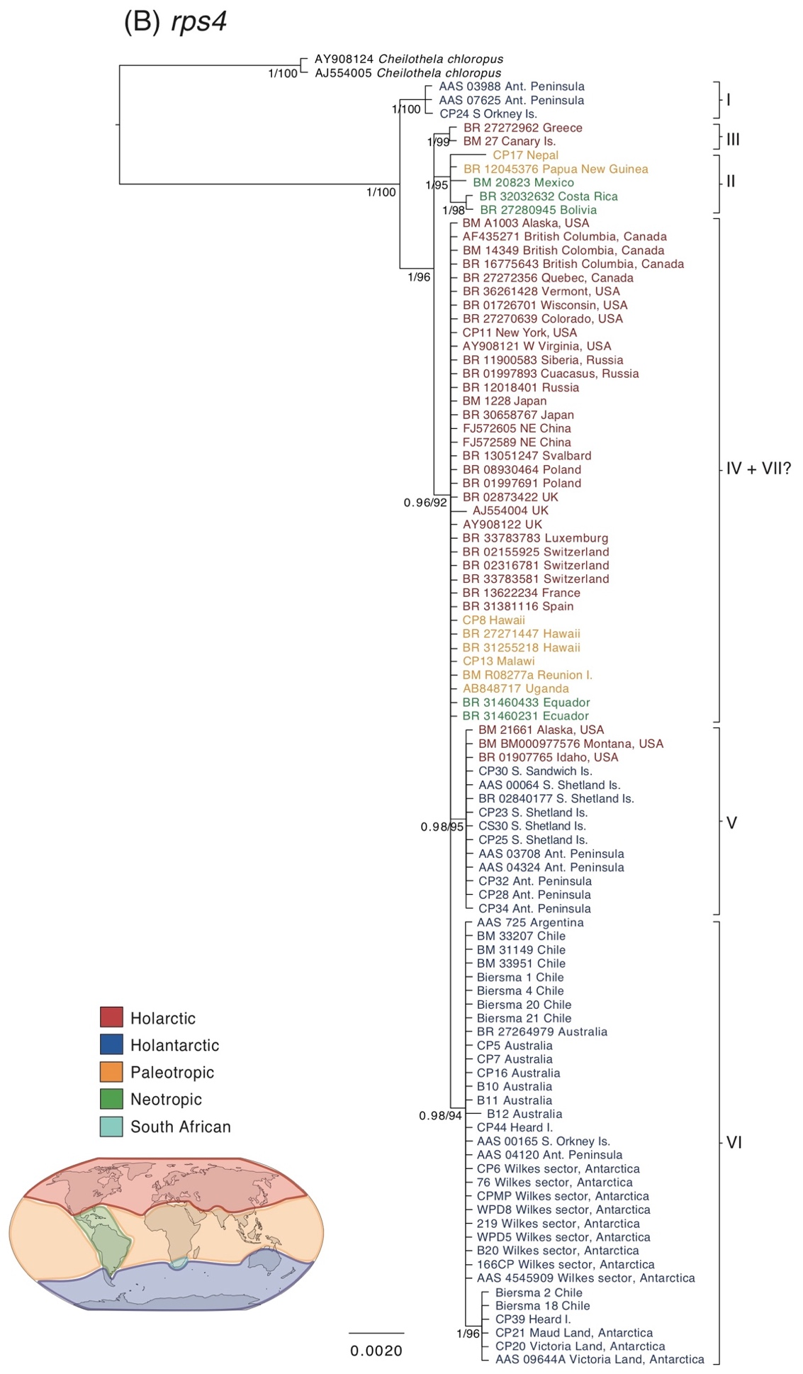
Fig. S1. (continued)
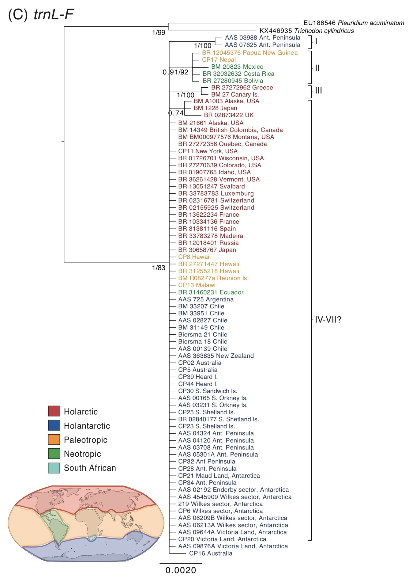
Fig. S1. (continued)
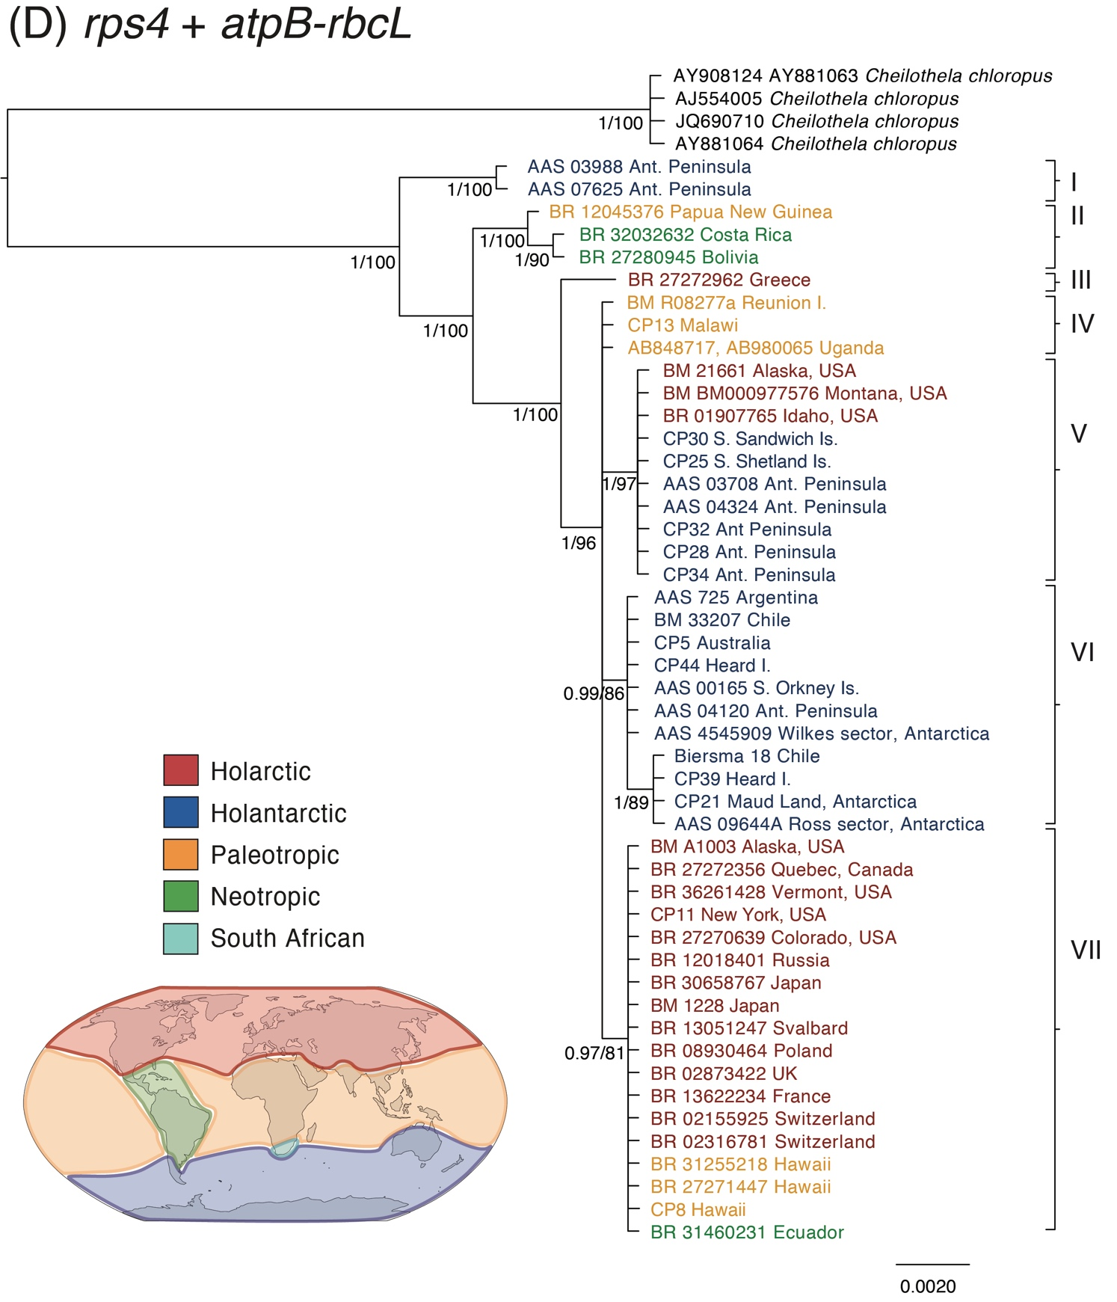
Fig. S1. (continued)
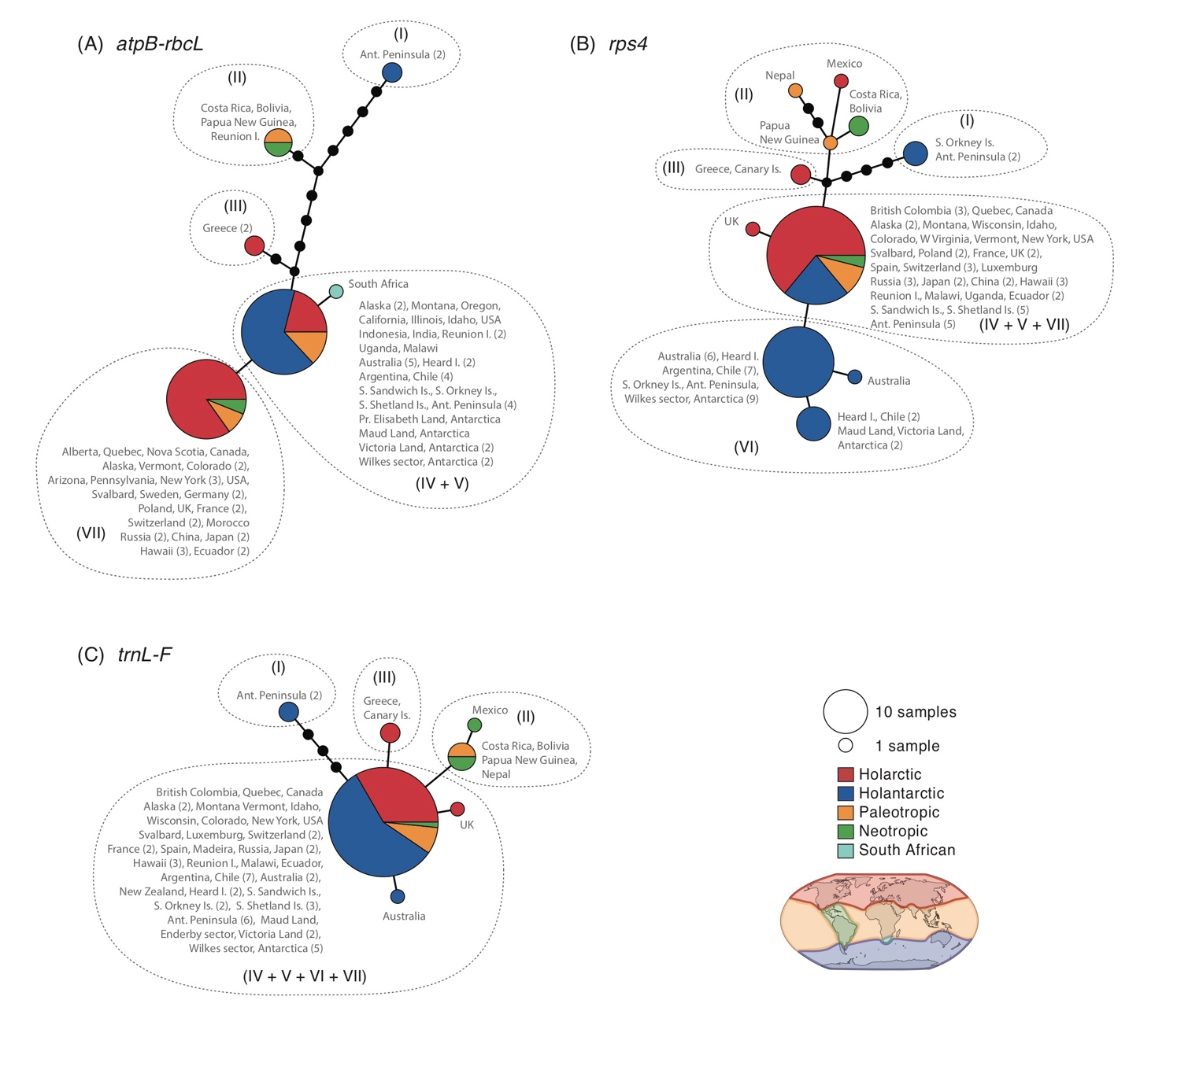 Supplementary Fig. S2. Haplotype networks of cpDNA markers (A) atpB-rbcL (B) rps4 and (C) trnL-F within the species Ceratodon purpureus with geographical information. Haplotype circle sizes correspond to the number of specimens. Colours refer to the bryofloristic kingdoms of the world (see map; redrawn from Schofield, 1992) and do not follow the same colour scheme as Figs. 2 and 3, as singe loci do not show evidence of all clades. Branches represent mutations between haplotypes, with mutations shown as 1-step edges.
Supplementary Table S2. Genetic diversity indices, demographic and spatial expansion model tests and Tajima’s D and Fu’s Fs neutrality tests as performed in using ARLEQUIN v3.5.1.2 (Excoffier & Lischer, 2010) for atpB-rbcL, rps4 and trnL-F within the species Ceratodon purpureus. Analyses were performed on total individual cpDNA loci as well as the concatenated cpDNA dataset. Within the latter, analyses were performed on all clades (I-VII; n=47) and the large ABGD-inferred cluster as defined with P_{max}=0.0017-0.0046 (III-VII; n=42) and P_{max}=0.001; (IV-VII; n=41), as shown in Fig. 2. SSD or HRI p-values were non-significant except where indicated with *.

 |  |  |  |  |  |  | Demographic expansion |  | Spatial expansion |  | Neutrality tests:
Clades | n | bpª | π |  | S | h | SSD | HRI | SSD | HRI | Tajima's D (P) | Fu's Fs (P)
atpB-rbcL (total) | 80 | 629 | 0.006±0.003 |  | 17 | 0.793±0.026 | 0.047 | 0.092 | 0.043 | 0.092 | -1.248 (0.092) | 2.420 (0.835)
rps4 (total) | 94 | 589 | 0.003±0.002 |  | 18 | 0.767±0.029 | 0.007 | 0.073 | 0.007* | 0.073 | -1.525 (0.038*) | -3.290 (0.089)
trnL-F (total) | 74 | 435 | 0.002±0.002 |  | 10 | 0.319±0.070 | 0.026 | 0.385 | 0.003 | 0.385 | -1.986 (0.002*) | -2.939 (0.066)
Concatenated cpDNA
I-VII | 47 | 1660 | 0.004±0.002 |  | 37 | 0.874±0.029 | 0.827* | 0.057 | 0.028 | 0.057 | -1.452 (0.050*)¹ | 2.094 (0.809)
III-VII | 42 | 1658 | 0.002±0.001 |  | 11 | 0.843±0.033 | 0.035 | 0.083 | 0.037 | 0.083 | -0.873 (0.210) | 0.972 (0.708)
IV-VII | 41 | 1657 | 0.002±0.001 |  | 5 | 0.835±0.033 | 0.038 | 0.091 | 0.040 | 0.091 | 0.828 (0.818) | 1.247 (0.734)
n: number of samples; bpª: no. of usable basepairs (loci <5.0% missing data); π: nucleotide diversity (average over locus); S: No. of sites with substitutions; h: gene diversity; SSD: Sum of Squared Deviations; HRI: Harpending's Raggedness Index. For Tajima’s D, Fu’s Fs and expansion models a P<0.05 is significant (*). ¹ = The significant Tajima’s D of clade I-VII of the concatenated cpDNA dataset had a P-value of 0.0499.

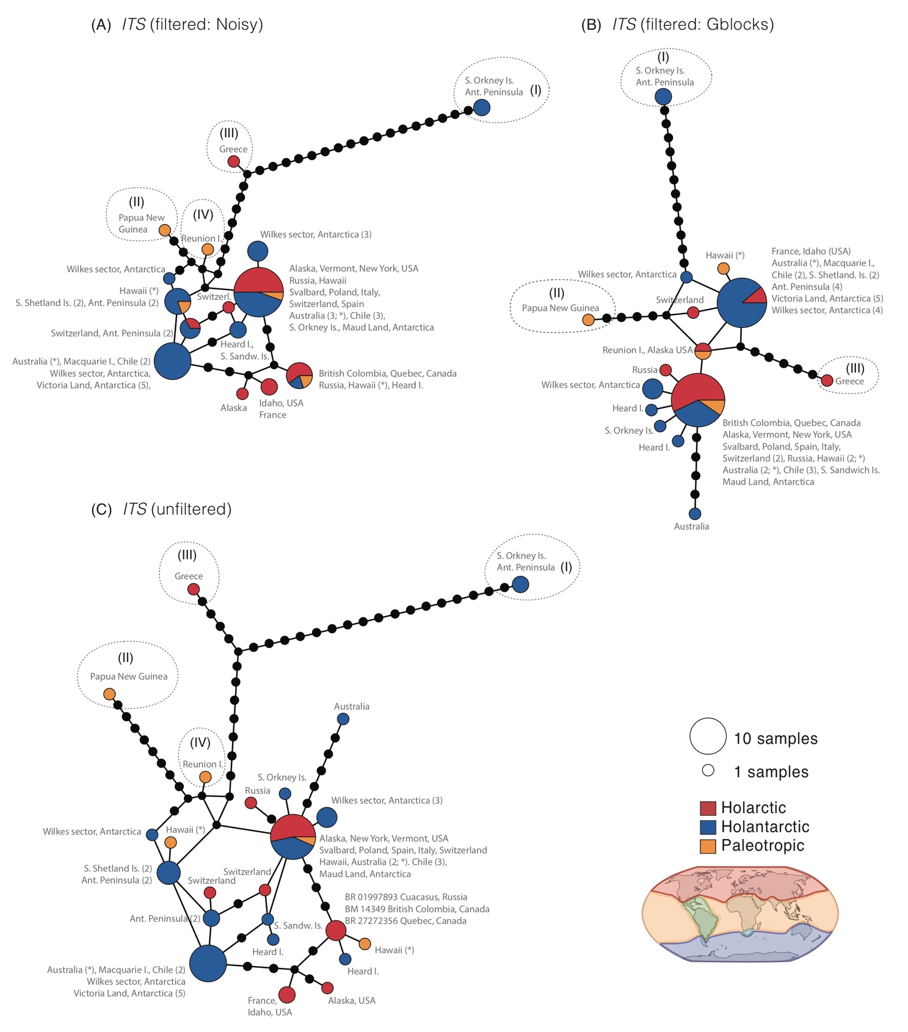
Supplementary Fig. S3. Haplotype networks of ITS within the species Ceratodon purpureus, after treatment with (A) NOISY, (B) Gblocks or as (C) original data. Haplotype circle sizes and colours correspond to the number of specimens and globally recognised bryofloristic kingdoms (see legend; Schofield, 1992), respectively. Branches represent mutations between haplotypes, with mutations shown as 1-step edges. Multiple copies of ITS derived from the same specimens (in samples from Hawaii and Australia) are indicated with (*).
Supplementary Table S3. Fst (below diagonal) and Φst (above diagonal) of Ceratodon purpureus samples of latitudinal and longitudinal geographically divided areas, including samples from the ‘concatenated cpDNA’ dataset. The number of samples (n) per geographic area is given in the top row. P values are represented by * for P<0.05 and ** for P<0.01.
Latitudinal | Φst  Fst | >30°N (n=18) | 30°S - 30°N (n=9) | >30°S (n=20)
 | >30°N | - | 0.197 (0.015*) | 0.153 (0.002**)
 | 30°S - 30°N | 0.195 (0.001**) | - | 0.186 (0.006**)
 | >30°S | 0.244 (0.000**) | 0.176 (0.001**) | -
Longitudinal | Φst  Fst | 30°W-165°W (Americas) (n=27) | 165°W-60°E (Australia/Asia) (n=9) | 60°E-30°W (Africa/Europe) (n=11)
 | 30°W-165°W | - | 0.084 (0.070) | 0.036 (0.153)
 | 165°W-60°E | 0.149 (0.001**) | - | 0.013 (0.186)
 | 60°E-30°W | 0.144 (0.000**) | 0.133 (0.002**) | -

Supplementary Table S4. Fst (below diagonal) and Φst (above diagonal) of Ceratodon purpureus samples of latitudinal and longitudinal geographically divided areas, including samples from the GBLOCKS filtered ITS dataset. The number of samples (n) per geographic area is given in the top row. P values are represented by * for P<0.05 and ** for P<0.01.
Latitudinal | Φst  Fst | >30°N (n=17) | 30°S - 30°N (n=6) | >30°S (n=33)
 | >30°N | - | 0.003 (0.398) | 0.087 (0.010**)
 | 30°S - 30°N | 0.184 (0.006**) | - | 0.016 (0.269)
 | >30°S | 0.160 (0.000**) | 0.069 (0.022*) | -
Longitudinal | Φst  Fst | 30°W-165°W (Americas) (n=24) | 165°W-60°E (Australia/Asia) (n=19) | 60°E-30°W (Africa/Europe) (n=13)
 | 30°W-165°W | - | -0.004 (0.516) | 0.017 (0.245)
 | 165°W-60°E | 0.064 (0.000**) | - | 0.051 (0.081)
 | 60°E-30°W | 0.150 (0.000**) | 0.170 (0.000**) | -

Supplementary Table S5. Analysis of Molecular Variance (AMOVA) within Ceratodon purpureus populations based on pairwise difference among and within populations at the haplotypic (Fst) and nucleotidic level (Φst), as calculated in the ‘concatenated cpDNA’ dataset (upper) and GBLOCKS filtered ITS dataset (lower). Populations are based on latitudinal and longitudinally separated geographic areas (see manuscript and Table S4.1 and S4.2 for latitudinal and longitudinally divided regions, respectively, as well as the number of individuals per area). P values are represented by * for P<0.05 and ** for P<0.01.
 |  | Latitudinal |  | Longitudinal
 |  | Fst | Φst | Fst | Φst
cpDNA | Among populations | 21.44 | 17.13 | 14.39 | 5.67
(average over 53 loci) | Within populations | 78.56 | 82.87 | 85.61 | 94.33
 | P-value | 0.000** | 0.000** | 0.000** | 0.066
ITS (GBLOCKS) | Among populations | 14.17 | 6.21 | 11.73 | 1.47
(average over 80 loci) | Within populations | 85.83 | 93.79 | 88.27 | 98.53
 | P-value | 0.000** | 0.034* | 0.000** | 0.222

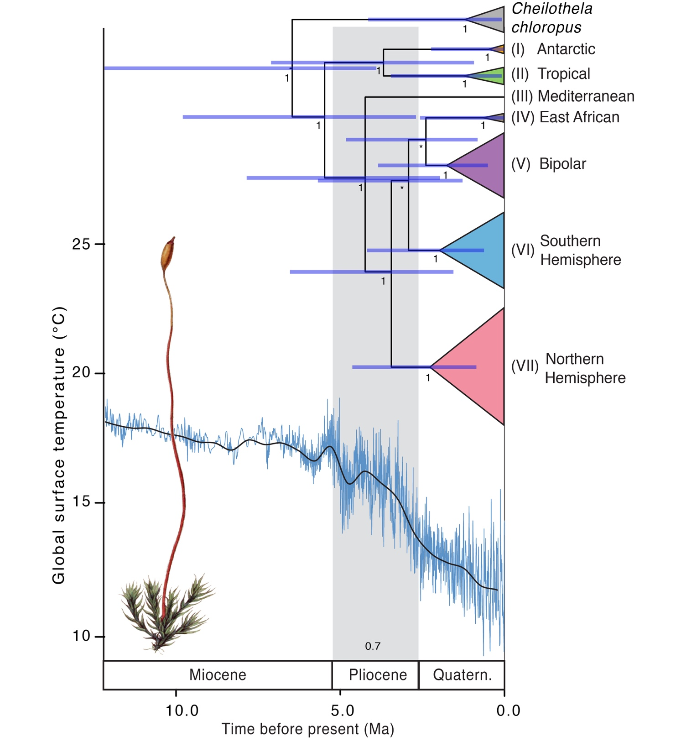
Supplementary Fig. S4. Time-calibrated phylogeny of Ceratodon purpureus using a Yule tree prior. All other analysis settings and tree representations are the same as in Fig. 5, showing the BEAST analysis using a coalescent tree prior.

