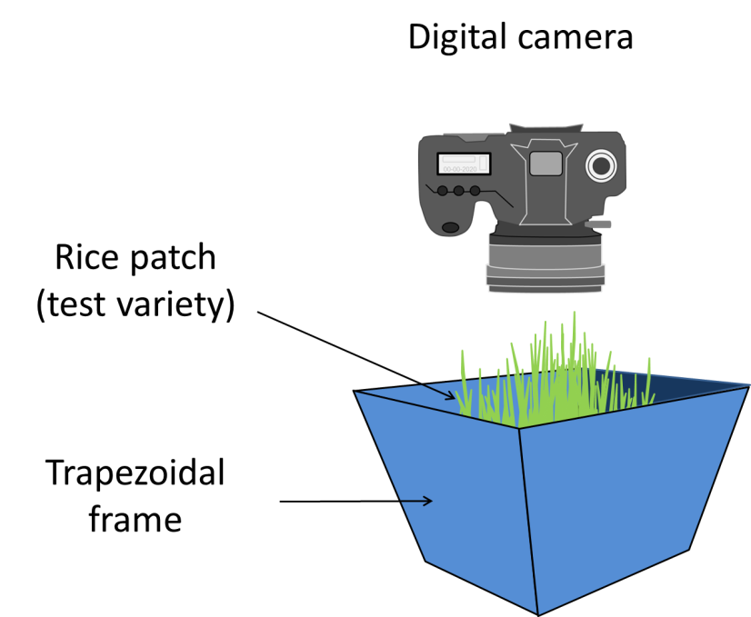

Fig S1. Diagram of inverted trapezoidal frame (with blue inside surface) placed over a rice patch during the adapted-Standard Seedling Seed-box Test during image capture using a digital camera.

