Web Appendix
Benefit cost analysis of an interprofessional education program within residential aged care facility in Western Australia

This Appendix documents (A) the pre-modelling data analyses and assumptions performed for the benefit-cost analysis of the IPE program and (B) the complete results of the base case analyses for all four perspectives (Project, Private, Efficiency and Referent-Group Analyses).
Benefit-cost analysis is a process of identifying, measuring and comparing the benefits and costs of an investment program or project. The key variables to calculate benefits and costs for the economic evaluation of the Interprofessional Education (IPE) program in a residential aged care facility (RACF) are described below. All benefits and costs were measured in 2016 Australian dollars (A$).

A. Data inputs, assumptions and pre-modelling analyses
A.1. Basic model parameters:
The evaluation considers an 8-year duration, of which the first 3 years (year 0 to 2) consists of program implementation, and last 5 years (year 3 to 8) captures the lasting effect of productivity improvement to students and staff due to IPE exposure. All analyses were conducted with three discount rates 2%, 5% and 7%.
According to IPE program reports and RACF administrative data:
- The program serviced 181 students over the 3 year period, averaging 60 students per year. The average university funding per student per annum was AU$231 (range: AU$0-$600).
- There were, on average, 182 training sessions organised for students within the IPE program every year. Some of these sessions were online training modules.
- The program had 10 RACF staff involved in supervising and training students (per year), and the whole facility had 30 aged care staff. On average, one new staff member was recruited each year to replace an existing staff member (moved into other duties or left the facility).
- During the evaluation period (8 years in total: 3 years of IPE program and 5 years afterward to capture the medium-term effect of the program), a total of 330 residents were in contact with IPE students.
A.2. Benefits
Three major benefit categories were identified.
- Improved productivity for graduates of the IPE program subsequently employed in an interprofessional setting, compared to students following the traditional placement stream. This was generated by increased understanding and practice of interprofessional care for older adults, and awareness of future employment options for students including increased likelihood of graduates working in aged care. This was the benefit accrued for individual students.
The market price for graduates working in the age care sectors was sourced from http://www.payscale.com/research/AU/Job=Aged_Care_Worker/Hourly_Rate (accessed 2016). Since the data were only available for intervals of years of work experience, we extrapolated to individual years using regression analyses. Three different functional forms were tested: linear, logarithmic and polynomial order 2. The best fitted form was the polynomial order 2. The extrapolation results are presented in Figure 1 and Table 1. These values were used in the Project and Private Analyses.
Figure 1: Fitting the predictive function for market prices of graduates working in aged care sector (salary – years of experience) | Table 1: Predicted values for market prices of graduates working in the aged care sector
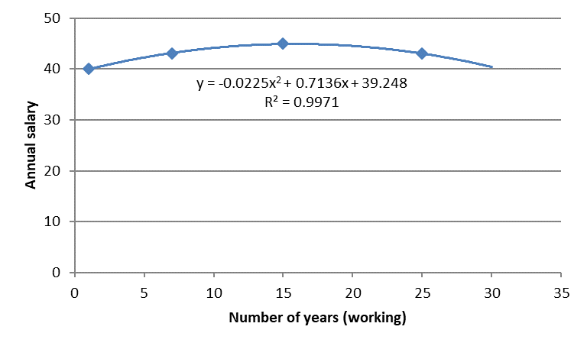 | Years | Observed | Predicted
 | 1 | $ 40,000 | $ 39,939
 | 2 |  | $ 40,585
 | 3 |  | $ 41,186
 | 4 |  | $ 41,742
 | 5 |  | $ 42,254
 | 6 |  | $ 42,720
 | 7 | $ 43,000 | $ 43,141
 | 8 |  | $ 43,517
 | 9 |  | $ 43,848
 | 10 |  | $ 44,134
 | 11 |  | $ 44,375
 | 12 |  | $ 44,571
 | 13 |  | $ 44,722
 | 14 |  | $ 44,828
 | 15 | $ 45,000 | $ 44,890
 | 16 |  | $ 44,906
 | 17 |  | $ 44,877
 | 18 |  | $ 44,803
 | 19 |  | $ 44,684
 | 20 |  | $ 44,520
 | 21 |  | $ 44,311
 | 22 |  | $ 44,057
 | 23 |  | $ 43,758
 | 24 |  | $ 43,414
 | 25 | $ 43,000 | $ 43,026
 | 26 |  | $ 42,592
To calculate the shadow price for IPE graduates, compared to the non-IPE students, we assumed that a graduate with IPE has the skill equivalent to a 2-year experience without IPE training. After 5 years working in the field, both an IPE and a non-IPE graduate, on average, would achieve the same level of skills. This means that IPE gives graduates an advantage (e.g. benefit) in improved skill and knowledge to work in an interprofessional environment, compared to a non-IPE graduate. However, this advantage gap disappears over time as the non-IPE graduates accumulate the skill and knowledge in their workplace. This “convergence effect” was conservative in the sense that we only accounted for an immediate impact of IPE while there might be a long-term benefits of IPE approach to student training. The same regression methodology was applied to obtain the predictions. The best fitted form was the polynomial order 2. The extrapolation results are presented in Figure 2 and Table 2. These values were used in the Efficiency and Referent-Group Analyses.
Figure 2: Fitting the predictive function for market prices of graduates working in aged care sector (salary – years of experience) | Table 2: Predicted values for market prices of graduates working in the aged care sector
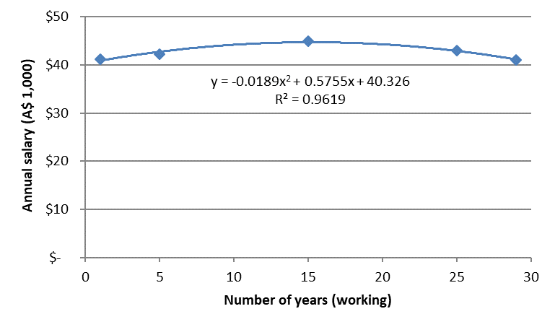 | Years | Observed | Predicted
 | 1 | $ 41,186 | $ 40,927
 | 2 |  | $ 41,420
 | 3 |  | $ 41,878
 | 4 |  | $42,300
 | 5 | $42,254 | $42,688
 | 6 |  | $43,040
 | 7 |  | $43,358
 | 8 |  | $43,641
 | 9 |  | $43,889
 | 10 |  | $44,102
 | 11 |  | $44,279
 | 12 |  | $44,422
 | 13 |  | $44,530
 | 14 |  | $44,603
 | 15 | $45,000 | $44,641
 | 16 |  | $44,644
 | 17 |  | $44,612
 | 18 |  | $44,545
 | 19 |  | $44,443
 | 20 |  | $44,306
 | 21 |  | $44,135
 | 22 |  | $43,928
 | 23 |  | $43,686
 | 24 |  | $43,409
 | 25 | $43,000 | $43,098
 | 26 |  | $42,751

- According to the program exit survey, 92% percent of staff surveyed in 2014 believed the program was beneficial to themselves and their colleagues. This translates into improved productivity and job satisfaction of RACF staff who are directly involved in training and supervising students and higher job satisfaction leading to lower absenteeism and turnover. The impacts therefore were quantified in three different benefit items: (i) productivity, (ii) savings from lower absenteeism and (iii) savings from lower turnover. These benefits accrued for the aged care organisation.
(i) According to the IPE program and the RACF administrative data, staff involved in providing training and supervision of students in the IPE placement program have an average of 5 years working experience. According to the post placement survey, supervision and training students improved the coordination and management skill and knowledge by the staff involved (Seaman & Williams, 2016). We assume this improvement is equivalent to an extra 2-years experience working in the same environment without coordinating students. Similar to the IPE impacts on students, we allowed the impacts to diminish after 5 years. Again, we extrapolated the data using regression analyses, using three different functional forms: linear, logarithmic and polynomial order 2. The best fitted form was the polynomial order 2. The extrapolation results are presented in Figure 3 and Table 3. These values were used in the Efficiency and Referent-Group analyses. Note that the market price (used in the Project and Private Analyses) continue to follow the values presented in Table 1 (above) for the corresponding years of work experience in the aged care sector.
Figure 3: Fitting the predictive function for shadow prices of RACF staff involved in student placement (salary – years of experience) | Table 3: Predicted values for shadow prices of RACF staff
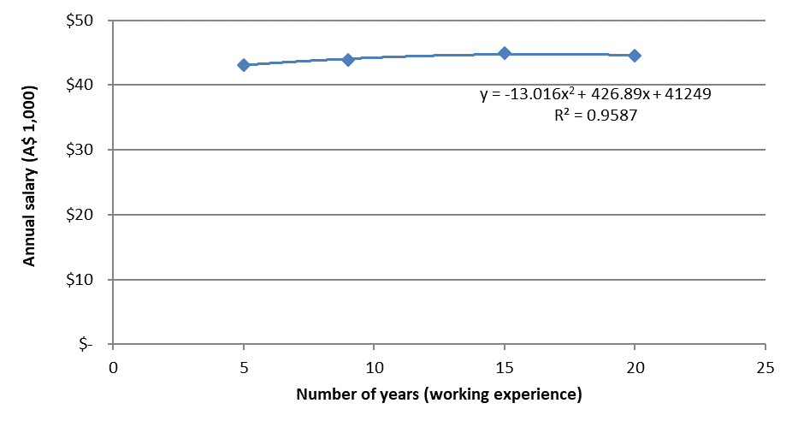 | Years | Observed | Predicted
 | 5 | $ 43,141 | $ 42,254
 | 6 |  | $ 42,720
 | 7 |  | $ 43,141
 | 8 |  | $ 43,517
 | 9 | $ 43,848 | $ 43,848
 | 10 |  | $ 44,134
 | 11 |  | $ 44,375
 | 12 |  | $ 44,571
 | 13 |  | $ 44,722
 | 14 |  | $ 44,828
 | 15 | $ 44,890 | $ 44,890
 | 16 |  | $ 44,906
 | 17 |  | $ 44,877
 | 18 |  | $ 44,803
 | 19 |  | $ 44,684
 | 20 | $ 44,520 | $ 44,520

(ii) The exit survey and focus group to evaluate the impacts of the IPE program showed that the RACF staff who were involved in the coordination and training of students had improved job satisfaction. The RACF administrative data during this period showed a lower rate of absenteeism: a reduction from 6% to 4%. We sourced information for the economic cost of absenteeism from the literature because neither the RACF administrative data nor the IPE program evaluation surveys were designed to collect this information. According to the DHS 2015 survey, for an organisation with 30 staff (full time equivalent), a 4% absenteeism rate (per annum) was associated with a productivity loss of A$42,000 while 6% was associated with A$63,000 (Direct Health Soutions, 2015). The difference was calculated as A$21,000 and used in the Efficiency and Referent-Group Analyses (because the cost of absenteeism was not accounted for in staff salary).

(iii) During the IPE period, the RACF recorded an annual reduction of 0.4% in staff turnover (according to administrative records). This (0.4% reduction) was determined by two fewer staff resignations compared to the period before the IPE program. The marginal cost of turnover (per staff member) was estimated in the literature as A$28,000 (Mukamel et al., 2016). This translated into savings of A$3,389 per annum for the RACF (3,389 = 28,000 * 0.4% * 30, with 30 being the average number of RACF staff per annum). Since this is the cost actually incurred by the aged care organisation (e.g. costs associated with advertisement of the position, interviewing, organisation orientation and job training), this cost was included in all analyses.

- The IPE program was found to bring “positive effects on the physical health, emotional wellbeing and social interaction of residents at the facility.” The exit survey and focus group showed that residents appreciated the interactions they had with students and with each other as a result of the IPE program (Seaman & Williams, 2016). We translated these impacts into improved quality of life and health outcomes for RACF residents through additional service delivery (e.g. student-led education sessions) during the program period, which translated to reduced unnecessary health service utilisation. Impacts of the IPE program on residents, therefore, were calculated as two benefit items: (i) increased quality of life, and (ii) reduced health care utilisations in terms of GP visits and ED transfer (per annum).
(i) The improved quality of life came from services provided and led by IPE students (which increased the mobility and physical performance of residents) and increased contact hours between students and residents during the placement period. During the exit survey, residents were asked their perception of students and the benefits the IPE students brought to the RACF and themselves, individually (Seaman & Williams, 2016). Subsequently, we made a conservative assumption of 5% improvement in quality of life attributable for increased contact hours and an additional 5% improvement due to increased mobility and physical performance. These summed to a 10% increase in quality of life per annum. Taking the Australian government’s implicit willingness to pay standard of A$50,000 (applied for health technology assessment of medical agents, services and devices by the Pharmaceutical Benefit Schedule and the Medical Benefit Scheme), we calculated the value of improved quality of life per resident per year at A$5,000 (see Table 4). This value was not captured in any market (i.e. residents were not charged for attending the extra services that IPE students provided during the placement period) and was therefore used in the Efficiency and Referent-Group Analyses.
Table 4: Estimated values of improved quality of life for RACF residents during the IPE operation period (2013-2015)
Calculations | Descriptions | Values (per annum)
A | Increase service from student attendance | 0.05
B | Increase mobility and physical performance | 0.05
C = A + B | Total improved QALY | 0.1
D | WTP per QALY in Australia | $ 50,000
E = C * D | Improved per resident | $ 5,000

(ii) An indirect benefit of the IPE program on RACF residents was improved health outcomes. According to the exit survey, during the period of IPE program residents who participated in sessions led or delivered by IPE students (e.g. balance, paro, wii, voice, pulmonary rehabilitation, men’s groups, ladies’ groups, communication groups) showed improved physical well-being and increased confidence to participate in physical activities. During the program period, medical students provided an increased amount of primary care to residents and recorded the reason the resident was attended and the outcomes of the visit. Ninety percent of student visits were believed to have prevented further escalation of a medical issue that would require an external GP visit or emergency transfer.
We translated the improved health outcomes into a reduction of 2 GP visits and 1 emergency transfer per year per resident. During this period, the administrative data showed that around 25% of residents had preventable GP visits and 10% had preventable ED transfers. This is a conservative assumption because ninety percent of student visits were believed to have prevented further escalation of a medical issue (Seaman & Williams, 2016), which would have potentially led to not only ED transfer but also hospital admission. We did not include any hospitalisation (inpatient admission) values because it is difficult to reliably quantify the number of episodes of preventable hospitalisation. These are the direct savings for the healthcare system that were generated through improved social care and education sectors. The direct beneficiary of this benefit is the healthcare system, which is represented by the Commonwealth and state governments. These benefits (shown in Table 5) were used to calculate the benefits in all analyses except for the Referent-Group.
Table 5: Estimated savings for the healthcare sectors due to improved health outcomes of RACF residents
Items | Number (per annum) | Number of residents had this outcomes | Market and shadow price | Total market and shadow values (annual)
 | A | B | C | A * B * C
Reduction in GP visits (item 23, MBS) | 2 (visits) | 27 (residents) | $ 37 | $ 2,035
Reduction in emergency admissions | 1 (transfer) | 11 (residents) | $ 913 | $ 10,043

All the calculated benefits are summarised in the table below.
Table 6: Summary of all calculated benefits in market and shadow prices
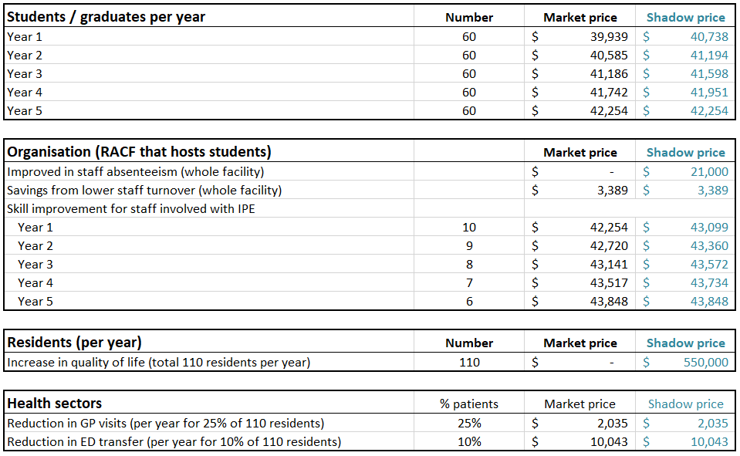

A.3. Costs
There are two major cost categories: the initial investment (incurred once in year 0, or 2013) and the operating cost (incurred during the 3 years of IPE program, 2013-2015).
- The initial investment covered the purchase of learning and teaching equipment for students that was used as part of care delivery for residents (bladder scanner, digital blood pressure monitor, oximeter, etc.), program equipment for new resident activities developed as part of the student placements (e.g. recumbent bike, stairs, exercise bars and balls), and a dedicated computer for student use. These cost information was included in all analyses. The data was sourced from the IPE program administrative records. Due to the confidentiality agreement between the aged care organisation and the research team, we do not disclose individual item costs (about 50 items). The total cost of all items is reported in Table 7 below (investment costs).

- The operating cost included two components: (i) recurrent expenditure of students, including training workshops and regular expenditure incurred when students were learning and working inside the facility, and (ii) the project management and supervision team, which was determined by the number of work days per annum. There was no pre-modelling analysis; the data and calculations came directly from the IPE program records. All operating expenditures are summarised in Table 7. The only deviation between the analyses in cost values were the shadow prices for the training space because all expenditures were recorded in the accounting records by either the RACF or the IPE program.
(i) The recurrent expenditure for the IPE students included: facility expenditure (e.g. working and training space, water and electricity usage), education (e.g. paid educators and trainers) and miscellaneous (e.g. education materials, printing, tea and coffee).
The IPE program offered regular workshops and training modules on interprofessional topics as well as top-up clinical and nursing skills. The modes of delivery included online self-learning (e.g. wound care and pressure injury) and within in the facility (e.g. understanding cognitive decline and dementia with geriatricians, case study sessions and quizzes with GPs, speech pathology, and chronic disease management). The RACF provided a space for workshops (e.g. a room with its equipment and electricity usage) and a dedicated student room for the IPE program. These expenditures were not accounted explicitly in the IPE program records but included in the RACF accounting records (i.e. the aged care organisation either paid rent or interest payments for the property on which they built the RACF, and paid for regular maintenance, electricity and water consumption). We sourced the rental information of similar property in the RACF areas from the open rental market, converted it into per square meter cost and calculated the annual expenditure for the IPE student room (15 square meters, according to the IPE program record). Similar calculations were performed for the training room, but applied by hours (i.e. when there was no IPE training workshops then the space was used for other activities in the facility).
The annual expenditure for education, including costs paid to clinical educators and trainers for (an average of) 163 workshops (e.g. geriatricians, dieticians, speech pathologists, pharmacists and nurse practitioners), and miscellaneous training expenditure (e.g. printed materials, tea, coffee) was sourced from the IPE program records.

(ii) The IPE program employed dedicated IPE coordinators (0.4 FTE) and facilitators (0.8 FTE) to manage and support the program within the facility environment. Additionally, the program employed a registered nurse (4 hours per week), physiotherapist (4 hours per week) and therapy assistant (6 hours per week) to supervise and support students in their training. The actual salaries were sourced directly from the IPE program records over the three-year implementation period.
Table 7: Summary of all calculated costs in market and shadow prices
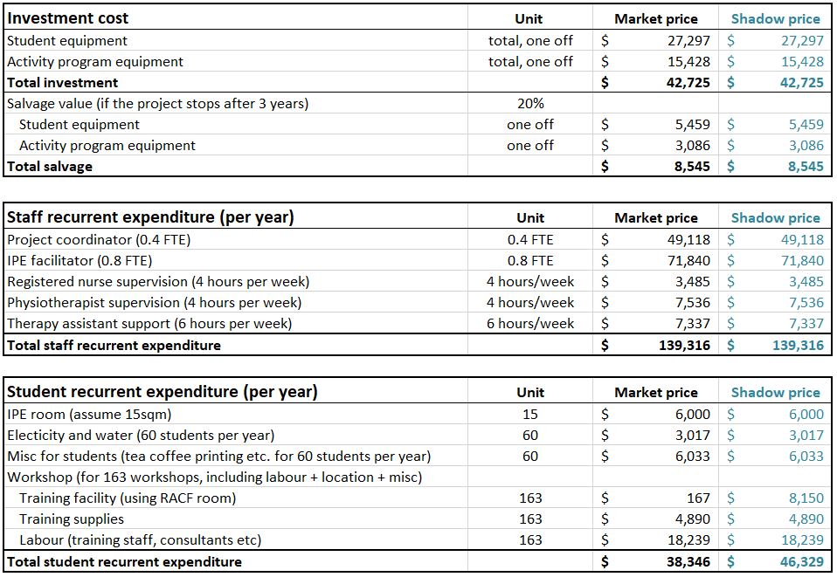

B. Complete base case results
The base case results are summarised in Table 8, Table 9, Table 10, Table 11, and Table 12. The Stata codes for the univariate and probabilistic sensitivity analyses can be made available for interested readers upon request.

Table 8: Summary results of the base case
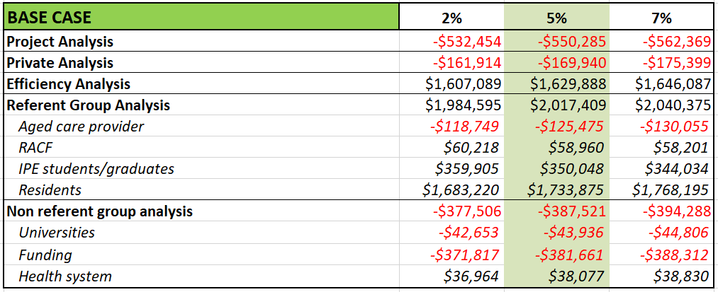

Table 9: Project Analysis - Base case results by year
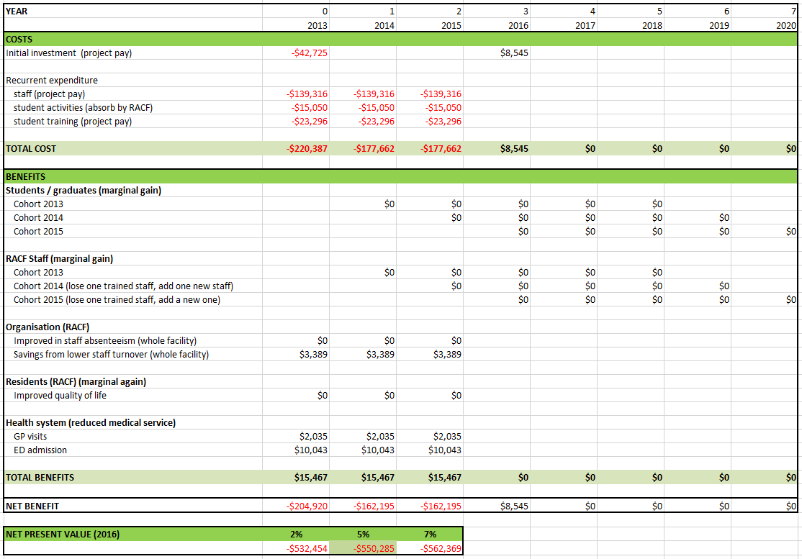
Table 10: Private Analysis - Base case results by year
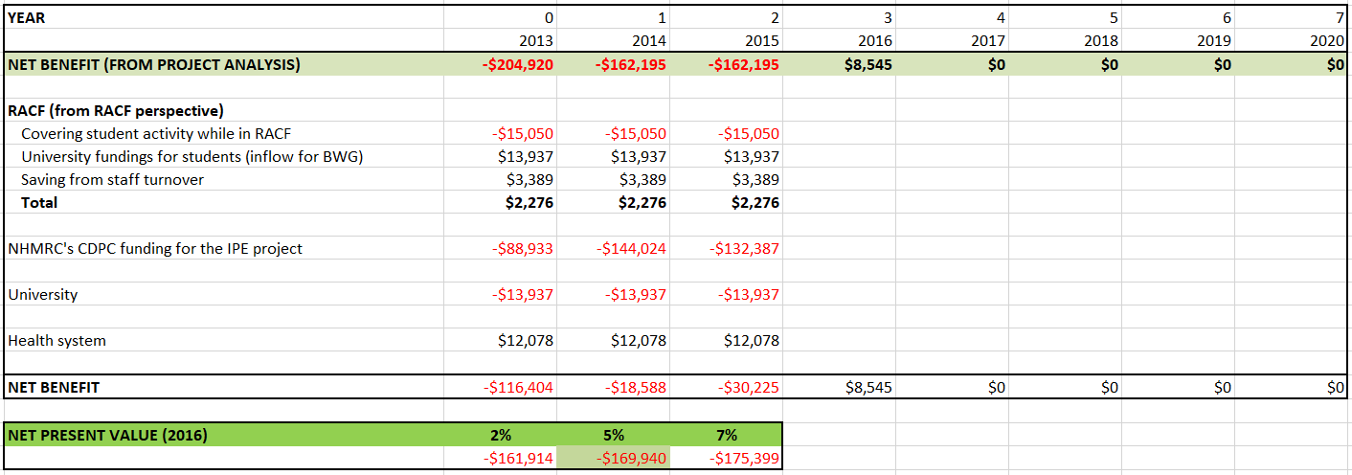

Table 11: Efficiency Analysis - Base case results by year
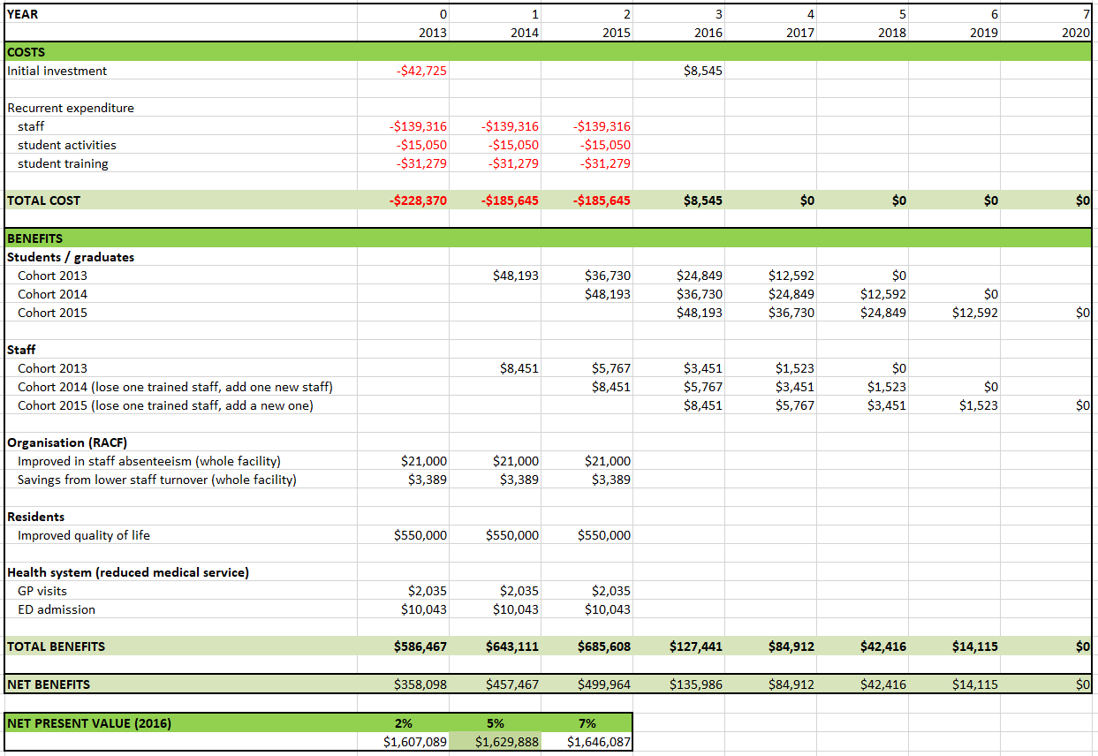
Table 12: Referent-Group Analysis - Base case results by year
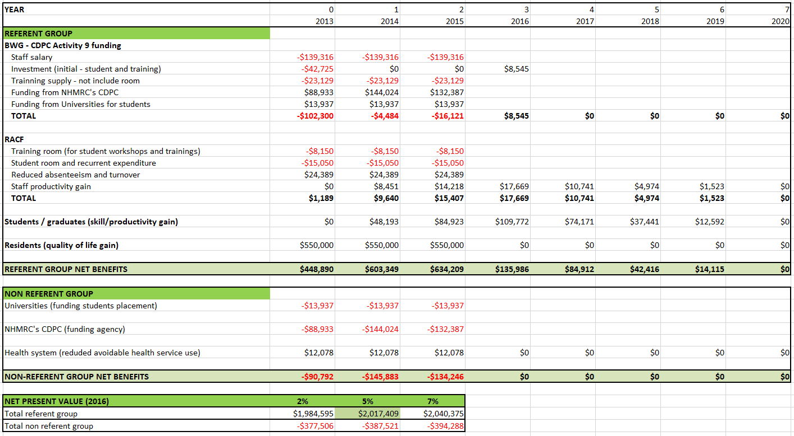

References
Direct Health Soutions. (2015). 2015 Absence Management Survey Report. Retrieved from
https://www.dhs.net.au/insight/2015-absenteeism-survey/
Mukamel, D. B., Spector, W. D., Limcangco, R., Wang, Y., Feng, Z., & Mor, V. (2009). The costs of
turnover in nursing homes. Medical Care, 47(10), 1039–1045.
Seaman, K. L., & Williams, E. (2016). Evaluating the outcomes for Interprofessional Education Programs in Residential Aged Care. Perth, Western Australia: Brightwater Care Group.

