Supporting Information File for Manuscript

**Exploring 3-Hydroxyflavone Scaffolds as Mushroom Tyrosinase Inhibitors: Synthesis, X-Ray Crystallography, Antimicrobial, Fluorescence Behaviour, Structure-Activity Relationship and Molecular Modelling Studies**.

Jamshaid Ashrafa, Ehsan Ullah Mughal[1]*a, Amina Sadiqb, Maryam Bibia, Nafeesa Naeema,

Anser Ali**\***c, Anam Massadaqc, Nighat Fatimad, Asif Javida, Muhammad Naveed Zafare, Bilal Ahmad Khanf, Muhammad Faizan Nazara, Amara Mumtazg, Muhammad Nawaz Tahirh and Masoud Mirzaei

*aDepartment of Chemistry, University of Gujrat, Gujrat-50700, Pakistan*

*bDepartment of Chemistry, Govt. College Women University, Sialkot-51300, Pakistan*

*cDepartment of Zoology, Mirpur University of Science and Technology, Mirpur-10250 (AJK), Pakistan*

*dDepartment of Pharmacy, COMSATS Institute of Information Technology, 22060 Abbottabad, Pakistan*

*eDepartment of Chemistry, Quaid-i-Azam University, Islamabad-45320, Pakistan*

*fDepartment of Chemistry, University of Azad Jammu and Kashmir, Muzaffarabad, Pakistan*

*gDepartment of Chemistry, COMSATS University Islamabad, Abbottabad Campus-22060, Pakistan*

*hDepartment of Physics, University of Sargodha, Sargodha-40100, Pakistan*

*iDepartment of Chemistry, Faculty of Science, Ferdowsi University of Mashhad, Mashhad,**Iran*

|  |  |
| --- | --- |
| **Crystallographic Data of Compound 15 (S1)** | **P1** |
| **Second 3-D Perspective of Compound 15 (S2)** | **P2** |
| **1H NMR Spectrum of Compound 2 (S1)** | **P3** |
| **13C NMR Spectrum of Compound 2 (S2)** | **P4** |
| **1H NMR Spectrum of Compound 11 (S3)** | **P5** |
| **13C NMR Spectrum of Compound 11 (S4)** | **P6** |
| **1H NMR Spectrum of Compound 14 (S5)** | **P7** |
| **13C NMR Spectrum of Compound 14 (S6)** | **P8** |
| **1H NMR Spectrum of Compound 15 (S7)** | **P9** |
| **13C NMR Spectrum of Compound 15 (S8)** | **P10** |
| **1H NMR Spectrum of Compound 20 (S9)** | **P11** |
| **13C NMR Spectrum of Compound 20 (S10)** | **P12** |
| **UV-Vis Spectra of Some Newly Synthesized Compounds (Table-S1)** | **P13** |
| **Emission Spectra of all the Synthesized Compounds (1-23) (Table-S2)** | **P15** |
| **Pictures of Petri Dishes of Some of the Tested Compounds (Table-S3)** | **P23** |

# Crystallographic Data of Compound 15 (S1)

**Table S1.** Crystallographic Data and Structure Reﬁnement of Compound **15**

|  |  |
| --- | --- |
| empirical formula | C16H11BrO3 |
| formula weight | 331.16 |
| temperature (*K*) | 296 |
| crystal system | Monoclinic |
| space group | *C*2*/c* |
| *a* (Å)  *b* (Å) | 21.1561(10)  7.4908(3) |
| *c* (Å) | 17.3113(8) |
| *α*, *γ* (°) | 90 |
| *β* (°) | 103.792(1) |
| *V* (Å3) | 2664.3(2) |
| *Z* | 8 |
| *D*calc (g cm-3) | 1.651 |
| *µ* (mm-1) | 3.089 |
| *F*(000) | 1328.0 |
| final *R*1*a*, *wR*2*b* [*I* > 2 σ(*I*)] | 0.0358(2189), 0.0882(3172) |
| GOOF | 1.004 |

*a* *R*1 = Σ||*F*o| - |*F*c||/Σ|*F*o|. *bwR*2 = {Σw(*F*o2 - *F*c2)2/ Σw(*F*o2)2}1/2.

**3-D Perspective of Compound 15 (S2)**

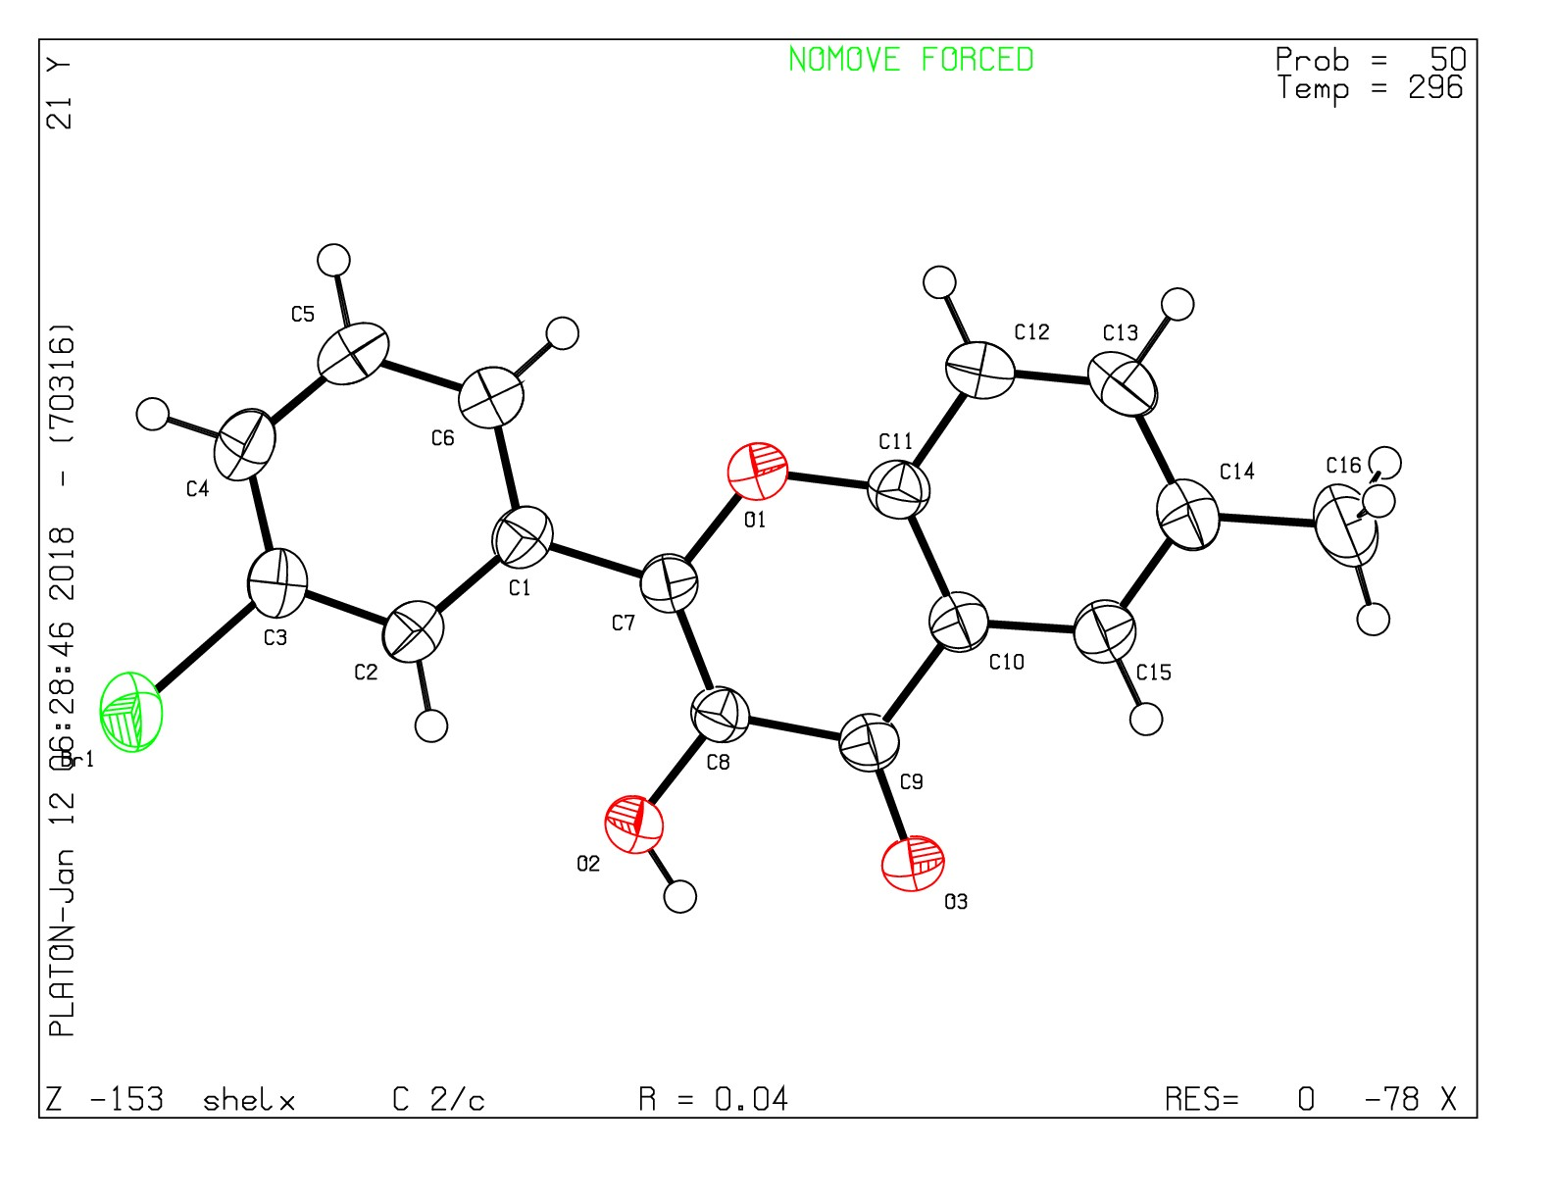

**NMR Spectra of Some Newly Synthesized Compounds**

**Note:** Due to compatibility issue between the data and word-file, there are some tilted lines on the NMR spectra. We apologize for that and request to ignore those errors.

**Figure S1: 1H NMR Spectrum of Compound 2**



**Figure S2: 13C NMR Spectrum of Compound 2**



**Figure S3: 1H NMR Spectrum of Compound 11**



**Figure S4: 13C NMR Spectrum of Compound 11**



**Figure S5: 1H NMR Spectrum of Compound 15**

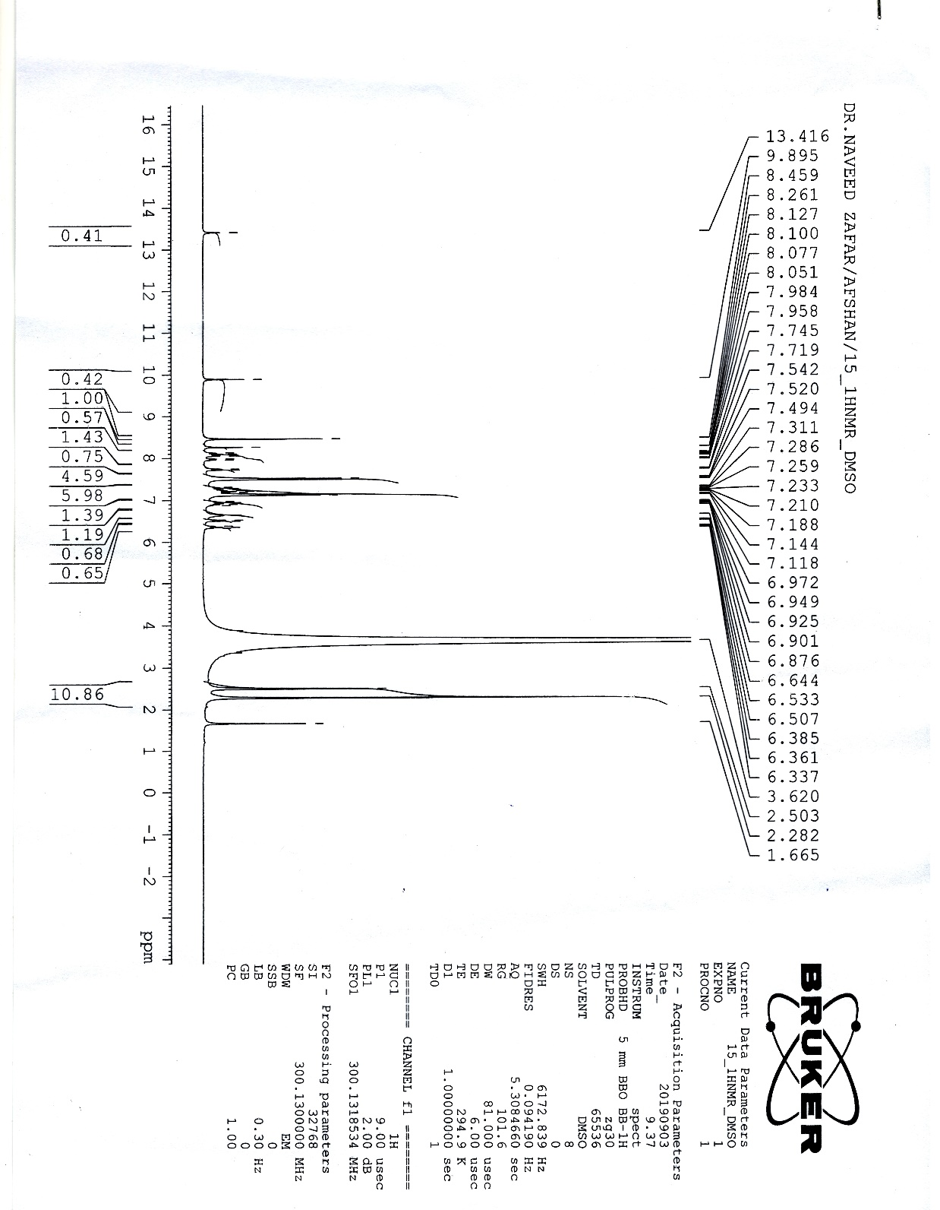

**Figure S6: 13C NMR Spectrum of Compound 14**

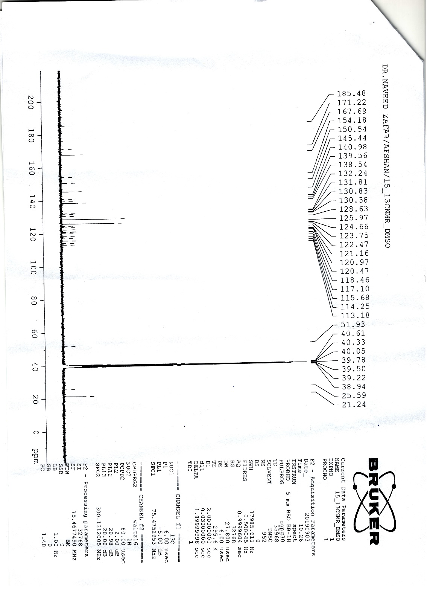

**Figure S7: 1H NMR Spectrum of Compound 15**



**Figure S8: 13C NMR Spectrum of Compound 15**



**Figure S9: 1H NMR Spectrum of Compound 20**



**Figure S10: 13C NMR Spectrum of Compound 20**



**Table S1: UV-Vis Spectra of Some Newly Synthesized Compounds**

**Note:** Codes starting from **A** & **M**…belong to the original compounds and numbering **1,2,3**…. belong to the corresponding compounds in paper

|  |  |
| --- | --- |
| **Compound No.** | **UV-Spectra** |
| **4 (S1)** |  |
| **11 (S2)** | **\** |
| **13 (S3)** |  |

|  |  |
| --- | --- |
| **14 (S4)** | E:\Mphill  theses\UV analysis\uv ananlysis 2nd trail plots\uv  plots in methanol after paint.png |
| **15 (S5)** |  |
| **20 (S6)** |  |

**Table S2: Emission Spectra of all Synthesized Compounds (1-23)**

|  |  |
| --- | --- |
|  | |
| **Compound No.** | **Fluorescence Spectra** | |
| **1 (S1)** |  | |
| **2 (S2)** |  | |
| **3 (S3)** | **C:\Users\R.S COMPUTER\Desktop\Flourescence finalized 2 after paint 1-4.png** | |
| **4 (S4)** | **C:\Users\R.S COMPUTER\Desktop\flourescence finalized 2 after paint  5-8.png** | |
| **5 (S5)** | **C:\Users\R.S COMPUTER\Desktop\flourescence finalized 2 after paint  5-8.png** | |
| **6 (S6)** | **C:\Users\R.S COMPUTER\Desktop\flourescence finalized 2 after paint  5-8.png** | |

|  |  |
| --- | --- |
| **7 (S7)** | **E:\Mphill  theses\Spectroscopic Analysis\Foourescence Analaysis\flourescence 2nd trail\flourescence finalized  2 after paint 9-13.png** |
| **8 (S8)** | **E:\Mphill  theses\Spectroscopic Analysis\Foourescence Analaysis\flourescence 2nd trail\flourescence finalized  2 after paint 9-13.png** |
| **9 (S9)** |  |

|  |  |
| --- | --- |
| **10 (S10)** | **E:\Mphill  theses\Spectroscopic Analysis\Foourescence Analaysis\flourescence 2nd trail\flourescence finalized  2 after paint 9-13.png** |
| **11 (S11)** |  |
| **12 (S12)** |  |

|  |  |
| --- | --- |
| **13 (S13)** |  |
| **14 (S14)** |  |
| **15 (S15)** |  |

|  |  |
| --- | --- |
| **16 (S16)** |  |
| **17 (S17)** |  |
| **18 (S18)** |  |

|  |  |
| --- | --- |
| **19 (S19)** |  |
| **20 (S20)** |  |
| **21 (S21)** |  |

|  |  |
| --- | --- |
| **22 (S22)** |  |
| **23 (S23)** |  |

**Table S3: Pictures of Petri Dishes of Some of the Tested Compounds**

|  |  |  |
| --- | --- | --- |
| **Compound No.**  **(Sample code)** | **Bacterial /Fungal**  **Strains** | **Anti-Microbial activities of Some Synthesized Compounds** |
| **Standard**  **(S1)** | ***E.coli*** |  |
| **4**  **(M4)**  **(M5)**  **(M6)**  **(S2)** | ***E.coli*** |  |
| **13**  **(M16)**  **14**  **(M17)**  **16**  **(18)**  **(S3)** | ***E.coli*** |  |
| **17**  **(19)**  **18**  **(20)**  **19**  **(21)**  **(S4)** | ***E.coli*** |  |
| **1**  **(M1)**  **2**  **(M2)**  **3**  **(M3)**  **(S5)** | ***S. aureus*** |  |
| **4**  **(M4)**  **(M5)**  **(M6)**  **(S6)** | ***S. aureus*** |  |
| **7**  **(M10)**  **8**  **(M11)**  **9**  **(M12)**  **(S7)** | ***S. aureus*** |  |
| **10**  **(M13)**  **11**  **(M14)**  **12**  **(M15)**  **(S8)** | ***S. aureus*** |  |
| **4**  **(M4)**  **(M5)**  **(M6)**  **(S9)** | ***P. aeruginosa*** |  |
| **Standard**  **(S10)** | ***C. parapsilosis*** |  |
| **1**  **(M1)**  **2**  **(M2)**  **3**  **(M3)**  **(S11)** | ***C. parapsilosis*** |  |
| **7**  **(M10)**  **8**  **(M11)**  **9**  **(M12)**  **(S12)** | ***C. parapsilosis*** |  |
| **10**  **(M13)**  **11**  **(M14)**  **12**  **(M15)**  **(S13)** | ***C. parapsilosis*** |  |
| **Standard**  **(S14)** | ***C. albicans*** |  |
| **1**  **(M1)**  **2**  **(M2)**  **3**  **(M3)**  **(S15)** | ***C. albicans*** |  |
| **5**  **(M7)**  **6**  **(M8)**  **(M9)**  **(S16)** | ***C. albicans*** |  |
| **7**  **(M10)**  **8**  **(M11)**  **9**  **(M12)**  **(S17)** | ***C. albicans*** |  |
| **10**  **(M13)**  **11**  **(M14)**  **12**  **(M15)**  **(S18)** | ***C. albicans*** |  |

1. *Corresponding Authors: [ehsan.ullah@uog.edu.pk](mailto:*ehsan.ullah@uog.edu.pk); Tel.: +92-333-8464959, [anser.zoology@must.edu.pk](mailto:anser.zoology@must.edu.pk) ; Tel : +92-346-9161834