Supplementary data

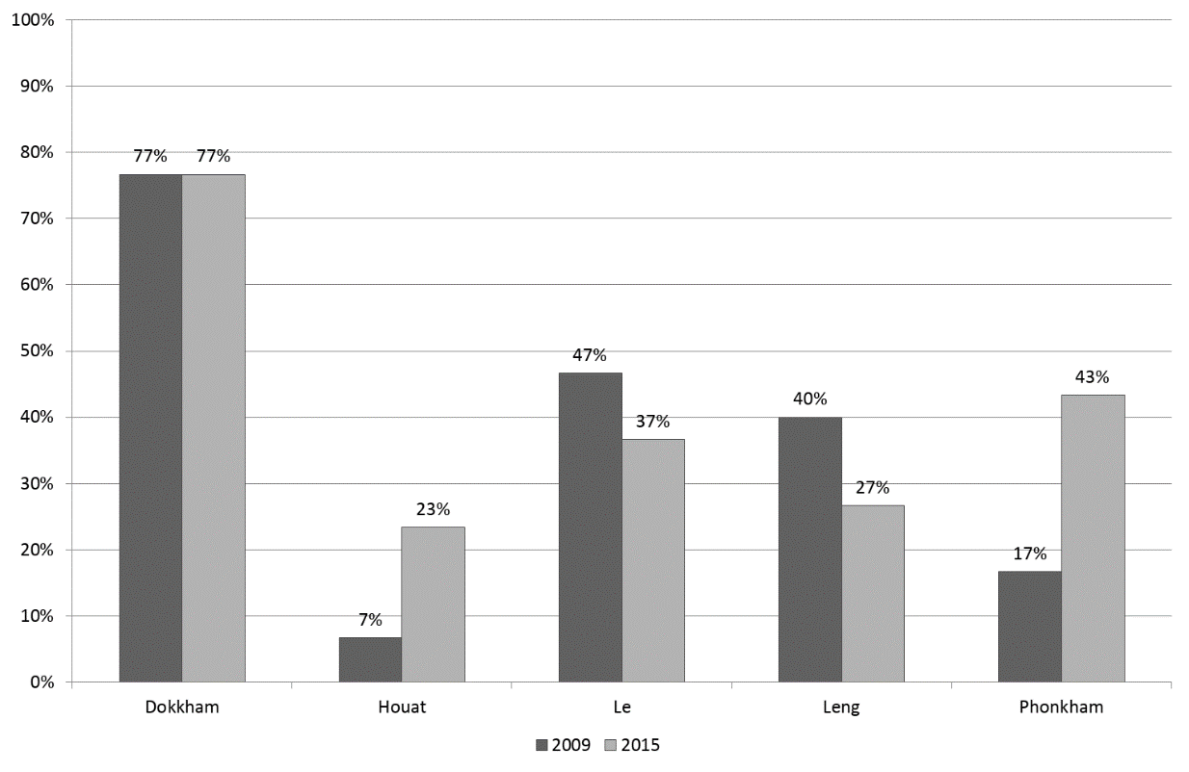
Fig. S1. Evolution of the poverty headcount in the study villages. Poverty headcount was calculated using the national poverty line set for rural areas, per person and per month, at 180,000 LAK in 2010 (applied to the 2009 dataset) and 253,000 LAK in 2013 (applied to the 2015 dataset).

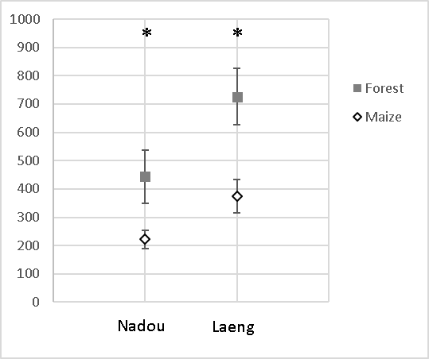
Nadou
Fig. S2. Permanganate-oxidizable carbon (Pox-C) (in mg.kg⁻¹) according to land use in two villages (n=5 per land use and village; 2018). * indicates significant differences between land use treatments according to Kruskal-Wallis test (P<0.05), Bonferroni correction.

No | Village | pH H₂O | OM (%) | N-avail (ppm) |  | P-avail (ppm) | K-avail (ppm) | % of soil particle |  |  | Soil Texture
 |  |  |  | NO3⁻ | NH4⁺ |  |  | Sand | Clay | Silt
1 | Phathang | 6,0 | 1,64 | 2,80 | 4,20 | 0,33 | 106,94 | 47,3 | 18,2 | 34,6 | L
2 | Houat | 4,8 | 0,55 | 2,10 | 2,80 | 1,89 | 127,27 | 45,3 | 22,2 | 32,6 | L
3 | Phiengchan | 5,7 | 2,51 | 1,40 | 3,50 | 1,12 | 121,21 | 25,3 | 32,2 | 42,6 | CL
4 | Phonekham | 5,5 | 1,20 | 5,60 | 9,10 | 0,26 | 107,13 | 35,3 | 22,2 | 42,6 | L
5 | Hainieng | 5,5 | 2,37 | 2,10 | 7,00 | 5,62 | 102,06 | 39,3 | 28,2 | 32,6 | CL
6 | Leng | 5,8 | 1,93 | 3,50 | 5,60 | 1,61 | 171,26 | 37,3 | 34,2 | 28,6 | CL
7 | Boumlong | 5,1 | 1,93 | 2,80 | 6,30 | 1,20 | 83,48 | 49,3 | 30,2 | 20,6 | SCL
8 | Chor | 5,6 | 3,82 | 2,10 | 18,90 | 1,17 | 92,08 | 29,3 | 34,2 | 36,6 | CL
9 | Xiengkeod | 5,9 | 2,95 | 2,80 | 4,20 | 1,11 | 113,98 | 45,3 | 24,2 | 30,6 | L
10 | Laeng* | 5,8 | 2,23 | nd | nd | nd | nd | 39,3 | 32,7 | 27,9 | CL
11 | Nadou* | 6,3 | 2,43 | nd | nd | nd | nd | 50,7 | 28,0 | 21,3 | SCL
12 | Xai* | 5,5 | 2,05 | nd | nd | nd | nd | 53,7 | 27,7 | 18,7 | SCL
Mean |  | 5,5 | 2,1 | 2,8 | 6,8 | 1,6 | 113,9 | 39,3 | 27,3 | 33,4
Table S1. Soil characteristics (0-20cm) of maize fields in 12 villages of Kham basin (DALaM soil laboratory). * Soils sampled in 2018, others were sampled in 2014. nd: no data available

