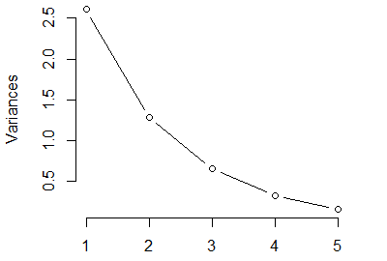
S2 Figure Screeplot of maternal post-supplementation during prengancy PCA.

