Supporting Information for:
Low Voltage Operating 2D MoS₂ Ferroelectric Memory Transistor with Hf_{1-x}Zr_{x}O₂ Gate Structure
Siqing Zhang¹, Yan Liu^{1,}*, Jiuren Zhou¹, Meng Ma¹, Anyuan Gao², Binjie Zheng², Lingfei Li², Xin Su², Genquan Han¹, Jincheng Zhang¹, Yi Shi², Xiaomu Wang^{2,}*, and Yue Hao¹
¹Wide Bandgap Semiconductor Technology Disciplines State Key Laboratory, School of Microelectronics, Xidian University, Xi’an 710071, China
²School of Electronic Science and Engineering, Nanjing University, Nanjing, Jiangsu, 210023, China
* Corresponding authors.
E-mail addresses: xdliuyan@xidian.edu.cn (Y Liu), xiaomu.wang@nju.edu.cn (X Wang).

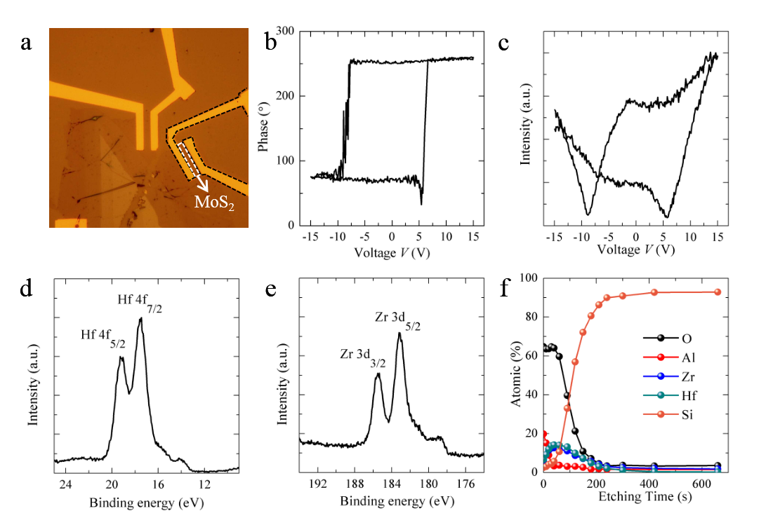
Fig. S1 a Optical image of the MoS₂/HZO FeFET. b PRphase and c PRampl of the HZO capacitor. XPS analysis of the 2 nm Al₂O₃/6 nm HZO/p⁺ Si shows pristine d Hf and e Zr peaks. f XPS depth profile of the Al₂O₃/HZO/p⁺ Si tri-layer structure.
A top-view optic image of the HZO/MoS₂ FeFET is shown in Fig. S1a. As shown in Fig. S1b and c, PRphase and PRampl of the HZO capacitor suggest ferroelectric behavior after 450 ℃ rapid thermal annealing (RTA) measured at 1kHz. As shown in Fig. S1d and e, the elemental and bond composition of HZO were examined by the X-ray photoelectron (XPS) measurements. Peaks are found to be 19.05 eV, 17.6 eV, 185.5 eV, and 183.2 eV, which correspond to the Hf 4f _{5/2}, Hf 4f _{7/2}, Zr 3d _{3/2} and Zr 3d _{5/2}, respectively [27]. The atomic concentration along the depth profile in Fig. S1f further confirms the distribution of the Al₂O₃/HZO/p⁺ Si tri-layer structure. All the above confirm that the HZO film grown via our ALD system is highly crystalline.
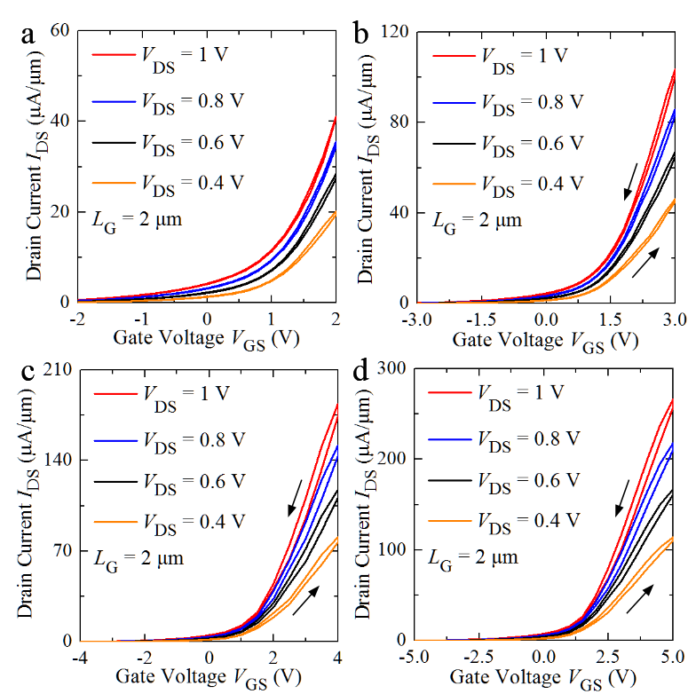
Fig. S2 Transfer curves of the HZO/MoS₂ FeFET at increasing gate voltage (V_{GS}) ranges with the linear y-axis.
For a start, the transfer curves of the HZO/MoS₂ FeFET under different back gate voltage sweep ranges (V_{GS,range}) and different drain voltages (V_{DS}) have been characterized in Fig. S2. It is demonstrated that, the counterclockwise hysteresis windows have been obtained at various gate voltage range (V_{GS,range}) from (-5, 5V) to (-2, 2V). Simply, the mechanism underlying the hysteretic behaviors shown in the transfer curves during the bi-direction sweeping of V_{GS} is threshold voltage shift, which can be modified by the effects of trapping/de-trapping [29] and polarization switching [30]. If the applied voltage is not high enough to switch the polarization in HZO film, charge trapping/de-trapping mechanism dominates and will cause clockwise hysteresis. The energy band at the interface between the MoS₂ channel and ferroelectric back gate tends to bend downward after the positive back gate voltage. The more traps located below the Fermi-level; the more electrons are captured close to the interface. This will increase the threshold voltage after the positive gate pulse. The energy band at the interface between the MoS₂ channel and ferroelectric back gate tends to bend upward after the negative back gate voltage. The more traps locate above the Fermi-level; the more electrons are released close to the interface. This will decrease the threshold voltage after the negative gate pulse [29]. If the applied voltage exceeds the coercive voltage in the HZO film, ferroelectric polarization mechanism dominates and will cause anti-clockwise hysteresis window [31-34]. Thus, it is easily concluded that the electrical performance of the device shown in Fig. S2 is dominated by ferroelectric switching. When the back-gate sweeps are in small ranges of 2V in Fig. S2a, we observed the nearly hysteresis-free switching. The hysteresis loops in Fig. S2b are counterclockwise for the back-gate sweep range of 6 V (from -3 V to 3 V). The minimum voltage under the drain is V_{GS} – V_{DS} = 2 V at V_{DS} = 1 V, which should be larger than the coercive voltage V_{c} to switch the ferroelectric at the drain side. The estimated coercive voltage is consistent with V_{c} of 1.9 V when the maximum sweeping voltage is 3 V in Fig. 2a. When the applied voltage in HZO film exceeds +V_{c}, the ferroelectric polarization points into the MoS₂ channel. Therefore, the electron charges in the MoS₂ channel accumulate and the threshold voltage decreases. When the applied voltage in HZO film exceeds –V_{c}, the ferroelectric polarization points away from the MoS₂ channel. Therefore, the electron charges in the MoS₂ channel deplete and the threshold voltage increases. Nonetheless, we observed that the wider back-gate voltage range leads to larger counterclockwise hysteresis loops in Fig. S2c and d. Due to the increment of V_{c} in Fig. 2a with increasing applied voltage, the ferroelectric polarization switching in the HZO film can be enhanced with a larger shift in threshold voltage.
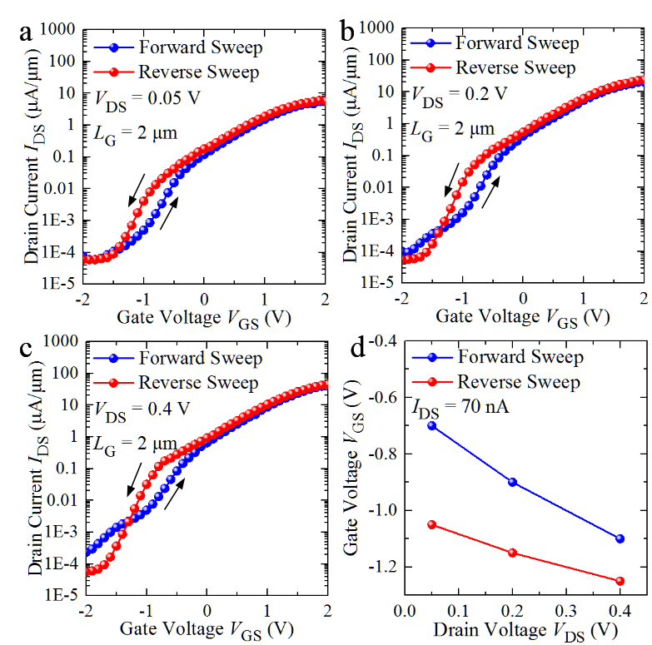
Fig. S3 Transfer curves of the HZO/MoS₂ FeFET on logarithmic scales with a V_{DS} = 0.05 V, b V_{DS} = 0.2 V, c V_{DS} = 0.4 V. d Extracted back gate voltage V_{GS} when drain current (I_{DS}) equals to 70 nA with different V_{DS}.
Notably, besides the impact of V_{GS,range}, it is found that V_{DS} can definitely adjust the memory window as well, which requires a further investigation. The I_{DS}-V_{GS} curves on logarithmic scales under different V_{DS} are characterized in Fig. S3. It is exhibited that, at a fixed V_{GS,range} = (-2, 2 V), the values of V_{GS} extracted at I_{DS} = 70 nA for the bi-directional sweeping of V_{GS} all shift towards the negative direction and the variation in forward sweeping of V_{GS} is much more obvious over that of reverse sweeping, indicating the significant phenomena of negative drain induced barrier lowering (DIBL) [36-40]. Generally, DIBL is a conventional short channel effect. With a short enough channel length, the increased V_{DS} can easily pull down the barrier between source/drain and enable a negative shift of threshold voltage, which is the so called effect of DIBL. However, for a ferroelectric FeFET, an increased V_{DS} is capable of producing a reduction of channel surface potential via the coupling between gate and drain induced by the parasitic capacitance between gate and drain (CGD), which means a positive shift of threshold voltage and can be called as negative DIBL.

