Supplementary Material

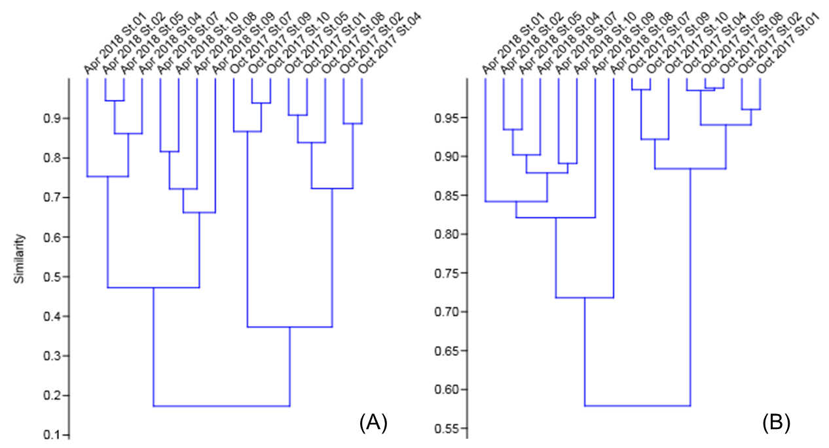
Supplementary Figure 1. Bray–Curtis similarity estimated by hierarchical cluster analysis with regard to zooplankton abundance (A) and the relative contribution (B) of each sampling station.

Supplementary Table 1. Total abundance, biomass, and ecological parameters for zooplankton collected in Oct 2017 and Apr 2018.
Oct 2017
 | St.01 | St.02 | St.04 | St.05 | St.07 | St.08 | St.09 | St.10
Number of taxon | 8 | 7 | 7 | 9 | 9 | 8 | 8 | 9
Total abundance (ind/m³) | 2249.82 | 3591.21 | 2859.64 | 1875.54 | 593.45 | 1486.29 | 450.49 | 503.63
Total biomass (wet mg/m³) | 78.17 | 79.46 | 39.98 | 84.25 | 33.17 | 36.15 | 23.69 | 21.94
Dominance | 0.72 | 0.78 | 0.86 | 0.83 | 0.66 | 0.84 | 0.66 | 0.57
Diversity | 0.62 | 0.52 | 0.35 | 0.42 | 0.75 | 0.39 | 0.73 | 0.88
Evenness | 0.23 | 0.24 | 0.20 | 0.17 | 0.24 | 0.18 | 0.26 | 0.27
Richness | 0.91 | 0.73 | 0.75 | 1.06 | 1.26 | 0.96 | 1.15 | 1.29
Apr 2018
 | St.01 | St.02 | St.04 | St.05 | St.07 | St.08 | St.09 | St.10
Number of taxon | 11 | 8 | 7 | 9 | 10 | 8 | 9 | 8
Total abundance (ind/m³) | 250.55 | 168.17 | 140.38 | 176.99 | 64.48 | 52.07 | 37.73 | 87.37
Total biomass (wet mg/m³) | 71.81 | 42.28 | 43.87 | 18.93 | 19.08 | 55.24 | 30.07 | 51.35
Dominance | 0.30 | 0.31 | 0.32 | 0.28 | 0.25 | 0.19 | 0.30 | 0.29
Diversity | 1.48 | 1.40 | 1.43 | 1.53 | 1.67 | 1.78 | 1.60 | 1.54
Evenness | 0.40 | 0.51 | 0.59 | 0.52 | 0.53 | 0.74 | 0.55 | 0.58
Richness | 1.82 | 1.38 | 1.22 | 1.55 | 2.21 | 1.81 | 2.25 | 1.58

Supplementary Table 2. Results of permutation test (p value) regarding with the zooplankton diversity among sampling stations. Significant difference between stations (p<0.05) was expressed as bold letter.

Oct 2017
 | St.01 | St.02 | St.04 | St.05 | St.07 | St.08 | St.09 | St.10
St.01 |  | 0.0014 | 0.0001 | 0.0001 | 0.0077 | 0.0001 | 0.0593 | 0.0001
St.02 |  |  | 0.0001 | 0.0002 | 0.0001 | 0.0001 | 0.0004 | 0.0001
St.04 |  |  |  | 0.0273 | 0.0001 | 0.2510 | 0.0001 | 0.0001
St.05 |  |  |  |  | 0.0001 | 0.4478 | 0.0001 | 0.0001
St.07 |  |  |  |  |  | 0.0001 | 0.6953 | 0.0515
St.08 |  |  |  |  |  |  | 0.0001 | 0.0001
St.09 |  |  |  |  |  |  |  | 0.0246
St.10
Apr 2018
 | St.01 | St.02 | St.04 | St.05 | St.07 | St.08 | St.09 | St.10
St.01 |  | 0.4190 | 0.5739 | 0.5776 | 0.1007 | 0.0306 | 0.4476 | 0.5380
St.02 |  |  | 0.8625 | 0.1917 | 0.0338 | 0.0056 | 0.2492 | 0.2247
St.04 |  |  |  | 0.3045 | 0.0558 | 0.0152 | 0.3184 | 0.3325
St.05 |  |  |  |  | 0.1941 | 0.0572 | 0.6165 | 0.8384
St.07 |  |  |  |  |  | 0.5252 | 0.7054 | 0.3387
St.08 |  |  |  |  |  |  | 0.2933 | 0.0642
St.09 |  |  |  |  |  |  |  | 0.7201
St.10

Supplementary Table 3. The δ¹⁵N of amino acids in frozen and preserved samples (Paratya spp.). We tested 10% formalin, 70% ethanol, and DESS-martin solution for preserved samples. DESS-martin fixed samples were purified by cation-exchange chromatography before derivatization. Formalin (r²=0.989), ethanol (r²=0.995), and DESS-martin (purified, r²=0.992) fixed samples showed good regression between frozen sample (control).

 |  | Ala | Gly | Val | Pro | Ser | Glu | Phe
Frozen | Control | 17.1 | 4.3 | 15.7 | 14.5 | 3.8 | 17.9 | 4.9
Preserved for a week | Formalin | 17.9 | 4.4 | 16.6 | 14.8 | 3.0 | 17.0 | 5.1
 | Ethanol | 17.8 | 5.2 | 16.3 | 15.0 | 4.4 | 18.4 | 5.6
 | DESS-martin | 17.1 | 4.7 | 15.8 | 15.2 | 3.5 | 18.1 | 4.9
Preserved for two months | Formalin | 16.7 | 3.9 | 15.1 | 14.4 | 3.2 | 17.2 | 5.4
 | Ethanol | 16.5 | 4.7 | 16.2 | 14.4 | 3.6 | 17.5 | 5.1
 | DESS-martin | 17.1 | 5.2 | 15.5 | 14.5 | 3.7 | 18.5 | 4.3

Supplementary Table 4. The offset of δ¹⁵N_{AAs} values between frozen and preserved samples (Paratya spp.).

 |  | δ¹⁵N_{AAs_Preserved}- δ¹⁵N_{AAs_control}
 |  | Ala | Gly | Val | Pro | Ser | Glu | Phe
Preserved for a week | Formalin | 0.8 | 0.2 | 0.9 | 0.3 | -0.8 | -0.9 | 0.2
 | Ethanol | 0.7 | 0.9 | 0.6 | 0.5 | 0.6 | 0.4 | 0.6
 | DESS-martin | 0.0 | 0.5 | 0.1 | 0.7 | -0.3 | 0.2 | 0.0
Preserved for two months | Formalin | -0.4 | -0.3 | -0.5 | -0.1 | -0.6 | -0.8 | 0.5
 | Ethanol | -0.6 | 0.5 | 0.5 | -0.1 | -0.2 | -0.4 | 0.2
 | DESS-martin | 0.0 | 0.9 | -0.2 | 0.0 | -0.1 | 0.6 | -0.6

