Supplementary Material

Supplementary Figures and Tables

Supplementary Figures
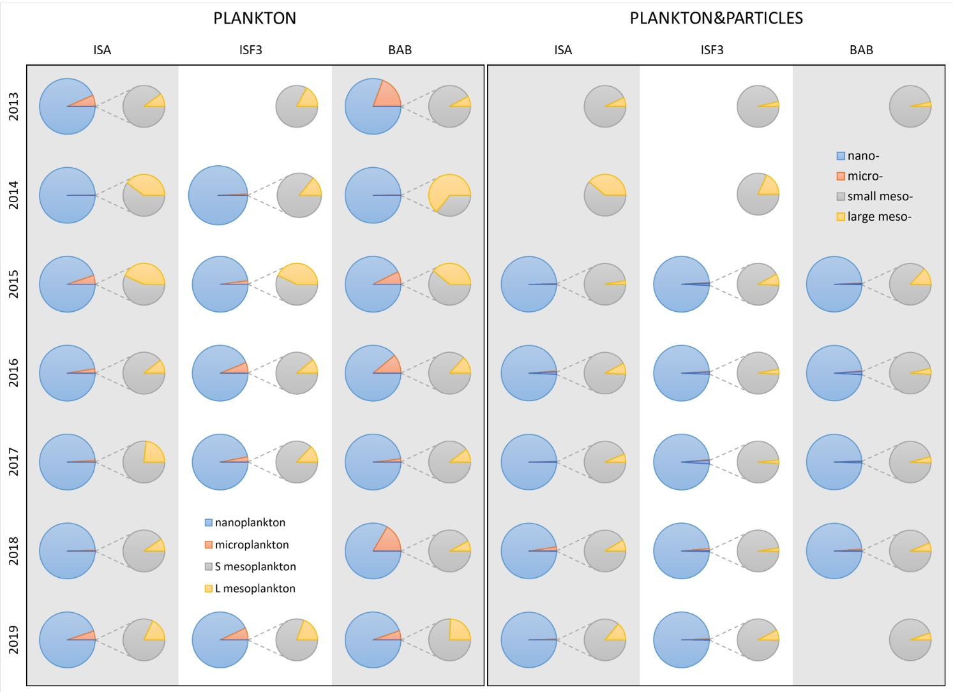
Supplementary Figure 1. Relative roles of different plankton (left panel) and P&P (right panel) size fractions in the total abundance (individuals·m⁻³ and counts·m⁻³, respectively) at 3 Isfjorden stations: ISA, ISF3 and BAB in 7 consecutive mid-summers (2013-2019).
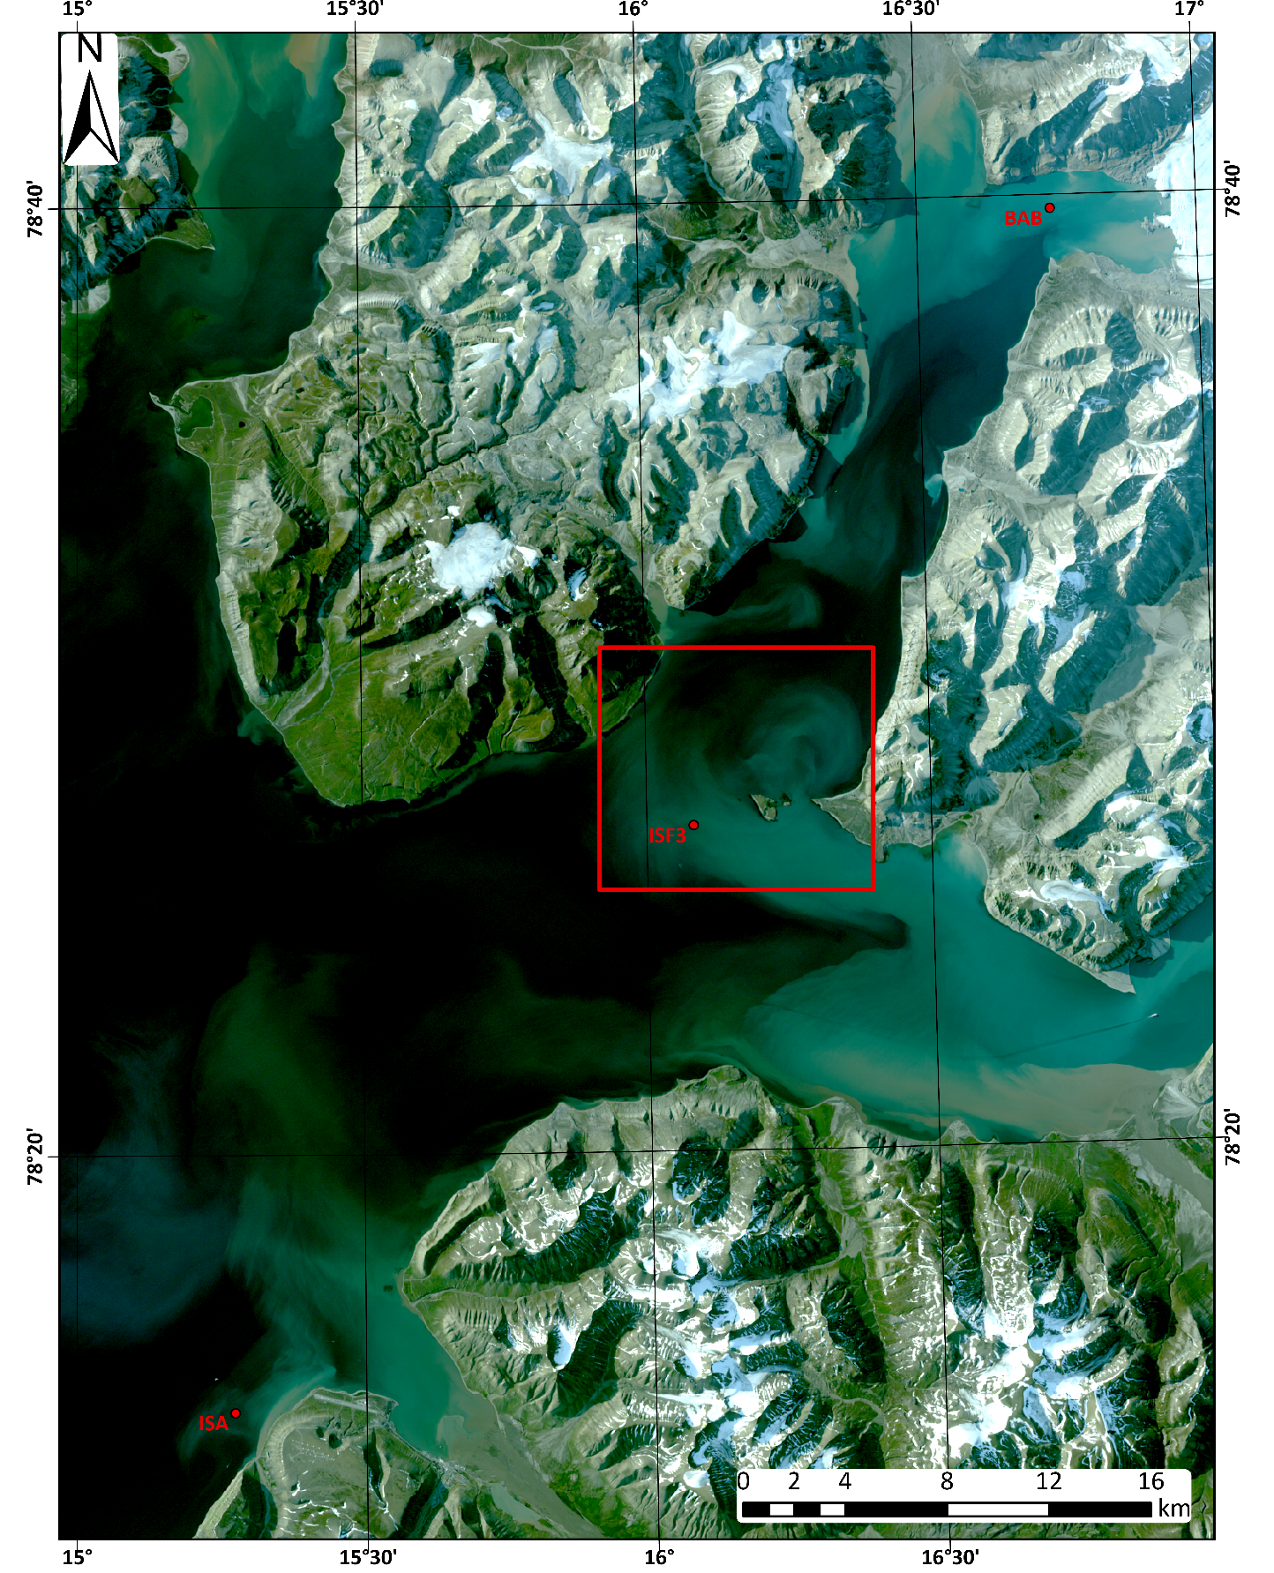
Supplementary Figure 2. Study area in Isfjorden. Red rectangle indicates an ISF station area with frequent eddy activity; Image: Landsat8 natural color composite, data source: glovis.usgs.gov/app LC08_L1TP_027240_20190731_20190819_01_T2, spectral bands: 4-3-2 (R30m); generated in ArcGIS Pro 2.5.

