Supplementary Material

Supplementary Figures and Tables
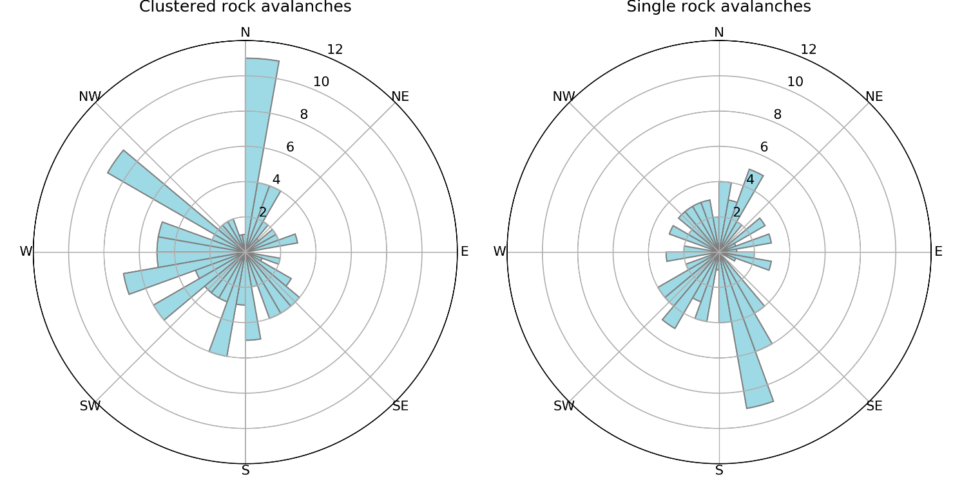
Figure S1. Distribution of slope aspects from headscarp points of A) clustered and B) single rock avalanches that occurred during the period 1984-2019 in the Saint Elias study area.
Table S1. Dates of Landsat imagery used to conduct systematic searches for rock avalanches in the Saint Elias study area. P61 and P63 are path and row nomenclature for Landsat, each of which only cover half of the study area.
Year | Early summer image | Late summer image
1984 | none available | 7/28 (P61) and 9/12 (P63)
1985 | 6/29 | 7/15 (P61 only)
1986 | 6/16 (P61) and 6/30 (P63) | 9/11
1987 | 7/5 (P61 only) | 8/29
1988 | 6/5 (P61 only) | 6/27 (P63) and 9/9 (P61)
1989 | 6/8 (P61 only) | 8/27 (P61 only)
1990 | 5/26 (P61 only) | 8/12 (P63) and 8/14 (P61)
1991 | 6/14 (P61 only) | 6/21 (P62) and 7/14 (P63)
1992 | 5/22 | 8/10
1993 | 5/25 | 7/12 (P62) and 9/5 (P63)
1994 | 6/13 | 8/16
1995 | 6/9 (P61 only) | 9/4
1996 | 6/2 | 9/6
1997 | 5/20 | 6/30 (P61) and 9/16 (P63)
1998 | 6/24 | 7/1 (P63) and 8/4 (P61)
1999 | 6/4 (P61 only) | 8/30
2000 | 6/5 | 9/9
2001 | 6/8 | 8/11
2002 | 5/26 | 8/14
2003 | 5/20 (P63 only) | 8/9
2004 | 5/31 | 8/3
2005 | 6/11 | 8/14
2006 | 6/14 | 8/1 (P62) and 8/8 (P63)
2007 | 6/10 (P61 only) | 8/28
2008 | 5/25 (P63) and 5/27 (P61) | 8/30
2009 | 6/6 | 8/2 (P61) and 8/8 (P63)
2010 | 6/9 | 9/13
2011 | 5/27 | 8/6 (P63) and 8/16 (P61)
2012 | 6/6 | 7/17 (P61) and 7/31 (P63)
2013 | 6/17 | 8/11 (P63) and 8/13 (P61)
2014 | 6/4 | 8/23
2015 | 6/23 | 8/3 (P61) and 9/2 (P63)
2016 | 6/9 | 8/28
2017 | 5/27 | 8/15
2018 | 6/6 (P63) and 6/8 (P61) | 9/3
2019 | 6/9 (P63) and 6/27 (P61) | 9/6

Table S2. Attribute data for 220 rock avalanches that occurred in the Saint Elias Mountains of southeast Alaska during the period 1984-2019. (Excel file attached).

Table S3. Possible earthquake events that could have triggered rock avalanches that occurred in 1983/1984 (RA 1) and 1987/1988 (RA 16 and RA 17) in the Saint Elias Mountains.
RA | Date | Location | Magnitude | Distance from rock avalanche headscarp | Reference
1 | 6/28/1983 | 60.219, -141.287 | 5.9 | 82 km | [1]
16 | 11/17/1987 | 58.586, -143.27 | 6.9 | 243 km | [2]
 | 11/30/1987 | 58.679, -142.786 | 7.9 | 217 km | [3]
 | 3/6/1988 | 56.953, -143.032 | 7.8 | 394 km | [4]
17 | 11/17/1987 | 58.586, -143.27 | 6.9 | 225 km | [2]
 | 11/30/1987 | 58.679, -142.786 | 7.9 | 201 km | [3]
 | 3/6/1988 | 56.953, -143.032 | 7.8 | 384 km | [4]
Earthquake data are from: [1] https://earthquake.usgs.gov/earthquakes/eventpage/usp0001weg,
[2] https://earthquake.usgs.gov/earthquakes/eventpage/usp0003a6c,
[3] https://earthquake.usgs.gov/earthquakes/eventpage/usp0003aq8/executive
[4] https://earthquake.usgs.gov/earthquakes/eventpage/usp0003dnb/executive

Table S4. Distances and rates of down glacier movement of RA 33 in subsequent years after deposition on Lucia Glacier in 1992.
Year | Total distance moved down glacier (meters) | Average movement rate (meters/year)
1994 | 500 | 250
1995 | 630 | 130
1997 | 1030 | 200
1998 | 1140 | 110
1999 | 1250 | 110
2000 | 1365 | 115
2003 | 1805 | 147
2008 | 2325 | 104
2013 | 2755 | 86
2019 | 3145 | 65
1994 | 500 | 250

Table S5: Rock avalanches in Glacier Bay National Park and Preserve, Alaska that occurred during 2017-2019. These events extend previous inventory data presented in Bessette-Kirton and Coe (2016) and Coe et al. (2018).
Year | Latitude of headscarp | Longitude of headscarp | Event date range | Area (km²)
2016/2017 | 58.6672 | -137.031398 | 10/1/16-6/23/17 | 0.38
2017 | 58.77739 | -136.9801513 | 6/23/17-8/10/17 | 0.96
2018 | 58.87916 | -137.5311436 | 4/7/18-4/27/18 | 2.90
2018 | 58.65409 | -137.088149 | 6/1/18-7/3/18 | 0.22
2019 | 58.77309 | -137.470608 | 5/12/19-6/13/19 | 0.30
2019 | 58.86264 | -136.9949318 | 5/12/19-6/13/19 | 0.17

