**Genomic insights of *Cryobacterium* isolated from ice core reveal genome dynamics for adaptation in glacier**

Yongqin Liu1, 2, 6\*, Liang Shen1, 5, Yonghui Zeng3, Tingting Xing1, 6, Baiqing Xu1, 2, Ninglian Wang2, 4

1Key Laboratory of Tibetan Environment Changes and Land Surface Processes, Institute of Tibetan Plateau Research, Chinese Academy of Sciences, Beijing, 100085, China

2CAS Center for Excellence in Tibetan Plateau Earth Sciences, Beijing, 100085, China

3Department of Environmental Science, Aarhus University, Roskilde 4000, Denmark

4College of Urban and Environmental Science, Northwest University, Xian, 710069, China

5College of Life Sciences, Anhui Normal University, Wuhu, 241000, China

6University of Chinese Academy of Sciences, Beijing 100101, China

\*Author for correspondence:

Yongqin Liu, yqliu@itpcas.ac.cn, Institute of Tibetan Plateau Research, Chinese Academy of Sciences, Beijing, 100101, China



Fig. S1 Phylogenetic clustering of 32 Microbacteriaceae strains. Phylogeny is based on 16S rRNA gene sequences with 1,000 bootstraps using MEGA10. *Rubrobacter xylanophilus* DSM9941 and *R. radiotolerans* RSPS-4 were used as out-groups. Bar 0.02 accumulated changes per nucleotide.

Fig. S2 Distribution of specific genes harbored by reference strains.

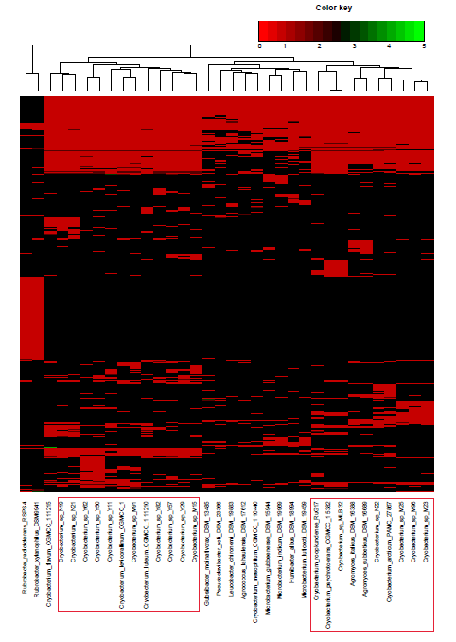

Fig. S3 Hierarchical clustering analysis representing the presence/absence of gene families from the category ‘cofactors/vitamin/prosthetic groups/pigmen’ based on the RAST annotations. Psychrophilic *Cryobacterium* were in red frame.