Supplementary Material

Supplementary Data

Supplementary Figures
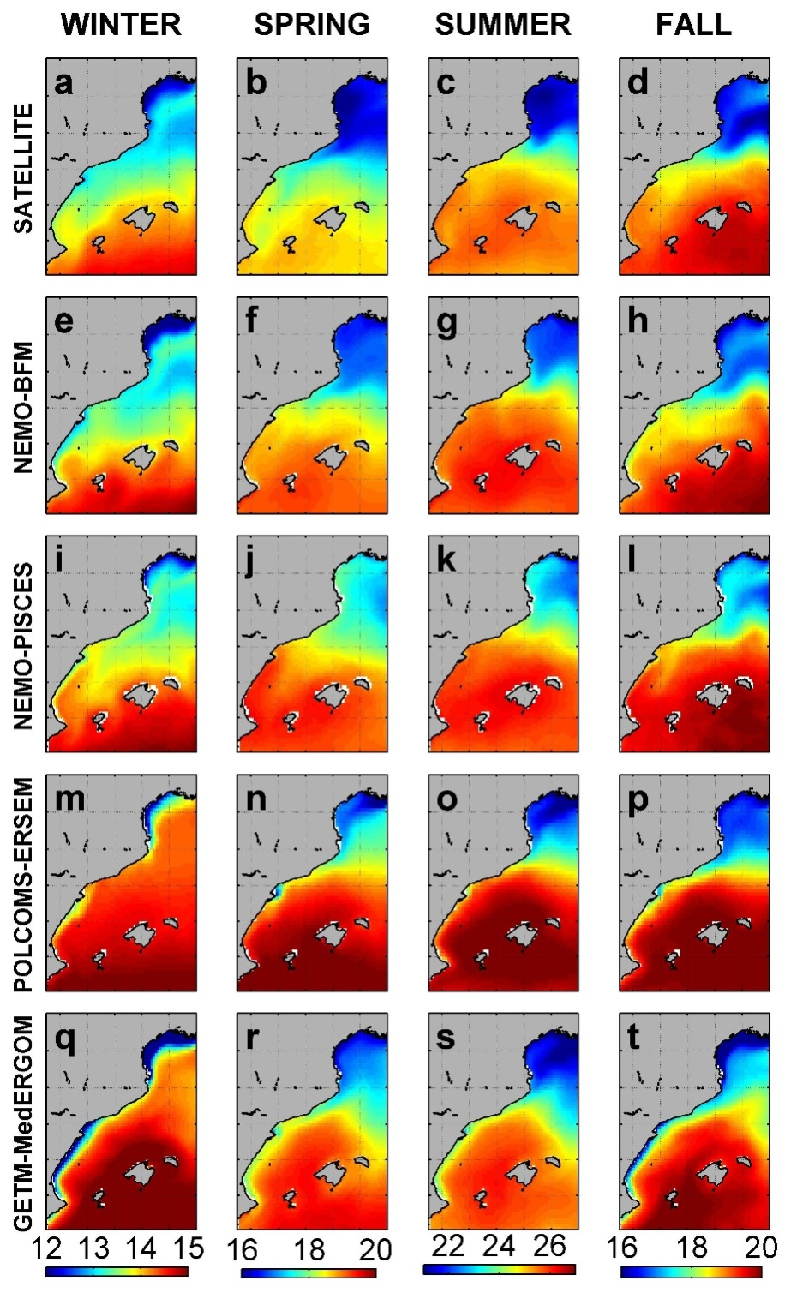
Supplementary Image1. Average seasonal sea surface temperature (ºC) from satellite and from the four runs.
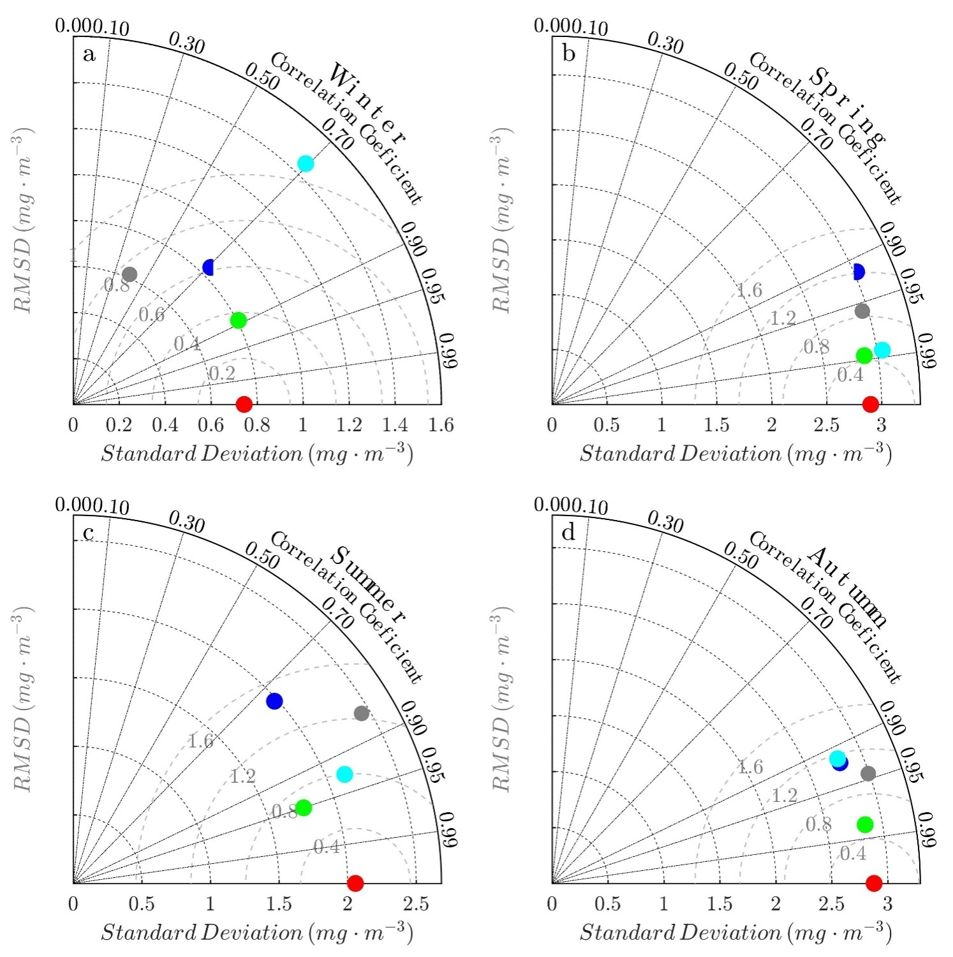
Supplementary Image2. Taylor diagram for the SST and different seasons. Red, satellite observations. Blue, NEMO-BFM; green, NEMO-PISCES; Grey, POLCOM-ERSEM; light blue, GETM-MedERGOM.

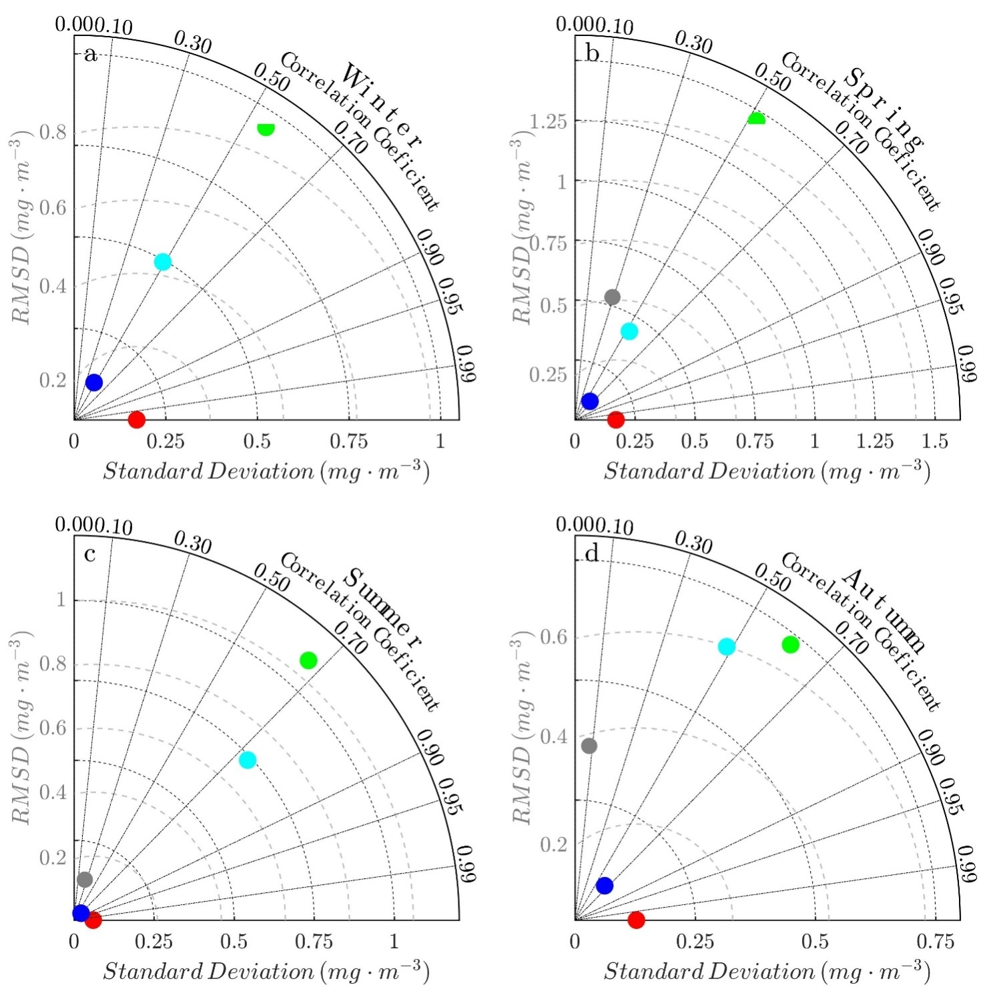
Supplementary Image3. Taylor diagrams for the surface chlorophyll-a and different seasons. Red, satellite observations. Blue, NEMO-BFM; green, NEMO-PISCES; Grey, POLCOM-ERSEM; light blue, GETM-MedERGOM.

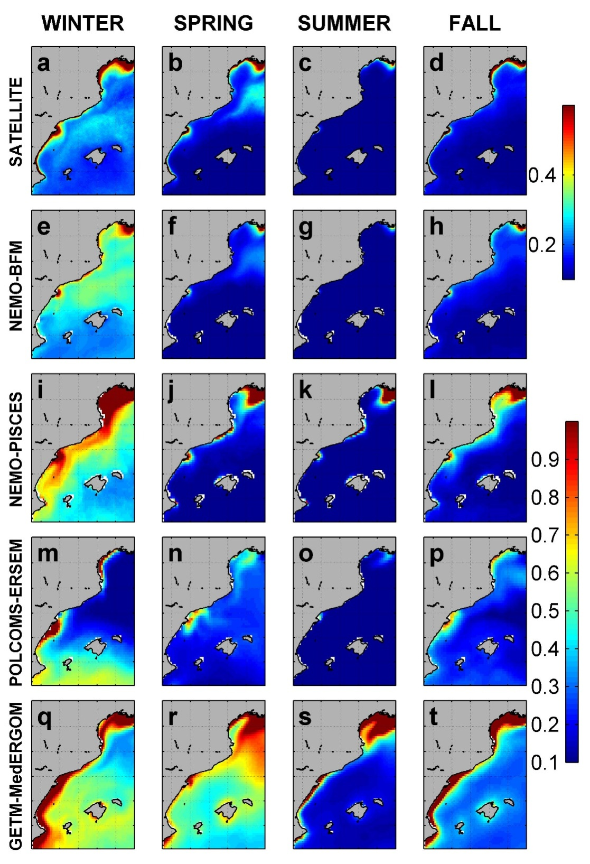
Supplementary Image4. Average seasonal surface chlorophyll (mg m⁻³) from satellite and from the four models.

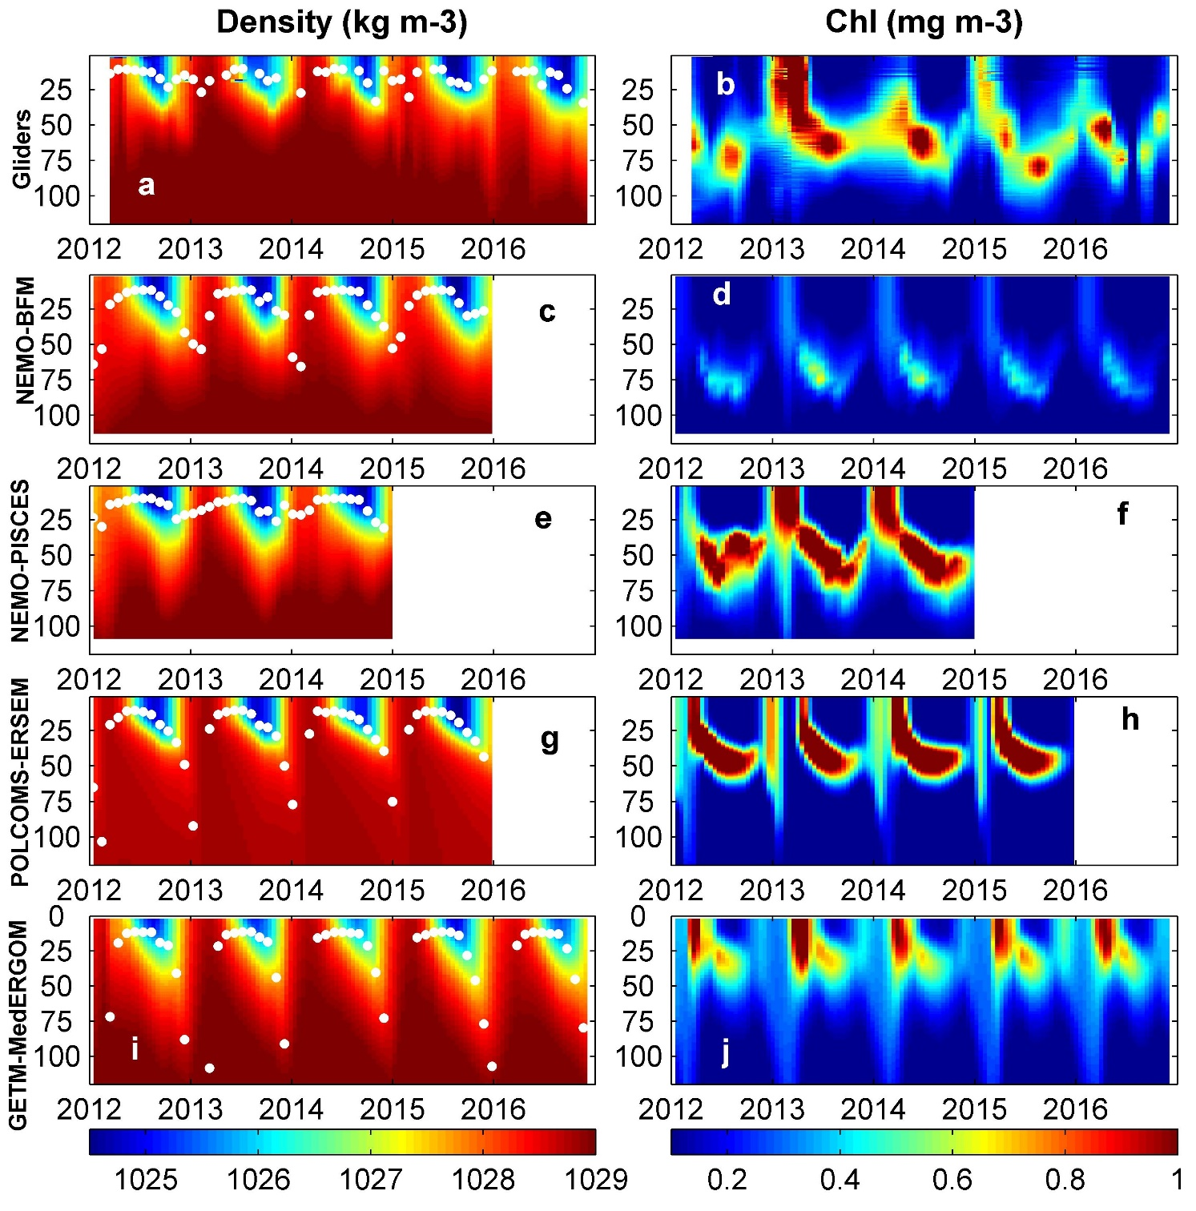
Supplementary Image5. z-t plots of simulated density and chlorophyll-a at Mallorca Channel from gliders and models. White dots are Mixed Layer Depth estimates. Vertical axes Depth (m)

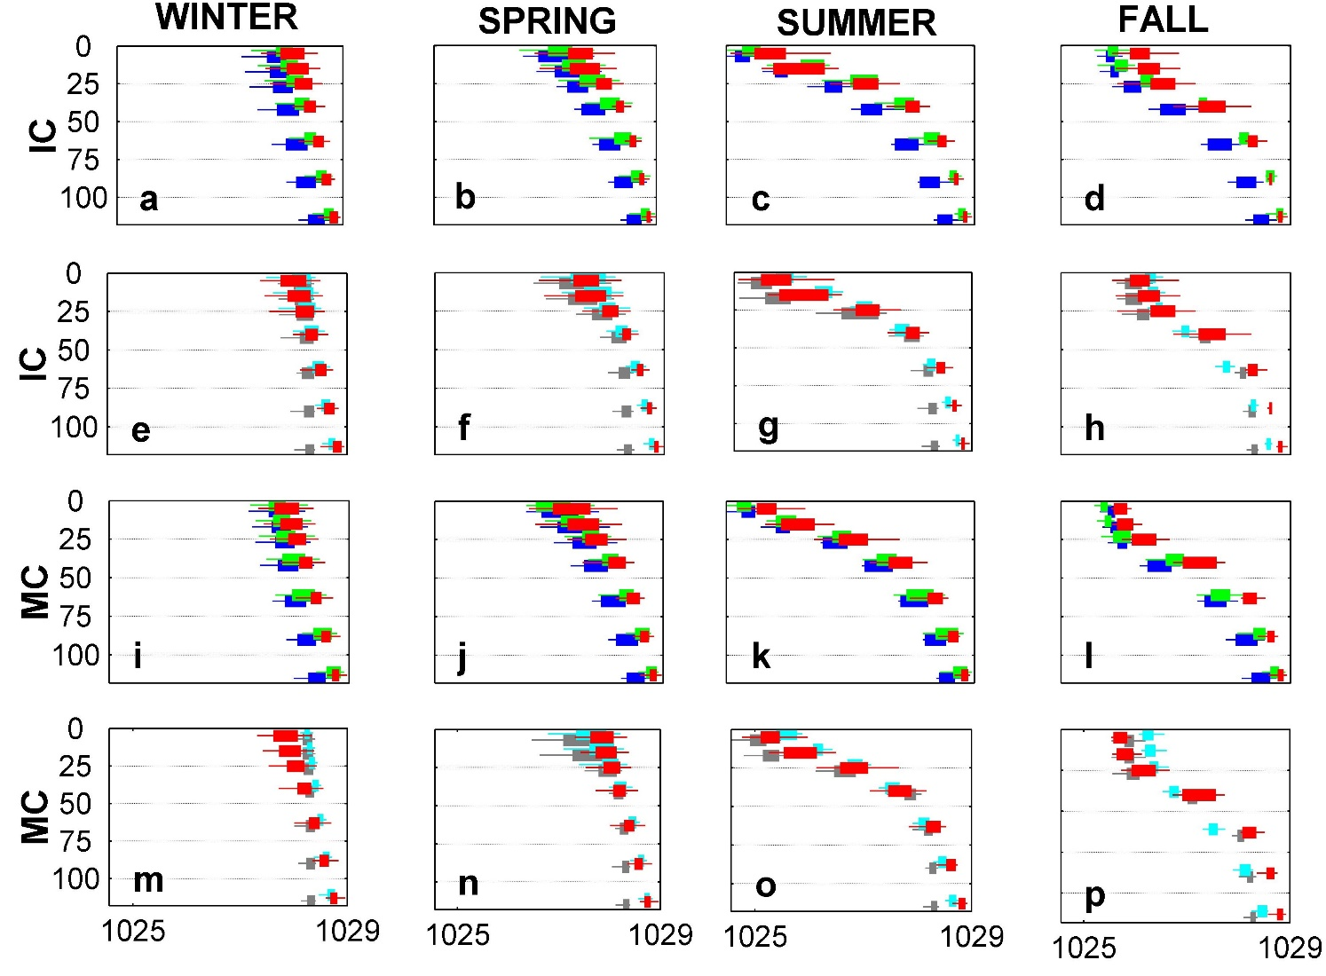
Supplementary Image6. Seasonal vertical profiles of density (Kg m⁻³) for both observations and model outputs. Vertical axes Depth (m). Boxplots represent 25 and 75th percentiles. When N<5, only dots are shown. Red, in situ data. Blue, NEMO-BFM; green, NEMO-PISCES; Grey, POLCOM-ERSEM; light blue, GETM-MedERGOM. IC, Ibiza Channel; MC, Mallorca Channel.

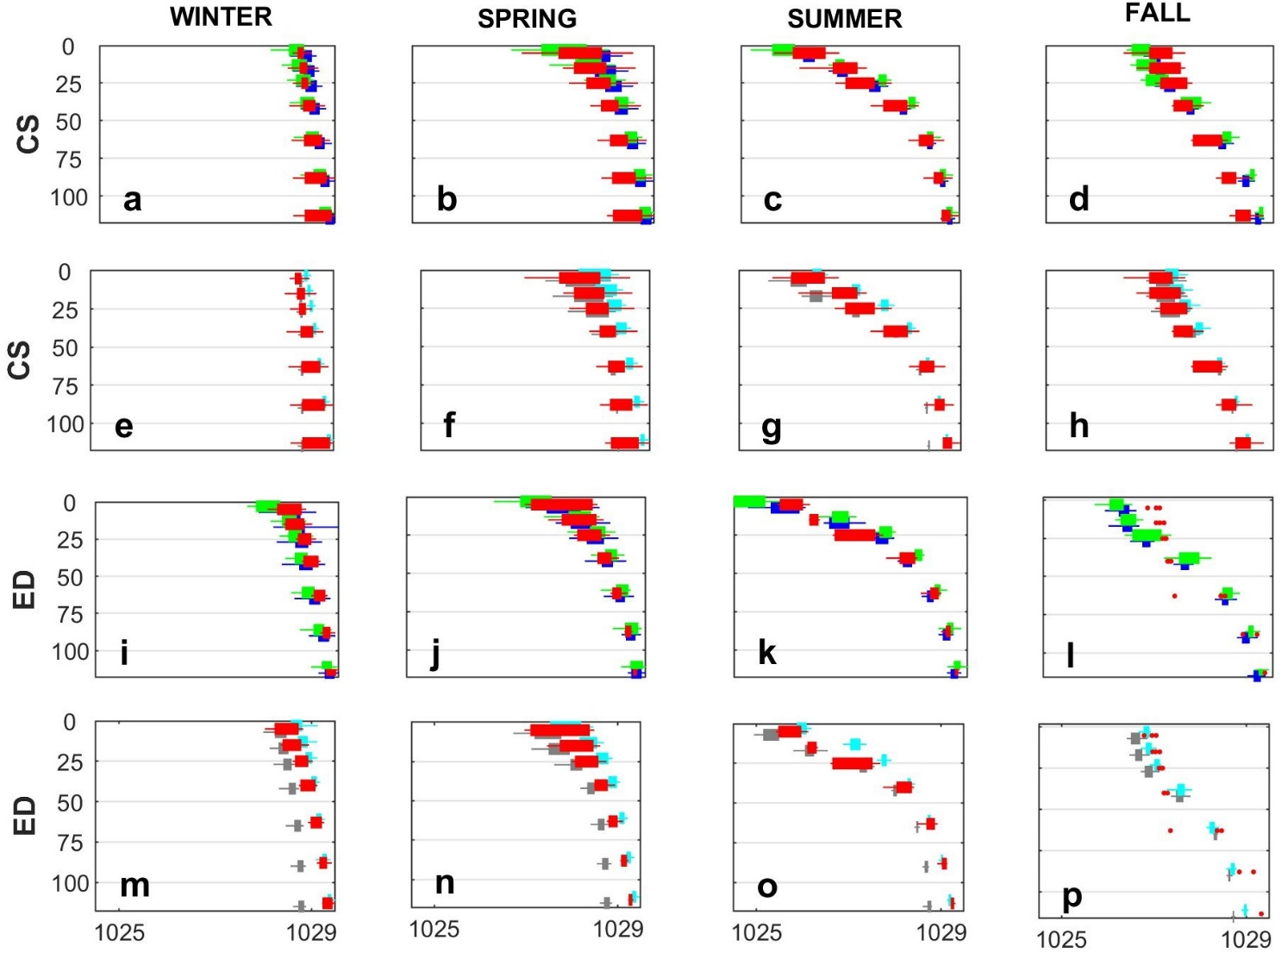
Supplementary Image7.Seasonal vertical profiles of density (Kg m⁻³) for both observations and model outputs. Vertical axes Depth (m). Boxplots represent 25 and 75th percentiles. When N<5, only dots are shown. Red, in situ data. Blue, NEMO-BFM; green, NEMO-PISCES; Grey, POLCOM-ERSEM; light blue, GETM-MedERGOM. CS, Catalan Shelf, ED, Ebro Delta.

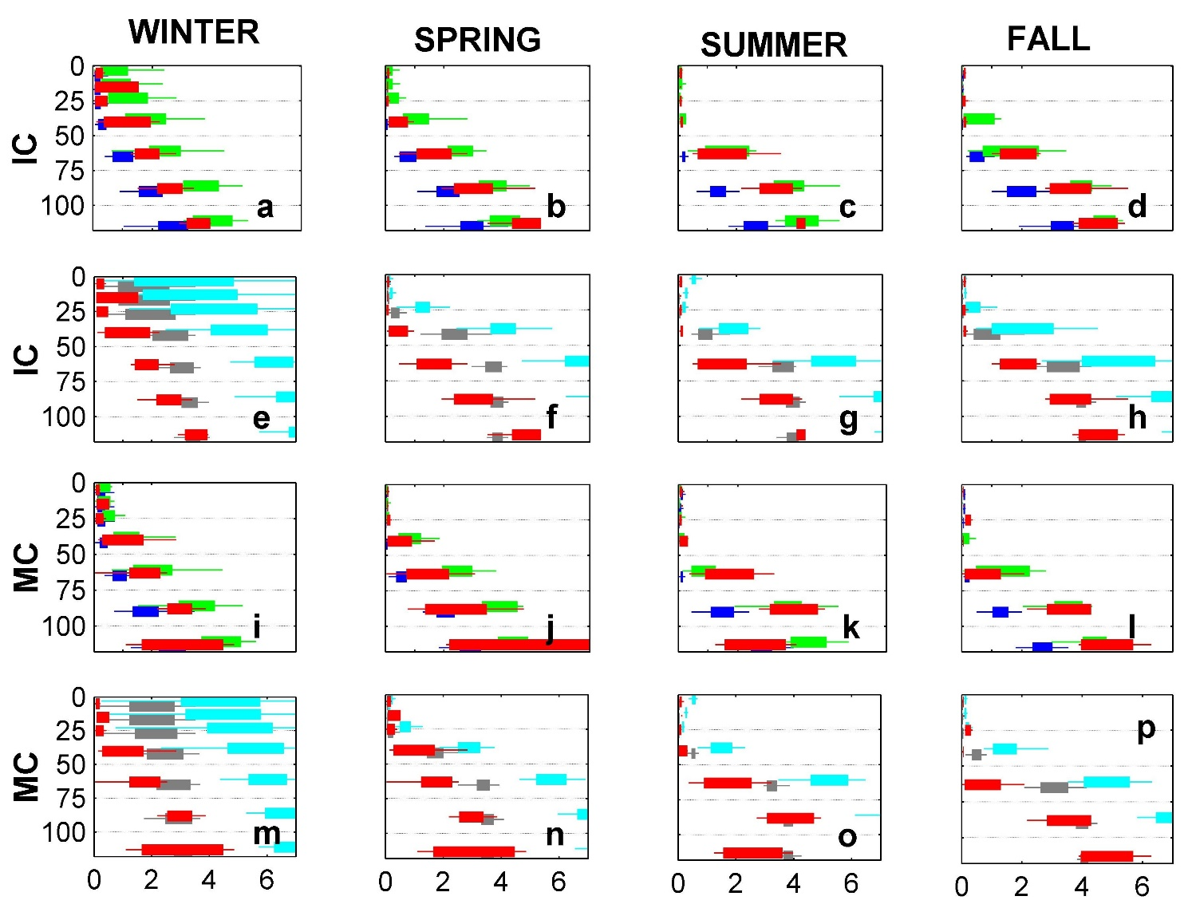
Supplementary Image8.Seasonal vertical profiles of nitrate (µM) for both data and model outputs. Vertical axes Depth (m). Boxplots represent 25 and 75th percentiles. When N<5, only dots are shown. Red, in situ data. Blue, NEMO-BFM; green, NEMO-PISCES; Grey, POLCOM-ERSEM; light blue, GETM-MedERGOM. IC, Ibiza Channel; MC, Mallorca Channel.
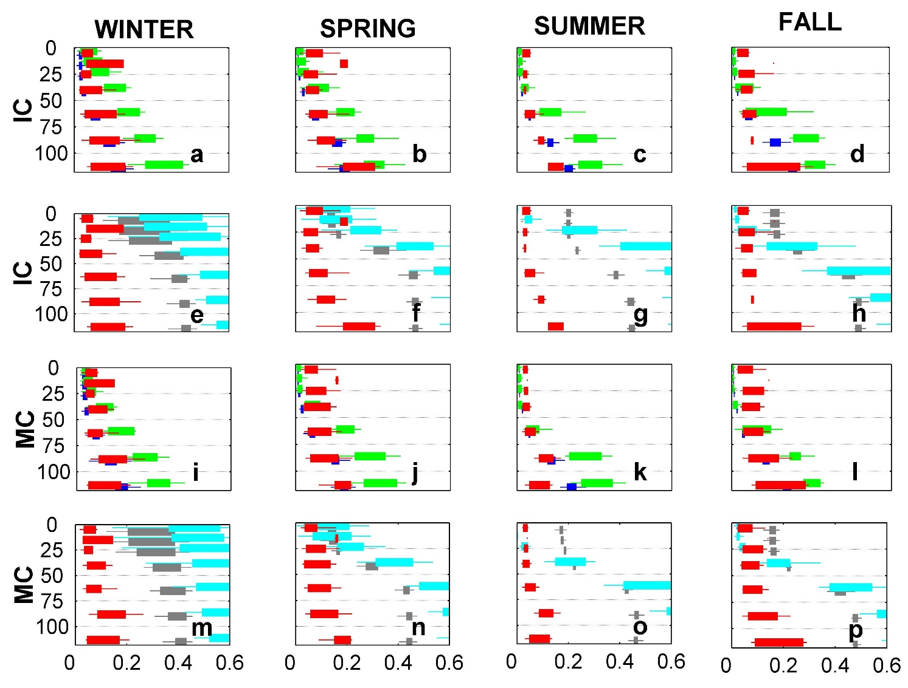
Supplementary Image9. Seasonal vertical profiles of phosphate (µM) for both data and model outputs. Vertical axes Depth (m). Boxplots represent 25 and 75th percentiles. When N<5, only dots are shown. Red, in situ data. Blue, NEMO-BFM; green, NEMO-PISCES; Grey, POLCOM-ERSEM; light blue, GETM-MedERGOM. IC, Ibiza Channel; MC, Mallorca Channel.

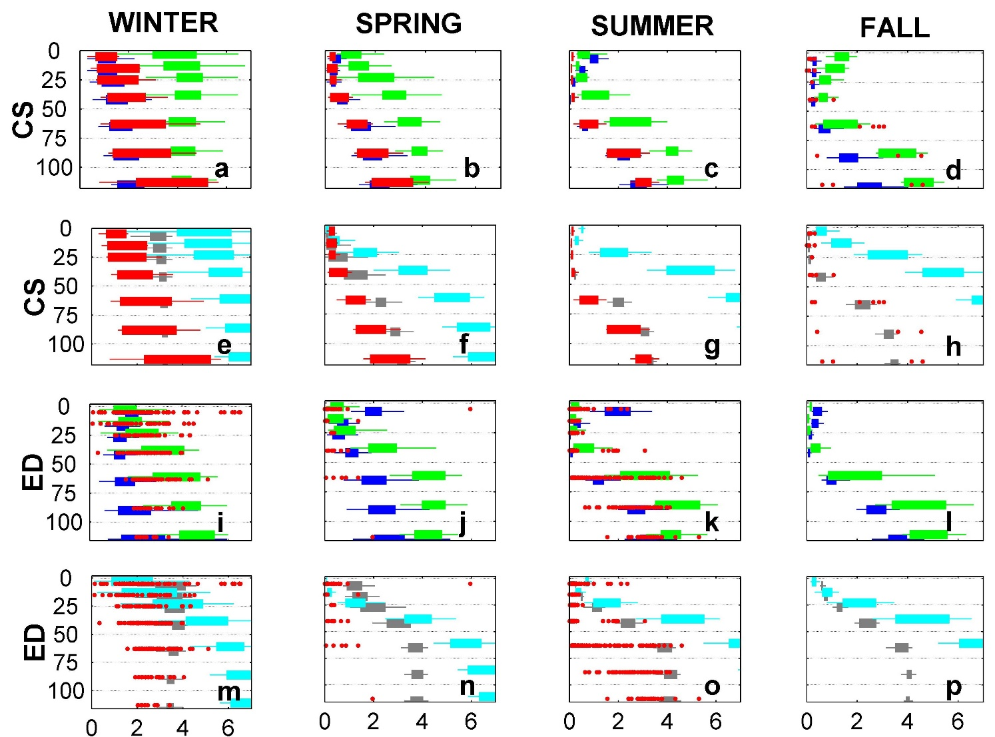
Supplementary Image10.Seasonal vertical profiles of nitrate (µM) for both data and model outputs. Vertical axes Depth (m) Boxplots represent 25 and 75th percentiles. When N<5, only dots are shown. Red, in situ data. Blue, NEMO-BFM; green, NEMO-PISCES; Grey, POLCOM-ERSEM; light blue, GETM-MedERGOM. CS, Catalan Shelf, ED, Ebro Delta.

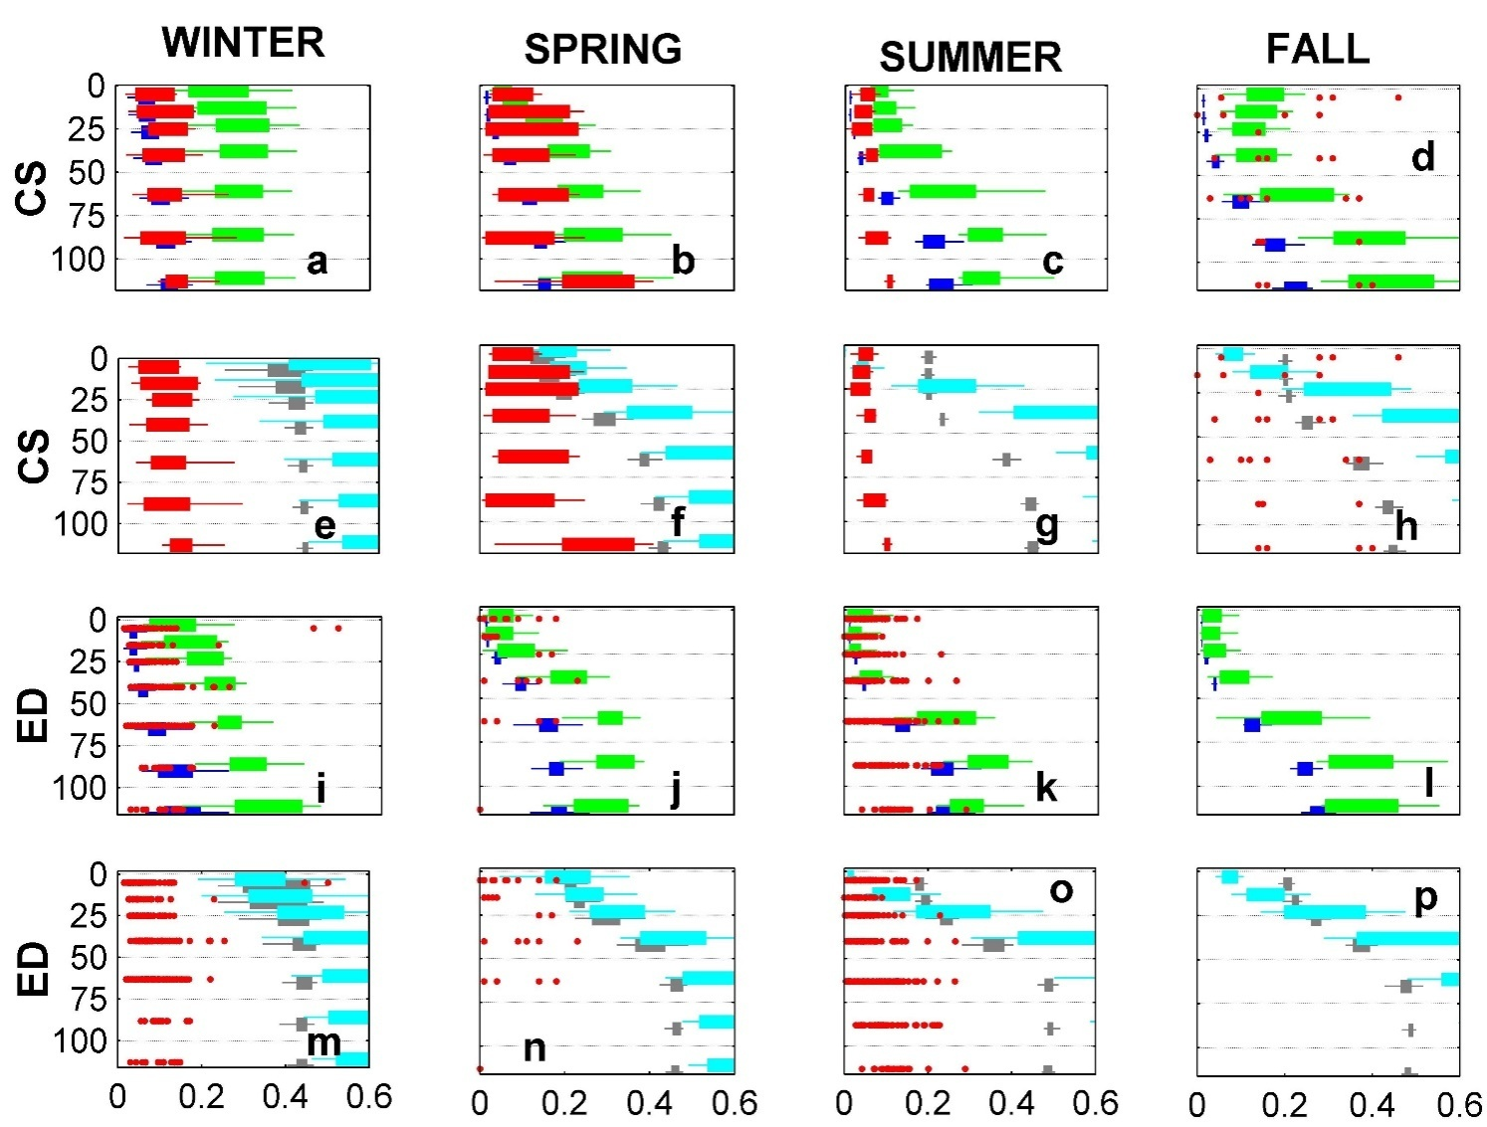
Supplementary Image11.Seasonal vertical profiles of phosphate (µM) for both data and model outputs. Vertical axes Depth (m). Boxplots represent 25 and 75th percentiles. When N<5, only dots are shown. Red, in situ data. Blue, NEMO-BFM; green, NEMO-PISCES; Grey, POLCOM-ERSEM; light blue, GETM-MedERGOM. CS, Catalan Shelf, ED, Ebro Delta.

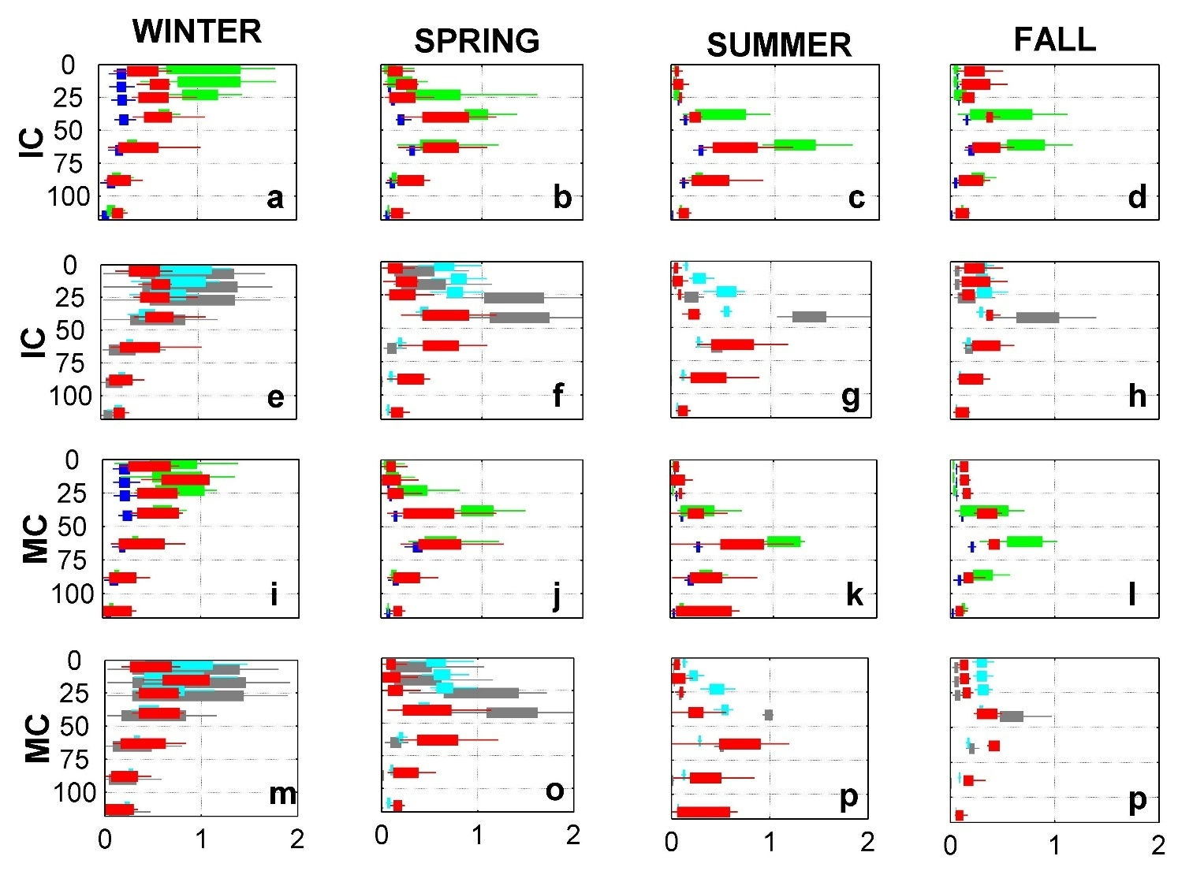
Supplementary Image12. Seasonal vertical profiles of chlorophyll-a (mg m⁻³) for both data and model outputs. Vertical axes Depth (m). Boxplots represent 25 and 75th percentiles. When N<5, only dots are shown. Red, in situ data. Blue, NEMO-BFM; green, NEMO-PISCES; Grey, POLCOM-ERSEM; light blue, GETM-MedERGOM. IC, Ibiza Channel; MC, Mallorca Channel.

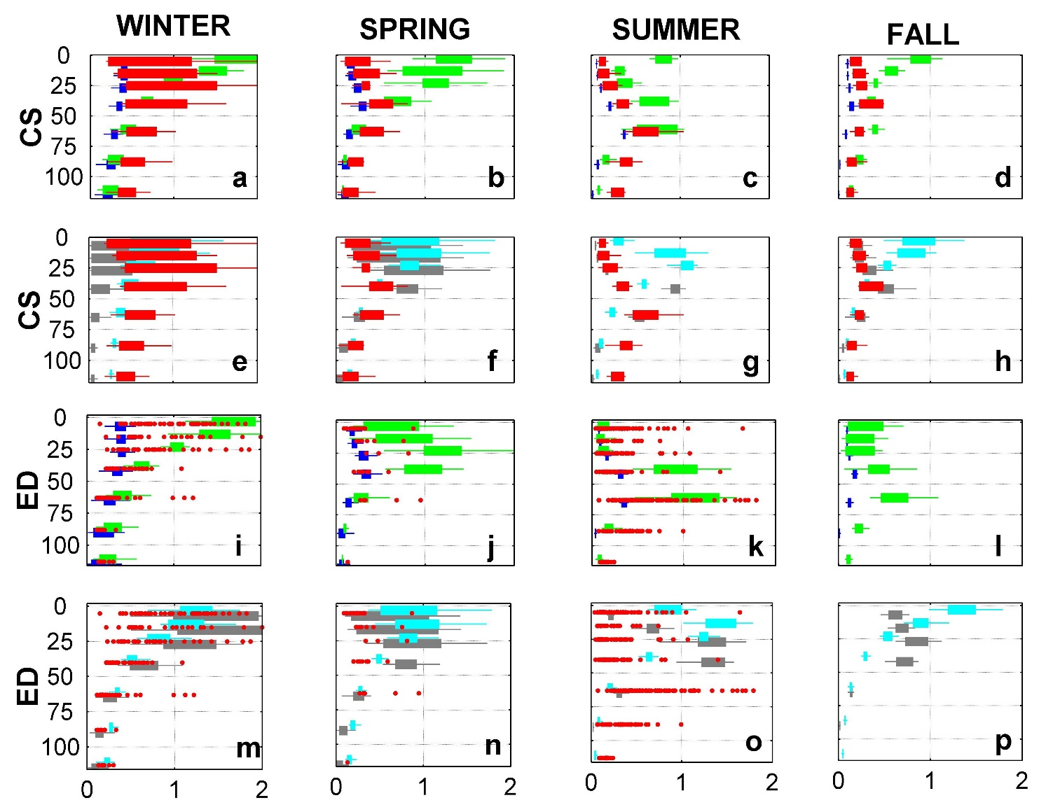
Supplementary Image 13. Seasonal vertical profile of chlorophyll a (mg m⁻³) for both data and model outputs. Vertical axes Depth (m). Boxplots represent 25 and 75th percentiles. When N<5, only dots are shown. Red, in situ data. Blue, NEMO-BFM; green, NEMO-PISCES; Grey, POLCOM-ERSEM; light blue, GETM-MedERGOM. CS, Catalan Shelf, ED, Ebro Delta.

Supplementary Tables
Table S1. Main characteristics of the physical and biogeochemical components of the reanalyses and hindcasts.
(a) Physical component
Reanalysis/ hindcast | NEMO-BFM | NEMO-PISCES | POLCOMS-ERSEM | GETM-MedERGOM
Physical model equations/ scheme and main reference | Nucleus for European Modelling of the Ocean. NEMO-OPA v3.2 and 3.4 (Simoncelli et al., 2014) | NEMO-v3.4  (Sotillo et al., 2015) | Proudman Oceanographic Laboratory Coastal Ocean Modelling System. POLCOMS (Holt and James, 2001; Kay et al., 2018) | General Estuarine Transport Model. (Macias et al., 2014b)
Domain | Mediterranean Sea | Ireland-Biscay-Iberia (IBI)-Mediterranean | IBI-Mediterranean | Mediterranean Sea
Horizontal Resolution. Vertical levels | 1/16º. 72 unevenly spaced vertical levels (Oddo et al., 2009) | 1/12º. 75 z-levels, geopotential vertical levels (z coordinate) | 1/10º . 40 sigma levels | 1/12º. 25 vertical sigma layers
Atmospheric forcing | 6-h ERA Interim ECMWF atmospheric data (Dee et al., 2011) | 3-h ERA Interim ECMWF atmospheric data | 6-h ERA Interim ECMWF atmospheric data | 6-h ERA Interim ECMWF atmospheric data
Rivers runoff dataset | monthly mean from CMAP (Xie and Arkin, 1997). Ebro, Nile and Rhone for which the Global Runoff Data Centre (Fekete et al., 2002) | Daily SMHI & PREVIMER & Monthly climatology (GRDC) | 2nd Global NEWS (Mayorga et al., 2010), with monthly variation based on Dai and Trenberth (2002) | Monthly Global River Data Center (GRDC, Germany)
Assimilation data and scheme | Satellite: SSH,SST.  in situ observations: temperature and salinity profiles. OCEANVAR scheme developed (Dobricic and Pinardi, 2008) | Satellite: SSH,SST.  in situ observations: temperature and salinity profiles SAM2 (Mercator Ocean assimilation system (Lellouche et al., 2013) | - | -

(b) Biogeochemical component
Reanalysis/ hindcast | NEMO-BFM | NEMO-PISCES | POLCOMS-ERSEM | GETM-MedERGOM
Biogeochemical model equations and parameterization | Biogeochemical Fluxes Model. (Vichi et al., 2007) | Pelagic Interactions Scheme for Carbon and Ecosystem Studies. (Aumont et al., 2015) | European Regional Seas Ecosystem Model v15.06. (Butenschön et al., 2016) | Mediterranean version of Ecological Regional Ocean Model  (Macias et al., 2019)
Validated run | CMEMS (Teruzzi et al., 2016) | CMEMS (IBI_REANALYSIS_BIO_005_003) (Sotillo et al., 2015) | CERES project hindcast. (Kay et al., 2018) | Macias et al. (2019)
Elements and phytoplankton variables | C,N,P,Si (diatoms), Chl, Fe | C,N,P,Si (diatoms), Chl, Fe | C,N,P,Si (diatoms), Chl | Chl, N,P
Assimilation | Chlorophyll from satellite (Teruzzi et al., 2014) | - | - | -
Phyto. groups (PFT) | diatoms, flagellates, picophyto. and dinoflagellates | Nanoflagellate, diatoms | Diatoms, nano., picophytoplankton and dinoflagellates | Macro, micro-, nanophyto.
Nutrient uptake/ assimilation | Monod/Droop | Monod | Linear/Droop | Monod
Carbon:chlorophyll ratio | Flexible (Geider et al., 1998; Flynn, 2003) | Flexible (Geider et al., 1997) | Flexible (Geider et al., 1997) | Fixed
Phytoplankton Stoichometry | Flexible. ½ to 2x Refield ratio (N/P) | Redfield fixed C/N/P = 122/16/1 | Flexible. Fixed minimum, maximum based on Redfield ratio, values depend on PFT. | Flexible N:P ratio following the Line of Frugality concept (Galbraith and Martiny, 2015)
Nutrient inputs: Rivers | Monthly from observations (Ludwig et al., 2009). All other inputs are treated as constants | DOC, DIC from Ludwig and Probst (1996) and transformed to N/P/Si with constant ratios  (Ludwig and Probst, 1996) | Global NEWS 2  (Mayorga et al., 2010); GEMS-GLORI (Meybeck and Ragu, 1997)databases | Monthly from observations (Ludwig et al., 2009) and Water base database at the European Environmental Agency (EAA)
Nutrient inputs: Atmosphere | Constant in time during the year, specific value for western basin (Ribera d’Alcalà, 2003) | Daily input but only Fe and Si (Aumont et al., 2008) | - | Constant in time during the year nitrate and ammonium (EMEP, 2014); phosphate (Markaki et al., 2003)
Initial conditions | MFSTEP project using MEDAR/ MEDATLAS 2002 (Crise et al., 2003) | World Ocean Atlas 2001 (Conkright et al., 2002), with GLODAP (Key et al., 2004) | GCOMS (Holt et al., 2009) merged with outputs EURO-BASIN project | World Ocean Atlas database (www.nodc.noaa.gov/OC5/indprod.html).

Supplementary Information

SI (A) Physical Component

NEMO-BFM
The physical component of this system (Simoncelli et al., 2014) is based on the NEMO (Nucleus for European Modelling) code version 3.2 and 3.4. The model is implemented in the Mediterranean at 1/16º x 1/16º horizontal resolution with 72 unevenly spaced vertical z-levels (Oddo et al., 2009). The model is forced by momentum, water and heat fluxes interactively computed by bulk formulae using the 6-h, 0.75° horizontal-resolution ERA Interim atmospheric fields from the European Centre for Medium-Range Weather Forecasts (ECMWF, Dee et al., 2011) along with the model predicted surface temperatures (Tonani et al., 2008). The river runoff is provided by monthly mean datasets from the Climate Prediction Centre Merged Analysis of Precipitation (CMAP) Data (Xie and Arkin, 1997), with the exception of the Ebro, Nile and Rhone for which the Global Runoff Data Centre dataset (Fekete et al., 2002) is used. The model covers the whole Mediterranean and has an open lateral boundary in the Atlantic. There, the monthly mean climatological fields computed from ten years of daily output of the 1/4° x 1/4° degrees global model (Drévillon et al., 2008) are used.
The model assimilates different types of data: sea level anomaly observations from satellite altimetry, satellite sea surface temperature (SST), in situ temperature profiles measured by VOS XBTs (Voluntary Observing Ship-eXpandable Bathythermograph), in situ temperature and salinity profiles measured by ARGO floats, and in situ temperature and salinity profiles from CTD casts. The data assimilating system is the OCEANVAR scheme developed by Dobricic and Pinardi (2008).

NEMO-PISCES
The physical component of this system (IBI_REANALYSIS_PHYS_005_002 in CMEMS catalogue) is based on the NEMO-v3.4 model. It is implemented in the Atlantic Iberian Biscay Irish zone (IBI area) with a boundary in the Western Mediterranean and another one in the mid-Atlantic (Sotillo et al., 2015), with a horizontal resolution of 1/12º and 75 vertical z-levels. Lateral open boundary data (temperature, salinity, velocities and sea level) are interpolated from daily outputs from the CMEMS GLOBAL reanalysis eddy resolving system. The model is also forced by momentum, water and heat fluxes interactively computed by bulk formulae using the ECMWF ERA-Interim atmospheric data. It also includes tidal forcing and riverine inputs, implemented as lateral point sources with flow rates based on monthly climatological data taken from GRDC, French “Banque Hydro” dataset and simulations from the Swedish Meteorological and Hydrological Institute. The model assimilates the same data as the NEMO-BFM system, although using the SAM2 (Mercator Ocean assimilation system (Lellouche et al., 2013).

POLCOMS-ERSEM
In this system, the physical component is based on the Proudman Oceanographic Laboratory Coastal Ocean Modelling System (POLCOMS)(Holt and James, 2001). The domain covers from the European Atlantic margin to the Mediterranean Sea with a 1/10º grid resolution and 40 sigma-levels of vertical resolution. Bathymetry was based on the GEBCO 1' dataset. For the open ocean boundary forcing, the daily mean GLORYS2V4 product from Mercator Ocean was used (GLOBAL_REANALYSIS_PHY_001_025 in the CMEMS catalogue). Initial conditions of temperature and salinity were set using World Ocean Atlas 2013 (Locarnini et al., 2013; Zweng et al., 2013). The model was spun up for 5 years before the biogeochemical (BGC) component was introduced. The atmospheric forcing was also based on the ECMWF ERA-interim product. In this case 6-hourly data has been used for winds, pressure, temperature and relative humidity, daily data for cloud cover, precipitation and radiation fluxes. River runoffs were taken from the second version of Global NEWS (Mayorga et al., 2010), with monthly variation based on analysis of discharge data from the database of Dai and Trenberth ( 2002). No data assimilation is included in this simulation.

GETM-MedERGOM
The General Estuarine Transport Model (GETM) solves the three-dimensional hydrostatic equations of motion applying the Boussinesq approximation and the eddy viscosity assumption (Burchard and Bolding, 2002), see also a detailed description of the GETM equations in Stips et al. (2004). The configuration for the Mediterranean Sea has a horizontal resolution of 5’ x 5’ and includes 25 vertical sigma layers stretched on the vertical with maximum resolution towards the surface. A third-order Total Variation Diminishing (TVD) numerical scheme is used as recommended by Burchard et al. (2006). ETOPO1 was used to build the bathymetric grid by averaging depth levels to the corresponding horizontal resolution of the model grid. The salinity and temperature climatologies used as initial conditions at the start of the model integration used in the present contribution (year 2000) were obtained from a long-term simulation hindcast performed by this model system starting in 1960. Boundary conditions at the western entrance of the Strait of Gibraltar were computed from the MEDAR/MEDATLAS dataset imposing monthly climatological vertically explicit values of salinity. The GETM configuration for the Mediterranean Sea is forced at the surface every 6 h by the atmospheric variables provided by ECMWF. Atmospheric inputs are interpolated on the Mediterranean Sea GETM grid and bulk formulae are used to calculate the corresponding relevant heat, mass, and momentum fluxes between atmosphere and ocean (Macías et al., 2014).
Values for river discharges were derived from the Global River Data Center (GRDC, Germany) database considering the largest (in flow) 53 rivers discharging into the Mediterranean basin.

(B) Biogeochemical component

NEMO-BFM
The BGC component of this system is based on the Biogeochemical Fluxes Model (BFM,Vichi et al., 2007a) which in its current form, is a Plankton Functional Type model (PFT model) with a high level of complexity that aims to describe both “classical food chain” and “microbial food web” pathways of material and energy fluxes in the pelagic ecosystem. This model also takes into account co-occurring effects of multinutrient interactions, simulating concurrently the cycle of carbon, nitrogen, phosphorus and silicon. Phytoplankton groups in this model are diatoms, flagellates, picophytoplankton and dinoflagellates.
Primary production and the uptake of dissolved inorganic carbon is parameterized as a function of light, temperature and carbon to chlorophyll content. This parameterization decouples carbon assimilation and nutrient uptake as described in Baretta-Bekker et al. (1997). Nutrient uptake depends on the external nutrient concentrations following a Michaelis-Menten kinetic and on the level of the intracellular nutrient storage or quota, following the Droop kinetic. This model uses a multi-nutrient limitation rule and follows the Liebig law, taking into account both nitrogen and phosphorous, and also silicon for diatoms. Carbon:chlorophyll a ratio is variable and defined as a complex function taking into account the acclimation of phytoplankton cells to light conditions and nutrient availability (Geider et al., 1998; Flynn, 2003). This model could simulate a variable stoichiometric formulation of the cell, showing how the ratio of the internal N and P quota could adapt to different limiting conditions, oscillating from half to twice of the carbon:nutrient ratio defined by Redfield (Vichi et al., 2007; Lazzari et al., 2016)
The specific simulation used in this study has been obtained from the CMEMS database (Teruzzi et al., 2016). Initial conditions for this simulation are obtained from a retrospective reanalysis performed during the MFSTEP project using the MEDAR/ MEDATLAS 2002 dataset (Crise et al., 2003). At the western open lateral boundary condition, seasonal profiles of phosphate, nitrate, silicate, dissolved oxygen are derived from climatological MEDAR-MEDATLAS data measured outside Strait of Gibraltar. The nutrient riverine discharge rates were described on a monthly scale for the major rivers (Rhone and Ebro here) from direct observations (Ludwig et al., 2009). All other inputs were considered as constant throughout the year due to the lack of data. Atmospheric deposition was set constant in time during the year, using a unique value for the western basin (580 Kt Nyr⁻¹)(Ribera d’Alcalà, 2003).
In this simulation, the model includes a 3DVAR data assimilation scheme to assimilate 7-day surface chlorophyll a and to correct phytoplankton groups (see Teruzzi et al., 2014, for further details). The assimilation implies 3D multivariate corrections based on the covariance among biogeochemical variables. This operator maintains the ratio among the phytoplankton groups and preserves the physiological status of the phytoplankton cells.

NEMO-PISCES
In this system, the BGC component is based on the PISCES (Pelagic Interactions Scheme for Carbon and Ecosystem Studies, Aumont et al., 2015). This model was developed aiming to simulate marine biological productivity and describe the biogeochemical cycles of carbon and of the main nutrients (P, N, Si, Fe). Four plankton functional types are simulated based on size: two phytoplankton groups (nanophytoplankton and diatoms), and micro/mesozooplankton. PISCES is a mixed Monod–quota model. Fe limitation is modeled following a quota parameterization but N and P limitations were based on a Monod model. Therefore, growth was defined as a function of the external nutrient concentrations (N and P), using also a constant Redfield ratio for nutrient uptake (C/N/P = 122/16/1). Carbon:chlorophyll a ratio is parameterized using a photo-adaptive model (Geider et al., 1997).
The specific simulation used in this study was also obtained from the CMEMS database (IBI_REANALYSIS_BIO_005_003 product). Regarding initial and boundary conditions, the IBI biogeochemical PISCES model application is initialized with data from the World Ocean Atlas 2001 for nitrate, phosphate, oxygen and silicate (Conkright et al., 2002), with GLODAP climatology including anthropogenic CO2 for Dissolved Inorganic Carbon and Alkalinity (Key et al., 2004) and, in the absence of corresponding data products, with model fields for dissolved iron and dissolved organic carbon. Boundary fluxes account for nutrient supply from three different sources: atmospheric deposition (Aumont et al., 2008), rivers for nutrients, dissolved inorganic carbon and alkalinity (Ludwig and Probst, 1996) and inputs of Fe from marine sediments. A detailed description of the numerical application used to generate this IBI MFC biogeochemical multiyear product is provided in Sotillo et al. (2015).

POLCOMS-ERSEM
This system is based on the European Regional Seas Ecosystem Model 15.06 (ERSEM,Butenschön et al., 2016). ERSEM was also developed for simulating ocean biogeochemistry and the planktonic ecosystem but including also the benthic parts of the marine ecosystem. It explicitly describes the major chemical elements of the ocean (carbon, nitrogen, phosphorus and silicate). Four functional types of primary producers are simulated: diatoms, nanoflagellates, picophytoplankton and dinoflagellates – these defined in terms of size. European Regional Seas Ecosystem Model 15.06 had a common ancestor with BFM (ERSEM I and II)(Vichi et al., 2007; Butenschön et al., 2016), thus they partially share the parameterization of primary production and other features. The phytoplankton is predated by three size classes of zooplankton, and nutrients are also cycled by a bacterial loop, with one functional type of bacteria. Carbon, nitrogen, phosphorus, silicate and chlorophyll are tracked independently, with no assumption of stoichiometric ratios. The formulation of photosynthesis combines the form originally presented in Baretta-Bekker et al. (1997) and the photo-adaptative model described by Geider et al. (1997), with the addition of photoinhibition at high light levels. Nutrient uptake uses a purely linear formulation of maximum uptake proportional to the affinity (Butenschön et al., 2016), in contrast to the BFM that assumed a Michaelis–Menten formulation (Lazzari et al., 2016). This model also simulates a stoichiometric flexibility within phytoplankton cells with an internal quota and storage capacity, similarly to BFM though with different quotas. Nitrogen and phosphorus could rise above their optimal quotas, allowing for “luxury storage” in nutrient-rich conditions.
The simulation used in this study was produced in the framework of the CERES project. For the ERSEM initial conditions, values from an initial 5-year spin-up from initial conditions developed for the GCOMS modelling system (Holt et al., 2009) were merged with outputs from a model of the North Atlantic at approximately 0.2°, created for the EURO-BASIN project,oxygen values from the World Ocean Atlas 2013 (Garcia et al., 2013) and dissolved inorganic carbon and alkalinity from GLODAP v2 (Key et al., 2015; Lauvset et al., 2016). The model was spun up for an additional 5 years following the initial 5 years physics-only run. The benthic compartment was not analyzed herein. Riverine nutrient inputs (N,P,Si,C in particulate, organic and inorganic forms) were taken from the second version of Global NEWS (Mayorga et al., 2010), with dissolved inorganic carbon and alkalinity from GEMS-GLORI (Meybeck and Ragu, 1997). In this hindcast, atmospheric deposition as an input of nutrient were not considered.

GETM-MedERGOM
MedERGOM is a modified version of the ERGOM model (Neumann et al., 2002) specifically adapted to represent the conditions of the pelagic ecosystem of the Mediterranean Sea. It has proven useful to describe present (Macias et al., 2014a), past (Macias et al., 2014b), and future (Macias et al., 2018a) biogeochemical conditions in this semi-enclosed basin. MedERGOM includes three phytoplankton types, three macronutrients (nitrate, ammonia, and phosphate), detritus and dissolved oxygen as main state variables. The distinction between the three phytoplankton types included in the model is based on their role within the planktonic community. Hence, macrophytoplankton can grow very efficiently under nutrient-rich, light plentiful conditions (but are not dependent on silicate), micro-, nanophytoplankton are able to grow in nutrient-limited conditions and with lower light levels, and N-fixing organisms (e.g., cyanobacteria) are able to fix molecular nitrogen and are regulated by salinity (as they are only allow to grow in low-salinity environments). The particular implementation of MedERGOM used in the present contribution considers a flexible N:P ratio on phytoplankton incorporation following the Line of Frugality concept (Galbraith and Martiny, 2015). As described in Macias et al. (2018b) the application of this flexible internal nutrient ratio allows a better description of the chemical (nutrients concentration) conditions of the Mediterranean Sea.

A continuous small atmospheric input of nitrate, phosphate, and ammonium (equivalent to their climatological mean) were imposed in the entire model domain: nitrate 8.0*10⁻² mmol m⁻² d⁻¹ and ammonium 4.0*10⁻² mmol m⁻² d⁻¹ from (EMEP, 2014); phosphate 1.2*10⁻³ mmol m⁻² d⁻¹ assuming a N:P in the atmospheric deposition 100 (Markaki et al., 2003). Inorganic nutrient loads (nitrate and phosphate) of the 53 rivers included in the model were obtained from Ludwig et al. (2009) who combined literature reports with the Water base database at the European Environmental Agency (EAA).

References:
Aumont, O., Bopp, L., and Schulz, M. (2008). What does temporal variability in aeolian dust deposition contribute to sea-surface iron and chlorophyll distributions? Geophys. Res. Lett. 35, 1–5. doi:10.1029/2007GL031131.
Aumont, O., Ethé, C., Tagliabue, A., Bopp, L., and Gehlen, M. (2015). PISCES-v2: An ocean biogeochemical model for carbon and ecosystem studies. Geosci. Model Dev. 8, 2465–2513. doi:10.5194/gmd-8-2465-2015.
Baretta-Bekker, J. G., Baretta, J. W., and Ebenhoh, W. (1997). Microbial dynamics in the marine ecosystem model {ERSEM} {II} with decoupled carbon assimilation and nutrient uptake. J. Sea Res. 38, 195–211. doi:10.1016/S1385-1101(97)00052-X.
Burchard, H., and Bolding, K. (2002). Getm – a general estuarine transport model. Scientific documentation. Tech. Rep. EUR 20253 en, 164.
Burchard H., Bolding K., Kühn W., Meister A., Neumann T., and Umlauf, L. (2006). Description of a flexible and extendable physical--biogeochemical model system for the water column. J. Mar. Syst. 61, 180–211. doi:doi:10.1016/j.jmarsys.2005.04.011.
Butenschön, M., Clark, J., Aldridge, J. N., Icarus Allen, J., Artioli, Y., Blackford, J., et al. (2016). ERSEM 15.06: A generic model for marine biogeochemistry and the ecosystem dynamics of the lower trophic levels. Geosci. Model Dev. 9, 1293–1339. doi:10.5194/gmd-9-1293-2016.
Conkright, M. E., Locarnini, R. a, Garcia, H. E., O’Brien, T. D., Boyer, T. P., Stepens, C., et al. (2002). World Ocean Atlas 2001: Objective analyses, data statistics, and figures CD-ROM documentation. Natl. Oceanogr. Data Cent. Intern. Rep. (NOAA Atlas NESDIS) 17, 17. Available at: http://www.nodc.noaa.gov/OC5/WOA01/pr_woa01.html.
Crise, A., Solidoro, C., and Tomini, I. (2003). Preparation of Initial Conditions for the Coupled Model OGCM and Initial Parameters Setting.
Dai, A., and Trenberth, K. E. (2002). Estimates of Freshwater Discharge from Continents: Latitudinal and Seasonal Variations. J. Hydrometeorol. 3, 660–687. doi:10.1175/1525-7541(2002)003<0660:EOFDFC>2.0.CO;2.
Dee, D. P., Uppala, S. M., Simmons, A. J., Berrisford, P., Poli, P., Kobayashi, S., et al. (2011). The ERA-Interim reanalysis: Configuration and performance of the data assimilation system. Q. J. R. Meteorol. Soc. 137, 553–597. doi:10.1002/qj.828.
Dobricic, S., and Pinardi, N. (2008). An oceanographic three-dimensional variational data assimilation scheme. Ocean Model. 22, 89–105. doi:10.1016/j.ocemod.2008.01.004.
Drévillon, M., Bourdallé-Badie, R., Derval, C., Lellouche, J. M., Rémy, E., Tranchant, B., et al. (2008). The GODAE/Mercator-Ocean global ocean forecasting system: Results, applications and prospects. J. Oper. Oceanogr. 1, 51–57. doi:10.1080/1755876X.2008.11020095.
EMEP (2014). Transboundary particulate matter, photo-oxidants, acidifying and eutrophying components. EMEP Rep. 1, 216. doi:10.1007/s13398-014-0173-7.2.
Fekete, B. M., Vörösmarty, C. J., and Grabs, W. (2002). Global, composite runoff field based on observed river discharge and simulated water balance. Fed. Inst. Hydrol. doi:10.1038/nrn1178.
Flynn, K. J. (2003). Modelling multi-nutrient interactions in phytoplankton; balancing simplicity and realism. Prog. Oceanogr. 56, 249–279. doi:10.1016/S0079-6611(03)00006-5.
Galbraith, E. D., and Martiny, A. C. (2015). A simple nutrient-dependence mechanism for predicting the stoichiometry of marine ecosystems. Proc. Natl. Acad. Sci. 112, 8199–8204. doi:10.1073/pnas.1423917112.
Garcia, H. E., Boyer, T. P., Locarnini, R. A., Antonov, J. I., Mishonov, A. V, Baranova, O. K., et al. (2013). World Ocean Atlas 2013. Volume 3: dissolved oxygen, apparent oxygen utilization, and oxygen saturation. NOAA Atlas NESDIS 75 3, 27. doi:10.7289/V5XG9P2W.
Geider, R. J., Mac Intyre, H. L., and Kana, T. M. (1997). A dynamic growth model of phytoplankton growth and acclimation: responses of the balanced growth rate and chlorophyll-a:carbon ratio to light limitation and temperature. Mar. Ecol. Prog. Ser. 148, 187–200.
Geider, R. J., Maclntyre, H. L., and Kana, T. M. (1998). A dynamic regulatory model of phytoplanktonic temperature acclimation to light , nutrients and temperature. Limnol. Oceanogr. 43, 679–694.
Holt, J., Harle, J., Proctor, R., Michel, S., Ashworth, M., Batstone, C., et al. (2009). Modelling the global coastal ocean. Philos. Trans. R. Soc. A Math. Phys. Eng. Sci. 367, 939–951. doi:10.1098/rsta.2008.0210.
Holt, J. T., and James, I. D. (2001). An s coordinate density evolving model of the northwest European continental shelf: 1. Model description and density structure. J. Geophys. Res. Ocean. 106, 14015–14034. doi:10.1029/2000JC000304.
Kay, S., Helén, A., Catalan, I., Eilola, K., Jordà, G., Ramírez-Romero, E., et al. (2018). Projections of physical and biogeochemical parameters and habitat indicators for European seas, including synthesis of Sea Level Rise and storminess. H2020 Ceres project deriverable D1.3. doi:10.4324/9781315757254.
Key, R. M., Kozyr, A., Sabine, C. L., Wanninkhof, R., Bullister, J. L., Feely, R. A., et al. (2004). A global ocean carbon climatology: Results from Global Data Analysis Project (GLODAP). Global Biogeochem. Cycles 18.
Key, R. M., Olsen, A., van Heuven, S., Lauvset, S. K., Velo, A., Lin, X., et al. (2015). Global Ocean Data Analysis Project, Version 2 (GLODAPv2). ORNL/CDIAC-162, NDP-093 ORNL/CDIAC, 14. doi:10.3334/CDIAC/OTG.NDP093_GLODAPv2.
Lauvset, S. K., Key, R. M., Olsen, A., Van Heuven, S., Velo, A., Lin, X., et al. (2016). A new global interior ocean mapped climatology: The 1° × 1° GLODAP version 2. Earth Syst. Sci. Data 8, 325–340. doi:10.5194/essd-8-325-2016.
Lazzari, P., Solidoro, C., Salon, S., and Bolzon, G. (2016). Spatial variability of phosphate and nitrate in the Mediterranean Sea: A modeling approach. Deep. Res. Part I Oceanogr. Res. Pap. 108, 39–52. doi:10.1016/j.dsr.2015.12.006.
Lellouche, J. M., Le Galloudec, O., Drévillon, M., Régnier, C., Greiner, E., Garric, G., et al. (2013). Evaluation of global monitoring and forecasting systems at Mercator Océan. Ocean Sci. 9, 57–81. doi:10.5194/os-9-57-2013.
Locarnini, R. A., Mishonov, A. V., Antonov, J. I., Boyer, T. P., Garcia, H. E., Baranova, O. K., et al. (2013). World Ocean Atlas 2013, Volume 1: Temperature. NOAA Atlas NESDIS 73, 40 pp. doi:10.1182/blood-2011-06-357442.
Ludwig, W., Dumont, E., Meybeck, M., and Heussner, S. (2009). River discharges of water and nutrients to the Mediterranean and Black Sea: Major drivers for ecosystem changes during past and future decades? Prog. Oceanogr. 80, 199–217. doi:10.1016/j.pocean.2009.02.001.
Ludwig, W., and Probst, J. L. (1996). Predicting the oceanic input of organic carbon by continental erosion. Global Biogeochem. Cycles 10, 23–41. doi:10.1029/95GB02925.
Macias, D. ., Stips, A., and Garcia-Gorriz, E. (2014a). The relevance of deep chlorophyll maximum in the open Mediterranean Sea evaluated through 3D hydrodynamic-biogeochemical coupled simulations. Ecol. Modell. 281, 26–31. Available at: http://www.sciencedirect.com/science/article/pii/S0304380014001161 [Accessed July 29, 2014].
Macias, D., Garcia-Gorriz, E., Piroddi, C., and Stips, A. (2014b). Biogeochemical control of marine productivity in the Mediterranean Sea during the last 50 years. Global Biogeochem. Cycles 28, 897–907. doi:10.1002/2014GB004846.
Macias, D., Garcia-Gorriz, E., and Stips, A. (2018a). Deep winter convection and phytoplankton dynamics in the NW Mediterranean Sea under present climate and future (horizon 2030) scenarios. Sci. Rep. 8. doi:10.1038/s41598-018-24965-0.
Macias, D., Huertas, I. E., Garcia-Gorriz, E., and Stips, A. (2019). Non-Redfieldian dynamics driven by phytoplankton phosphate frugality explain nutrient and chlorophyll patterns in model simulations for the Mediterranean Sea. Prog. Oceanogr. 173, 37–50. doi:10.1016/j.pocean.2019.02.005.
Macias, D. M., Stips, A., and Garcia-Gorriz, E. (2018b). Adaptive nitrogen to phosphate ratio in biogeochemical models , consequences for the stoichiometry of the Mediterranean Sea. JRC111042, ed. Luxembourg: Publications Office of the European Union doi:10.2760/797879.
Markaki, Z., Oikonomou, K., Kocak, M., Kouvarakis, G., Chaniotaki, A., Kubilay, N., et al. (2003). Atmospheric deposition of inorganic phosphorus in the Levantine Basin, eastern Mediterranean: Spatial and temporal variability and its role in seawater productivity. Limnol. Oceanogr. 48, 1557–1568. doi:10.4319/lo.2003.48.4.1557.
Mayorga, E., Seitzinger, S. P., Harrison, J. A., Dumont, E., Beusen, A. H. W., Bouwman, A. F., et al. (2010). Global Nutrient Export from WaterSheds 2 (NEWS 2): Model development and implementation. Environ. Model. Softw. 25, 837–853. doi:10.1016/j.envsoft.2010.01.007.
Meybeck, M., and Ragu, A. (1997). Presenting the GEMS-GLORI , a compendium of world river discharge to the oceans. Ass. Hydrol. Sci. Publ. 243, 3–14.
Neumann, T., Fennel, W., and Kremp, C. (2002). Experimental simulations with an ecosystem model of the Baltic Sea: A nutrient load reduction experiment. Global Biogeochem. Cycles 16, 7-1-7–19. doi:10.1029/2001GB001450.
Oddo, P., Adani, M., Pinardi, N., Fratianni, C., Tonani, M., and Pettenuzzo, D. (2009). A nested Atlantic-Mediterranean Sea general circulation model for operational forecasting. Ocean Sci. 5, 461–473. doi:10.5194/os-5-461-2009.
Ribera d’Alcalà, M. (2003). Nutrient ratios and fluxes hint at overlooked processes in the Mediterranean Sea. J. Geophys. Res. 108, 8106. doi:10.1029/2002JC001650.
Simoncelli, S., Fratianni, C., Pinardi, N., Grandi, A., Drudi, M., Oddo, P., et al. (2014). Mediterranean Sea physical reanalysis (MEDREA 1987-2015) (Version 1). E.U. Copernicus Mar. Serv. Inf. doi:https://doi.org/10.25423/medsea_reanalysis_phys_006_004.
Sotillo, M. G., Cailleau, S., Lorente, P., Levier, B., Aznar, R., Reffray, G., et al. (2015). The myocean IBI ocean forecast and reanalysis systems: Operational products and roadmap to the future copernicus service. J. Oper. Oceanogr. 8, 63–79. doi:10.1080/1755876X.2015.1014663.
Stips, A., Bolding, K., Pohlmann, T., and Burchard, H. (2004). Simulating the temporal and spatial dynamics of the North Sea using the new model GETM (general estuarine transport model). in Ocean Dynamics, 266–283. doi:10.1007/s10236-003-0077-0.
Teruzzi, A., Cossarini, G., Lazzari, P., Salon, S., Bolzon, G., Crise, A., et al. (2016). Mediterranean Sea biogeochemical reanalysis (CMEMS MED REA-Biogeochemistry 1999-2015). Copernicus Monit. Environ. Mar. Serv. doi:https://doi.org/10.25423.
Teruzzi, A., Dobricic, S., Solidoro, C., and Cossarini, G. (2014). A 3-D variational assimilation scheme in coupled transport-biogeochemical models: Forecast of Mediterranean biogeochemical properties. J. Geophys. Res. Ocean. 119, 200–217. doi:10.1002/2013JC009277.
Tonani, M., Pinardi, N., Dobricic, S., Pujol, I., and Fratianni, C. (2008). A high-resolution free-surface model of the Mediterranean Sea. Ocean Sci. 4, 1–14. doi:10.5194/os-4-1-2008.
Vichi, M., Pinardi, N., and Masina, S. (2007). A generalized model of pelagic biogeochemistry for the global ocean ecosystem. Part I: Theory. J. Mar. Syst. 64, 89–109. doi:10.1016/j.jmarsys.2006.03.006.
Xie, P., and Arkin, P. A. (1997). Global Precipitation: A 17-Year Monthly Analysis Based on Gauge Observations, Satellite Estimates, and Numerical Model Outputs. Bull. Am. Meteorol. Soc. 78, 2539–2558. doi:10.1175/1520-0477(1997)078<2539:GPAYMA>2.0.CO;2.
Zweng, M. M., Reagan, J. R., Antonov, J. I., Mishonov, A. V., Boyer, T. P., Garcia, H. E., et al. (2013). World Ocean Atlas 2013, Volume 2: Salinity. doi:10.1182/blood-2011-06-357442.

https://doi.org/10.25423/medsea_reanalysis_phys_006_004
http://www.bafg.de/GRDC
http://www.hydro.eaufrance.fr/
https://www.bodc.ac.uk/data/documents/nodb/254621/
http://www.getm.eu
http://www.ngdc.noaa.gov/mgg/global/
https://doi.org/10.25423/MEDSEA_REANALYSIS_BIO_006_008
www.euro-basin.eu

