Supplement Information
S Table 1 Characteristics of phase 3 randomized crossover trials registered on ClinicalTrials.gov (N = 124)
S Figure 1 Examples of registering ‘Arms’ and ‘Assigned Interventions’
S Figure 2 Examples of registering ‘Participant Flow’
S Figure 3 An example of registering a time-to-event outcome (NCT00004635)
S Figure 4 An example of reporting adverse events by intervention and by period (NCT00518531)
S Table 2 Phase 3 randomized crossover trials registered on ClinicalTrials.gov (N = 124)

S Table 1 Characteristics of phase 3 randomized crossover trials registered on ClinicalTrials.gov (N = 124)
Characteristics§ | n | (%)
Study classification
Efficacy Study | 60 | (48)
Safety/Efficacy Study | 53 | (43)
Safety | 2 | (2)
Pharmacodynamics | 6 | (5)
(Blank) | 3 | (2)
Funding source
Industry | 99 | (80)
Others | 25 | (20)
Intervention type
Drug | 110 | (89)
Biological | 7 | (6)
Device | 7 | (6)
Masking
Open label | 21 | (17)
Single blind | 5 | (4)
Double blind* | 74 | (60)
Triple blind | 9 | (7)
Quadruple blind | 15 | (12)
§ The categories for each trial characteristic are provided in the registration system for ‘Protocol’ section on ClinicalTrials.gov.
*Double blind refers to a type of masking where two or more parties are blinded from assignment in a trial, based on glossary on ClinicalTrials.gov.

S Figure 1 Examples of registering ‘Arms’ and ‘Assigned Interventions’
- An example of registering ‘Arms’ and ‘Assigned Interventions’ by sequence (NCT00090142)
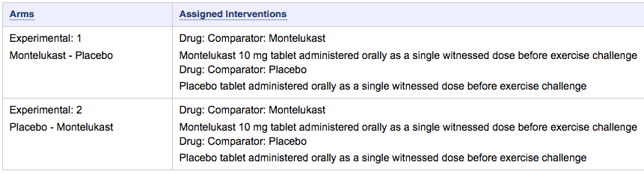
Sequence2
Sequence1

- An example of registering ‘Arms’ by intervention (NCT00690820)
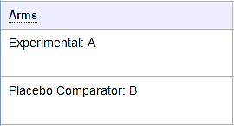
Intervention 1
Intervention 2

S Figure 2 Examples of registering ‘Participant Flow’
- An example of registering ‘Participant Flow’ using one table (NCT00432744)

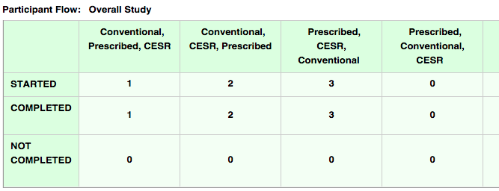

- An example of registering ‘Participant Flow’ using separate tables for different periods (NCT00432744) [28]
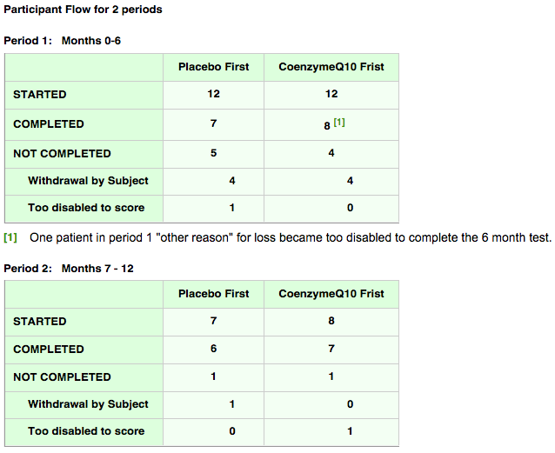

S Figure 3 An example of registering a time-to-event outcome (NCT00004635)
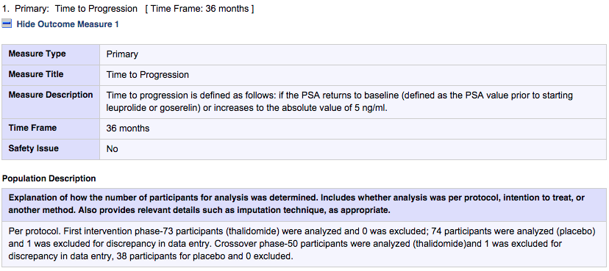
S Figure 4 An example of reporting adverse events by intervention and by period (NCT00518531)
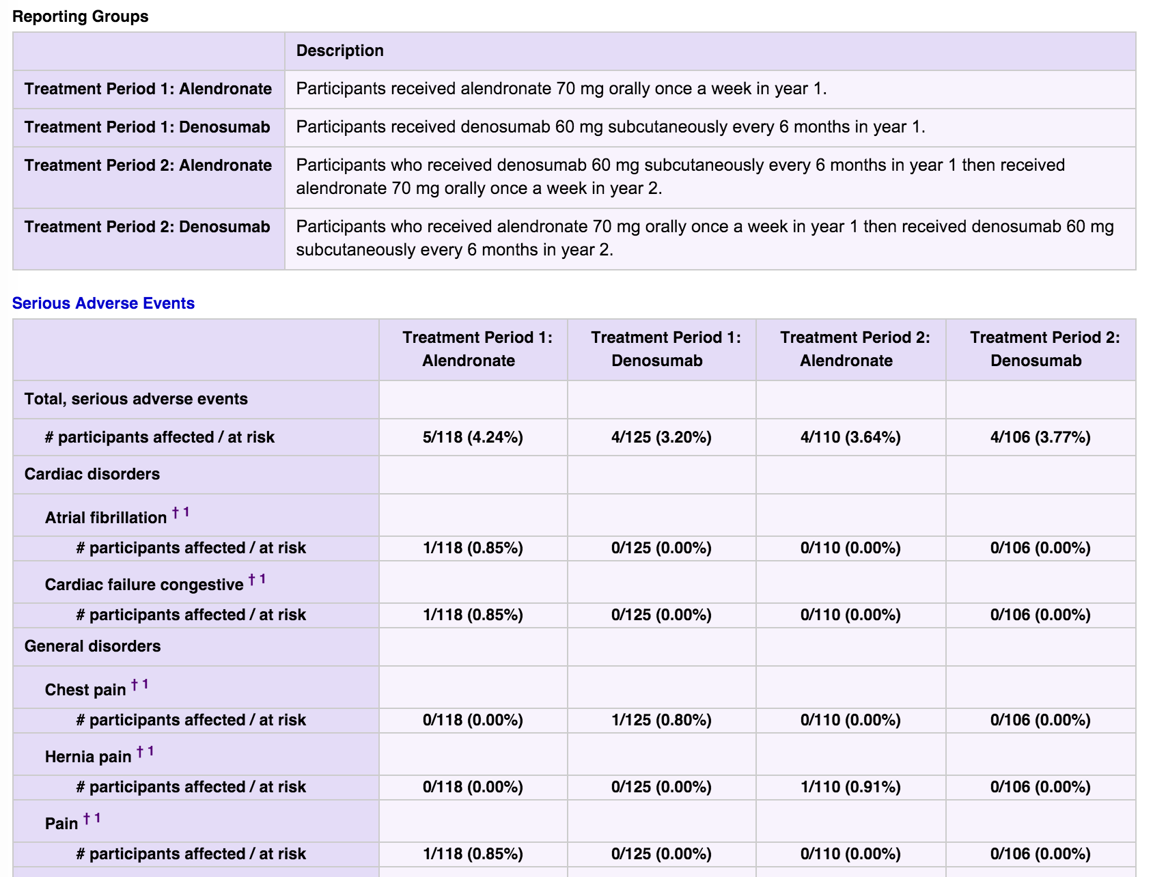
* Only first few adverse events the trial reported on ClinicalTrials.gov are listed as an example above.

S Table 2 Phase 3 randomized crossover trials registered on ClinicalTrials.gov (N = 124)

ID | ClinicalTrials.gov # | Title
1 | NCT00004635 | Thalidomide for the Treatment of Hormone-Dependent Prostate Cancer
2 | NCT00090142 | Montelukast in Exercise-Induced Bronchospasm - 2004 (0476-275)(COMPLETED)
3 | NCT00092131 | Montelukast in Exercise-Induced Bronchospasm - 2003 (0476-270)
4 | NCT00127166 | Two Investigational Drugs in the Prevention of Airway Constriction Brought on by Exercise in Asthmatic Patients (0476-911)
5 | NCT00131248 | Medical Treatment for Gastroesophageal Reflux Disease (GERD) in Preterm Infants
6 | NCT00200967 | Asthma Clinical Research Network (ACRN) Trial - Long-Acting Beta Agonist Response by Genotype (LARGE)
7 | NCT00245570 | Montelukast Compared With Placebo and Salmeterol in Exercise-Induced Bronchoconstriction (0476-316)
8 | NCT00276016 | The Effects of Phenylephrine Compared With Those of Placebo and Pseudoephedrine on Nasal Congestion in Subjects With Seasonal Allergic Rhinitis (SAR)(P04579)
9 | NCT00295061 | Comparison of Pharmacokinetic, Safety, Tolerability of Alpha-1 MP and Prolastin In Alpha1-antitrypsin Deficient Adults (ChAMP)
10 | NCT00297167 | Study to Evaluate the Safety and Efficacy of EUR-1008 (APT-1008) Pancreatic Enzyme Product in Participants With Cystic Fibrosis and Exocrine Pancreatic Insufficiency
11 | NCT00322231 | A Study of an Investigational Zoster Vaccine, in Subjects With a History of Herpes Zoster (V211-014)
12 | NCT00364182 | Study Comparing On-Demand Treatment With Two Prophylaxis Regimens Of BeneFIX In Patients With Severe Hemophilia B
13 | NCT00382993 | A Study of Combination Product (Sumatriptan Succinate and Naproxen Sodium) in Migraine Subjects Who Report Poor Response or Intolerance to Short Acting Triptans (Study 2 of 2)
14 | NCT00383162 | A Study of Combination Product (Sumatriptan Succinate and Naproxen Sodium) in Migraine Subjects Who Report Poor Response or Intolerance to Short Acting Triptans (Study 1 of 2)
15 | NCT00393042 | Sleep and Tolerability Study: Comparing the Effects of Adderall XR and Focalin XR
16 | NCT00395304 | Childhood Asthma Research and Education (CARE) Network Trial - Best Add-On Therapy Giving Effective Response (BADGER)
17 | NCT00432744 | Phase III Trial of Coenzyme Q10 in Mitochondrial Disease
18 | NCT00432835 | Temporary Gastric Electrical Stimulation for Drug Refractory Gastroparesis
19 | NCT00441545 | Head to Head Study Against Sevelamer Hydrochloride
20 | NCT00487695 | Confocal Endomicroscopy for Barrett's Esophagus
21 | NCT00489411 | Duloxetine in Treating Peripheral Neuropathy Caused by Chemotherapy in Patients With Cancer
22 | NCT00494143 | Metabolic Cost Savings for Transtibial Amputees Wearing the Controlled Energy Storage and Return (CESR) Foot
23 | NCT00500149 | A Classroom Study to Assess the Time of Onset of Vyvanse (Lisdexamfetamine Dimesylate) in Pediatric Subjects Aged 6-12 With Attention Deficit/Hyperactivity Disorder (ADHD)
24 | NCT00506285 | Methylphenidate Transdermal System (MTS) in the Treatment of Adult ADHD
25 | NCT00518531 | Denosumab Adherence Preference Satisfaction Study
26 | NCT00522951 | SH L 562BB Phase II/III Dose Justification and Gadoteridol-controlled Comparative Study
27 | NCT00538850 | Fentanyl Sublingual Spray in Treating Patients With Breakthrough Cancer Pain
28 | NCT00554853 | PPAR-gamma Agonists, Rheumatoid Arthritis and Cardiovascular Disease (RAPPAR)
29 | NCT00565266 | Asthma Clinical Research Network (ACRN) Trial - Tiotropium Bromide as an Alternative to Increased Inhaled Corticosteroid in Patients Inadequately Controlled on a Lower Dose of Inhaled Corticosteroid (TALC)
30 | NCT00572572 | Aprepitant + a 5HT3 + Dexamethasone in Patients With Germ Cell Tumors
31 | NCT00573170 | TREXIMET Versus Butalbital-containing Combination Medications for the Acute Treatment of Migraine in Adults
32 | NCT00574548 | Study Evaluating the Safety, Tolerability and Immunogenicity of 13vPnC as a 2-Dose Regimen or With 23vPS
33 | NCT00594516 | Study on the Safety and Effectiveness of Switching Between Two Forms of Tapentadol in Patients With Chronic Low Back Pain
34 | NCT00600028 | Treatment of Chronic Cough in Idiopathic Pulmonary Fibrosis With Thalidomide
35 | NCT00615030 | Study of Indacaterol Dosed in the Evening in Patients With Chronic Obstructive Pulmonary Disease (COPD)
36 | NCT00615459 | A Crossover Study to Determine the Effect on Lung Function of Indacaterol in Patients With Moderate to Severe Chronic Obstructive Pulmonary Disease (COPD), Using Tiotropium as an Active Control
37 | NCT00620022 | The Effect of Indacaterol on Exercise Endurance in Patients With Moderate to Severe Chronic Obstructive Pulmonary Disease
38 | NCT00626028 | Comparison of Inhaled Nitric Oxide and Oxygen in Patient Reactivity During Acute Pulmonary Vasodilator Testing
39 | NCT00660075 | Effects of Sitagliptin on Postprandial Lipemia in Men With Type 2 Diabetes
40 | NCT00662818 | Telcagepant (MK-0974) Treatment of Migraine in Participants With Stable Vascular Disease (MK-0974-034)
41 | NCT00666263 | Study of the Effectiveness of Intravenous Immune Globulin (10%) for the Treatment of Multifocal Motor Neuropathy
42 | NCT00667992 | Study Comparing Budesonide Hydrofluoroalkane (HFA) vs Chlorofluorocarbon (CFC) Pressurized Metered Dose Inhalers (pMDI) in Patients With Mild to Moderate Asthma
43 | NCT00690820 | Study Investigating a Delayed-Release Pancrelipase in Patients With Pancreatic Exocrine Insufficiency (PEI) Due to Cystic Fibrosis (CF)
44 | NCT00697515 | Safety and Efficacy Workplace Environment Study of Lisdexamfetamine Dimesylate (LDX) in Adults With Attention-Deficit Hyperactivity Disorder (ADHD)
45 | NCT00734604 | A Study for Patients With Erectile Dysfunction to Test Whether Tadalafil Taken Once a Day Can Better Improve Psychological Outcomes.
46 | NCT00748098 | Polysomnography Study of GSK1838262 Extended Release Tablets Versus Placebo in RLS and Associated Sleep Disturbance
47 | NCT00773279 | Efficacy, Safety and Preference Study of a Insulin Pen PDS290 vs. a Novo Nordisk Marketed Insulin Pen in Diabetics
48 | NCT00812006 | A Study of Rizatriptan for the Treatment of Acute Migraine in Patients on Topiramate for Migraine Prophylaxis
49 | NCT00813488 | Fentanyl Buccal Tablets Versus Immediate Release Oxycodone for Breakthrough Pain in Patients With Chronic Pain
50 | NCT00837967 | Study to Investigate the Safety and Efficacy of High Dose of Symbicort SMART in Japanese Patients
51 | NCT00883740 | Effects Of Pregabalin (Lyrica) On Sleep Maintenance In Subjects With Fibromyalgia
52 | NCT00894556 | A Study to Evaluate the Efficacy and Tolerability of Rizatriptan for Treatment of Acute Migraine (0462-087)
53 | NCT00904670 | Quillivant Oral Suspension (Quillivant XR) in the Treatment of Attention Deficit Hyperactivity Disorder (ADHD)
54 | NCT00931385 | Characterization of 24 Hour Spirometry Profiles of Inhaled BI 1744 CL and Inhaled Foradil in Patients With Chronic Obstructive Pulmonary Disease
55 | NCT00932646 | Characterisation of 24-hour FEV1-time Profiles of Inhaled BI 1744 CL and Inhaled Foradil in Patients With Chronic Obstructive Pulmonary Disease
56 | NCT00991276 | Polysomnography Study Of Pregabalin And Pramipexole Versus Placebo In Patients With Restless Legs Syndrome And Associated Sleep Disturbance
57 | NCT00992459 | Study of the Efficacy and Safety of HPN-100, Glyceryl Tri-(4-phenylbutyrate), for the Treatment of Adults With Urea Cycle Disorders (Help UCD)
58 | NCT00999908 | Comparison of the Effects of Indacaterol and Tiotropium on Inspiratory Capacity
59 | NCT01000961 | Phase 3 Study of Cysteamine Bitartrate Delayed-release (RP103) Compared to Cystagon in Patients With Cystinosis
60 | NCT01005888 | C1 Esterase Inhibitor (C1INH-nf) for the Prevention of Acute Hereditary Angioedema (HAE) Attacks
61 | NCT01012765 | Effect of Indacaterol on Inspiratory Capacity (IC)
62 | NCT01029340 | Trial to Evaluate the Efficacy and Safety of a New Full Length Recombinant Human FVIII for Hemophilia A (Leopold I)
63 | NCT01040130 | Effect of Treatment BI 1744 CL (5 and 10 mcg) Versus Placebo on Exercise Endurance Time During Constant Work Rate Cycle Ergometry I
64 | NCT01040793 | Effect of Treatment BI 1744 CL (5 and 10 mcg) Versus Placebo on Exercise Endurance Time During Constant Work Rate Cycle Ergometry II
65 | NCT01064310 | Patient Preference Study of Pazopanib Versus Sunitinib in Advanced or Metastatic Kidney Cancer
66 | NCT01072149 | A Study to Evaluate the Efficacy, Safety, Tolerability, Pharmacokinetic (PK), and Pharmacodynamic (PD) Profiles of 3 Doses of Fluticasone Furoate (FF)/GW642444 Inhalation Powder at the End of a 28-day Treatment Period in Subjects With Chronic Obstructive Pulmonary Disease (COPD) Compared to Placebo
67 | NCT01112865 | Cross Over Convenience And Preference Study Of New Mark VII Compared To Genotropin Pen In Pediatric And Adult Subjects (CHOOSE)
68 | NCT01132118 | Hydroxychloroquine to Improve Insulin Sensitivity in Rheumatoid Arthritis
69 | NCT01154127 | Effect of NVA237 on Exercise Endurance in Patients With Chronic Obstructive Pulmonary Disease (COPD)
70 | NCT01233258 | A Trial to Compare Prophylaxis Therapy to On-demand Therapy With a New Full Length Recombinant FVIII in Patients With Severe Hemophilia A (Leopold II)
71 | NCT01273883 | A Trial of Magnesium Dependent Tinnitus
72 | NCT01294787 | Effect of QVA149 on Exercise Tolerance in Patients With Chronic Obstructive Pulmonary Disease (COPD)
73 | NCT01370590 | A Study to Evaluate the Effectiveness of Ezetimibe/Atorvastatin 10 mg/20 mg Combination Tablet Compared to Marketed Ezetimibe 10 mg and Atorvastatin 20 mg Tablets in Participants With High Cholesterol (MK-0653C-185 AM1)
74 | NCT01370603 | A Study to Evaluate the Effectiveness of Ezetimibe/Atorvastatin 10 mg/40 mg Combination Tablet Compared to Marketed Ezetimibe 10 mg and Atorvastatin 40 mg Tablets in Participants With High Cholesterol (MK-0653C-190 AM1)
75 | NCT01401465 | Study To Evaluate Patient Preference, Satisfaction And Efficacy Of a Nasal Aerosol Versus an Aqueous Nasal Spray
76 | NCT01432236 | A Phase 3b Multicenter Study of Pregabalin in Fibromyalgia Subjects Who Have Comorbid Depression
77 | NCT01455415 | Effect Of Pregabalin Treatment In Patients With Diabetic Nerve Pain Who Currently Use A Non-Steroid Anti-Inflammatory Drug (NSAID) For Another Pain
78 | NCT01462370 | Study to Assess the Safety and Efficacy of Etoricoxib Versus Ibuprofen in the Treatment of Dysmenorrhea (MK-0663-145 AM1)
79 | NCT01471171 | Efficacy and Safety of Aclidinium Bromide 400 g BID (Twice a Day)Compared to Placebo in Patients With Stable Moderate to Severe Chronic Obstructive Pulmonary Disease (COPD)
80 | NCT01474772 | Efficacy and Safety Study of Pregabalin in the Treatment of Pain on Walking in Patients With Diabetic Peripheral Neuropathy (DPN)
81 | NCT01490125 | The Effect of QVA149 on Patient Reported Dyspnea in Moderate to Severe Chronic Obstructive Pulmonary Disease (COPD)
82 | NCT01515657 | Pharmacodynamic Evaluation of PL2200 Versus Enteric-Coated and Immediate Release Aspirin in Diabetic Patients
83 | NCT01533922 | Effect on Exercise Endurance and Lung Hyperinflation of Tiotropium + Olodaterol in COPD Patients
84 | NCT01533935 | Effect on Exercise Endurance and Lung Hyperinflation of Tiotropium + Olodaterol in COPD Patients.
85 | NCT01559012 | Transdermal Clonidine in the Treatment of Severe Hyperemesis Gravidarum (CLONEMESI)
86 | NCT01570751 | A Trial Comparing the Efficacy, Patient-reported Outcomes and Safety of Insulin Degludec 200 U/mL vs Insulin Glargine in Subjects With Type 2 Diabetes Mellitus Requiring High-dose Insulin
87 | NCT01606189 | A Study to Compare Sublingual Cannabis Based Medicine Extracts With Placebo to Treat Brachial Plexus Injury Pain
89 | NCT01606306 | Individualized Therapy For Asthma in Toddlers (INFANT)
90 | NCT01607411 | A Clinical Study to Evaluate Experimental Children's Toothpastes in an In-Situ Caries Model
91 | NCT01667679 | Efficacy and Safety of 20 mg Sumatriptan Powder Delivered Intranasally With the Bi-directional Device Compared With 100 mg Sumatriptan Tablets in Adults With Acute Migraine With or Without Aura (COMPASS)
92 | NCT01691885 | RELOVAIR Lung Deflation Study
93 | NCT01699685 | Swiss studY for the Treatment of COPD Patients With the Free combiNation of indacatERol and GlYcopyrroniumbromide. (SYNERGY)
94 | NCT01754259 | Effects of Ranolazine on Coronary Flow Reserve in Symptomatic Diabetic Patients and CAD (RAND-CFR)
95 | NCT01766076 | Atorvastatin for HAART Suboptimal Responders
96 | NCT01791972 | Efficacy of Albuterol SPIROMAX in Adult and Adolescent Patients With Exercise-Induced Bronchoconstriction (EIB)
97 | NCT01808755 | D Mannose in Recurrent Urinary Tract Infections
98 | NCT01829243 | Milnacipran and Neurocognition, Pain and Fatigue in Fibromyalgia : A 13-week Randomized, Placebo Controlled Cross Over Trial
99 | NCT01835912 | Chronic Versus Acute Dosing of Sodium Citrate for Swimming 200m
100 | NCT01857063 | Study of the Efficacy and Safety of MK-0476 in Japanese Pediatric Participants With Seasonal Allergic Rhinitis (MK-0476-519)
101 | NCT01868009 | DISKUS vs. ELLIPTA Device Preference Study in Chronic Obstructive Pulmonary Disease (COPD)
102 | NCT01962922 | Crossover Study to Compare PK of Once Daily LCP-Tacro Tablets to Generic Tacrolimus Capsules Twice Daily.
103 | NCT01967173 | Best African American Response to Asthma Drugs (BARD)
104 | NCT01978119 | A Non-inferiority Study to Evaluate the Efficacy, Safety, and Tolerability of Combination Dry Powder of Fluticasone Propionate and Salmeterol (FSC) 250/50 Microgram (mcg) Twice Daily (BID) in Adults and Adolescents With Asthma
105 | NCT01978145 | A Non-inferiority Study to Evaluate the Efficacy, Safety, and Tolerability of Fluticasone Propionate/Salmeterol (FSC) 250/50 Microgram (mcg) Through a Capsule-Based Inhaler and a Multi-Dose Inhaler Administered Twice Daily (BID) in Adults With Chronic Obstructive Pulmonary Disease (COPD)
106 | NCT01994746 | Efficacy and Safety of Nasal Glucagon for Treatment of Hypoglycemia in Adults
107 | NCT01996319 | Randomized, Double-blind, Placebo-controlled, Multicenter, Cross-over Study to Assess the Effects of a 3 Week Therapy Each With QVA149 Versus Placebo on Pulmonary Function and Average Physical Activity Levels in Patients With COPD. (MOVE)
108 | NCT02030600 | A Trial Comparing the Safety and Efficacy of Insulin Degludec and Insulin Glargine, With or Without OADs in Subjects With Type 2 Diabetes (SWITCH 2)
109 | NCT02034513 | A Trial Comparing the Safety and Efficacy of Insulin Degludec and Insulin Glargine, Both With Insulin Aspart as Mealtime Insulin in Subjects With Type 1 Diabetes (SWITCH 1)
110 | NCT02052141 | Safety and Efficacy Study of CINRYZE for Prevention of Angioedema Attacks in Children Ages 6-11 With Hereditary Angioedema
111 | NCT02066298 | Steroids In Eosinophil Negative Asthma (SIENA)
112 | NCT02147158 | A Study of the Efficacy and Safety of Ulipristal Acetate Intermittent Treatment for Abnormal Uterine Bleeding Associated With Leiomyomas
113 | NCT02226198 | A Study to Evaluate the Efficacy and Safety of Rosuvastatin in Children and Adolescents With Homozygous Familial Hypercholesterolemia (HYDRA)
114 | NCT02275546 | Performance and Safety of Vaginal Ring Applicator in Healthy Females (MK-8342A-063)
115 | NCT02322788 | Comparing the Efficacy of Bricanyl M2 and Bricanyl M3 at 0.5 and 1.5 mg Dose Levels, to Allow for a Switch From Bricanyl Turbuhaler M2 to Bricanyl Turbuhaler M3
116 | NCT02339246 | Pharmacokinetic Comparison Of All FK-506 Formulations (ASTCOFF)
117 | NCT02347072 | 24-hour Lung Function in Subjects With Moderate to Very Severe COPD After Treatment With PT003, Open-Label Spiriva Respimat as an Active Control, and Placebo
118 | NCT02347085 | 24-hour Lung Function in Subjects With Moderate to Very Severe COPD After Treatment With PT003 and Placebo MDI
119 | NCT02487446 | Efficacy and Safety Study of QVA149 in COPD Patients
120 | NCT02487498 | Efficacy and Safety Study of Indacaterol Maleate/Glycopyrronium Bromide in Chronic Obstructive Pulmonary Disease (COPD) Patients.
121 | NCT02502734 | Effect of Inhaled Fluticasone Furoate on Short-term Growth in Paediatric Subjects With Asthma
123 | NCT02584959 | Study to Evaluate the Clinical Efficacy and Safety of Subcutaneously Administered C1 Esterase Inhibitor for the Prevention of Angioedema Attacks in Adolescents and Adults With Hereditary Angioedema
124 | NCT02629965 | Comparing the Efficacy of Tiotropium + Olodaterol Fixed Dose Combination (FDC) Over Tiotropium in Improvement of Lung Hyperinflation, Exercise Capacity and Physical Activity in Japanese COPD Patients

