Supplementary Information

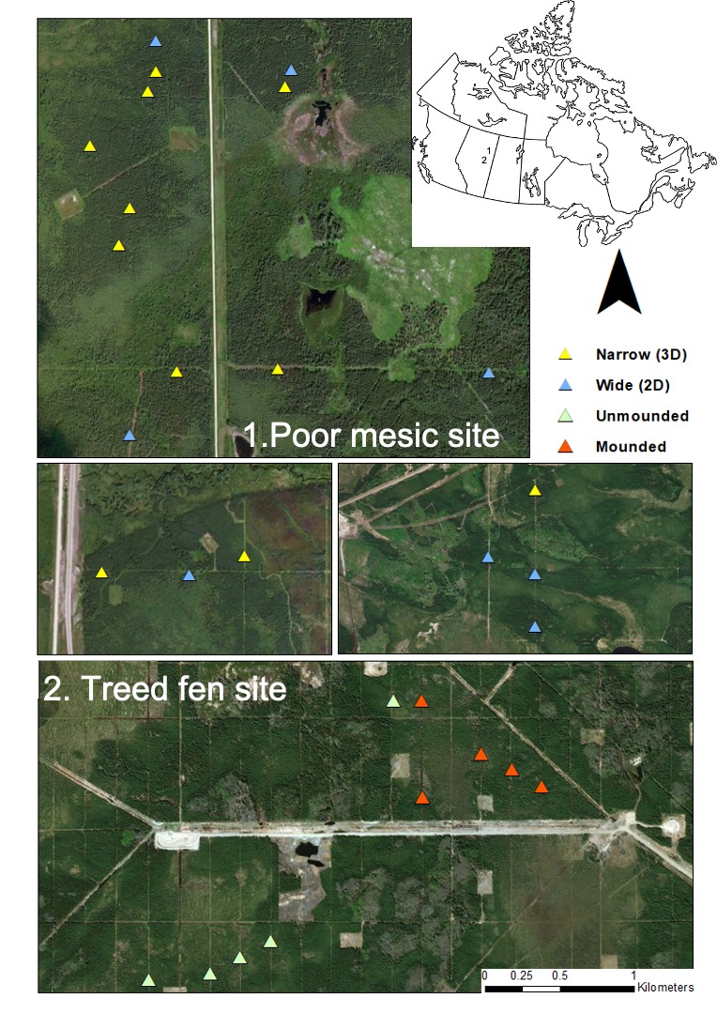
Figure S1. Location of seismic lines across both the poor mesic and treed fen sites. Yellow triangles indicate narrow (3D or low impact) lines which are approximately 1-5 m in width. Blue triangles indicate wide (2D) lines which are typically between 5 – 10 m in width). Green triangles indicate narrow lines which have not had artificial microtopography created using the mounding technique (orange triangles).
Base map: Esri, DigitalGlobe, GeoEye, i-cubed, USDA FSA, USGS, AEX, Getmapping, Aerogrid, IGN, IGP, swisstopo, and the GIS User Community

