Supplementary Table 1 Synthetic oligonucleotides used in this study.
Primer | 5’ → 3’ sequenceª | Positions | Purpose
ExpTetR1-NdeI | CAACATATGGTGAGCAGCACCATTCCAGCACTTC | +1 to +708 | Amplification of sco3201 for protein expression
ExpTetR2-XhoI | CAACTCGAGCCCCTCTTCCGCGGGCCC
0116F | AGCCAGTGGCGATAAGCGCCGTACACCTTGG | -219 to +43 | Amplification of the sco0116 promoter for EMSA
0116R | AGCCAGTGGCGATAAGGCCTGCGGTTTTCCT
0430F | AGCCAGTGGCGATAAGTAGAACTGGGCGGTGT | -238 to +32 | Amplification of the sco0430 promoter for EMSA
0430R | AGCCAGTGGCGATAAGTCGTAAAGCGGAGGGT
2386F | AGCCAGTGGCGATAAGACCCAGGTGACGA | -268 to +1 | Amplification of the sco2386 promoter for EMSA
2386R | AGCCAGTGGCGATAAGCGGGGACAAGACT
2390F | AGCCAGTGGCGATAAGTCCTTCACCGAC | -265 to -7 | Amplification of the sco2390 promoter for EMSA
2390R | AGCCAGTGGCGATAAGCTTTCTCCAACG
4167F | AGCCAGTGGCGATAAGGAGCCGTTCCG | -234 to +19 | Amplification of the sco4167 promoter for EMSA
4167R | AGCCAGTGGCGATAAGTGCGACCACCC
6792F | AGCCAGTGGCGATAAGGGCAGGCACA | -153 to +100 | Amplification of the sco6792 promoter for EMSA
6792R | AGCCAGTGGCGATAAGGAAGCGGCAC
Plabel | AGCCAGTGGCGATAAG |  | FITC labeling
RT-0116F | CTCGCCACCGACATCG | +337 to +438 | RT-PCR of sco0116
RT-0116R | GTCACGGGCCAGGAACT
RT-0117F | CTGCTCGGAGGCGACATGA | +253 to +397 | RT-PCR of sco0117
RT-0117R | ACCAGGACAGGGCGGAAAG
RT-0310F | CGAGACGGGCTGGG | +630 to +830 | RT-PCR of sco0310
RT-0310R | ATCTTCACGGGGAGGTT
RT-0312F | TGGCGGACAGCGAG | +557 to +781 | RT-PCR of sco0312
RT-0312R | GGGAGGGGCAGTGG
RT-0429F | AGTGATCCGTGCTGCGCT | +237 to +389 | RT-PCR of sco0429
RT-0429R | CCGAGGCTCCTGAGGTTGTC
RT-0430F | TACTCAACACCCTCCACAG | +436 to +602 | RT-PCR of sco0430
RT-0430R | CACGCCCAGCAGCAT
RT-0548F | ACGGCTTCGTGATGGGG | +722 to +955 | RT-PCR of sco0548
RT-0548R | TGGCGTGGGCGTTGAC
RT-1831F | CGGACGAGCAGTGGCAGT | +302 to +466 | RT-PCR of sco1831
RT-1831R | GGCGCAGACCGTTGGA
RT-2131F | CGGCATCGGCTTCACG | +1092 to +1283 | RT-PCR of sco2131
RT-2131R | GGGTTGTTCCAGTACTCCTTGA
RT-2386F | ATCGCCTCCGACCCCT | +933 to +1046 | RT-PCR of sco2386
RT-2386R | GCTCGCCTGTTCGAGATAGAC
RT-2387F | CCACACCCGCCACA | +600 to +804 | RT-PCR of sco2387
RT-2387R | GCCCAGCTCCTTGAAC
RT-2390F | CCAAGAACAACGACGACCC | +665 to +909 | RT-PCR of sco2390
RT-2390R | GTTGCCGTCCAGCAGGTT
RT-4167F | CGACGCTGACCGAACG | +59 to +223 | RT-PCR of sco4167
RT-4167R | CCTGCTTGGAGCGGAA
RT-4168F | CGGGTCCTCACGGTGAAC | +367 to +588 | RT-PCR of sco4168
RT-4168R | GGCGGTGAAGCGGATG
RT-5399F | CCGCCCTGTCCCAC | +554 to +802 | RT-PCR of sco5399
RT-5399R | GGCTCATCACGACCACG
RT-6027F | CGAGACGGGCTGGG | +630 to +830 | RT-PCR of sco6027
RT-6027R | ATCTTCACGGGGAGGTT
RT-6474F | CTGTTCACCCGCTATCTG | +454 to +667 | RT-PCR of sco6474
RT-6474R | TGCCCGTGCCGAAG
RT-6475F | CGGCTTCTACACCTACGA | +861 to +1020 | RT-PCR of sco6475
RT-6475R | CTTGGCGAACACCTCC
RT-6564F | TACCGCTGGGCCACCA | +631 to +856 | RT-PCR of sco6564
RT-6564R | CCCGCTCCGCCAACTT
RT-6785F | ACCTCCTCGACGGAGGCT | +689 to +877 | RT-PCR of sco6785
RT-6785R | GTGCGGTGAACAGGGCTT
RT-6786F | TCGGCAAACCCCTCAAGC | +443 to +583 | RT-PCR of sco6786
RT-6786R | CGTGTTCCGGCGCGTA
RT-6787F | CGTCCGCTTCGAGATCGC | +849 to +1028 | RT-PCR of sco6787
RT-6787R | CCGCCGTGGAGTTGCA
RT-6788F | CCGCCGAGAGCCTG | +644 to +832 | RT-PCR of sco6788
RT-6788R | GGTCACCGACCTCCTTG
RT-6789F | GGTATCGCCTACTCGTGTG | +1009 to +1152 | RT-PCR of sco6789
RT-6789R | CGCCTTCTCCTGAATCGT
RT-6790F | CGGATTTGGGAGAAGC | +853 to +1045 | RT-PCR of sco6790
RT-6790R | GCAGCGGCAACAGG
RT-6792F | AGGGGTTCGTGGTCGC | +283 to +527 | RT-PCR of sco6792
RT-6792R | CGGGTTGAGCAGGAAGGAG
ªEngineered restriction enzyme sites are in bold. Underlined nucleotides show no homology to the template; they were used for FITC labeling.
Supplementary Table 2. Quaternary gradient mobile phase composition. A, isooctane:ethyl acetate (99.8:0.2, v/v); B, acetone:ethyl acetate (2:1, v/v) containing 0.15% acetic acid (v/v); C, 2-propanol:water (85:15, v/v) containing 0.043% acetic acid (v/v) and 0.104% triethylamine (v/v); D, ethyl acetate.
Time (min) | Percent solvent |  |  |  | Flow-rate (mL/min)
 | A | B | C | D
0 | 100 | 0 | 0 | 0 | 0.8
1.5 | 100 | 0 | 0 | 0 | 0.8
1.6 | 97 | 3 | 0 | 0 | 0.8
9 | 94 | 6 | 0 | 0 | 0.8
11 | 70 | 30 | 0 | 0 | 0.8
14 | 45 | 55 | 0 | 0 | 0.8
15 | 45 | 55 | 0 | 0 | 0.8
16 | 40 | 55 | 5 | 0 | 0.8
20 | 35 | 55 | 10 | 0 | 0.8
20.1 | 33 | 50 | 17 | 0 | 0.8
25 | 38 | 45 | 17 | 0 | 0.8
25.1 | 48 | 35 | 17 | 0 | 0.8
30 | 53 | 30 | 17 | 0 | 0.8
40 | 40 | 0 | 60 | 0 | 0.8
40.1 | 0 | 100 | 0 | 0 | 0.8
42 | 0 | 100 | 0 | 0 | 0.8
42.1 | 50 | 0 | 0 | 50 | 0.8
45 | 50 | 0 | 0 | 50 | 0.8
47 | 100 | 0 | 0 | 0 | 0.8
53 | 100 | 0 | 0 | 0 | 0.8

Supplementary Table 3. RNA seq data of differentially expressed TetR-family genes at three tested time points in the two strains. The strain M145/pWHM3 being taken as reference.
TetR genes^{a`} | logFC
 | 24h | 36h | 48h
sco0116 | 0 | 1.139 | 0
sco0310 | 0 | 1.048 | 0
sco0428 | 0 | -1.052 | 1.788
sco2223 | 0 | 0 | 1.136
sco2994 | 0 | 0 | 1.070
sco3201 | 1.664 | 3.034 | 4.081
sco3207 | 0 | 1.049 | 0
sco4167 | 0 | -1.600 | 0
sco6792 | 2.253 | 0 | 0
sco5209 | 0 | -1.261 | 0
sco7539 | 0 | 0 | 1.238
ªThe TetR-family genes adjacently located to the fatty acid metabolism gene cluster are in bold.

Supplementary Table 4. The most enriched metabolic pathways at three tested time points.
24 h | 36 h | 48 h
Phenylalanine, tyrosine and tryptophan biosynthesis | Phenylalanine, tyrosine and tryptophan biosynthesis | Fatty acid biosynthesis
Fatty acid metabolism | Tyrosine metabolism | alpha-Linolenic acid metabolism
alpha-Linolenic acid metabolism | Tryptophan metabolism | Sphingolipid metabolism
Synthesis and degradation of ketone bodies | Fatty acid biosynthesis | Glycosphingolipid biosynthesis - globo series
Biosynthesis of unsaturated fatty acids | Alanine, aspartate and glutamate metabolism | beta-Alanine metabolism
Lysine degradation | Glyoxylate and dicarboxylate metabolism | Galactose metabolism
Inositol phosphate metabolism | Starch and sucrose metabolism | Inositol phosphate metabolism
 | Butanoate metabolism | Other glycan degradation
 | Porphyrin and chlorophyll metabolism
 | Nitrogen metabolism

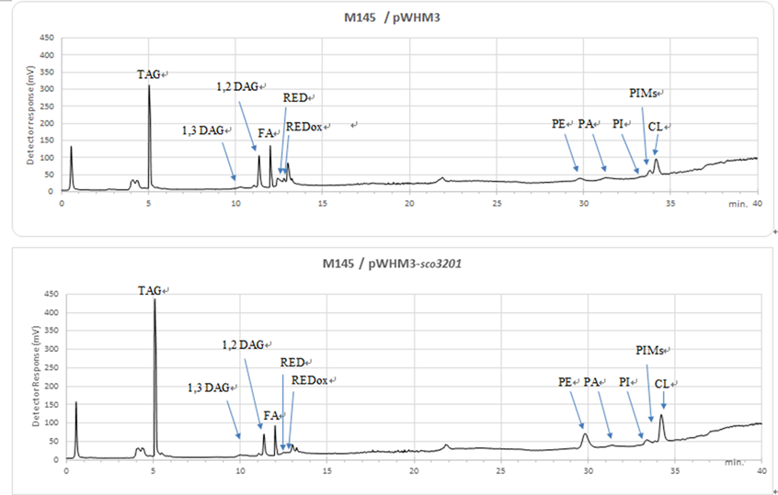
Supplementary Fig. 1. Results of LC-Corona.

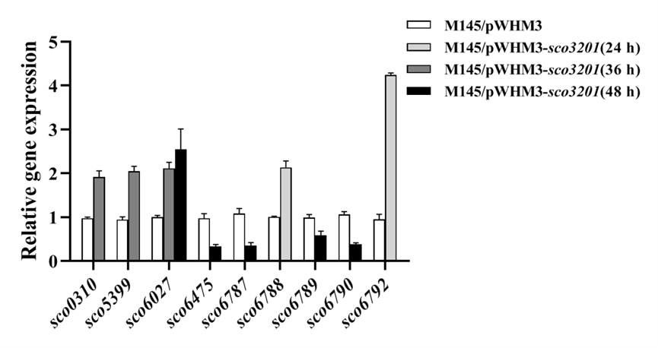
Supplementary Fig. 2. qRT-PCR analysis of the expression level of various FAD associated genes.

