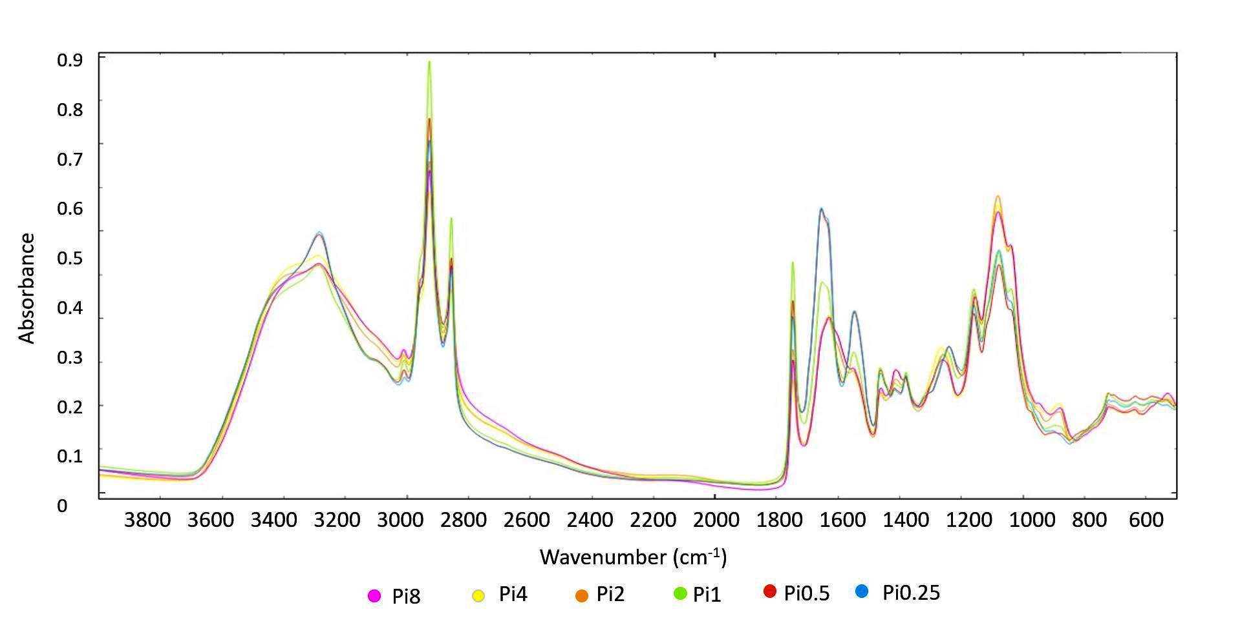
Supplementary Figure 5. FTIR-HTS spectra of Cunninghamella blakesleeana (EMSC corrected); ammonium sulphate nitrogen source, different Pi-levels

