Supplementary material to:

Summertime in situ chlorophyll a and particulate organic carbon standing stocks in surface waters of the Fram Strait and the Arctic Ocean (1991 – 2015)

Nöthig¹*, E.-M., S. Ramendenc^{1,2}, A. Haas¹, L. Hehemann¹, A. Walter¹, A. Bracher^{1,3}, C. Lalande^{1,4}, K. Metfies¹, I. Peeken¹, E. Bauerfeind¹, A. Boetius¹

¹Alfred Wegener Institute Helmholtz Centre for Polar and Marine Research, Am Handelshafen 12, 27570 Bremerhaven, Germany
²University of Bremen, Department of Geosciences, Klagenfurterstrasse, Marum, Leobener Strasse, 28359 Bremen, Germany
³ Institute of Environmental Physics, University Bremen, Otto-Hahn-Allee 1, 28359 Bremen, Germany
⁴ Amundsen Science, Université Laval, Pavillon Alexandre-Vachon, Québec, Québec, G1V 0A6, Canada

Table S1: List of the RV Polarstern expeditions carried out for sampling chlorophyll a (Chla) and particulate organic carbon (POC) from the water column using a SEA-BIRD CTD system and 24 Niskin bottle (12 L), see also: https://www.pangaea.de/expeditions/cr.php/Polarstern

Cruise label | Additional name/label | Area | Start | End | Cruise reports
PS94 | ARK-XXIX/3 | Arctic Ocean, Central Basin | 2015-08-17  Tromsø | 2015-10-15  Bremerhaven | Cruise report
PS93.2 | ARK-XXIX/2.2 | Fram Strait/Greenland Sea | 2015-07-20  Tromsø | 2015-08-14  Tromsø | Cruise report
PS85 | ARK-XXVIII/2 | Gakkel Ridge, Arctic Ocean | 2014-06-06  Bremerhaven | 2014-07-03  Tromsø | Cruise report
ARK-XXVII/3 | PS80 | Arctic Ocean | 2012-08-02  Tromsø | 2012-10-08  Bremerhaven | Cruise report
ARK-XXVII/2 | PS80 | Fram Strait | 2012-07-15  Longyearbyen | 2012-07-30  Tromsø | Cruise report
ARK-XXVII/1 | PS80 | Fram Strait | 2012-06-14  Bremerhaven | 2012-07-15  Longyearbyen | Cruise report
ARK-XXVI/3 | PS78 | Arctic Ocean | 2011-08-05  Tromsø | 2011-10-06  Bremerhaven | Cruise report
ARK-XXVI/2 | PS78 | Fram Strait | 2011-07-13  Longyearbyen | 2011-08-03  Tromsø | Cruise report
ARK-XXVI/1 | PS78 | Fram Strait | 2011-06-15  Bremerhaven | 2011-07-13  Longyearbyen | Cruise report
ARK-XXV/2 | PS76 | Fram Strait | 2010-06-30  Longyearbyen | 2010-07-29  Reykjavik | Cruise report
ARK-XXIV/2 | PS74 | Fram Strait | 2009-07-10  Longyearbyen | 2009-08-03  Reykjavik | Cruise report
ARK-XXIII/2 | PS72 | Fram Strait | 2008-07-04  Longyearbyen | 2008-08-10  Reykjavik | Cruise report
ARK-XXII/2 | PS70 | Arctic Ocean | 2007-07-28  Tromsø | 2007-10-07  Bremerhaven | Cruise report
ARK-XXII/1c | PS70 | Fram Strait (HAUSGARTEN) | 2007-07-09  Longyearbyen | 2007-07-25  Tromsø | Cruise report
ARK-XX/1 | PS66 | Greenland Sea/Fram strait | 2004-06-16  Bremerhaven | 2004-07-16  Longyearbyen | Cruise report
ARK-XIX/4b | PS64 | Arctic Ocean | 2003-09-21  Longyearbyen | 2003-10-13  Bremerhaven | Cruise report
ARK-XVII/2 | PS59 | Gakkel Ridge | 2001-07-31  Tromsø | 2001-10-07  Bremerhaven | Cruise report
ARK-XVII/1 | PS59 | Fram Strait | 2001-06-19  Bremerhaven | 2001-07-30  Tromsø | Cruise report
ARK-XVI/1 | PS57 | Arctic Ocean | 2000-06-30  Bremerhaven | 2000-07-30  Longyearbyen | Cruise report
ARK-XV/3 | PS55 | Norwegian-Greenland Sea | 1999-09-08  Tromsø | 1999-10-14  Bremerhaven | Cruise report
ARK-XIV/2 | PS52 | Norwegian-Greenland Sea | 1998-08-28  Tromsø | 1998-10-15  Bremerhaven | Cruise report
ARK-XIII/2 | PS44 | Arctic Ocean | 1997-06-24  Tromsø | 1997-08-11  Tromsø | Cruise report
ARK-XIII/1b | PS44 | Norwegian Sea | 1997-05-25  Longyearbyen | 1997-06-23  Tromsø | Cruise report
ARK-XIII/1a | PS44 | Norwegian Sea | 1997-05-14  Bremerhaven | 1997-05-24  Longyearbyen | Cruise report
ARK-XII | PS41 | Arctic Ocean | 1996-07-12  Bremerhaven | 1996-09-23  Bremerhaven | Cruise report
ARK-XI/1 | PS36 | Laptev Sea | 1995-07-07  Bremerhaven | 1995-09-20  Tromsø | Cruise report
ARK-X/1 | PS31 | Greenland Sea | 1994-07-06  Bremerhaven | 1994-08-16  Tromsø | Cruise report
ARK-IX/4 | PS27 | Laptev Sea | 1993-08-06  Tromsø | 1993-10-06  Bremerhaven | Cruise report
ARK-VIII/2 | PS19 | Barents Sea | 1991-06-20  Tromsø | 1991-07-31  Tromsø | Cruise report

Table S2: List of the RV Lance and Maria S Merian expeditions carried out for sampling chlorophyll a (Chla) and particulate organic carbon (POC) from the water column using a SEA-BIRD CTD system and 24 Niskin bottle (12 L)

Cruise label | Additional name/label | Area | Start | End | Cruise reports
Lance 2000 | ARKTIEF I | Greenland Sea | 2000-09-11  Hamburg | 2000-10-02  Longyearbyen | https://www.ifm.uni-hamburg.de/en/workareas/experimental/berichte/lance2000.pdf
Lance 21-2001 | ARKTIEF II | Greenland Sea | 2001-09-07  Tromsø | 2001-10-02  Longyearbyen | https://www.ifm.uni-hamburg.de/en/workareas/experimental/berichte/lance21_2001.pdf
MSM02/04 | DAMOCLES | Fram Strait | 2006-08-20  Longyearbyen | 2006-09-17  Reykjavik | https://epic.awi.de/id/eprint/37062/2/msm02-expeditionsheft.pdf
MSM29 | HAUSGARTEN 2013 | Fram Strait | 2013-06-23  Tromsø | 2013-07-12  Tromsø | https://epic.awi.de/id/eprint/37062/23/msm29-msm31-expeditionsheft.pdf

Table S3: Kruskal Wallis test for Chla and POC standing stocks in the different regions of the AO

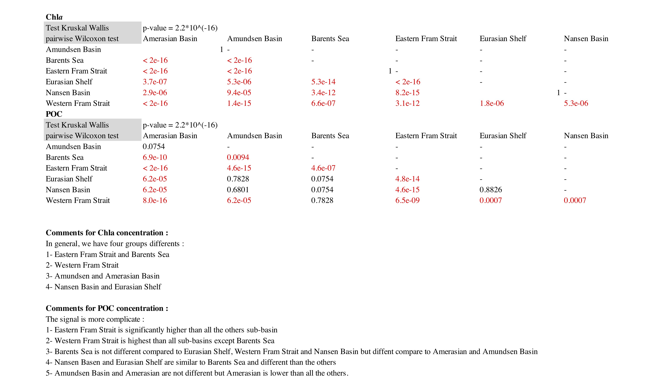
Figure S1: Vertical profiles of Chl a and POC for the different regions sampled; concentrations per 20 m depth intervals. Upper) Sub-regions for the comparison of regional differences. Western Fram Strait (WFS), eastern Fram Strait (EFS), Barents Sea (BS), Eurasian shelf (ESf), Nansen Basin (NB), Amundsen Basin (AmB), and Amerasian Basin (AB, including Makarov and Canadian basins); middle) mean Chla values (µg/l) and, down) mean POC values (µg/l), 0-100 m from 1991 to 2015. Black lines represent standard deviations.

