Supplementary Material
- Core material and age model
A piston core MZ01 (120°50.94’E, 26°32.82’N) was taken from a water depth of 64.7 m in the inner shelf of the East China Sea by the R/V Kan 407 during the “Coastal Investigation and Research Project of China” cruise in July 2007 (Liu et al., 2010). The climate in the studied area is strongly affected by the East Asian monsoons and Kuroshio Current. In summer, the Changjiang River carries huge amounts of fresh water and sediment to the ECS, developing a diluted water barrier layer in the vast continental shelf. When the EAWM prevails, the China Coastal Current (CCC) flows along the inner shelf of the Yellow Sea and ECS, carrying Changjiang diluted water (CDW) and large amounts of sediment to the Min-Zhe mud area (Lee and Chao, 2003). Together with the EAWM, the CCC leads to strong cooling along the inner shelf from the Yellow Sea to the northern SCS. In contrast, branches of the Kuroshio Current, including the Taiwan Warm Current (TWC) and Western Kuroshio Branch Current (WKBC), transport high temperature and salinity water northward and onward (Lie and Cho, 2016). They intrude into the ECS shelf and meet the colder CDW, leading to a distinctive stratification and oceanic front (Chern et al., 1990). In winter, colder CDW on the surface would dampen the vertical caused by the EAWM and thus keep the subsurface and bottom water warmer than the surface in winter and fall (Locarnini et al., 2013; Zweng et al., 2013) (Supplementary Figure 1).
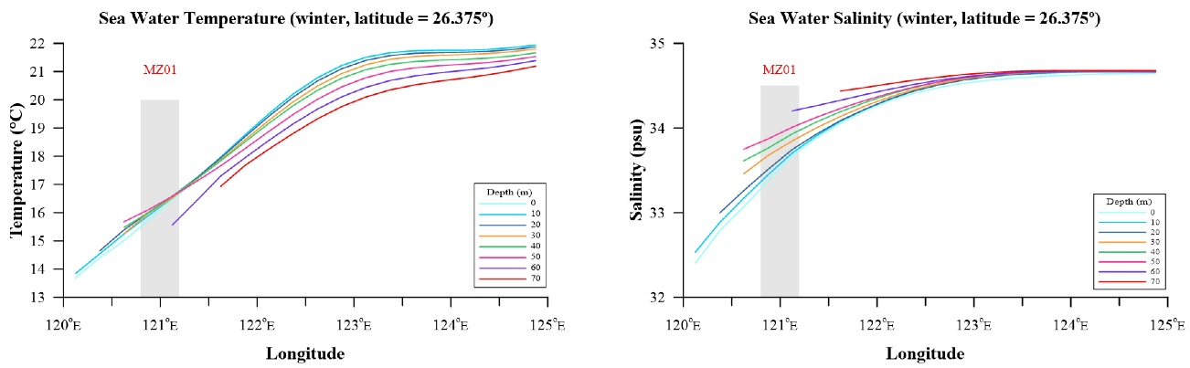
▲Supplementary Figure 1: vertical sea water temperature (left) and salinity (right) profile of winter (Locarnini et al., 2013; Zweng et al., 2013). The gray bar denotes the longitude position of MZ01.

In total, 148 samples were collected for the identification of grain size, major elements, sea surface and subsurface temperatures from the core length 2.96 m; each sample had a time resolution of approximately 60 years according to our constructed age model, schematized below (Supplementary Figure 2).
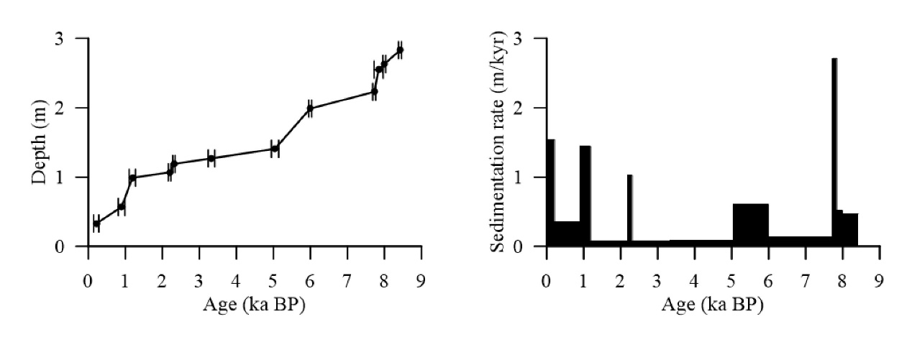
▲Supplementary Figure 2: MZ01 Age model (left) and sedimentation rate (right).

A preliminary age model of core MZ01 has been published previously, which was based on five old Accelerator Mass Spectrometry (AMS) ¹⁴C dates (Liu et al., 2010) (Supplementary Table 1). In this study, a new age model for the core is presented using 12 new AMS ¹⁴C ages (Supplementary Table 1). The AMS ¹⁴C measurements were done by taking approximately 7 mg mixtures of strictly-selective mainly epifauna benthic foraminifer shells (>149μm), which were dated at the University of Tokyo, Japan. All measured ages were calibrated to calendar years according to the Marine 13 dataset (Reimer et al., 2013) through the CALIB 7.04 Program (Stuiver et al., 2017) with the 121±25 years (Yoneda et al., 2007; Supplementary Table 2) surface-ocean reservoir correction. The interpolated time series of the whole core was established by the Ager program of ARAND Software (Howell et al., 2006). The age model developed for this core suggests an average sedimentation rate of ~33.6 cm/kyr, and the bottom of the core thus reaches back to approximately 8,400 years ago.
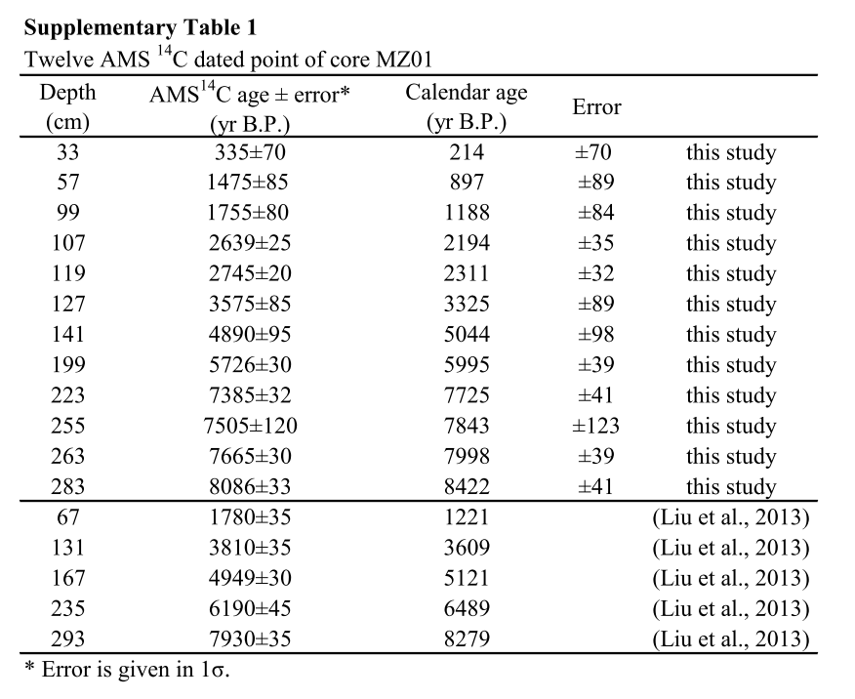

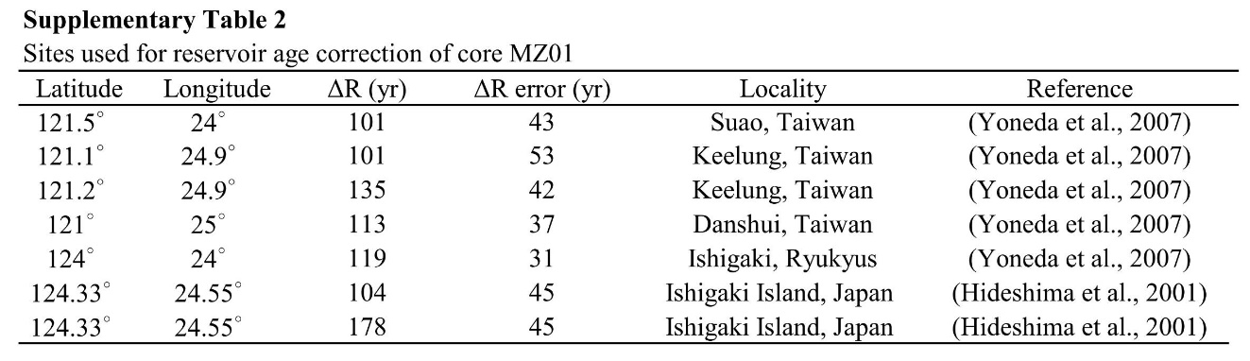

2. BIT Index
The BIT (Branched and Isoprenoid Tetraether) index is an indicator of the terrestrial organic matter input. Higher BIT values in marine sediment means more terrestrial organic matter input, and may bias the seawater temperature estimation through using TEX₈₆ (Weijers et al., 2006). Previous studies have shown that there would be a deviation of 2℃ in the temperature estimation by TEX₈₆ once the BIT value exceeds 0.4 (Weijers et al., 2006). Besides, Zhu et al. (2011) also indicated that when the BIT value is less than 0.2 in the ECS, the TEX86 proxy is much more robust and represents precisely the satellite-derived annual mean seawater temperature.
The BIT values of MZ01 range from 0.03 to 0.09 (Supplementary Figure 3), indicating nearly zero or very minor contribution of terrestrial organic matter transported and deposited at this site. Thus, the uses of TEX₈₆ as a seawater temperature proxy in MZ01 is reliable.
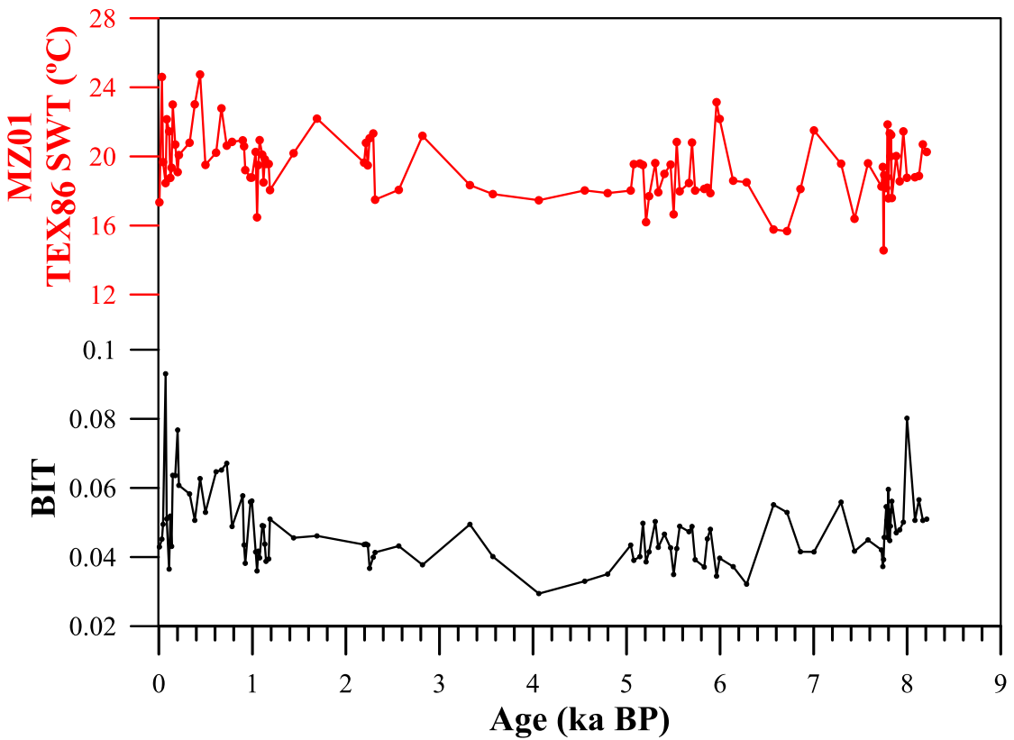
▲Supplementary Figure 3: TEX₈₆-derived temperature (up) and BIT (down) variations of core MZ01.

3. Continuity Superposition Error Calculation Method
The commonly used method to assess the uncertainties of paleoclimatic records usually have failed to take account of the interrelationship between the errors in the X (ages) and Y (proxy) vectors. In an effort to solve such problems, the present method [named the Continuity Superposition Error Calculation Method (CSECM)] was designed to combine the errors in both X and Y and then applied to the U^{k’}₃₇ and TEX₈₆ records in this study. The CSECM was divided into four processes, and some specific steps involved in each process were depicted as follows. All the numerical computing were done by the mathematics software Matlab with the the Hibert-Huang Transformation (HHT) tool box provided by the Research Center of Adaptive Data Analysis (RCADA) at the National Central University, Taiwan (https://in.ncu.edu.tw/~ncu34951/research1.htm).
(1) Data processing - the original Y series (U^{k’}₃₇ and TEX₈₆) were transformed by linear interpolation to create a new Y’ on uniformly-spacing (∆t=80 years*) for further analysis. Likewise, the age errors of each data point (X’) were obtained by applying the same method. In this way, we have the new X’, X’-error and Y’, while the Y’-error was calculated after the third process when the targeted signal had been decomposed out.
* ∆t generated from the measuring resolution that emanates from the whole core age (approximately 8400 years) divided by the measuring number, which is 107 and 100 for U^{k’}₃₇ and TEX₈₆ separately. The measuring resolution was approximately 80 years.
- Signal decomposition - like most natural systems, the climatic record is seldom generated from a signal or isolated force, which is nonlinear, non-stationary and composed of different timescale variability and noise. The EEMD (Ensemble Empirical Mode Decomposition; (Wu and Huang, 2004)) method can decompose a signal to a sequence of IMFs (Intrinsic Mode Function Components) according to the timescale of record. It is very suitable for processing the paleoclimatic data and providing detailed information. The EEMD decomposition of the U^{k’}₃₇ and TEX₈₆ sea water temperature records in this study can be seen in Supplementary Figures 4 and 5.
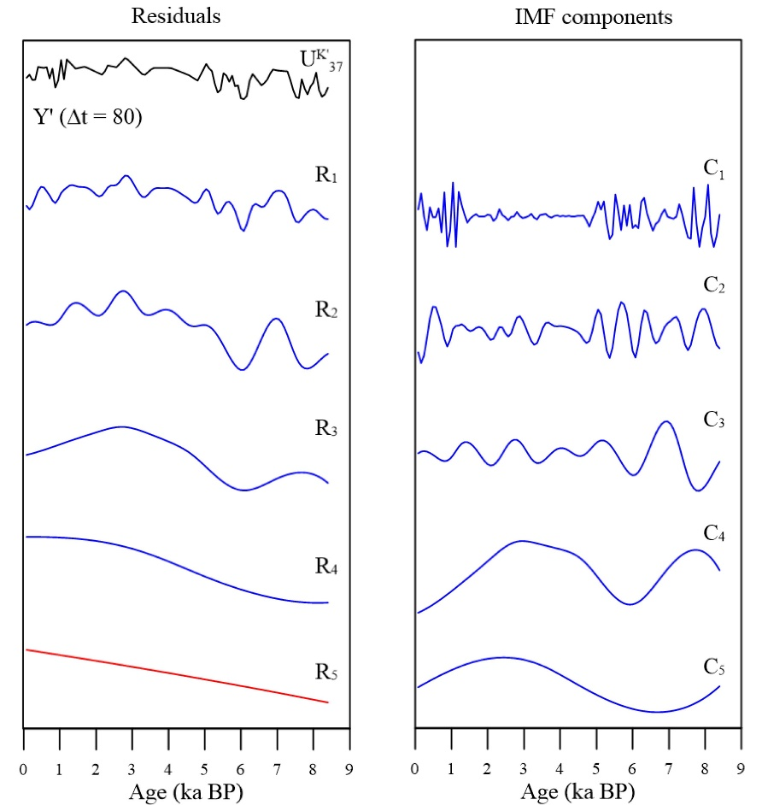
▲Supplementary Figure 4: EEMD decomposition of the U^{k’}₃₇. Curves in right panel are IMF components dissected from linear interpolated U^{k’}₃₇ record (first curve in the left panel) through EEMD, and the remaining curves in the left panel represents residuals.

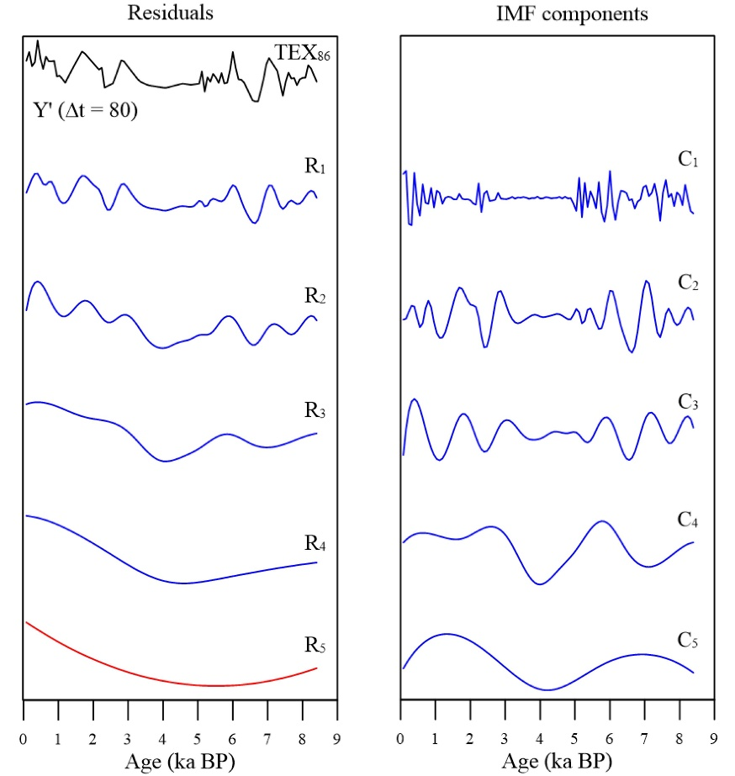
▲Supplementary Figure 5: EEMD decomposition of the TEX₈₆. Curves in right panel are IMF components dissected from linear interpolated TEX₈₆ record (first curve in the left panel) through EEMD, and the remaining curves in the left panel represents residuals.

Supplementary Figures 4 and 5 show the process when performing a series of EEMD calculations; the IMF components ((C_{i}); in the right panel) and successive residues ((R_{i}); in the left panel) were extracted from the original data (Y’ (t); black curve). This means that the Y’ (t) can be decomposed into the first IMF component (C₁) with a residual (R₁), which (R₁) still can be decomposed after, i.e., R_{i} = C_{(i+1)} + R_{(i+1)} for i ≥1. Ultimately, the calculation will end with the R_{(i+1)} which is indecomposable.
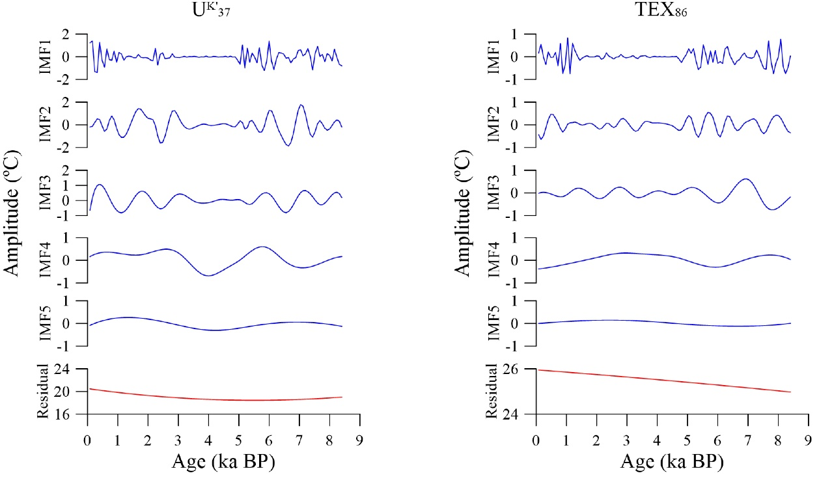▲Supplementary Figure 6: The eventual result of U^{k’}₃₇ (left) and TEX₈₆ (right) through EEMD decomposition.

- Signal picking- After the EEMD calculation, the independent IMF components with different timescales and a final residue are provided as the Supplementary Figure 6. For caution’s sake, an additional procedure was used to inspect the decomposed results and remove the component which may contain any noises that indicate meaningless signals.
According to the Nyquist-Shannon sampling theorem, the signal is meaningful when the Sampling Frequency (sf) equal to or larger than 2 times the Nyquist-Frequency (f), (Shannon, 1949).
sf ≥ 2 f (Nyquist-Shannon sampling theorem)
Once the Nyquist-Frequency is larger than one-half times the sampling Frequency, under-sampled data points will be produced and thus lead to misinterpretation of the signal. In other words, the unreal value probably yields into the time series, leading to incorrect climatic mechanism interpretations. In this study, the sf = $\frac{1}{80 (years)} which is$equal to the reciprocal of the measuring resolution; therefore the f must be less than$\frac{1}{160 (years)}$. In this way, the frequency of IMF components not consistent with the limitation (IMF 1 in this study) should be removed. And the summations of the rest of the IMF components with final residual ($\sum_{2}^{5}{IMF}+R_{5}$) is the targeted signal Y’’ (t).
- X-Y Error Superposition – Based on the processes (1)-(3), a difference ∆Y exists between the new time series Y’’ and the original Y series. The error of the Y-vector can be produced from the following standard deviation formulas:
Y-vector error $=\frac{ \sqrt{{\sum_{i=1}^{n}{(}∆Y_{i}-∆Y)}^{2 }}}{n-1}$ (n= the number of data points)

The X-vector error of each data point was measured from each X’-error divide the mean of the X’-error which were mentioned in the first process:
X-vector error =$\frac{ {\left(X^{'}-error\right)}_{i} }{\overline{X^{'}-error}}$

The Continuity Superposition Error (CSE):
CSE = (X-vector error)_{i} $×$ (Y-vector error)
= $\frac{\frac{ \sqrt{{\sum_{i=1}^{n}{(}∆Y_{i}-∆Y)}^{2 }}}{n} × {\left(X^{'}-error\right)}_{i}}{\overline{X^{'}-error}}$
Supplementary Figure 7 demonstrates the CSE calculation result of the U^{k’}₃₇ and TEX₈₆. The black and blue curve stand for original Y and targeted Y’’ records separately. The gray strip region means the temperature range after CSE conversion. The wider the strip holds, the more likelihood the temperature will be and vice versa.

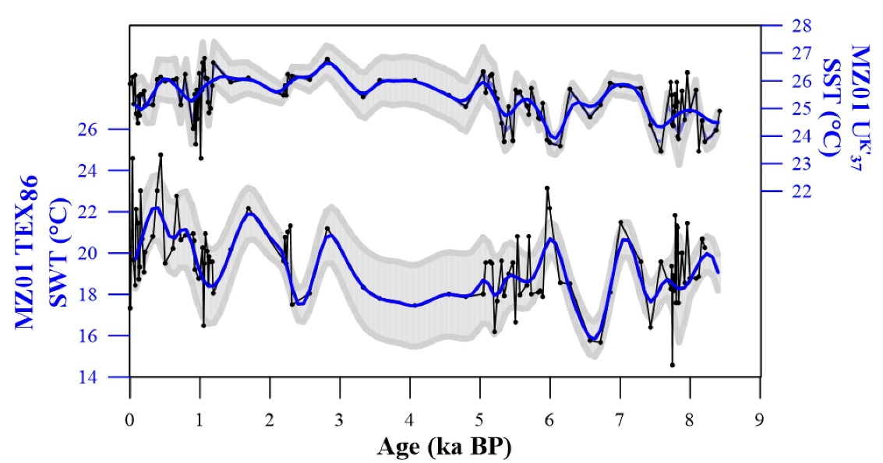
▲Supplementary Figure 7: the CSE result of MZ01 U^{k’}₃₇ and TEX_{86.}

References:
Chern, C.-S., Wang, J., and Wang, D.-P. (1990). The exchange of Kuroshio and East China Sea shelf water. Journal of Geophysical Research: Oceans 95(C9), 16017-16023. doi: 10.1029/JC095iC09p16017.
Hideshima, S., Matsumoto, E., Abe, O., and Kitagawa, H. (2016). Northwest Pacific Marine Reservoir Correction Estimated from Annually Banded Coral from Ishigaki Island, Southern Japan. Radiocarbon 43(2A), 473-476. doi: 10.1017/S0033822200038352.
Howell, P., Pisias, N., Ballance, J., Baughman, J., and Ochs, L. (2006). ARAND time-series analysis software. Brown University, Providence RI.
Lee, H.-J., and Chao, S.-Y. (2003). A climatological description of circulation in and around the East China Sea. Deep Sea Research Part II: Topical Studies in Oceanography 50(6), 1065-1084. doi: https://doi.org/10.1016/S0967-0645(03)00010-9.
Lie, H.-J., and Cho, C.-H. (2016). Seasonal circulation patterns of the Yellow and East China Seas derived from satellite-tracked drifter trajectories and hydrographic observations. Progress in Oceanography 146, 121-141. doi: https://doi.org/10.1016/j.pocean.2016.06.004.
Liu, S., Shi, X., Liu, Y., Qiao, S., Yang, G., Fang, X., et al. (2010). Records of the East Asian winter monsoon from the mud area on the inner shelf of the East China Sea since the mid-Holocene. Chinese Science Bulletin 55(21), 2306-2314. doi: 10.1007/s11434-010-3215-3.
Locarnini, R.A., Mishonov, A.V., Antonov, J.I., Boyer, T.P., Garcia, H.E., Baranova, O.K., et al. (2013). World ocean atlas 2013. Volume 1, Temperature. doi: http://doi.org/10.7289/V55X26VD.
Reimer, P.J., Bard, E., Bayliss, A., Beck, J.W., Blackwell, P.G., Ramsey, C.B., et al. (2016). IntCal13 and Marine13 Radiocarbon Age Calibration Curves 0–50,000 Years cal BP. Radiocarbon 55(4), 1869-1887. doi: 10.2458/azu_js_rc.55.16947.
Shannon, C.E. (1949). Communication in the Presence of Noise. Proceedings of the IRE 37(1), 10-21. doi: 10.1109/JRPROC.1949.232969.
Stuiver, M., Reimer, P.J., and Reimer, R.W. (2017). "CALIB 7.1 (Version 7.0. 4)".).
Weijers, J.W.H., Schouten, S., Spaargaren, O.C., and Sinninghe Damsté, J.S. (2006). Occurrence and distribution of tetraether membrane lipids in soils: Implications for the use of the TEX86 proxy and the BIT index. Organic
Wu, Z., and Huang, N.E. (2004). A study of the characteristics of white noise using the empirical mode decomposition method. Proceedings of the Royal Society of London. Series A: Mathematical, Physical and Engineering Sciences 460(2046), 1597-1611. doi: 10.1098/rspa.2003.1221.
Yoneda, M., Uno, H., Shibata, Y., Suzuki, R., Kumamoto, Y., Yoshida, K., et al. (2007). Radiocarbon marine reservoir ages in the western Pacific estimated by pre-bomb molluscan shells. Nuclear Instruments and Methods in Physics Research Section B: Beam Interactions with Materials and Atoms 259(1), 432-437. doi: https://doi.org/10.1016/j.nimb.2007.01.184.
Zhu, C., Weijers, J.W.H., Wagner, T., Pan, J.-M., Chen, J.-F., and Pancost, R.D. (2011). Sources and distributions of tetraether lipids in surface sediments across a large river-dominated continental margin. Organic Geochemistry 42(4), 376-386. doi: https://doi.org/10.1016/j.orggeochem.2011.02.002.
Zweng, M.M., Reagan, J.R., Antonov, J.I., Locarnini, R.A., Mishonov, A.V., Boyer, T.P., et al. (2013). World ocean atlas 2013. Volume 2, Salinity. doi: http://doi.org/10.7289/V5251G4D.

