Online supplementary material for

Michelutti N, Douglas MSV, Antoniades D, Lehnherr I, St. Louis VL, St. Pierre K, Muir DCG, Brunskill G, and Smol JP. Contrasting the ecological effects of decreasing ice cover versus accelerated glacial melt on the High Arctic’s largest lake. Proc R Soc B. 10.1098/rspb

S2. Lake Hazen “Main” ²¹⁰Pb and ¹³⁷Cs data with age-depth model.
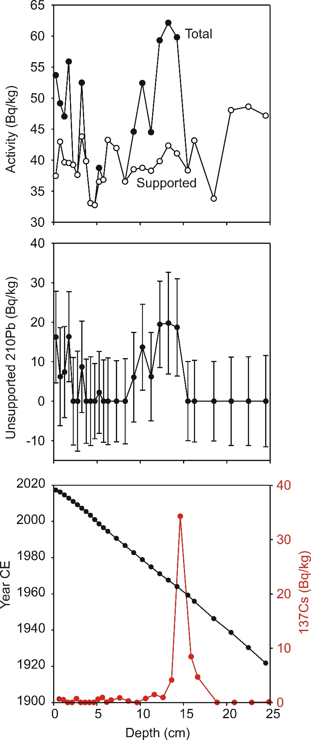
S3. Lake Hazen “Blister” ²¹⁰Pb and ¹³⁷Cs data with age-depth model.
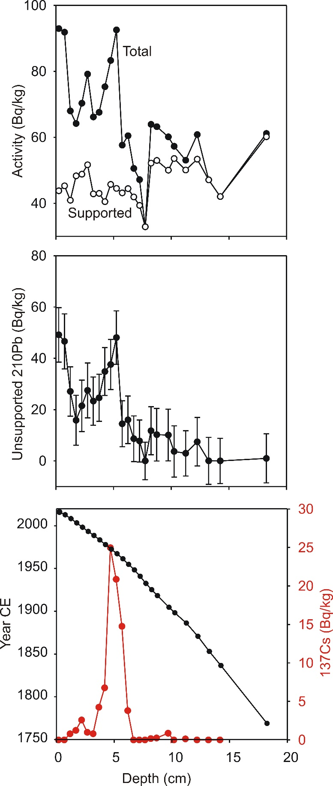

S4. Methods for calculating mean water residence times.
Mean water residence times (MRT_{H2O}) for Lake Hazen were calculated from the sum of the various hydrologic inputs to the lake, including glacial runoff, snowmelt runoff and direct precipitation on the lake surface. Modeled annual glacial runoff for the Lake Hazen watershed dating back to 1949 have been previously published [13], and more recently updated to 2016 CE [12]. Mean values published by [12] were used to estimate annual snowmelt runoff from land and snow deposited directly on the lake. We assumed no year-on-year change in water storage within the lake. The lake volume of 51. 4 km³ [19] was divided by the mean (or median) of the annual hydrologic inputs (I_{total}) for a given period of n years (equation 1). This was done for distinct time intervals (Table 1) to demonstrate the great influence of glacial runoff on mean water residence time in Lake Hazen.
$${MRT}_{H2O} (y)=\frac{Storage (m^{3})}{(\sum_{i=1}^{n}{I_{total }\left(m^{3} y^{-1}\right)} )/n}$$

