Fluorescence Intensity Fluctuation Spectrometry Suite (FIFSpA)

User Guide

Raicu Lab, Physics Department, University of Wisconsin-Milwaukee

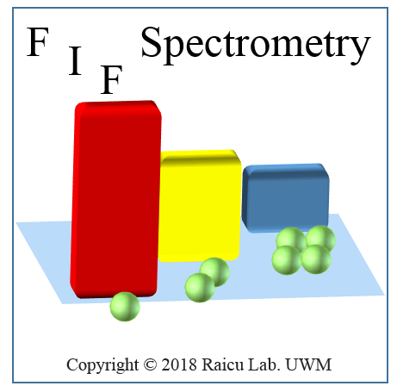

Details of the Fluorescence Intensity Fluctuation (FIF) Spectrometry method¹ are provided in “A General Method to Quantify Ligand-Driven Oligomerization Using Single- or Two-Photon Excitation Microscopy” by, Michael R. Stoneman, Gabriel Biener, Richard J. Ward, John D. Pediani, Dammar Badu, Annie Eis, Ionel Popa, Graeme Milligan and Valerică Raicu

Table of Contents
1. Disclaimer of Warranty and Limitation of Liability 3
2. System Requirements 3
3. Installation Guide 3
3.1. MATLAB® Runtime already installed on computer 4
3.2. MATLAB® Runtime not installed on computer 4
4. Overview of the FIF Spectrometry Suite 4
4.1. Main Toolbar 4
4.2. ROI Manager Module 4
4.3. Fluctuation Data Assembly Module 5
4.4. Model Fitting Module 5
5. Instructions for Use 6
5.1. Region of Interest Manager Module 6
5.1.1. ROI Module Icons 6
5.1.2. Polygon List Box 7
5.1.3. Image Stack Window 7
5.1.4. Instructions to run on data 8
5.1.4.1. Starting from new data set 8
5.1.4.2. Continuation from previously saved ROI and segment files 9
5.2. Fluctuation Data Assembly Module 9
5.2.1. Fluctuation Data Assembly Icons 10
5.2.2. Fluctuation Analysis Settings Window 11
5.2.3. Instructions to run on data 12
5.2.3.1. Continuation from ROI Manager Module 12
5.2.3.2. Loading Brightness and Concentration Values from ‘.mflc’ file 13
5.3. Model Fitting Module 13
5.3.1. Model Fitting Module Icons 14
5.3.2. Brightness Histogram Plot Window 14
5.3.3. The Fitting Adjustment Window 15
5.3.4. Model Fitting Settings Window 16
5.3.5. Instructions to run on data 16
6. Expected Output 16
7. References 17

- Disclaimer of Warranty and Limitation of Liability
Disclaimer of Warranty
THERE IS NO WARRANTY FOR THE PROGRAM, TO THE EXTENT PERMITTED BY APPLICABLE LAW. EXCEPT WHEN OTHERWISE STATED IN WRITING THE COPYRIGHT HOLDERS AND/OR OTHER PARTIES PROVIDE THE PROGRAM "AS IS" WITHOUT WARRANTY OF ANY KIND, EITHER EXPRESSED OR IMPLIED, INCLUDING, BUT NOT LIMITED TO, THE IMPLIED WARRANTIES OF MERCHANTABILITY AND FITNESS FOR A PARTICULAR PURPOSE. THE ENTIRE RISK AS TO THE QUALITY AND PERFORMANCE OF THE PROGRAM IS WITH YOU. SHOULD THE PROGRAM PROVE DEFECTIVE, YOU ASSUME THE COST OF ALL NECESSARY SERVICING, REPAIR OR CORRECTION.
Limitation of Liability
THE SOFTWARE IS TO BE USED AS IS AND AT YOUR OWN RISK. WE ASSUME NO LIABILITY FOR LOSS OF ANY KIND, INCLUDING BUT NOT LIMITED TO MATERIAL LOSS, DATA LOSS, FINANCIAL LOSS, OR LOST REVENUE RESULTING FROM THE USE OF THE SOFTWARE OR OF THIS MANUAL OR FROM THEIR BECOMING UNAVAILABLE FOR ANY PERIOD OF TIME. WE ARE NEITHER EXPLICITLY NOR IMPLICITLY PROVIDING ANY ASSURANCE THAT THE SOFTWARE IS PERFORMING AS ADVERTISED OR THAT IT CONTAINS NO ERRORS. NEITHER ARE WE PROVIDING ANY EXPLICIT OR IMPLICIT GUARANTEE THAT THIS USERS MANUAL IS ACCURATE OR THAT IT AGREES WITH THE SOFTWARE THAT IT AIMS TO DESCRIBE. THE SOFTWARE OR THE MANUAL MAY BE CHANGED WITHOUT NOTICE AT THE SOLE DISCRETION OF UW-MILWAUKEE.
Copyright
THIS SOFTWARE IS Copyright © 2018 Raicu Lab. UWM
IF YOU USE THIS SOFTWARE FOR AN ACADEMIC PUBLICATION THEN YOU ARE OBLIGED TO PROVIDE PROPER ATTRIBUTION. THIS IS DONE BY GIVING CREDIT TO THE RAICU LAB AS DEVELOPERS OF THE SOFTWARE, AND CITING OUR ARTICLE ENTITLED, “A GENERAL METHOD TO QUANTIFY LIGAND-DRIVEN OLIGOMERIZATION FROM FLUORESCENCE-BASED IMAGES”
- System Requirements
Operating System: Windows 7 64 bit or later
Processor Speed: Intel Pentium Core Duo (equivalent or better)
Memory (a.k.a RAM): 2 GB or higher
Hard Disk Space: 500 MB or more available
Internet connection is required for initial installation
- Installation Guide
  - MATLAB® Runtime already installed on computer
In order to run the FIF Spectrometry software, MATLAB® Runtime version 8.4 (R2014b) must be installed. If MATLAB® Runtime of the specific version has already been installed on the computer, then the FIF Spectrometry software can simply be started by double clicking the icon titled “FIF_Spectrometry_Suite.exe” located within the main installation folder.
  - MATLAB® Runtime not installed on computer
If MATLAB® Runtime has not been installed, first navigate inside the folder entitled “MCR_installation” and double click the executable file “MyAppInstaller_web.exe.”. This executable file will search online automatically for the relevant version of MATLAB® Runtime and install on the computer. If, for some reason, this installation fails, consult the “MCRinstallation_readme.txt” file inside the “MCR_installation” folder to manually install MATLAB® Runtime. The installation time for the MATLAB® Runtime will vary between 20 minutes and 40 minutes, depending on the speed of the computer. Once MATLAB® Runtime is installed, the user can then run the FIF Spectrometry software by double clicking the executable file “FIF_Spectrometry_Suite.exe.”
The “FIF_Spectrometry_Suite.exe” executable file can be copied anywhere on the computer, according to the preference of the user. The executable file must be copied along with the
“Measuring_Instrument_DB.txt” and “splash.png” files. A better option would be to create a shortcut icon for “FIF_Spectrometry_Suite.exe” by right clicking the file, selecting ‘create shortcut’, and then copying the shortcut to a desirable folder or the desktop.
- Overview of the FIF Spectrometry Suite
  - Main Toolbar
Launch the FIF Spectrometry Suite by double clicking the icon. After launching, the Main Toolbar will appear, as displayed in figure 1. There are three buttons in the Main Toolbar; each button opens one of three different modules responsible for implementing a different part of the fluorescence intensity fluctuation (FIF) spectrometry analysis. The three modules are entitled: ROI Manager, Fluctuation Data Assembly, and Model Fitting. A brief overview of each of the modules is included in this chapter, and a detailed description of all the functions associated with each module is given in Chapter 5.

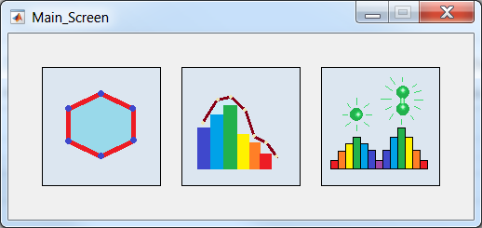
Figure 1. Fluorescence Fluctuation Suite main toolbar. This window includes three buttons: the leftmost button invokes the ROI manager, the middle button invokes the Fluctuation Data Assembly Module, and the rightmost button invokes the Model Fitting Module.
  - ROI Manager Module
The ROI Manager Module, displayed in figure 2, is launched by clicking the icon in the Main Toolbar. The main functions of this module include loading a set of fluorescence images, drawing ROI polygons to define the boundaries of entire cells within the images, and segmenting each ROI into smaller regions (segments). The ROI polygons and segments are stored in a list box as they are generated; each ROI and corresponding set of segments can be viewed on the fluorescence image on which it was drawn by simply clicking the name of the ROI in the list box after checking the show segment check box in the bottom of the ROI Manager. The ROI and segment lists can be saved to a file and reloaded at any point using icons located in this module. The demarcated segments are used in the Fluctuation Data Assembly Module described next.

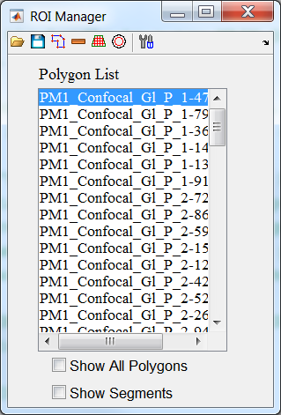
Figure 2. ROI Manager Module
  - Fluctuation Data Assembly Module
The Fluctuation Data Assembly Module, displayed in figure 3, is launched by pressing the icon in the Main Toolbar. The main functions of this module are to calculate the effective brightness and concentration for each demarcated segment of the fluorescence images, create a surface plot of the frequency of occurrence of each effective brightness-concentration pair, and generate effective brightness spectrograms. The brightness spectrograms, which represent cross sections through the surface plot for particular concentration ranges, are used for further analysis in the Model Fitting Module, as described below. The brightness and concentration information, as well as any of the generated plots can be saved to a file and reloaded at any time.
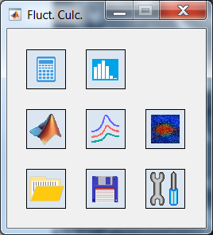
Figure 3. Fluctuation Data Assembly Module.
  - Model Fitting Module
The Model Fitting Module, displayed in figure 4, is launched by pressing the icon in the Main Toolbar. This module contains the machinery to fit the effective brightness spectrograms, generated in the Fluctuation Data Assembly Module, with an array of Gaussian functions. The mean value of each Gaussian function used in the fitting corresponds to the peak brightness value from a particular oligomer size, and the area of each gaussian (relative to the area underneath the entire histogram) reflects the relative abundance of the particular oligomer corresponding to that Gaussian. Each histogram can be fit using the Fitting Adjustment Window (described in Section 5.3) which is launched from within this module; the Fitting Adjustment Window allows the user to either adjust the parameters of each Gaussian manually, or fit the curve automatically with the push of a button.

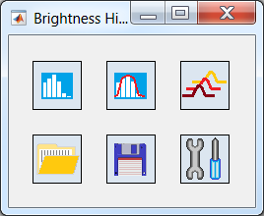
Figure 4. Model fitting Module.
- Instructions for Use
In this chapter, we intend to elaborate on each of the modules introduced in Chapter 4 by describing in detail the function of the icons contained in each module window. Throughout this chapter, bold italicized text represents the name of the different module and settings windows. Text written in blue font represent the names of different icons used to carry out a task in the software. Finally, text written in green font represent different settings which must be set by the user.
  - Region of Interest Manager Module
Open the ROI Manager Module, displayed in figure 2, by clicking the icon in the Main Toolbar. This window includes a Polygon List-Box which displays the names of all the ROIs which have been drawn by the user. In addition to the list-box, this module presents the following icons: Load ROIs/segments/Images, save ROIs +segments, draw a polygon, remove polygon from list, segment ROIs, extract membrane, and ROI manager settings. The actions of all these icons, as well as the features of the list-box, are described in the following sections. The ROI Manager Module also includes two check boxes. The Show All Polygons check box displays all the polygons already drawn for the currently displayed image. The Show Segments checkbox will overlay the currently selected ROI with the segments generated for that particular ROI, as depicted in Figure 6.
    - ROI Module Icons
Table I – Description of icons used in the ROI Manager Module along with their actions.
Icon | Name | Description
 | Load ROIs/segments/Images | Opens a window for the user to choose which image folder/file or ROI list/Segment list they would like to load. Using this window the user can load images (*.tif, *.png, *.lsm) as well as previously saved ROI lists (*.mroi, *.roi, *.zip) and segment lists (*.mseg).
 | Save ROIs + Segments | Saves the name and polygon coordinate information for all ROIs, and associated segments, displayed in the Polygon List-Box
 | Draw a Polygon | A toggle icon. When the icon is pushed in, the user can draw a polygon. When it is pushed out, the user cannot draw a polygon on top of the image window.
 | Remove ROI | Removes selected ROIs from the Polygon List-Box.
 | Segment ROI | Initiates the segmentation procedure which generates small segments within each of the ROIs which are selected in the Polygon List-Box.
 | Select a Membrane | Selects a membrane and draws a matching polygon. An ROI needs to be selected. This icon will be operational in future versions.
 | ROI Manager Settings | Opens a window from which the user can change general settings related to the saving of the ROI and segment lists as well as settings pertinent to the segmentation process (see figure 5).

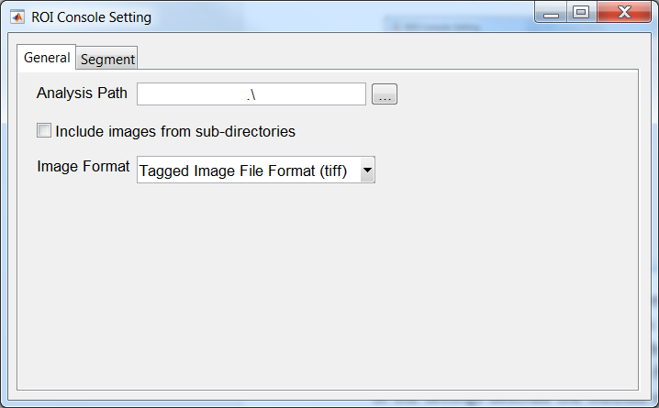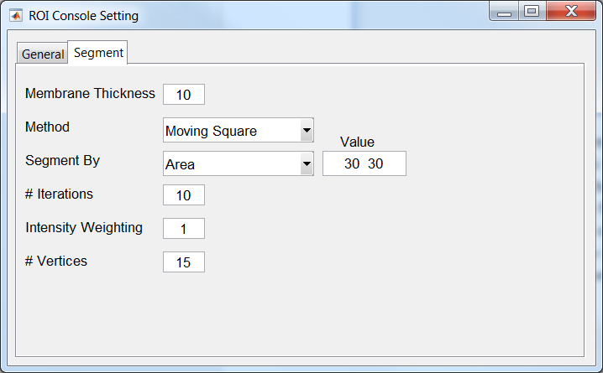
Figure 5. ROI Manager Settings Window. The ROI Manager Settings Window includes two tabs: General and Segment. The General tab contains general settings, such as the output path for saving files (Analysis Path) as well as a checkbox where the user can choose to load more than one fluorescence image at a time (Include images from sub-directories). Finally, the Image Format drop down box provides the user with the option of choosing the desired file type to load. The Segment tab provides settings relating to the segmentation process: segmentation method (moving squares, curve guided, or SLIC), segment by (Area, Number of segments) along with the input value for that property, number of iterations and intensity weighting (only applicable for the SLIC segmentation process), and lastly, polygon minimum number of vertices.
    - Polygon List Box
Each time a new polygon is drawn, the region is assigned an identifying name and is saved as a new ROI in the Polygon List Box. One (or more) polygons can be displayed in the Image Stack Window (see 5.1.3 for more details) by selecting the name (or names) of the ROI in the List Box; Table II lists a variety of keystrokes available for selecting one ROI at a time, multiple consecutive ROIs, or multiple non-consecutive ROIs. Double clicking the ROI name in the Polygon List opens the polygon-property-editor; the name of the polygon which is displayed in the List Box can be edited in the property-editor window.
Table II – Functions associated with mouse click/keystroke combinations executed within the Polygon List Box.
Mouse click/Keystroke | Description
Alt +left mouse click | Draws the selected ROI polygon on corresponding fluorescence image (see figure 6). Only applicable when the Show All Polygons checkbox is unchecked.
Shift +left mouse click | Selects a consecutive range of ROIs in the Polygon List Box. Left click the first ROI in the list you would select, hold down the shift key, then select the last ROI you would like to select.
Ctrl +left mouse click | Selects a non-consecutive range of ROI names. With the control key held down, click all the ROI names in the list you would like selected.
Left mouse click + show segments checkbox on | Displays the individual segments for the selected ROI (see figure 6).
    - Image Stack Window
Fluorescence images loaded to the program are displayed in the Image Stack Window. It is in this window where ROI polygons can be drawn on the image and segmented using an automated procedure (see 5.1.4 below).

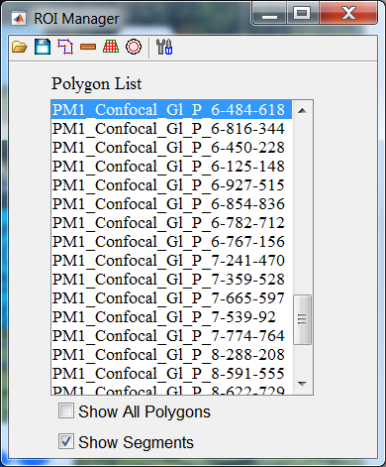
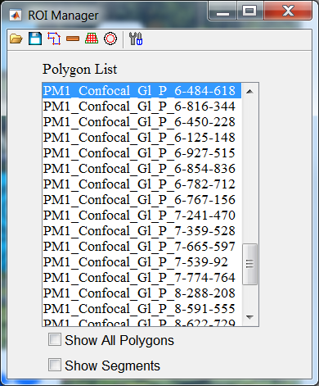
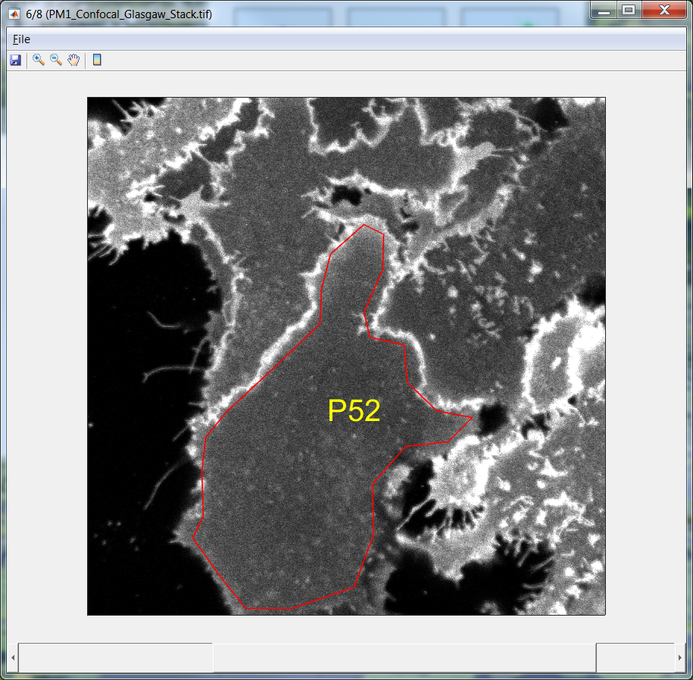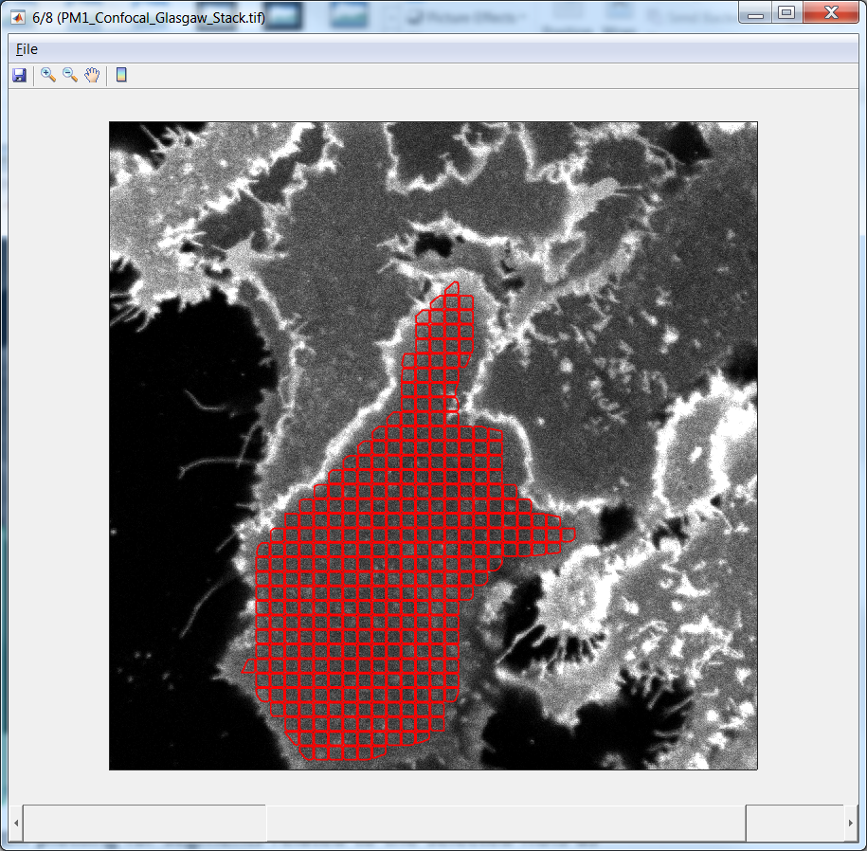
Figure 6. Display of a single ROI (left image) and segmented ROI (right image) drawn on a fluorescence image. To display a previously drawn ROI, hold down Alt and left click the corresponding ROI name stored in the Polygon List. To display multiple consecutive ROIs, left click the first ROI you wish to display, hold down shift, and then left click the final ROI you wish to display. To display non-consecutive ROIs, left click on the ROI names while you wish to display while holding the control button. To display all ROIs, check the Show All Polygons checkbox. To display the locations of individual segments, check the Show Segments checkbox and left mouse click the desired ROI.

Table III. Description of icons used in the Images Stack Window along with their actions
Icon | Name | Description
 | Save Image Stack | Saves image stack as a tiff stack This option will be incorporated in future versions.
/ | Zoom In / Zoom Out | Zooms in/out of Image Stack Window
 | Pan | Pan image. Only applies when image is zoomed in.
 | Contrast Control | Adds/Removes a scrollbar on right side of window to control contrast and image saturation (see last row in this table).
 | Image Stack Scrollbar | Scrolls between images of the image stack. Located on the bottom of the Image Stack Window
 | Contrast Scrollbar | Increases saturation as user scrolls downwards. Located on the right side of the Image Stack Window after pressing the Contrast Control icon.

    - Instructions to run on data
      - Starting from new data set
- Open the ROI Manager Module by clicking the icon in the Main Toolbar.
- Load a set of fluorescence images.
- Click the Load ROIs/segments/Images icon, .
- Navigate to and select the file/folder containing fluorescence image data.
- If set of fluorescence images are organized into a single file, or stack, select the single file containing all images.
- If each fluorescence image is saved as an individual file, navigate to the folder containing all images and select a single image from the folder. Note: in order for the program to load all images contained within the folder, the Include images from sub-directories checkbox must be checked prior to clicking the Load ROIs/segments/Images icon. This checkbox is located in the General tab of the ROI Manager Settings Window.
- Draw new polygons and add them to the ROI list.
  - Press the Draw a Polygon icon, , in the ROI manager Module.
  - Click once on the image and a cross will appear.
  - Position the cross where you would like to begin drawing the polygon and click to create a vertex. Move the mouse to the location of the next vertex and click again. Repeat this until the ROI is drawn; close the shape by double clicking.
  - Check to see that a new ROI has been added to the Polygon List. The ROI name will be a combination of the name of the image the polygon was drawn on and the pixel position of the first vertex.
  - Repeat steps c and d to add additional ROIs to the Polygon List.
- Segment the ROIs.
  - Select newly added polygons in the Polygon List.
- To select a single ROI, left click on the name of the ROI in the list.
- To segment more than one ROI at a time, left click the first ROI in the list you would like to segment, hold down the shift key, then select the last ROI you would like to segment. This selects all ROIs in the list between, and including, the two ROI names which were clicked.
  - Press the Segment ROI icon, .
- Save the list of ROIs and Segments by pressing the save icon in the ROI Manager Module. Both the list of ROIs (*.mroi extension) and segments (*.mseg extension) will be saved to the folder designated in the Analysis Path text field in the ROI Manager Setting Window.
      - Continuation from previously saved ROI and segment files
- Open the ROI Manager Module by clicking the icon in the Main Toolbar.
- Load a set of fluorescence images according to step 2 from section 5.1.4.1.
- Load previously drawn ROIs by clicking the Load ROIs/segments/Images icon, , and selecting the ‘.mroi’ file containing the saved ROI coordinates.
- Load previously drawn segments by clicking the Load ROIs/segments/Images icon, , and selecting the ‘.mseg’ file containing the saved segment coordinates.
- Repeat steps 3-5 from section 5.1.4.1.
  - Fluctuation Data Assembly Module
Open the Fluctuation Data Assembly Module, displayed in figure 3, by pushing the icon in the Main Toolbar. In this module, the effective brightness ($ε_{eff})$ and concentration values (C_{M}) for segments belonging to all selected ROIs in the Polygon List Box can be calculated. This is accomplished by first selecting the relevant ROIs in the Polygon List and then pushing the Calculate Button, , in the top left corner of the module. A progress bar indicating the progress of the calculation is displayed while the calculation is being performed. At this point, a surface plot displaying the frequency of occurrence of effective brightness for each concentration value (figure 7) and a wire stack of effective brightness spectrograms (figure 8), can be created. The effective brightness and concentration ranges along with the bin sizes for the surface plot can be set in the Fluctuation Analysis Settings Window (see 5.2.2 below). Likewise, the user can adjust the number, concentration range, and bin sizes of the brightness spectrograms in the same window. The actions of all the icons placed in the Fluctuation Data Assembly Module are given in table IV.
    - Fluctuation Data Assembly Icons
Table IV – Description of the actions of the icons used in the Fluctuation Data Assembly Module.
Icon | Name | Description
 | Calculate Brightness and Concentration | Calculates the effective brightness and concentration for all segments selected in the Polygon List Box.
 | Plot Intensity Histogram and Best-Fit Gaussian | Displays the intensity histograms and corresponding best-fit Gaussian for the segments belonging to the selected ROI.
 | Surface Plot | Generates a surface plot of the frequency of occurrence of effective brightness for each protomer concentration (figure 7).
 | Wire Stack of Brightness Spectrograms | Generates a set of effective brightness spectrograms. Each spectrogram is obtained for a user settable concentration range (figure 8).
 | Load Brightness and Concentration Information | Loads effective brightness and concentration data from a saved ‘.mflc’ file.
 | Save Brightness and Concentration Information | Saves effective brightness and concentration data to a ‘.mflc’ or excel file.
 | Fluctuation Analysis Settings | Opens a window (figure 9) which contains the settings for calculating effective brightness and concentration values. Also contains settings for generating surface plots and brightness spectrograms.

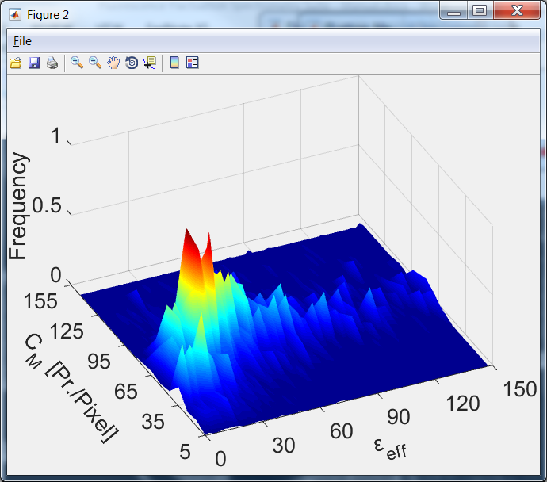
Figure 7. Surface plot of the frequency of occurrence of effective brightness ($ε_{eff})$ for each protomer concentration (C_{M}) The fluorescence images were collected on Chinese hamster ovary cells expressing secretin receptors treated with secretin ligand. The image stack includes 15 images. The number of ROIs was 69; each ROI was broken into segments with dimensions of 30x30 pixel² . The segmentation process used the moving square algorithm. The binning along the brightness axis was 2 and along the concentration axis was 10.

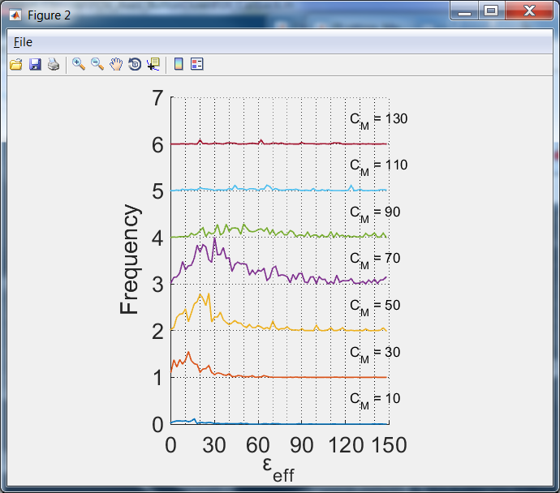
Figure 8. Wire stack of brightness spectrograms. The effective brightness spectrograms obtained for the same brightness and concentration data shown in figure 7. The binning in the brightness direction was 2 and the binning in the concentration direction was 20.
    - Fluctuation Analysis Settings Window
The settings available in the Fluctuation Analysis Settings Window pertain to numerous steps in the FIF Spectrometry Suite. They include settings which are related to the extraction of the mean and variance of fluorescence intensity histograms, settings for the calculation of effective brightness and concentration values from the mean and variance of each intensity histogram, and finally settings for the generation of brightness-concentration surface plots and brightness spectrograms. There are two tabs in the Fluctuation Analysis Settings Window, the plot tab and the fluctuation tab, both of which are described in more detail below.
In the fluctuation tab, there are a number of settings (Histogram Bin, #Gaussians, Fitting Method, Fitting Range, Method, and Avg. Background Intensity) related to extracting the mean and variance of fluorescence intensity histograms which are constructed from the pixel-level intensities of individual segments generated in the ROI Manager Module; a separate intensity histogram is constructed for each individual segment generated. Histogram Bin allows the user to set the intensity bin size used to generate the intensity histograms. Method sets whether the mean and variance of the intensity histogram is determined by fitting a Gaussian function to the histogram or calculating the first and second moments of the distribution. Fitting Method determines whether the fitting of the intensity histogram is achieved iteratively or analytically. #Gaussians sets the number of Gaussians (typically set to a value of one) used to fit the intensity histogram. Both Fitting Method and #Gaussians only apply when Gaussian Fitting is chosen from the Method dropdown list. Finally, Avg. Background Intensity is the background intensity level which is subtracted from each pixel in the fluorescence image prior to constructing the intensity histograms for each segment; this value must be determined by measuring the mean intensity in multiple subregions of the fluorescence images where there are no cells/fluorophores present.
Once the mean and variance are extracted from an intensity histogram, the corresponding effective brightness and average concentration (in protomers/pixel) are computed from these two values. The second set of settings in the fluctuation tab (Monomer Brightness, Intercept, Slope, γ-factor) are essential parameters used in calculating the effective brightness and concentration from the mean and variance values of each individual intensity histogram. For more details on the theoretical formulation for calculating the effective brightness from intensity distributions, see Stoneman et al¹. The Monomer Brightness represents the brightness of a monomeric form of the fluorophore; this value must be determined from measurements of a calibration sample known to be monomeric. The mean value of an intensity histogram is divided by the Monomer Brightness value to determine the average number of protomers per pixel (C_{M} in figures 7 and 8) for the corresponding segment. γ-factor is a shape factor which depends on the shape of the laser PSF as well as the geometry of the sample². Finally, the variance of the intensity histogram must be corrected for fluctuations in intensity arising due to the detector^{1,3,4} in order to correctly compute the effective brightness. The Intercept and Slope settings are needed to make this correction and can be determined for a particular measurement system by measuring both the variance as well as mean intensity from small subregions of images taken of a constant light source¹. The relationship between the variance and intensity of the constant light source is linear and therefore a scatter plot of the variance vs average intensity can be fit with a straight line; the slope and intercept of the fitted line are then used for the Slope and Intercept parameters, respectively.
In the plot tab, the user can set the brightness and concentration ranges (min and max) and bin sizes (Bin) used to generate the surface plot (figure 7) and the effective brightness spectrograms (figure 8). The ranges and bin sizes used to generate the brightness spectrograms are particularly important, because these values are automatically passed onto the Model Fitting Module for fitting of the brightness spectrograms.

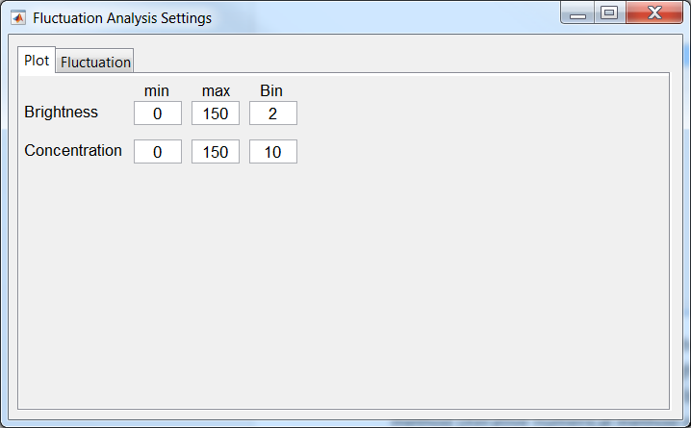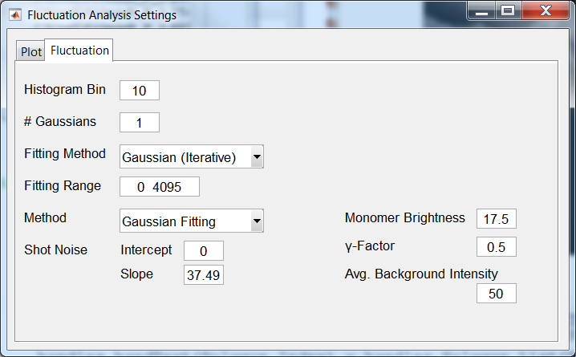
Figure 9. Fluctuation Analysis Settings Window for the “plot” (left) as well as “fluctuation” (right) tabs. In the plot tab, the user can set the brightness and concentration ranges and bin sizes for both the surface plot (figure 7) and the brightness spectrogram cross section plot (figure 8). In the fluctuation tab, the user can set parameters related to the calculation of effective brightness and concentration values from individual intensity histograms. See Section 5.2.2 for a description of each setting in the window.

    - Instructions to run on data
There are two routes for arriving at the step of generating of brightness spectrograms from pairs of brightness and concentration values. The first route is to simply continue analysis after segmentation in the ROI Manager Module is complete. In other words, after generating segments from user drawn ROIs (see section 5.1.4.1), the Fluctuation Data Assembly module is launched, and brightness and concentration values are calculated for each highlighted segment in the ROI Manager Module through the push of the Calculate Brightness and Concentration icon (see Table IV). Instructions for calculating brightness and concentration values when no break in the running of the program occurs are given in section 5.2.3.1. The second route for generating brightness spectrograms utilizes the option to save calculated brightness and concentration information and reload the values at a later time. In this scenario, the user has already: (i) drawn all ROIs, (ii) generated segments for each ROI, (iii) calculated brightness and concentration values for each segment, (iv) saved the values in a ‘.mflc’ file (v) closed the program and (vi) has now reopened the program to continue the analysis. The instructions to continue analysis after the program has been closed and reopened are detailed in 5.2.3.2.
      - Continuation from ROI Manager Module
- Open the Fluctuation Data Assembly module by pushing the icon in the main panel.
Note: do not close the ROI Manager Module or Image Stack Window
- Adjust the parameters used to fit the intensity histograms and calculate brightness and concentration values (see Section 5.2.2). First press the Fluctuation Analysis Settings icon, t, to launch the Fluctuation Analysis Settings Window . After setting parameters, close the Fluctuation Analysis Settings Window.
- Calculate effective brightness and concentration for each selected segment.
  - Select the desired ROIs in the Polygon List Box (See Table II for instructions on selecting multiple ROIs at once). Note: brightness and concentration values will only be calculated for segments which belong to selected ROIs
  - Press the Calculate Brightness and Concentration icon, , in the Fluctuation Data Assembly Module panel.
- Once the brightness and concentration values have been calculated, display the surface plot by pressing the Surface Plot icon, .
and plot the wire stack by pressing the Wire Stack of Brightness Spectrograms icon, .
- Save the effective brightness and concentration information by pressing the save icon in the Fluctuation Analysis Settings Window. There are two file formats in which the fluctuation information can be saved. Analysis is saved in an ‘.mflc’ file by default; brightness and concentration information saved in this type of format can be loaded to the program for later use. The brightness and concentration data can also be saved in an excel form. To save in excel format, the extension ‘.xlsx’ must be typed after the desired file name when prompted to choose the name and location of the output file.
      - Loading Brightness and Concentration Values from ‘.mflc’ file
- Open the ROI Manager Module by clicking the icon in the Main Toolbar. No ‘tiff’, ‘.mroi’ or ‘.mseg’ files need to be loaded at this time. However, the ROI Manager must be open before the Fluctuation Data Assembly Module can be opened.
- Open the Fluctuation Data Assembly Module by pushing the icon in the main panel
- Load the brightness and concentration data by pushing the Load Fluctuation Information icon,
in the Fluctuation Data Assembly Window. The brightness and concentration values must be in the form of an ‘.mflc’ file. When prompted to select a file after pushing this icon, do not select an excel file, as an error will occur.
- Adjust the brightness and concentration bin size and range for the brightness spectrogram plots in the Fluctuation Analysis Settings Window.
- Repeat steps 4-5 from section 5.2.3.1
  - Model Fitting Module
The Model Fitting Module, displayed in figure 4, is launched by pressing the e icon in the Main Toolbar. This module contains the machinery to fit the effective brightness spectrograms, generated in the Fluctuation Data Assembly Module, with a model consisting of an array of Gaussian functions, which is the final step in the FIF Spectrometry method. The mean value of each Gaussian function used in the model fitting corresponds to the peak brightness value from a particular oligomer size; these values are all linearly related through a single parameter, the monomeric brightness value (Monomer Brightness). The area of each Gaussian (relative to the area underneath the entire histogram) reflects the relative abundance of the particular oligomer corresponding to that Gaussian. The functionality of each icon in Model Fitting Module is explained in table V.
    - Model Fitting Module Icons
Table V – Actions of the icons within the Model Fitting Module’s panel.
Icon | Name | Description
 | Plot Brightness Spectrogram | Opens a plotting window (see figure 10) which displays a brightness spectrogram and corresponding model function for a single concentration range
 | Launch Fitting Adjustment Window | Launches the Fitting Adjustment Window (see figure 11) which contains buttons for adjusting Gaussian parameters used to fit the brightness spectrograms
 | Simultaneous Multi Curve Fitting | Simultaneously fits all the brightness spectrograms calculated for different concentrations ranges. This option will be incorporated in future versions
 | Load Brightness and Concentration 2-D Histogram | Loads brightness and concentration 2-D histogram table for fitting and further analysis. This option will be incorporated in future versions.
 | Save Brightness Spectrograms and Fitting Parameters | Saves the brightness spectrograms and relative abundance fitting parameters to an excel file.
 | Model Fitting Settings | Launches window containing settings pertinent to the spectrogram fitting function
    - Brightness Histogram Plot Window
The brightness spectrograms which are generated in the Fluctuation Data Assembly Module are transferred to the Model Fitting Module by pushing the Plot Brightness Spectrogram icon ; this icon also opens up the Brightness Histogram Plot Window (see figure 10) which displays both a single measured brightness spectrogram along with a simulating curve consisting of a sum of multiple Gaussians. The fitting of the model function to the measured spectrogram can be adjusted in the Fitting Adjustment Window (see Section 5.3.4). The fitting parameters of the simulating Gaussian function (mean, standard deviation, and relative abundances) are printed above the plot.
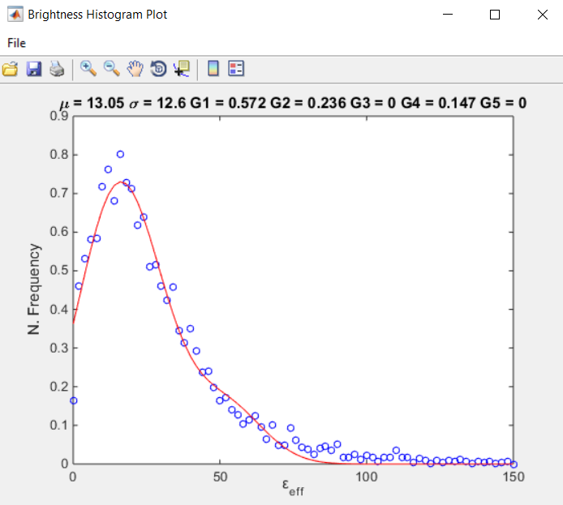
Figure 10. Brightness Histogram Plot Window. Measured brightness spectrogram (blue circles) and simulating function (red line) consisting of a sum of multiple Gaussians.
    - The Fitting Adjustment Window
In order to adjust the fitting parameters of the brightness spectrogram simulating function, the user needs to launch the Fitting Adjustment Window (figure 11) by pressing the Launch Fitting Adjustment Window icon, . The Fitting Adjustment Window allows the user to either adjust the parameters needed to fit the spectrograms manually, or automatically fit with the push of a button. A list of the Fitting Adjustment Window icons and their associated actions are given in Table VI. In order to start the fitting process, the user needs to push the down arrow icon, . Once the arrow is pressed, the fields within the Fitting Adjustment Window fill up and a red colored fitting curve appears in the Brightness Histogram Plot Window. Once an approximate fitting is achieved, the user may fine-tune the fitting by pressing the Auto fit single curve icon in the upper right corner Fitting Adjustment Window.
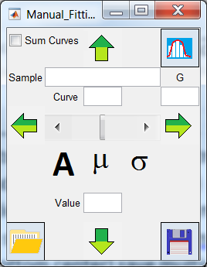
Figure 11. Fitting Adjustment Window.
Table VI – Actions of the icons within the Fitting Adjustment Window.
Icon | Name | Description
 | Auto fit single curve | Once pushed, the displayed brightness histogram is fitted automatically.
 | Update mean and STD | Updates the mean and STD of the Gaussian functions used to fit the brightness spectrograms. Mean is typically set to the value of the Monomer Brightness. STD is the standard deviation of a brightness distribution obtained from a monomeric sample
 | Load Initial Guess | Loads amplitudes for all the Gaussians as well as the mean and STD. This option will be incorporated in future versions.
 | Up or Down Arrow | Switches between spectrograms of different concentrations in the Brightness Histogram Plot Window. The currently selected spectrogram is displayed in the text box to the right of the “Curve” label.
 | Left or RightArrow | Switches active Gaussian, i.e., the Gaussian whose parameters are currently being adjusted by the Amplitude icon. The active Gaussian is displayed in the text box below the “G” label. The number represents the oligomer size the Gaussian corresponds to. 1 represents monomer, 2 – dimer, etc.
 | Amplitude | Signals the software that the amplitude was chosen by the user for manipulation by the Value change Scrollbar.
 | Mean | Signals the software that the mean was chosen by the user for manipulation by the Value change Scrollbar.
 | Standard Deviation | Signals the software that the standard deviation of the Gaussians was chosen by the user for manipulation by the Value change Scrollbar.
 | Value changing Scrollbar | A scrollbar that changes the parameters of the Gaussian fitting parameters (Amplitude, Mean, and STD).
    - Model Fitting Settings Window
The settings window for the Model Fitting Module contains a text field with the number of Gaussians used to fit the brightness spectrogram (each Gaussian corresponds to a different sized oligomer) as well as check buttons which determine whether the mean and standard deviation are fixed or adjustable during the fitting process. Typically, the mean and standard deviation are set to values obtained from calibration samples and held fixed during the fitting process. Therefore these boxes would be unchecked after setting the values for those parameters in the Fitting Adjustment Window.
    - Instructions to run on data
- Invoke the Model Fitting Module by pressing the icon in the Main Toolbar.
- Load a set of brightness spectrograms by pressing the Plot Brightness Histogram icon, .
- Launch the Fitting Adjustment Window, by pressing .
- Press the Down arrow, .
- Manually fit the brightness spectrogram from the lowest concentration range by implementing the following steps:
  - Press the icon and change the value (using the Value changing Scrollbar )to that obtained from fitting the spectrogram from a monomeric standard (i.e., to the value used for the Monomer Brightness value)
  - Press the icon and change the standard deviation value to that obtained by fitting a spectrogram from a monomeric standard
  - Press the Update mean and STD icon in the bottom right corner of the Fitting Adjustment Window
  - Open the Model Fitting Settings window, , and uncheck the adjustability of the mean and standard deviation check buttons
  - Go back to the Fitting Adjustment Window and toggle the icon
  - Adjust the value changing scrollbar until the section of the curve corresponding to the mean of the active Gaussian looks reasonably fit
  - Press the right arrow, , to switch which Gaussian is active, i.e., which Gaussian amplitude will be changed by adjusting the value changing scrollbar.
  - Repeat ‘f’ and ‘g’ for each Gaussian used in the model
  - Once the fitting looks decent, the user can improve by pressing the Auto fit single curve icon in the top right corner of the Fitting Adjustment Window
  - Press Confirm or Reject once the confirmation popup window shows up
- Repeat the fitting procedure for all concentration ranges:
  - Press the Up arrow, , to load the spectrogram for the next concentration range to the Plot Brightness Histogram Window
  - Repeat steps ‘f’ through ‘j’ from step 5 for all concentrations
- Save the results of the fittings by pressing the Save Brightness Spectrograms and Fitting Parameters of the Model Fitting Module panel
- Expected Output
Fluorescence images and ROI files used to generate a number of example FIF spectrograms are posted on Figshare digital repository and is accessible from the following link: https://figshare.com/s/77b90d060901fa8b4cb3.
For the expected output from each of the data sets, consult Figures 2 and 3 and Supplementary Figure 4 of the manuscript¹ entitled “A general method to quantify ligand-driven oligomerization from fluorescence-based images“. Each dataset on the digital repository is named with its corresponding figure number in the manuscript.
- References
1 Stoneman, M. R. et al. A general method to quantify ligand-driven oligomerization from fluorescence-based images. Nat Methods 16, 493-496 (2019).
2 Chen, Y., Muller, J. D., So, P. T. & Gratton, E. The photon counting histogram in fluorescence fluctuation spectroscopy. Biophys. J. 77, 553-567 (1999).
3 Unruh, J. R. & Gratton, E. Analysis of molecular concentration and brightness from fluorescence fluctuation data with an electron multiplied CCD camera. Biophys. J. 95, 5385-5398 (2008).
4 Godin, A. G. et al. Revealing protein oligomerization and densities in situ using spatial intensity distribution analysis. Proc. Natl. Acad. Sci. U. S. A. 108, 7010-7015 (2011).

